Supplementary figure 5: RNA integrity. (a) 28S rRNA and 18S rRNA bands of 1 µg total RNA on denaturing agarose gel electrophoresis. Intensity of 28S rRNA displays approximately twice the intensity of 18S rRNA, indicating intact RNA. (b) Electropherogram from microfluidics-based electrophoresis analysis (2100 Bioanalyzer, Agilent Technologies) with an optimal RIN = 10 and a virtual gel image of 1 µg total RNA.
(a)
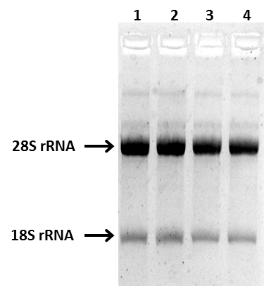

(b)
