Supplementary Information
Archives of Toxicology
Development and Analysis of an Adverse Outcome Pathway Network for Human Neurotoxicity
Nicoleta Spinu¹, Anna Bal-Price², Mark T.D. Cronin¹, Steven J. Enoch¹, Judith C. Madden¹, Andrew P. Worth²
¹School of Pharmacy and Biomolecular Sciences, Liverpool John Moores University, Byrom Street, Liverpool,
L3 3AF, UK
²European Commission, Joint Research Centre (JRC), Ispra, Italy

Corresponding Author: Andrew P. Worth; Tel: +39 0332 789566; E-mail: andrew.worth@ec.europa.eu; European Commission, Joint Research Centre (JRC), Ispra, Italy

Supplementary Figures
Figure S1. The eccentricity of KEs across the AOP neurotoxicity network. 2
Figure S2. The betweenness centrality of the KEs across the AOP neurotoxicity network. 3
Figure S3. Statistical distribution of analytical parameters in relation to the number of KEs in the AOP neurotoxicity network. 4
Figure S4. Derived AOP network for neurotoxicity containing adjacent and non-adjacent relationships. 5

Supplementary Tables
Table S1. Data available in the ToxCastTM dashboard linking biological processes with available assays which can be anchored to KEs defined in neurotoxicity-relevant AOPs. 6

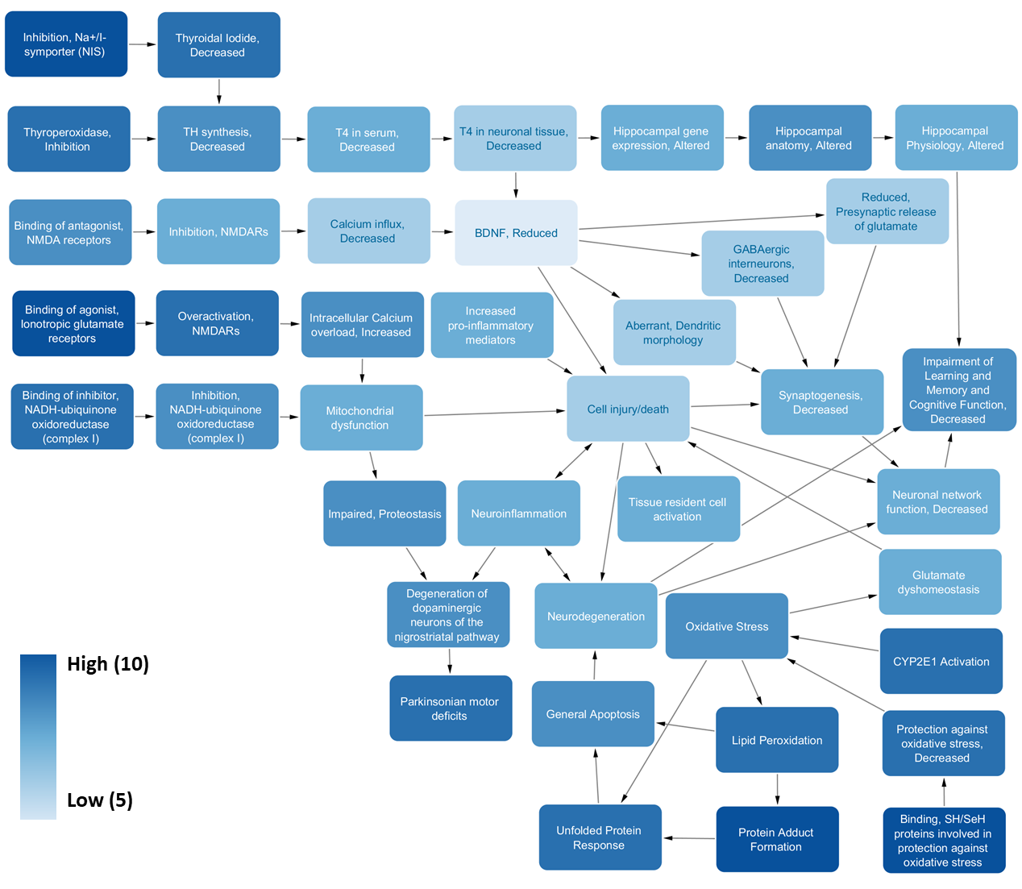
Figure S1. The eccentricity of KEs across the AOP neurotoxicity network.
The darker the colour, the more upstream is the KE positioned across the network, being less influenced by other KEs and less involved in the network. Reduction of BNDF is the lightest in colour, which means that it is the most connected KE. This parameter also confirms that reduction of BDNF can be listed as one of the most common/ highly connected KEs. The visual representation of the eccentricity was set from the score of 5 because this was the lowest score calculated by the NetworkAnalyzer App of Cytoscape software and therefore, served as the comparator for differences in scoring metrics for the individual KEs.
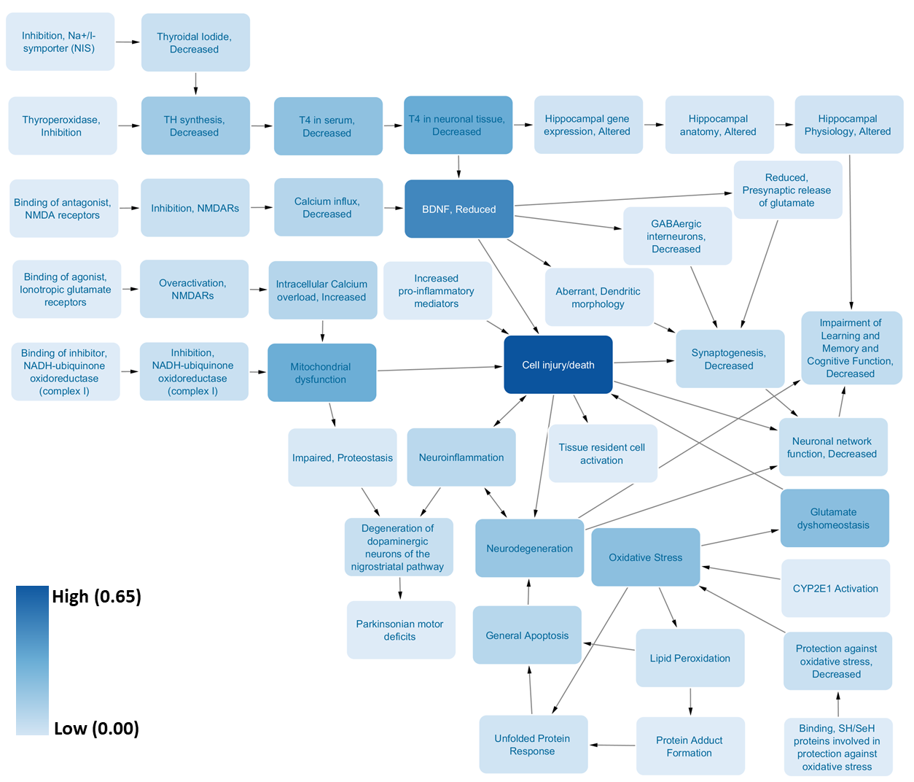
Figure S2. The betweenness centrality of the KEs across the AOP neurotoxicity network.
The darker the colour, the more centrally located is the KE in comparison with the other KEs. This parameter confirms that cell injury/death can be considered as the most comon/highly connected KE, having the highest score of 0.65.

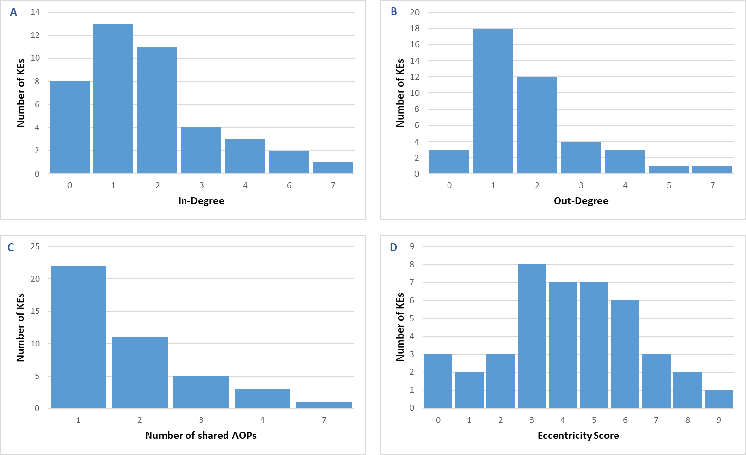
Figure S3. Statistical distribution of analytical parameters in relation to the number of KEs in the AOP neurotoxicity network.
(A) represents the number of KEs and associated number of incoming KEs. (B) shows the number of KEs and associated number of outgoing KEs. (C) indicates the distribution of KEs in shared AOPs. (D) shows the distribution of KEs according to the eccentricity score (a measure of how upstream or downstream a KE is).

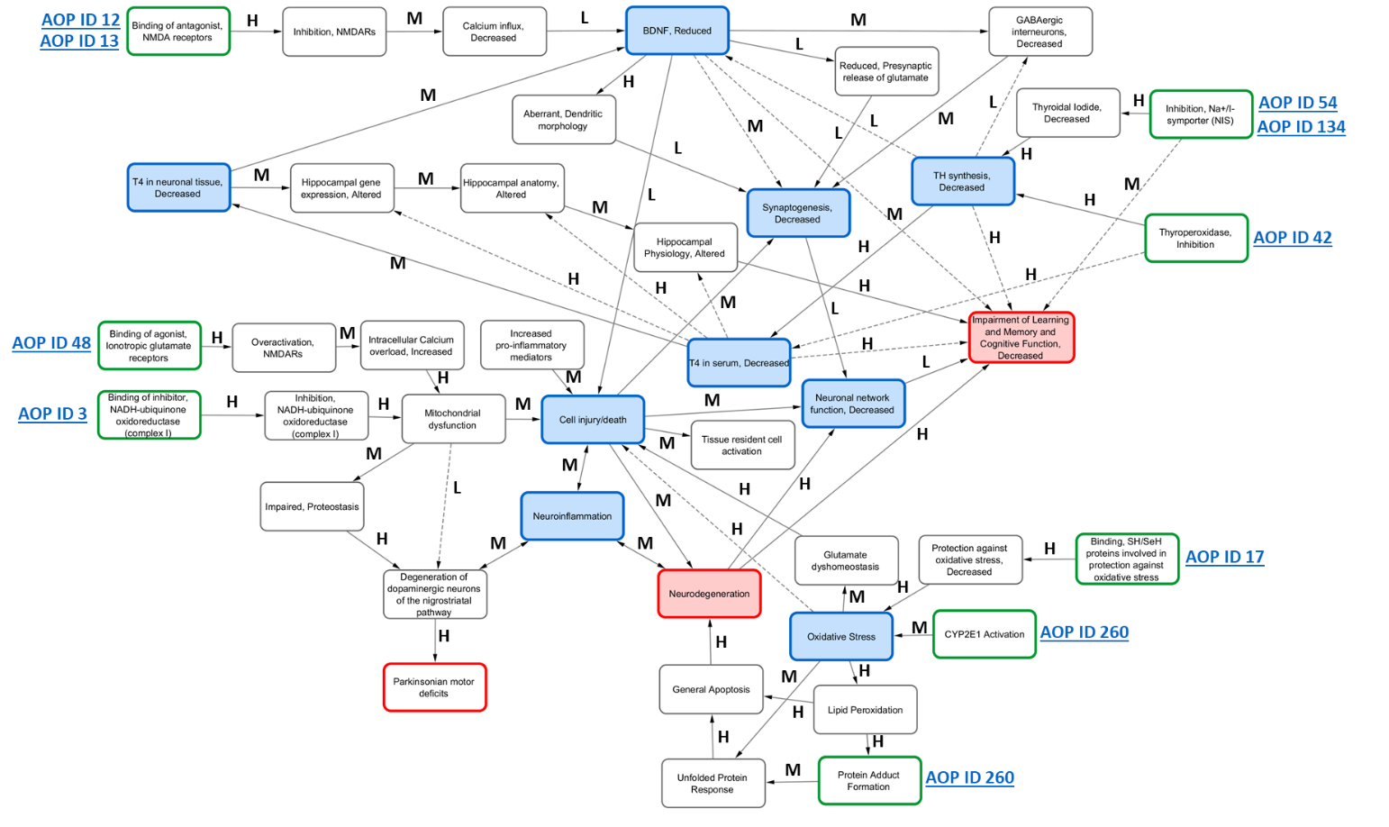
Figure S4. Derived AOP network for neurotoxicity containing adjacent and non-adjacent relationships.
Green squares indicate MIEs, red squares indicate AOs, blue squares indicate the most common/highly connected KEs. Solid arrows indicate adjacent relationships between KEs. Dashed arrows indicate non-adjacent relationships between KEs. The qualitative weight of evidence between two KEs is annotated as H for high, M for medium and L for low level of evidence.

Table S1. Data available in the ToxCastTM dashboard linking biological processes with available assays which can be anchored to KEs defined in neurotoxicity-relevant AOPs.
Assay Component Endpoint Name | Biological Process Target | Assay  Function Type | Gene Name | Intended Target  Family | Organism | AOP KE
NVS_ENZ_rCNOS | Receptor binding | Enzymatic activity | Nitric oxide synthase 1 | Oxidoreductase | Rat | Oxidative Stress
NVS_LGIC_rAMPA | Receptor binding | Binding | Glutamate receptor, ionotropic, AMPA 1 | Ion channel | Rat | Binding of agonist, Ionotropic glutamate receptors
NVS_IC_rKAR | Receptor binding | Binding | Glutamate receptor, ionotropic, kainate 1 | Ion channel | Rat | Binding of agonist, Ionotropic glutamate receptors
NVS_GPCR_bDR_NonSelective | Receptor binding | Binding | Dopamine receptor D1 | G protein-coupled receptor | Bovine | Dopaminergic neurons
NVS_TR_gDAT | Receptor binding | Binding | Solute carrier family 6 (neurotransmitter transporter, dopamine), member 3 | Transporter | Guinea pig | Dopaminergic neurons
NVS_GPCR_bNPY_NonSelective | Receptor binding | Binding | Neuropeptide Y | G protein-coupled receptor | Bovine | GABAergic neurons
NVS_GPCR_rGABBR | Receptor binding | Binding | Gamma-aminobutyric acid (GABA) B receptor 1 | G protein-coupled receptor | Rat | GABAergic neurons
NVS_LGIC_bGABAR_Agonist | Receptor binding | Binding | Gamma-aminobutyric acid (GABA) A receptor, alpha 1 | Ion channel | Bovine | GABAergic neurons
NVS_LGIC_bGABARa1 | Receptor binding | Binding | Gamma-aminobutyric acid (GABA) A receptor, alpha 1 | Ion channel | Bovine | GABAergic neurons
NVS_LGIC_bGABARa5 | Receptor binding | Binding | Gamma-aminobutyric acid (GABA) A receptor, alpha 5 | Ion channel | Bovine | GABAergic neurons
NVS_LGIC_rGABAR_NonSelective | Receptor binding | Binding | Gamma-aminobutyric acid (GABA) A receptor, alpha 1 | Ion channel | Rat | GABAergic neurons
NVS_LGIC_rGABARa6 | Receptor binding | Binding | Gamma-aminobutyric acid (GABA) A receptor, alpha 6 | Ion channel | Rat | GABAergic neurons
NVS_IC_rCaBTZCHL | Receptor binding | Binding | Calcium channel, voltage-dependent, P/Q type, alpha 1A subunit | Ion channel | Rat | Calcium channels
NVS_IC_rCaChN | Receptor binding | Binding | Calcium channel, voltage-dependent, N type, alpha 1B subunit | Ion channel | Rat | Calcium channels
NVS_IC_rCaDHPRCh_L | Receptor binding | Binding | Calcium channel, voltage-dependent, P/Q type, alpha 1A subunit | Ion channel | Rat | Calcium channels

