Supporting Information
Time-resolved characterization of the mechanisms of toxicity induced by silica and amino-modified polystyrene in alveolar-like macrophages
Sarah Deville^{a,b,c}, Birgit Honrath^{d}, Quynh T.D. Tranª, Gyorgy Fejer^{e}, Ivo Lambrichts^{c}, Inge Nelissen^{b}, Amalia M. Dolga^{d} and Anna Salvatiª
ªDepartment Pharmacokinetics, Toxicology and Targeting, Groningen Research Institute of Pharmacy, University of Groningen, Groningen, The Netherlands; ^{b}Health Department, Flemish Institute for Technological Research, Mol, Belgium; ^{c}Biomedical Research Institute, Hasselt University, Diepenbeek, Belgium; ^{d}Department of Molecular Pharmacology, Groningen Research Institute of Pharmacy, University of Groningen, Groningen, The Netherlands; ^{e}School of Biomedical Sciences, Faculty of Medicine and Dentistry, Plymouth University, Derriford Research Facility, Plymouth, United Kingdom.

* Corresponding author; Groningen Research Institute of Pharmacy, University of Groningen, A. Deusinglaan 1, 9713AV Groningen, The Netherlands; a.salvati@rug.nl.

Supplementary methods
Nanoparticle uptake studies
In order to measure nanoparticle uptake by flow cytometry, cells were exposed to 40 nm yellow-green fluorescent carboxylated polystyrene nanoparticles (COOH-PS, FluoSpheres, ThermoFisher Scientific) and 50 nm green fluorescent plain silica nanoparticles (SiO₂ nanoparticles, sicastar-greenF, Micromod Partikeltechnologie, Rostock, Germany). Nanoparticle dispersions were prepared by diluting the concentrated stock dispersions in complete cell culture medium immediately prior to exposure to the cells. Cells were exposed as described in the main manuscript. After 24 hours, floating and adhering cells harvested with 1.5 mM EDTA in PBS were combined. Cells were washed one time with complete cell culture medium and two times with PBS by means of centrifugation. Finally cells were resuspensed in PBS and cell fluorescence intensity was measured immediately using a CytoFLEX flow cytometer. A 488 nm laser was used and the emission light was collected using a 525/40 nm band pass filter. Gates in the forward and side scattering double scatter plots were set in order to exclude cell debris. Cell doublets were excluded in the FSC-A versus FSC-H double scatter plots. A minimum of 20 000 cells were measured. Then, the averaged mean and standard deviation over two replicates of the obtained fluorescence intensity distributions were calculated.
Flow cytometry assays on cellular functions
For all these assay, cells were seeded in a 12-well plate with surface area 3.5 cm² and in each well 1000 µl of nanoparticle dispersions were added.
For assessment of lysosomal integrity and swelling, cells were stained with 50 nM LysoTracker Red (Life Technologies, Eugene, USA) diluted in complete cell culture medium for 20 minutes at 37°C. In order to excite the dye, a 561 nm laser was used and its emission was collected using a 610/20 nm band-pass filter.
For the measurement of the intracellular ROS levels, cells were stained with 2.5 µM H₂DCFDA (Life Technologies) diluted in Hanks’ Balanced Salt Solution without calcium and magnesium (HBSS, Gibco) for 20 minutes at 37°C. A 488 nm laser was used to excite the dye and its emission was collected using a 525/40 nm band pass filter. For the determination of the mitochondrial ROS levels, cells were stained with 1.25 µM MitoSOX Red (Life Technologies) diluted in HBSS for 20 minutes at 37°C. A 488 nm laser was used to excite the dye and its emission was collected using a 690/50 nm band pass filter. Lipid peroxidation was determined by staining the cells with 2 µM BODIPY 581/591 Ceramide-11 (Life Technologies) diluted in complete cell culture medium for 1 hour at 37°C. A 488 nm laser was used to excite the dye and its emission was collected using a 525/40 nm band pass filter.
Mitochondrial membrane potential was determined by staining the cells with 200 nM TMRE (Life Technologies) in complete cell culture medium for 20 minutes at 37°C. A 561 nm laser was used and its emission was collected using a 585/42 nm band-pass filter.
Intracellular calcium levels were detected using 2 µM rhodamine-2 AM (Life Technologies) diluted in serum-free medium for 20 minutes at room temperature. Thereafter, cells were pelleted and resuspended in complete cell culture medium for another 20 minutes at room temperature. Next, cells were pelleted, resuspended in PBS and measured using a 561 nm laser. Rhodamine-2 AM emission was collected using a 610/20 nm band-pass filter.
Phosphatidylserine exposure in apoptotic and dead cells was detected using a Pacific Blue Annexin V/SYTOX AADvanced Apoptosis Kit (Life Technologies). A 405 nm laser was used to excite Annexin V and its emission was collected using a 450/45 nm band-pass filter and a 488 nm laser was used to excite SYTOX AADvanced and its emission was collected using a 660/20 nm band-pass filter.
Samples were prepared for flow cytometry and results analyzed as described in the main manuscript.
Measurement of cell viability and caspase 3/7 activity
In order to assess the viability and caspase 3/7 activation, 25 000 MPI cells were seeded in a 96 well plate and 48 hours after seeding were exposed as described above to different doses of SiO₂ and NH₂-PS nanoparticles in cell culture medium for the indicated times (100 µl nanoparticle dispersions). After the desired exposure time, the medium containing the nanoparticle dispersion was removed and 100 µl of MTT (3-(4,5-dimethylthiazol-2-yl)-2,5-diphenyltetrazolium bromide) reagent (Sigma-Aldrich, St. Louis, USA) dissolved to a final concentration of 500 µg/ml in cell culture medium was applied to the cells for 30 minutes at 37°C and 5% CO₂. Thereafter, the medium containing the MTT reagent was removed and the precipitated formazan crystals were solubilized using 100 µl dimethyl sulfoxide (DMSO). The absorbance was read out at 550 nm (ThermoMax, Molecular Devices, Sunnyvale, USA). The caspase 3/7 activity was determined using a Caspase 3/7-Glo kit (Promega, Madison, USA) according to the manufacturer’s guidelines. 25 000 MPI cells were seeded in a white 96 well plate and 48 hours after seeding were exposed as described above to different doses of SiO₂ and NH₂-PS nanoparticles in cell culture medium for the indicated times (100 µl). Thereafter, the medium was removed, replaced by 100 µl of the reagent and incubated for 1 hour at room temperature. Luminescence was measured using a LumiCount plate reader (Packard Instrument Company, Fallbrook, USA). The experiment was repeated two times. The results of three technical replicates of a representative experiment are shown together with their mean.
Fluorescence microscopy
In order to visualize the lysosomes and autophagosomes, 125 000 cells were seeded using the procedure described before on glass coverslips which were placed on the bottom of a 24-well plate. Cells were fixed after the desired exposure time using 4% paraformaldehyde (Klinipath, Duiven, The Netherlands) for 20 minutes at room temperature. Thereafter, cells were washed with PBS and permeabilized using 0.5% Tween20 in PBS for 10 minutes at room temperature. Next, cells were blocked with 5% bovine serum albumin (Sigma-Aldrich) in PBS for 30 minutes at room temperature. Rat monoclonal antibodies for Lamp1A (Abcam, Cambridge, UK) and rabbit polyclonal antibodies for LC3A/LC3B (Life Technologies) were applied in blocking buffer for 1 hour at room temperature. After washing, donkey anti rat Alexa 488 secondary antibodies and donkey anti rabbit Alexa 647 secondary antibodies (both Life Technologies) were applied in blocking buffer for 1 hour at room temperature. After washing, samples were counterstained using 500 nM of 4′,6-diamidino-2-phenylindole (DAPI, Life Technologies) in PBS for 5 minutes at room temperature. Thereafter, samples were mounted with Mowiol 4-88 (Merck Millipore) and dried overnight. Image acquisition was performed using a Leica AF6000 epifluorescence microscope and a SP8 Leica confocal fluorescence microscope (Leica, Wetzlar, Germany).
Quantitative real-time PCR (qPCR)
For qPCR, 500 000 MPI cells were seeded in a 6 well plate and 48 hours after seeding, were exposed to different doses of nanoparticles as described above. Then, total RNA was extracted using Trizol RNA extraction (TRI Reagent Solution, Applied Biosystems, Landsmeer, Netherlands). Briefly, 500 µl Trizol reagent was added to the cells and incubated for 5 minutes, followed by the addition of 1-bromo-3-chloropropane (Sigma-Aldrich) and 15 minutes incubation. Afterwards, lysates were collected and centrifuged at 12 000 g for 15 minutes at 4°C. The aqueous phase was separated and incubated with isopropanol for 10 minutes. After centrifugation at 12 000 g for 8 minutes at 4°C, the RNA was washed with 75% ethanol and centrifuged again at 7500 g for 5 minutes at 4°C. The cDNA was synthesized from 1000 ng RNA using the Reverse Transcriptase System (Promega), and the following protocol: 10 minutes 25°C, 45 minutes 42°C, 5 minutes 99°C. Quantitative real-time PCR was performed using SYBR Green (Roche Diagnostics, Almere, Netherlands) and the following protocol including a final step to generate the melting curve: 2 minutes 95°C, 10 minutes 95°C, 45x[30 seconds 95 °C, 30 seconds 60°C, 30 seconds 72°C], 30 seconds 95°C, 30 seconds 55°C, 30 seconds 95°C. The qPCR was performed in an Eco Illumina (Illumina, Eindhoven, Netherlands). For analysis, the LinRegPCR software¹ was used to calculate N0 values which were normalized to N0 of GAPHD as an internal control. The results for cells exposed to the nanoparticles were normalized by the results in untreated cells in order to obtain the fold change in gene expression in comparison to untreated controls. For each sample two technical replicates were measured and their mean calculated. Four independent experiments were made. The results of the individual experiments are shown together with their average.

The following murine primers were used:
CHOP | 5’ CATACACCACCACACCTGAAAG 3’  3’ CCGTTTCCTAGTTCTTCCTTGC 5’
Beclin-1 | 5’ GGCCAATAAGATGGGTCTGA 3’  3’ GCTGCACACAGTCCAGAAAA 5’
GAPHD | 5’ GGAGAGTGTTTCCTCGTCCC 3’  3’ ATGAAGGGGTCGTTGATGGC 5’

Supplementary figures

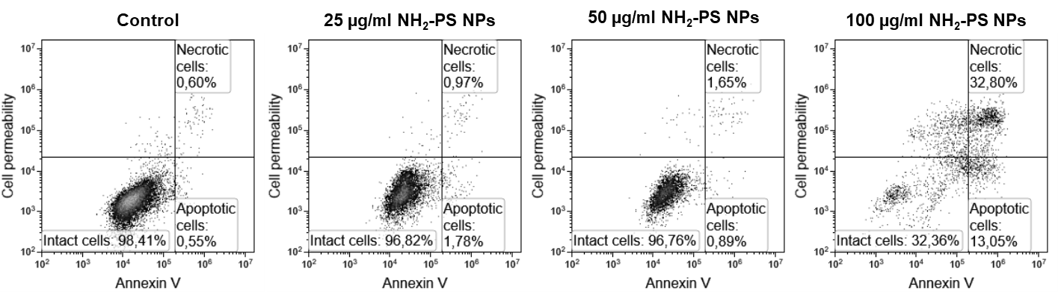
Figure S1: Annexin V – SYTOX staining for monitoring eventual presence of apoptotic cells and changes in cell membrane permeability. Representative examples of Annexin V – SYTOX double scatter plots after 24 hours of exposure to NH₂-PS NPs together with the percentage of intact cells (Annexin V negative and no increased cell permeability), apoptotic cells (Annexin V positive cells without increase in cell permeability), necrotic cells (Annexin V positive cells with increased cell permeability). The corresponding fluorescence intensity results of replicate measurements are shown in Figure 1B. For cells exposed to 100 µg/ml NH₂-PS NPs due to the strong toxicity, it was possible to measure only 5000 cells (instead of 20000).

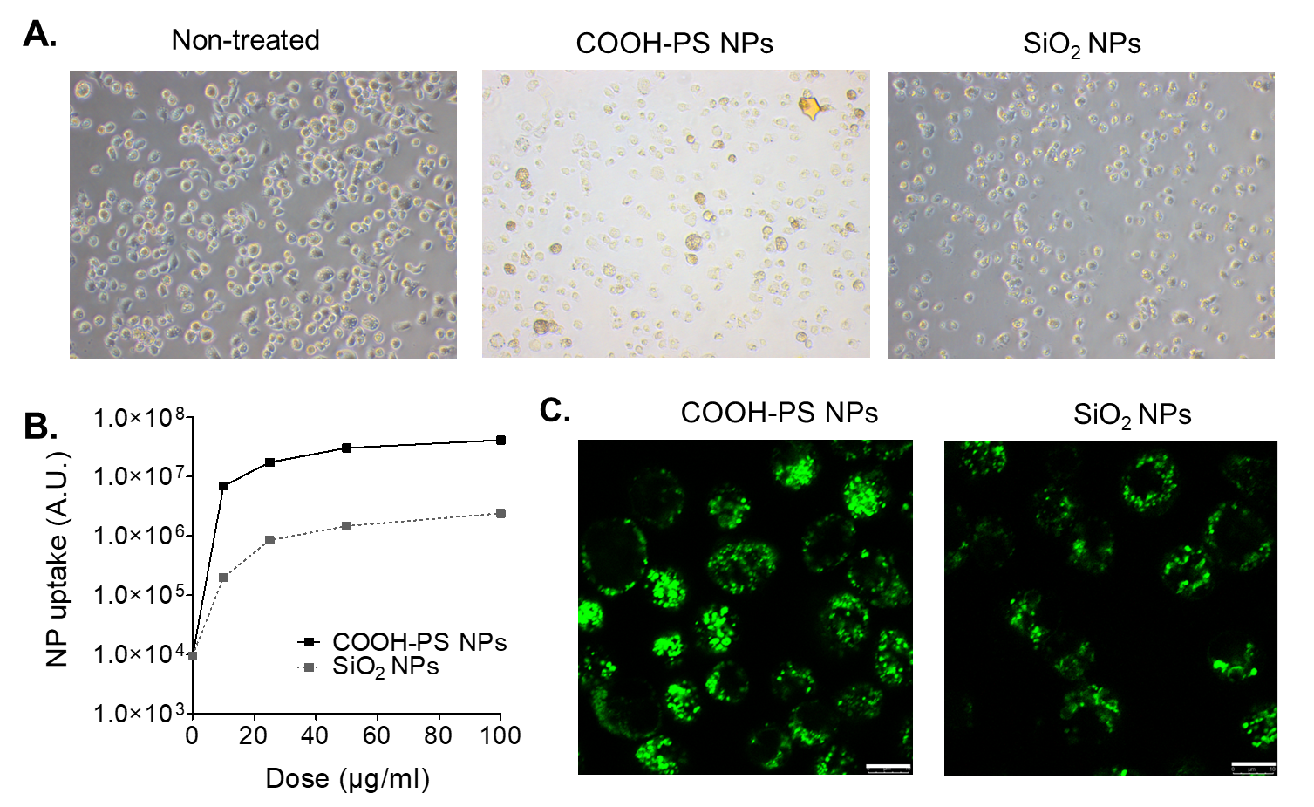

Figure S2: High uptake of 40 nm COOH-PS and 50 nm SiO₂ nanoparticles in MPI cells. (A) Light microscopy images of MPI cells after 24 hours exposure to 25 µg/ml fluorescent nanoparticles. The massive uptake of nanoparticles turns the MPI cells yellow even in standard light microscopy. (B) Uptake by flow cytometry in MPI cells exposed to different doses of fluorescent nanoparticles for 24 hours and (C) confocal microscopy images of cells exposed for 4 hours to 25 µg/ml fluorescent nanoparticles (scale bar is 10 µm). Flow cytometry and confocal microscopy confirm highly efficient uptake of nanoparticles by MPI cells.
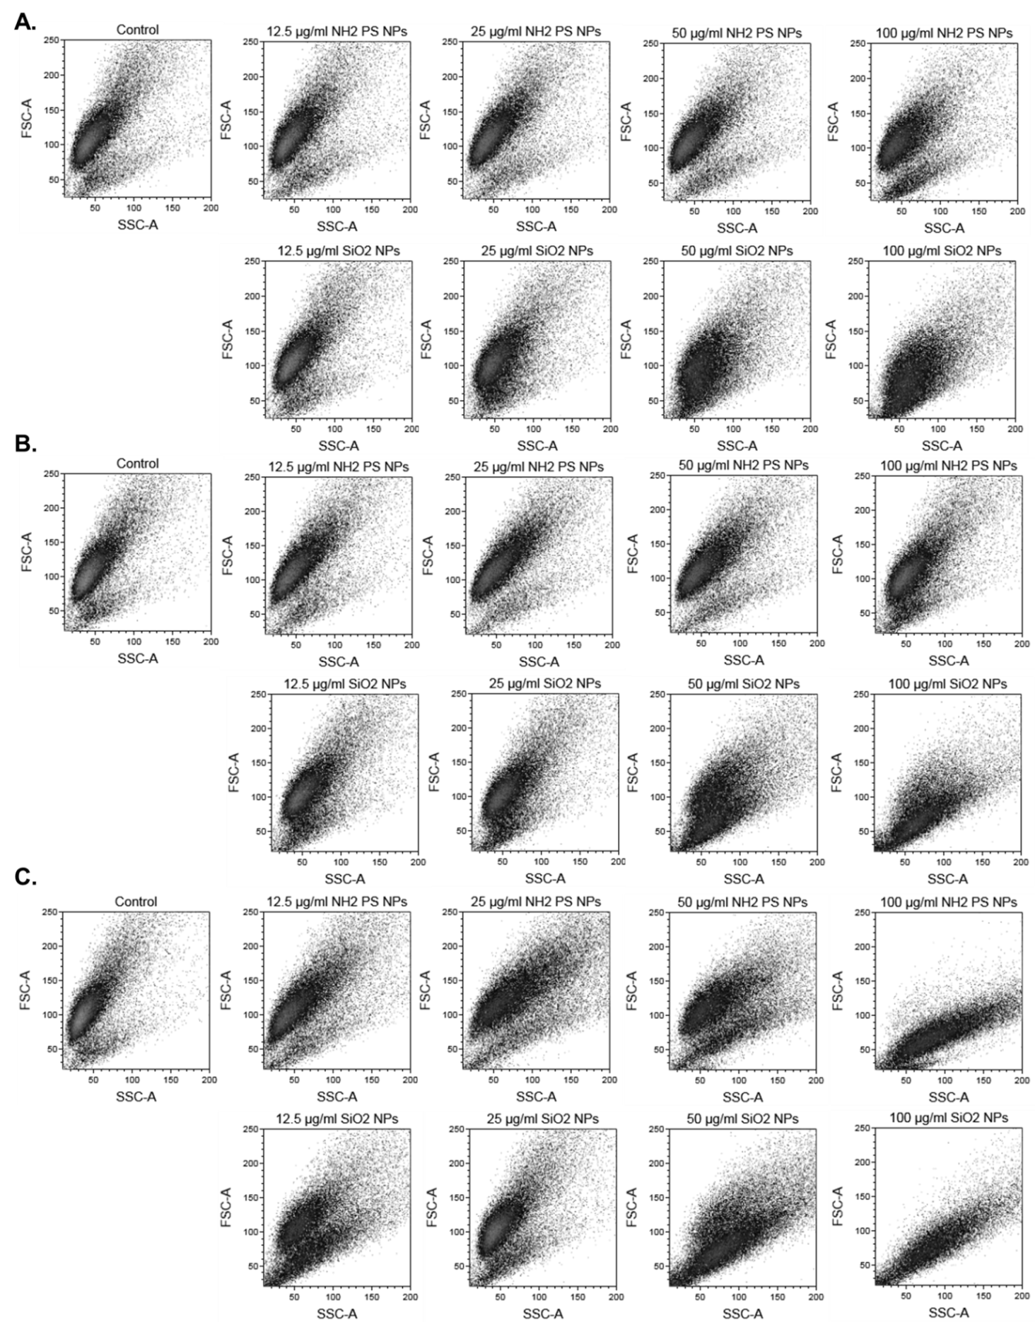
Figure S3: Forward and side scattering of MPI cells after exposure to NH₂-PS and SiO₂ nanoparticles. Examples of double scatter plots of forward and side scattering (FSC-A and SSC-A respectively) obtained by flow cytometry of MPI cells after (A) 4 hours, (B) 8 hours and (C) 24 hours of exposure to different doses of nanoparticles. The results show changes in forward and side scattering of the cells exposed to nanoparticles, indicative of changes in cell size and cell granularity (density), respectively.
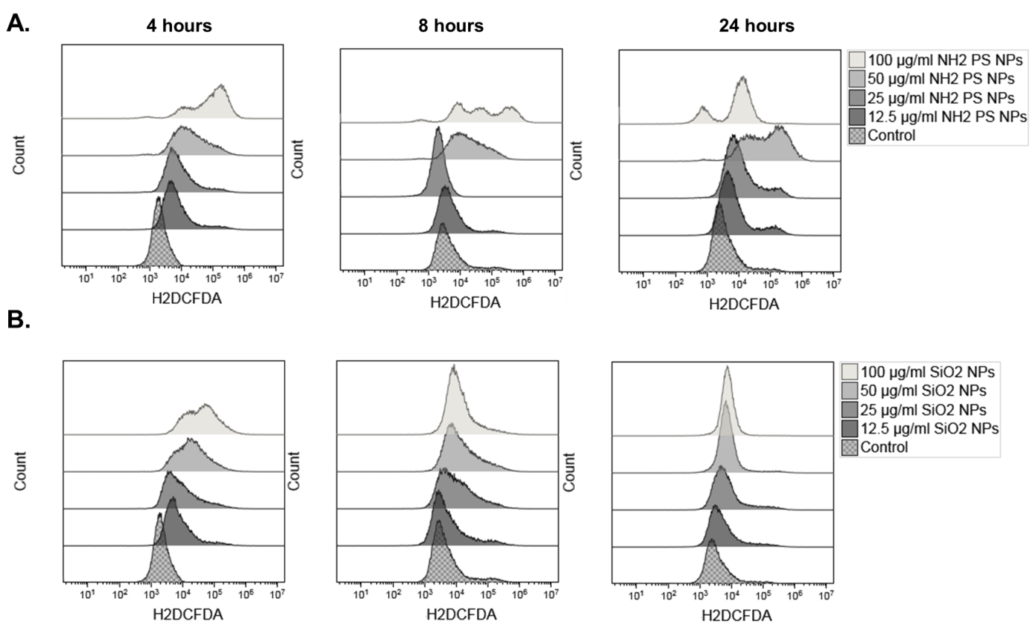
Figure S4: Induction of cellular ROS in MPI cells after exposure to (A) NH₂-PS and (B) SiO₂ nanoparticles. ROS production was determined by H₂DCFDA assay. Representative examples of H₂DCFDA fluorescence intensity distributions are shown for MPI cells exposed for different times to different doses of (A) NH₂-PS and (B) SiO₂ nanoparticles. The corresponding mean fluorescence intensity results of two technical replicate samples are shown in Figure 2A.

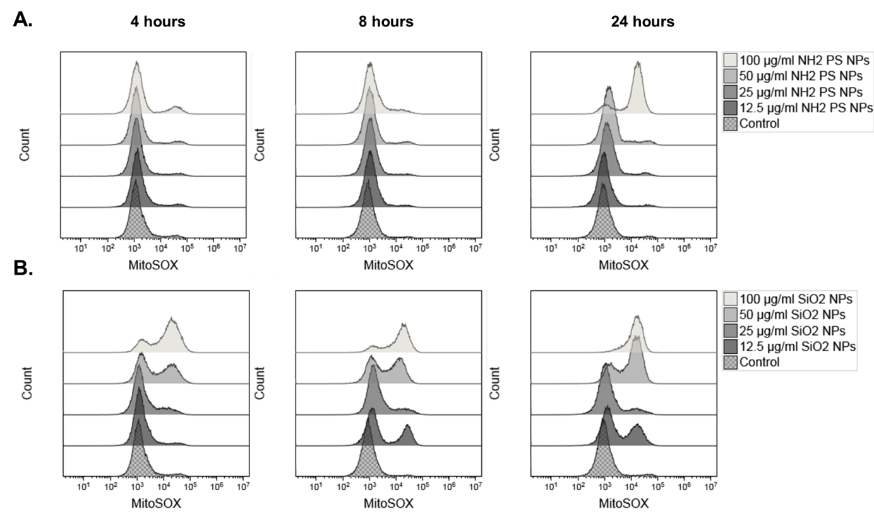
Figure S5: Induction of mitochondrial ROS in MPI cells after exposure to (A) NH₂₋PS and (B) SiO₂ nanoparticles. Mitochondrial ROS production was measured using MitoSOX. Representative examples of MitoSOX fluorescence intensity distributions are shown for MPI cells exposed for different times to different doses of (A) NH₂-PS and (B) SiO₂ nanoparticles. The corresponding mean fluorescence intensity results of two technical replicate samples are shown in Figure 2B.

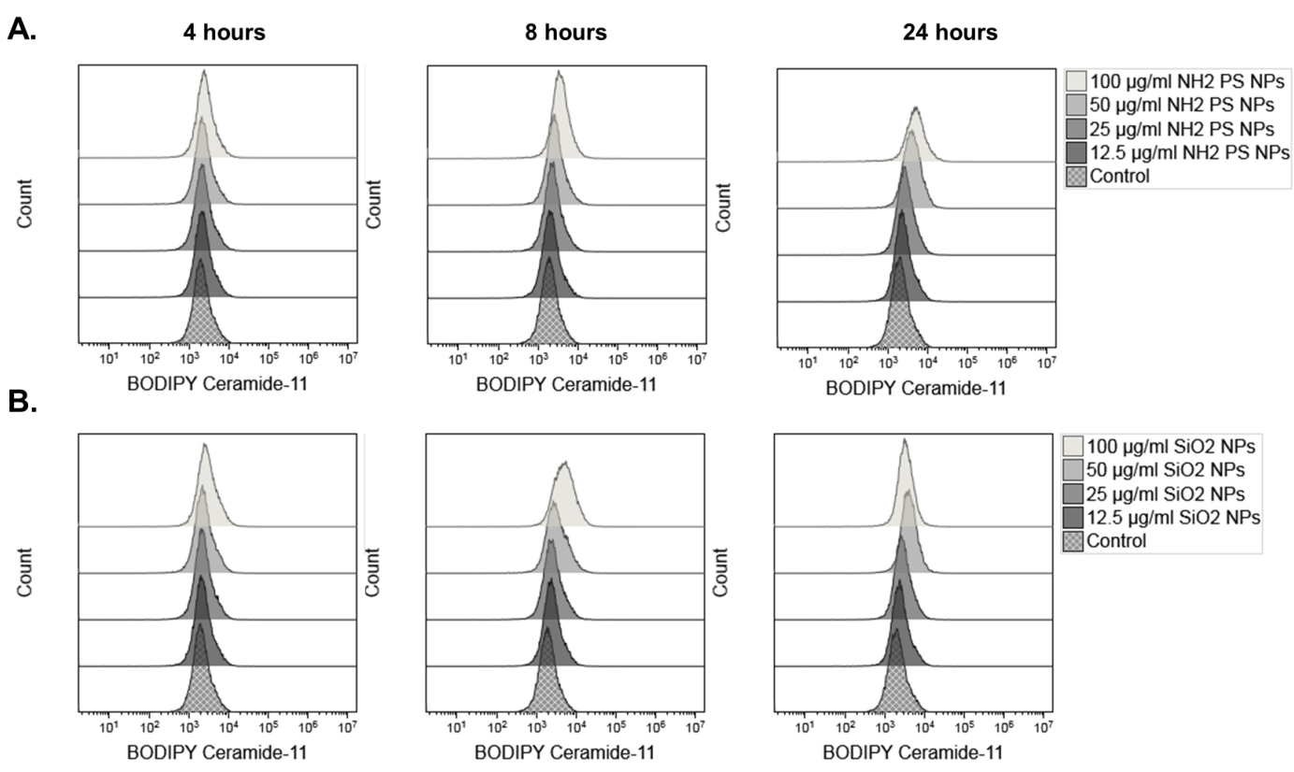
Figure S6: Induction of lipid peroxidation in MPI cells after exposure to (A) NH₂-PS and (B) SiO₂ nanoparticles. Lipid peroxidation was determined by BODIPY Ceramide-11. Representative examples of BODIPY Ceramide-11 fluorescence intensity distributions are shown for MPI cells exposed for different times to different doses of (A) NH₂-PS and (B) SiO₂ nanoparticles. The corresponding mean fluorescence intensity results of two technical replicate samples are shown in Figure 2C.
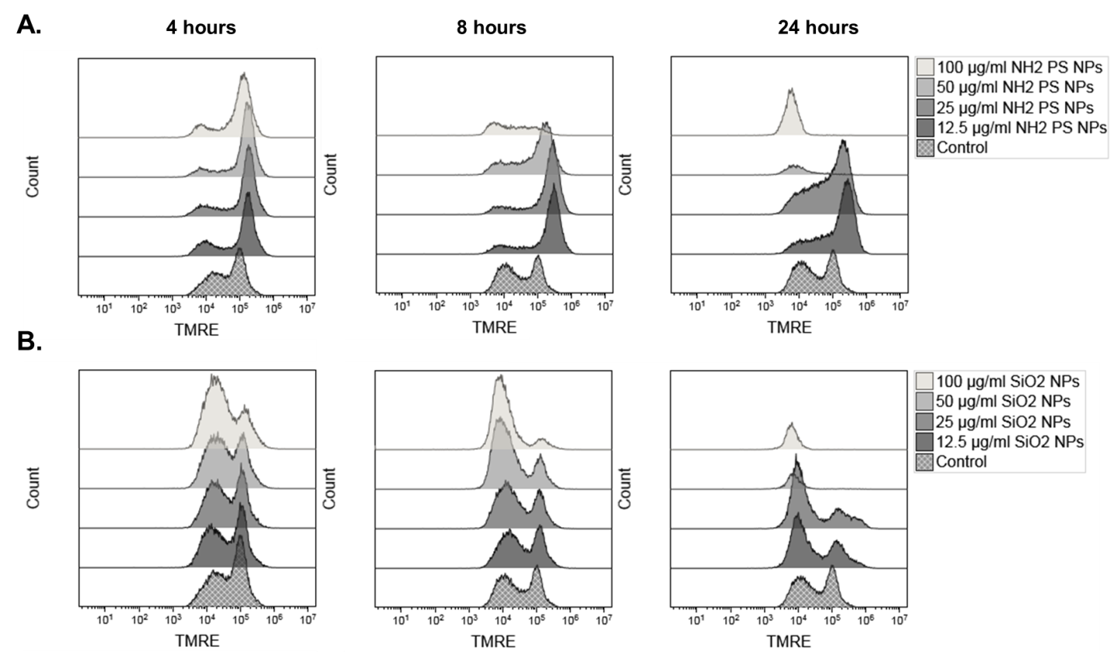
Figure S7: Effect of NH₂-PS and SiO₂ nanoparticles on mitochondrial membrane potential in MPI cells. Mitochondrial potential was assessed using TMRE assay. Representative examples of TMRE fluorescence intensity distributions are shown for MPI cells exposed for different times to different doses of (A) NH₂-PS and (B) SiO₂ nanoparticles. The corresponding mean fluorescence intensity results of two technical replicate samples are shown in Figure 3B.
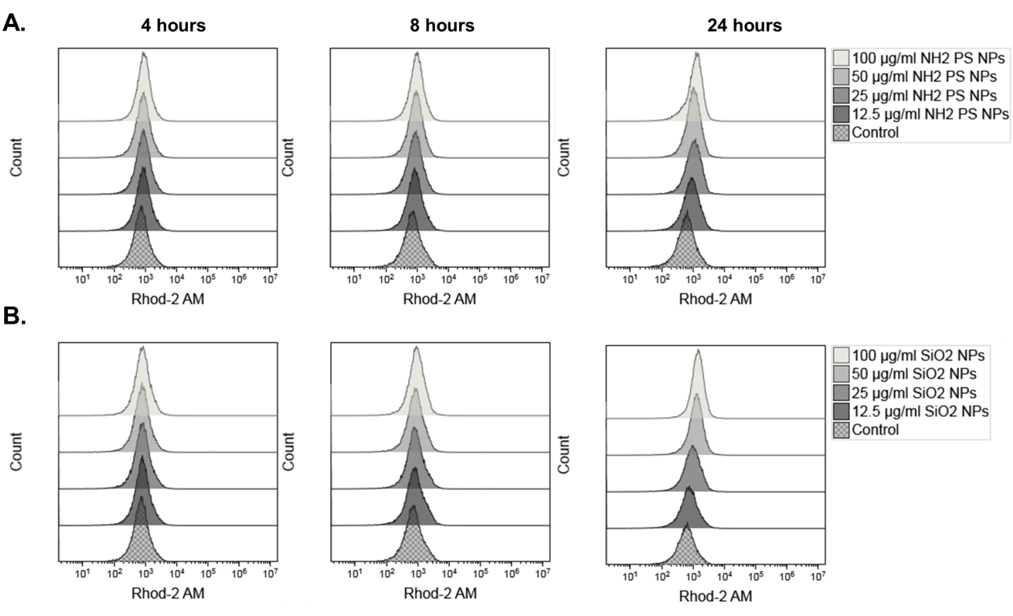
Figure S8: Effect of NH₂-PS and SiO₂ nanoparticles on intracellular calcium levels. Calcium levels were measured by the calcium indicator rhodamine-2 AM (Rhod-2 AM). Representative examples of Rhod-2 AM fluorescence intensity distributions are shown for MPI cells exposed for different times to different doses of (A) NH₂-PS and (B) SiO₂ nanoparticles. The corresponding mean fluorescence intensity results of two technical replicate samples are shown in Figure 3C.

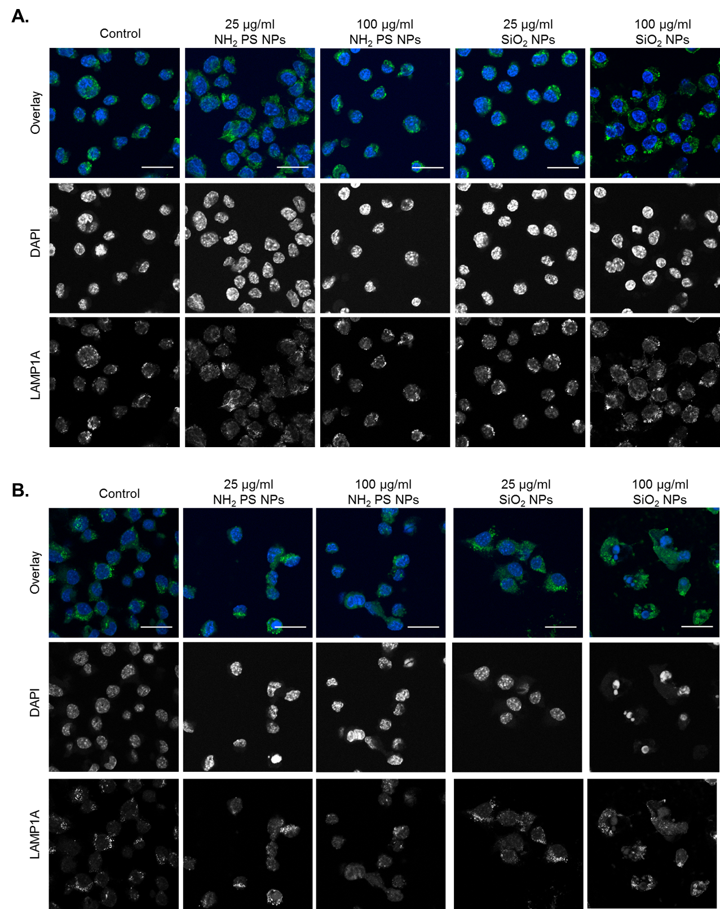
Figure S9: Effect of NH₂-PS and SiO₂ nanoparticles on lysosomes in MPI cells. Confocal microscopy images of MPI cells after (A) 8 hour and (B) 24 hour exposure to nanoparticles. Green: LAMP1A stained lysosomes; blue: DAPI stained nuclei. Scale bar: 20 µm. Corresponding images after 4 hours of exposure are shown in Figure 4. No evident alterations of lysosomal size were detected.
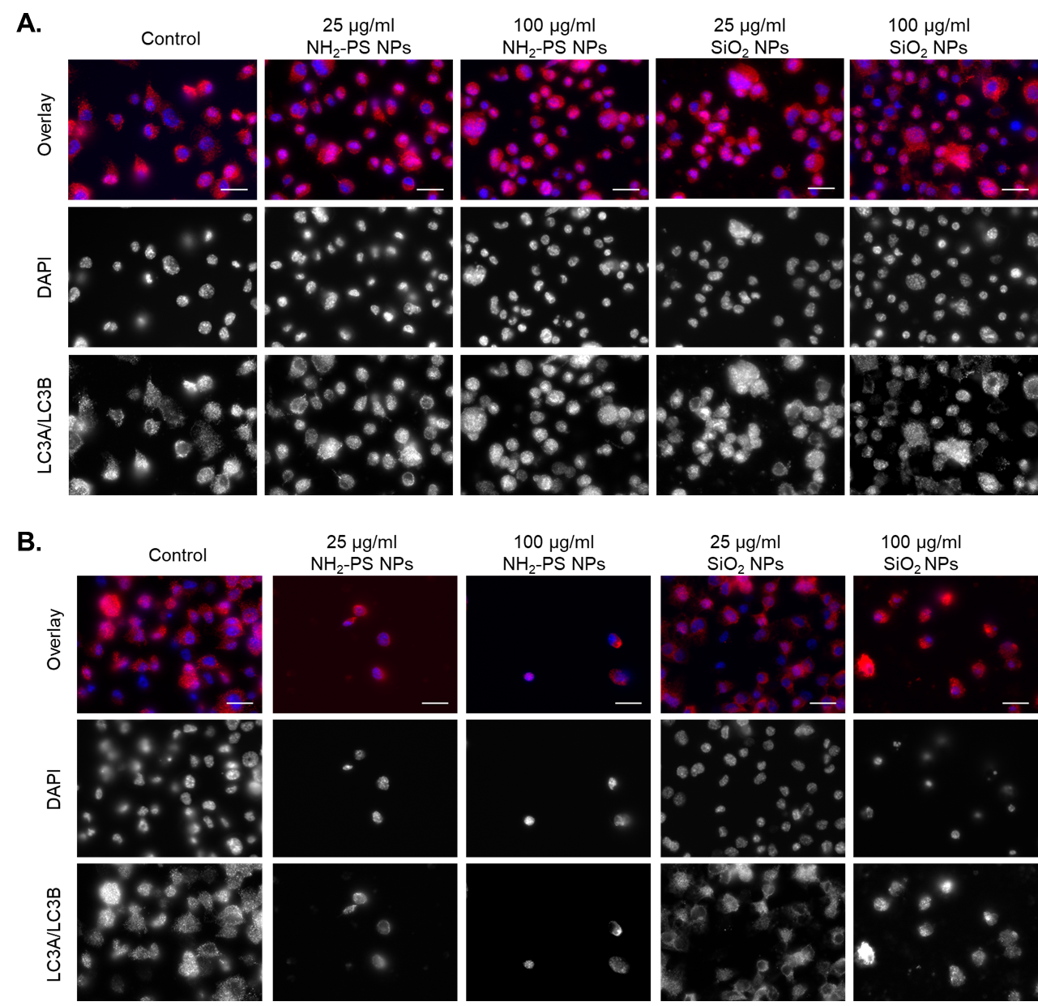
Figure S10. Effect of NH₂-PS and SiO₂ nanoparticles on autophagy in MPI cells. Confocal microscopy images of MPI cells after (A) 8 hour and (B) 24 hour exposure to NH₂₋PS and SiO₂ nanoparticles. Red: LC3A and LC3B staining of autophagosomal membranes; blue: DAPI stained nuclei. Scale bar: 10 µm. No evident induction of autophagy was detected.

References
1. Ruijter, J. M.; Ramakers, C.; Hoogaars, W. M.; Karlen, Y.; Bakker, O.; van den Hoff, M. J.; Moorman, A. F., Amplification efficiency: linking baseline and bias in the analysis of quantitative PCR data. Nucleic acids research 2009, 37 (6), e45.

