Supplementary Material
Method S1
Bacterial quantification
For strain specific quantitative PCR (ss-qPCR) total genomic DNA was isolated from the remaining solution using the RTP® Bacteria DNA Mini Kit (Invitek, STRATEC Molecular GmbH, Berlin, Germany). Prior to ss-qPCR, purity of DNA was estimated using a Nanodrop-1000 Spectrophotometer (Thermo Fisher Scientific, Darmstadt, Germany) and the amount obtained quantified by fluorometry (QuBit 4 Fluorometer, Thermo Fisher Scientific, Darmstadt, Germany).
Primer design
Strain-specific primers were designed for both strains using the WGS data. Sequence alignments and primer design were carried out using the Primer Express (version 3.0.1; Applied Biosystems, Foster City, CA, USA) and in silico primer specificity by BLAST in conjunctin with the Accelrys (version 2.5; San Diego, California). The primers selected for further use were 5’- CAT GGC ACC AGC GAA ACC -3’ (forward) and 5’- CTG CTA CTA CCC CTA CTG ATA TTT TCT CT -3’ (reverse) for M. luteus and 5’- GTA TCC GCA CCG TCT ACA CC -3’ (forward) and 5’- CAA TGC CTC CAG ATC CAC CA -3’ (reverse) for P. oleovorans, targeting a 90 bp intergenic region and a 110 bp region of a 2-acylglycerophosphoethanolamine acyltransferase, respectively.
Assessment of assay specificity and efficiency
Specificity of both primer pairs was assessed by performing end point PCR with DNA obtained from pure cultures of M. luteus and P. oleovorans as well as by analysis of the melting curve. Standard curves were generated for both bacterial species using serial dilutions of genomic DNA containing 2 x 10¹ - 2 x 10⁶ copies of the target gene per reaction. Quantitative (q)PCR was performed on a CFX96 Touch™ Real-Time PCR Detection System (Bio-Rad Laboratories, Hercules, CA, USA) using the SsoAdvanced™ Universal SYBR® Green mix (Bio-Rad Laboratories, Munich, Germany). Amplification reactions were performed in technical triplicates using 5 µl of template DNA in 25 μL of reaction volume with Biorad Hard-Shell® 96-Well PCR plates and 80 nM of forward and reverse primers, respectively (initial denaturation at 95 °C for 5 min, followed by 40 cycles of 95 °C for 15 s and 61 °C for 30 s and an incremental melting curve from 50 °C to 95 °C at 0.5 °C/5 s).
Linear relationship between quantification cycle (C_{q}) and log input DNA copy number was evaluated based on three biological replicates and amplification efficiencies (E) calculated based on the slope of standard curve (E=10^{−1/slope}−1).
Ss-qPCR
The corresponding amount of M. luteus and P. oleovorans was subsequently tested for each sample in technical replicates on a 96 well plate. Genomic DNA containing 2 x 10⁶ copies of the target gene served as internal quantification control. Negative controls containing water instead of template were included in each run. Running conditions resembled those used for the generation of standard curves. A reaction was considered positive if the exponential amplification curve exceeded the threshold within 40 cycles. The quantification cycle (C_{q}) was then defined as the cycle number at which the sample fluorescence crossed the threshold. Genome copy numbers were calculated based on representative standard curves for each sample.

Primer | Sequence forward | Sequence reverse
CYP1A1 | 5’-TCC AAG AGT CCA CCC TTC C-3’ | 5’-AAG CAT GAT CAG TGT AGG GAT CT-3’
CYP2D6 | 5`-AAG AAG TCG CTG GAG CAG TG-3’ | 5`-TTG TCC AAG AGA CCG TTG GG-3’
CYP1B1 | 5`-TGG ATT TGG AGA ACG TAC CG-3’ | 5`-CCA CGA CCT GAT CCA ATT CT-3’
GAPDH | 5`-CTC TGC TCC TCC TGT TCG AC-3’ | 5`-ACG ACC AAA TCC GTT GAC TC-3’
Supplementary Table S2. Primers used for quantitative RT-PCR.

Supplementary Figure S3. Gram staining of tissue sections of models colonised (A) with M. luteus, (B) P. oleovorans, (C) a mixture thereof and an untreated control (D). All samples were collected at day 8.

Supplementary Figure S4. Functional IPA-analysis of skin models colonised with (A) M. luteus and (B) P. oleovorans. The activation Z-score indicates an increase or decrease of the corresponding transcriptional pools, with the number of affected transcripts quoted next to each bar.
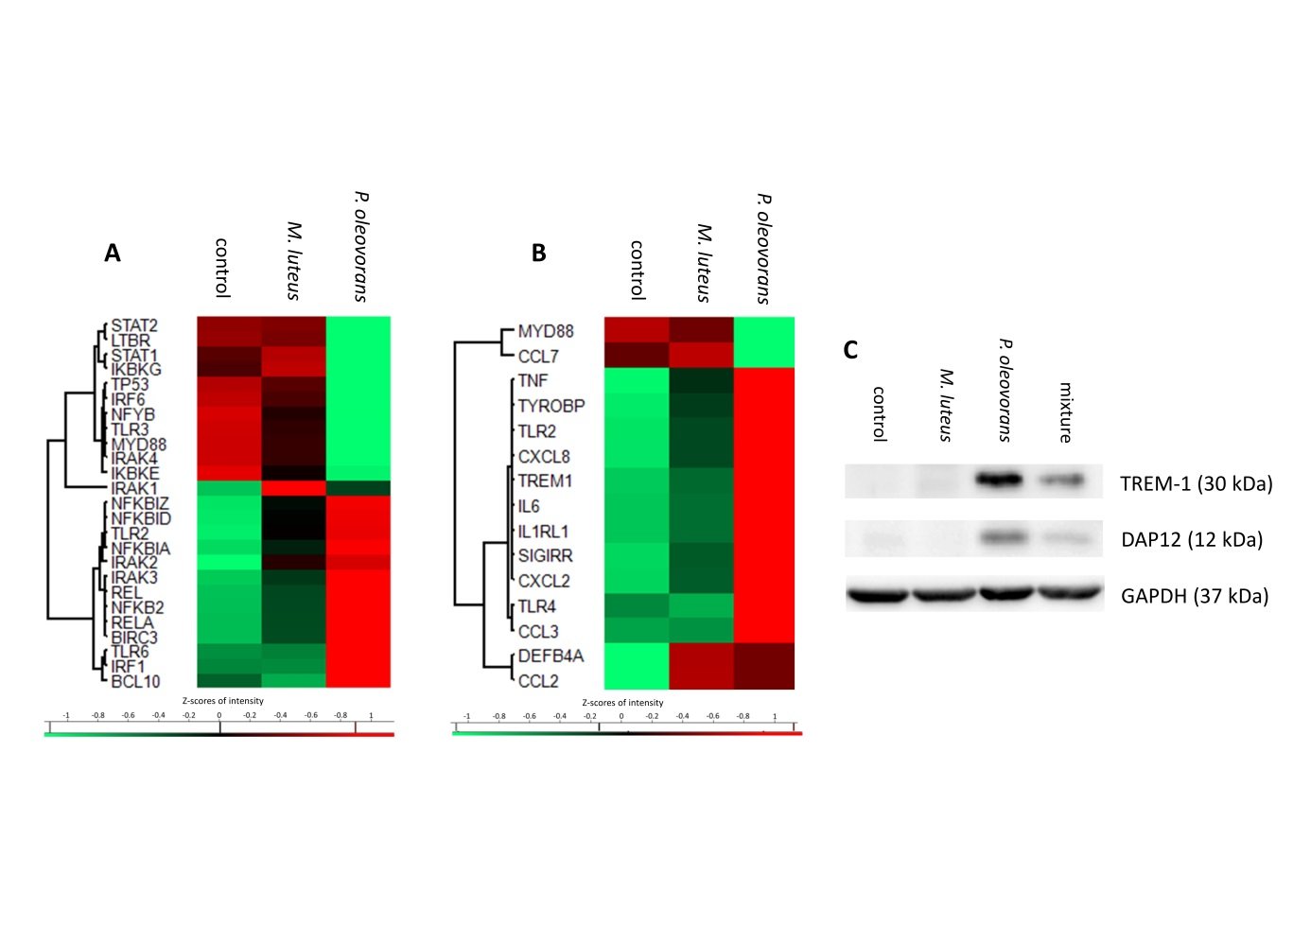
Supplementary Figure S5. Transcriptional cluster maps of the NFκB pathway (A) and TREM-signalling related genes (B) in microbially competent skin models at day 8 of microbial colonisation. Shown are the gene symbols and Z-scores of significantly differentially expressed genes with an F-value < 0.05 across three independent experiments. (C) Exemplary shown is an immunoblot of total protein of microbially competent skin models, colonised as indicated.

 | P. oleovorans |  | M. luteus
Gene Symbol | Fold Change | P-value | Fold Change | P-value
AC171558.1 | 1.79 | 0.0069 | 1.28 | 0.2808
OMP | 2.01 | 0.0064 | 1.01 | 0.9862
OR1A1 | 2.01 | 0.0430 | 1.27 | 0.1219
OR1E1 | 1.45 | 0.0324 | 1.07 | 0.9323
OR1F1 | 2.16 | 0.0269 | 1.36 | 0.3600
OR1J4 | 2.79 | 0.0011 | 2.03 | 0.0428
OR1N1 | 1.7 | 0.0040 | 1.32 | 0.0523
OR1N2 | 1.76 | 0.0036 | 1.35 | 0.1463
OR1S1 | 2.02 | 0.0423 | 1.25 | 0.6662
OR2A7; ARHGEF34P | -1.58 | 0.0209 | -1.37 | 0.1797
OR2A25 | 1.68 | 0.0312 | 1.09 | 0.7259
OR2AP1 | 1.79 | 0.0141 | 1.4 | 0.1018
OR2J2 | 2.42 | 0.0048 | 1.02 | 0.8699
OR2M3 | 1.73 | 0.0376 | 1.3 | 0.7766
OR2M4 | -1.65 | 0.0422 | -2.22 | 0.0178
OR2T2 | 1.84 | 0.0086 | 1.23 | 0.8239
OR2T4 | 1.87 | 0.0076 | -1.11 | 0.7499
OR2T27 | 2.19 | 0.0046 | 1.18 | 0.6003
OR2T35 | 1.71 | 0.0227 | -1.07 | 0.7544
OR2V2 | 2.2 | 0.0093 | 1.3 | 0.2170
OR2Y1 | 2.04 | 0.0089 | 1.93 | 0.0898
OR3A4P; OR3A5P | 1.85 | 0.0042 | 1.46 | 0.0552
OR4A16 | 1.71 | 0.0483 | 1.06 | 0.9652
OR4C3 | 2.68 | 0.0010 | 1.45 | 0.2553
OR4C45 | 1.73 | 0.0433 | 1.11 | 0.6251
OR4D2 | 2.23 | 0.0102 | 1.37 | 0.2484
OR4E2 | 1.78 | 0.0488 | 1.19 | 0.7440
OR4F3 | 1.12 | 0.2879 | -1.75 | 0.0158
OR4F5 | 1.69 | 0.0190 | -1.03 | 0.9798
OR4F15 | 1.85 | 0.0356 | 2.23 | 0.0979
OR4K15 | 1.16 | 0.6018 | -1.31 | 0.0398
OR4M2 | 1.08 | 0.4247 | 1.21 | 0.0474
OR4M2; AC171558.2 | 1.69 | 0.0340 | 1.29 | 0.2340
OR4P4 | 2.39 | 0.0039 | 1.07 | 0.8226
OR4Q3 | 1.88 | 0.0016 | 1.09 | 0.5529
OR4X1 | 1.42 | 0.0404 | -1.05 | 0.9860
OR5AK2 | 1.82 | 0.0408 | -1.19 | 0.6512
OR5AP2 | 1.75 | 0.0258 | 1.33 | 0.2311
OR5AS1 | 1.46 | 0.0164 | 1.04 | 0.6689
OR5H1 | 1.56 | 0.0268 | 1.17 | 0.3041
OR5H6 | 1.72 | 0.0280 | 2.06 | 0.0264
OR5M1 | 2.01 | 0.0037 | -1.02 | 0.9225
OR5M8 | 2.04 | 0.0266 | 1.3 | 0.1823
OR5M9 | 1.7 | 0.0064 | 1.1 | 0.5617
OR5P2 | -15.8 | 3.74E-05 | -2.41 | 0.0324
OR5P2 | -5.84 | 0.0005 | -3.27 | 0.0114
OR5P3 | -2.01 | 0.0061 | -2.02 | 0.0203
OR5P3 | -4.15 | 0.0012 | -1.68 | 0.1121
OR5R1 | 1.15 | 0.1591 | -1.39 | 0.0376
OR6C3 | 2.5 | 0.0207 | 1.73 | 0.2329
OR6C70 | 1.37 | 0.0417 | 1.3 | 0.1876
OR6K2 | 3.28 | 0.0098 | 1.08 | 0.5145
OR6K6 | -1.25 | 0.3533 | -1.38 | 0.0405
OR6M1 | 1.56 | 0.0226 | 1.03 | 0.7031
OR6Q1 | 3.35 | 0.0008 | 1.18 | 0.4992
OR6X1 | 2.31 | 0.0008 | 1 | 0.9155
OR7A5 | 1.95 | 0.0044 | 1.04 | 0.7636
OR7E24 | 2.97 | 0.0018 | 1.56 | 0.3432
OR7G1 | 1.98 | 0.0011 | 1.32 | 0.1336
OR8B3 | -1.51 | 0.3317 | -2.07 | 0.0181
OR8B12 | 1.8 | 0.0098 | 1.72 | 0.1877
OR8S1 | 1.78 | 0.0098 | 1.18 | 0.2960
OR9A2 | 2.04 | 0.0204 | 1.19 | 0.3365
OR9G4 | 1.56 | 0.0263 | -1.01 | 0.3899
OR9I1 | 1.99 | 0.0101 | 1.14 | 0.5733
OR9Q1 | 4.89 | 0.0002 | -1.2 | 0.7552
OR9Q2 | 5.09 | 1.37E-05 | -1.58 | 0.0379
OR10AC1 | 1.76 | 0.0034 | -1.09 | 0.7708
OR10C1 | 1.9 | 0.0087 | 1.14 | 0.5509
OR10J4 | 1.84 | 0.0145 | 1.23 | 0.1774
OR10S1 | 1.61 | 0.0212 | 1.13 | 0.4626
OR12D1 | 1.85 | 0.0085 | 1.19 | 0.6590
OR13A1 | 1.69 | 0.0344 | -1.02 | 0.7281
OR14C36 | 1.5 | 0.0111 | -1.58 | 0.3706
OR51E2 | 1.52 | 0.0332 | -1.03 | 0.9894
OR51F1 | 1.51 | 0.0221 | -1 | 0.6906
OR51H1 | 2.28 | 0.0081 | 1.15 | 0.4326
OR51L1 | 1.61 | 0.0348 | 1.9 | 0.1414
OR52E1 | -2.08 | 0.0386 | -1.6 | 0.0463
OR52E2 | 1.94 | 0.0044 | 1.08 | 0.7729
OR52H1 | 1.65 | 0.0644 | 1.63 | 0.0200
OR52N5 | 1.66 | 0.0223 | 1.23 | 0.2946
OR52R1 | 1.61 | 0.0265 | 1.25 | 0.1126
OR56A1 | 1.83 | 0.0389 | 1.99 | 0.0909

Supplementary Figure S6. List of olfactory receptors for which co-colonisation led to altered gene expression. Shown are fold changes relative to the control and the respective p-values. Upregulated genes are highlighted in red and downregulated genes in green (p< 0.05).

Supplementary Figure S7. Cytokine excretion of THP-1 cells treated with day 8-supernatant from microbially competent skin, colonised as indicated.

