Supplementary Material

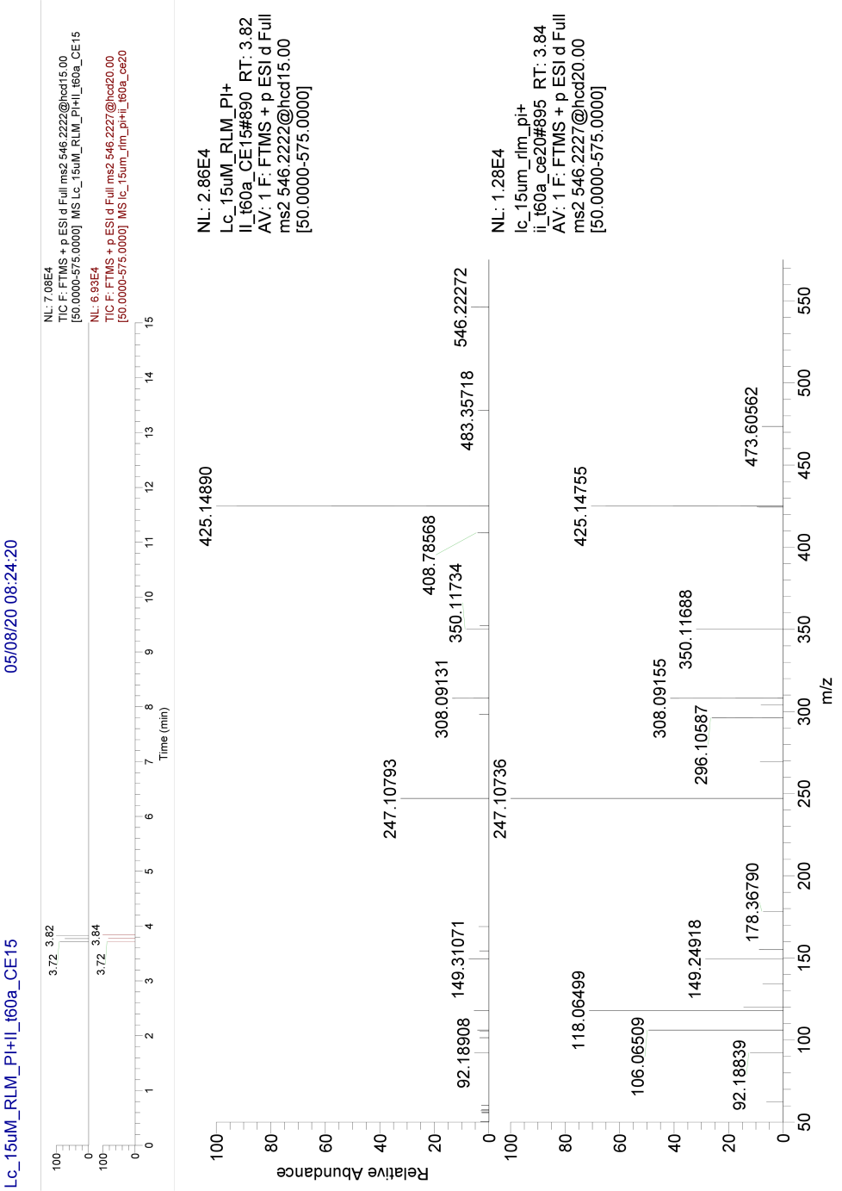
Fig. 10 Product ion spectra of the metabolite Las_M47 (C22H35N5O6S, m/z 546.22283), a new GSH conjugate, detected by tandem mass spectrometry and collision energy of 15 eV and 20 eV.

