Supplemental materials

Table S1: No (NOECs) and lowest observed effect concentrations (LOECs) as well as EC₁₀ concentrations for specific observations made in the fish embryo test (FET) with zebrafish (Danio rerio) embryos exposed to nine analogues of valproic acid. Most sensitive effects are listed in black fields; most prominent effects are listed in shaded fields. Data for valproic acid are given in Table 4.
 | 2-Ethylhexanoic acid (µM) |  |  |  | 2-Propylheptanoic acid (µM) |  |  |  | 2-Methylpentanoic acid (µM)
 | NOEC | LOEC | EC₁₀ |  | NOEC | LOEC | EC₁₀ |  | NOEC | LOEC | EC₁₀
Coagulation | 6.25 | 50 | 109 |  | 12.5 | 25 | 44 |  | 600 | 900 | 615
Blood congestion | ̶ | ̶ | ̶ |  | 12.5 | 50 | 25 |  | <177.7 | 600 | 742
Body under-pigmentation | ̶ | ̶ | ̶ |  | ̶ | ̶ | ̶ |  | ̶ | ̶ | ̶
Brain discoloration | ̶ | ̶ | ̶ |  | ̶ | ̶ | ̶ |  | ̶ | ̶ | ̶
Chorda deformation | ̶ | ̶ | ̶ |  | ̶ | ̶ | ̶ |  | ̶ | ̶ | ̶
Craniofacial deformation | 100 | 200 | 102 |  | 12.5 | 50 | 21 |  | 177.7 | 266.6 | 380
Enlarged otic vesicles | ̶ | ̶ | ̶ |  | ̶ | ̶ | ̶ |  | ̶ | ̶ | ̶
Eye under-pigmentation | ̶ | ̶ | ̶ |  | ̶ | ̶ | ̶ |  | ̶ | ̶ | ̶
Head deformation | ̶ | ̶ | ̶ |  | 25 | 50 | 29 |  | ̶ | ̶ | ̶
Jitter/tremor | 100 | 200 | 421 |  | <16 | 50 | 16 |  | ̶ | ̶ | ̶
Lack of hatch | 50 | 400 | 91 |  | 12.5 | 25 | 44 |  | 600 | 900 | 615
Lack of heartbeat | 200 | 400 | 318 |  | ̶ | ̶ | ̶ |  | ̶ | ̶ | ̶
Lack of movement | ̶ | ̶ | ̶ |  | ̶ | ̶ | ̶ |  | ̶ | ̶ | ̶
Lack of otoliths | ̶ | ̶ | ̶ |  | ̶ | ̶ | ̶ |  | ̶ | ̶ | ̶
Loss of somite differentiation | ̶ | ̶ | ̶ |  | ̶ | ̶ | ̶ |  | ̶ | ̶ | ̶
Lying in lateral position | ̶ | ̶ | ̶ |  | ̶ | ̶ | ̶ |  | ̶ | ̶ | ̶
Pectoral fins deformed | ̶ | ̶ | ̶ |  | ̶ | ̶ | ̶ |  | ̶ | ̶ | ̶
Pericardial edemata | 25 | 50 | 65 |  | <12.5 | 12.5 | 11 |  | 266.6 | 600 | 373
Reduced heartbeat | 100 | 200 | n.d. |  | 25 | 50 | 39 |  | ̶ | ̶ | ̶
Reduced otic vesicles | ̶ | ̶ | ̶ |  | ̶ | ̶ | ̶ |  | ̶ | ̶ | ̶
Scoliosis/lordosis | 12.5 | 200 | 651 |  | 25 | 50 | 41 |  | 266.6 | 600 | 393
Small eyes | 25 | 400 | n.d. |  | 25 | 50 | 153 |  | ̶ | ̶ | ̶
Yolk discoloration | ̶ | ̶ | ̶ |  | ̶ | ̶ | ̶ |  | ̶ | ̶ | ̶
Yolk edemata | 50 | 100 | 105 |  | <10 | 50 | 10 |  | 400 | 600 | 552
Yolk sac absorption reduced | ̶ | ̶ | ̶ |  | ̶ | ̶ | ̶ |  | ̶ | ̶ | ̶
Yolk sac deformation | ̶ | ̶ | ̶ |  | ̶ | ̶ | ̶ |  | ̶ | ̶ | ̶
Note: Pericardial and yolk edemata appeared with all substances tested (even at the lowest test concentrations). Edemata formation may be reversible over time.
Table S1 (continued): No (NOECs) and lowest observed effect concentrations (LOECs) as well as EC₁₀ concentrations for specific observation made in the fish embryo test (FET) with zebrafish (Danio rerio) embryos exposed to nine analogues of valproic acid. Most sensitive effects are listed in black fields; most prominent effects are listed in shaded fields.
 | 2-Methylhexanoic acid (µM) |  |  |  | 2-Ethylbutyric acid (µM) |  |  |  | 2,2-Dimethylvaleric acid (µM)
 | NOEC | LOEC | EC₁₀ |  | NOEC | LOEC | EC₁₀ |  | NOEC | LOEC | EC₁₀
Coagulation | 500 | 1000 | 519 |  | 400 | 800 | 529 |  | 666.6 | 800 | 701
Blood congestion | 250 | 500 | 459 |  | 400 | 800 | 700 |  | 462.9 | 555.5 | 604
Body under-pigmentation | ̶ | ̶ | ̶ |  | ̶ | ̶ | ̶ |  | ̶ | ̶ | ̶
Brain discoloration | ̶ | ̶ | ̶ |  | ̶ | ̶ | ̶ |  | 555.5 | 666.6 | 637
Chorda deformation | ̶ | ̶ | ̶ |  | ̶ | ̶ | ̶ |  | 666.6 | 800 | 750
Craniofacial deformation | 500 | 1000 | 743 |  | ̶ | ̶ | ̶ |  | 462.9 | 555.5 | 481
Enlarged otic vesicles | ̶ | ̶ | ̶ |  | ̶ | ̶ | ̶ |  | ̶ | ̶ | ̶
Eye under-pigmentation | ̶ | ̶ | ̶ |  | ̶ | ̶ | ̶ |  | ̶ | ̶ | ̶
Head deformation | ̶ | ̶ | ̶ |  | ≤800 | 800 | 1160 |  | 555.5 | 666.6 | 637
Jitter/tremor | <442 | 500 | 442 |  | ̶ | ̶ | ̶ |  | ≤666.6 | 666.6 | 977
Lack of hatch | ̶ | ̶ | ̶ |  | 400 | 800 | 525 |  | 555.5 | 666.6 | 627
Lack of heartbeat | ̶ | ̶ | ̶ |  | 400 | 800 | 622 |  | 666.6 | 800 | 764
Lack of movement | ̶ | ̶ | ̶ |  | ̶ | ̶ | ̶ |  | 462.9 | 555.5 | 501
Lack of otoliths | ̶ | ̶ | ̶ |  | values non-calculable |  |  |  | 666.6 | 800 | 772
Loss of somite differentiation | ̶ | ̶ | ̶ |  | ̶ | ̶ | ̶ |  | 385.8 | 462.9 | 520
Lying in lateral position | ̶ | ̶ | ̶ |  | ̶ | ̶ | ̶ |  | 385.8 | 800 | 422
Pectoral fins deformed | ̶ | ̶ | ̶ |  | ̶ | ̶ | ̶ |  | 555.5 | 666.6 | 599
Pericardial edemata | 250 | 500 | 385 |  | 200 | 400 | 363 |  | 385.8 | 462.9 | 426
Reduced heartbeat | ̶ | ̶ | ̶ |  | ≤800 | 800 | n.d. |  | 555.5 | 666.6 | 679
Reduced otic vesicles | ̶ | ̶ | ̶ |  | ̶ | ̶ | ̶ |  | 666.6 | 800 | 759
Scoliosis/lordosis | 250 | 500 | 383 |  | 800 | >800 | 892 |  | 385.8 | 462.9 | 663
Small eyes | ̶ | ̶ | ̶ |  | 400 | 800 | 1160 |  | 462.9 | 666.6 | 540
Yolk discoloration | ̶ | ̶ | ̶ |  | ̶ | ̶ | ̶ |  | 462.9 | 555.5 | 469
Yolk edemata | 250 | 500 | 402 |  | ̶ | ̶ | ̶ |  | 462.9 | 800 | 535
Yolk sac absorption reduced | ̶ | ̶ | ̶ |  | ̶ | ̶ | ̶ |  | 462.9 | 555.5 | 502
Yolk sac deformation | ̶ | ̶ | ̶ |  | ̶ | ̶ | ̶ |  | ̶ | ̶ | ̶
Note: Pericardial and yolk edemata appeared with all substances tested (even at the lowest test concentrations). Edemata formation may be reversible over time.
Table S1 (continued): No (NOECs) and lowest observed effect concentrations (LOECs) as well as EC₁₀ concentrations for specific observation made in the fish embryo test (FET) with zebrafish (Danio rerio) embryos exposed to nine analogues of valproic acid Most sensitive effects are listed in black fields; most prominent effects are listed in shaded fields.
 | 4-Pentenoic acid (µM) |  |  |  | 4-ene Valproic acid (µM) |  |  |  | Hexanoic acid (µM)
 | NOEC | LOEC | EC₁₀ |  | NOEC | LOEC | EC₁₀ |  | NOEC | LOEC | EC₁₀
Coagulation | 538.66 | 910.33 | 697 |  | 400 | >400 | 328 |  | 512.26 | 563.49 | 557
Blood congestion | <414.35 | 414.35 | 654 |  | 118.5 | 177.7 | 154 |  | 512.26 | 563.49 | 510
Body under-pigmentation | ̶ | ̶ | ̶ |  | 400 | >400 | 468 |  | ̶ | ̶ | ̶
Brain discoloration | ̶ | ̶ | ̶ |  | ̶ | ̶ | ̶ |  | ̶ | ̶ | ̶
Chorda deformation | ̶ | ̶ | ̶ |  | ̶ | ̶ | ̶ |  | ̶ | ̶ | ̶
Craniofacial deformation | <414.35 | 414.35 | 626 |  | 118.5 | 177.7 | 177 |  | 512.26 | 563.49 | 517
Enlarged otic vesicles | ̶ | ̶̶ | ̶ |  | 400 | >400 | 525 |  | ̶ | ̶ | ̶
Eye under-pigmentation | ̶ | ̶ | ̶ |  | 400 | >400 | 329 |  | ̶ | ̶ | ̶
Head deformation | ̶ | ̶ | ̶ |  | ̶ | ̶ | ̶ |  | ̶ | ̶ | ̶
Jitter/tremor | ̶ | ̶ | ̶ |  | 118.5 | <118.5 | 176 |  | >681.81 | 681.81 | 1092 (96hpf)
Lack of hatch | 700.26 | 910.33 | 875 |  | ̶ | ̶ | ̶ |  | ̶ | ̶ | ̶
Lack of heartbeat | ̶ | ̶ | ̶ |  | 400 | >400 | 468 |  | 619.83 | 681.81 | 897
Lack of movement | 700 .26 | 910.33 | 822 |  | 266.6 | >266.6 | 395 |  | >456 | 563.49 | 456
Lack of otoliths | ̶ | ̶ | ̶ |  | ̶ | ̶ | ̶ |  | ̶ | ̶ | ̶
Loss of somite differentiation | 538.66 | 700.26 | 645 |  | 266.6 | >266.6 | 322 |  | >460 | 750 | 460
Lying in lateral position | 700.26 | 910.33 | 770 |  | 177.7 | >177.7 | 189 |  | >453 | 563.49 | 453
Pectoral fins deformed | ̶ | ̶ | ̶ |  | >177.7 | 177.7 | 234 |  | ̶ | ̶ | ̶
Pericardial edemata | 538.66 | 700.26 | 568 |  | 79.01 | >79.01 | 93 |  | values non-calculable
Reduced heartbeat | 700.26 | 910.33 | 854 |  | 266.6 | 400 | 429 |  | 563.49 | 750 | 848
Reduced otic vesicles | ̶ | ̶ | ̶ |  | 400 | >400 | 520 |  | 681.81 | 750 | n.d.
Scoliosis/lordosis | 700.26 | 910.33 | 747 |  | 266.6 | >266.6 | 289 |  | >490 | 563.49 | 490
Small eyes | ̶ | ̶ | ̶ |  | 266.6 | >266.6 | 277 |  | ̶ | ̶ | ̶
Yolk discoloration | 538.66 | 700.26 | 596 |  | 79.01 | 177.7 | 233 |  | >191 | 512.26 | 191
Yolk edemata | 538.66 | 700.26 | 618 |  | 177.7 | >177.7 | 245 |  | >412 | 512.26 | 412
Yolk sac absorption reduced | ̶ | ̶ | ̶ |  | 118.5 | >118.5 | 166 |  | >512.26 | 512.26 | 466
Yolk sac deformation | ̶ | ̶ | ̶ |  | 400 | >400 | 413 |  | ̶ | ̶ | ̶
Note: Pericardial and yolk edemata appeared with all substances tested (even at the lowest test concentrations). Edemata formation may be reversible over time.

Dose-response curves for specific effects following exposure of zebrafish (Danio rerio) embryos to 9 selected valproic acid analogues
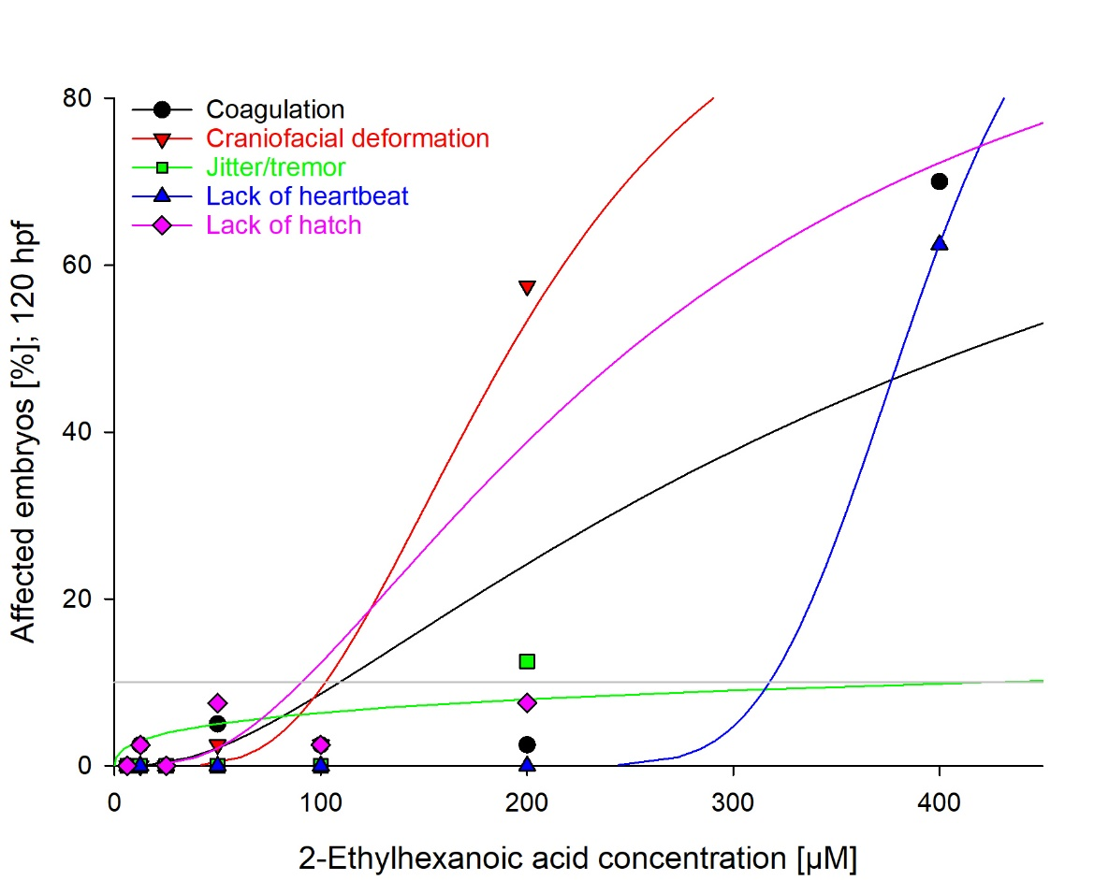
EC₁₀ (µM)
109
102
421
318
91

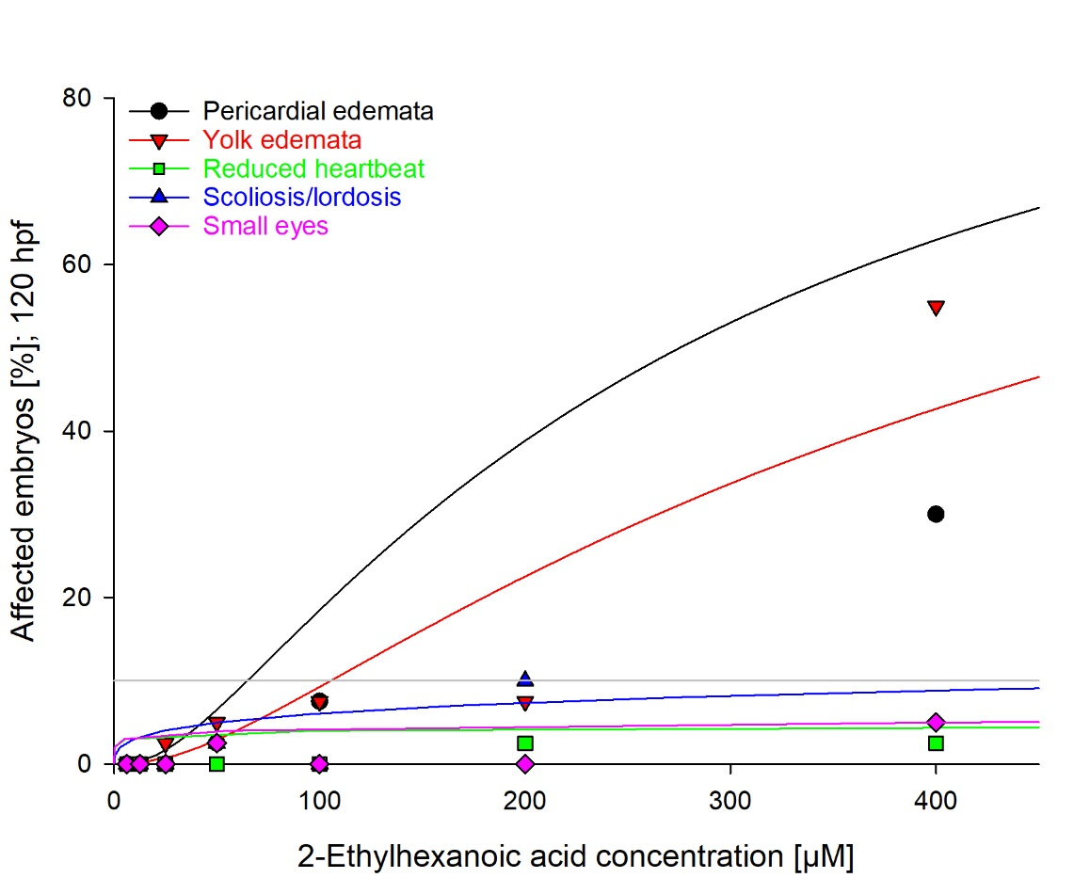
EC₁₀ (µM)
65
105
n.d.
651
n.d.

Fig. S1: Dose-response curves for specific effects induced by exposure of zebrafish (Danio rerio) embryos to 2-ethylhexanoic acid for 120 h. Data are given as percentage of individuals affected (%) in n = 20 - 40 replicates.

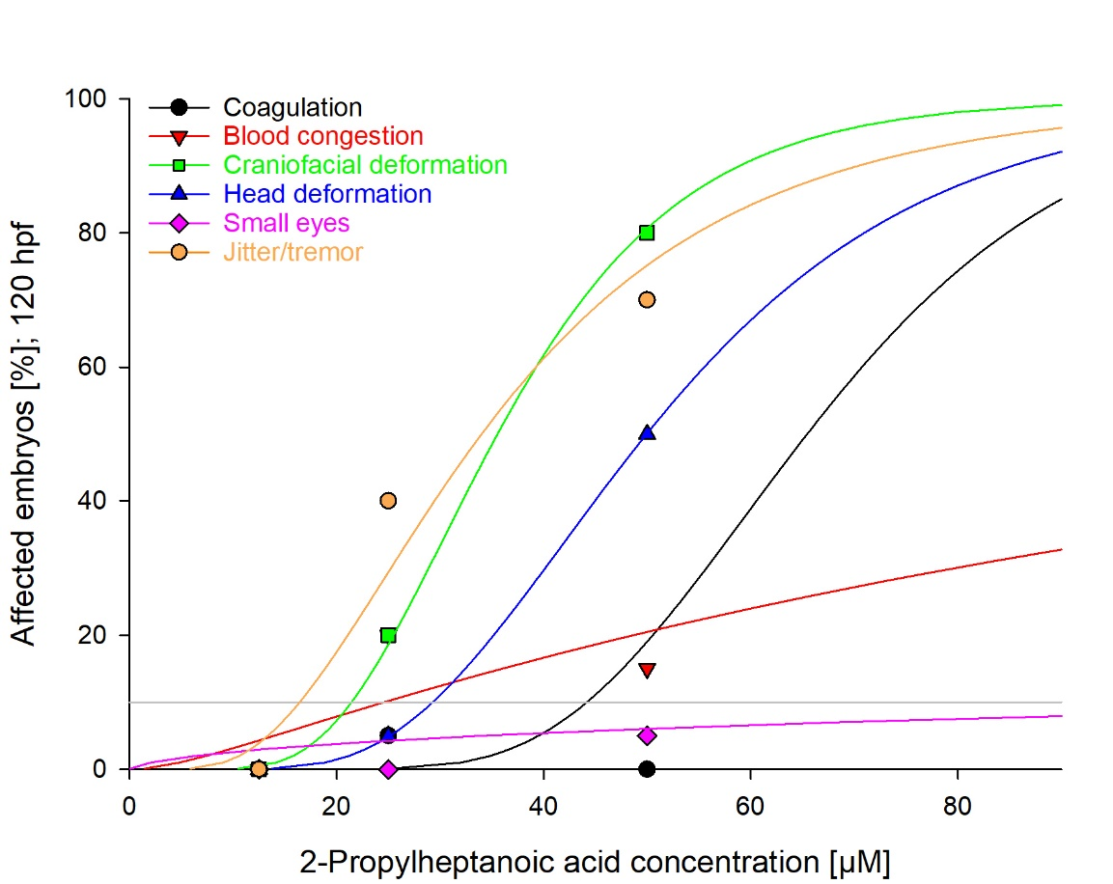
EC₁₀ (µM)
44
25
21
29
153
16

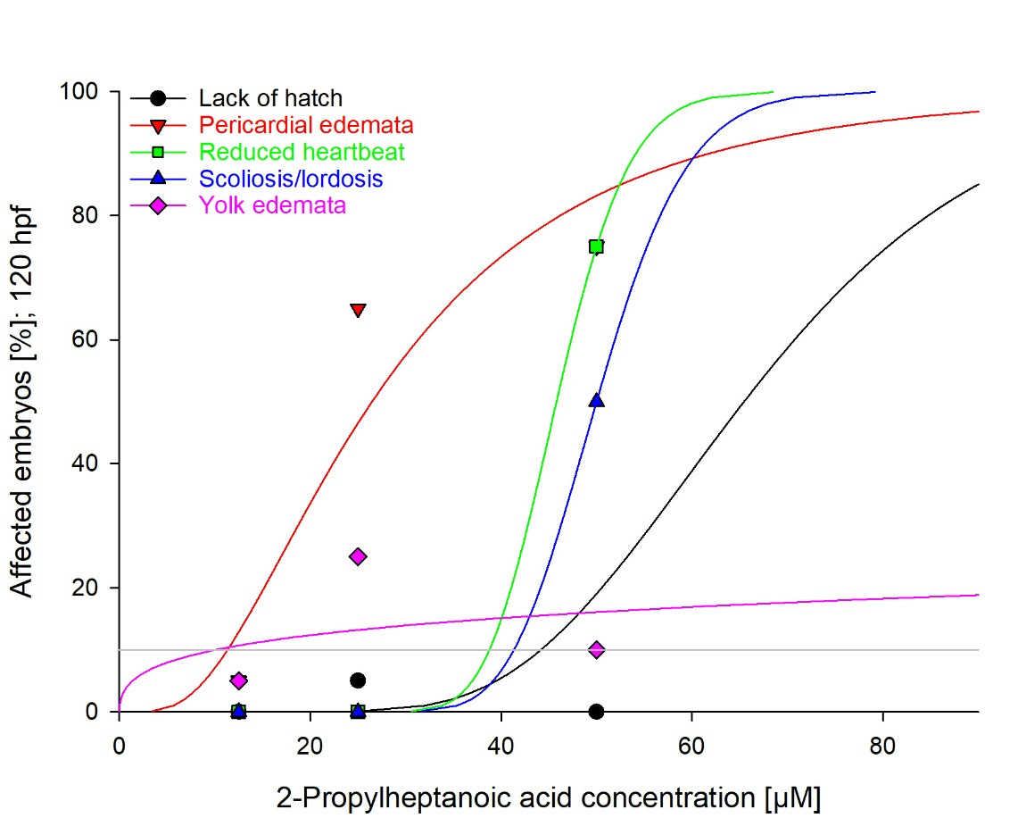
EC₁₀ (µM)
44
11
39
41
10

Fig. S2: Dose-response curves for specific effects induced by exposure of zebrafish (Danio rerio) embryos to 2-propylheptanoic acid for 120 h. Data are given as percentage of individuals affected (%) in n = 20 - 40 replicates.

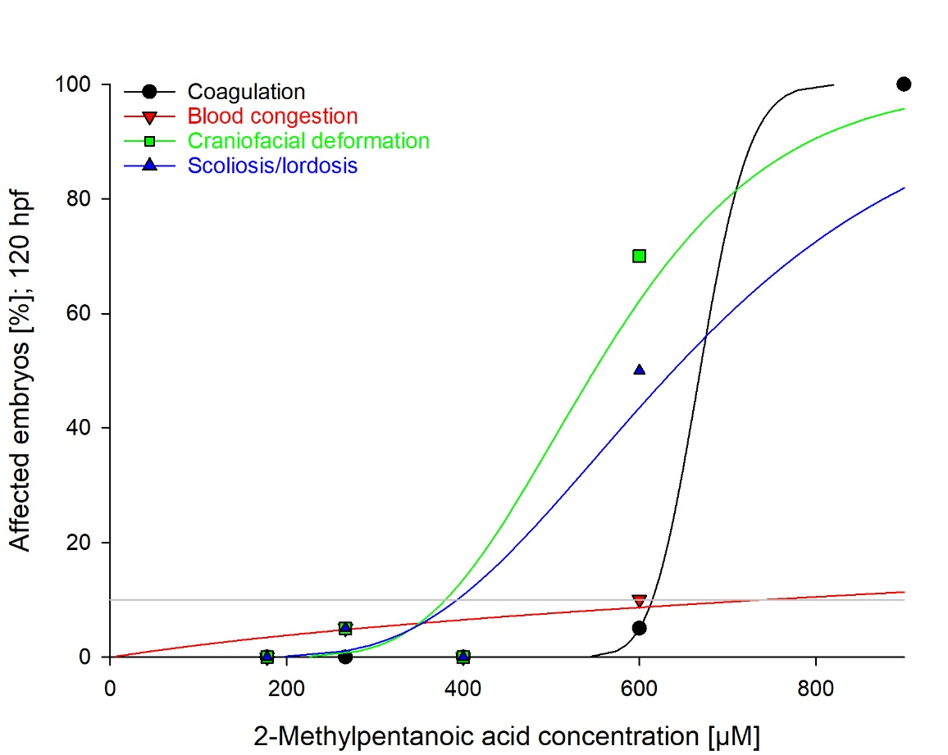
EC₁₀ (µM)
615
742
380
393

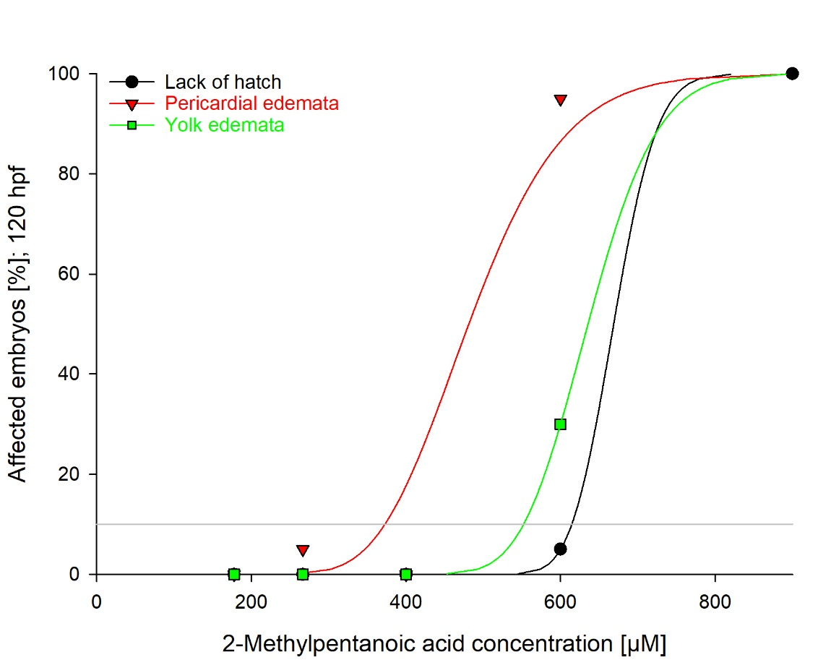
EC₁₀ (µM)
615
373
552

Fig. S3: Dose-response curves for specific effects induced by exposure of zebrafish (Danio rerio) embryos to 2-methylpentanoic acid for 120 h. Data are given as percentage of individuals affected (%) in n = 20 - 40 replicates.
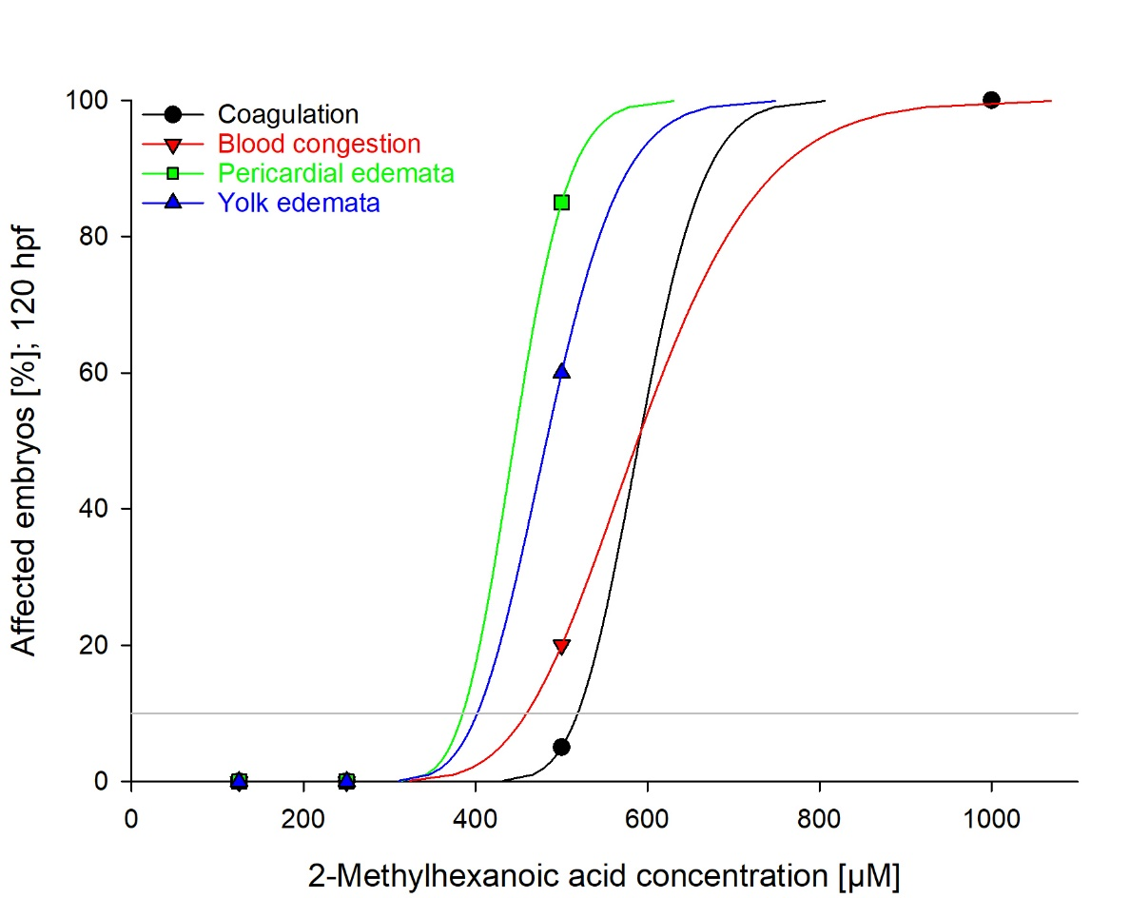
EC₁₀ (µM)
519
459
385
402

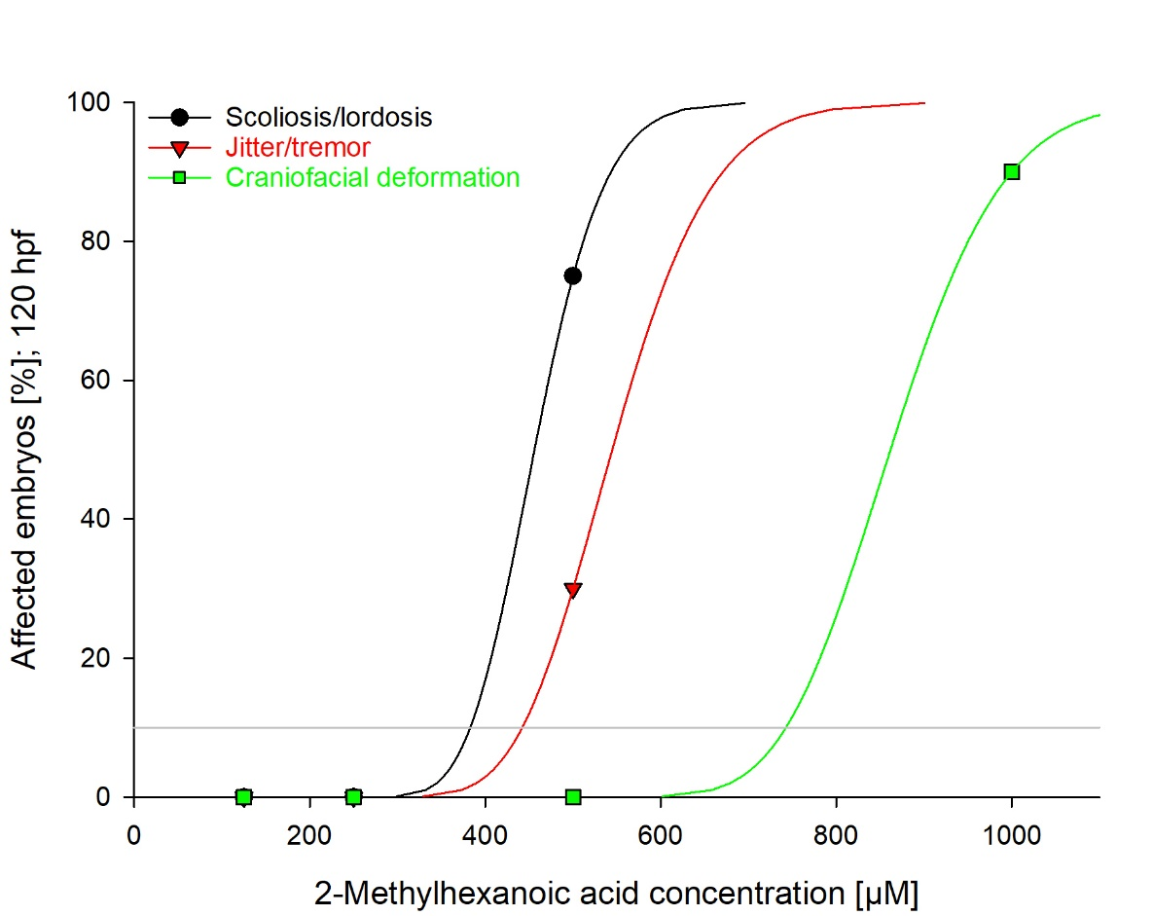
EC₁₀ (µM)
383
442
743

Fig. S4: Dose-response curves for specific effects induced by exposure of zebrafish (Danio rerio) embryos to 2-methylhexanoic acid for 120 h. Data are given as percentage of individuals affected (%) in n = 20 - 40 replicates.

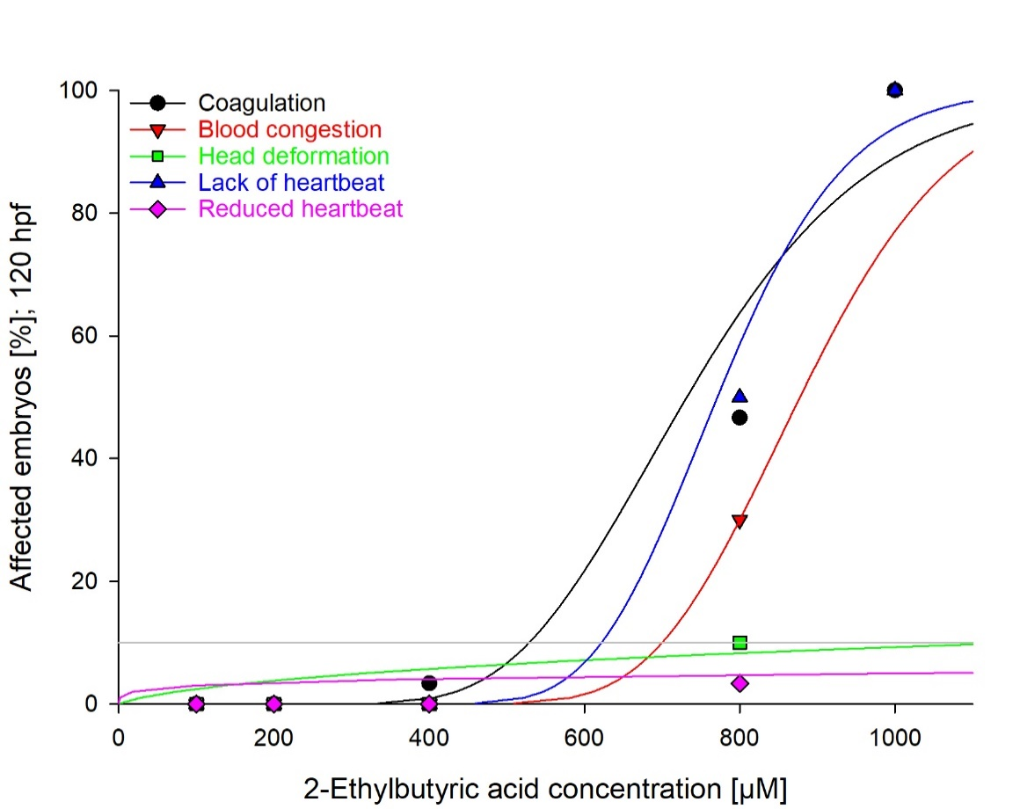
EC₁₀ (µM)
529
700
1160
622
n.d.

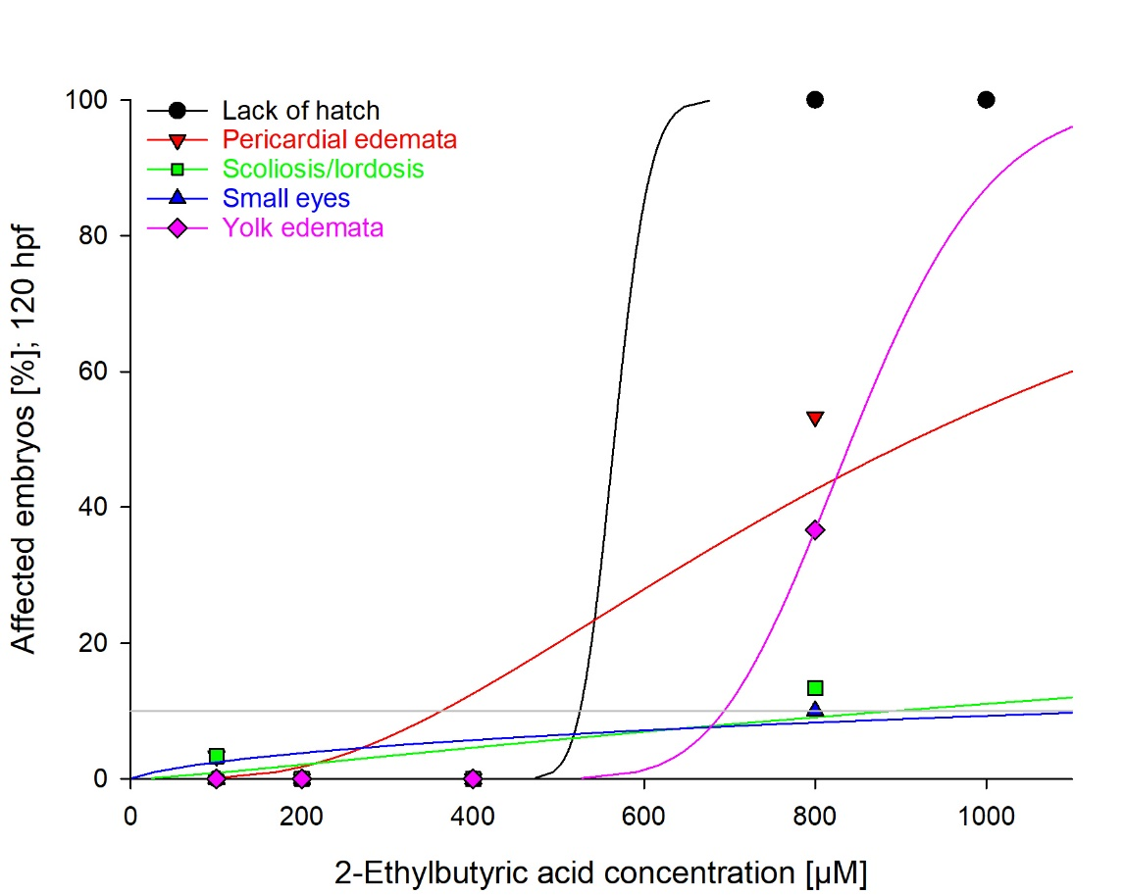
EC₁₀ (µM)
525
363
892
1160
693

Fig. S5: Dose-response curves for specific effects induced by exposure of zebrafish (Danio rerio) embryos to 2-ethylbutyric acid for 120 h. Data are given as percentage of individuals affected (%) in n = 20 - 40 replicates.
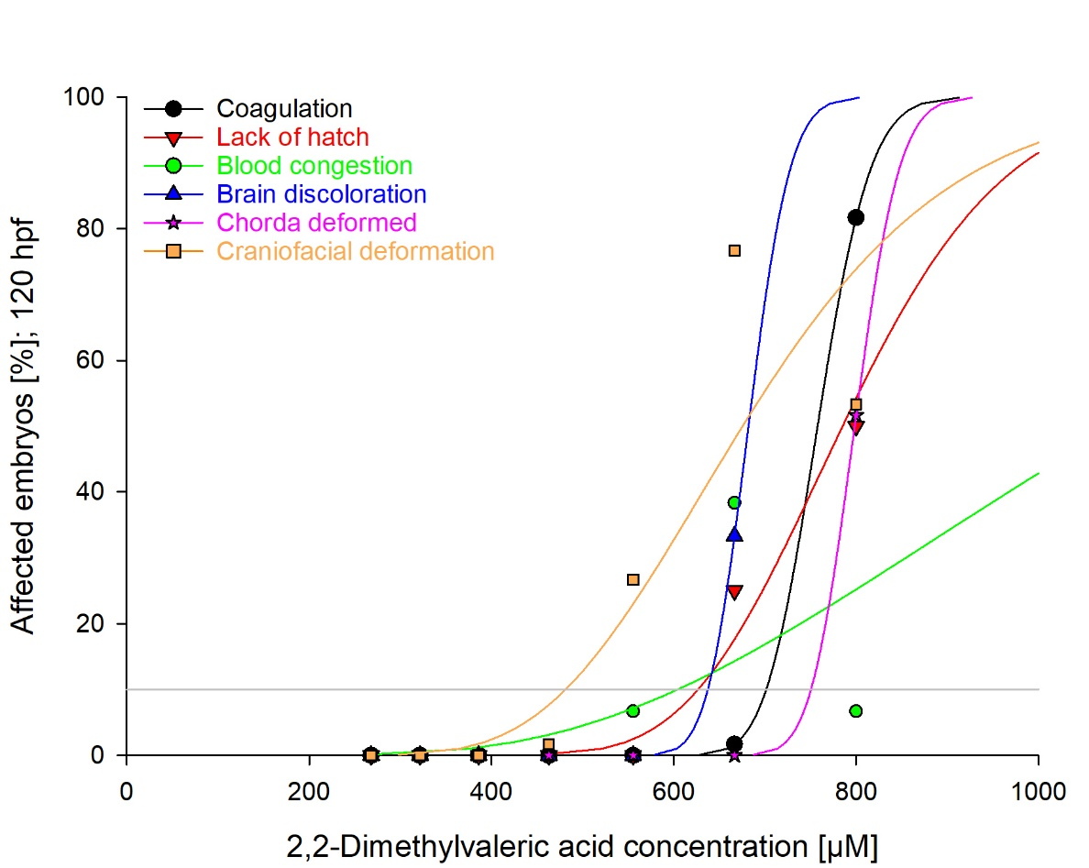
EC₁₀ (µM)
701
627
604
637
750
481

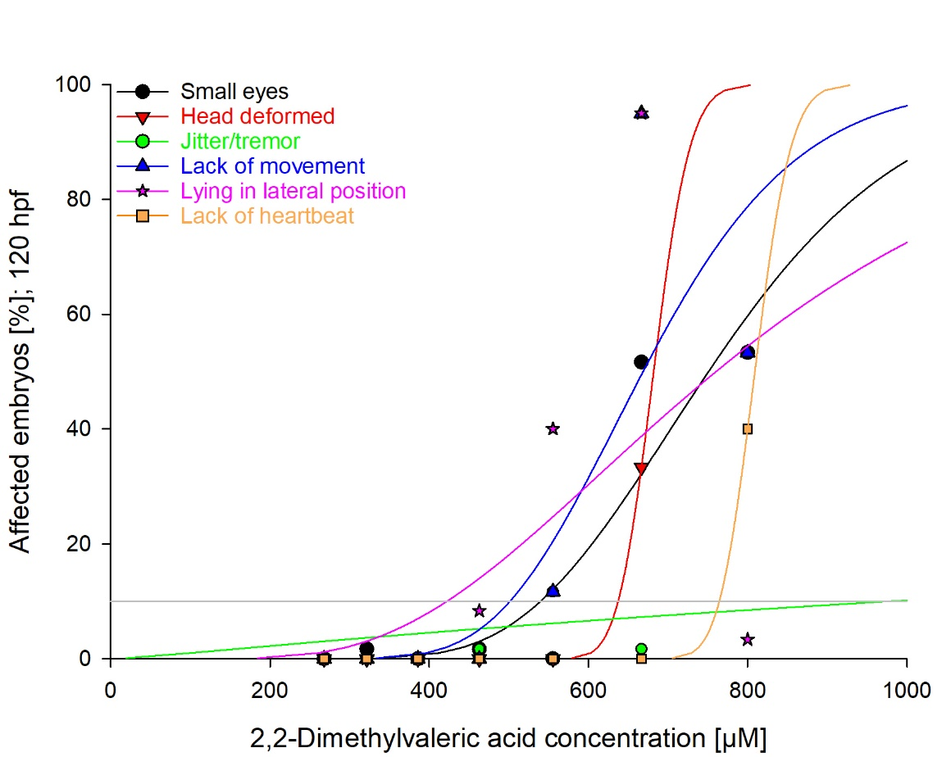
EC₁₀ (µM)
540
637
977
501
422
764

Fig. S6: Dose-response curves for specific effects induced by exposure of zebrafish (Danio rerio) embryos to 2,2-dimethylvaleric acid for 120 h. Data are given as percentage of individuals affected (%) in n = 20 - 40 replicates.

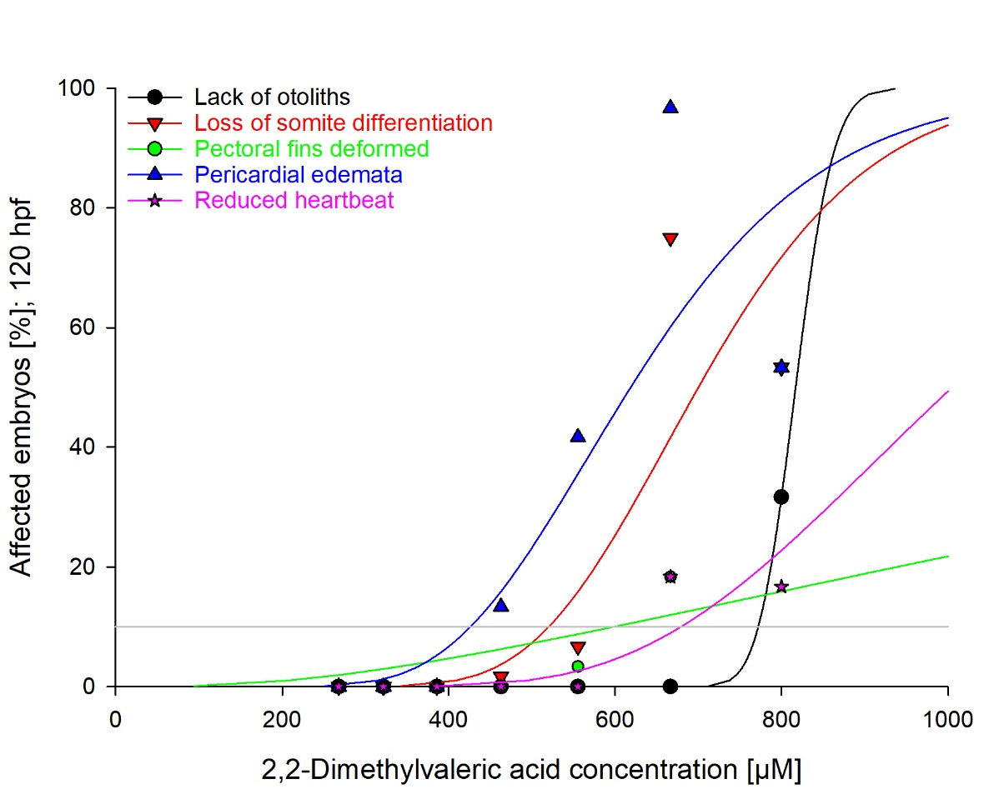
EC₁₀ (µM)
772
520
599
426
679

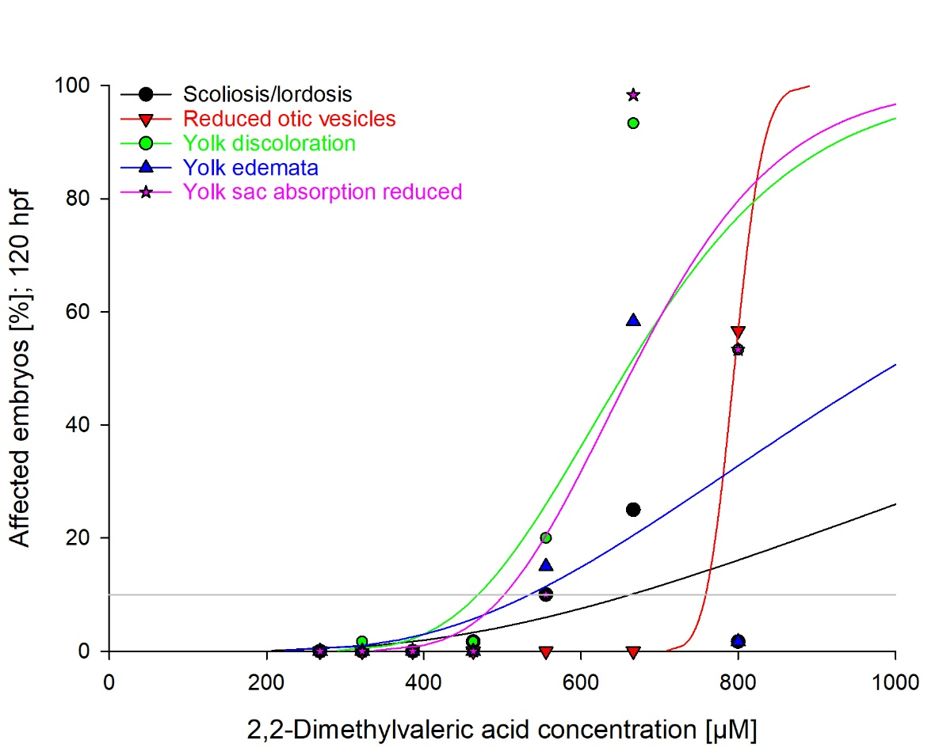
EC₁₀ (µM)
663
759
469
535
502

Fig. S6 (continued): Dose-response curves for specific effects induced by exposure of zebrafish (Danio rerio) embryos to 2,2-dimethylvaleric acid for 120 h. Data are given as percentage of individuals affected (%) in n = 20 - 40 replicates.

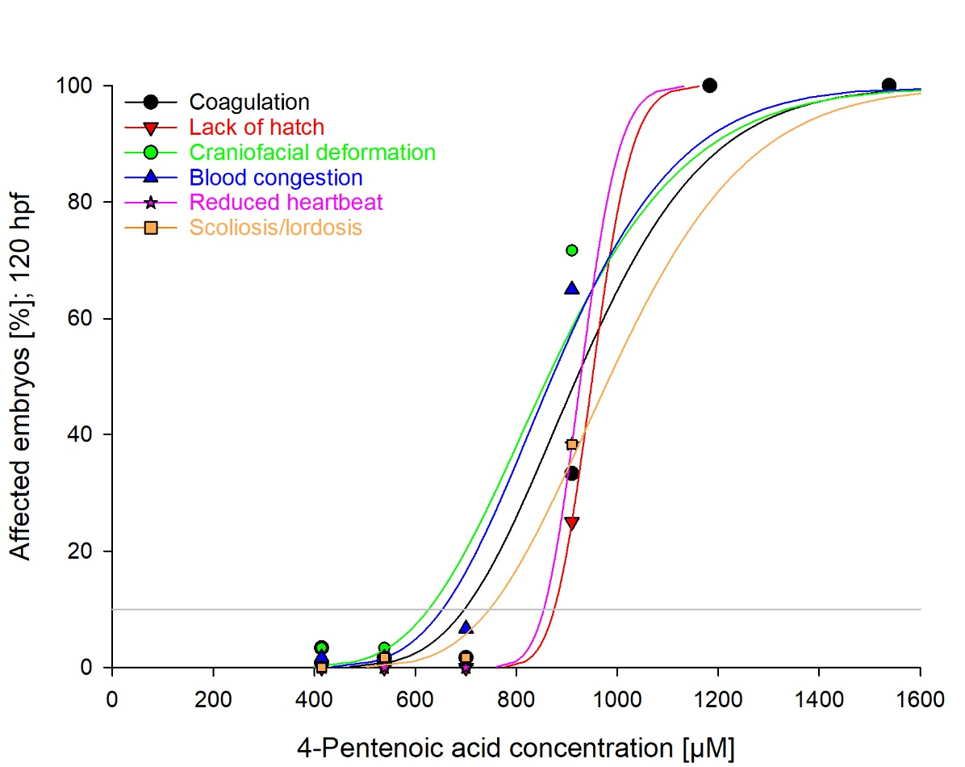
EC₁₀ (µM)
697
875
626
654
854
747

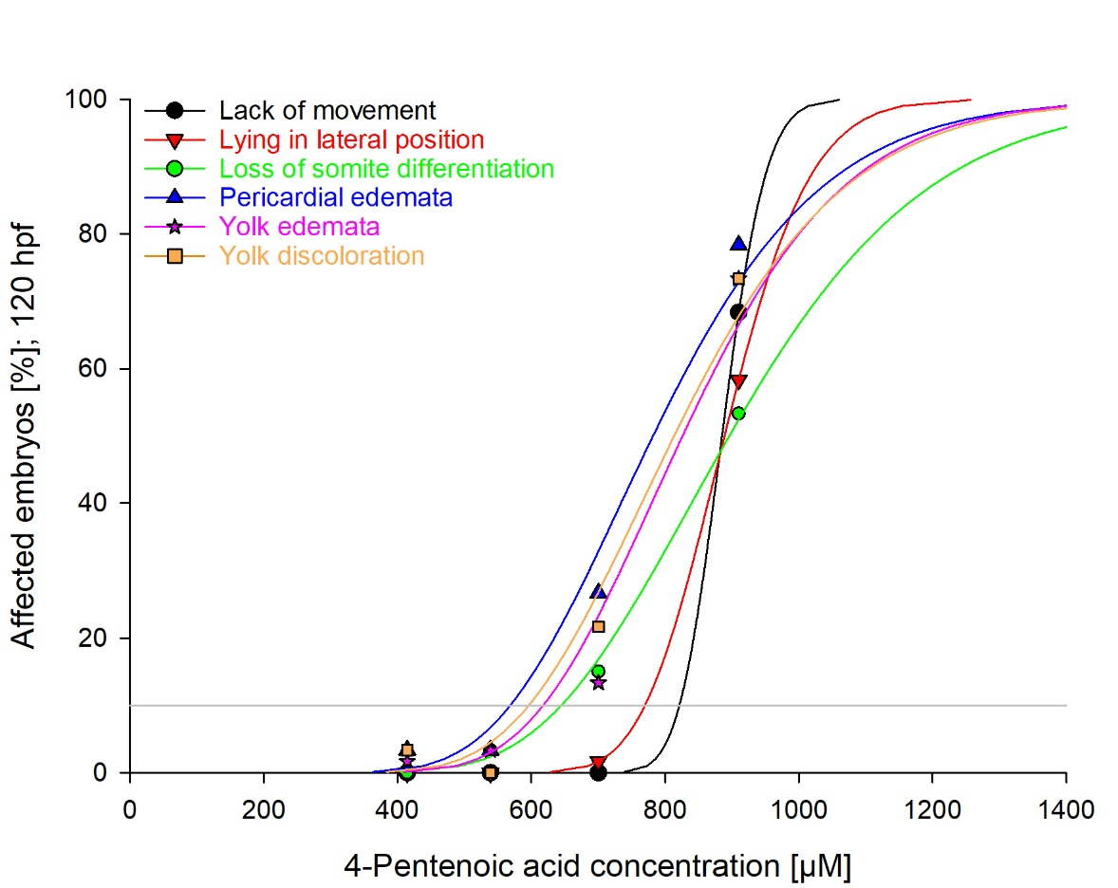
EC₁₀ (µM)
822
770
645
568
618
596

Fig. S7: Dose-response curves for specific effects induced by exposure of zebrafish (Danio rerio) embryos to 4-pentenoic acid for 120 h. Data are given as percentage of individuals affected (%) in n = 20 - 40 replicates
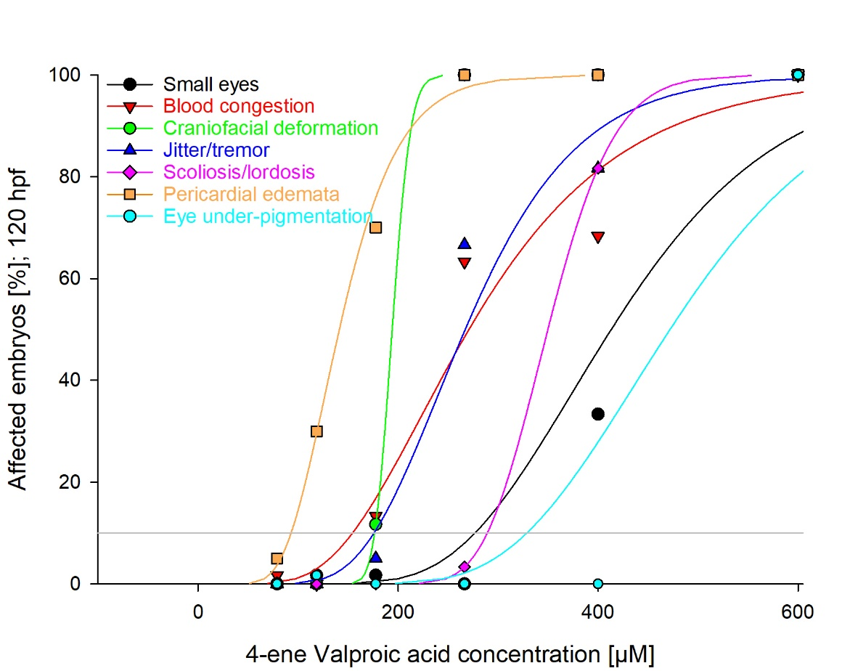
EC₁₀ (µM)
277
154
177
176
289
93
329

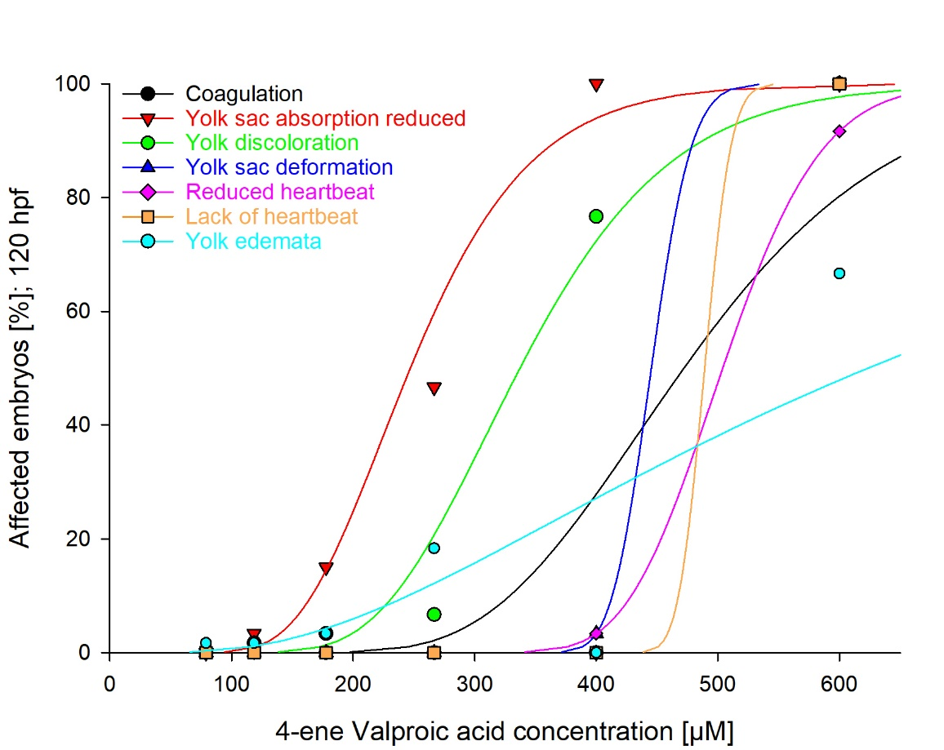
EC₁₀ (µM)
328
166
233
413
429
468
245

Fig. S8: Dose-response curves for specific effects induced by exposure of zebrafish (Danio rerio) embryos to 4-ene-valproic acid for 120 h. Data are given as percentage of individuals affected (%) in n = 20 - 40 replicates.

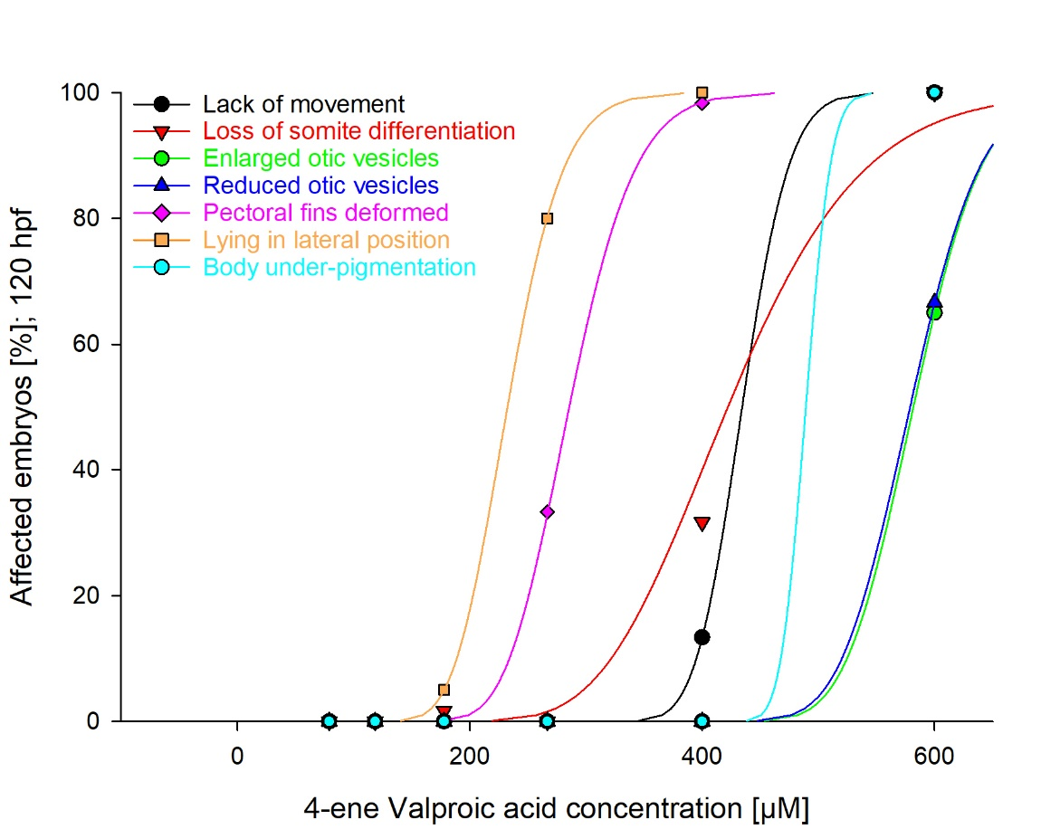
EC₁₀ (µM)
395
322
525
520
234
189
468

Fig. S8 (continued): Dose-response curves for specific effects induced by exposure of zebrafish (Danio rerio) embryos to 4-ene-valproic acid for 120 h. Data are given as percentage of individuals affected (%) in n = 20 - 40 replicates.

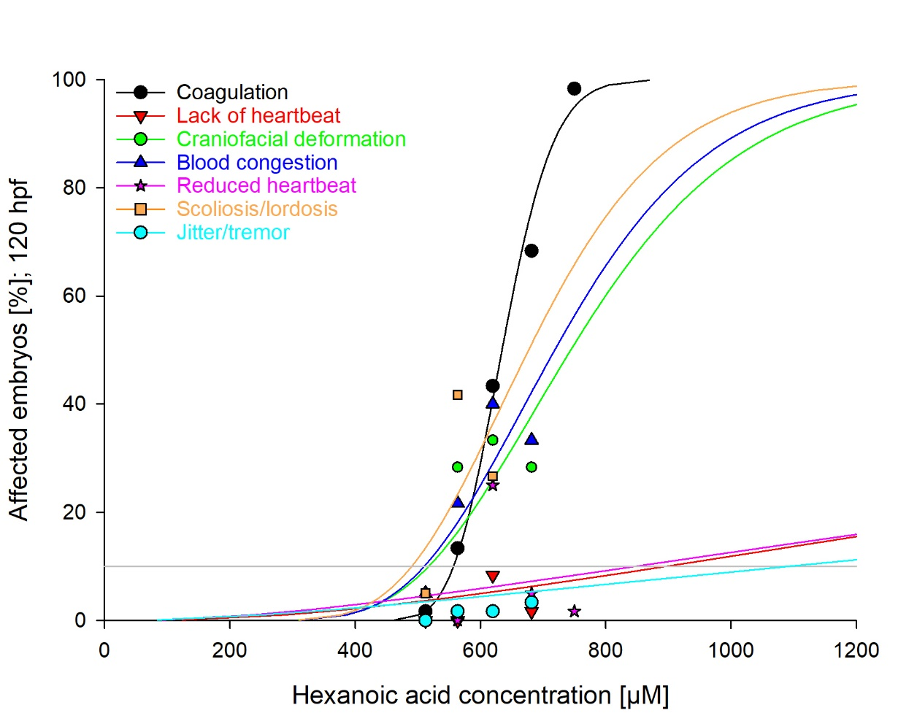
EC₁₀ (µM)
557
897
517
510
848
490
1092

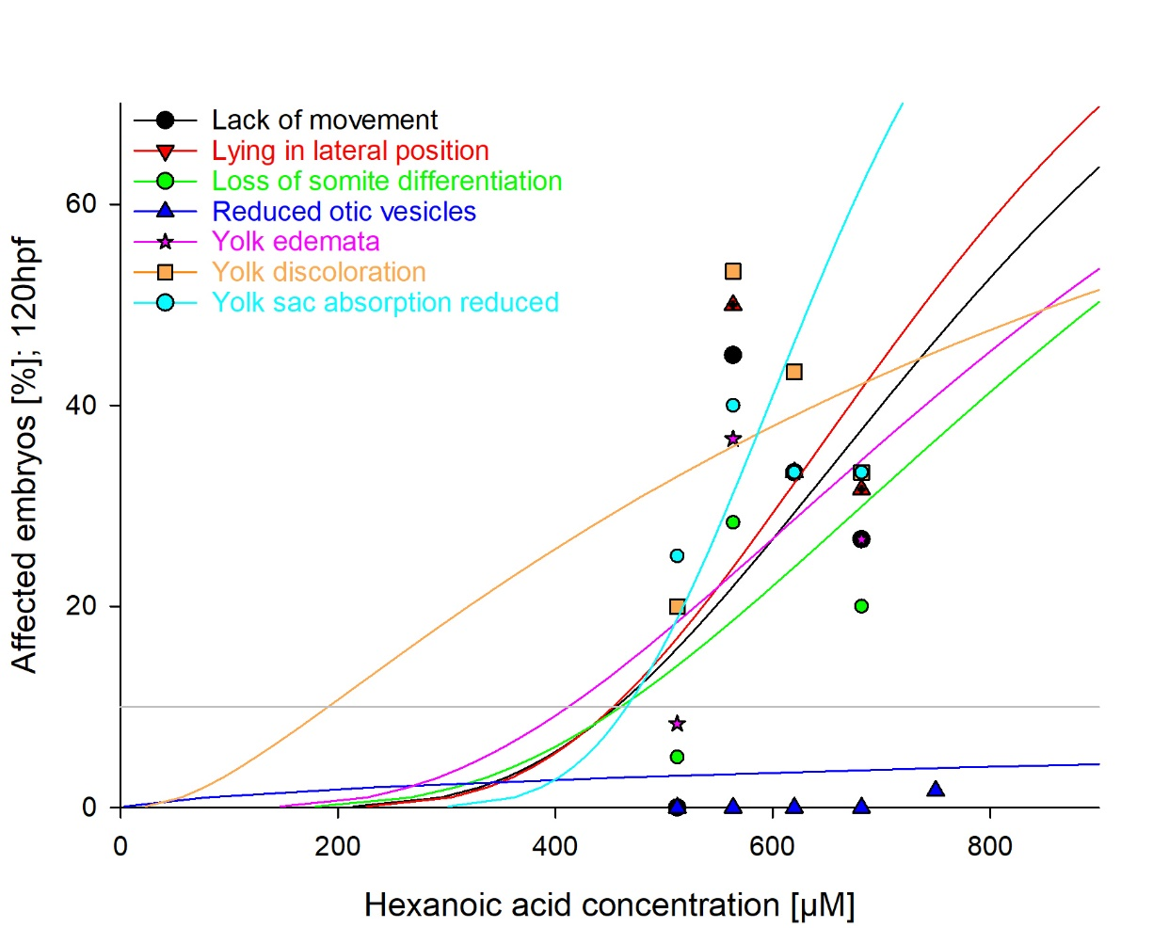
EC₁₀ (µM)
456
453
460
n.d.
412
191
466

Fig. S9: Dose-response curves for specific effects induced by exposure of zebrafish (Danio rerio) embryos to hexanoic acid for 120 h for 120 h. Data are given as percentage of individuals affected (%) in n = 20 - 40 replicates.

