Prediction of dose-dependent in vivo acetylcholinesterase inhibition by profenofos in rats and humans using physiologically based kinetic (PBK) modeling-facilitated reverse dosimetry
Isaac Omwenga^{a,b*}, Shensheng Zhaoª, Laetitia Kanja^{b}, Hans Mol^{c}, Ivonne M.C.M. Rietjensª, Jochem Louisse^{c}
ª Division of Toxicology, Wageningen University and Research, Stippeneng 4, 6708 WE, Wageningen, The Netherlands
^{b} Department of Public Health, Pharmacology and Toxicology, Faculty of Veterinary Sciences, University of Nairobi, P.O. Box 29053-00625, Nairobi, Kenya
^{c} Wageningen Food Safety Research, Wageningen University and Research, Akkermaalsbos 2, 6708 WB, Wageningen, The Netherlands
^{d} Department of Animal Science, Meru University of Science and Technology, P.O Box, 972-60200 Meru, Kenya.

*Corresponding author
Isaac Omwenga
Division of Toxicology, Wageningen University and Research
PO BOX 8000, 6708 EA Wageningen,
The Netherlands
E-mail address: isaac.omwenga@wur.nl

Supplementary Table 1. Physiological and chemical-specific parameters used for the PBK models.
Model parameter | Human | Rat
Physiological parameters
Body weight  Fractional tissue volumes | 70 | 0.20
Fat | 0.213 | 0.07
Bone | 0.0856 | 0.0659
Brain | 0.02 | 0.0052
Gut | 0.0171 | 0.026
Heart | 0.0057 | 0.0044
Kidney | 0.0044 | 0.0092
Liver | 0.021 | 0.036
Lung | 0.0076 | 0.0052
Muscle | 0.4 | 0.488
Skin | 0.0371 | 0.1656
Spleen | 0.0026 | 0.0024
Venous blood | 0.0514 | 0.0429
Arterial blood | 0.0257 | 0.0215
Rest of body | 0.1098 | 0.0577
Cardiac output (mL/s) | 108.33 | 1.33
Fractional tissue blood flows
Fat | 0.05 | 0.059
Bone | 0.05 | 0.10
Brain | 0.12 | 0.014
Gut | 0.1465 | 0.0101
Heart | 0.04 | 0.04
Kidney | 0.19 | 0.145
Liver (Venous side) | 0.2154 | 0.242
Lung | 1 | 1
Muscle | 0.17 | 0.237
Skin | 0.05 | 0.051
Spleen | 0.0172 | 0.011
Rest of body | 0.02119 | 0.112
Renal clearance (L/hr) | 6.7 | 0.078
Chemical specific parameters profenofos
Molecular weight | 373.63
LogP | 4.88
pKa | NA
LogD*(olive oil: water) | 4.09
Binding data
Fu blood | 0.034
Fraction unbound microsomes | 0.07ª | 0.232^{b}
Fraction unbound cytosol | 0.07^{c} | 0.232^{d}
Fraction unbound plasma (in vitro incubations) | 0.83e | 0.93^{f}
Tissue to plasma partition coefficients
Fat | 96.3 | 147
Bone | 15.4 | 11.9
Brain | 14.1 | 23.3
Gut | 11.1 | 14.1
Heart | 3.47 | 7.47
Kidney | 5.35 | 8.84
Liver | 8.82 | 9.70
Lung | 1.24 | 11.1
Muscle | 5.43 | 5.44
Skin | 6.62 | 12.4
Spleen | 5.45 | 5.05
Rest of body | 1 | 1
Absorption Ka (/hr) | 1 | 1
Fraction absorbed | 1 | 1
Chemical specific parameters: BCP
LogP | - | 3.04
pKa | - | 7.54
LogD*(olive oil: water) | - | 1.80
Tissue plasma partition coefficients
Fat | - | 5.62
Bone | - | 2.90
Brain | - | 5.65
Gut | - | 3.54
Heart | - | 2.05
Kidney | - | 2.36
Liver | - | 2.52
Lung | - | 2.87
Muscle | - | 1.58
Skin | - | 3.11
Spleen | - | 1.49
Rest of body | - | 1
Binding data
Fu blood | - | 0.113
Fraction unbound microsomes | - | 0.761^{g}
Chemical specific parameters: BCP glucuronide
LogP | - | 1.06
pKa | - | 2.72
LogD* (olive oil: water) | - | 4.85
Tissue to plasma partition coefficients
Fat | - | 0.13
Bone | - | 0.79
Brain | - | 1.49
Gut | - | 1.16
Heart | - | 1.00
Kidney | - | 1.05
Liver | - | 1.01
Lung | - | 1.12
Muscle | - | 0.93
Skin | - | 1.05
Spleen | - | 1.02
Rest of body | - | 1
Binding data
Fu blood | - | 0.226
Scaling factors
Microsomal protein (mg) per g liver | 32 | 35
Cytosolic protein (mg) per g liver | 80.7 | 80.7
Plasma (mg)per g blood | 550 | 550

ª fraction unbound profenofos in human microsome incubation (with 2 mg/mL)
^{b} fraction unbound profenofos in rat microsome incubation (with 0.5 mg/mL)
^{c} fraction unbound profenofos in human cytosol incubation (with 2 mg/mL)
^{d} fraction unbound profenofos in rat cytosol incubation (with 0.5 mg/mL)
^{e} fraction unbound profenofos in human plasma incubation (estimated with help of simcyp (via Kd: 13 µM); 4.4 mg plasma/mL (0.20 g albumin/L))
^{f} fraction unbound profenofos in rat plasma incubation (estimated with help of simcyp (via Kd: 13 µM); 1.65 mg plasma/mL (0.074 g albumin/L))
^{g} fraction unbound BCP in rat microsome incubation (with 1 mg/mL)

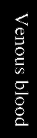
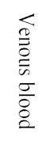

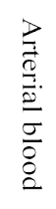
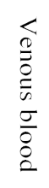
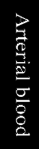
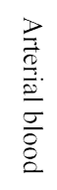
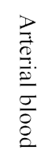
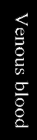
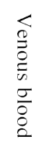

Lung

Rest of body

Fat

Bone

Brain

Heart

Kidney

Muscle

Skin

Spleen

Liver

Lung

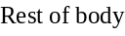

Fat

Bone

Brain

Heart

Kidney

Muscle

Skin

Spleen

Liver

Lung

Rest of body

Fat

Bone

Brain

Heart

Kidney

Muscle

Skin

Spleen

Liver

BCP
BCP
Glucuronide
Oral Dose

GI tract

BCP glucuronide in Urine

GI tract

GI tract

Supplementary Figure 1. Schematic diagram of the PBK model for profenofos for rat consisting of three sub-models including one for profenofos (left), 4-bromo-2-chlorophenol (BCP) (center) and for BCP glucuronide (right). BCP formation is also described in the blood compartments in the PBK model, but for the sake of clarity of the figure, this is not depicted in the schematic diagram.
Abbreviation: GI tract: gastrointestinal tract.

Supplementary Table 2. Results of BMD modelling of predicted human dose-response data, applying model averaging
Fitted Models
model | converged | loglik | npar | AIC
full model | Yes | 17.79 | 13 | -9.58
null model | Yes | -57.88 | 2 | 119.76
Expon. m3- | Yes | -1.13 | 4 | 10.26
Expon. m5- | Yes | 12.71 | 5 | -15.42
Hill m3- | Yes | -0.61 | 4 | 9.22
Hill m5- | Yes | 13.53 | 5 | -17.06
Inv.Expon. m3- | Yes | 4.78 | 4 | -1.56
Inv.Expon. m5- | Yes | 13.13 | 5 | -16.26
LN m3- | Yes | 2.16 | 4 | 3.68
LN m5- | Yes | 13.47 | 5 | -16.94
Weights for Model Averaging
EXP | HILL | INVEXP | LOGN | EXP
0.14 | 0.33 | 0.22 | 0.31 | 0.14
Final BMD Values
endpoint | subgroup | BMDL | BMDU
Response | All | 0.01 | 0.81

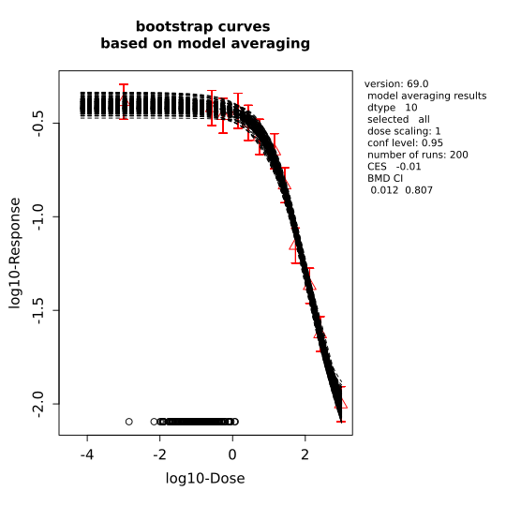

Supplementary Figure 2. Bootstrap curves based on model averaging for predicted human AChE inhibition.

A B
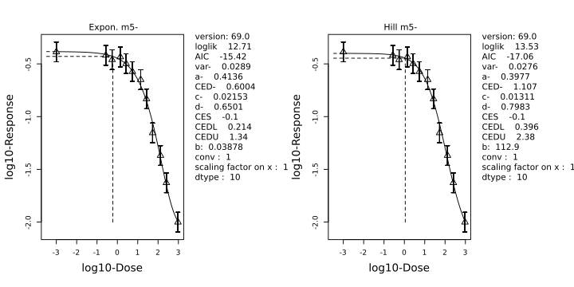
C D
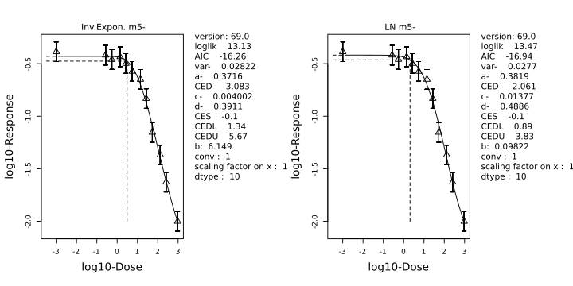

Supplementary Figure 3. BMD modelling results for individual models for predicted human AChE inhibition. A: Exponential model 5, B: Hill model 5, C:Inv. Exponential model 5, D: Log-Normal Family model 5.

Supplementary Table 3. Results of BMD modelling of predicted rat dose-response data, applying model averaging.

Fitted Models
model | converged | loglik | npar | AIC
full model | yes | -10.87 | 13 | 47.74
null model | yes | -44.71 | 2 | 93.42
Expon. m3- | yes | -15.31 | 4 | 38.62
Expon. m5- | yes | -12.87 | 5 | 35.74
Hill m3- | yes | -15.25 | 4 | 38.50
Hill m5- | yes | -13.15 | 5 | 36.30
Inv.Expon. m3- | yes | -14.61 | 4 | 37.22
Inv.Expon. m5- | yes | -13.70 | 5 | 37.40
LN m3- | yes | -14.87 | 4 | 37.74
LN m5- | yes | -13.38 | 5 | 36.76

Weights for Model Averaging
EXP | HILL | INVEXP | LOGN | EXP
0.35 | 0.27 | 0.17 | 0.21 | 0.35

Final BMD Values
endpoint | subgroup | BMDL | BMDU
Response | all | 0.45 | 190

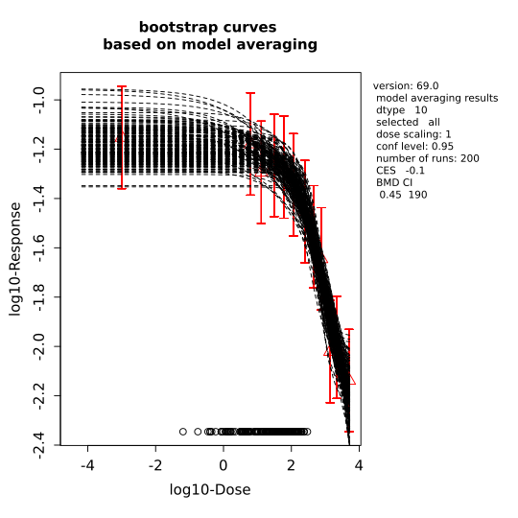
Supplementary Figure 4. Bootstrap curves based on model averaging for predicted rat AChE inhibition.

A B
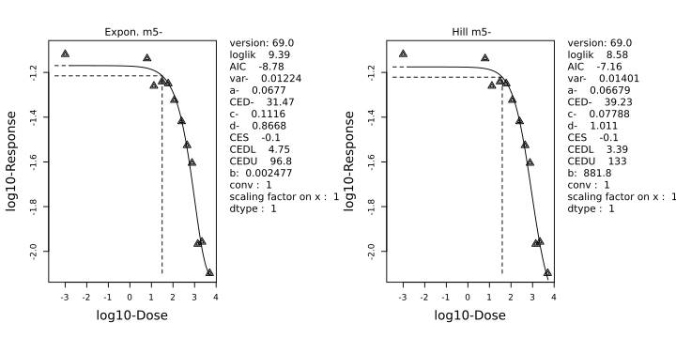

C D
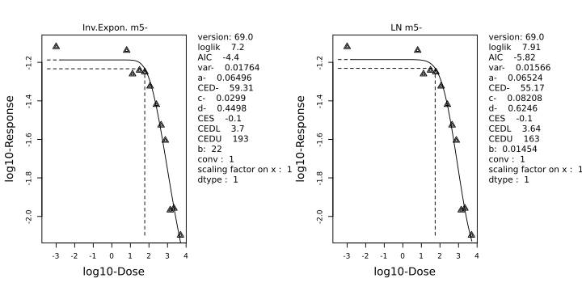

Supplementary Figure 5. BMD modelling results for individual models for predicted rat AChE inhibition. A: Exponential model 5, B: Hill model 5, C: Inv. Expontial model 5, D: Log-Normal Family model 5.

