Supplementary material

In vitro interactions of Alternaria mycotoxins, an emerging class of food contaminants, with the gut microbiota: a bidirectional relationship.

Francesco Crudo^{1,2}, Georg Aichinger¹, Jovana Mihajlovic³, Elisabeth Varga¹, Luca Dellafiora², Benedikt Warth¹, Chiara Dall’Asta², David Berry^{1,3,4}, Doris Marko^{1,2.*}

Author affiliations:
¹ Department of Food Chemistry and Toxicology, Faculty of Chemistry, University of Vienna, Währinger Str. 38, 1090 Vienna, Austria;
² Department of Food and Drug, University of Parma, Area Parco delle Scienze 27/A, 43124 Parma, Italy;
³ Department of Microbiology and Ecosystem Science, Centre for Microbiology and Environmental Systems Science, University of Vienna, Althanstr. 14, 1090 Vienna, Austria;
⁴ Joint Microbiome Facility of the Medical University of Vienna and the University of Vienna.

Corresponding author:
Prof. Dr. Doris Marko
Department of Food Chemistry and Toxicology, University of Vienna
Währinger Str. 38, 1090 Wien, Austria
doris.marko@univie.ac.at

Table of Contents

Online Resource 1 Chemical structures of the mycotoxins contained in the extract. 3
Online Resource 2 Bacterial strains and media employed in the study. 4
Online Resource 3 Growth curves of the strains exposed to various concentrations of the complex Alternaria extract (CE).. 5
Online Resource 4 Doubling time of the strains exposed to the various concentrations of the Alternaria extract, each in comparison to the respective solvent control (0.1-0.001% DMSO). 12
Online Resource 5. OD₆₀₀ values recorded after 24 h and 48 h incubation with various concentrations of the Alternaria extract, each in comparison to the respective solvent control (0.1-0.001% DMSO). 13
Online Resource 6. Total recovery of Alternaria mycotoxins after 24 h incubation of strains with 25 µg/mL of CE 14
Online Resource 7 Bar charts showing the amount of the least affected mycotoxins recovered in pellets and supernatants of the tested strains after 24 h incubation with 25 µg/mL of CE.. 15
Online Resource 8 Theoretical recoveries of mycotoxins from bacterial pellets (normalized based on a theorethical OD600 of 0.5). 16
Online Resource 9 Concentrations of mycotoxins the bacterial strains were exposed to during treatments with various concentrations of the Alternaria extract. 17

Online Resource 1. Chemical structures of the Alternaria mycotoxins contained in the extract.

Online Resource 2. Bacterial strains and media employed in the study.
Strainª | Abbreviation | Received from | Phylum | Gram staining | Medium^{b}
Alistipes finegoldii_AR1 (99% 16S rRNA gene sequence similarity with A. finegoldii DSM 17242) | AF | Own isolation | Bacteroidetes | – | YCFA-g
Alistipes timonensis DSM25383 | AT | DSMZ | Bacteroidetes | – | YCFA-g
Akkermansia muciniphila DSM22959 | AM | DSMZ | Verrucomicrobia | – | BHI-muc
Bacteroides caccae DSM19204 | BC | DSMZ | Bacteroidetes | – | m-BHI
Bacteroides eggerthii DSM20697 | BE | DSMZ | Bacteroidetes | – | m-BHI
Bacteroides thetaiotaomicron DSM2079 | BT | DSMZ | Bacteroidetes | – | m-BHI
Bacteroides vulgatus DSM1447 | BV | DSMZ | Bacteroidetes | – | m-BHI
Parabacteroides distasonis_AR2 (99% 16S rRNA gene sequence similarity with P. distasonis DSM 20701¹) | PD | Own isolation | Bacteroidetes | – | m-BHI
Escherichia coli ATCC23716 | EC | ATCC | Proteobacteria | – | m-BHI
Lactobacillus hominis DSM23910 | LH | DSMZ | Firmicutes | + | m-MRS
Bifidobacterium longum subsp. infantis ATCC 15697 | BL | ATCC | Actinobacteria | + | m-MRS
Bifidobacterium_sp.AR3 (95% 16S rRNA gene sequence similarity with B. longum¹) | B. sp | Own isolation | Actinobacteria | + | m-MRS
Clostridium innocuum DSMZ1286 | CI | DSMZ | Firmicutes | + | m-BHI
Ruminococcus bicirculans _AR4 (99% 16S rRNA gene sequence similarity with Ruminococcus bicirculans 80/3¹) | RB | Own isolation | Firmicutes | + | YCFA-g
ª In-house isolated strains are identified to genus or species level based on the best BLAST (Morgluis et al. 2008, Bioinformatics; https://pubmed.ncbi.nlm.nih.gov/18567917/) result for their 16S rRNA gene sequence similarity.
^{b} YCFA-g: yeast extract-casein hydrolysate-fatty acids broth supplemented with glucose; BHI-muc: brain heart infusion broth supplemented with mucin; m-BHI: modified brain heart infusion broth; m-MRS: modified De Man, Rogosa, Sharpe broth.

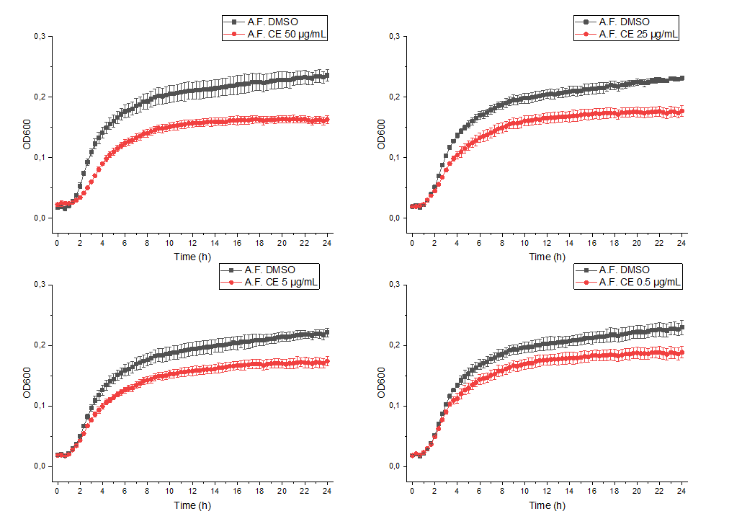
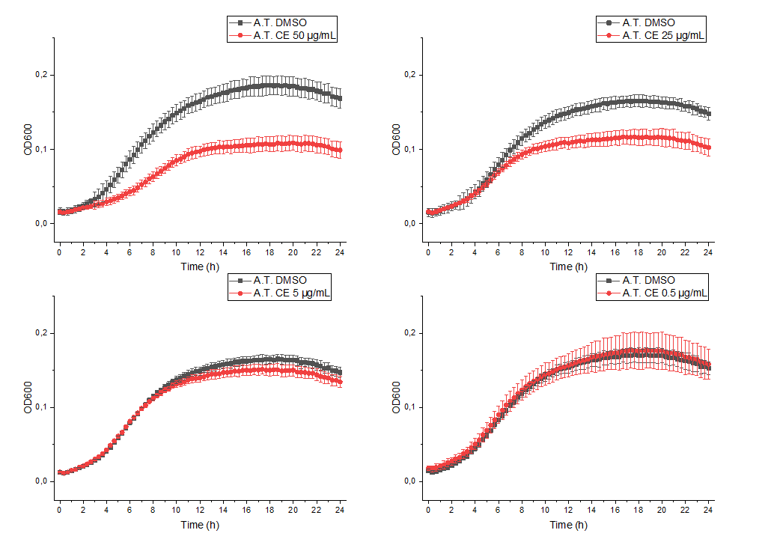

Online Resource 3. Growth curves of the strains exposed to various concentrations of the complex Alternaria extract (CE). The growth curves are expressed as mean values (three replicates) ± SD of optical densities measured at 600 nm. DMSO indicate the growth curves of the respective controls (0.1% - 0.001% DMSO).
AF: A. finegoldii; AT: A. timonensis; AM: A. muciniphila; BC: B. caccae; BE: B. eggerthii; BT: B. thetaiotaomicron; BV: B. vulgatus; PD: P. distasonis; EC: E. coli; LH: L. hominis; BL: B. longum; B. sp.: Bifidobacterium sp.; CI: C. innocuum; RB: R. bicirculans .
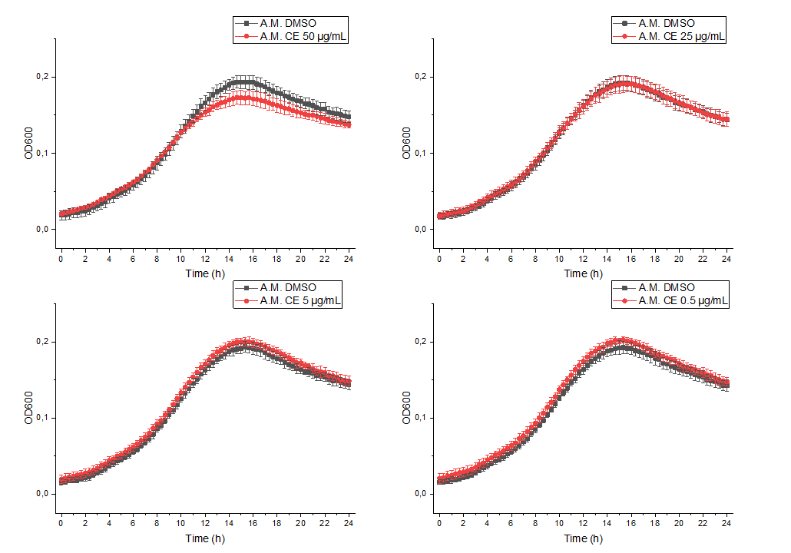
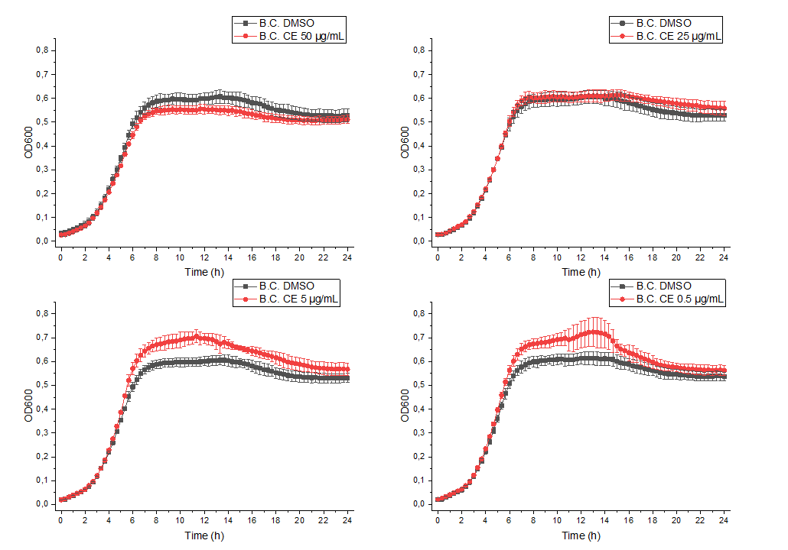
Online Resource 3. Continue.
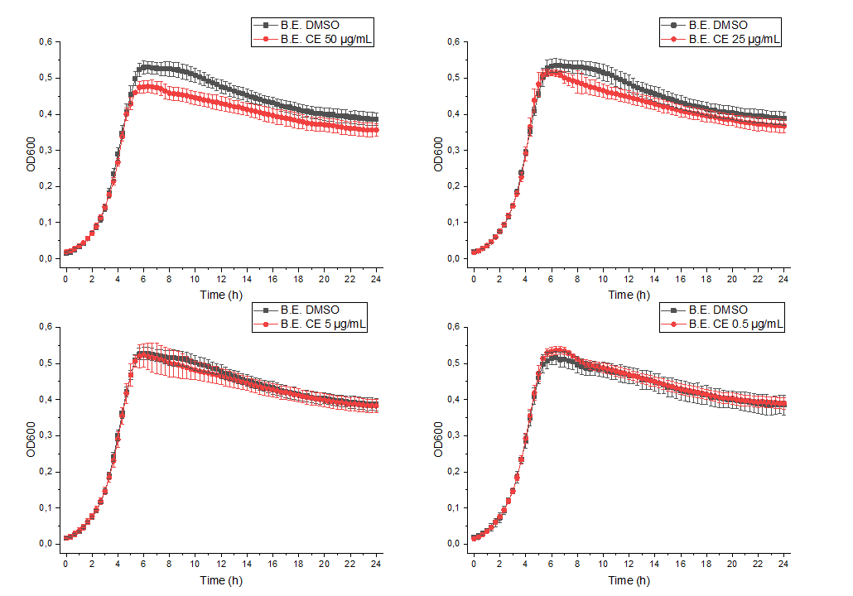
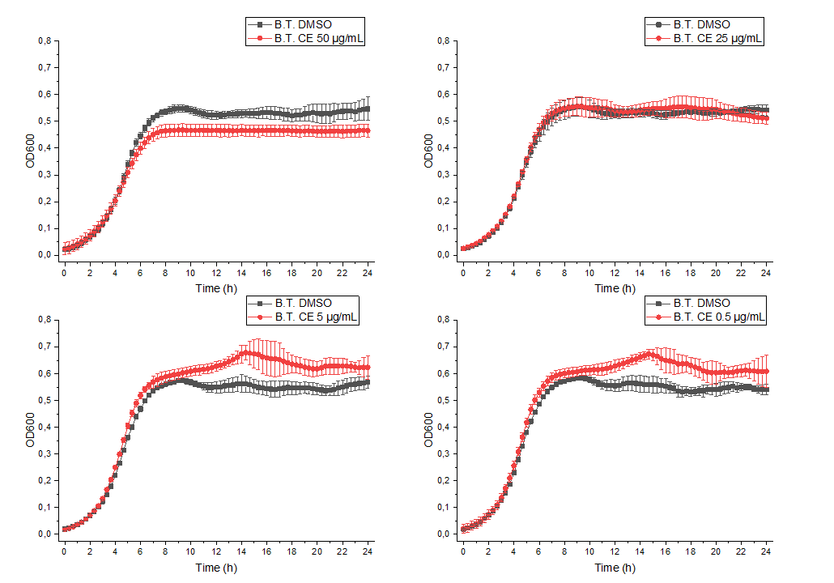
Online Resource 3. Continue.
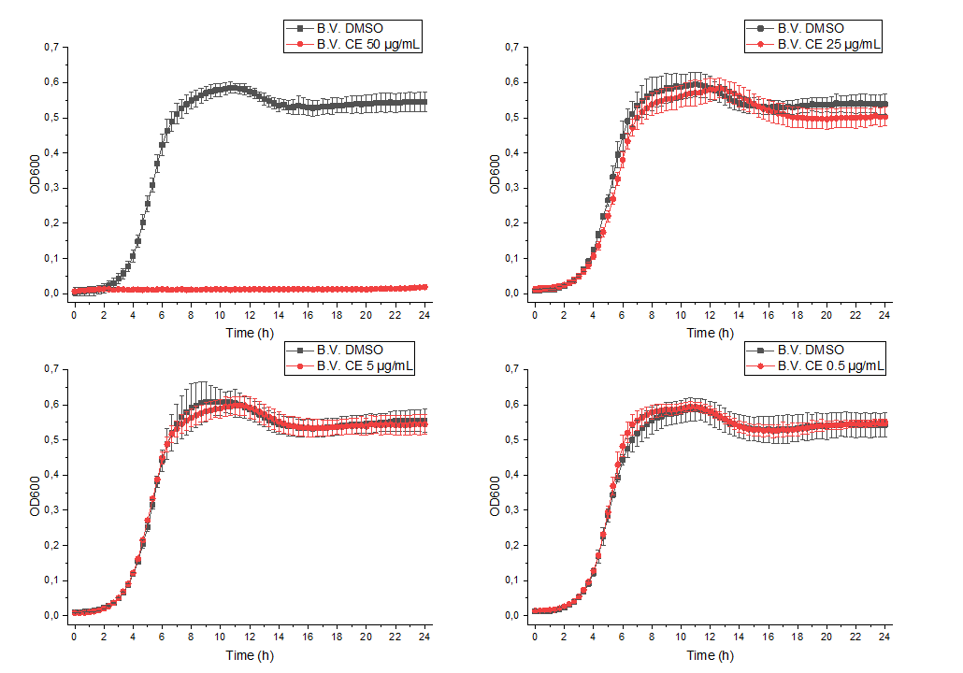
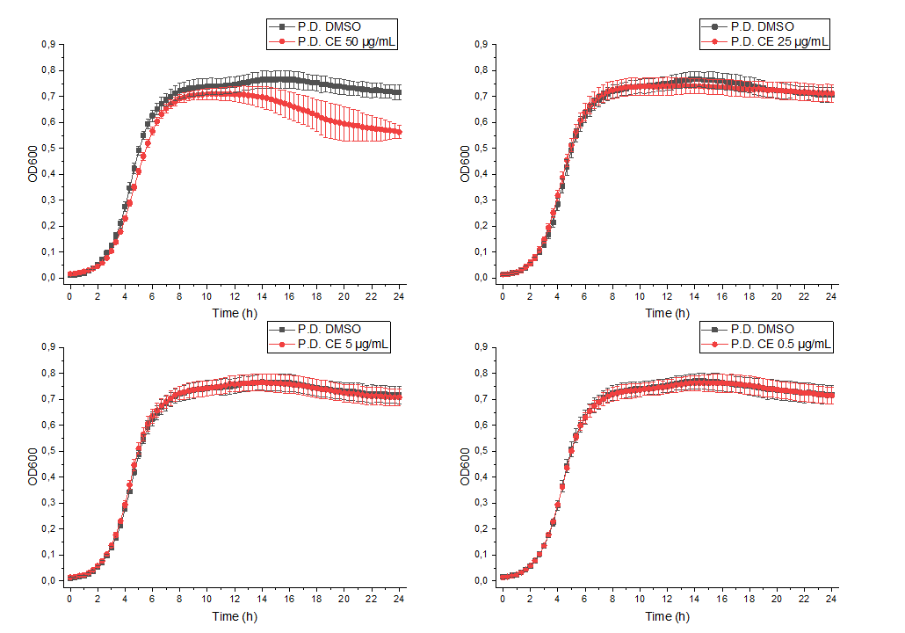
Online Resource 3. Continue.
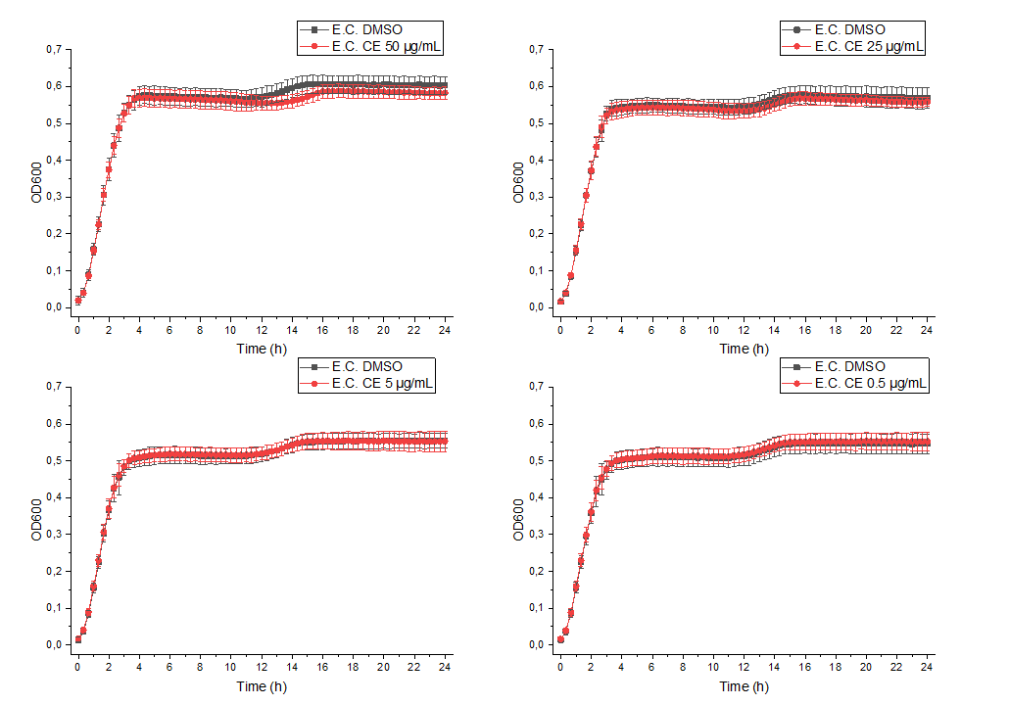
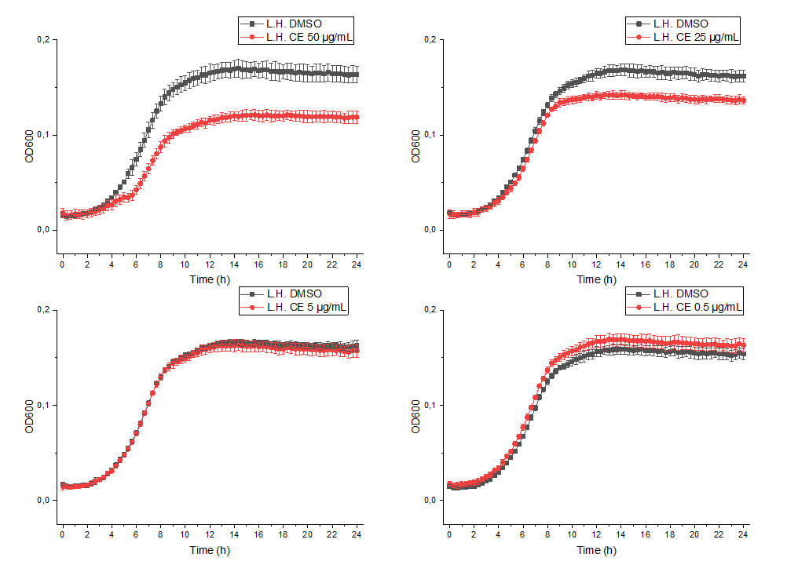
Online Resource 3. Continue.
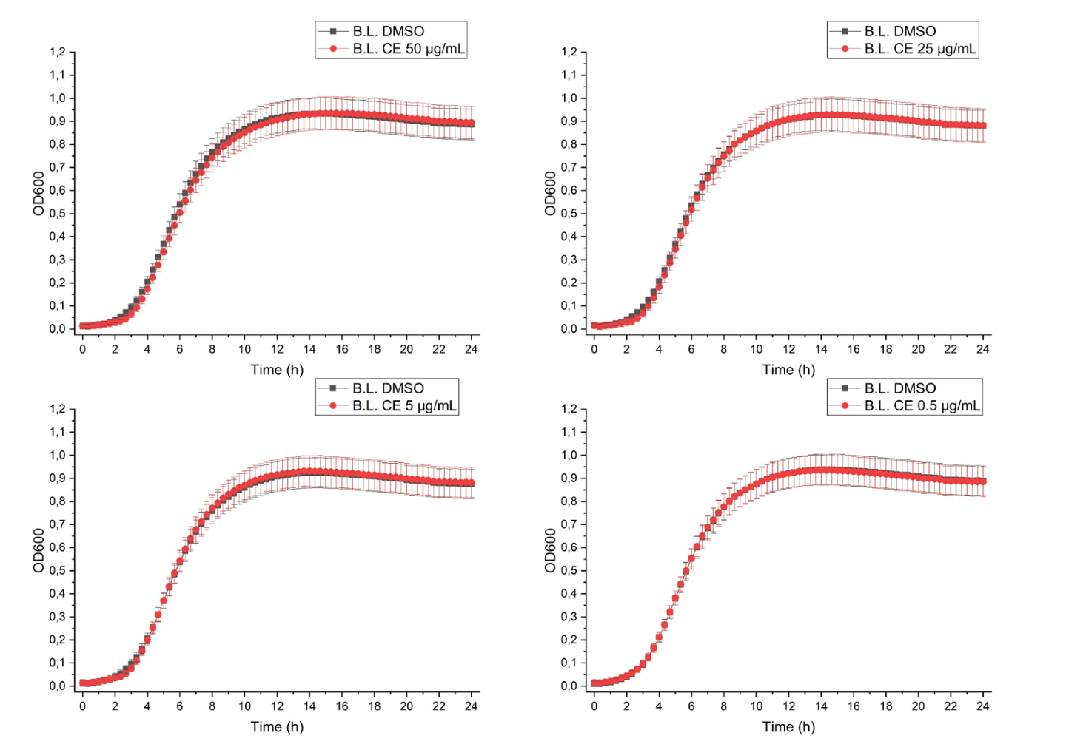
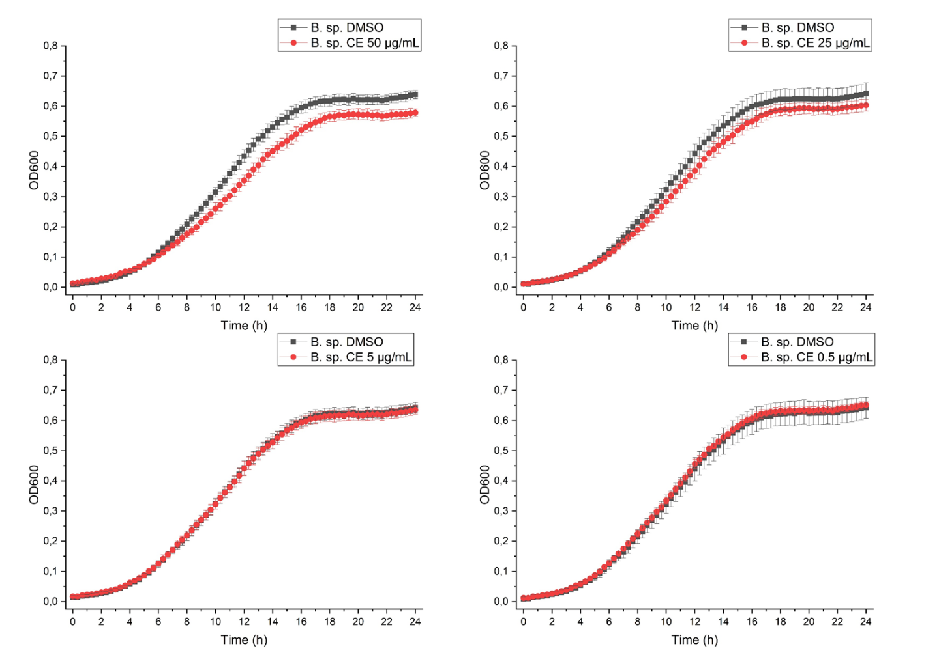
Online Resource 3. Continue.
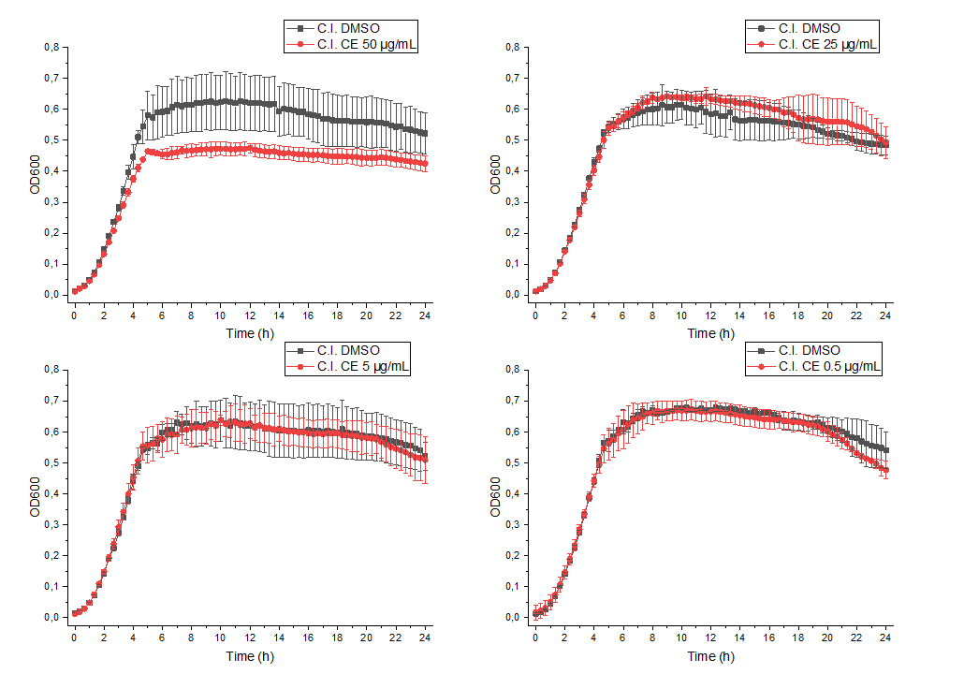
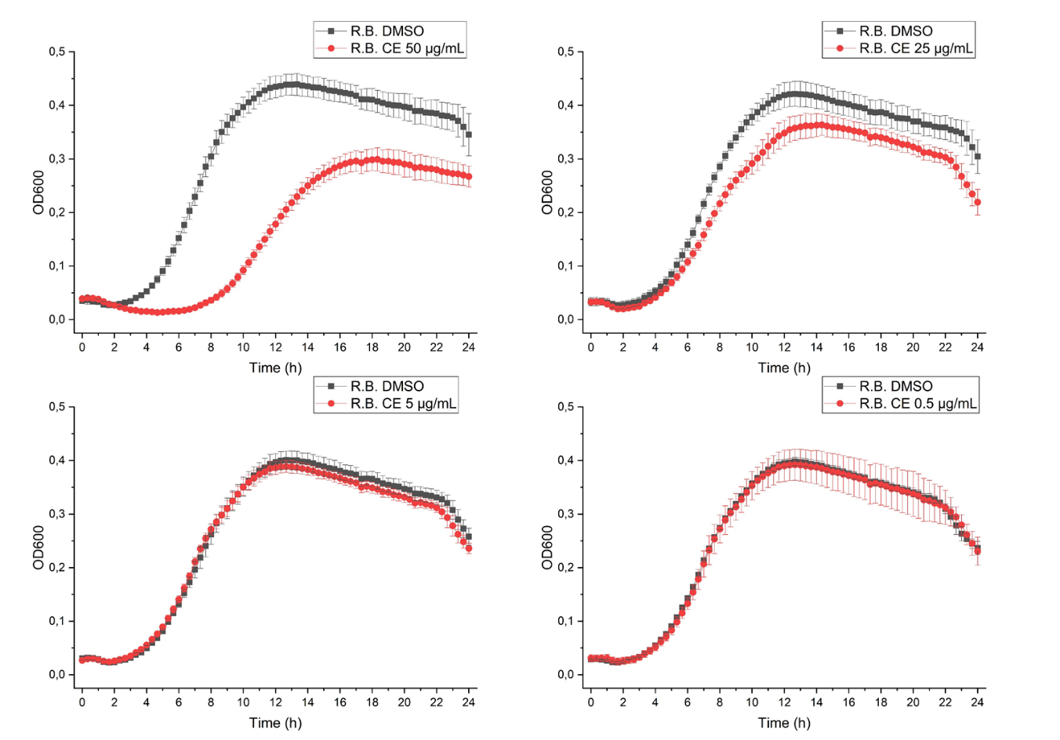
Online Resource 3. Continue.

Online Resource 4. Doubling time of the strains exposed to the various concentrations of the Alternaria extract, each in comparison to the respective solvent control (0.1-0.001% DMSO).
Strain |  | Doubling time (hours; mean ± SD)
Strain |  | Treatment with 50 µg/mL of CE |  |  |  |  |  |  |  | Treatment with 25 µg/mL of CE |  |  |  |  |  |  |  | Treatment with 5 µg/mL of CE |  |  |  |  |  |  |  | Treatment with 0.5 µg/mL of CE
Strain |  | Control |  |  |  | Treated |  |  |  | Control |  |  |  | Treated |  |  |  | Control |  |  |  | Treated |  |  |  | Control |  |  |  | Treated
A. finegoldii |  | 1.03 | ± | 0.28 |  | 1.45 | ± | 0.11* |  | 0.99 | ± | 0.05 |  | 1.24 | ± | 0.07* |  | 1.04 | ± | 0.09 |  | 1.20 | ± | 0.05* |  | 0.97 | ± | 0.03 |  | 1.04 | ± | 0.06
A. timonensis |  | 2.20 | ± | 0.28 |  | 3.93 | ± | 0.73* |  | 2.28 | ± | 0.31 |  | 2.65 | ± | 0.33 |  | 2.08 | ± | 0.12 |  | 2.10 | ± | 0.09 |  | 2.10 | ± | 0.10 |  | 2.25 | ± | 0.11
A. muciniphila |  | 3.48 | ± | 0.44 |  | 3.87 | ± | 0.13 |  | 3.34 | ± | 0.27 |  | 3.55 | ± | 0.25 |  | 3.28 | ± | 0.26 |  | 3.61 | ± | 0.37 |  | 3.28 | ± | 0.25 |  | 3.68 | ± | 0.42
B. caccae |  | 1.36 | ± | 0.16 |  | 1.30 | ± | 0.01 |  | 1.27 | ± | 0.11 |  | 1.28 | ± | 0.04 |  | 1.18 | ± | 0.02 |  | 1.18 | ± | 0.05 |  | 1.17 | ± | 0.09 |  | 1.18 | ± | 0.04
B. eggerthii |  | 0.99 | ± | 0.05 |  | 1.05 | ± | 0.06 |  | 1.04 | ± | 0.03 |  | 1.03 | ± | 0.03 |  | 1.00 | ± | 0.02 |  | 1.03 | ± | 0.07 |  | 1.03 | ± | 0.04 |  | 1.03 | ± | 0.03
B. thetaiotaomicron |  | 1.22 | ± | 0.15 |  | 1.35 | ± | 0.33 |  | 1.28 | ± | 0.02 |  | 1.27 | ± | 0.04 |  | 1.18 | ± | 0.09 |  | 1.10 | ± | 0.02 |  | 1.18 | ± | 0.08 |  | 1.13 | ± | 0.21
B. vulgatus |  | 0.83 | ± | 0.15 |  |  | –– | * |  | 0.84 | ± | 0.04 |  | 1.00 | ± | 0.13 |  | 0.88 | ± | 0.03 |  | 0.82 | ± | 0.08 |  | 0.86 | ± | 0.07 |  | 0.88 | ± | 0.05
P. distasonis |  | 0.81 | ± | 0.05 |  | 0.89 | ± | 0.03 |  | 0.83 | ± | 0.03 |  | 0.82 | ± | 0.06 |  | 0.82 | ± | 0.05 |  | 0.84 | ± | 0.06 |  | 0.86 | ± | 0.07 |  | 0.86 | ± | 0.03
E. coli |  | 0.53 | ± | 0.05 |  | 0.53 | ± | 0.01 |  | 0.52 | ± | 0.03 |  | 0.53 | ± | 0.02 |  | 0.52 | ± | 0.03 |  | 0.54 | ± | 0.02 |  | 0.53 | ± | 0.03 |  | 0.53 | ± | 0.02
L. hominis |  | 2.00 | ± | 0.06 |  | 2.62 | ± | 0.37* |  | 2.07 | ± | 0.03 |  | 2.09 | ± | 0.21 |  | 1.92 | ± | 0.12 |  | 1.95 | ± | 0.10 |  | 1.96 | ± | 0.12 |  | 2.00 | ± | 0.15
B. longum |  | 0.82 | ± | 0.15 |  | 0.78 | ± | 0.16 |  | 0.87 | ± | 0.10 |  | 0.77 | ± | 0.16 |  | 0.92 | ± | 0.12 |  | 0.84 | ± | 0.11 |  | 0.83 | ± | 0.14 |  | 0.90 | ± | 0.15
Bifidobacterium sp. |  | 1.68 | ± | 0.03 |  | 2.13 | ± | 0,12* |  | 1.73 | ± | 0.27 |  | 1.92 | ± | 0.02 |  | 1.72 | ± | 0.14 |  | 2.00 | ± | 0.15 |  | 1.69 | ± | 0.29 |  | 1.80 | ± | 0.10
C. innocuum |  | 0.74 | ± | 0.04 |  | 0.80 | ± | 0.06 |  | 0.68 | ± | 0.04 |  | 0.70 | ± | 0.03 |  | 0.72 | ± | 0.05 |  | 0.67 | ± | 0.02 |  | 0.68 | ± | 0.03 |  | 0.81 | ± | 0.16
R. bicirculans |  | 1.55 | ± | 0.06 |  | 1.61 | ± | 0.11 |  | 1.57 | ± | 0.14 |  | 1.58 | ± | 0.08 |  | 1.57 | ± | 0.05 |  | 1.62 | ± | 0.04 |  | 1.58 | ± | 0.03 |  | 1.57 | ± | 0.06
* Significant different compared to the respective control with DMSO. Differences were evaluated by Student’s t-test (p<0.05).
– No growth

Online Resource 5. OD₆₀₀ values recorded after 24 h and 48 h incubation with various concentrations of the Alternaria extract, each in comparison to the respective solvent control (0.1-0.001% DMSO).
Strain | Time |  | OD₆₀₀ (mean ± SD)
Strain | Time |  | Treatment with 50 µg/mL of CE |  |  |  |  |  |  |  | Treatment with 25 µg/mL of CE |  |  |  |  |  |  |  | Treatment with 5 µg/mL of CE |  |  |  |  |  |  |  | Treatment with 0.5 µg/mL of CE
Strain | Time |  | Control |  |  |  | Treated |  |  |  | Control |  |  |  | Treated |  |  |  | Control |  |  |  | Treated |  |  |  | Control |  |  |  | Treated
E. coli | 24 h |  | 0.59 | ± | 0.04 |  | 0.58 | ± | 0.03 |  | 0.59 | ± | 0.03 |  | 0.58 | ± | 0.03 |  | 0.58 | ± | 0.03 |  | 0.58 | ± | 0.04 |  | 0.58 | ± | 0.04 |  | 0.57 | ± | 0.02
 | 48 h |  | 0.56 | ± | 0.04 |  | 0.56 | ± | 0.03 |  | 0.56 | ± | 0.03 |  | 0.55 | ± | 0.04 |  | 0.56 | ± | 0.02 |  | 0.56 | ± | 0.03 |  | 0.55 | ± | 0.02 |  | 0.56 | ± | 0.04
B. vulgatus | 24 h |  | 0.59 | ± | 0.09 |  | 0.04 | ± | 0.02* |  | 0.60 | ± | 0.07 |  | 0.52 | ± | 0.05 |  | 0.58 | ± | 0.04 |  | 0.55 | ± | 0.04 |  | 0.58 | ± | 0.06 |  | 0.63 | ± | 0.04
 | 48 h |  | 0.62 | ± | 0.04 |  | 0.02 | ± | 0.01* |  | 0.63 | ± | 0.08 |  | 0.56 | ± | 0.04 |  | 0.60 | ± | 0.03 |  | 0.58 | ± | 0.06 |  | 0.61 | ± | 0.03 |  | 0.60 | ± | 0.06
B. thetaiotaomicron | 24 h |  | 0.64 | ± | 0.04 |  | 0.63 | ± | 0.03 |  | 0.64 | ± | 0.03 |  | 0.63 | ± | 0.04 |  | 0.62 | ± | 0.04 |  | 0.63 | ± | 0.03 |  | 0.62 | ± | 0.03 |  | 0.63 | ± | 0.03
 | 48 h |  | 0.56 | ± | 0.03 |  | 0.56 | ± | 0.03 |  | 0.56 | ± | 0.04 |  | 0.56 | ± | 0.03 |  | 0.56 | ± | 0.04 |  | 0.56 | ± | 0.04 |  | 0.56 | ± | 0.03 |  | 0.55 | ± | 0.03
B. caccae | 24 h |  | 0.66 | ± | 0.05 |  | 0.64 | ± | 0.04 |  | 0.65 | ± | 0.02 |  | 0.64 | ± | 0.03 |  | 0.65 | ± | 0.03 |  | 0.66 | ± | 0.04 |  | 0.67 | ± | 0.03 |  | 0.65 | ± | 0.04
 | 48 h |  | 0.66 | ± | 0.04 |  | 0.61 | ± | 0.04 |  | 0.67 | ± | 0.06 |  | 0.61 | ± | 0.03 |  | 0.63 | ± | 0.02 |  | 0.65 | ± | 0.03 |  | 0.72 | ± | 0.03 |  | 0.66 | ± | 0.03
* Significant different compared to control with DMSO. Differences were evaluated by Student’s t-test (p<0.05).

Online Resource 6. Total recovery of Alternaria mycotoxins after 24 h incubation of strains with 25 µg/mL of CE
Strain | AOH |  |  |  | AME |  |  |  | ALT |  |  |  | TeA |  |  |  | TEN |  |  |  | ATX-I |  |  |  | ALP |  |  |  | ALS |  |  |  | AST
A. finegoldii | 52.0* | ± | 5.0 |  | 69.3* | ± | 2.1 |  | 120 | ± | 18 |  | 103 | ± | 5 |  | 83.0 | ± | 44.6 |  | 106* | ± | 35 |  | 34.8* | ± | 8.8 |  | 102* | ± | 15 |  | 30.6* | ± | 2.5
A. timonensis | 69.3* | ± | 19.2 |  | 69.6* | ± | 10.1 |  | 127 | ± | 8 |  | 103 | ± | 6 |  | 114 | ± | 37 |  | 100 | ± | 28 |  | 64.5* | ± | 26.7 |  | 87.5 | ± | 8.8 |  | 57.6* | ± | 14.6
A. muciniphila | 53.7* | ± | 10.8 |  | 92.9 | ± | 13.3 |  | 106 | ± | 16 |  | 86.6 | ± | 5.6 |  | 58.1* | ± | 12.1 |  | 100 | ± | 3 |  | 56.4* | ± | 1.6 |  | 90.8 | ± | 4.2 |  | 60.0* | ± | 8.5
B. caccae | 61.6* | ± | 15.3 |  | 75.0* | ± | 19.0 |  | 133 | ± | 25 |  | 109 | ± | 11 |  | 86.8 | ± | 10.9 |  | 138 | ± | 43 |  | 24.7* | ± | 7.6 |  | 83.5 | ± | 10.8 |  | 70.5* | ± | 17.2
B. eggerthii | 118 | ± | 11 |  | 72.4* | ± | 10.0 |  | 63.1 | ± | 33.9 |  | 100 | ± | 12 |  | 122 | ± | 16 |  | 142* | ± | 2 |  | 57.9* | ± | 6.7 |  | 93.1 | ± | 13.3 |  | 64.3* | ± | 6.3
B. thetaiotaomicron | 42.3* | ± | 2.5 |  | 77.3* | ± | 18.0 |  | 91.6 | ± | 25.1 |  | 106 | ± | 7 |  | 102 | ± | 24 |  | 133 | ± | 49 |  | 20.3* | ± | 4.6 |  | 92.4 | ± | 12.7 |  | 61.9* | ± | 15.0
B. vulgatus | 58.1* | ± | 11.5 |  | 91.4* | ± | 2.3 |  | 100 | ± | 38 |  | 92.5 | ± | 8.5 |  | 85.5 | ± | 37.5 |  | 89.8 | ± | 1.7 |  | 24.4* | ± | 5.3 |  | 98.7 | ± | 13.0 |  | 74.5* | ± | 11.7
P. distasonis | 80.2* | ± | 3.4 |  | 73.2* | ± | 4.7 |  | 84.4 | ± | 37.8 |  | 96.9 | ± | 6.4 |  | 116 | ± | 12 |  | 183 | ± | 4 |  | 26.3* | ± | 2.5 |  | 86.6 | ± | 4.9 |  | 50.7* | ± | 16.7
E. coli | 33.5* | ± | 4.4 |  | 55.4* | ± | 12.0 |  | 119 | ± | 12 |  | 103 | ± | 11 |  | 93.0 | ± | 24.5 |  | 93.7 | ± | 10.4 |  | 31.0* | ± | 1.7 |  | 93.5 | ± | 10.2 |  | 48.7* | ± | 6.9
L. hominis | 60.7* | ± | 20.3 |  | 87.2 | ± | 29.5 |  | 77.2 | ± | 8.9 |  | 125 | ± | 13 |  | 69.5 | ± | 19.4 |  | 93.8 | ± | 33.5 |  | 101 | ± | 36 |  | 56.1* | ± | 8.1 |  | 68.3* | ± | 4.6
B. longum | 46.1* | ± | 6.0 |  | 102 | ± | 28 |  | 65.0 | ± | 20.9 |  | 118 | ± | 8 |  | 80.5 | ± | 7.6 |  | 80.8* | ± | 2.5 |  | 75.0* | ± | 1.6 |  | 49.9* | ± | 4.6 |  | 73.2* | ± | 10.2
Bifidobacterium sp. | 102 | ± | 16 |  | 75.3* | ± | 8.6 |  | 53.8* | ± | 7.0 |  | 119 | ± | 3 |  | 62.0* | ± | 4.8 |  | 136* | ± | 6 |  | 117* | ± | 2 |  | 51.4* | ± | 8.9 |  | 56.8* | ± | 4.8
C. innocuum | 50.1* | ± | 4.2 |  | 84.5* | ± | 10.3 |  | 120 | ± | 3 |  | 96.3 | ± | 6.4 |  | 79.7 | ± | 9.8 |  | 119 | ± | 31 |  | 19.0* | ± | 5.0 |  | 93.6 | ± | 15.7 |  | 87.7 | ± | 20.0
R. bicirculans | 80.8 | ± | 17.4 |  | 90.4 | ± | 14.1 |  | 112 | ± | 12 |  | 89.4 | ± | 8.7 |  | 79.0 | ± | 8.4 |  | 131 | ± | 43 |  | 14.0* | ± | 3.3 |  | 86.4 | ± | 24.8 |  | 91.9 | ± | 33.4
* Significant different compared to control with DMSO. Differences were evaluated by Student’s t-test (p<0.05).

.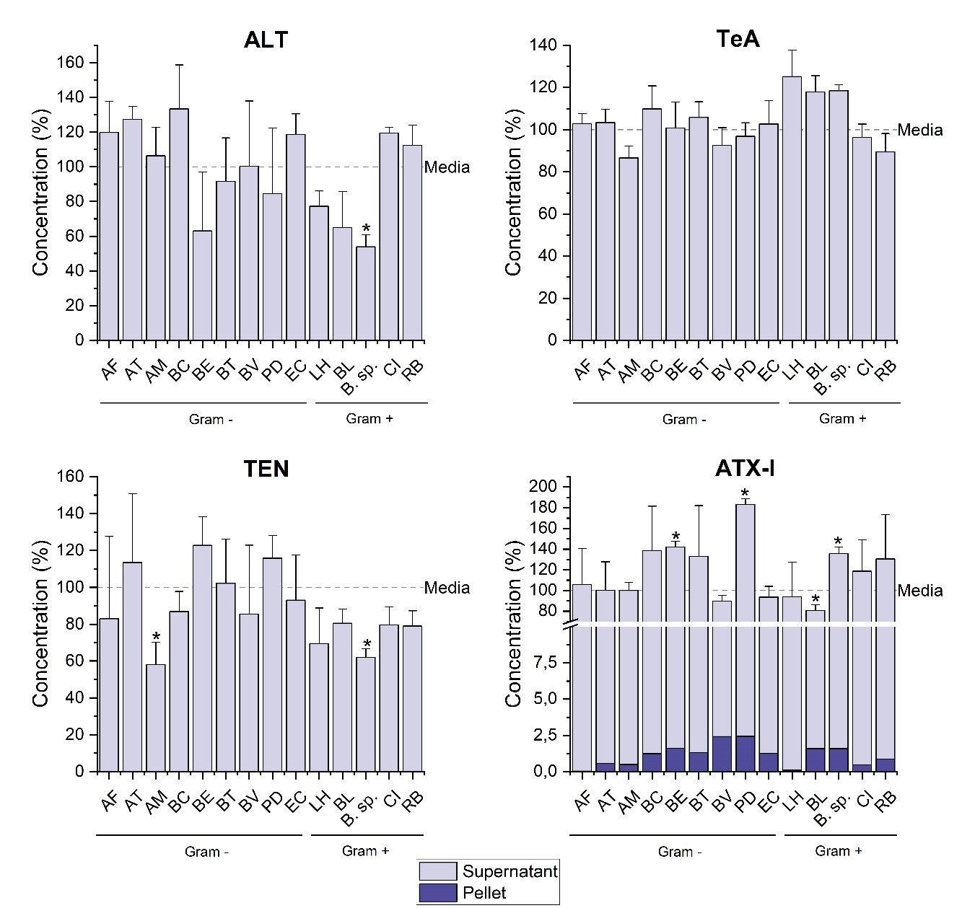

Online Resource 7. Bar charts showing the amount of the least affected mycotoxins recovered in pellets and supernatants of the tested strains after 24 h incubation with 25 µg/mL of CE. Data are reported as means + SD. Differences between the total mycotoxin recovery in samples and media controls (media + CE) were evaluated by Student’s t-test (* = p<0.05).
AF: A. finegoldii; AT: A. timonensis; AM: A. muciniphila; BC: B. caccae; BE: B. eggerthii; BT: B. thetaiotaomicron; BV: B. vulgatus; PD: P. distasonis; EC: E. coli; LH: L. hominis; BL: B. longum; B. sp.: Bifidobacterium sp.; CI: C. innocuum; RB: R. bicirculans.

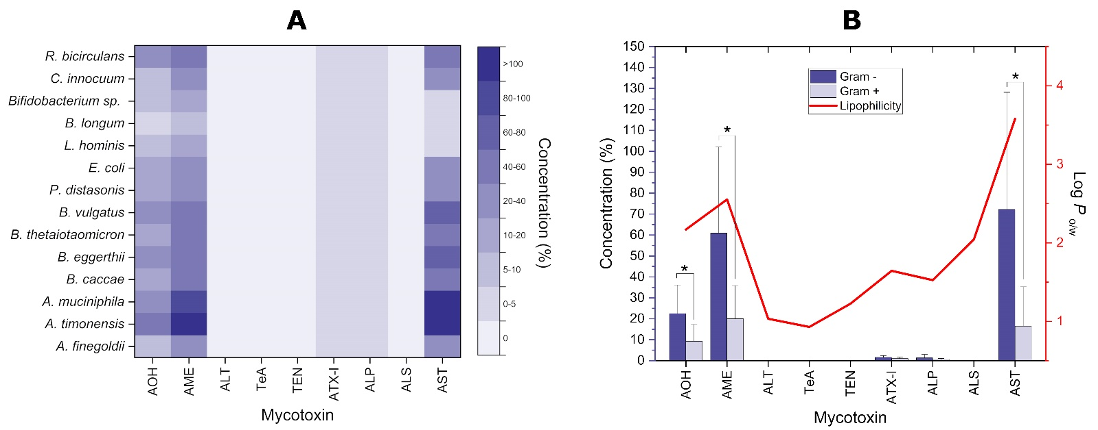

Online Resource 8 Theoretical recoveries of mycotoxins from bacterial pellets. Theoretical recoveries were calculated by normalizing the experimentally determined mycotoxin concentrations in bacterial pellets to a theoretical OD600 value of 0.5, corresponding to the median OD600 value recorded in the suspensions containing the various strains tested. (a) Heatmap showing the theoretical average amount (in % compared to the total mycotoxin recovery experimentally determined) of mycotoxins in bacterial pellets after 24 h incubation with 25 µg/mL of CE. (b) Double-axis plot showing the theoretical mean ± SD (in % compared to the total mycotoxin recovery experimentally determined) of mycotoxin concentrations in pellets of Gram negative and positive strains (blue and light blue columns, respectively; left axis), and the mean value of theoretical lipophilicity (solid line; right axis) of mycotoxins. Significant differences between Gram negative and positive strains were evaluated by Student’s t-test (*p < 0.05).

Online Resource 9. Concentrations of mycotoxins the bacterial strains were exposed to during treatments with various concentrations of the Alternaria extract.

Mycotoxins |  | Mycotoxin concentrations (nM) per treatmentª
Mycotoxins |  | 50 µg/mL |  | 25 µg/mL |  | 5 µg/mL |  | 0.5 µg/mL
AOH |  | 153 |  | 76.5 |  | 15.3 |  | 1.53
AME |  | 119 |  | 59.7 |  | 11.9 |  | 1.19
ALT |  | 133 |  | 66.7 |  | 13.3 |  | 1.33
TeA |  | 151599 |  | 75799 |  | 15160 |  | 1516
TEN |  | 2.41 |  | 1.21 |  | 0.24 |  | 0.02
ATX-I |  | 1407 |  | 704 |  | 141 |  | 14.1
ATX-II |  | 2012 |  | 1006 |  | 201 |  | 20.1
ALP |  | 1798 |  | 899 |  | 180 |  | 18.0
STTX-III |  | 3014 |  | 1507 |  | 301 |  | 30.1
ALS |  | 48.2 |  | 24.1 |  | 4.82 |  | 0.48
AST |  | 2300 |  | 1150 |  | 230 |  | 23.0
ª Mycotoxin concentrations the bacterial strains were exposed to were calculated based on the concentrations experimentally determined by Puntscher et al. (2019b)

