Supplementary Materials:
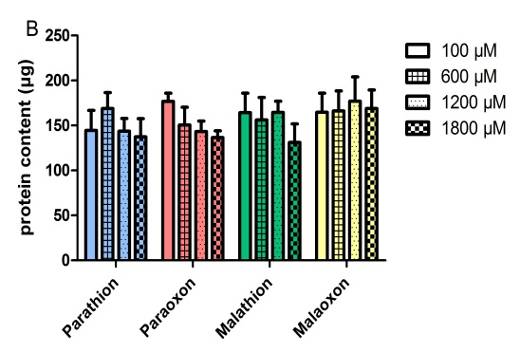
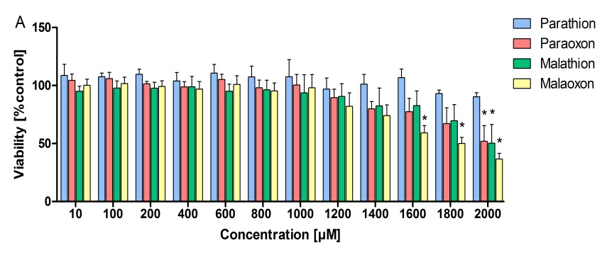

S1: Viability of PCLS after 8 h OP exposure (A) and corresponding protein content (B). To determine optimal concentrations of the OP substances for analysis of cytokine release and induction of oxidative stress, PCLS were treated for 8 h with either paraoxon, parathion, malaoxon, malathion (10 – 2000 µmol/L) or the solvent control acetonitrile. Viability was analyzed by Alamar Blue assay and protein content was measured by BCA assay. Results are shown as % of the solvent control acetonitrile (A) or total protein content (B). Data are shown as mean ± SEM. Asterisk indicate significant differences to the solvent control (*p<0.05; n=3).

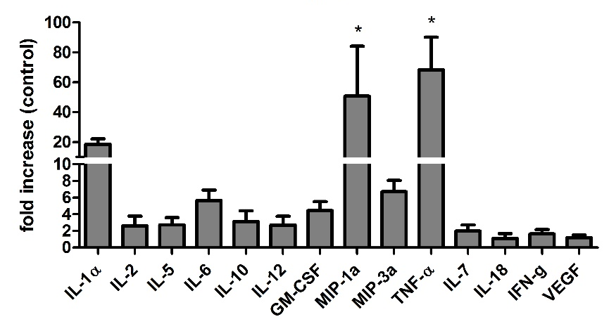
S2: Effects of the positive control LPS on cytokine expression in PCLS. To verify that PCLS are suitable for the investigation of cytokine expression, PCLS were exposed for 8 h with 100 ng/ml LPS and cytokine expression was detected by a multiplex assay. Results are shown as % of the untreated control. Data are shown as mean ± SEM. Asterisk indicate significant differences to the solvent control (*p<0.05; n=3).

