Supplementary Table 1. MRM transitions of the PFASs tested in the present study.
Name | Q1 Mass Da | Q3 Mass Da | Dwell (msec) | DP | EP | CE | CXP
¹³C₄-PFHpA | 366.9 | 321.8 | 4.0 | -55 | -10 | -12 | -55
¹³C₄-PFOA | 416.9 | 371.9 | 4.0 | -40 | -15 | -24 | -19
¹³C₅-PFNA | 468.0 | 423.0 | 4.0 | -75 | -10 | -16 | -27
¹³C₂-PFDA | 515.0 | 470.0 | 4.0 | -65 | -10 | -16 | -31
¹³C₃-PFBS | 301.9 | 79.9 | 4.0 | -90 | -10 | -65 | -21
¹⁸O₂-PFHxS | 403.0 | 84.0 | 4.0 | -30 | -10 | -40 | -8
¹³C₄-PFOS | 502.9 | 99.0 | 4.0 | -80 | -5 | -34 | -7
PFHpA | 362.9 | 318.9 | 4.0 | -55 | -10 | -12 | -55
PFHpA | 362.9 | 169.0 | 4.0 | -55 | -10 | -24 | -11
PFOA | 412.9 | 369.1 | 4.0 | -40 | -10 | -14 | -11
PFOA | 412.9 | 169.0 | 4.0 | -40 | -15 | -24 | -19
PFNA | 462.9 | 419.1 | 4.0 | -75 | -10 | -16 | -27
PFNA | 462.9 | 169.0 | 4.0 | -75 | -10 | -26 | -11
PFDA | 512.9 | 469.0 | 4.0 | -65 | -10 | -16 | -31
PFDA | 512.9 | 219.0 | 4.0 | -65 | -10 | -26 | -13
PFBS | 298.9 | 79.9 | 4.0 | -90 | -10 | -75 | -21
PFBS | 298.9 | 98.9 | 4.0 | -90 | -10 | -40 | -21
PFHxS | 398.9 | 80.0 | 4.0 | -110 | -10 | -104 | -17
PFHxS | 398.9 | 98.9 | 4.0 | -110 | -10 | -42 | -15
PFOS | 498.9 | 99.0 | 4.0 | -80 | -5 | -94 | -7
PFOS | 498.9 | 80.0 | 4.0 | -80 | -5 | -100 | -11

Supplementary Table 2. RMSD analysis of docking replicates for each ligand in OAT4 and URAT1.

Protein | Ligand | RMSD (Å) pose 1 vs pose 2 | RMSD (Å) pose 1 vs pose 3
OAT4 | PFHpA | 0.003 | 0.010
OAT4 | PFOA | 0.757 | 0.026
OAT4 | PFNA | 1.329 | 0.930
OAT4 | PFDA | 0.707 | 0.200
OAT4 | PFBS | 0.054 | 0.897
OAT4 | PFHxS | 0.760 | 0.034
OAT4 | PFOS | 1.972 | 1.489
OAT4 | Prostaglandine E2 | 2.116 | 1.094
URAT1 | PFHpA | 0.007 | 0.802
URAT1 | PFOA | 0.759 | 0.010
URAT1 | PFNA | 0.707 | 1.064
URAT1 | PFDA | 0.889 | 1.414
URAT1 | PFBS | 0.901 | 0.004
URAT1 | PFHxS | 1.378 | 1.476
URAT1 | PFOS | 1.162 | 1.708
URAT1 | Uric acid | 0.001 | 0.001

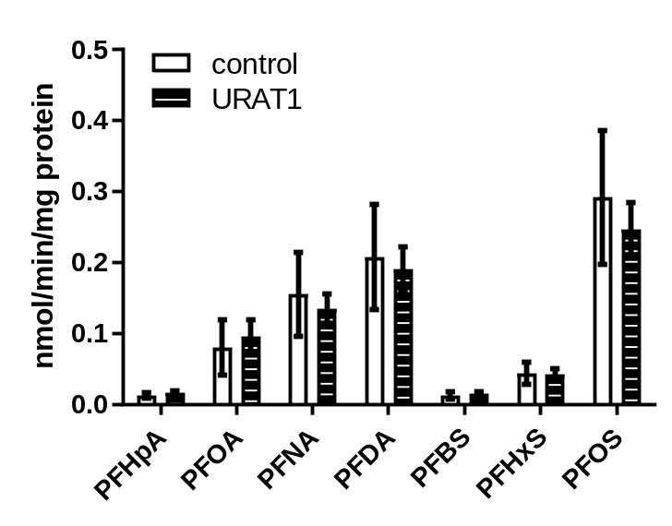

Supplementary Figure 1. Cellular PFAS levels in transporter-transfected cells (URAT1) or control-transfected cells (no transporter) upon exposure of cells to a mixture of PFASs (10 µM, for 10 minutes). Data are shown as the average (bars) and SEM (error bars) of three replicates per condition.

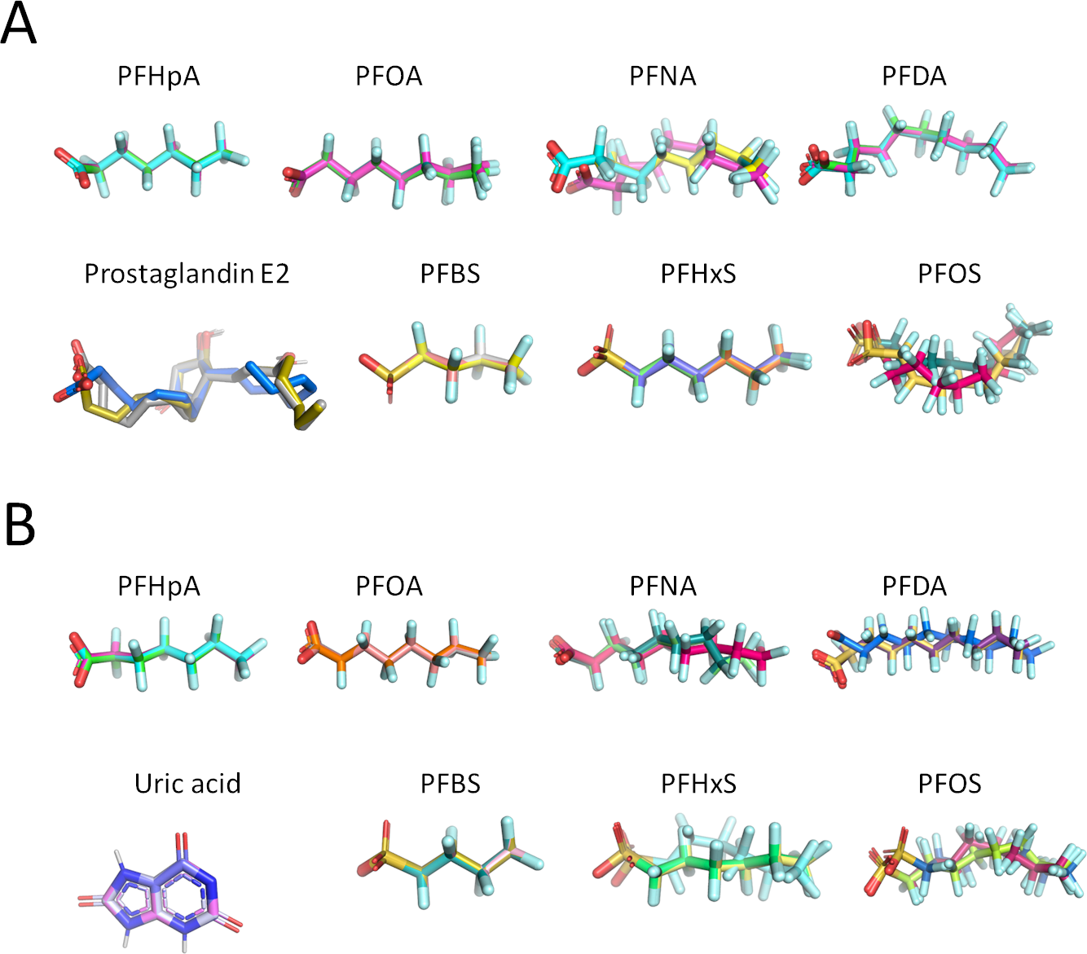

Supplementary Figure 2. Superimposition of the three docking poses calculated for each molecule under analysis within OAT4 (A) or URAT1 (B).

