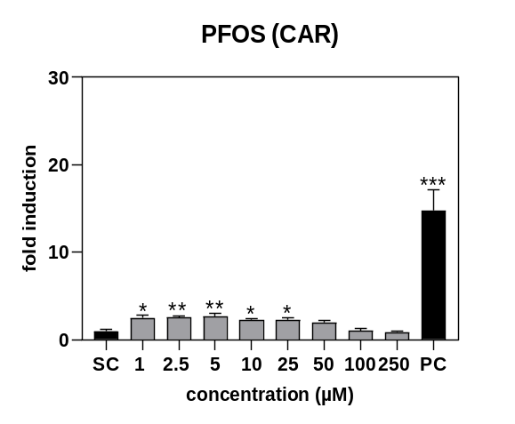
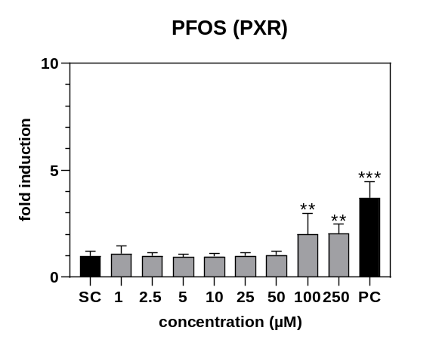
b
a

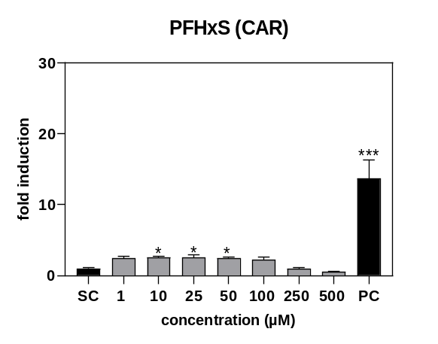
d
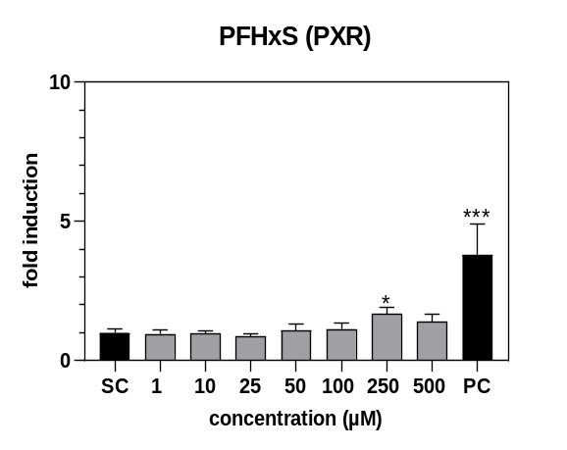
c

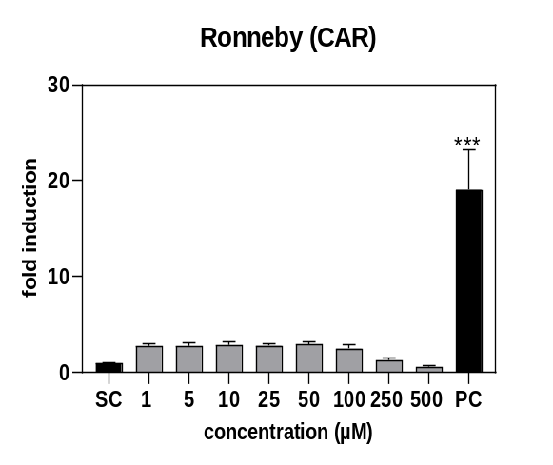
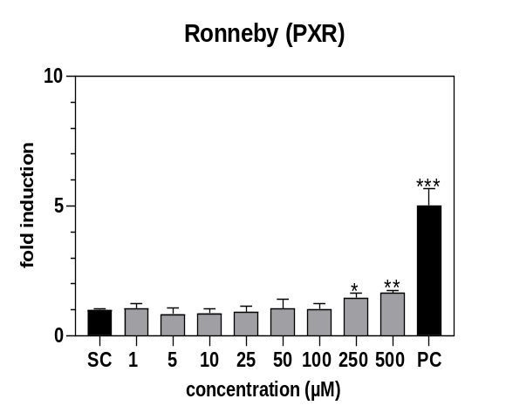
f
e

Supplementary Fig. 2: Activation of PXR and CAR nuclear receptors in HEK293T cells after 24 h incubation with different concentrations of PFOS, PFHxS, and the Ronneby mixture. PXR activation is shown in a, c and e (a: PFOS, c: PFHxS, and e: Ronneby), and CAR activation is shown in b, d and f (b: PFOS, d: PFHxS, and f: Ronneby). Nuclear receptor activation was expressed as the ratio of firefly luciferase signals normalized to Renilla luciferase signals. The positive control (PC) for PXR was 10 μM SR12813, and the PC for CAR was 10 μM CITCO. The solvent control (SC) consisted of medium with 1% DMSO. Statistical analysis was conducted using one-way ANOVA followed by Dunnett’s test (* p < 0.05, ** p < 0.01 and *** p < 0.001).

