Investigation of parenteral nutrition-induced hepatotoxicity using human liver spheroid co-cultures

Milos Mihajlovic¹, Sybren De Boever¹, Andrés Tabernilla¹, Ellen Callewaert¹, Julen Sanz-Serrano¹, Anouk Verhoeven¹, Amy Maerten¹, Zenzi Rosseel^{2,3}, Elisabeth De Waele^{3,4}, Mathieu Vinken¹

¹ Department of Pharmaceutical and Pharmacological Sciences, Vrije Universiteit Brussel, Brussels, Belgium
² Department of Pharmacy, Universitair Ziekenhuis Brussel (UZ Brussel), Brussels, Belgium
³ Department of Clinical Nutrition, Universitair Ziekenhuis Brussel (UZ Brussel), Brussels, Belgium
⁴ Faculty of Medicine and Pharmacy, Vrije Universiteit Brussel, Brussels, Belgium

Supplementary Material

Figure S1. Cycle threshold (Ct) values for HPRT1 on day 3 and day 9 of spheroid cell culture. HPRT1 expression was stable, with no significant differences between the 2 time points. Data are derived from 3 independent experiments performed in duplicate and expressed as mean ± SD. Unpaired t-test was used for statistical analysis.

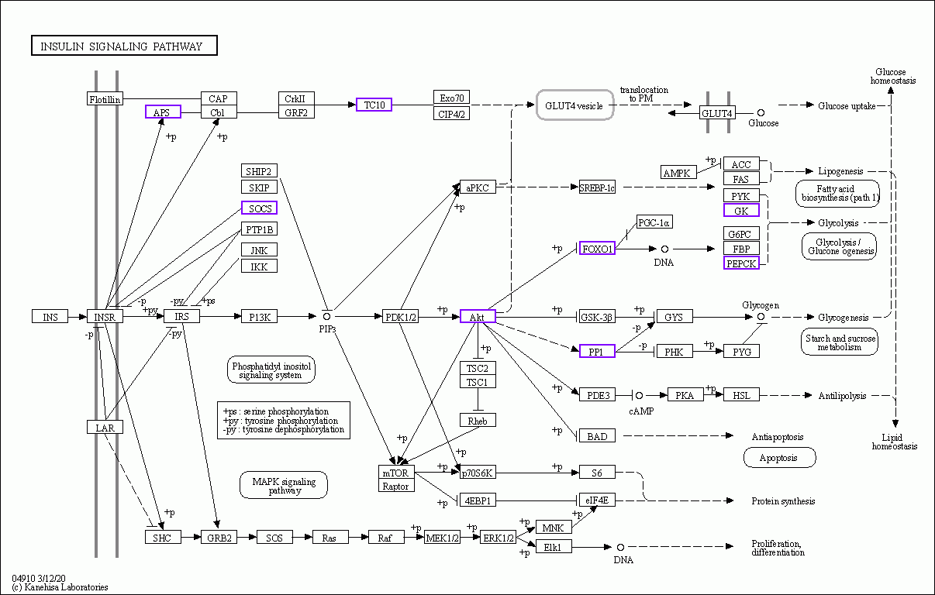
Figure S2. Schematic representation of the insulin signaling pathway (KEGG pathway map 04910) following 144 hours of exposure to TPN 1%. Differentially expressed genes are indicated in purple.

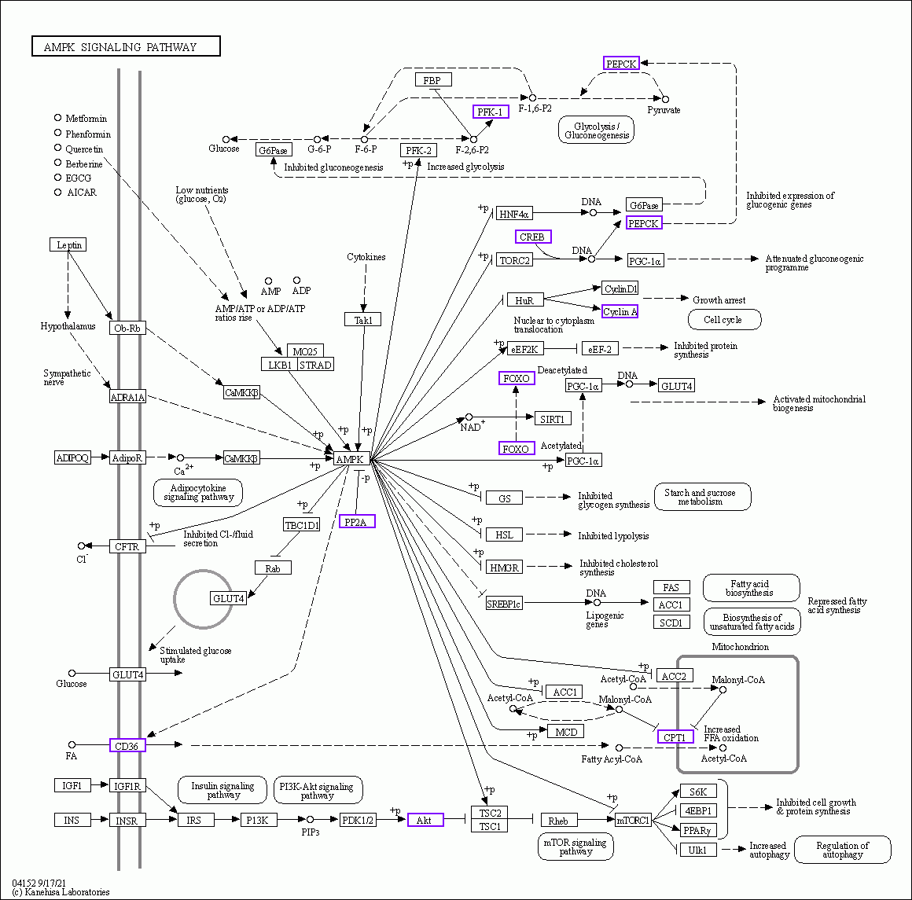
Figure S3. Schematic representation of the AMPK signaling pathway (KEGG pathway map 04152) following 144 hours of exposure to TPN 1%. Differentially expressed genes are indicated in purple.

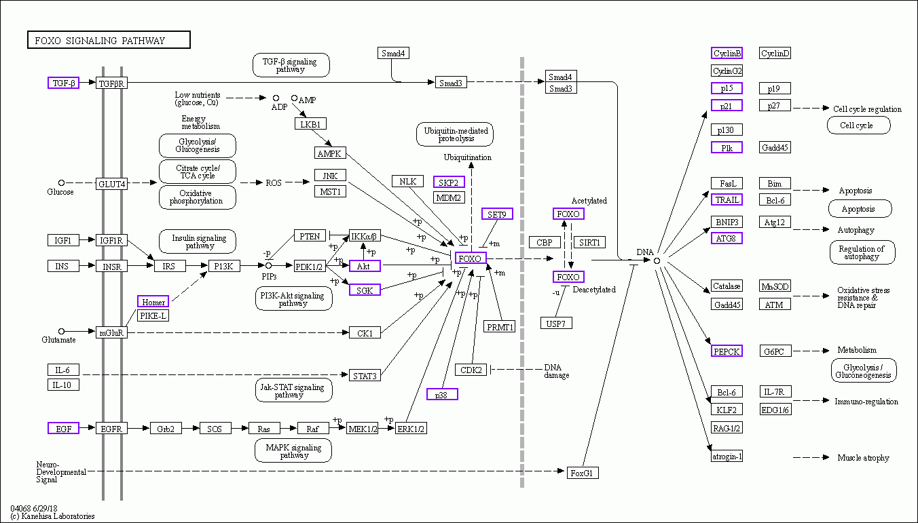

Figure S4. Schematic representation of the FoxO signaling pathway (KEGG pathway map 04068) following 144 hours of exposure to TPN 1%. Differentially expressed genes are indicated in purple.

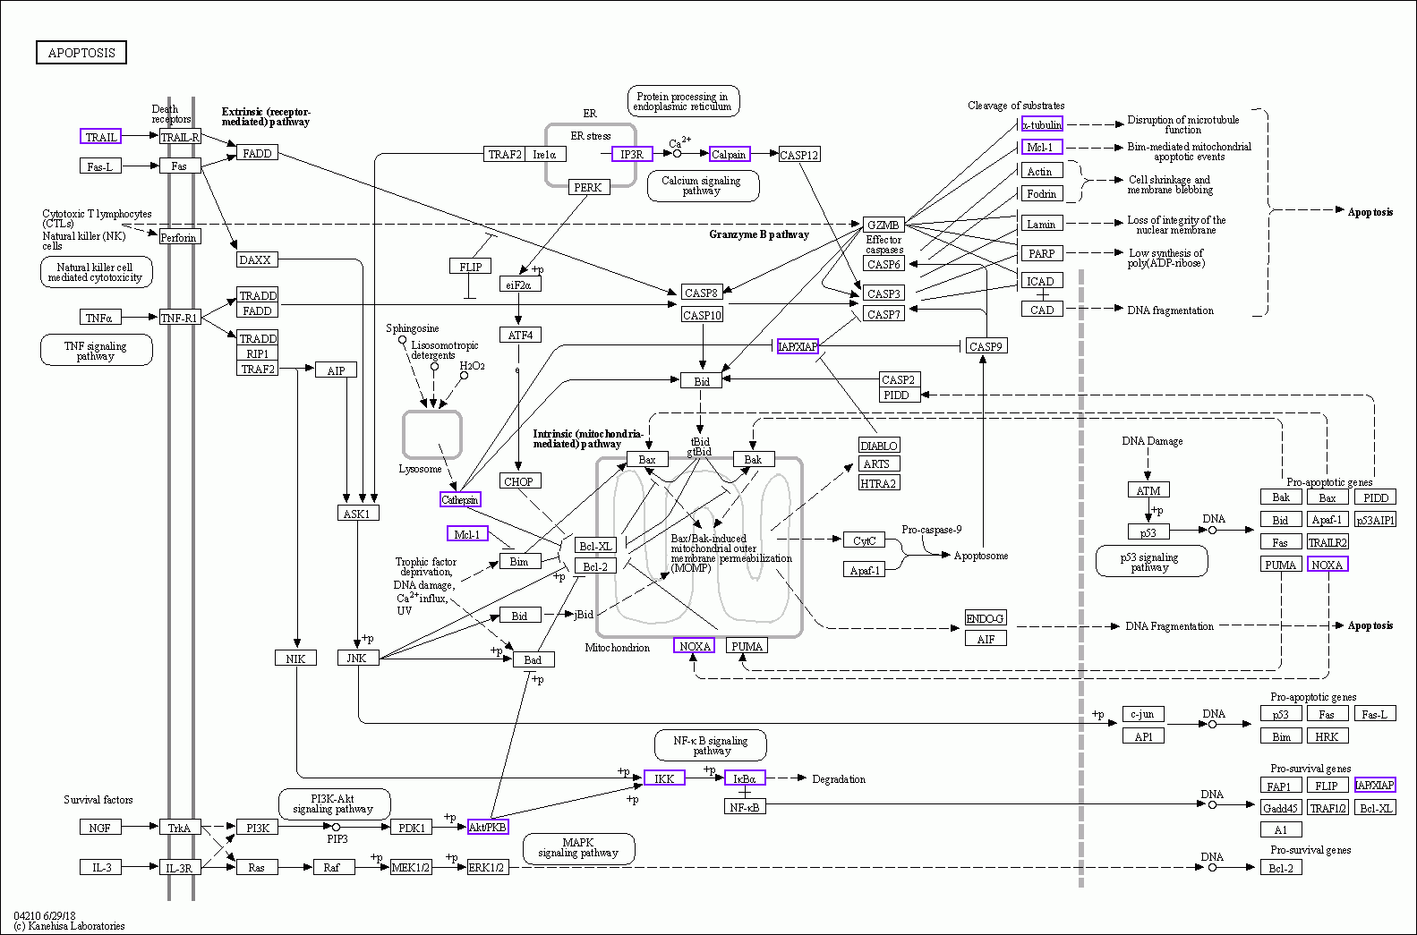
Figure S5. Schematic representation of apoptosis pathway (KEGG pathway map 04210) following 144 hours of exposure to TPN 1%. Differentially expressed genes are indicated in purple.

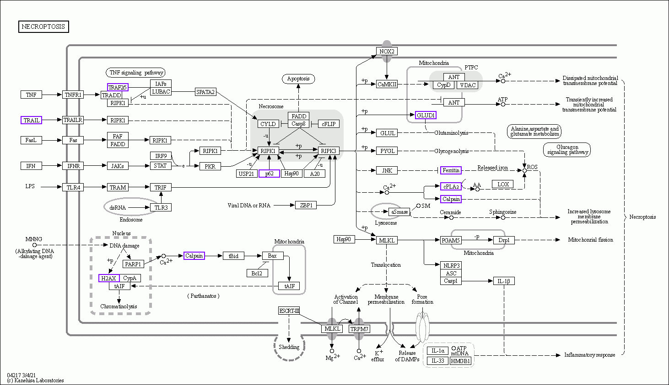
Figure S6. Schematic representation of necroptosis pathway (KEGG pathway map 04217) following 144 hours of exposure to TPN 1%. Differentially expressed genes are indicated in purple.

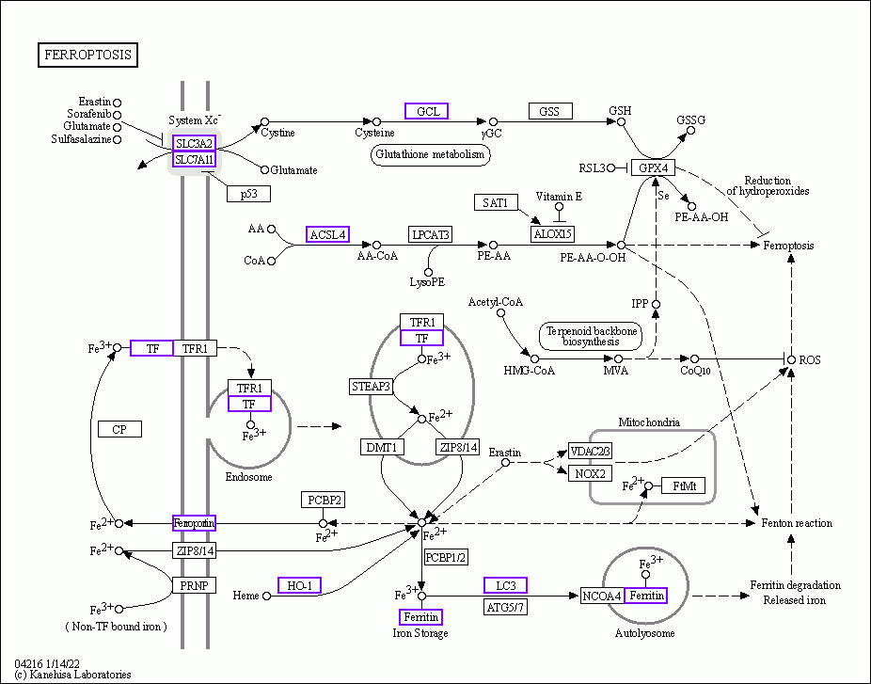
Figure S7. Schematic representation of ferroptosis pathway (KEGG pathway map 04216) following 144 hours of exposure to TPN 1%. Differentially expressed genes are indicated in purple.

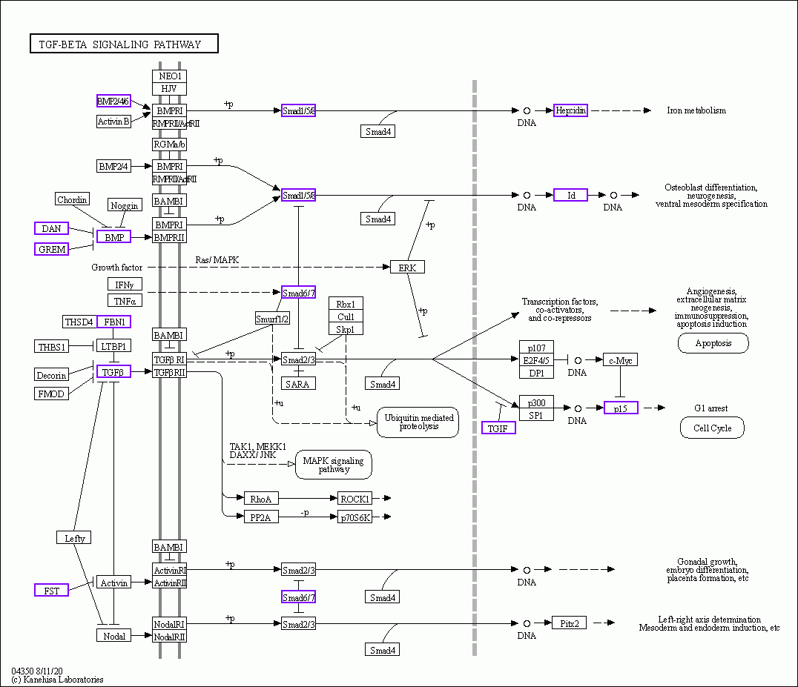
Figure S8. Schematic representation of the TGF-β signaling pathway (KEGG pathway map 04350) following 144 hours of exposure to TPN 1%. Differentially expressed genes are indicated in purple.

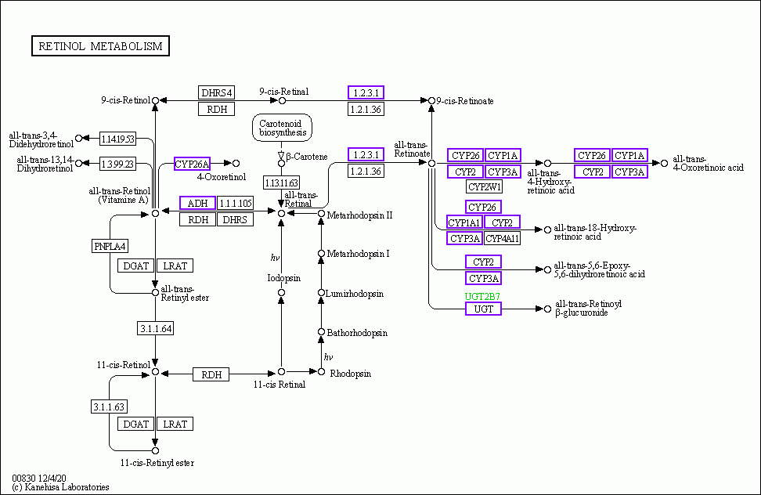
Figure S9. Schematic representation of retinol metabolism (KEGG pathway map 00830) following 144 hours of exposure to TPN 1%. Differentially expressed genes are indicated in purple.

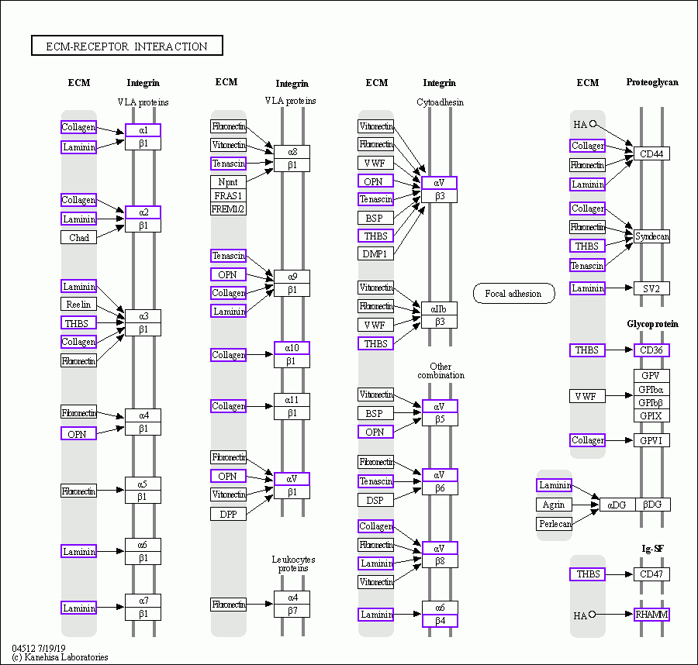
Figure S10. Schematic representation of extracellular matrix (ECM)-receptors interactions (KEGG pathway map 04512) following 144 hours of exposure to TPN 1%. Differentially expressed genes are indicated in purple.

Figure S11. The mRNA levels of nuclear receptors and transcription factors involved in molecular initiating events of steatosis, after 24 hours or 144 hours of exposure to TPN 1%. AHR - aryl hydrocarbon receptor; LXR - liver X receptor; PXR - pregnane X receptor; HNF4A - hepatocyte nuclear factor 4 alpha; NFE2L2 - nuclear factor erythroid 2-related factor 2; PPARD – peroxisome proliferator-activated receptor delta. Read count values derived from RNA sequencing analysis from 3 independent experiments are expressed as mean ± SD. Unpaired t-test was used for statistical analysis; * p < 0.05, ** p < 0.01, *** p < 0.001, **** p < 0.0001.

