Supplementary information

- LC-UV method for the quantification of formaldehyde

Supplementary Table 1 LC-UV conditions for analysis of formaldehyde after derivatisation with 2,4-dinitrophenylhydrazine (formaldehyde-2,4-dinitrophenylhydrazine).
LC instrument | Azura HPLC (Knauer)
Acquisition & data evaluation software | Chromeleon 7.2
Column | Purospher STAR RP-18 E  (150 x 3 mm, 5 µm; Merck)
Column temperature [°C] | 20
Mobile phase | H₂O + 40 mM ammonium acetate (A),  ACN (B)
Gradient | Isocratic elution (50 % A)
Flow rate [ml/min] | 0.6
Run time [min] | 20
Injection volume [µl] | 10
UV wavelength monitored  & used for data evaluation [nm] | 360

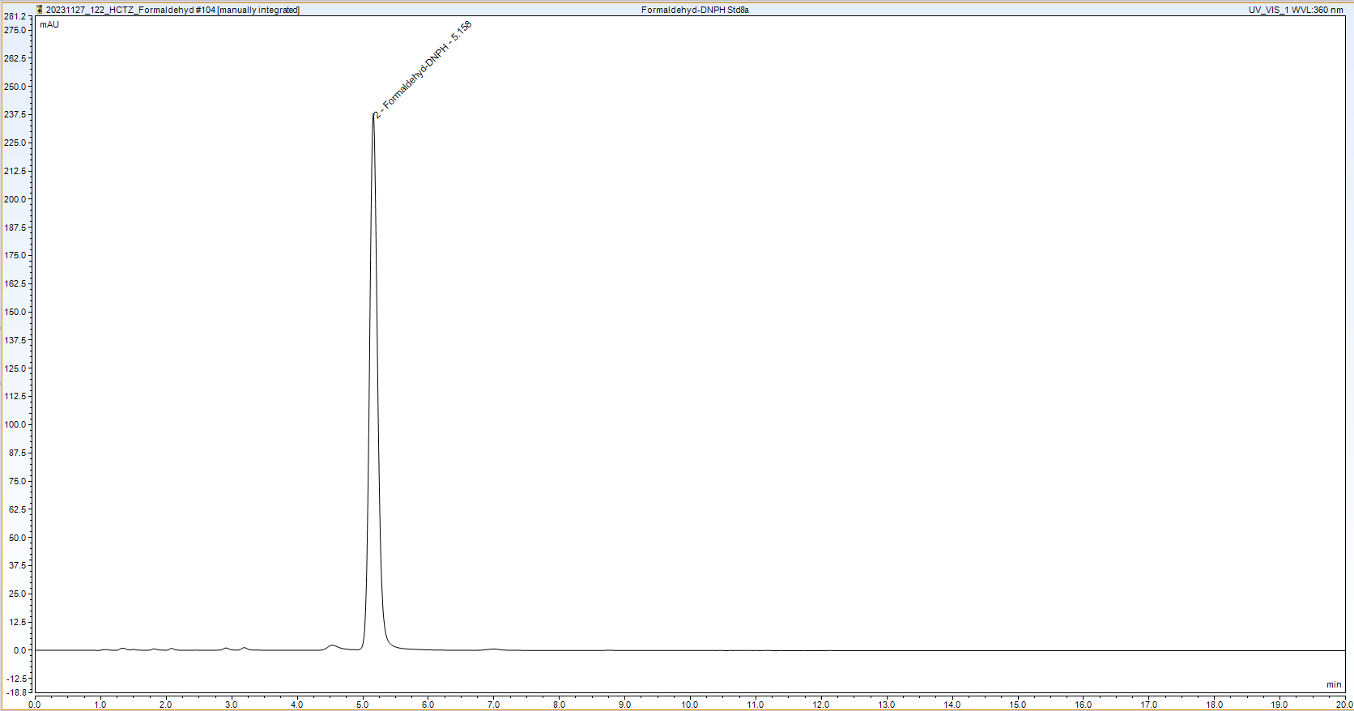
Supplementary Fig. 1 LC-UV chromatogram of a formaldehyde-2,4-dinitrophenylhydrazine reference standard solution acquired at 360 nm (retention time for formaldehyde-2,4-dinitrophenylhydrazine: 5.16 min)
- LC-MS method for the quantification of S-(hydroxymethyl)glutathione and glutathione

Supplementary Table 2 LC-MS conditions for analysis of S-(hydroxymethyl)glutathione and glutathione.
LC instrument | Acquity UPLC (Waters)
Column | Supel Carbon LC  (100 x 3 mm, 2.7 µm; Merck)
Column temperature [°C] | 50
Mobile phase | H₂O + 0.1 % formic acid (A),  ACN + 0.1 % formic acid (B)
Gradient | Time [min] | A [%] | B [%]
Gradient | 0.00 | 95.0 | 5.0
Gradient | 2.00 | 95.0 | 5.0
Gradient | 6.00 | 87.5 | 12.5
Gradient | 6.01 | 2.0 | 98.0
Gradient | 10.00 | 2.0 | 98.0
Gradient | 10.01 | 95.0 | 5.0
Gradient | 12.00 | 95.0 | 5.0
Flow rate [ml/min] | 0.5
Injection volume [µl] | 7.5
MS instrument | LTQ XL Linear Ion Trap  (Thermo Fisher Scientific)
Acquisition & data evaluation software | LTQ Tune Plus 2.7 & Xcalibur 4.0  (Thermo Fisher Scientific)
Ionisation mode (polarity) | ESI (positive)
Acquisition mode | Full scan (m/z 150 - 400)
Heater temperature [°C] | 350
Sheath gas flow rate [arb] | 50
Aux gas flow rate [arb] | 15
Sweep gas flow rate [arb] | 10
Spray voltage [kV] | 4.0
Capillary temperature [°C] | 300
Capillary voltage [V] | 30
Tube lens voltage [V] | 130
Extracted ion chromatograms used for data evaluation | m/z 338 ± 0.5 ([M+H]⁺ for HM-GSH);  m/z 308 ± 0.5 ([M+H]⁺ for GSH)

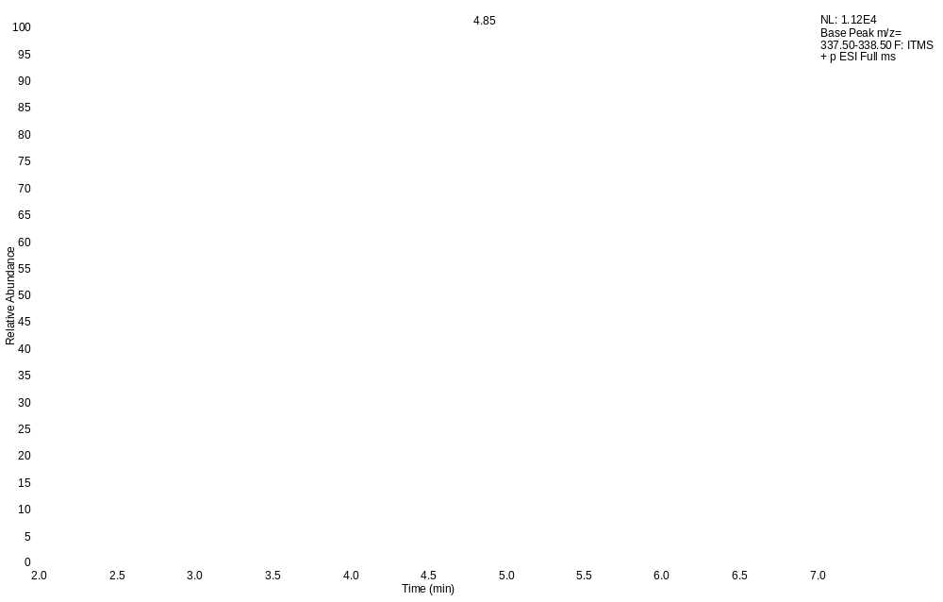
Supplementary Fig. 2 LC-ESI-MS chromatogram of an incubation sample under +S9 conditions supplemented with 10 mg of glutathione after 10 min incubation time acquired in the positive ionisation mode (XIC of m/z 338 ± 0.5, [M+H]⁺ of S-(hydroxymethyl)glutathione; retention time for S-(hydroxymethyl)glutathione: 4.85 min)
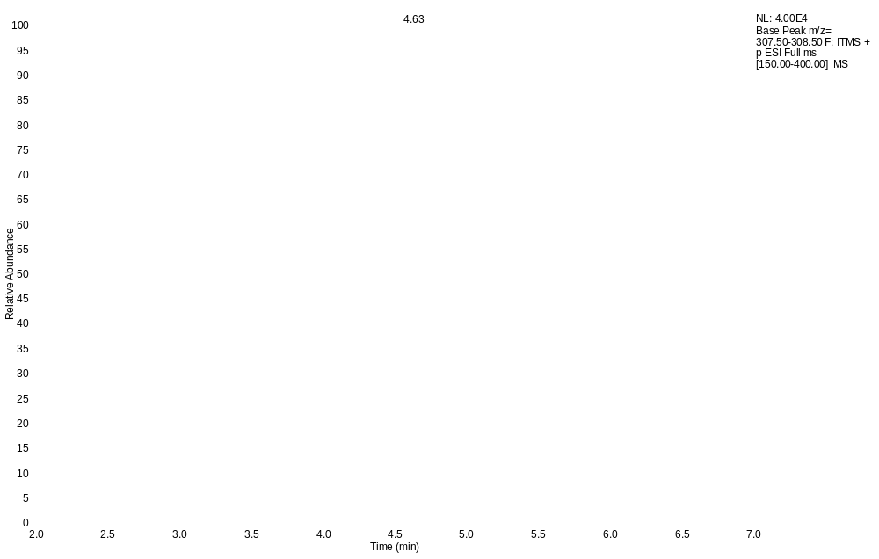
Supplementary Fig. 3 LC-ESI-MS chromatogram of a glutathione reference standard solution acquired in the positive ionisation mode (XIC of m/z 308 ± 0.5, [M+H]⁺ of glutathione; retention time for glutathione: 4.63 min)
- LC-MS method for the quantification of NO-HCTZ.
Supplementary Table 3 LC-MS conditions for analysis of NO-HCTZ.
LC instrument | Acquity UPLC (Waters)
Column | Zorbax RRHD Eclipse Plus C18  (50 x 3 mm, 1.8 µm; Agilent)
Column temperature [°C] | 50
Mobile phase | H₂O + 0.1 % formic acid (A),  ACN + 0.1 % formic acid (B)
Gradient | Time [min] | A [%] | B [%]
Gradient | 0.00 | 95.0 | 5.0
Gradient | 0.50 | 95.0 | 5.0
Gradient | 3.00 | 45.0 | 55.0
Gradient | 3.01 | 2.5 | 97.5
Gradient | 5.50 | 2.5 | 97.5
Gradient | 5.51 | 95.0 | 5.0
Gradient | 7.00 | 95.0 | 5.0
Flow rate [ml/min] | 0.5
Injection volume [µl] | 7.5
MS instrument | LTQ XL Linear Ion Trap  (Thermo Fisher Scientific)
Acquisition & data evaluation software | LTQ Tune Plus 2.7 & Xcalibur 4.0  (Thermo Fisher Scientific)
Ionisation mode (polarity) | ESI (negative)
Acquisition mode | Full scan (m/z 200 - 350)
Heater temperature [°C] | 350
Sheath gas flow rate [arb] | 50
Aux gas flow rate [arb] | 15
Sweep gas flow rate [arb] | 10
Spray voltage [kV] | 4.0
Capillary temperature [°C] | 300
Capillary voltage [V] | 30
Tube lens voltage [V] | 130
Extracted ion chromatograms used for data evaluation | m/z 325 ± 0.5 ([M-H]⁻ for NO-HCTZ)

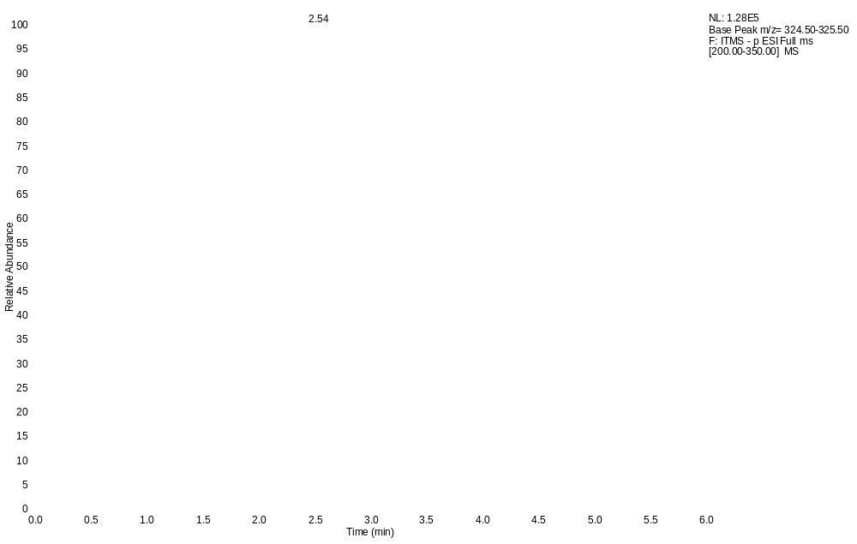
Supplementary Fig. 4 LC-ESI-MS chromatogram of a NO-HCTZ reference standard solution acquired in the negative ionisation mode (XIC of m/z 325 ± 0.5, [M-H]⁻ of NO-HCTZ; retention time for NO-HCTZ: 2.54 min).

- Example Synthesis of NO-HCTZ (Procedure 1):
Hydrochlorothiazide (100 g), acetic acid (420 g) and water (200 mL) were charged to a reactor and the contents cooled to 0-5 °C. Sodium nitrite (48.6 g, 2.1 equiv.) was dissolved in water (200 mL) and the resultant solution charged to the reactor at a rate to maintain an internal temperature of 0-5 °C. Upon completion of the charge, the temperature was adjusted to 15-25 °C and the mixture was stirred for 16 hours. The mixture was filtered to obtain crude wet N-nitroso-hydrochlorothiazide (109.74 g). Crude wet N-nitroso-hydrochlorothiazide (70 g) and methanol (2100 mL) were charged to a reactor and the contents heated to 40-50 °C, stirred for 1 hour then cooled to 20-30 °C. Water (2100 mL) was charged to the reactor and the resultant mixture stirred for 16 hours at 20-30 °C. The mixture was filtered and the solid washed with water. The wet solid was dried in vacuo at 45 °C for 20 hours to obtain N-nitroso-hydrochlorothiazide (51.9 g). Assay by ¹H qNMR was determined to be 95.9 %w/w using 2,3,5,6-tetrachloronitrobenzene as internal standard and acetonitrile-d₃ as the solvent.
¹H NMR (500 MHz, DMSO-d₆, ppm): δ 8.9 (br s, 1H), 8.4 (s, 1H), 8.3 (s, 1H), 8.0 (br s, 2H), 5.4 (s, 2H).
¹³C NMR (126 MHz, DMSO-d₆, ppm): δ 139.1, 138.7, 135.8, 124.9, 122.9, 119.2, 54.1.
- Example Synthesis of NO-HCTZ (Procedure 2):
Synthesis was performed as previously described (Simonov et al. 2005). In short, hydrochlorothiazide (40 g) was suspended in 400 ml acetic acid. A solution of sodium nitrite (22.24 g, 2.4 equiv.) in 400 mL of water was added slowly at room temperature. After 3 hours, reaction control by HPLC indicated the reaction to be completed and the product was precipitated by adding 600 mL of water and filtered. The solid obtained was suspended in 250 mL acetonitrile and filtered again. The crude product then was dissolved in acetonitrile (1 L) and crystallised by slowly adding water (800 mL). The product was collected by filtration and dried under high vacuum to yield 18.5 g (41 %) of the product as a slightly yellow solid. Assay by ¹H qNMR was determined to be 98.2 % w/w using Ethyl 4-(dimethylamino)benzoate as internal standard and DMSO-d₆ as the solvent.
Spectral data is identical to the data shown in Procedure 1.

- Synthesis Procedure for NO-HCTZ Degradation Product, thiatriazine:
The thiatriazine degradation product was generated synthetically using a mimic of the Ames pre-incubation conditions. An example synthesis procedure is provided:
Buffer solution A: Disodium hydrogen phosphate (14.2 g, 100 mmol) was dissolved in deionised water (250 g) to give a clear and colourless solution.
Buffer solution B: Sodium dihydrogen phosphate dihydrate (3.12 g, 20.0 mmol) was dissolved in deionised water (50.0 g) to give a clear and colourless solution.
Buffer: Buffer solution A (203 mL) was added buffer solution B (47.5 mL). The pH of the resulting was found to be between 7.0 and 7.5.
Thiatriazine: N-nitroso-hydrochlorothiazide (3.34 g, 10.2 mmol) was dissolved in N,N-dimethylformamide (33 mL) and stirred at 40 °C under an inert atmosphere to give a clear bright yellow solution. Buffer solution (50 mL) was added slowly to give a turbid mixture. Deionised water (30 mL) was added to resolubilise the solids and give a homogeneous yellow solution. Buffer solution (100 mL) was added to give a clear yellow solution. The solution was stirred for 1 h to give a clear mostly colourless solution. The solution was analysed by HPLC-MS and found to contain mostly product (75area%). The reaction mixture was transferred directly to a prep LC cartridge and purified using the typical purification and isolation procedure to give HCTZ thiatriazine as a white solid (1.4 g).
- Typical Thiatriazine Purification and Isolation Procedure
Semi-preparative reversed phase chromatography and lyophilisation were used to purify and isolate the thiatriazine degradation product from the mimicked Ames pre-incubation buffer conditions. The reaction mixture was injected directly (3.5 mL portions until all material processed) onto a Waters XBridge BEH Shield RP18, 30 x 100 mm, 5 µm column using water as a mobile phase with a flow-rate of 60 mL/min. An example chromatogram is provided in Figure 5. Collected fractions were combined and lyophilised.
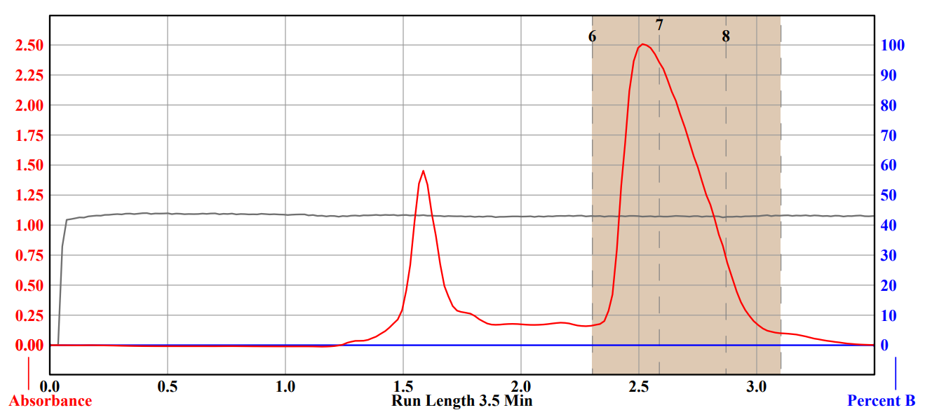
Supplementary Fig. 5 Example semi-preparative scale chromatogram from the purification and isolation of thiatriazine from the mimicked pre-incubation Ames buffer system. Red = UV trace, Blue = Gradient programme, Grey = Column pressure trace

- Thiatriazine Analysis Methods:
The analytical results provided are given from a typical batch:
- Description: White solid free from visible extraneous matter
- Identity by NMR: 1D and 2D NMR experiments were performed for characterisation, using methanol-d₄ as sample solvent. ¹H NMR (500 MHz, methanol-d₄, ppm) δ 4.8 (br s) 7.3 (s) 8.4 (s). ¹³C NMR (126 MHz, methanol-d₄, ppm) δ 121.3, 125.4, 133.1, 137.1, 142.2, 145.4.
- Residual DMF: tested by ¹H NMR, result: 0.06 %w/w
- Water content: tested by Karl Fischer titration, result: 6.1 %w/w, considered to be a mono-hydrate with 0.8 %w/w excess water
- Inorganic impurities: tested using cation chromatography with conductivity detection: sodium content of 6.9 %w/w, considered to be a mono-sodium salt with 0.1 %w/w excess sodium
- Formaldehyde content: analysis was performed using GC headspace analysis (FID detection) with derivatisation forming diethoxymethane from formaldehyde. Sample and standard solutions were prepared by dissolution in 1 % para-toluenesulfonic acid in ethanol using the headspace oven to facilitate reaction (30 minutes at 70 °C) prior to GC injection. Result: 0.03 %w/w.
- Chromatographic purity: analysis was performed using reversed phase UHPLC. The chromatographic method parameters used for purity/impurity determination are provided in Table 4. Total organic impurities content was determined to be 3.3 %. Four of the impurities were observed at greater than 0.1 % and were determined to be present at 1.9, 0.17, 0.76 and 0.23 area%.
- Impurity identification: Negative ion high-resolution mass spectrometry and CID-MS-MS were used to tentatively identify the impurities observed within the sample. The impurity present at 0.76 % was proposed to be 4-chloro-2-formamido-5-sulfamoylbenzene-1-sulfonic acid, however, other structures with the aldehyde group in different positions could be consistent with the acquired CID-MS/MS spectrum. Furthermore, a structure with a hydroxyl group and a N-(dioxo-λ6-sulfanyl)formamide moiety could plausibly explain this data. The impurity at 1.9 % was proposed to be 2-amino-4-chloro-5-sulfamoylbenzene-1-sulfonic acid based on the consistency of the CID-MS/MS spectrum with that of the deprotonated proposed structure.

Supplementary Table 4 LC conditions used for the purity/impurity analysis of the NO-HCTZ thiatriazine degradation product.
LC instrument | Acquity UPLC (Waters)
Column | Acquity BEH Phenyl  (50 x 2.1 mm, 1.7 µm; Waters)
Column temperature [°C] | 40
Mobile phase | H₂O (A),  ACN (B),  0.25 M ammonium acetate in water (C)
Gradient | Time [min] | A [%] | B [%] | C [%]
Gradient | 0.00 | 90.0 | 5.0 | 5
Gradient | 3.40 | 5.0 | 90.0 | 5
Gradient | 3.80 | 5.0 | 90.0 | 5
Gradient | 3.90 | 90.0 | 5.0 | 5
Gradient | 5.20 | 90.0 | 5.0 | 5
Flow rate [ml/min] | 0.7
Injection volume [µl] | 0.5
Sample Solution Preparation | 1 mg/mL in water
UV wavelength monitored  & used for data evaluation [nm] | 254

- Ames testing

Chemicals & Reagents
Supplementary Table 5 Solvents
Chemical | CAS | Purity | Supplier | Product code
Dimethyl sulphoxide  (DMSO) | 67-68-5 | ≥99.7% | Honeywell | 41640
Dimethylformamide  (DMF) | 68-12-2 | 99.8% | Sigma Aldrich | 227056
Phosphate buffered saline  (PBS), tablets dissolved in Type 2 water | Not applicable | Not applicable | Calbiochem | 524650-1EA
Type 1 water (ultrapure, resistivity at 25°C of >18 MΩ) Type 2 water (resistivity of 1 to 15 MΩ) prepared with the Avidity water purification system
Supplementary Table 6 Positive controls.
Chemical | Solvent | CAS | Purity | Supplier | Product code | Strain | S9 | Dose  µg/plate
2-Aminoanthracene  (2AA) | DMSO | 613-13-8 | 96 % | Sigma Aldrich | A38800 | TA1535 | + | 2
2AA | DMSO | 613-13-8 | 96 % | Sigma Aldrich | A38800 | TA1537 | + | 2
2AA | DMSO | 613-13-8 | 96 % | Sigma Aldrich | A38800 | TA98 | + | 2
2AA | DMSO | 613-13-8 | 96 % | Sigma Aldrich | A38800 | TA100 | + | 2
2AA | DMSO | 613-13-8 | 96 % | Sigma Aldrich | A38800 | uvrA/pKM101 | + | 20
Sodium azide  (NaN₃) | Type 1 water | 26628-22-8 | ≥99.5 % | Sigma Aldrich | 71289 | TA1535 and TA100 | - | 0.5
9-Aminoacridine.HCl  (9AA.HCl) | Type 1 water | 52417-22-8 | 98 % | Sigma Aldrich | A38401 | TA1537 | - | 50
2-Nitrofluorene  (2NF) | DMSO | 607-57-8 | 98 % | Sigma Aldrich | N16754 | TA98 | - | 1
Potassium dichromate  (Cr₂K₂O₇) | Type 1 water | 7778-50-9 | 99.5 % | Thermo Fisher Scientific | 196590500 | uvrA/pKM101 | - | 0.5
Methyl methanesulphonate (MMS) | DMSO | 66-27-3 | 99 % | Sigma Aldrich | 129925 | TA1535, TA100 | - | 125, 250, 650, 1000
4-Nitroquinoline-1-oxide  (4NQO) | DMSO | 56-57-5 | ≥ 98 % | Sigma Aldrich | N8141 | uvrA/pKM101 | - | 1, 2, 5, 10

Supplementary Table 7 Other chemicals and reagents.
Chemical | CAS | Purity | Supplier | Product code
N-Nitrosodiethylamine  (NDEA) | 55-18-5 | 99.8 % | Supelco (Sigma Aldrich) | PHR2408-1G
Glutathione  (GSH) | 70-18-8 | 99.7 % | Sigma Aldrich | G6013
Formaldehyde solution | 50-00-0 | 37.2 % in water | Sigma Aldrich | F8775
Nicotinamide adenine dinucleotide phosphate, monosodium salt  (NADP) | 698999-85-8 | > 98 % | Apollo Scientific | BIB3013
Glucose-6-phosphate, monosodium salt  (G6P) | 54010-71-8 | > 99 % | Apollo Scientific | BIG5011
Magnesium chloride hexahydrate  (MgCl₂.6H₂O) | 7791-18-6 | ≥ 99 % | Sigma Aldrich | M2670
Potassium chloride  (KCl) | 7447-40-7 | ≥ 99.0 % | Sigma Aldrich | P5405
Nutrient broth no 2 | NA | NA | Oxoid via Thermo Fisher | CM0067B
L-Histidine.HCl.H₂O | 5934-29-2 | ≥ 98 % | Sigma Aldrich | H8125
Biotin | 58-85-5 | ≥ 99 % | Sigma Aldrich | B4501
Tryptophan | 73-22-3 | 99.0 to 101.0 % | Sigma Aldrich | T8941
Sodium chloride  (NaCl) | 7647-14-5 | ≥ 98 % | Sigma Aldrich | S3014
Bacto agar | NA | NA | Becton Dickinson | 214010

Bacterial strains
The bacterial strains used were Salmonella typhimurium LT2 strains TA1535, TA1537, TA98 and TA100, and Escherichia coli WP2 strain uvrA/pKM101 (Supplementary Table 8). The strains were acquired in 2013 by Gentronix Ltd, Alderley Park, from the AstraZeneca (AZ) Genetic Toxicology Department, Alderley Park, UK. AZ acquired the strains from the following sources: TA1535, TA1537 and TA100 were originally obtained in 1995 by AZ Sweden, from Professor B N Ames, Biochemistry Department, University of California, Berkeley, California, USA.; TA98 was originally obtained in 2008 by AZ Sweden, from BioReliance Corporation, Rockville, Maryland, USA.; the E. coli strain was originally obtained in 1995 by AZ Sweden, from Dr S Venitt, Institute of Cancer Research, Royal Marsden Hospital, Surrey, UK. The strains were maintained as frozen stocks and genotype confirmation checks were carried out for each experiment as described by Maron and Ames, Mortelmans and Riccio, Mortelmans and Zeiger, i.e.: absence of contamination; spontaneous revertant frequency; pre-existing revertant numbers; presence of the deep rough (rfa) marker (not WP2 uvrA/pKM101); sensitivity to UV light; presence of plasmid pKM101 (TA98, TA100 and WP2 uvrA/pKM101). Cultures used in all experiments were prepared from these bacterial strain stock samples.

Supplementary Table 8 Genotypes of bacterial strains.
Strain | Amino acid marker |  |  |  | Other relevant mutations |  | Plasmid
 | Mutation  (his or trp) | Type of mutation | Main DNA target |  | Cell wall | DNA repair
Salmonella typhimurium LT2
TA1535 | hisG46 | base pair substitution | GC |  | rfa | uvrB | none
TA1537 | hisC3076 | frameshift | GC |  | rfa | uvrB | none
TA98 | hisD3052 | frameshift | GC |  | rfa | uvrB | pKM101
TA100 | hisG46 | base pair substitution | GC |  | rfa | uvrB | pKM101
Escherichia coli WP2
WP2 uvrA/pKM101 | trpE | base pair substitution | AT |  | + | uvrA | pKM101

Ames experimental conditions
All testing was conducted using triplicate minimal glucose agar medium (Vögel-Bonner agar) plates which were prepared in-house by the Test Facility (Gentronix Ltd.). Bacteria were subcultured from ampoules of frozen stocks which were thawed and used to inoculate aliquots of nutrient broth no.2 with the addition of ampicillin at 25 µg/mL for the pKM101 plasmid-bearing strains; they were grown overnight on an orbital incubator set at 37 °C and 120 rpm for approximately 9 hours, to achieve >10⁹ cells/mL of overnight stock culture in exponential growth phase. Top agar consisted of salt agar (6 g/L Bacto agar, 5 g/L NaCl) supplemented with biotin and histidine (each at 0.05 mmol/L) for the S. typhimurium strains, and tryptophan (0.018 mmol/L) for the E. coli strain; it was maintained at approximately 50 °C on test days.
Aliquots of stock GSH dilutions were prepared and stored in an ultra-low temperature freezer (approximately -80 °C) until the day of the test when sufficient vials were removed from frozen storage, thawed and used. For treatments in the presence of S9 mix, appropriate aliquots of concentrated GSH concentration solutions (in phosphate buffer) were administered by replacing the equivalent amount of water in the S9 mix; for treatments in the absence of S9 mix, appropriate aliquots of concentrated GSH concentration solutions (in phosphate buffer) were administered by replacing the equivalent amount of phosphate buffer.

Pre-incubation test procedures
The pre-incubation test was based on the methods of Maron and Ames, 1983 (Maron and Ames 1983), Mortelmans and Riccio, 2000 (Mortelmans and Riccio 2000) Mortelmans and Zeiger, 2000 (Mortelmans and Zeiger 2000) and Venitt et al, 1984 (Venitt et al. 1984).
Aliquots (100 μL) of bacterial culture were mixed with ≤ 100 µL of: solvent (DMF or DMSO); positive control; reference item formulation dilution; or test item formulation dilution, and 500 μL of phosphate buffer (-S9 conditions) or S9 mix (+S9 conditions, either rat or hamster liver, with or without GSH) and then pre-incubated. After pre-incubation, 2 mL of molten top agar were added. The mixture was poured immediately onto minimal glucose agar plates. Plates were inverted and incubated for 3 days at 37°C.
For each experiment, dosing was completed within a maximum of 4 hours from formulating stock solutions. For dose ranges, see Supplementary Table 9.

Supplementary Table 9 Dose ranges used for Ames testing of NO-HCTZ, FA, and the thiatriazine degradation product

Figure | Doses applied (µg/plate) |  |  | Doses applied (µmol/plate)
Figure | NO-HCTZ | FA | Thiatriazine | NO-HCTZ | FA | Thiatriazine
5 | 1.6  5  16  50  160  500  1600  5000 | 1.563  3.125  6.25  12.5  25  50  100 | 1.6  5  16  50  160  500  1600  5000 | 0.0049  0.0153  0.049  0.153  0.49  1.53  4.9  15.3 | 0.052  0.104  0.208  0.416  0.833  1.67  3.33 | 0.00539  0.0169  0.0539  0.169  0.539  1.69  5.39  16.9
8b |  |  | 160  500  1600  5000 |  |  | 0.539  1.69  5.39  16.9
10, 11, Supplementary Fig. 6 | 1.6  5  16  50  160  500  1600  5000 |  |  | 0.0049  0.0153  0.049  0.153  0.49  1.53  4.9  15.3

Scoring plates
After incubation at 37 °C for 3 days, all plates were examined both macroscopically and microscopically for evidence of cytotoxicity, precipitate and any other effects relevant to the interpretation of the test. Microscopic examination was used to check the condition of the histidine/tryptophan-requiring microcolonies that constituted the background lawns. Revertant (his⁺/trp⁺) colony numbers were scored using a Sorcerer Colony Counter (Perceptive Instruments, UK). In cases where the mean incidence of revertant colonies on the solvent control plates was 20 or less (typically with strains TA1535 and TA1537), plates were scored manually.

- Ames assays conducted using higher glutathione content

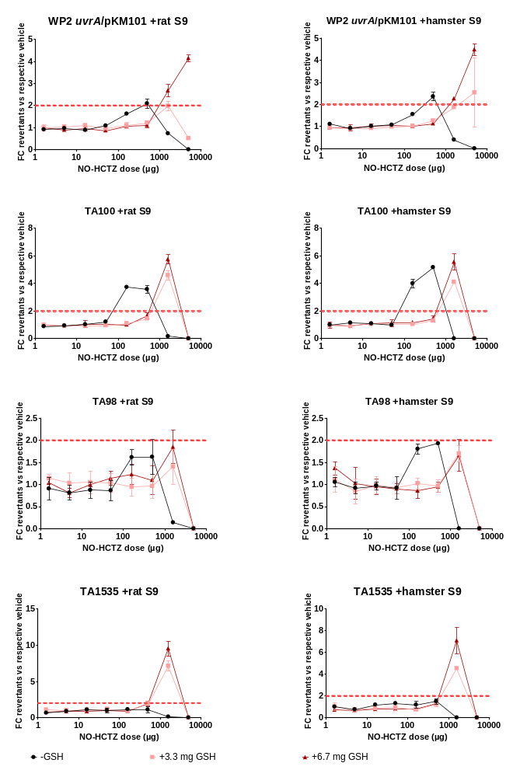
Supplementary Fig. 6 A greater mutagenic response is observed when 6.7 mg of GSH is added to the Ames test system rather than 3.3 mg in strain WP2 uvrA/pKM101 only. Ames assays were performed employing a liquid-preincubation method (60 minutes at 37 °C) in the absence and presence of phenobarbital/5,6-benzoflavone-induced rat or hamster liver S9. GSH was included or excluded as indicated at 3.3 or 6.7 mg/plate in the pre-incubation mix. The red dashed line indicates the mutagenic threshold. Error bars represent standard deviations across three technical replicates.

