Supplementary Materials
In vitro approaches to investigate the effect of chemicals on antibody production: the case study of PFASs
Martina Iulini¹, Valeria Bettinsoli^{1,2}, Ambra Maddalon¹, Valentina Galbiati^{1*}, Aafke W.F. Janssen³, Karsten Beekmann³, Giulia Russo⁴, Francesco Pappalardo⁴, Stella Fragki⁵, Alicia Paini⁵, Emanuela Corsini¹
¹Laboratory of Toxicology, Department of Pharmacological and Biomolecular Sciences “Rodolfo Paoletti”, Università degli Studi di Milano, Milan, Italy
²Department of Pharmacy, Università degli Studi di Napoli Federico II, Napoli, Italy
³Wageningen Food Safety Research (WFSR), Wageningen, The Netherlands
⁴Department of Health and Drug Sciences, Università degli Studi di Catania, Italy
⁵esqLABS GmbH, 26683 Saterland, Germany

* Corresponding Author:
Valentina Galbiati
Laboratory of Toxicology,
Department of Pharmacological and Biomolecular Sciences “Rodolfo Paoletti”
Università degli Studi di Milano
Via Balzaretti 9,
20133 Milan, Italy.
E-mail address: valentina.galbiati@unimi.it

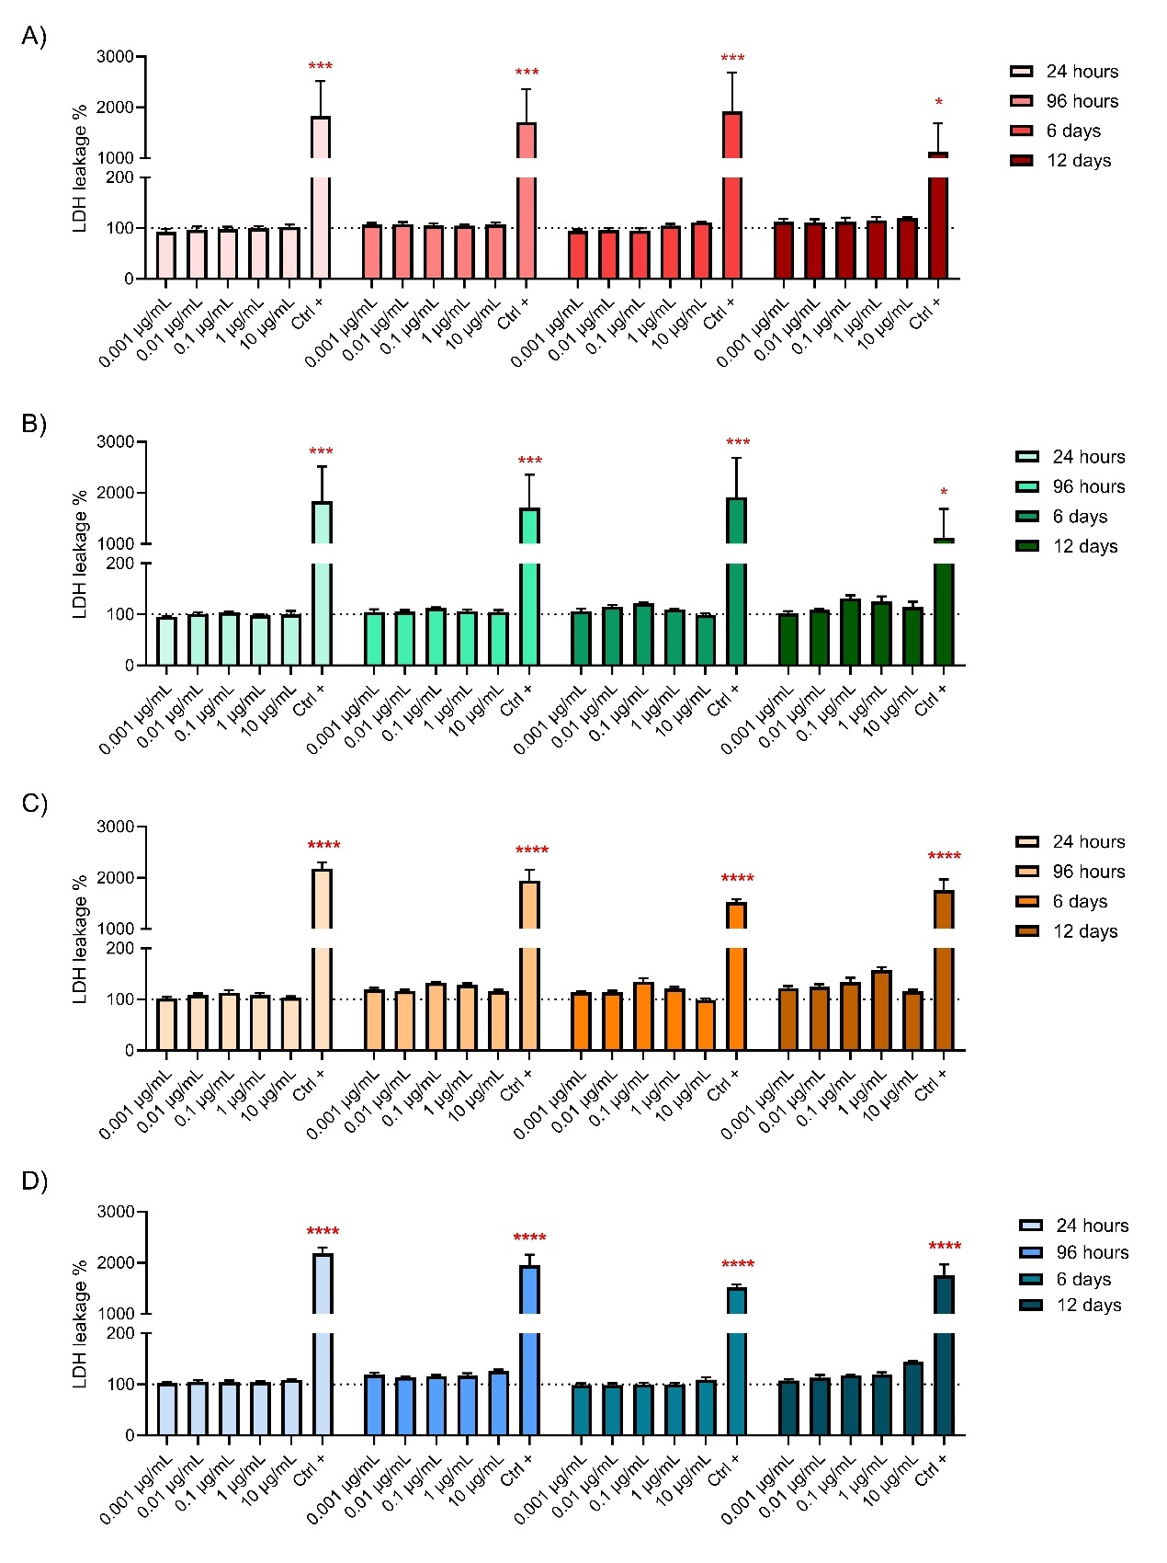
Figure 1: Effects of PFOA, PFNA, PFHxS and PFOS on cell viability. PBMCs (1x10⁶ cells/ml) were treated for 24 and 96h, 6 and 12 days with increasing concentrations of PFOA (A), PFNA (B), PFHxS (C) and PFOS (D). The Ctrl + is the LDH positive control present in the CyQUANT™ LDH Cytotoxicity Assay Kit. Results are expressed as percentage (%) of cytotoxicity. Each value represents the mean ± standard error of the mean (SEM), with n = 2 male and 2 female donors pooled together. Statistical analysis was performed using two-way ANOVA, followed by Dunnett’s test. Results were considered significant if p ≤ 0.05, with * p ≤ 0.05 and ** p ≤ 0.001 vs DMSO (represented by the dot line set at 100 %). The same figure is also reported in Corsini et al. (2024).

