Supplementary Information to the manuscript:
Deriving safe limits for N-Nitroso-bisoprolol by error-corrected Next Generation Sequencing (ecNGS) and Benchmark Dose (BMD) analysis, integrated with QM modeling and CYP docking analysis

Table of Content:
1 Table 1: List of Abbreviations 2
2 Table 2: Common beta agonists and beta blockers 4
3 Duplex Sequencing 7
3.1 Graphical presentation of individual mutation frequencies 7
3.2 Table 3: Individual mutation frequencies (Liver) 8
3.3 Table 4: Individual mutation frequencies (Bone Marrow) 9
4 Comparison of BMD approaches 10
4.1 Table 5: Summary of BMD metrics using various BMD approaches. 10
4.2 Liver, non-covariate BMD analysis with NBP 10
4.3 Bone marrow, non-covariate BMD analysis with NBP 12
4.4 Liver, covariate BMD analysis with NBP (black line) using NDEA (red line) liver in mouse as the covariate data set 13
4.5 Bone Marrow, covariate BMD analysis with NBP (red line) compared to BaP in mouse (black line) 14
5 Relationship between BMDL50 (TGR) and TD50 (Carcinogenicity) 15

Table 1: List of Abbreviations

AI | Acceptable Intake
AUC | Area Under the Curve
BMD | Benchmark Dose
BMDL₅₀, BMDU₅₀ | Lower and upper limit of the benchmark dose confidence interval with a CES of 50 %
BMR | Benchmark Response
bw | body weight
CADRE | Computer-Aided Discovery and RE-design
CDER | Center for Drug Evaluation and Research
CES | Critical Effect Size
CHD | Coronary Heart Disease
CHMP | Committee for Human Medicinal Products
CI | Confidence Interval
Cmax | Maximum serum concentration
CoC | Cohort of Concern
CPCA | Carcinogenicity Potency Categorization Approach
CPDB | Carcinogenic Potency Database
CPNP | 1-cyclopentyl-4-nitrosopiperazine
CYP | Cytochrome P450 isoenzymes
DMSO | Dimethyl sulfoxide
DNA | Desoxyribonucleic acid
DS | Duplex Sequencing
EAT | Enhanced Ames Test
ECHA | European Chemicals Agency
ecNGS | Error-corrected Next Generation Sequencing
EDF | Energy pair distributions
EMA | European Medicines Agency
ESRA | electronic-structure read-across
FDA | US Food and Drug Administration
GTTC | Genetic Toxicology Technical Committee
HA | Health Authority
HED | Human Equivalent Dose
HESI | Health and Environmental Sciences Institute
HPRT | Hypoxanthine Phosphoribosyl Transferase
ICH | International Committee of Harmonization
LCDB | Lhasa Carcinogenicity Database
LED | Lowest Effective Dose
MF | Mutation frequency
MDD | Maximum Daily Dose
MGMT | Methylguanine-methyltransferase
NA | Nitrosamine
NBP | Nitroso-bisoprolol
NcWP | Non-clinical Working Party
NDEA | Nitroso-diethylamine
NDELA | Nitroso-diethanolamine
NDMA | Nitroso-dimethylamine
NDSRI | Nitrosamine drug substance-related impurity
NMP | N-Methylpyrrolidone
NMOR | N-Nitrosomorpholine
NMRI | Naval Medical Research Institute. The NMRI mouse is a standard mouse strain frequently used in many fields of research, such as pharmacology and toxicology.
NNK | Nicotine derived nitrosamine ketone or 4-(methylnitrosamino)-1-(3-pyridyl)-1-butanone
NO(A)EL | No Observed (Adverse) Effect Level
NPIP | N-Nitrosopiperidine
NPYR | N-Nitrosopyrrolidine
OECD | Organization of Economic Cooperation and Development
PDE | Permitted Daily Exposure
PoD | Point of Departure
QM/MM | Quantum mechanics/molecular mechanics
SAR | Structure-activity-relationship
SAVA | solvent-accessible volume area
TD₅₀ | Tumor dose 50 – the daily dose causing tumors in 50% of animals in a lifetime bioassay
TGR | Transgenic Rodent Assay
Tmax | Time point at which the maximum serum concentration is reached
TTC | Threshold of Toxicological Concern
WHO | World Health Organization

Table 2: Common beta agonists and beta blockers

Table 1: Common beta agonists and beta blockers
API | MOA | NDSRI | EMA | FDA | CPCA
Acebutolol | β₁-blocker | 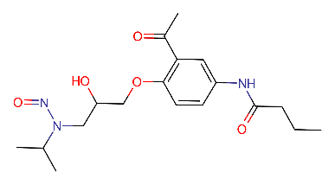 | x | x | 4
Albuterol / Salbutamol | β₂-agonist | 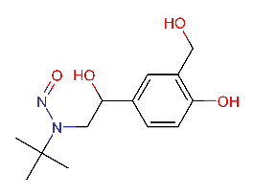 | - | x | 5
Arformoterol  Formoterol | β₂-agonist | 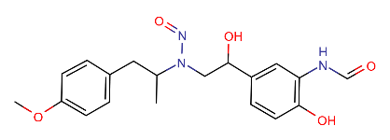 | - | x | 4
Atenolol | β₁-blocker | 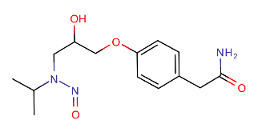 | x | x | 4
Betaxolol | β₁-blocker | 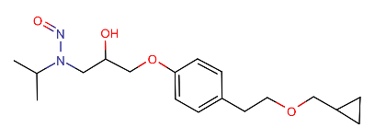 | x | x | 4
Bisoprolol | β₁-blocker | 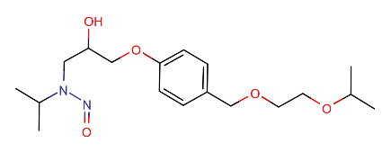 | x | x | 4
Celiprolol | β₁-blocker  β₂-agonist | 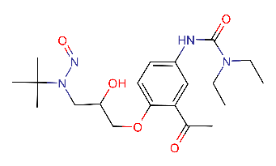 | x | - | 5
Cardevilol | Nonselective  β-blocker | 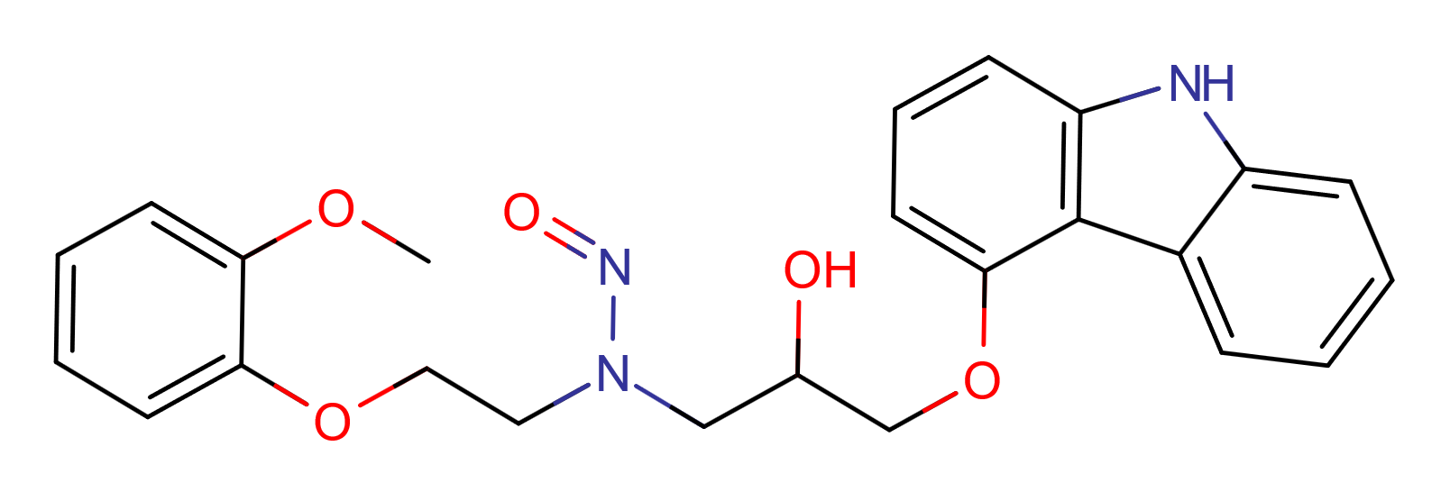 | - | x | 3
Carteolol | β₁-blocker | 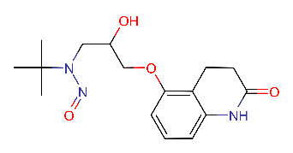 | - | x | 5
Esmolol | β₁-blocker | 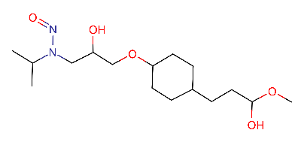 | x | x | 4
Isoproterenol | β₁-agonist  β₂-agonist | 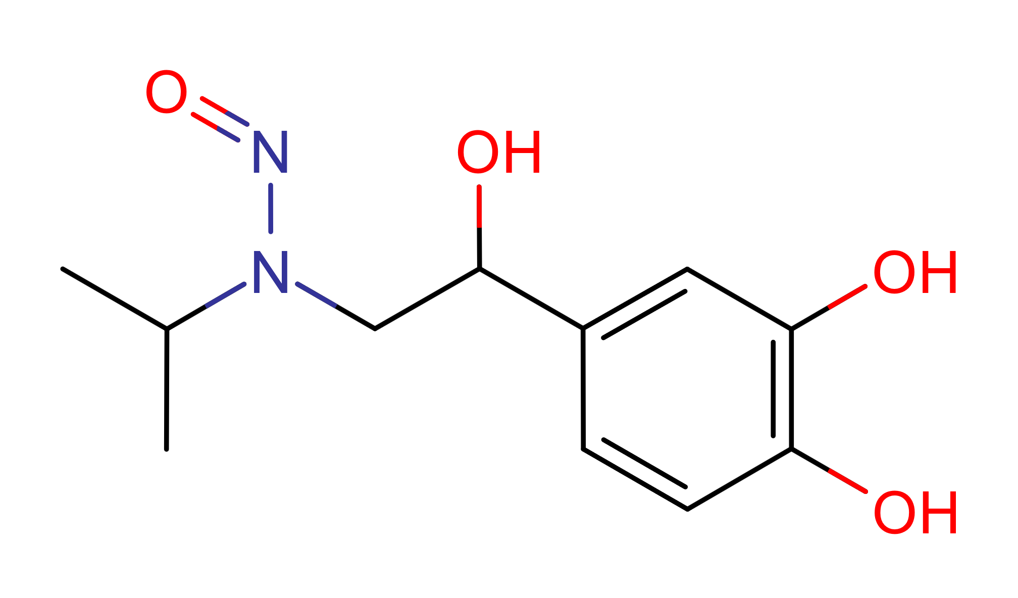 | - | x | 4
Labetalol | Nonselective  β-blocker  α₁-blocker | 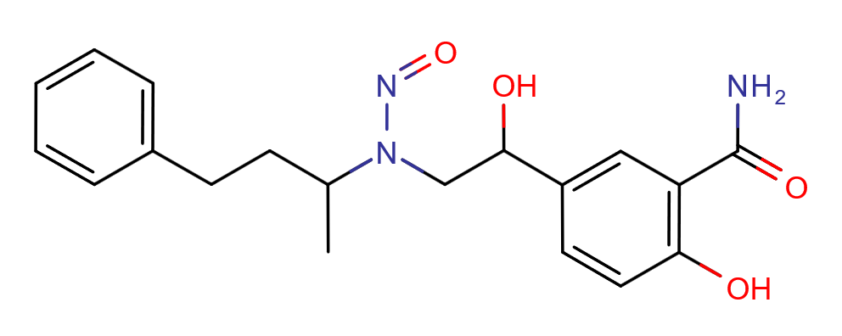 | x | x | 4
Landiolol | β₁-blocker | 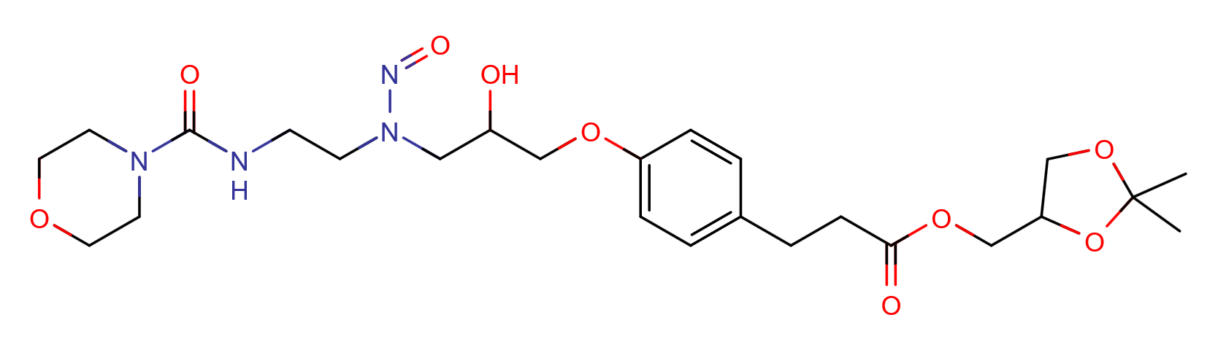 | x | - | 3
Levalbuterol | β₂-agonist | 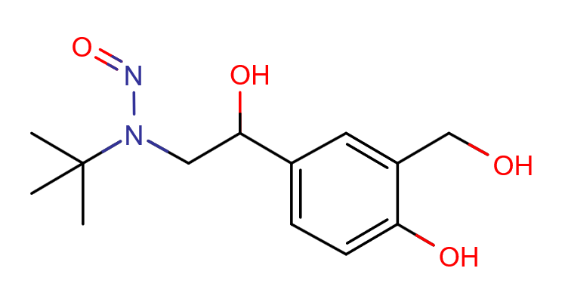 | - | x | 5
Levobunolol | Nonselective  β-blocker | 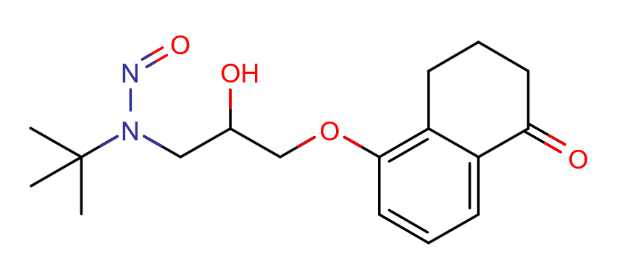 | - | x | 5
Metoprolol | β₁-blocker | 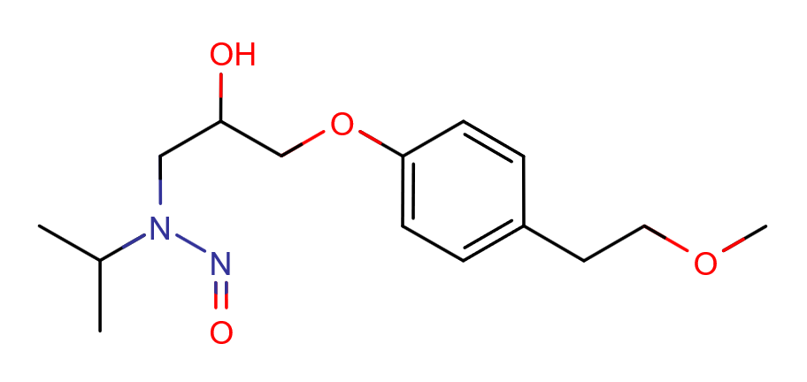 | x | x | 4
Nadolol | Nonselective  β-blocker | 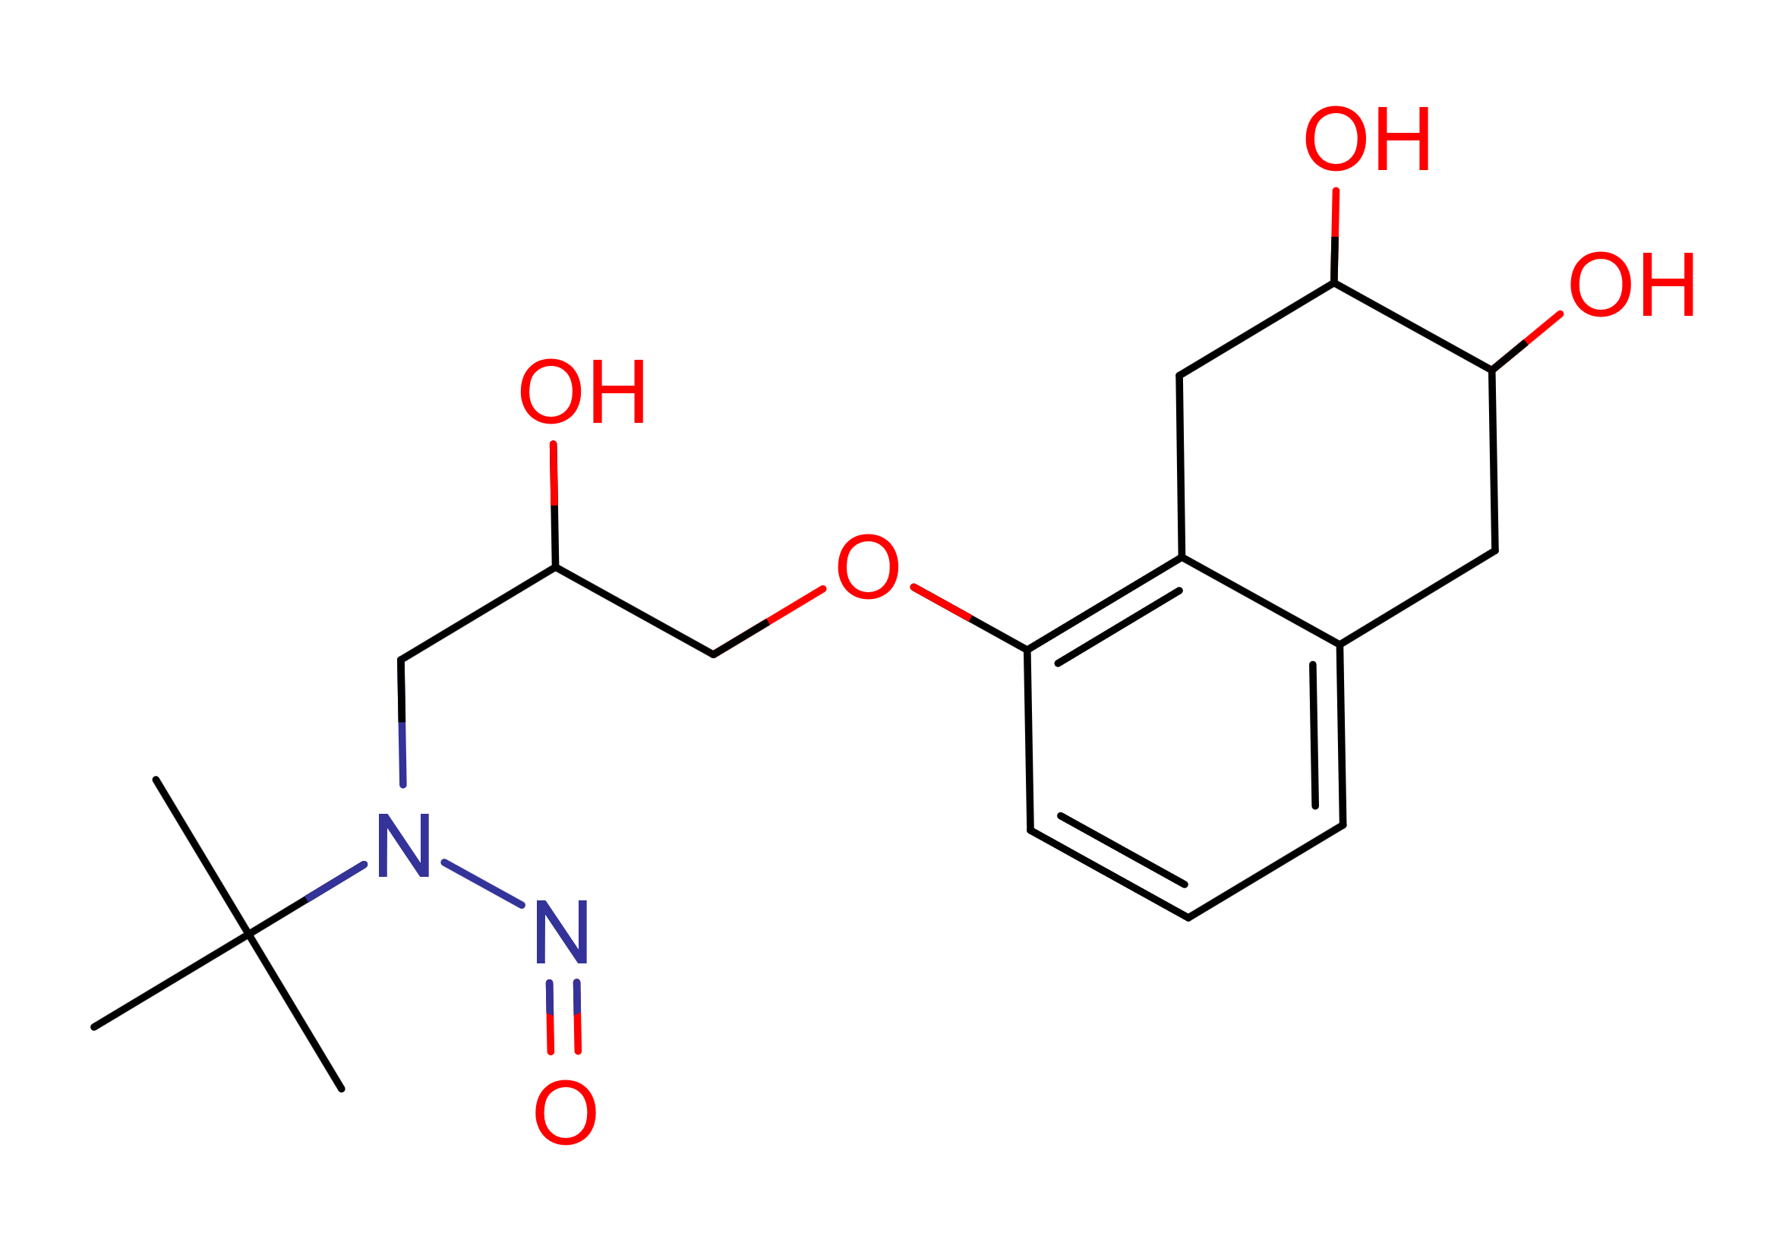 | - | x | 5
Nebivolol | β₁-blocker | 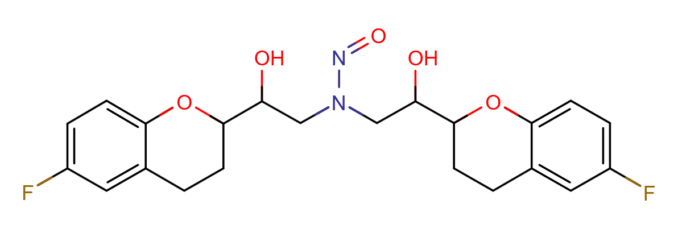 | x | x | 4
Olodaterol | β₂-agonist | 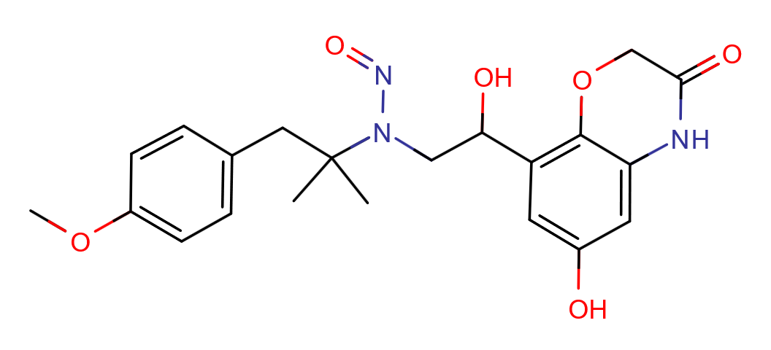 | - | x | 5
Pindolol | Nonselective  β-blocker | 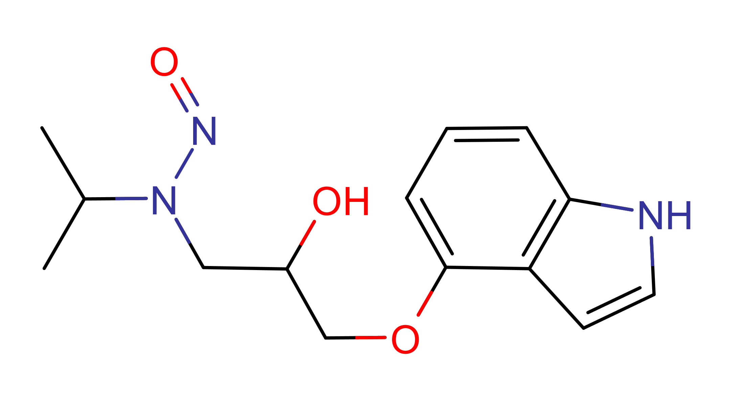 | - | x | 4
Propranolol | Nonselective  β-blocker | 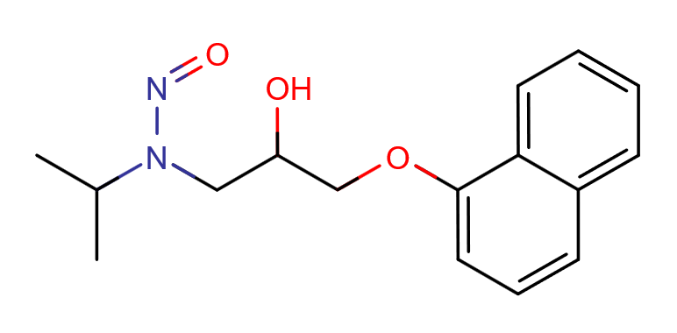 | x | x | 4
Salmeterol | β₂-agonist | 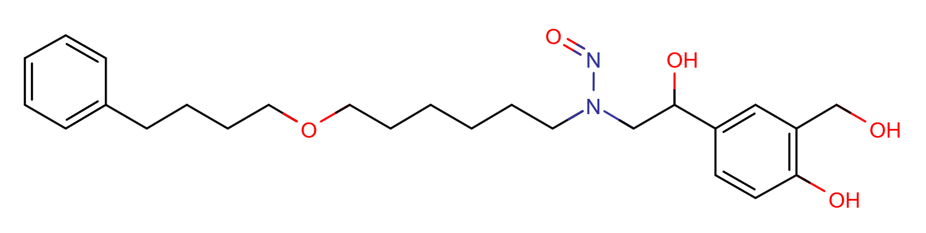 | - | x | 3
Sotalol | Nonselective  β-blocker | 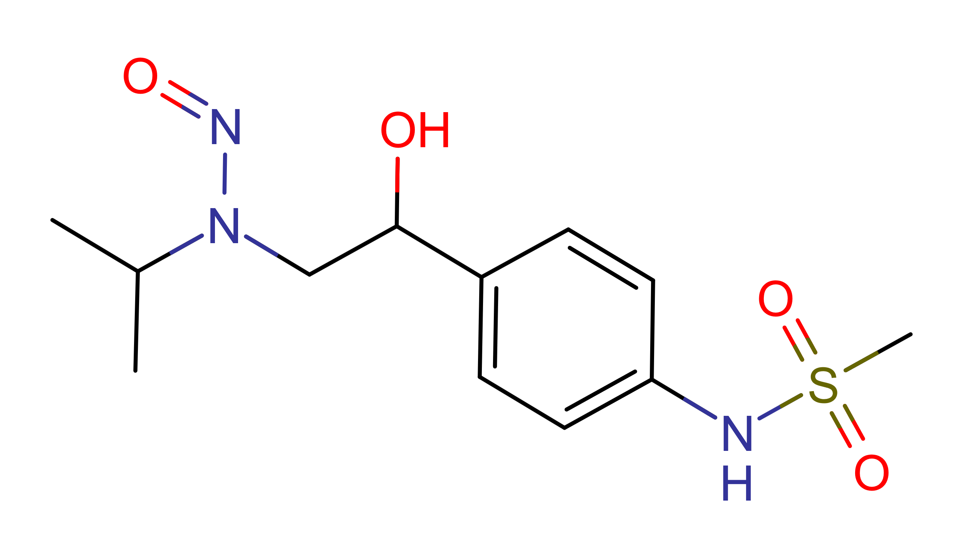 | x | x | 4
Timolol | Nonselective  β-blocker | 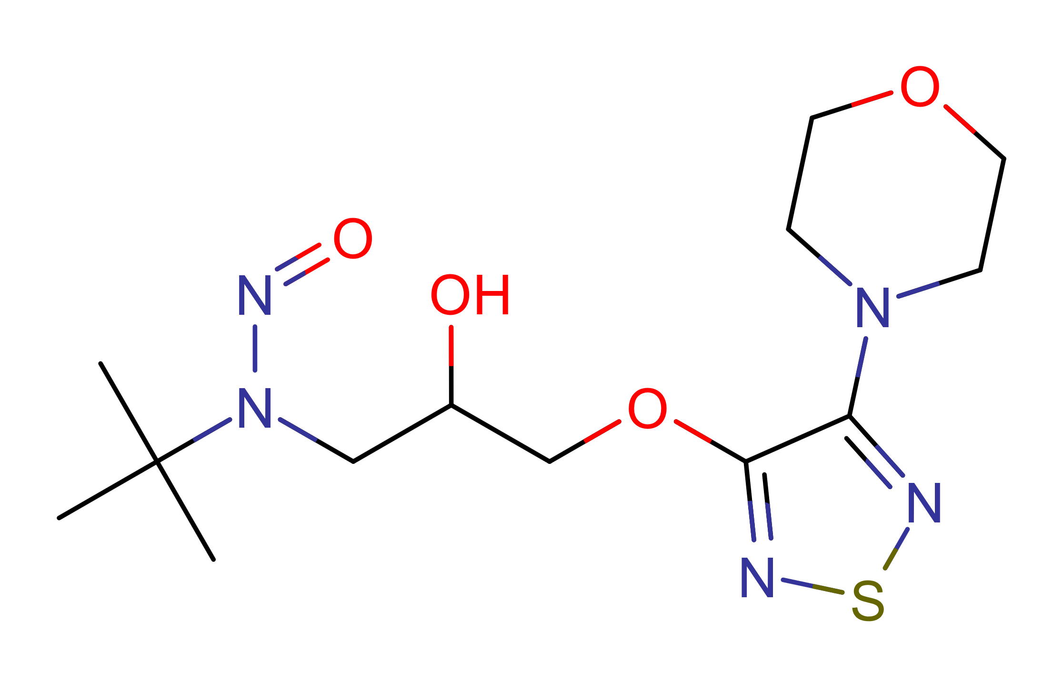 | - | x | 5
Vilanterol | β₂-agonist | 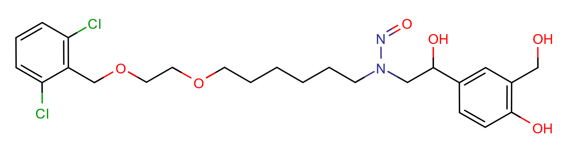 | - | x | 3

Duplex Sequencing

Graphical presentation of individual mutation frequencies
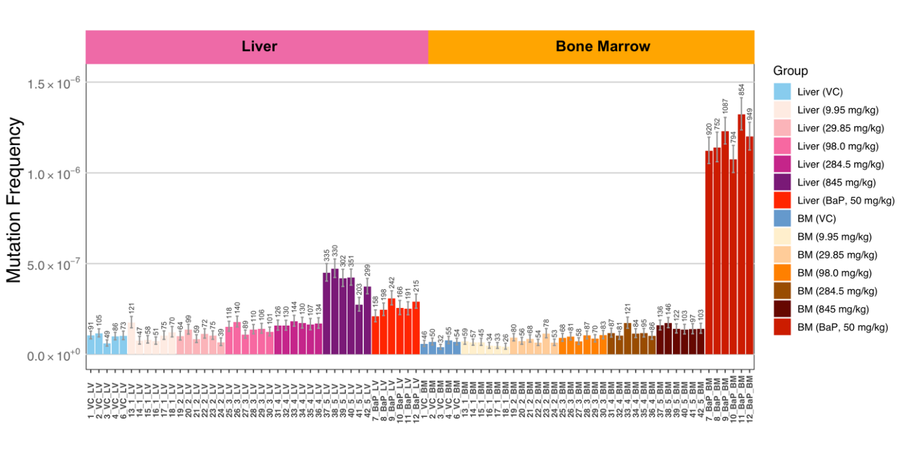Figure 1: Mutation frequency by sample. Bar chart representing sample mutation frequency calculated using the min method. Numbers above bars are the number of unique mutations included in the mutation frequency calculation for that sample. Error bars represent 95% binomial proportion Wilson score intervals calculated using the mutation frequency data. Bars are colored by treatment group and tissue. LV = Liver; BM = Bone Marrow.

Table 3: Individual mutation frequencies (Liver)
Dose | Total Duplex Bases | Total Mutant Duplex Bases | Mutation Frequency (MF) | MF Lower CI (95%) | MF Upper CI (95%)
Vehicle Control (VC) | 869086732 | 91 | 1.05E-07 | 8.53E-08 | 1.29E-07
Vehicle Control (VC) | 903333269 | 105 | 1.16E-07 | 9.60E-08 | 1.41E-07
Vehicle Control (VC) | 813952167 | 49 | 6.02E-08 | 4.55E-08 | 7.96E-08
Vehicle Control (VC) | 872074164 | 86 | 9.86E-08 | 7.99E-08 | 1.22E-07
Vehicle Control (VC) | 716509110 | 73 | 1.02E-07 | 8.10E-08 | 1.28E-07
Positive Control (BaP, 50mg/kg) | 754103148 | 158 | 2.10E-07 | 1.79E-07 | 2.45E-07
Positive Control (BaP, 50mg/kg) | 805092330 | 198 | 2.46E-07 | 2.14E-07 | 2.83E-07
Positive Control (BaP, 50mg/kg) | 783852155 | 242 | 3.09E-07 | 2.72E-07 | 3.50E-07
Positive Control (BaP, 50mg/kg) | 651156421 | 166 | 2.55E-07 | 2.19E-07 | 2.97E-07
Positive Control (BaP, 50mg/kg) | 760081492 | 191 | 2.51E-07 | 2.18E-07 | 2.90E-07
Positive Control (BaP, 50mg/kg) | 740107597 | 215 | 2.90E-07 | 2.54E-07 | 3.32E-07
NBP (9.95 mg/kg) | 692218756 | 121 | 1.75E-07 | 1.46E-07 | 2.09E-07
NBP (9.95 mg/kg) | 627260083 | 47 | 7.49E-08 | 5.64E-08 | 9.96E-08
NBP (9.95 mg/kg) | 723661816 | 58 | 8.01E-08 | 6.20E-08 | 1.04E-07
NBP (9.95 mg/kg) | 698554164 | 51 | 7.30E-08 | 5.55E-08 | 9.60E-08
NBP (9.95 mg/kg) | 727958188 | 75 | 1.03E-07 | 8.22E-08 | 1.29E-07
NBP (9.95 mg/kg) | 576490852 | 70 | 1.21E-07 | 9.61E-08 | 1.53E-07
NBP (29.85 mg/kg) | 636322163 | 64 | 1.01E-07 | 7.88E-08 | 1.28E-07
NBP (29.85 mg/kg) | 728556900 | 99 | 1.36E-07 | 1.12E-07 | 1.65E-07
NBP (29.85 mg/kg) | 702434865 | 59 | 8.40E-08 | 6.51E-08 | 1.08E-07
NBP (29.85 mg/kg) | 641288204 | 72 | 1.12E-07 | 8.92E-08 | 1.41E-07
NBP (29.85 mg/kg) | 724792045 | 75 | 1.03E-07 | 8.26E-08 | 1.30E-07
NBP (29.85 mg/kg) | 588103729 | 39 | 6.63E-08 | 4.85E-08 | 9.06E-08
NBP (98.0 mg/kg) | 776079924 | 118 | 1.52E-07 | 1.27E-07 | 1.82E-07
NBP (98.0 mg/kg) | 784324139 | 140 | 1.78E-07 | 1.51E-07 | 2.11E-07
NBP (98.0 mg/kg) | 814595403 | 89 | 1.09E-07 | 8.88E-08 | 1.34E-07
NBP (98.0 mg/kg) | 806304171 | 110 | 1.36E-07 | 1.13E-07 | 1.64E-07
NBP (98.0 mg/kg) | 751772355 | 106 | 1.41E-07 | 1.17E-07 | 1.71E-07
NBP (98.0 mg/kg) | 817201250 | 101 | 1.24E-07 | 1.02E-07 | 1.50E-07
NBP (284.5 mg/kg) | 794941742 | 126 | 1.59E-07 | 1.33E-07 | 1.89E-07
NBP (284.5 mg/kg) | 822777998 | 130 | 1.58E-07 | 1.33E-07 | 1.88E-07
NBP (284.5 mg/kg) | 788402342 | 144 | 1.83E-07 | 1.55E-07 | 2.15E-07
NBP (284.5 mg/kg) | 755864354 | 130 | 1.72E-07 | 1.45E-07 | 2.04E-07
NBP (284.5 mg/kg) | 654448456 | 107 | 1.63E-07 | 1.35E-07 | 1.98E-07
NBP (284.5 mg/kg) | 786998006 | 134 | 1.70E-07 | 1.44E-07 | 2.02E-07
NBP (845 mg/kg) | 745557291 | 335 | 4.49E-07 | 4.04E-07 | 5.00E-07
NBP (845 mg/kg) | 699405051 | 330 | 4.72E-07 | 4.24E-07 | 5.26E-07
NBP (845 mg/kg) | 721333430 | 302 | 4.19E-07 | 3.74E-07 | 4.69E-07
NBP (845 mg/kg) | 829575039 | 351 | 4.23E-07 | 3.81E-07 | 4.70E-07
NBP (845 mg/kg) | 742011402 | 203 | 2.74E-07 | 2.38E-07 | 3.14E-07
NBP (845 mg/kg) | 800183874 | 299 | 3.74E-07 | 3.34E-07 | 4.18E-07

Table 4: Individual mutation frequencies (Bone Marrow)
Dose | Total Duplex Bases | Total Mutant Duplex Bases | Mutation Frequency (MF) | MF Lower CI (95%) | MF Upper CI (95%)
Vehicle Control (VC) | 796476813 | 46 | 5.78E-08 | 4.33E-08 | 7.70E-08
Vehicle Control (VC) | 736274037 | 50 | 6.79E-08 | 5.15E-08 | 8.95E-08
Vehicle Control (VC) | 823601045 | 32 | 3.89E-08 | 2.75E-08 | 5.48E-08
Vehicle Control (VC) | 720608232 | 55 | 7.63E-08 | 5.86E-08 | 9.93E-08
Vehicle Control (VC) | 792922245 | 54 | 6.81E-08 | 5.22E-08 | 8.88E-08
Positive Control (BaP, 50mg/kg) | 820200346 | 920 | 1.12E-06 | 1.05E-06 | 1.20E-06
Positive Control (BaP, 50mg/kg) | 659657387 | 752 | 1.14E-06 | 1.06E-06 | 1.22E-06
Positive Control (BaP, 50mg/kg) | 883589016 | 1087 | 1.23E-06 | 1.16E-06 | 1.31E-06
Positive Control (BaP, 50mg/kg) | 739203226 | 794 | 1.07E-06 | 1.00E-06 | 1.15E-06
Positive Control (BaP, 50mg/kg) | 645810095 | 854 | 1.32E-06 | 1.24E-06 | 1.41E-06
Positive Control (BaP, 50mg/kg) | 790880394 | 949 | 1.20E-06 | 1.13E-06 | 1.28E-06
NBP (9.95 mg/kg) | 823866178 | 59 | 7.16E-08 | 5.55E-08 | 9.24E-08
NBP (9.95 mg/kg) | 873072052 | 57 | 6.53E-08 | 5.04E-08 | 8.46E-08
NBP (9.95 mg/kg) | 679368783 | 45 | 6.62E-08 | 4.95E-08 | 8.86E-08
NBP (9.95 mg/kg) | 723394665 | 34 | 4.70E-08 | 3.36E-08 | 6.57E-08
NBP (9.95 mg/kg) | 712450053 | 33 | 4.63E-08 | 3.30E-08 | 6.50E-08
NBP (9.95 mg/kg) | 624084910 | 26 | 4.17E-08 | 2.84E-08 | 6.10E-08
NBP (29.85 mg/kg) | 868216775 | 80 | 9.21E-08 | 7.40E-08 | 1.15E-07
NBP (29.85 mg/kg) | 777464386 | 56 | 7.20E-08 | 5.55E-08 | 9.35E-08
NBP (29.85 mg/kg) | 798272097 | 68 | 8.52E-08 | 6.72E-08 | 1.08E-07
NBP (29.85 mg/kg) | 845669341 | 54 | 6.39E-08 | 4.89E-08 | 8.33E-08
NBP (29.85 mg/kg) | 684742948 | 78 | 1.14E-07 | 9.13E-08 | 1.42E-07
NBP (29.85 mg/kg) | 826188116 | 53 | 6.42E-08 | 4.90E-08 | 8.39E-08
NBP (98.0 mg/kg) | 746827348 | 68 | 9.11E-08 | 7.18E-08 | 1.15E-07
NBP (98.0 mg/kg) | 829050968 | 81 | 9.77E-08 | 7.86E-08 | 1.21E-07
NBP (98.0 mg/kg) | 820480560 | 58 | 7.07E-08 | 5.47E-08 | 9.14E-08
NBP (98.0 mg/kg) | 830747781 | 87 | 1.05E-07 | 8.49E-08 | 1.29E-07
NBP (98.0 mg/kg) | 814429772 | 70 | 8.59E-08 | 6.80E-08 | 1.09E-07
NBP (98.0 mg/kg) | 780442770 | 83 | 1.06E-07 | 8.58E-08 | 1.32E-07
NBP (284.5 mg/kg) | 743053554 | 87 | 1.17E-07 | 9.49E-08 | 1.44E-07
NBP (284.5 mg/kg) | 789914481 | 81 | 1.03E-07 | 8.25E-08 | 1.27E-07
NBP (284.5 mg/kg) | 704522957 | 121 | 1.72E-07 | 1.44E-07 | 2.05E-07
NBP (284.5 mg/kg) | 734261756 | 84 | 1.14E-07 | 9.24E-08 | 1.42E-07
NBP (284.5 mg/kg) | 813044851 | 95 | 1.17E-07 | 9.56E-08 | 1.43E-07
NBP (284.5 mg/kg) | 841480481 | 86 | 1.02E-07 | 8.28E-08 | 1.26E-07
NBP (845 mg/kg) | 853334898 | 136 | 1.59E-07 | 1.35E-07 | 1.89E-07
NBP (845 mg/kg) | 845099584 | 146 | 1.73E-07 | 1.47E-07 | 2.03E-07
NBP (845 mg/kg) | 867330923 | 122 | 1.41E-07 | 1.18E-07 | 1.68E-07
NBP (845 mg/kg) | 755648257 | 103 | 1.36E-07 | 1.12E-07 | 1.65E-07
NBP (845 mg/kg) | 700072281 | 97 | 1.39E-07 | 1.14E-07 | 1.69E-07
NBP (845 mg/kg) | 730599814 | 103 | 1.41E-07 | 1.16E-07 | 1.71E-07

Comparison of BMD approaches

Table 5: Summary of BMD metrics using various BMD approaches.
 | BMDL  liver | BMDU  liver | BMDL  BM | BMDU  BM
No covariate | 91 | 255 | 29 | 131
NDEA mouse & rat liver as covariates | 96 | 176 | 140 | 286
NDEA mouse liver as covariate | 96 | 186 | - | -
BaP mouse bone marrow as covariate | - | - | 100 | 283

Liver, non-covariate BMD analysis with NBP
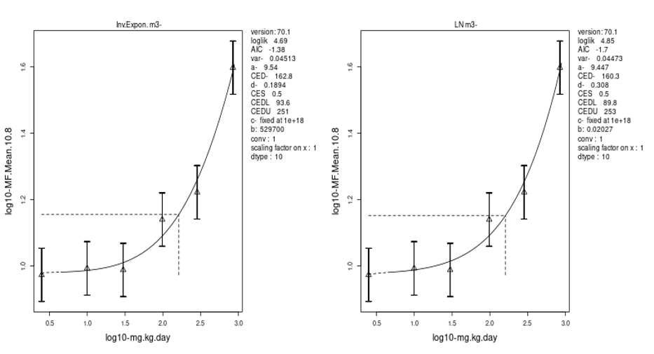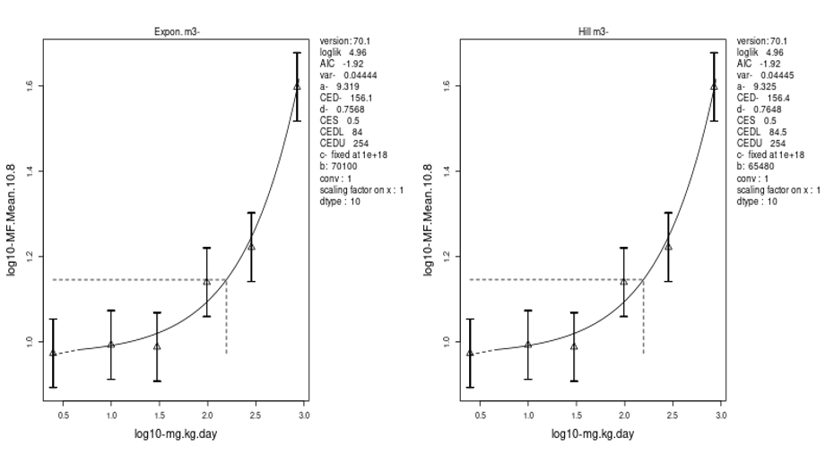
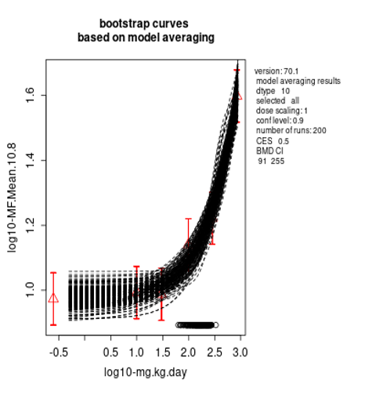
mg/kg/day | BMDL₅₀ | BMDU₅₀
NBP Liver Mouse | 91 | 255

Bone marrow, non-covariate BMD analysis with NBP
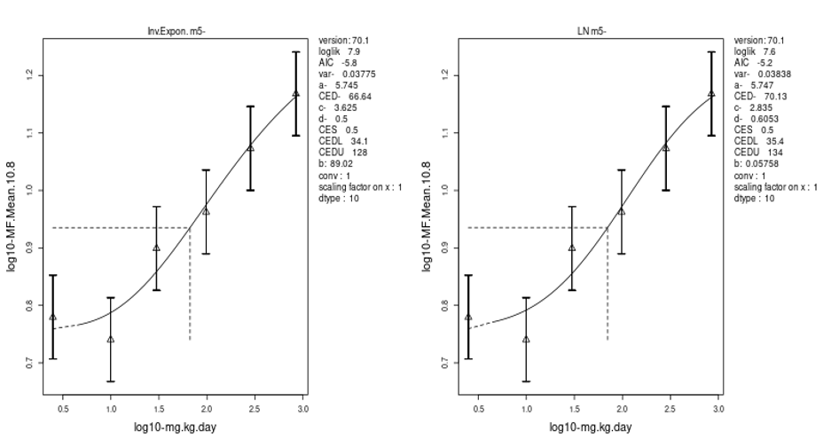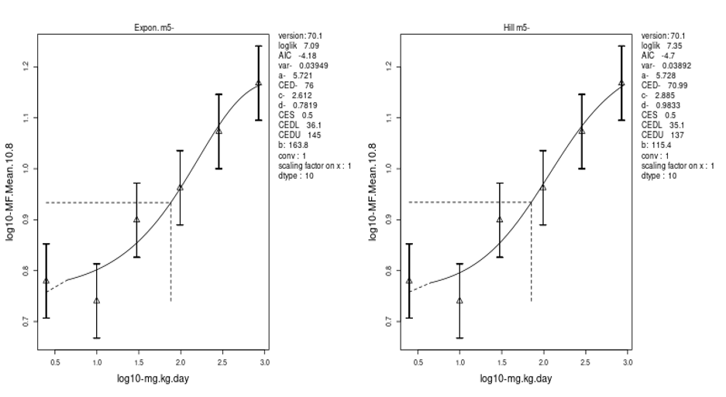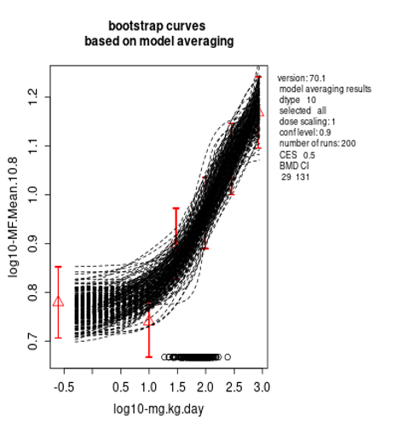
mg/kg/day | BMDL₅₀ | BMDU₅₀
NBP bone marrow Mouse | 29 | 131

Liver, covariate BMD analysis with NBP (black line) using NDEA (red line) liver in mouse as the covariate data set
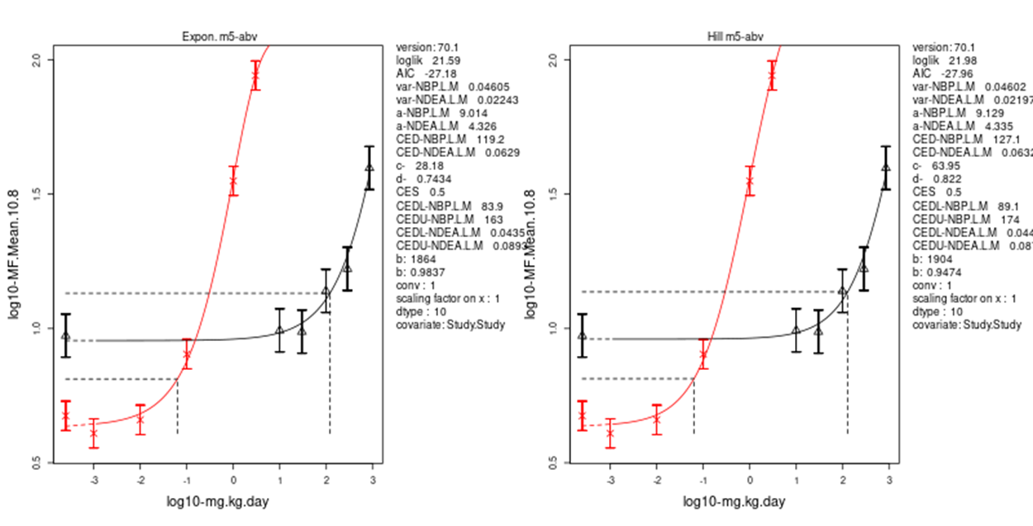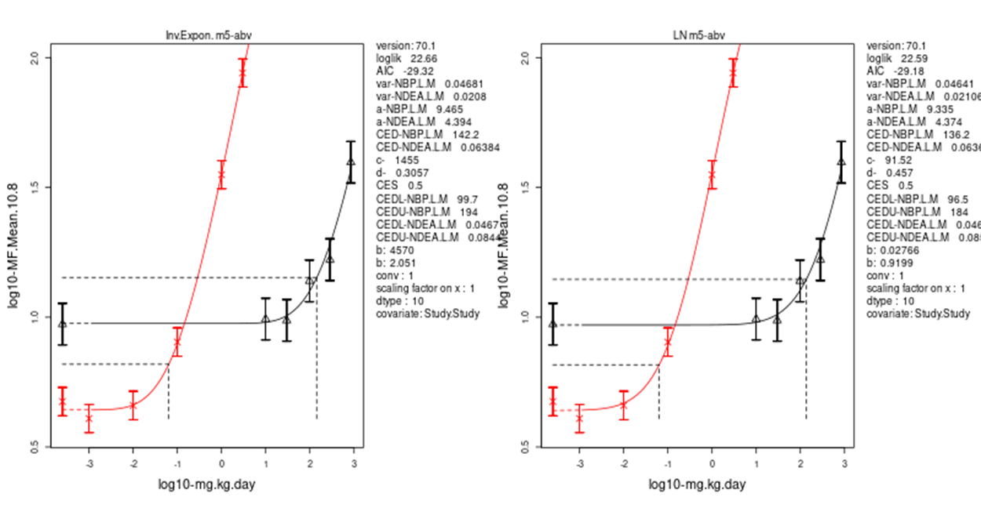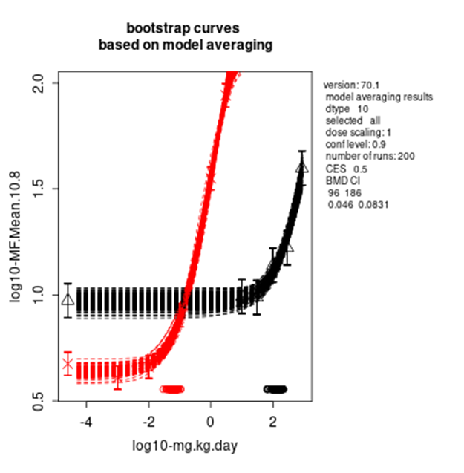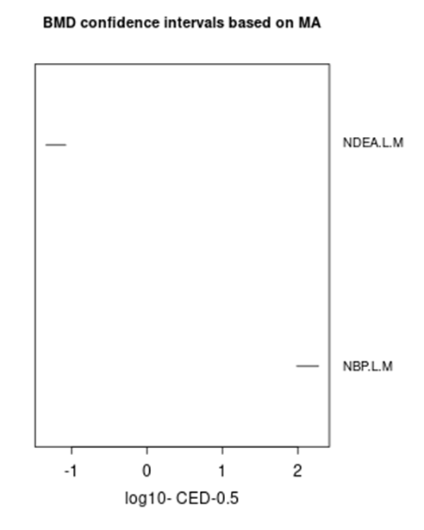
mg/kg/day | BMDL₅₀ | BMDU₅₀
NDEA Liver BigBlue Mouse | 0.046 | 0.0831
NBP Liver Mouse | 96 | 186

Bone Marrow, covariate BMD analysis with NBP (red line) compared to BaP in mouse (black line)
Table 6. Mutation frequency data for benzo(a)pyrene (BaP).
n | Chemical | Dose | Mean MF x10-8 | SD MF x10-8 | Tissue | Reference
6 | BaP | 0 | 12.47585 | 2.46185781 | BM | LeBlanc.2022
6 | BaP | 12.5 | 33.26541667 | 2.98007621 | BM | LeBlanc.2022
6 | BaP | 25 | 67.03606667 | 6.38055555 | BM | LeBlanc.2022
6 | BaP | 50 | 104.6130167 | 6.95379745 | BM | LeBlanc.2022

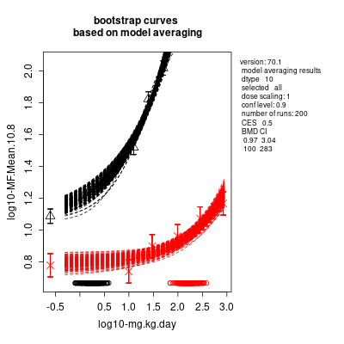
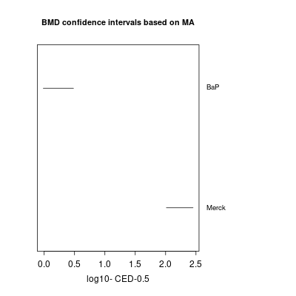
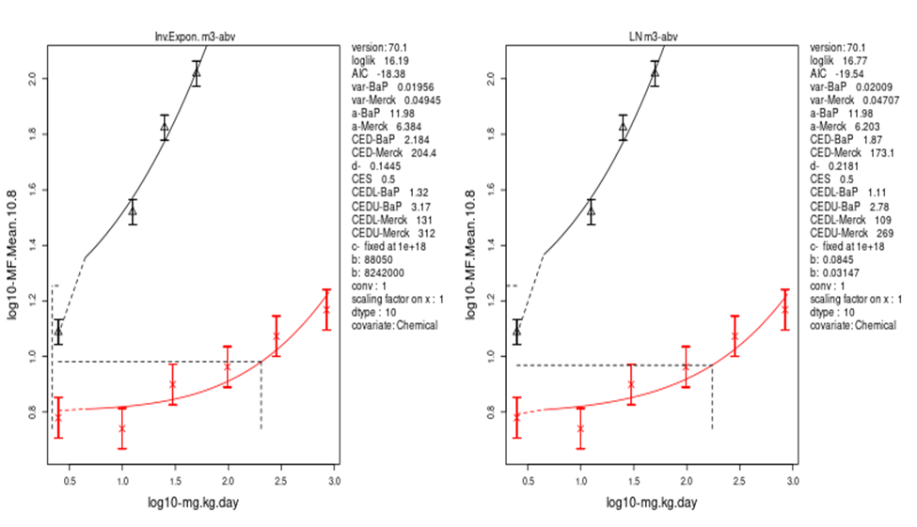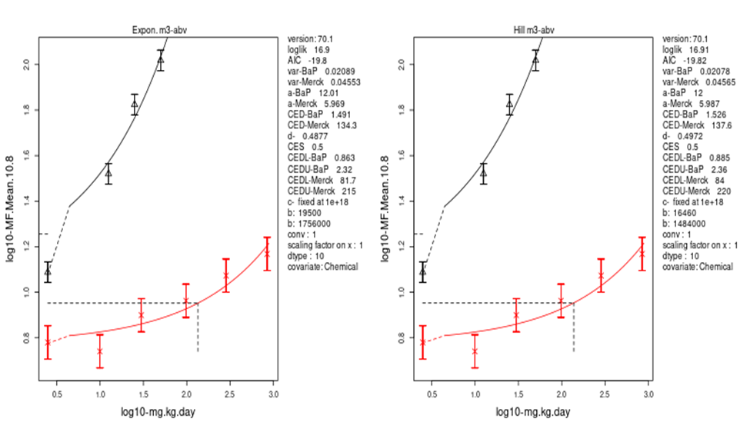
mg/kg/day | BMDL₅₀ | BMDU₅₀
BaP Bone Marrow MutaMouse | 0.97 | 3.04
NBP Bone Marrow Mouse | 100 | 283

Relationship between BMDL50 (TGR) and TD50 (Carcinogenicity)
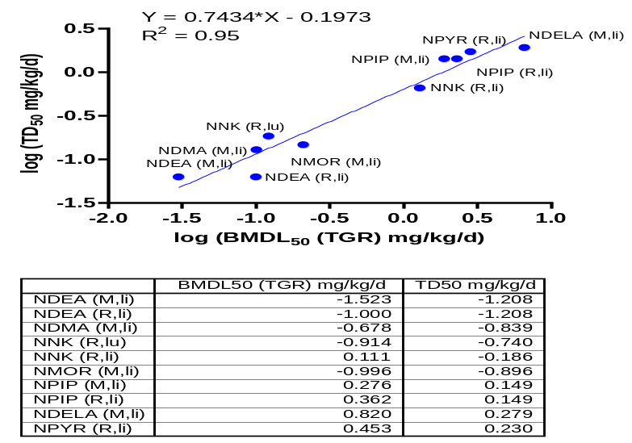
Figure 2: Relative potency relationship of nitrosamines between in vivo TGR mutation BMDL and cancer bioassay TD₅₀. TD₅₀ values are from (1). NDEA (2), NDMA (3) and N-Nitrosopyrrolidine NPIP (4) have been published. Work from the HESI-GTTC Mechanism-based Genotoxicity Risk Assessment (MGRA) Nitrosamines in vivo working group, yet to be published. Presented by Dr George Johnson on the German Pharm-Tox Summit 2025 in Hannover. M=mouse, R=rat, li=liver, lu=lung

1. Bercu, J. P. et al., Acceptable intakes (AIs) for 11 small molecule N-nitrosamines (NAs). Regul Toxicol Pharmacol 142, 105415 (2023).
2. Bercu, J. P. et al., Comparison of the Transgenic Rodent Mutation Assay, Error Corrected Next Generation Duplex Sequencing, and the Alkaline Comet Assay to Detect Dose-Related Mutations Following Exposure to N-Nitrosodiethylamine. Mutation Research/Genetic Toxicology and Environmental Mutagenesis https://doi.org/10.1016/j.mrgentox.2023.503685, 503685 (2023).
3. Lynch, A. e. a., Comparison of the Transgenic Rodent Mutation Assay, Error Corrected Next Generation Duplex Sequencing, and the Alkaline Comet Assay to Detect Dose-Related Mutations Following Exposure to NDMA. In Press (2023).
4. Powley, M. W. et al., N-nitrosamine impurity risk assessment in pharmaceuticals: Utilizing In vivo mutation relative potency comparison to establish an acceptable intake for NTTP. Regul Toxicol Pharmacol 152, 105681 (2024).

