Supplementary Material
Table S1 – Key resources
REAGENT or RESOURCE | SOURCE | IDENTIFIER
Antibodies
Anti-Villin antibody for Immunofluorescence (1:200) | Santa Cruz Biotechnology | Cat# sc-58897  RRID: AB_2304475
Anti-MUC2 for immunofluorescence (1:100) | Santa Cruz Biotechnology | Cat# sc-7314  RRID: AB_627970
Anti-Lyzozyme for immunofluorescence (1:100) | DAKO | Cat# A009902-2  RRID: AB_2341230
Anti-ZO-1 for immunofluorescence (1:200) – used in combination with Anti-Villin and Anti-MUC2. | Fisher Scientific | Cat# PA585256  RRID: AB_2792399
ZO-1 Monoclonal Antibody (ZO1-1A12), Alexa Fluor™ 594 (1:200) – used in combination with Anti-Lyzozyme. | Fisher Scientific | Cat# 339194  RRID: AB_2532188
Goat anti-Mouse IgG (H+L) Highly Cross-Adsorbed Secondary Antibody, Alexa Fluor™ Plus 488 (1:250) | Fisher Scientific | Cat# A32723  RRID: AB_2633275
Donkey anti-Rabbit IgG (H+L) Highly Cross-Adsorbed Secondary Antibody, Alexa Fluor™ 647 (1:250) | Fisher Scientific | Cat# A-31573  RRID: AB_2536183
Chemicals, Peptides, and Recombinant Proteins
Matrigel hESC-Qualified Matrix | Corning | 354277
Matrigel Growth Factor Reduced | Corning | 354230
mTeSR plus | Stem cell technologies | 662640
Gentle Cell Dissociation Reagent | Stem cell technologies | 100-0485
Y-27632 | Stem cell technologies | 72304
Recombinant Human Activin A | Cell guidance systems | GFH6-100
Recombinant Human BMP-4 Protein | R&D systems | 314-BP-010/CF
Recombinant Human FGF2 Protein | R&D systems | 233-FB-025/CF
Recombinant Human EGF Protein | R&D systems | 236-EG-200/CF
Forskolin | Merck | F3917
5-aza-2’-deoxycytidine (5mM) | Merck | A3656
A 83-01 | Stem cell technologies | 72022
PD98059 | Stem cell technologies | 72174
RPMI-1640 Medium | Merck | R8758
DMEM/F-12 with 15 mM HEPES | Stem cell technologies | 36254
Advanced DMEM/F-12 | Fisher Scientific | 12634010
GlutaMAX™ Supplement | Fisher Scientific | 35050038
B-27™ Supplement (50X), minus vitamin A | Fisher Scientific | 12587010
N-2 Supplement | Fisher Scientific | 17502048
HepExtend™ Supplement | Fisher Scientific | A2737501
Accutase™ Cell Dissociation Reagent | Fisher Scientific | A1110501
L-Glutamine (200 mM) | Fisher Scientific | 25030024
Penicillin and Streptomycin (5,000 U/mL) | Fisher Scientific | 15070063
Triton X-100 | Merck | T8787
Tween20 | Merck | P9416
Bovine Serum Albumin | Merck | A2153
Lithium L-lactate | Merck | L2250
β-Nicotinamide adenine dinucleotide sodium salt | Merck | N0632
Iodonitrotetrazolium chloride | Merck | I8377
Phenazine methosulfate | Merck | P9625
Trizma hydrochloride | Merck | T3253
Trizma base | Merck | T4661
Sulfuric acid solution | Honeywell International Inc. | 84741
Lipopolysaccharides from Escherichia coli O111:B4 | Merck | L4391
Nigericin | Merck | N7143
Hoechst 33342 | Fisher Scientific | H3570
Defined Fetal Bovine Serum | Hyclone | SH30070.01
GAPDH primer | Qiagen | PPH00150F-200
TNFα primer | Qiagen | PPH00341F-200
Acetic acid | Merck | 695092
Alcian Blue solution | Merck | B8438
Periodic acid | Merck | P7875
Schiff’s reagent | Merck | 1.09033.0500
Critical Commercial Assays
RLT buffer | Qiagen | 79216
RNeasy mini kit | Qiagen | 74106
QuantiTect Reverse Transcription Kit | Qiagen | 205311
Rotor‐Gene® SYBR® Green PCR kit | Qiagen | 204174
ProLong™ Gold Antifade Mountant | Fisher Scientific | P36934
Human IL-6 DuoSet ELISA | R&D systems | DY206
Human IL-8/CXCL8 DuoSet ELISA | R&D systems | DY208
Human TNF-alpha DuoSet ELISA | R&D systems | DY210
Experimental Models: Cell Lines
Caco-2 cells | ATCC | HTB-37
hiPSC CS83iCTR-33nxx | Cedars-Sinai Medical Center | CS83iCTR-33nxx
Equipment
Orbital Shaker | Fisher Scientific | 10309644
Nanodrop™ | Fisher Scientific | 13-400-525
Rotor‐Gene Q® | Qiagen | 9001862
EVOM3 Trans Epithelial Electrical Resistance (TEER) meters | WPI | EVOM3
Electrode blades for STX4 EVOM™ | WPI | STX4-BLADES
SpectraMax | Molecular Devices | iD3
Re-scan confocal microscope | Confocal.nl | RCM1
Inverted phase contrast microscope | Olympus | CKX53
Software and Algorithms
Fiji-ImageJ | Schindelin et al., 2012 PMID: 22743772 | https://imagej.net/Fiji/Downloads
GraphPad Prism 10.2.3 | GraphPad | N/A
Disposables
Millicell Cell Culture Insert, 12 mm, polycarbonate, 3.0 µm | Millipore | PITP01250
Microscope slide 26x76x1mm | Fisher Scientific | 15998086
Microscope cover glass, 170 µm thick | Fisher Scientific | 10039670
QiaShredder | Qiagen | 79656
Nunc™ MaxiSorp™ ELISA Plates, Uncoated | Biolegend | 423501

Table S2 – Primers used for RT-qPCR
Gene symbol | GeneBank Accession No. | Primer sequence (5’-3’) | PCR efficiency (%) | Regression coefficient (R2) | Source
POU5F1 | NM_002701.6 | F: TGGAGTTTGTGCCAGGGTTT  R: TCACCTTCCCTCCAACCAGT | 106 | 0.995 | This paper
SOX17 | NM_022454.4 | F: GCAAGATGCTGGGCAAGTC  R: CTTGTAGTTGGGGTGGTCCTG | 92 | 0.990 | This paper
CDX2 | NM_001265.6 | F: CCAGCGGCGGAACCTGTG  R: GTCTTTCGTCCTGGTTTTCAC | 110 | 0.995 | (Janssen et al., 2021)
LGR5 | NM_003667.4 | F: GGAAATCATGCCTTACAGAGC  R: CACTCCAAATGCACAGCACTG | 109 | 0.995 | (Janssen et al., 2021)
LYZ | NM_000239.3 | F: CCCTGGTCAGCCTAGCACTC  R: CCTTGCCCTGGACCGTAACA | 97 | 0.998 | (Janssen et al., 2021)
VIL1 | NM_007127.3 | F: CGGAAAGCACCCGTATGGAG  R: CGTCCACCACGCCTACATAG | 109 | 0.997 | (Janssen et al., 2021)
MUC2 | NM002457.4 | F: AGAAGGCACCGTATATGACGAC  R: CAGCGTTACAGACACACTGCTC | 107 | 0.999 | (Janssen et al., 2021)
CHGA | NM_001275.4 | F: TCCGACACACTTTCCAAGCC  R: TTCTGCTGATGTGCCCTCTC | 99 | 0.997 | (Janssen et al., 2021)
IL6 | NM_000600.3 | F: AGCCACTCACCTCTTCAGAAC  R: GCCTCTTTGCTGCTTTCACAC | 105 | 0.992 | (Ching et al., 2013)
IL8 | NM_000584.2 | F: CTGATTTCTGCAGCTCTGTG  R: GGGTGGAAAGGTTTGGAGTATG | 103 | 0.997 | (Teodorowicz et al., 2017)
TNF-α | NM_000594 | PPH00341F-200 | - | - | Qiagen
GAPDH | NM_002046 | PPH00150F-200 | - | - | Qiagen
ACTB | NM_001101.5 | QT00095431 | - | - | Qiagen

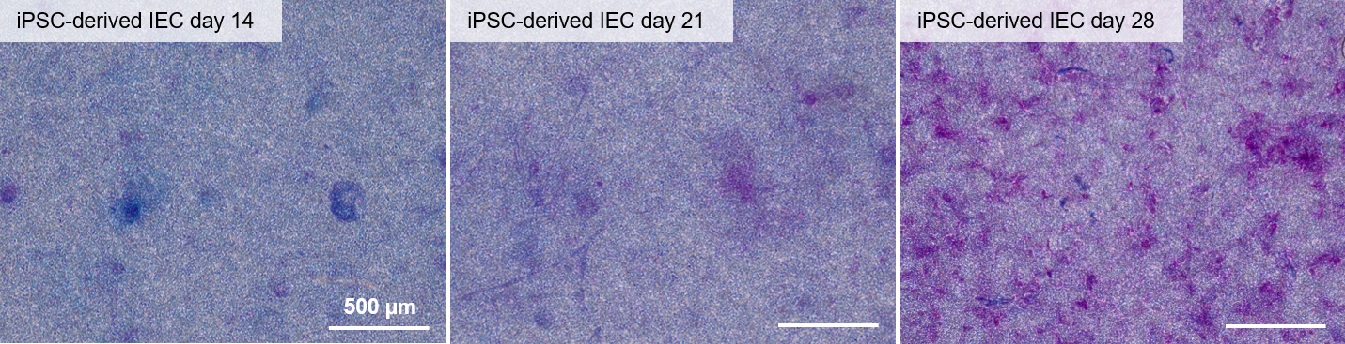
Fig. S1 – Histochemical staining with Alcian blue and Periodic acid–Schiff reaction was performed on paraformaldehyde-fixed iPSC-derived intestinal-like epithelial cells for acidic (blue) and neutral (magenta) mucus, respectively. Images were acquired on an Olympus CKX53 inverted phase contrast microscope. Images were taken at 20x magnification, scalebar represents 500 µm.

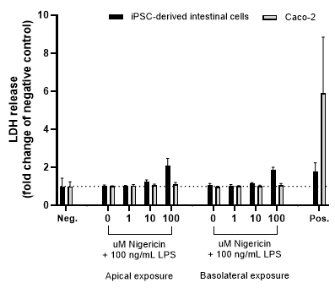
Fig S2 – Basolateral LDH levels after exposure to LPS plus nigericin on the apical or basolateral sides. Data are expressed as the percentage change compared to the negative control as the mean ± SD (N=4).

