New approach methodologies for metabolic disruption: a high-throughput human liver cell phospholipidosis assay
Archives of Toxicology
Neele Wewer¹, Albert Braeuning¹, Dajana Lichtenstein^{1,}*
¹German Federal Institute for Risk Assessment, Dept. Chemical and Product Safety, Max-Dohrn-Str. 8-10, 10589 Berlin, Germany
*Corresponding author. E-mail address: dajana.lichtenstein@bfr.bund.de (Dajana Lichtenstein)

Table S1 Tested substances with corresponding CAS number, supplier, used solvent, and stock concentration
Substance | Substance class | CAS number | Supplier | Solvent | Stock conc. [M]
Acetaminophen | Painkiller | 103-90-2 | Sigma-Aldrich | DMSO | 0.2
Amikacin | Antibiotic | 37517-28-5 | Cayman Chemicals | water | 0.1
Amiodarone HCl | Antiarrhythmic | 19774-82-4 | Biotechnology Santa Crus | DMSO | 0.05
Amitriptyline HCl | Antidepressant | 549-18-8 | Cayman Chemicals | DMSO | 0.1
Caffeine | Stimulant | 58-08-2 | Sigma-Aldrich | water | 0.1
Carbamazepine | Antiepileptic | 298-46-4 | Sigma-Aldrich | DMSO | 0.1
Chloroquine diphosphate | Antimalarial | 50-63-5 | Sigma-Aldrich | water | 0.05
Chlorpromazine HCl | Antipsychotic | 69-09-0 | TCI Deutschland GmbH | water | 0.1
Clomipramine HCl | Antidepressant | 17321-77-6 | Sigma-Aldrich | DMSO | 0.1
Clozapine | Antipsychotic | 5786-21-0 | TCI Deutschland GmbH | DMSO | 0.1
Dexamethasone | Immunosuppressant | 50-02-2. 2392-39-4 | Sigma-Aldrich | DMSO | 0.3
Diclofenac | Immunosuppressant | 15307-86-5 | Adipogen AG | DMSO | 0.1
Disopyramide | Antiarrhythmic | 3737-09-5 | TCI Deutschland GmbH | DMSO | 0.2
Doxycycline H₂O | Antibiotic | 17086-28-1 | LKT Laboratories | DMSO | 0.1
Erythromycin | Antibiotic | 114-07-8 | TCI Deutschland GmbH | DMSO | 0.1
Fluoxetine HCl | Antidepressant | 56296-78-7 | TCI Deutschland GmbH | DMSO | 0.1
Gentamicin Sulfate | Antibiotic | 1405-41-0 | Sigma-Aldrich | water | 0.05
Haloperidol | Antipsychotic | 52-86-8 | Cayman Chemicals | DMSO | 0.05
Hydroxyzine 2HCl | Antipsychotic/ Antihistamine | 2192-20-3 | LKT Laboratories | water | 0.1
Imipramine HCl | Antidepressant | 113-52-0 | Sigma-Aldrich | water | 0.05
Ketoconazole | Antifungal | 65277-42 | Sigma-Aldrich | DMSO | 0.05
Maprotiline HCl | Antidepressant | 10347-81-6 | Cayman Chemicals | DMSO | 0.1
Menadione | Vitamin | 58-27-5 | LGC Standards | DMSO | 0.1
Methapyrilene HCl | Antihistamine | 135-23-9 | Sigma-Aldrich | DMSO | 0.1
Ofloxacin HCl | Antibiotic | 118120-51-7 | LKT Laboratories | water | 0.1
Procainamide HCl | Antiarrhythmic | 614-39-1 | Santa Cruz Biotechnology | water | 0.1
Propranolol | Antiarrhythmic | 318-98-9 | Sigma-Aldrich | water | 0.1
Rifampicin | Antibiotic | 13292-46-1 | Sigma-Aldrich | DMSO | 0.05
Sotalol | Antiarrhythmic | 959-24-0 | Cayman Chemicals | DMSO | 0.1
Tamoxifen | Antiestrogenic | 10540-29-1 | Sigma-Aldrich | DMSO | 0.025
Tetracycline HCl | Antibiotic | 64-75-5 | Sigma-Aldrich | DMSO | 0.1
Thioridazine | Neuroleptic | 130-61-0 | Cayman Chemicals | DMSO | 0.1
Tilorone 2HCl | Antiviral | 27591-69-1 | TCI Deutschland GmbH | water | 0.1
Triparanol | Cholesterol synthesis inhibitor | 78-41-1 | Santa Cruz Biotechnology | DMSO | 0.05
Valproic acid | Antiepileptic | 99-66-1 | Sigma-Aldrich | DMSO | 1

Table S2 Detailed information of defined ranges for the PLD induction classification into high, medium, low and no phospholipidosis induction of measured in vitro results from this work and published data
Categorization | This work | Sawada et. al., 2005ª | Nioi et. al., 2007^{b} | Van de Water et. al., 2011^{c} | Tilmant et. al., 2011^{d} | Park et. al., 2012e | Tomida et. al., 2017^{f}
high PLD induction | > 500 % | Authors' own classification | > 3.5x | > 100 % | > 4x | > 200 % | > 2.5x
medium PLD induction | 300-500 % | Authors' own classification | 2x-3.5x | 50-100 % | 3x-4x | 150-200 % | 2-2.5x
low PLD induction | 200-300 % | Authors' own classification | 1.5-2x | < 50 % | 2-3x | < 150 % | 1.5-2x
no PLD induction | < 200 % | Authors' own classification | no significant changes | not detected | < 2x | no significant changes | < 1.5x
Method details applied in publication (cell number per well, well format, incubation duration, used dye): ª30,000 HepG2 cells, 24-well, 72 h, electron microscopy; ^{b}3,000 HepG2 cells, 96-well, 48 h, LipidTOX™; ^{c}5,000 HepG2 cells, 96-well, 24 h, NBD-PE; ^{d}10,000 HepG2 cells, 96-well, 24 h, LipidTOX™; ^{e}5,000 HepG2 cells, 96-well, 24 h, LipidTOX™ and NBD-PE; ^{f}100,000 diff. HepaRG cells, 96-well, 48 h, LYSO-ID Red dye

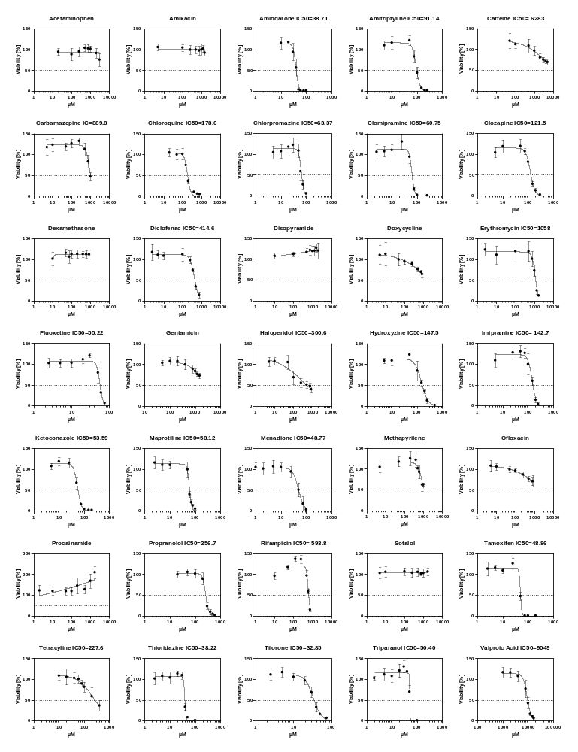Figure S1 Viability of HepaRG cells after incubation with all tested substance. Cell viability was measured using the WST-1 assay after 24 h of incubation. Absorbance was normalized to solvent control and the fitted curves for IC₅₀ calculated. Data represent mean ± SD (n=3 independent experiments)
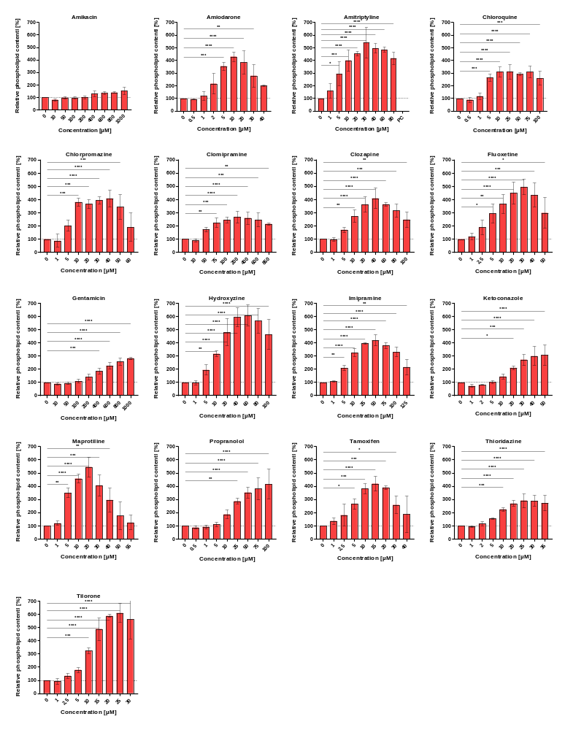
Figure S2 Phospholipid quantification after treatment with known phospholipidosis inducers. Differentiated HepaRG cells were treated for 24 h with LipidTOX™ and indicated concentrations of each substance. Displayed are concentration-dependent induction for substances that showed phospholipidosis induction in vivo. The phospholipid content was normalized to the solvent control. Data are presented as the mean of three biological replicates ± SD (one-way ANOVA against solvent control: *p ≤ 0.05, **p ≤ 0.01, ***p ≤ 0.001, and ****p ≤ 0.0001)

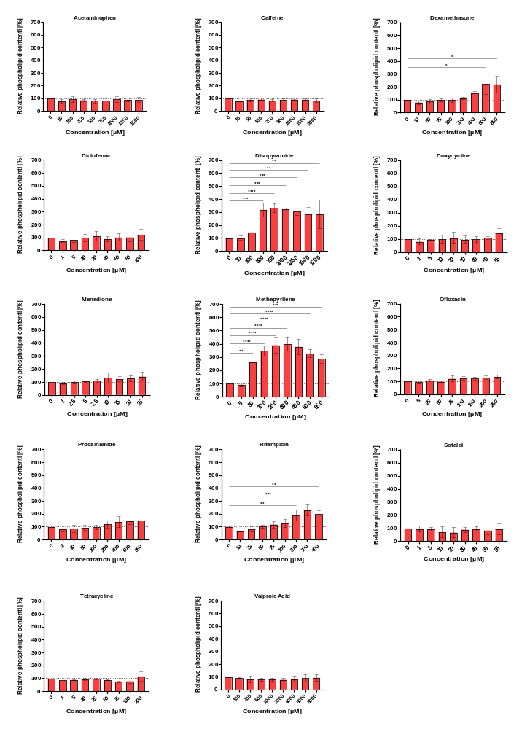
Figure S3 Phospholipid quantification after treatment with known non-phospholipidosis inducers. Differentiated HepaRG cells were treated for 24 h with LipidTOX™ and indicated concentrations of each substance. Displayed are concentration-dependent induction for substances that showed no phospholipidosis induction in vivo. The phospholipid content was normalized to the solvent control. Data are presented as the mean of three biological replicates ± SD (one-way ANOVA against solvent control: *p ≤ 0.05, **p ≤ 0.01, ***p ≤ 0.001, and ****p ≤ 0.0001)

