Supplementary data:

Material and methods:
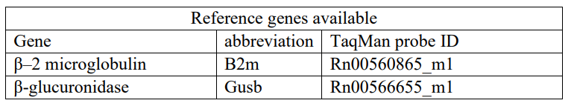
a)

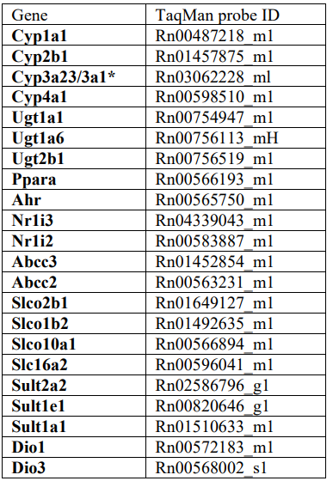
b)

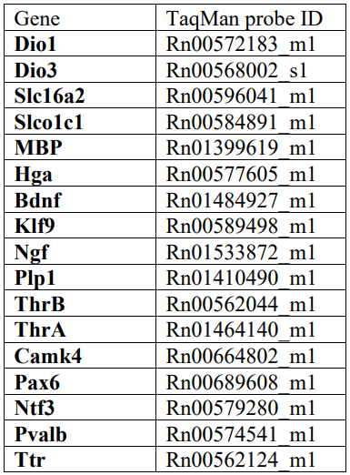
c)

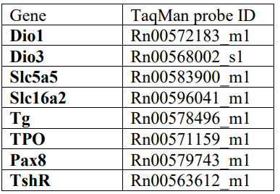
d)

Table 1: List of the target gene names for qPCR analysis and related Taqman probe identification number. a) reference genes, b) hepatic genes, c) brain genes, d) thyroid genes.

Table 2: Immunofluorescence marker information for spatial transcriptomic:
Antibody ID | Name | Channel | host | company | clone # | Catalog # | concentration
Mf-748 | NeuN | 488 | rabbit | abCam | EPR12763 | ab190195 | 400
0 | syto83 | 532 | 0 | 0 | 0 | 0 | 25
MF-783 | GFAP | 594 |  | CST | GA5 |  | 100
MF-737 | MBP | 647 | mouse | Novus | 2H9 | NBP-22121AF647 | 100

Results:

Table 3: Summary of in-life parameters selected in dams
 | Dams in Phase 1 (GD21) |  |  | Dams in phase 2 (PND21)
Groups | Control | PCN | PTU | Control | PCN | PTU
Number of animal examined | 10 | 10 | 10 | 6 | 7 | 8
Mean body weight (g) GD3 | 270.7 ± 31 | 260.9 ± 24 | 278.5 ± 16 | 264.8 ± 29 | 265.6 ± 21 | 265.8 ± 33
GD9 | 310.9 ± 35 | 295.3 ± 29 | 315.4 ± 18 | 295.1 ±32 | 297.2 ± 27 | 300.4 ± 40
GD21 | 438.2 ±52 | 431.4 ± 35 | 438.6 ± 33 | 345.8 ± 41 | 347.3 ± 38 | 344.8 ± 47
PND4 | ND | ND | ND | 338.3 ± 36 | 333.3 ± 29 | 317.0 ±40
PND14 | ND | ND | ND | 359.6 ± 43 | 359.0 ± 43 | 343.9 ±47
PND21 | ND | ND | ND | 346.1 ± 38 | 353.0 ± 41 | 349.8 ± 48
Mean body weight gain (g) GD3-9 | 40.2 ± 8 | 34.4 ± 10 | 36.9 ± 3 | 30.3 ± 6 | 31.6 ± 10 | 34.7 ± 11
GD3-21 | 167.5 ± 29 | 170.5 ± 21 | 160.1 ± 21 | 164.0 ± 27 | 155.2 ± 22 | 151.2 ± 33
PND3-7 | ND | ND | ND | 71.2 ± 16 | 70.3 ±17 | 57.3 ± 18
PND3-21 | ND | ND | ND | 74.1 ± 13 | 86.6 ± 24 | 83.9 ± 26
Mean food consumption (g) GD3-6 | 79.6 ± 10 | 74.5 ± 13 | 77.2 ± 4 | 72.3 ± 8 | 67.5 ± 10 | 68.7 ± 13
GD13-21 | 231.6 ± 25 | 229.8 ± 24 | 214.7 ± 30 | 218.7 ± 37 | 207.3 ±34 | 186.1 ±35 (↓ 15%)
PND4-7 | ND | ND | ND | 142.5 ± 19 | 149.4 ± 21 | 116.5 ± 19 (↓ 18%)
PND14-21 | ND | ND | ND | 537.7 ± 75 | 572.8 ± 87 | 438.4 ± 65 (↓ 18%)
Absolute organ weight
Liver (g) | 13.7 ± 2 | 17.5 ± 2 | 12.9 ± 2 | 15.7 ± 2 | 19.3 ± 2 (↑ 22%) | 14.9 ± 2
Thyroid gland (mg) | 16.2 ± 2 | 18.3 ± 4 | 34.0 ± 10 (↑ 109%) | 17.8 ± 7 | 21.1 ± 6 | 25.0 ± 6
Relative organ weights
Liver (% of body weight) | 3.1 | 4.0 | 2.9 | 4.5 ± 0.2 | 5.5 ± 0.3 (↑ 22%) | 4.3 ± 0.4
Thyroid gland (% of body weight) | 0.004 ± 0.001 | 0.004 ± 0.001 | 0.008 ± 0.001 (↑ 100%) | 0.005 ± 0.001 | 0.006 ± 0.001 | 0.007 ± 0.001
Gravid uterine weight (g) | 100.7 ± 20 | 104.7 ± 14 | 100.1 ± 10 | ND | ND | ND
Observation at cesarean section
Number of implementations | 14.0 ± 1 | 14.5 ± 1 | 13.9 ± 1 | ND | ND | ND
Number of live fetuses | 12.8 ± 2 | 13.1 ± 2 | 13.4 ± 1 | ND | ND | ND
fetal death (%) | 0 | 0 | 0 | ND | ND | ND
Fetal weight (mg) males | 5.9 ± 0.3 | 6.1 ± 0.5 | 5.6 ± 0.2 | ND | ND | ND
Females | 5.6 ± 0.3 | 5.8 ± 0.3 | 5.3 ± 0.4 | ND | ND | ND
Sex ratio | 0.88 | 0.63 | 0.86 | ND | ND | ND
Reproductive data
Duration of gestation (days) | ND | ND | ND | 23.1 | 23.4 | 23.5
Number of pups delivered | ND | ND | ND | 13.9 ± 2 | 12.4 ± 2 | 13.0 ± 2
Sex ratio | ND | ND | ND | 0.59 | 1.16 | 1.30
Values represent mean ± standard deviation. Values in parenthesis represent percent of control. ND, not determined. Red values are significantly different from control (Dunn’s test p<0.05)

Table 4: Summary of histopathological observations in dams and PND21 pups

Groups | Control | PCN |  | PTU
GD21 Dams
THYROID GLAND:
Hypertrophy, follicular cell | 0/10 | 4/9 [3,+ ; 1,++] |  | 10/10 [+++]
PND21 Dams
THYROID GLAND:
Hypertrophy, follicular cell | 0/6 |  | 4/7 [3,+ ; 1,++] |  | 8/8 [2,++ ; 6,+++]
PND21 male pups
LIVER:
Rarefaction | 6/7 [1,+ ; 5,+++] |  | 7/7 [2,++ ; 5,+++] |  | 0/8
THYROID GLAND :
Hypertrophy, follicular cell | 0/15 |  | 0/16 |  | 23/23 [14,++ ; 9,+++]
BRAIN:
Periventricular Heterotopia | 0/6 |  | 0/7 |  | 2/8 [+]
Persistent external granular layer, Diffuse | 0/6 |  | 0/7 |  | 8/8 [4,+ ; 4,++]
PND21 female pups
LIVER:
Rarefaction | 6/6 [+++] |  | 7/7 [1,++; 6,+++] |  | 1/8 [++]
THYROID GLAND:
Hypertrophy, follicular cell | 0/9 |  | 0/12 |  | 8/8 [4,+; 4,++]
BRAIN:
Periventricular Heterotopia | 0/6 |  | 0/7 |  | 5/8 [+]
Persistent external granular layer, Diffuse | 0/6 |  | 0/7 |  | 8/8 [2,+; 6,++]

Data represent the number of animals with the lesion / total number of animals examined. GD, gestation day; LD, lactation day; PND, postnatal day. Severity grades for graded histopathological findings are shown in brackets: Minimal +, Slight ++, moderate +++.

Table 5: Summary of in-life parameters selected in PND21 pups
 | Male pups on PND21 |  |  | Female pups on PND21
Groups | Control | PCN | PTU | Control | PCN | PTU
Number of animals examined | 23 | 27 | 35 | 25 | 29 | 27
Mean body weight (g) PND21 | 61.2 ± 7 | 67.1 ± 7 | 44.7 ± 3 (↓ 27%) | 59.4 ± 7 | 62.8 ± 7 | 41.6 ± 3 (↓ 30%)
Absolute organ weight
Brain (g) | 1.6 ± 0.1 | 1.7 ± 0.1 | 1.6 ± 0.1 | 1.6 ± 0.2 | 1.6 ± 0.1 | 1.5 ± 0.1
Liver (g) | 2.55 ± 0.4 | 3.1 ± 0.5 | 1.5 ± 0.2 | 2.4 ± 0.4 | 2.7 ± 0.4 | 1.5 ± 0.1
Thyroid gland (mg) | 4.4 ± 1 | 5.9 ± 2 | 8.3 ± 2 (↑ 89%) | 5.7 ± 1 | 7.7 ± 3 | 6.5 ± 2
Relative organ weights
Brain (% of body weight) | 2.7 ±0.3 | 2.5 ± 0.2 | 3.5 ± 0.3 | 2.7 ± 0.3 | 2.5 ± 0.3 | 3.7 ± 0.5
Liver (% of body weight) | 4.1 ± 0.2 | 4.5 ± 0.2 | 3.3 ± 0.3 | 4.0 ± 0.3 | 4.4 ± 0.2 | 3.6 ± 0.2
Thyroid gland (% of body weight) | 0.007 ± 0.003 | 0.009 ± 0.003 | 0.019 ± 0.005 (↑ 171 %) | 0.01 ± 0.002 | 0.012 ± 0.003 | 0.016 ± 0.006 (↑ 60%)
Values represent mean ± standard deviation. Values in parenthesis represent percent of control. Red values are significantly different from control (Dunn’s test p<0.05).

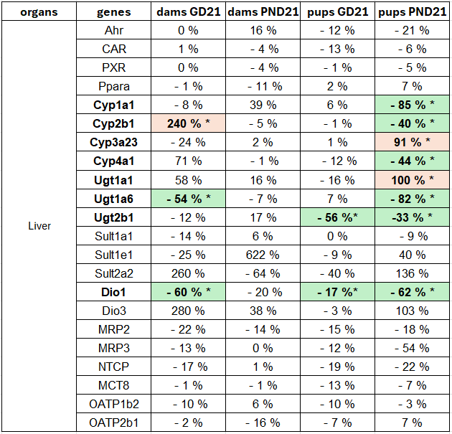
a)

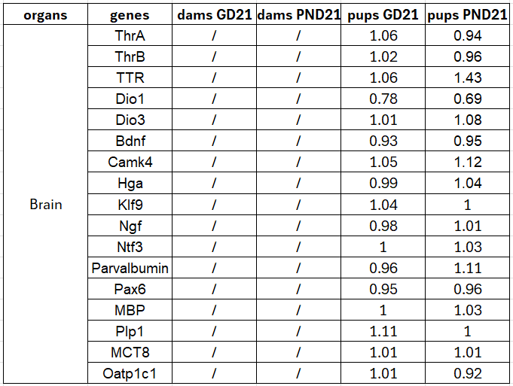
b)

Table 6: mRNA quantification. Transcriptional expression levels were determined using quantitative real-time PCR. The results shown are the percentage change compared to the control. Genes that are significantly upregulated are shown in orange, while downregulated genes are shown in green. n=10 for dams (GD21), n=8 for dams (PND21), n=10 for pups (GD21), n=10 for pups (PND21). Dunnett LSD test: *p-value<0.01. a) Transcript quantification in the liver PTU-exposed animal. b) Transcript quantification in the brain of PCN-exposed animals.
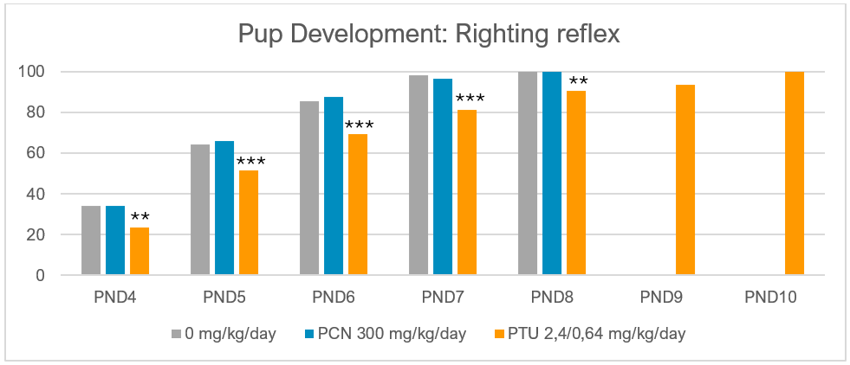

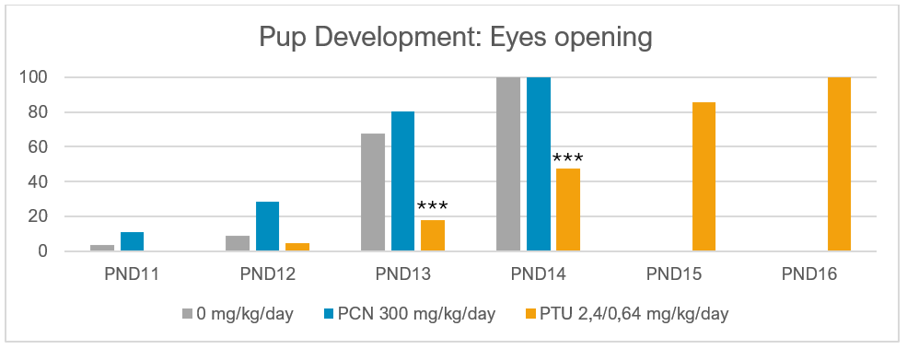

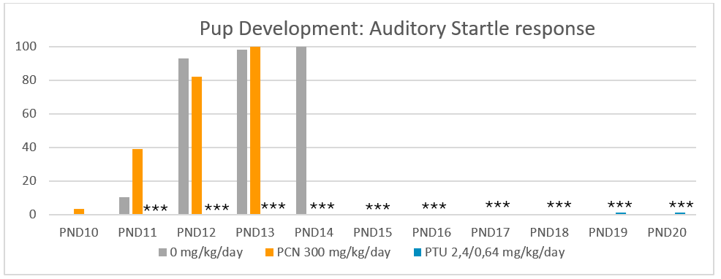

Figure 1: Developmental landmark: Observations were scheduled to start approximately one or two days before the projected day of onset and continued until present for all pups in the litter or at PND20. N=80. ** p-value < 0.001 and *** p-value < 0.0001.

Figure 2: Metabolomic statistical analysis in juvenile rats. The statistical analysis consists in a Principal component analysis score plot (left), a Partial Least Squares Discriminant Analysis score plot (right) with the corresponding table summarizing total Y explained variance (R2); predictable Y variation (Q2); and prediction accuracy from the cross-validation.

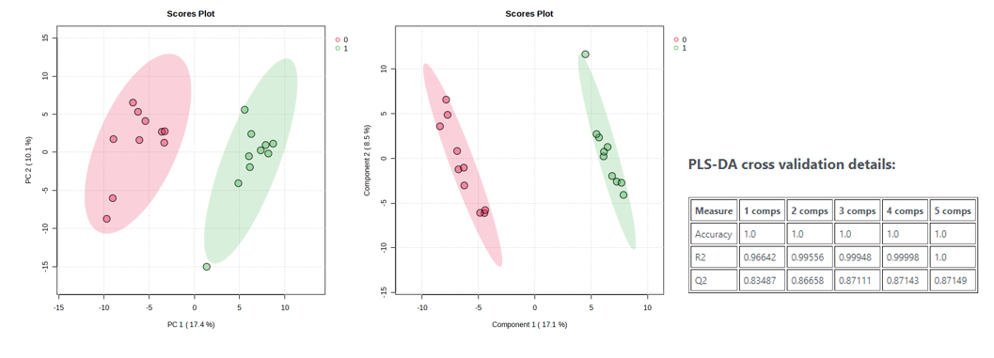
- Metabolomic, liver, GD21, PTU

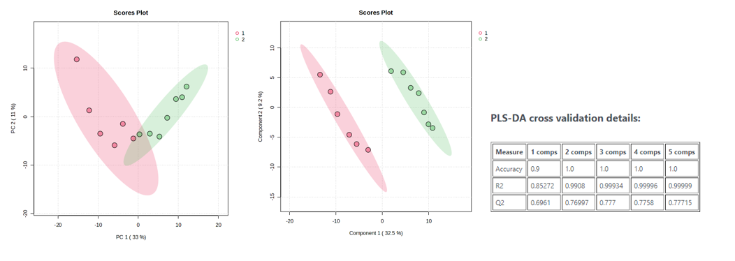
- Metabolomic, brain, PND21, PCN

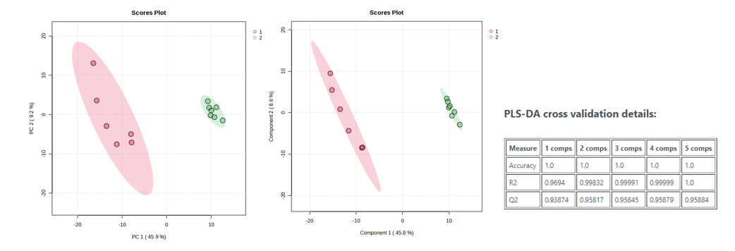
- Metabolomic, brain, PND21, PTU

- Metabolomic, liver, PND21, PCN

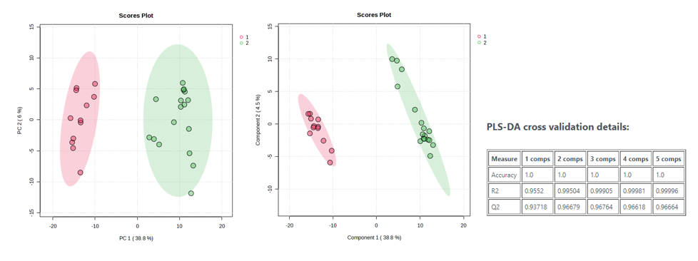
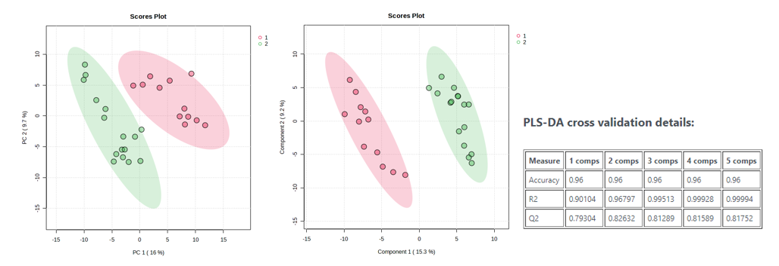
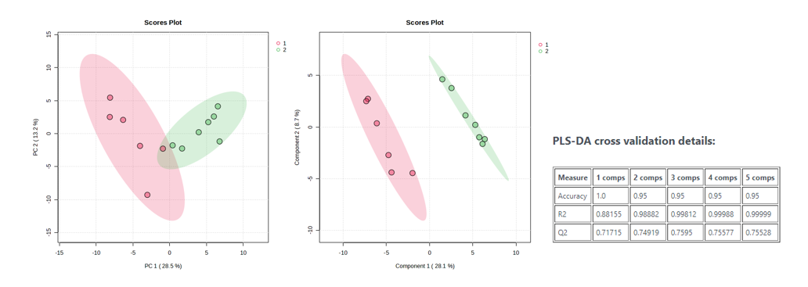
- Metabolomic, Liver, PND21, PTU

- Metabolomic, thyroid, PND21, PCN

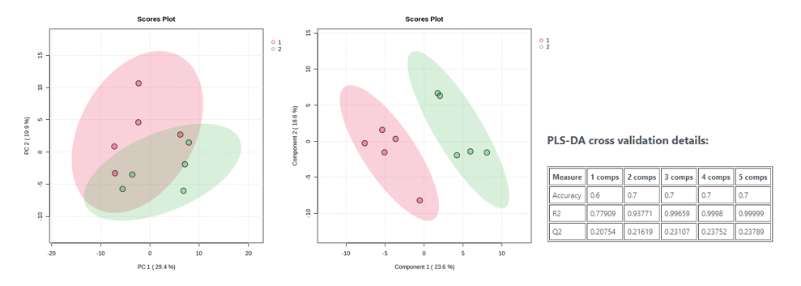
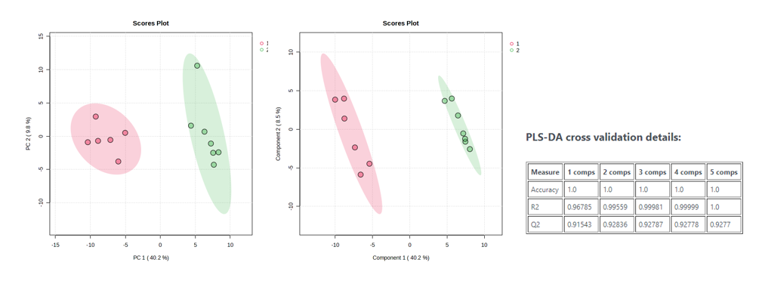
- Metabolomic, thyroid, PND21, PTU

Figure 3: Statistical analyses of Spatial transcriptomic data. Principal Component Analysis (PCA) and t-distributed stochastic neighbor embedding (tSNE) methods were used to plot samples and visualize group discrimination.

- Statistics on PVH region
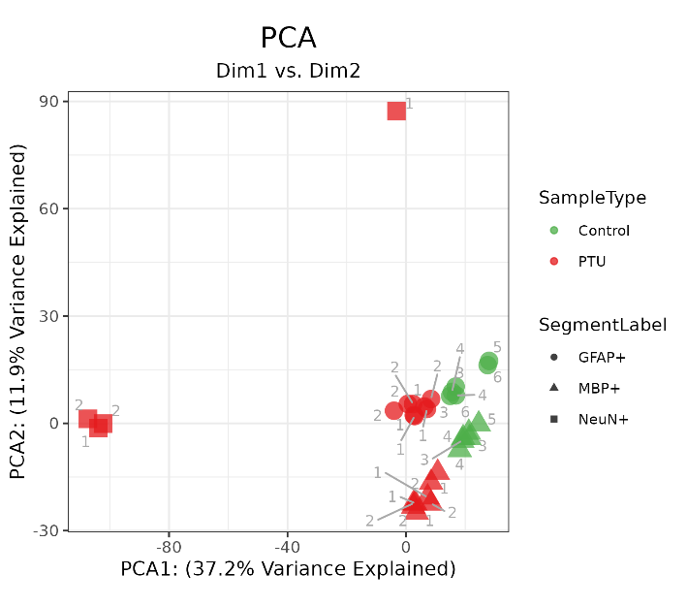

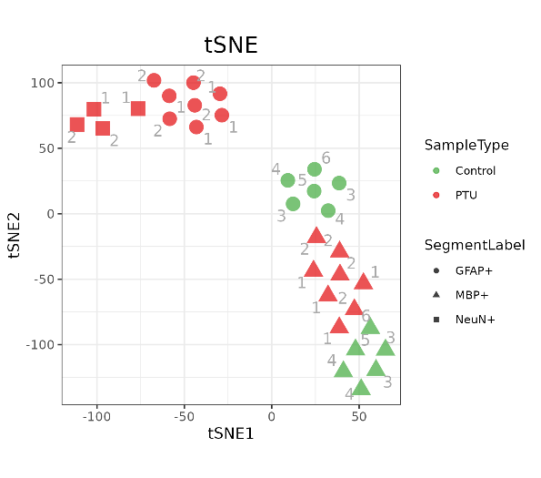

- Statistic on external granular layer
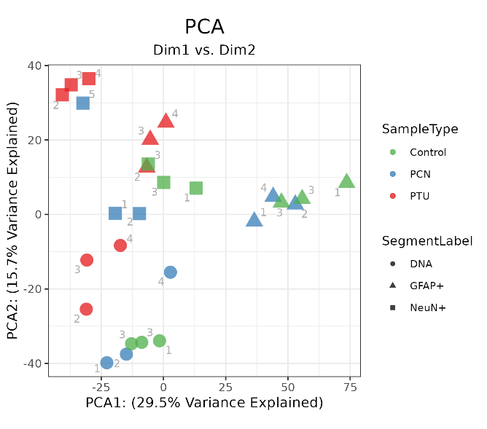
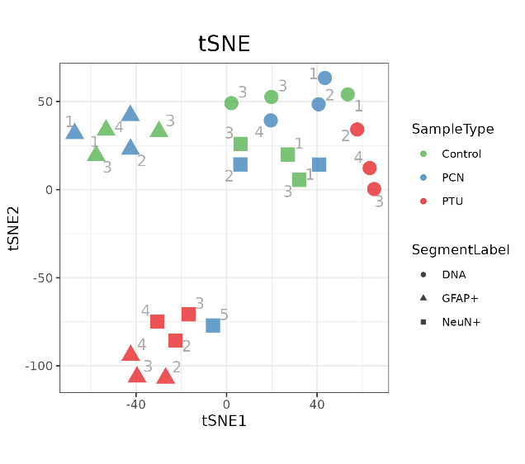

Table 7: List of significantly deregulated pathways in Spatial transcriptomic in PTU condition
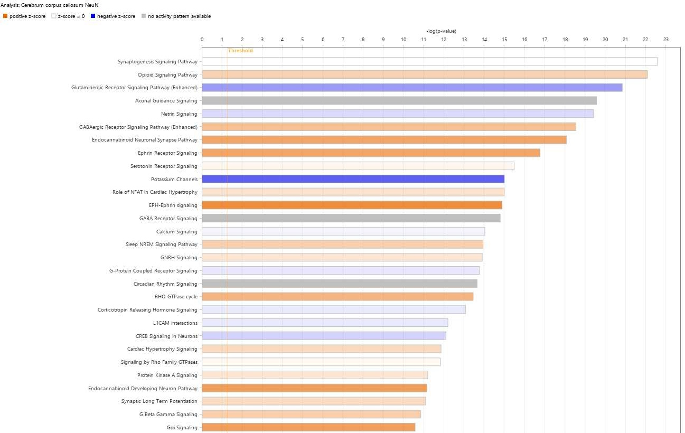
a) PVH region, neurons, PTU treatment

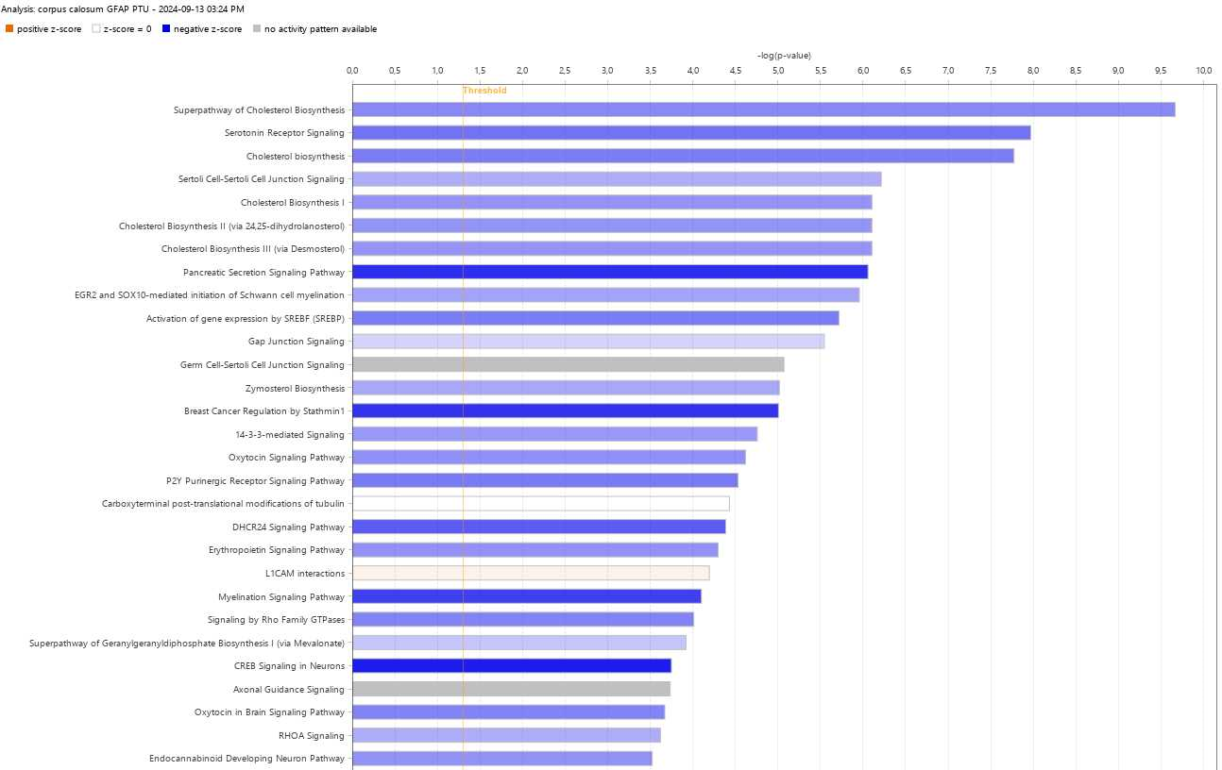
- PVH region, astrocytes, PTU treatment
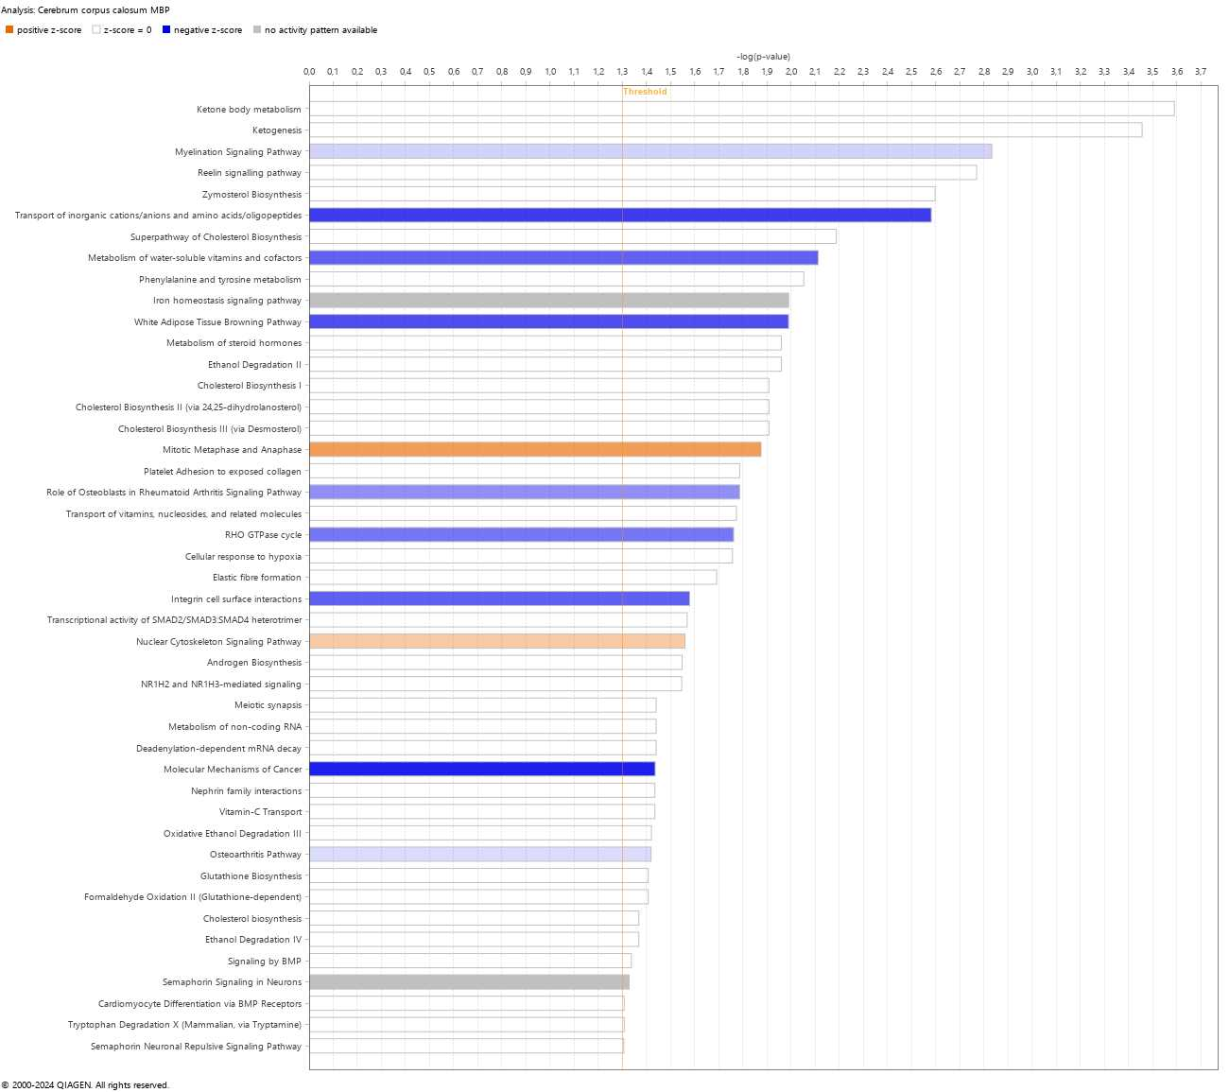
- PVH region, oligodendrocytes, PTU treatment

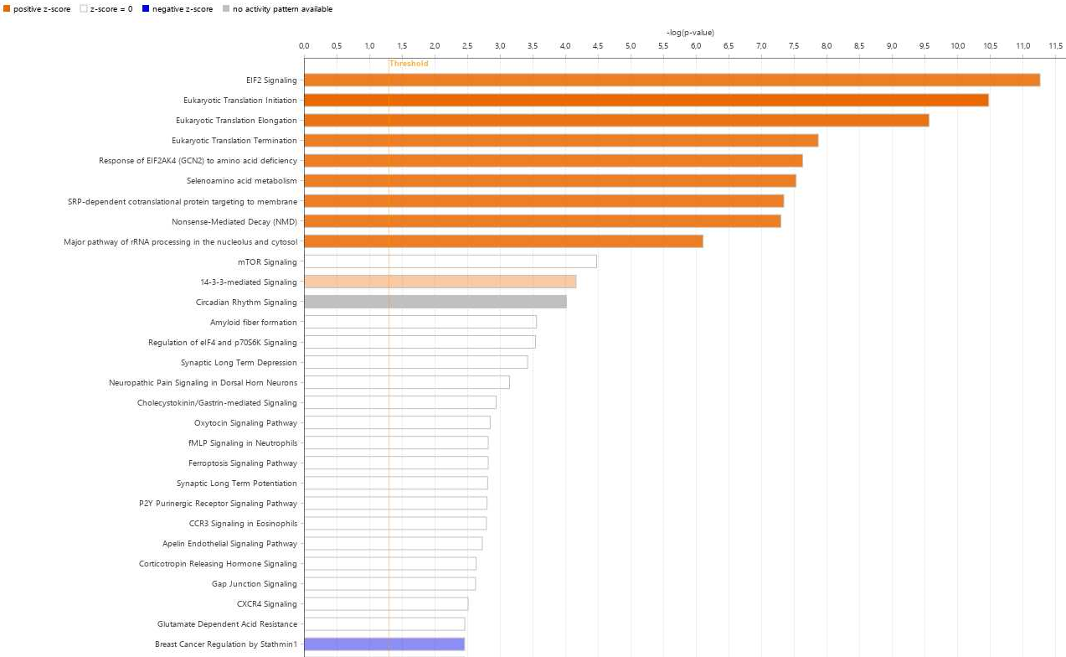
- EGL region, neurons, PTU treatment

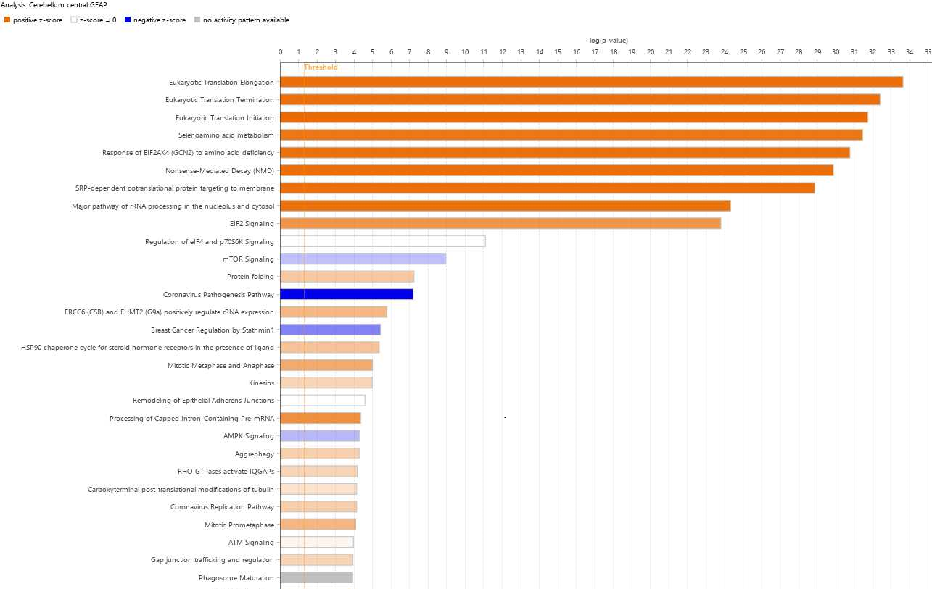
- EGL region, astrocytes, PTU treatment

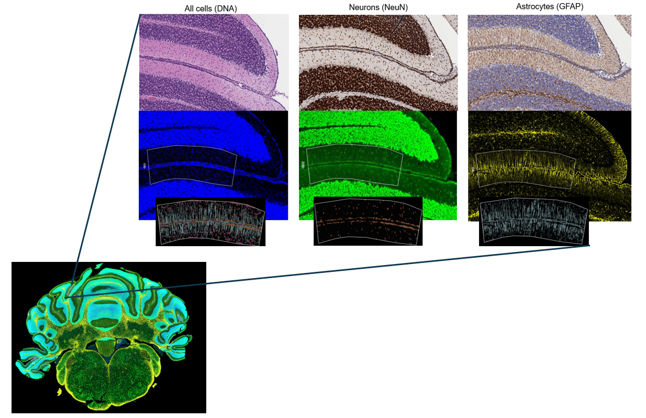

Figure 4: Immunofluorescence in external granular layer region in PTU condition. Immunofluorescence using antibody NeuN (Neurons) and GFAP (Astrocytes) for the staining and segmentation in the external granular layer region located in the cerebellum.

Table 8: List of significantly deregulated pathways in Spatial transcriptomic in PCN condition

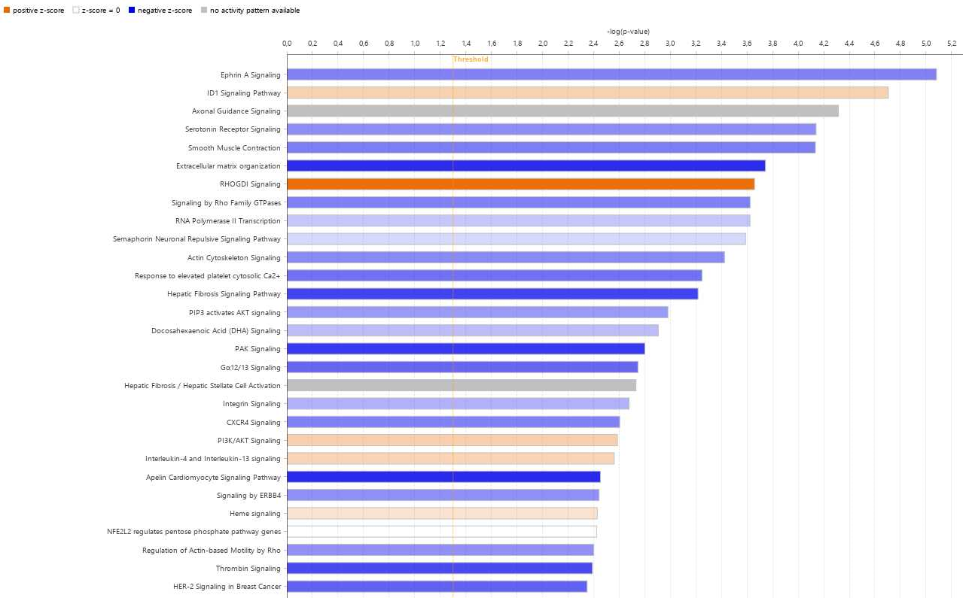
- Cerebellum region, neurons, PCN treatment

- Cerebellum region, astrocytes, PCN treatment
