Supplementary Material
Supplementary Table 1: Predictive performance metrics of various DILI prediction strategies. Calculations were based on distinguishing No- from Most-DILI concern and Clinical Development Failure drugs, and assuming that mifepristone and primidone are DILI-positive, despite being classified No-DILI concern in DILIrank, for the reasons outlined in text. Ideal thresholds are based on Youden’s index(YOUDEN 1950).

DILI Prediction  Strategy | Parameter |  | Classification  Threshold Value |  | Sensitivity  (No vs Most/  Clinical Dev) |  | Specificity (No vs Most/  Clinical Dev) | Balanced Accuracy | ROC AUC
1: Screening  heuristics | LogP |  | 3 |  | 61.6% |  | 39.1% | 50.4% | 55.8%
1: Screening  heuristics | Dose |  | 100 mg |  | 79.5% |  | 82.6% | 81.0% | 89.8%
1: Screening  heuristics | Rule of Two |  | LogP >=3, Dose >= 100 mg |  | 45.5% |  | 91.3% | 68.4% | -
1: Screening  heuristics | In vivo Cmax |  | 1.1 µM |  | 82.1% |  | 93.5% | 87.8% | 93.1%
1: Screening  heuristics | In silico Cmax |  | 1.1 µM |  | 81.2% |  | 91.3% | 86.3% | 90.5%
1: Screening  heuristics | Lowest In vitro toxicity (incl. BSEP) |  | 29.44 µM  (ideal) |  | 70.5% |  | 66.7% | 68.6% | 67.34%
2a: In vitro hepatotoxicity  excl. BSEP  (retrospective) | Ratio of in vivo Cmax to functional in vitro toxicity (excl. BSEP) |  | 0.25 (mechanistic) |  | 50.9% |  | 100% | 75.4% | 96.5%
2a: In vitro hepatotoxicity  excl. BSEP  (retrospective) |  |  | 0.011  (ideal) |  | 97.3% |  | 84.2% | 90.8% | 96.5%
2b: In vitro hepatotoxicity  incl. BSEP  (retrospective) | Ratio of in vivo Cmax to lowest in vitro toxicity (incl. BSEP) |  | 0.25 (mechanistic) |  | 55.4% |  | 100% | 77.7% | 96.8%
2b: In vitro hepatotoxicity  incl. BSEP  (retrospective) |  |  | 0.024  (ideal) |  | 92.9% |  | 89.1% | 91.0% | 96.8%
3a: In vitro hepatotoxicity  excl. BSEP  (prospective) | Ratio of in silico Cmax to functional in vitro toxicity (excl. BSEP) |  | 0.25 (mechanistic) |  | 50.0% |  | 94.7% | 72.4% | 92.3%
3a: In vitro hepatotoxicity  excl. BSEP  (prospective) |  |  | 0.017  (ideal) |  | 91.1% |  | 84.2% | 87.6% | 92.3%
3b: In vitro hepatotoxicity  incl. BSEP  (prospective) | Ratio of in silico Cmax to lowest in vitro toxicity (incl. BSEP) |  | 0.25 (mechanistic) |  | 55.4% |  | 95.7% | 75.5% | 93.7%
3b: In vitro hepatotoxicity  incl. BSEP  (prospective) |  |  | 0.017  (ideal) |  | 92.0% |  | 81.2% | 86.6% | 93.7%
4: BSEP inhibition alone | Ratio of in vivo Cmax to BSEP IC50 |  | 0.25 (mechanistic) |  | 42.0% |  | 100% | 71.0% | 96.4%
4: BSEP inhibition alone |  |  | 0.012  (ideal) |  | 92.6% |  | 92.0% | 92.3% | 96.4%
5: Bile acid model simulations | Duration of Bile Acid Elevation above two-fold |  | 100 min |  | 22.2% |  | 100% | 61.1% | 61.7%

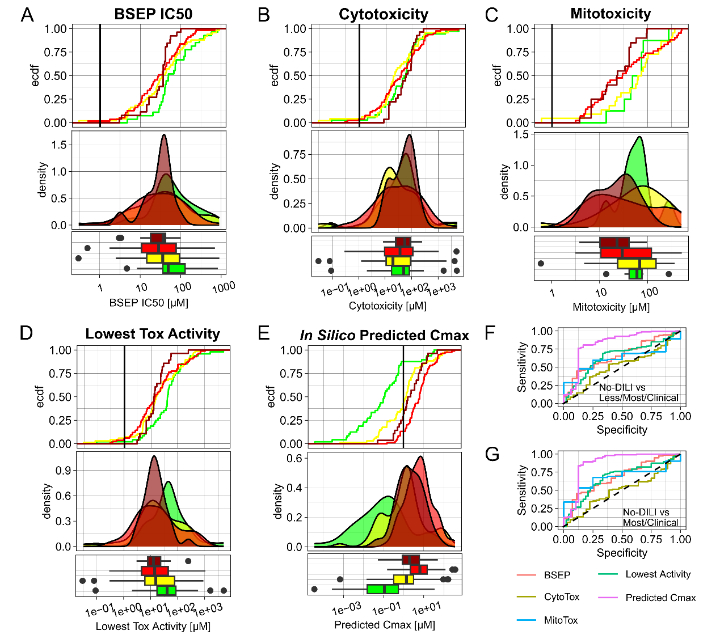
SI-Fig. 1: DILI predictivity of in vitro toxicity and in silico-predicted Cmax values alone. Cumulative distribution, probability density and boxplots of different properties of drugs of the different DILIrank classes: In vitro BSEP IC50 (A), cytotoxicity (B), mitochondrial toxicity (C), the lowest toxicity potency per compound (D) and in silico-predicted Cmax values (E). ROC curves of the various parameters for distinguishing No-DILI compounds from Less-/Most-DILI/Clinical Development Failures (F) or only from Most-DILI/Clinical Development Failures. (G).

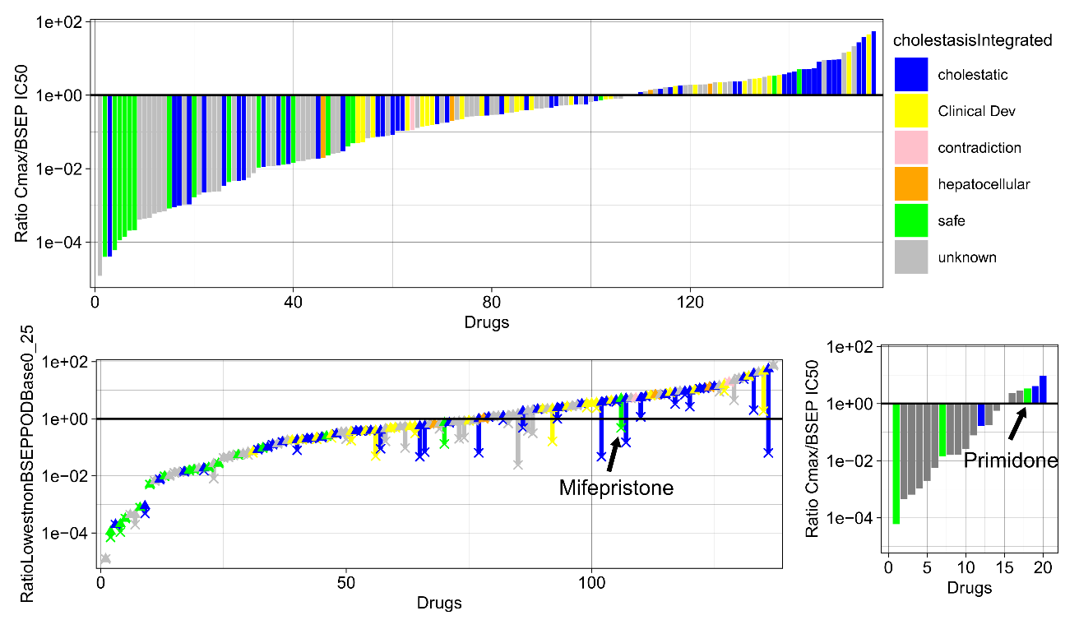
SI-Fig. 2: DILI patterns of drugs with BSEP inhibition data. Ratio of in vivo Cmax to BSEP IC50 values of each drug (A). Changes in Cmax to toxicity ratios when including BSEP IC50 values for compounds that have at least one functional in vitro toxicity values (B). Ratio of Cmax to BSEP IC50 values of compounds that have no functional in vitro toxicity value (C).

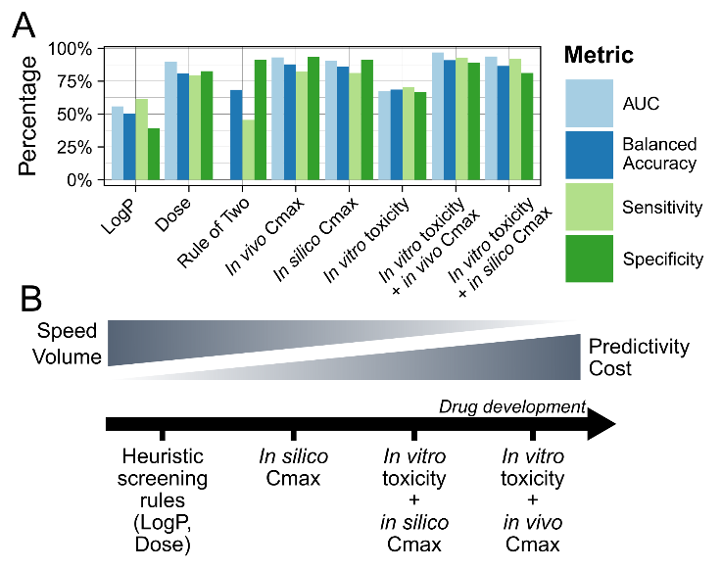
SI-Fig. 3: Summary of predictivity evaluations of various DILI prediction strategies. In vitro activity refers to the lowest in vitro measured toxicity per compound, including cytotoxicity, mitochondrial toxicity and BSEP inhibition (A). Ideal thresholds based on Youden’s index are used. Rule of Two does not possess a ROC AUC value, due to absence of drug risk ranking. Schematic representation of the role of different DILI prediction strategies in the drug development timeline (B).

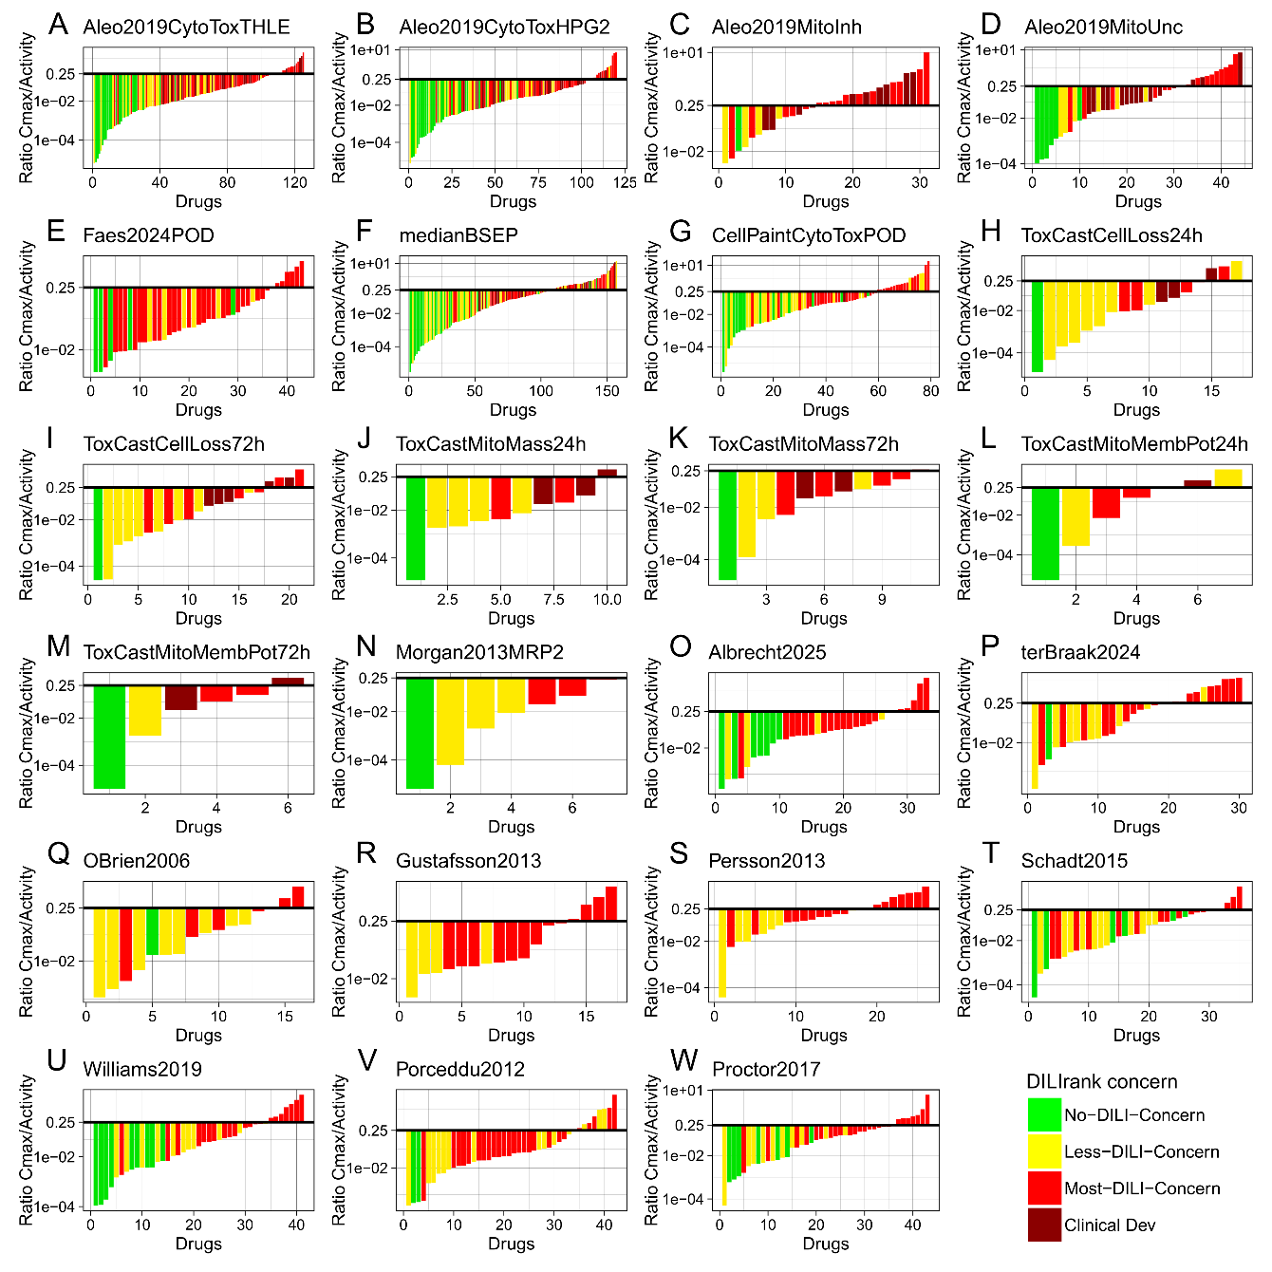
SI-Fig. 4: Individual results of each dataset integrated in this study. Ratio of in vivo Cmax to lowest functional in vitro toxicity of each drug for each in vitro toxicity dataset integrated in this study (A-W).

