Supplementary Information
Quercetin mitigates size-dependent oxidative and metabolic toxicity of citrate-coated silver nanoparticles in human erythrocytes
Inês Santos¹, Vera M. Costa^{2,3,4}, Félix Carvalho^{2,3}, Eduarda Fernandes^{1*}, Marisa Freitas^{1*}

¹LAQV, REQUIMTE, Laboratory of Applied Chemistry, Department of Chemical Sciences, Faculty of Pharmacy, University of Porto, 4050-313 Porto, Portugal
²UCIBIO - Applied Molecular Biosciences Unit, Laboratory of Toxicology, Department of Biological Sciences, Faculty of Pharmacy, University of Porto, 4050‐313 Porto, Portugal
³Associate Laboratory i4HB - Institute for Health and Bioeconomy, Faculty of Pharmacy, University of Porto, 4050-313 Porto, Portugal
⁴ Faculty of Medicine, University of Porto (FMUP), Rua Alameda Prof Hernâni Monteiro, 4200-319, Porto, Portugal
* Correspondence: marisafreitas@ff.up.pt / egracas@ff.up.pt
Journal name: Archives of Toxicology
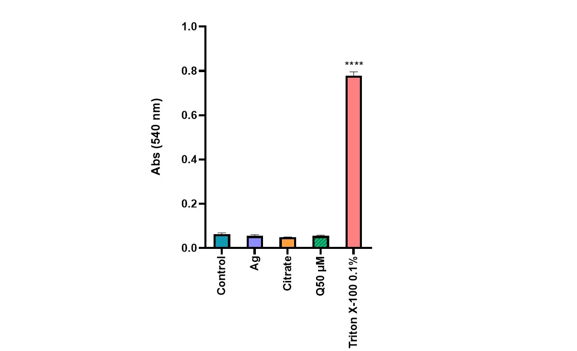
Fig. S1 Haemolytic effect to Triton X-100 (0.1%), Ag⁺ (0.5 µg/mL), citrate (0.02 µg/mL) and quercetin (50 µM) per se on erythrocytes after 5 hours of exposure. ****p<0.0001, compared to control (untreated cells). Each value represents the mean ± SEM of at least three independent assays.
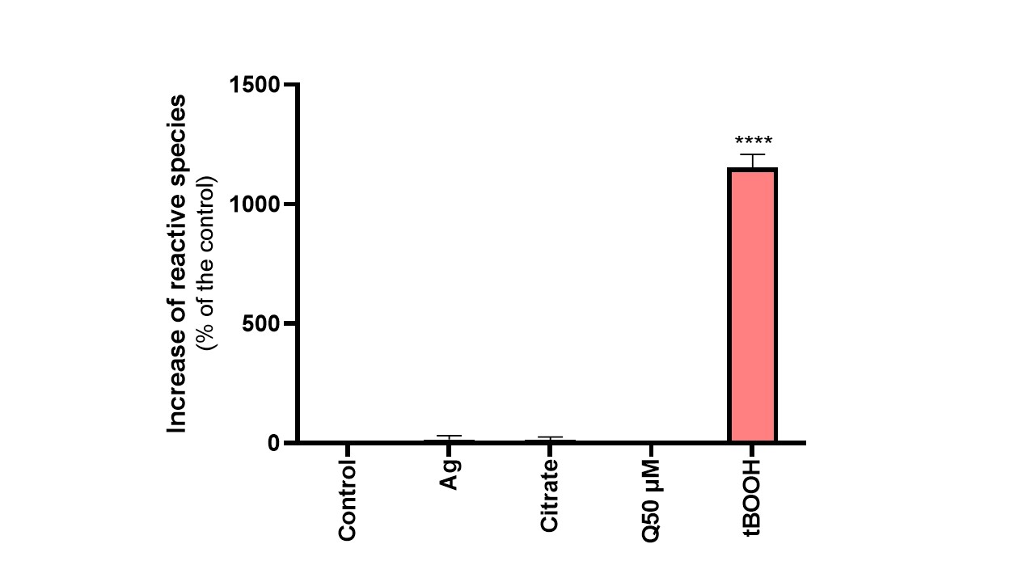
Fig. S2 Reactive species (RS) formation by erythrocytes to tBOOH (20 µM), Ag+ (0.5 µg/mL), citrate (0.02 µg/mL) and quercetin (50 µM) per se. ****p<0.0001, compared to control (untreated cells). Each value represents the mean ± SEM of at least three independent assays.
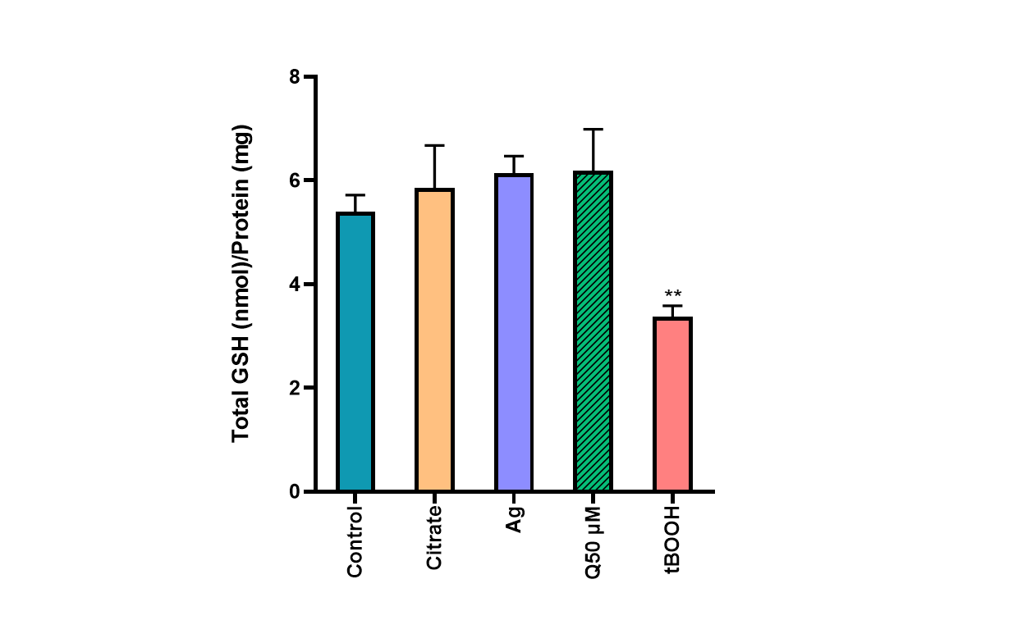
Fig. S3 Total GSH levels on erythrocytes to tBOOH (250 µM), Ag⁺ (0.5 µg/mL), citrate (0.02 µg/mL) and quercetin (50 µM) per se. **p<0.01, compared to control (untreated cells). Each value represents the mean ± SEM of at least three independent assays.

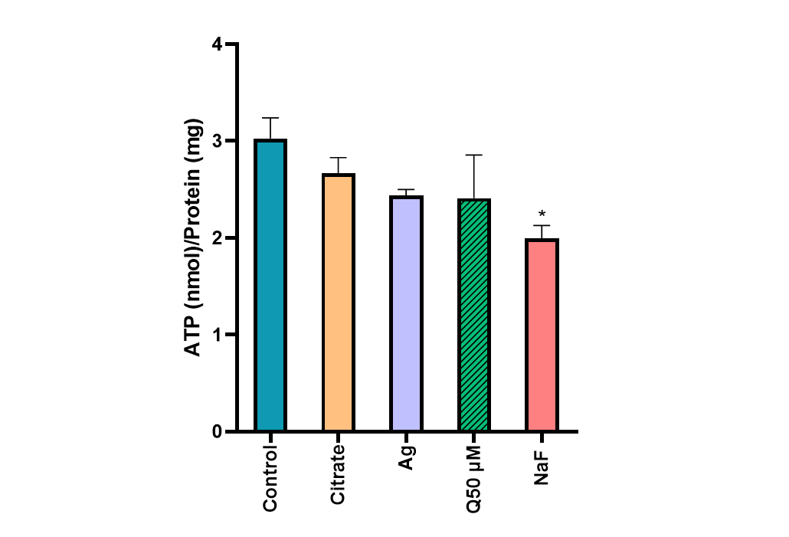
Fig. S4 ATP levels on erythrocytes after exposure to NaF (200 µM), Ag⁺ (0.5 µg/mL), citrate (0.02 µg/mL) and quercetin (50 µM) per se. *p<0.05, compared to control (untreated cells). Each value represents the mean ± SEM of at least three independent assays.
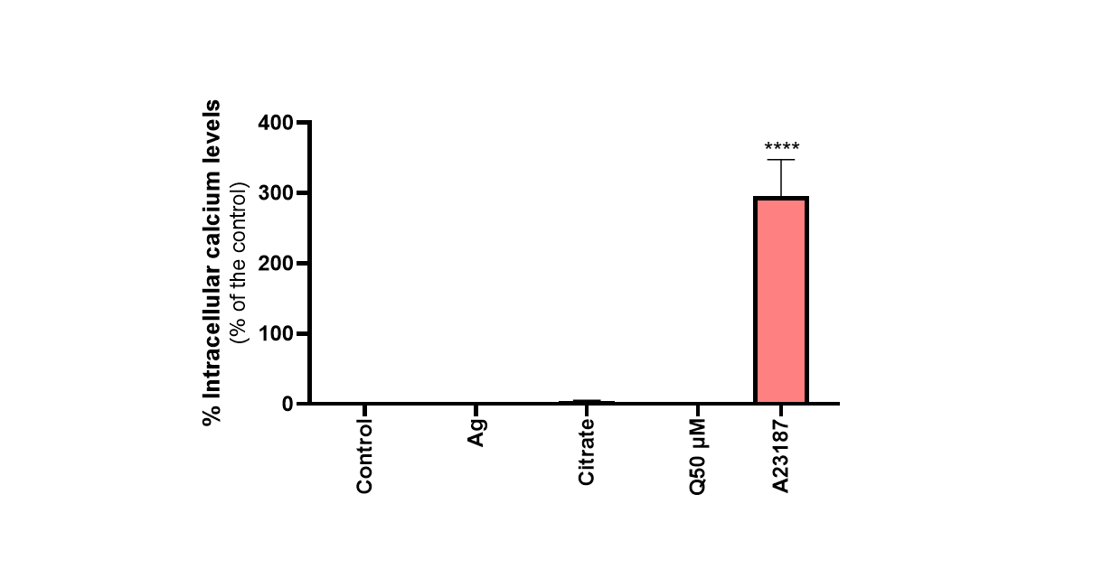
Fig. S5 Intracellular calcium levels on erythrocytes after exposure to A23187 (5 µM), Ag⁺ (0.5 µg/mL), citrate (0.02 µg/mL) and quercetin (50 µM) per se. ****p<0.0001, compared to control (untreated cells). Each value represents the mean ± SEM of at least three independent assays.

