Immunomodulatory potential of Alternaria mycotoxins on immune and intestinal cells:
a comparative systematic in vitro study
Vanessa Partsch^{1,2}, Amina Selimagić¹, Francesco Crudo¹, Doris Marko¹
¹University of Vienna, Faculty of Chemistry, Department of Food Chemistry and Toxicology, 1090 Vienna, Austria
²University of Vienna, Faculty of Chemistry, Doctoral School in Chemistry, 1090 Vienna, Austria

Corresponding authors:
Dr. Francesco Crudo
Department of Food Chemistry and Toxicology, University of Vienna
Währinger Str. 38, 1090 Vienna, Austria
francesco.crudo@univie.ac.at

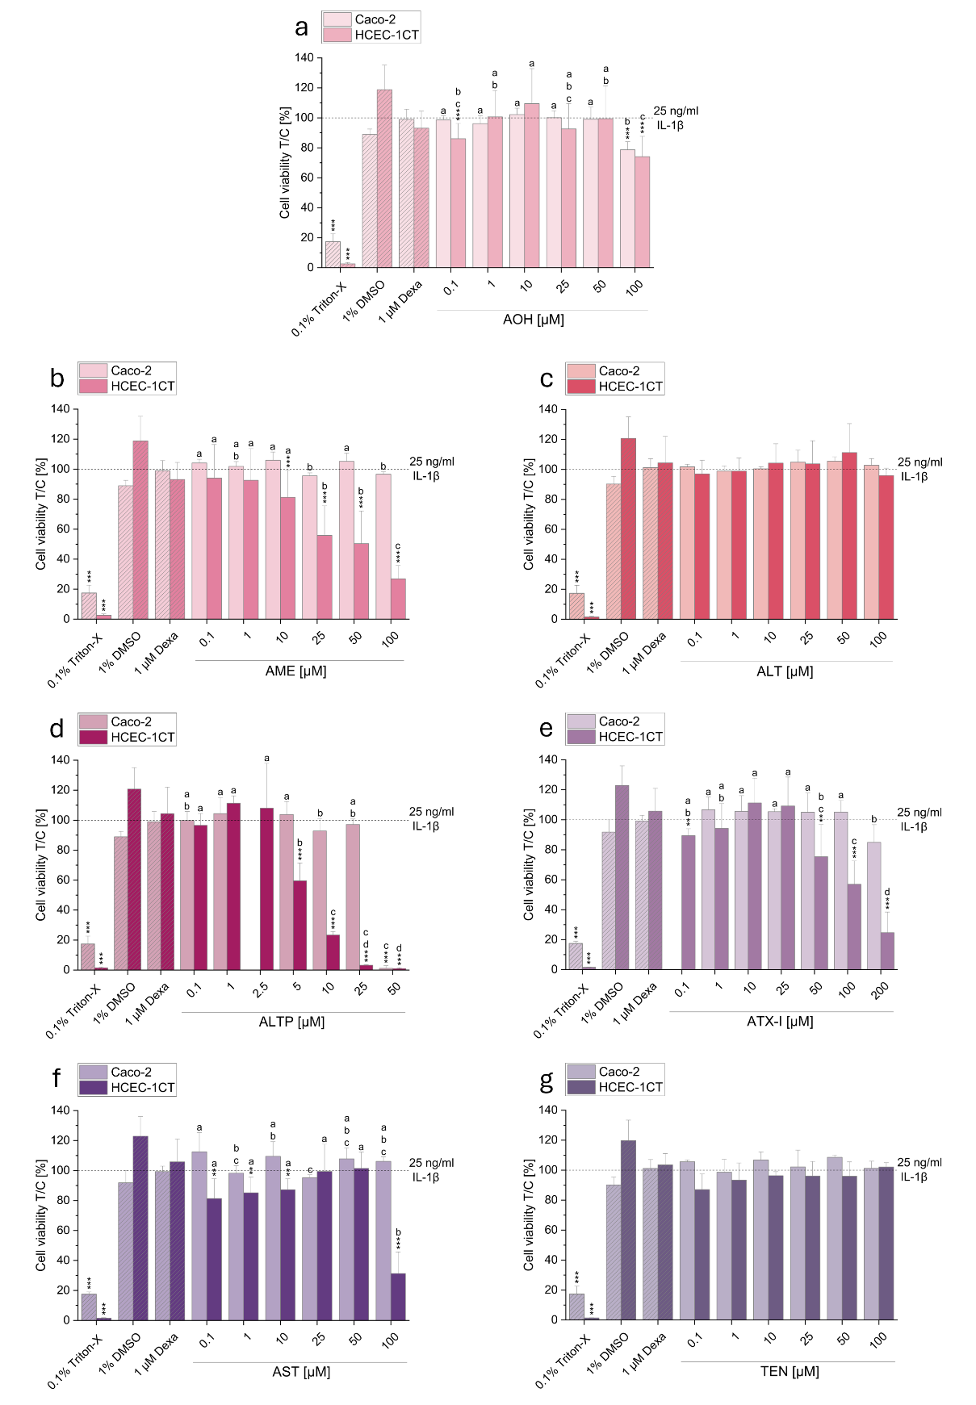
Supplementary Fig. 1 Cytotoxic effects of the seven Alternaria mycotoxins alternariol (AOH; a), alternariol monomethyl ether (AME; b), altenuene (ALT; c), alterperylenol (ALTP; d), altertoxin I (ATX-I; e), altersetin (AST; f), and tentoxin (TEN; g) on Caco-2 and HCEC-1CT cells assessed with the CellTiter-Blue® (CTB) assay. Cells were pre-incubated with non-toxic concentrations of the respective mycotoxins or 1 µM dexamethasone (Dexa; used as a control) for 2 h, followed by stimulation with 25 ng/mL IL-1β for an additional 3 h. Triton X-100 (0.01 %) was used as a positive control for cytotoxicity. Data are presented as mean + SD from at least three independent experiments. Results are expressed relative to the positive control (25 ng/mL IL-1β), indicated by dotted lines. Statistical significances between mycotoxin-treated samples and the positive control were evaluated using the Student’s t-test (*p<0.05, **p<0.01, and ***p<0.001). One-way ANOVA followed by a Fisher-LSD post hoc test (a-d; p<0.05) was applied to determine statistically significant differences between concentrations of the same mycotoxin
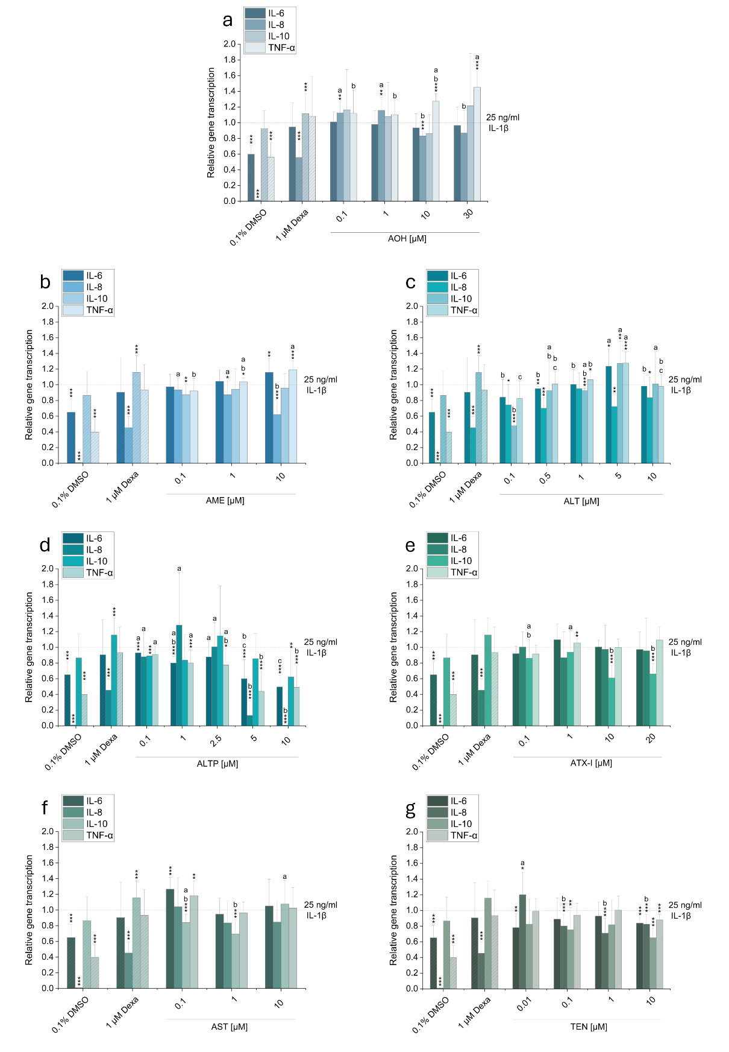
Supplementary Fig. 2 Impact of the seven Alternaria mycotoxins alternariol (AOH; a), alternariol monomethyl ether (AME; b), altenuene (ALT; c), alterperylenol (ALTP; d), altertoxin I (ATX-I; e), altersetin (AST; f), and tentoxin (TEN; g) on relative gene transcription levels of IL-6, IL-8, IL-10 and TNF-α in IL-1ß stimulated Caco-2 cells. Cells were pre-incubated with non-toxic concentrations of the respective mycotoxins or 1 µM dexamethasone (Dexa; used as negative control) for 2 h, followed by stimulation with 25 ng/mL IL-1β for an additional 3 h. Gene expression changes are presented as mean + SD of at least three biological replicates, calculated as relative gene transcription (2^{−ΔΔCT}), normalized to GAPDH, and compared to the positive control (25 ng/ml IL-1ß). Statistical significances between mycotoxin-treated samples and the positive control were evaluated using the Student’s t-test (*p<0.05, **p<0.01, and ***p<0.001). One-way ANOVA followed by a Fisher-LSD post hoc test (a-d; p<0.05) was applied to determine statistically significant differences between concentrations of the same mycotoxin
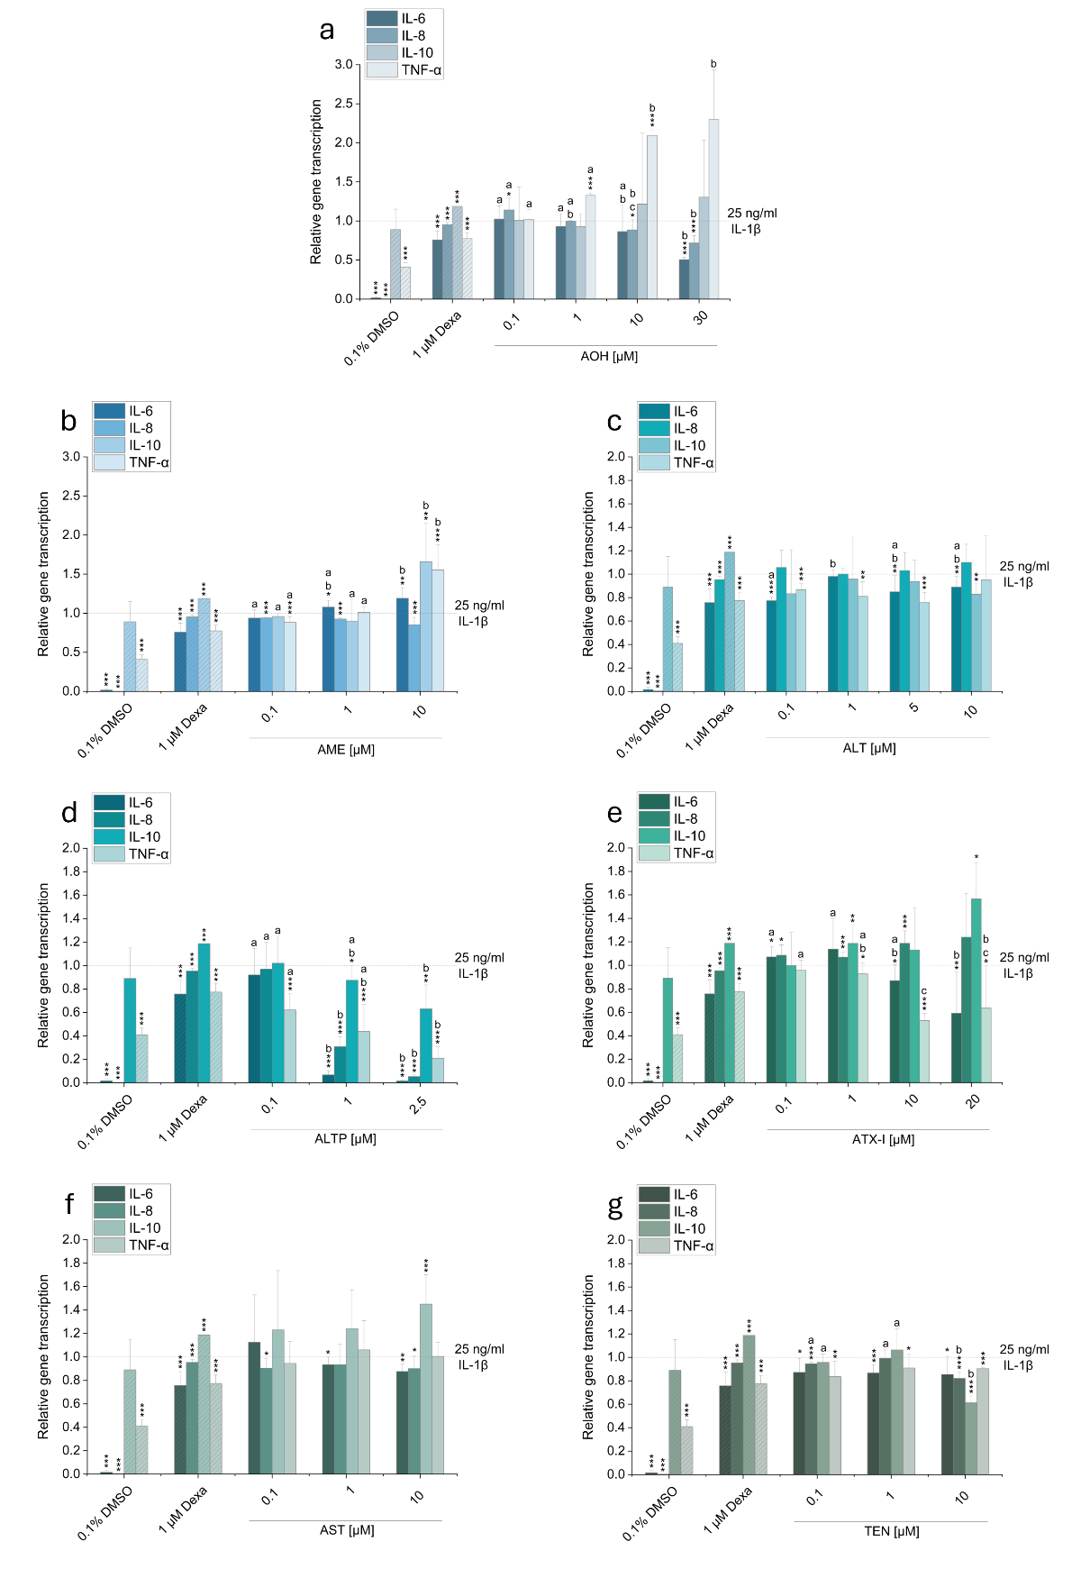
Supplementary Fig. 3 Impact of the seven Alternaria mycotoxins alternariol (AOH; a), alternariol monomethyl ether (AME; b), altenuene (ALT; c), alterperylenol (ALTP; d), altertoxin I (ATX-I; e), altersetin (AST; f), and tentoxin (TEN; g) on relative gene transcription levels of IL-6, IL-8, IL-10 and TNF-α in IL-1ß stimulated HCEC-1CT cells. Cells were pre-incubated with non-toxic concentrations of the respective mycotoxins or 1 µM dexamethasone (Dexa; used as negative control) for 2 h, followed by stimulation with 25 ng/mL IL-1β for an additional 3 h. Gene expression changes are presented as mean + SD of at least three biological replicates, calculated as relative gene transcription (2^{−ΔΔCT}), normalized to GAPDH, and compared to the positive control (25 ng/ml IL-1ß). Statistical significances between mycotoxin-treated samples and the positive control were evaluated using the Student’s t-test (*p<0.05, **p<0.01, and ***p<0.001). One-way ANOVA followed by a Fisher-LSD post hoc test (a-d; p<0.05) was applied to determine statistically significant differences between concentrations of the same mycotoxin

