Supplementary Figures
Figure 1
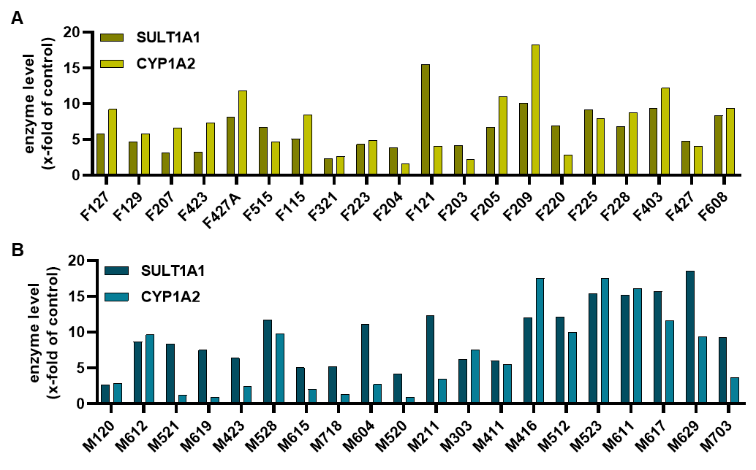
Fig. 1: CYP1A2 and SULT1A1 protein expression in human liver biopsies. Evaluation of western blot analysis for CYP1A2 and SULT1A1 expression in female (A) and male (B) human liver biopsies normalized to HepG2 cells with CYP1A2 and SULT1A1 expression. Hsp90 expression served as loading control.

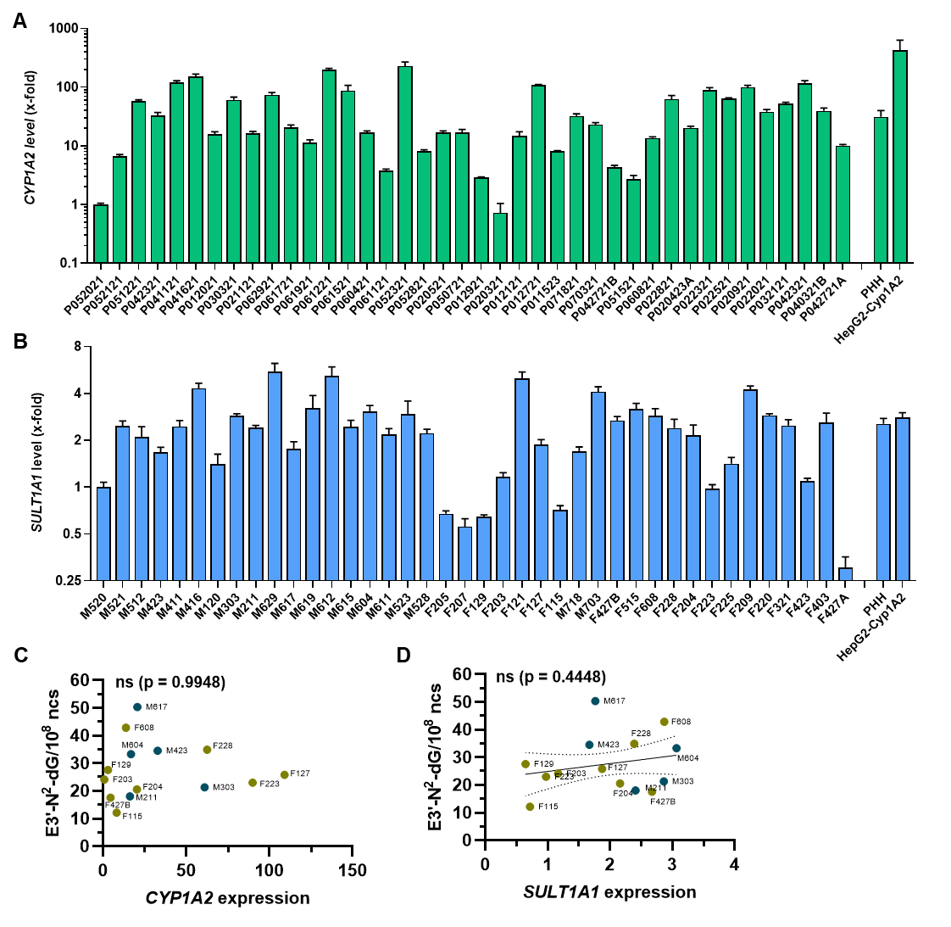
Figure 2

Fig. 2: CYP1A2 and SULT1A1 expression in human liver biopsies and correlation with estragole-derived DNA adducts. A - B Gene expression analysis of CYP1A2 (A) and SULT1A1 (B) expression in female and male human liver biopsies using qPCR. Gene expression levels were normalized to ACTB and GAPDH expression as housekeeping genes. C Correlation analysis of CYP1A2 expression with E3′-N²-dG adducts in liver samples above the LOQ. D Correlation analysis of SULT1A1 expression with E3′-N²-dG adducts in liver samples above the LOQ. Data given as mean + SD. Statistical analysis (C and D) was performed using two tailed, unpaired Pearson correlation test.

Supplementary Tables

Table 1: Antibodies used in this study.
Antibody | Catalog No. | Provider
Anti-Hsp90α/β (F-8), mouse monoclonal | sc-13119 | Santa Cruz Biotechnology,  Heidelberg, Germany
Anti-CYP1A2 (D15), mouse monoclonal | sc-53241 | Santa Cruz Biotechnology,  Heidelberg, Germany
Anti-SULT1A1, polyclonal rabbit | GTX55811 | Genetex, Irvine, California, USA
mouse IgGκ binding protein-HRP | sc-516102 | Santa Cruz Biotechnology,  Heidelberg, Germany
Goat-anti-Rabbit-HRP | #7074 | Cell Signaling Technology,  Danvers, Massachusetts, USA

Table 2: Used primer sequences to determine CYP1A2 and SULT1A1 expression levels by qPCR
qPCR-Primer | Sequence (5‘-3‘)
hCYP1A2-for | TTCGTAAACCAGTGGCAGGT
hCYP1A2-rev | AGGGCTTGTTAATGGCAGTG
hSULT1A1-for | CAAAGGATGTGGCAGTTTCC
hSULT1A1-rev | CCGACCATGAACTTCTCCAG
hACTB-for | tggcatccacgaaactacc
hACTB-rev | gtgttggcgtacaggtctt
hGAPDH-for | catgagaagtatgacaacag
hGAPDH-rev | atgagtccttccacgata

