SUPPLEMENTARY MATERIAL

Gene | Large Intestine |  |  | Ileum
Gene | ADI | NOAEL | MIXTURE | ADI | NOAEL | MIXTURE
Il22 | 0.98 ± 0.56 | 1.13 ± 0.70 | 7.86 ± 2.23 | 1.30 ± 0.87 | 1.21 ± 0.88 | 4.69 ± 2.42
Tlr4 | 0.86 ± 0.59 | 2.80 ± 0.43 | 6.22 ± 1.22 | 1.34 ± 0.45 | 3.06 ± 0.70 | 8.14 ± 1.65
Lcn2 | 1.26 ± 0.19 | 6.61 ± 1.66 | 10.2 ± 3.11 | 1.17 ± 0.69 | 6.08 ± 1.90 | 6.73 ± 2.08
Muc2 | 1.01 ± 0.30 | 0.15 ± 0.04 | 0.06 ± 0.01 | 0.96 ± 0.20 | 0.32 ± 0.08 | 0.15 ± 0.05
Ocln | 0.89 ± 0.30 | 0.18 ± 0.10 | 0.05 ± 0.01 | 1.13 ± 0.50 | 0.25 ± 0.09 | 0.14 ± 0.05
Zo1 | 1.13 ± 0.27 | 0.28 ± 0.07 | 0.06 ± 0.02 | 1.10 ± 0.28 | 0.33 ± 0.08 | 0.17 ± 0.07
Cldn3 | 1.02 ± 0.43 | 0.14 ± 0.03 | 0.04 ± 0.008 | 1.17 ± 0.53 | 0.35 ± 0.06 | 0.13 ± 0.03
Cldn4 | 0.83 ± 0.38 | 0.11 ± 0.04 | 0.05 ± 0.02 | 1.18 ± 0.48 | 0.08 ± 0.03 | 0.07 ± 0.02

Supplementary Table 1. Summary statistics of RT-qPCR assay outcomes in female rat ileum and large intestine for expression of markers of inflammation (Il22, Tlr4, Lcn2) and gut integrity (Muc2, Ocln, Zo1, Cldn3, Cldn4) in response to treatment with glyphosate at the EU acceptable daily intake (ADI) and no-observed adverse effect level (NOAEL) doses, and a glyphosate, 2,4-D and dicamba mixture (each at the EU ADI). Relative changes in untransformed gene expression values compared to control, untreated animals +/- standard deviation about the mean is shown.

Gene | Large Intestine |  |  | Ileum
Gene | ADI | NOAEL | MIXTURE | ADI | NOAEL | MIXTURE
Il22 | 1.32 ± 0.39 | 0.90 ± 0.22 | 4.12 ± 1.07 | 1.32 ± 0.5 | 3.73 ± 1.10 | 4.59 ± 1.20
Tlr4 | 1.23 ± 0.31 | 2.48 ± 0.80 | 5.15 ± 1.48 | 1.08 ± 0.73 | 2.37 ± 0.57 | 4.54 ± 1.34
Lcn2 | 1.10 ± 0.21 | 4.26 ± 0.89 | 10.2 ± 3.11 | 0.97 ± 0.59 | 3.66 ± 0.77 | 5.01 ± 1.48
Muc2 | 1.43 ± 0.39 | 0.26 ± 0.09 | 0.09 ± 0.04 | 1.05 ± 0.18 | 0.49 ± 0.12 | 0.23 ± 0.05
Ocln | 0.98 ± 0.34 | 0.22 ± 0.10 | 0.08 ± 0.02 | 1.03 ± 0.28 | 0.33 ± 0.05 | 0.24 ± 0.09
Zo1 | 1.06 ± 0.31 | 0.42 ± 0.14 | 0.13 ± 0.03 | 1.10 ± 0.18 | 0.43 ± 0.11 | 0.25 ± 0.10
Cldn3 | 0.90 ± 0.34 | 0.22 ± 0.08 | 0.06 ± 0.01 | 1.12 ± 0.34 | 0.43 ± 0.14 | 0.23 ± 0.05
Cldn4 | 1.18 ± 0.29 | 0.14 ± 0.04 | 0.06 ± 0.02 | 1.06 ± 0.23 | 0.21 ± 0.06 | 0.10 ± 0.03

Supplementary Table 2. Summary statistics of RT-qPCR assay outcomes in male rat ileum and large intestine for expression of markers of inflammation (Il22, Tlr4, Lcn2) and gut integrity (Muc2, Ocln, Zo1, Cldn3, Cldn4) in response to treatment with glyphosate at the EU ADI and NOAEL doses, and a glyphosate, 2,4-D and dicamba mixture (each at the EU ADI). Relative changes in untransformed gene expression values compared to control, untreated animals +/- standard deviation about the mean is shown.

Parameter | Compartment | Source of Variation | % of total variation | p-value
Muc2 expression | Caecum | Interaction | 0.8066 | 0.0113
Muc2 expression | Caecum | Sex Factor | 2.075 | <0.0001
Muc2 expression | Caecum | Treatment Factor | 92.83 | <0.0001
Muc2 expression | ileum | Interaction | 1.654 | 0.0082
Muc2 expression | ileum | Sex Factor | 2.436 | <0.0001
Muc2 expression | ileum | Treatment Factor | 86.76 | <0.0001
Ocln expression | Caecum | Interaction | 0.328 | 0.3516
Ocln expression | Caecum | Sex Factor | 0.484 | 0.03
Ocln expression | Caecum | Treatment Factor | 92.22 | <0.0001
Ocln expression | ileum | Interaction | 2.045 | 0.0135
Ocln expression | ileum | Sex Factor | 1.051 | 0.0178
Ocln expression | ileum | Treatment Factor | 83.77 | <0.0001
Zo-1 expression | Caecum | Interaction | 2.665 | <0.0001
Zo-1 expression | Caecum | Sex Factor | 1.782 | <0.0001
Zo-1 expression | Caecum | Treatment Factor | 89.3 | <0.0001
Zo-1 expression | ileum | Interaction | 1.228 | 0.0939
Zo-1 expression | ileum | Sex Factor | 1.135 | 0.0156
Zo-1 expression | ileum | Treatment Factor | 84.36 | <0.0001
Cldn3 expression | Caecum | Interaction | 0.996 | 0.0009
Cldn3 expression | Caecum | Sex Factor | 0.5541 | 0.002
Cldn3 expression | Caecum | Treatment Factor | 94.15 | <0.0001
Cldn3 expression | ileum | Interaction | 1.948 | 0.0044
Cldn3 expression | ileum | Sex Factor | 1.11 | 0.0057
Cldn3 expression | ileum | Treatment Factor | 86.91 | <0.0001
Cldn4 expression | Caecum | Interaction | 0.2467 | 0.3784
Cldn4 expression | Caecum | Sex Factor | 0.6205 | 0.0065
Cldn4 expression | Caecum | Treatment Factor | 94.03 | <0.0001
Cldn4 expression | ileum | Interaction | 2.95 | <0.0001
Cldn4 expression | ileum | Sex Factor | 1.55 | <0.0001
Cldn4 expression | ileum | Treatment Factor | 89.76 | <0.0001
Zonulin conc. | Serum | Interaction | 11.54 | <0.0001
Zonulin conc. | Serum | Sex Factor | 4.494 | 0.0023
Zonulin conc. | Serum | Treatment Factor | 52.27 | <0.0001
Calprotectin conc. | Caecum | Interaction | 39.4 | <0.0001
Calprotectin conc. | Caecum | Sex Factor | 18.73 | <0.0001
Calprotectin conc. | Caecum | Treatment Factor | 38.45 | <0.0001
Il22 expression | Caecum | Interaction | 4.117 | 0.0002
Il22 expression | Caecum | Sex Factor | 0.8393 | 0.0356
Il22 expression | Caecum | Treatment Factor | 81.75 | <0.0001
Il22 expression | ileum | Interaction | 9.499 | <0.0001
Il22 expression | ileum | Sex Factor | 3.831 | 0.0016
Il22 expression | ileum | Treatment Factor | 61.29 | <0.0001
Lcn2 expression | Caecum | Interaction | 0.8444 | 0.5108
Lcn2 expression | Caecum | Sex Factor | 1.441 | 0.05
Lcn2 expression | Caecum | Treatment Factor | 72.39 | <0.0001
Lcn2 expression | ileum | Interaction | 1.032 | 0.2637
Lcn2 expression | ileum | Sex Factor | 1.834 | 0.009
Lcn2 expression | ileum | Treatment Factor | 79.59 | <0.0001
Tlr4 expression | Caecum | Interaction | 1.508 | 0.1706
Tlr4 expression | Caecum | Sex Factor | 0.002593 | 0.9252
Tlr4 expression | Caecum | Treatment Factor | 76.96 | <0.0001
Tlr4 expression | ileum | Interaction | 1.63 | 0.1463
Tlr4 expression | ileum | Sex Factor | 2.517 | 0.0046
Tlr4 expression | ileum | Treatment Factor | 75.57 | <0.0001
GSH | Caecum | Interaction | 3.983 | 0.1971
GSH | Caecum | Sex Factor | 0.2029 | 0.6223
GSH | Caecum | Treatment Factor | 40.06 | <0.0001
Η₂Ο₂ decomposition rate | Caecum | Interaction | 2.168 | 0.6408
Η₂Ο₂ decomposition rate | Caecum | Sex Factor | 1.033 | 0.3725
Η₂Ο₂ decomposition rate | Caecum | Treatment Factor | 11.26 | 0.0399
TAC | Caecum | Interaction | 2.322 | 0.6331
TAC | Caecum | Sex Factor | 0.1898 | 0.7084
TAC | Caecum | Treatment Factor | 8.29 | 0.1147
TBARS | Caecum | Interaction | 4.006 | 0.3415
TBARS | Caecum | Sex Factor | 3.815 | 0.0764
TBARS | Caecum | Treatment Factor | 18.71 | 0.0025
CARBS | Caecum | Interaction | 2.249 | 0.5961
CARBS | Caecum | Sex Factor | 0.4961 | 0.5196
CARBS | Caecum | Treatment Factor | 20.62 | 0.0014

Supplementary Table 3. Analysis of interactions in the two-way ANOVA models applied to understand the effects of the treatment with glyphosate at the EU acceptable daily intake (ADI) and no-observed adverse effect level (NOAEL) doses, and a glyphosate, 2,4-D and dicamba mixture (each at the EU ADI). The source of variation lists the interaction between sex and treatment (Interaction) and the main effects of sex (Sex Factor) and treatment (Treatment Factor). Percentage (%) of Total Variation represents the proportion of total variation in gene expression explained by each source of variation. The p-value indicates the statistical significance of each factor.

Dose | Sex | Comp | Firmicutes | Bacteroidota | Actinobacteriota | Campylobacterota | Desulfobacterota
ADI | F | Caecum | 53.0 ± 5.6 | 35.7 ± 6.8 | 0.6 ± 0.2 | 0.9 ± 1.0 | 2.3 ± 1.3
ADI | F | Ileum | 80.6 ± 9.7 | 4.8 ± 5.6 | 7.8 ± 5.4 | 0.0 ± 0.0 | 0.1 ± 0.1
ADI | M | Caecum | 56.9 ± 2.3 | 32.7 ± 2.2 | 0.6 ± 0.1 | 1.0 ± 0.3 | 3.3 ± 0.5
ADI | M | Ileum | 81.1 ± 18.3 | 12.5 ± 17.2 | 2.7 ± 1.1 | 0.3 ± 0.4 | 1.7 ± 2.4
Control | F | Caecum | 56.5 ± 6.1 | 33.0 ± 7.9 | 0.5 ± 0.2 | 0.2 ± 0.1 | 3.3 ± 1.3
Control | F | Ileum | 80.1 ± 10.3 | 8.8 ± 10.3 | 6.5 ± 5.3 | 0.1 ± 0.1 | 0.9 ± 1.6
Control | M | Caecum | 62.2 ± 3.6 | 29.2 ± 3.0 | 1.2 ± 1.0 | 0.1 ± 0.2 | 1.6 ± 0.6
Control | M | Ileum | 85.1 ± 9.4 | 7.3 ± 8.4 | 4.0 ± 2.8 | 0.1 ± 0.1 | 0.5 ± 0.6
Mixture | F | Caecum | 57.1 ± 4.5 | 32.9 ± 5.3 | 0.5 ± 0.2 | 0.5 ± 0.4 | 2.4 ± 0.6
Mixture | F | Ileum | 89.4 ± 4.6 | 2.1 ± 2.3 | 4.4 ± 3.2 | 0.1 ± 0.1 | 0.4 ± 0.8
Mixture | M | Caecum | 60.7 ± 4.8 | 32.9 ± 4.7 | 0.4 ± 0.1 | 0.8 ± 0.5 | 1.9 ± 0.9
Mixture | M | Ileum | 91.0 ± 4.6 | 0.4 ± 0.4 | 6.5 ± 3.6 | 0.0 ± 0.0 | 0.1 ± 0.2
NOAEL | F | Caecum | 53.6 ± 6.0 | 33.3 ± 3.7 | 0.8 ± 0.4 | 0.6 ± 0.8 | 5.4 ± 3.5
NOAEL | F | Ileum | 75.8 ± 12.6 | 1.7 ± 1.9 | 14.4 ± 10.5 | 0.0 ± 0.0 | 0.3 ± 0.6
NOAEL | M | Caecum | 58.7 ± 2.3 | 33.8 ± 2.8 | 0.6 ± 0.1 | 0.5 ± 0.3 | 2.3 ± 1.1
NOAEL | M | Ileum | 84.6 ± 8.9 | 5.1 ± 7.4 | 7.0 ± 5.2 | 0.1 ± 0.2 | 0.3 ± 0.4
Dose | Sex | Comp | Verrucomicrobiota | Spirochaetota | Proteobacteria | Patescibacteria | Elusimicrobiota
ADI | F | Caecum | 2.3 ± 3.3 | 1.0 ± 0.6 | 0.3 ± 0.3 | 0.3 ± 0.1 | 0.4 ± 0.3
ADI | F | Ileum | 1.1 ± 1.5 | 0.0 ± 0.0 | 5.1 ± 8.6 | 0.2 ± 0.4 | 0.0 ± 0.0
ADI | M | Caecum | 0.0 ± 0.0 | 3.0 ± 0.8 | 0.1 ± 0.3 | 0.4 ± 0.1 | 0.3 ± 0.2
ADI | M | Ileum | 0.0 ± 0.0 | 0.2 ± 0.2 | 1.2 ± 1.1 | 0.2 ± 0.2 | 0.0 ± 0.0
Control | F | Caecum | 2.6 ± 4.0 | 1.5 ± 1.0 | 0.2 ± 0.2 | 0.5 ± 0.2 | 0.2 ± 0.1
Control | F | Ileum | 0.4 ± 1.1 | 0.0 ± 0.0 | 2.5 ± 2.1 | 0.5 ± 0.7 | 0.0 ± 0.0
Control | M | Caecum | 0.4 ± 0.4 | 1.9 ± 1.8 | 0.7 ± 0.7 | 0.4 ± 0.3 | 0.6 ± 0.5
Control | M | Ileum | 0.2 ± 0.3 | 0.4 ± 0.6 | 2.0 ± 1.9 | 0.1 ± 0.1 | 0.1 ± 0.1
Mixture | F | Caecum | 0.2 ± 0.6 | 1.7 ± 0.9 | 0.2 ± 0.2 | 0.5 ± 0.2 | 0.3 ± 0.4
Mixture | F | Ileum | 0.1 ± 0.3 | 0.0 ± 0.1 | 3.1 ± 3.5 | 0.3 ± 0.2 | 0.0 ± 0.0
Mixture | M | Caecum | 0.0 ± 0.0 | 1.2 ± 1.3 | 0.2 ± 0.1 | 0.1 ± 0.1 | 0.1 ± 0.1
Mixture | M | Ileum | 0.0 ± 0.0 | 0.0 ± 0.0 | 2.0 ± 2.0 | 0.0 ± 0.0 | 0.0 ± 0.0
NOAEL | F | Caecum | 1.8 ± 2.4 | 1.0 ± 1.1 | 0.4 ± 0.4 | 0.6 ± 0.4 | 0.5 ± 0.5
NOAEL | F | Ileum | 0.1 ± 0.2 | 0.0 ± 0.0 | 7.2 ± 7.9 | 0.2 ± 0.4 | 0.0 ± 0.0
NOAEL | M | Caecum | 0.0 ± 0.0 | 1.2 ± 0.7 | 0.3 ± 0.4 | 0.3 ± 0.3 | 0.4 ± 0.3
NOAEL | M | Ileum | 0.0 ± 0.0 | 0.0 ± 0.0 | 2.6 ± 2.4 | 0.1 ± 0.1 | 0.0 ± 0.0

Supplementary Table 4. Gut microbiota composition at the phylum level in response to treatment with glyphosate at the EU acceptable daily intake (ADI) and no-observed adverse effect level (NOAEL) doses, and a glyphosate, 2,4-D and dicamba mixture (each at the EU ADI). Microbiota composition was determined by 16S V3-V4 region sequencing. Data represents relative abundance of the different 16S amplicon sequence variants having their abundance agglomerated at the phylum level.

description | group | p_adjust
4-aminobutanoate degradation V | ADI | 0.305
4-aminobutanoate degradation V | NOAEL | 0.748
4-aminobutanoate degradation V | Mixture | 0.087
acetyl-CoA fermentation to butanoate II | ADI | 0.933
acetyl-CoA fermentation to butanoate II | NOAEL | 0.995
acetyl-CoA fermentation to butanoate II | Mixture | 0.886
L-glutamate degradation V (via hydroxyglutarate) | ADI | 0.737
L-glutamate degradation V (via hydroxyglutarate) | NOAEL | 0.954
L-glutamate degradation V (via hydroxyglutarate) | Mixture | 0.891
L-lysine fermentation to acetate and butanoate | ADI | 0.899
L-lysine fermentation to acetate and butanoate | NOAEL | 0.978
L-lysine fermentation to acetate and butanoate | Mixture | 0.822
pyruvate fermentation to butanoate | ADI | 0.185
pyruvate fermentation to butanoate | NOAEL | 0.608
pyruvate fermentation to butanoate | Mixture | 0.786
succinate fermentation to butanoate | ADI | 0.857
succinate fermentation to butanoate | NOAEL | 0.912
succinate fermentation to butanoate | Mixture | 0.995

Supplementary Table 5. Gut microbiota functional analysis in response to treatment with glyphosate at the EU acceptable daily intake (ADI) and no-observed adverse effect level (NOAEL) doses, and a glyphosate, 2,4-D and dicamba mixture (each at the EU ADI) fails to show any effects on the pathways linked to the production of short-chain fatty acids in the gut microbiota of the rats. Only statistically significance changes are displayed in this table. Functional analysis was inferred using Picrust2. Statistical significance was determined using the standard statistical analysis in Picrust2 using the DeSeq2 statistical method. The p-values were adjusted using the Benjamini–Hochberg procedure.

description | group | p_adjust
superpathway of N-acetylglucosamine, N-acetylmannosamine and N-acetylneuraminate degradation | ADI | 6.89E-05
sucrose degradation III (sucrose invertase) | ADI | 6.89E-05
L-lysine biosynthesis VI | ADI | 9.85E-05
superpathway of pyrimidine nucleobases salvage | ADI | 9.85E-05
glycolysis III (from glucose) | ADI | 0.0002
dTDP-L-rhamnose biosynthesis I | ADI | 0.0002
UMP biosynthesis | ADI | 0.0002
galactose degradation I (Leloir pathway) | ADI | 0.0002
adenosine ribonucleotides de novo biosynthesis | ADI | 0.0002
coenzyme A biosynthesis I | ADI | 0.0002
L-lysine biosynthesis III | ADI | 0.0002
superpathway of adenosine nucleotides de novo biosynthesis II | ADI | 0.0002
superpathway of adenosine nucleotides de novo biosynthesis I | ADI | 0.0003
UDP-N-acetylmuramoyl-pentapeptide biosynthesis II (lysine-containing) | ADI | 0.0003
peptidoglycan biosynthesis I (meso-diaminopimelate containing) | ADI | 0.0003
peptidoglycan biosynthesis III (mycobacteria) | ADI | 0.0003
UDP-N-acetylmuramoyl-pentapeptide biosynthesis I (meso-diaminopimelate containing) | ADI | 0.0003
gluconeogenesis I | ADI | 0.0004
O-antigen building blocks biosynthesis (E. coli) | ADI | 0.0004
CDP-diacylglycerol biosynthesis I | ADI | 0.0004
adenosine deoxyribonucleotides de novo biosynthesis II | ADI | 0.0004
guanosine deoxyribonucleotides de novo biosynthesis II | ADI | 0.0004
gondoate biosynthesis (anaerobic) | ADI | 0.0004
CDP-diacylglycerol biosynthesis II | ADI | 0.0004
tRNA charging | ADI | 0.0004
pyruvate fermentation to acetate and lactate II | ADI | 0.0007
guanosine ribonucleotides de novo biosynthesis | ADI | 0.0007
superpathway of phospholipid biosynthesis I (bacteria) | ADI | 0.0009
S-adenosyl-L-methionine cycle I | ADI | 0.0013
superpathway of N-acetylneuraminate degradation | ADI | 0.0015
phosphatidylglycerol biosynthesis I (plastidic) | ADI | 0.0016
phosphatidylglycerol biosynthesis II (non-plastidic) | ADI | 0.0016
inosine-5'-phosphate biosynthesis I | ADI | 0.0018
cis-vaccenate biosynthesis | ADI | 0.0041
glycolysis I (from glucose 6-phosphate) | ADI | 0.0053
Bifidobacterium shunt | ADI | 0.0053
fatty acid elongation -- saturated | ADI | 0.0053
hexitol fermentation to lactate, formate, ethanol and acetate | ADI | 0.0053
L-methionine biosynthesis III | ADI | 0.0054
peptidoglycan maturation (meso-diaminopimelate containing) | ADI | 0.0089
peptidoglycan biosynthesis IV (Enterococcus faecium) | ADI | 0.0096
adenine and adenosine salvage III | ADI | 0.0096
superpathway of pyrimidine ribonucleotides de novo biosynthesis | ADI | 0.0096
teichoic acid (poly-glycerol) biosynthesis | ADI | 0.0096
UDP-N-acetyl-D-glucosamine biosynthesis I | ADI | 0.0096
TCA cycle VIII (helicobacter) | ADI | 0.0131
superpathway of pyrimidine deoxyribonucleosides degradation | ADI | 0.0138
L-lysine biosynthesis I | ADI | 0.0153
polyisoprenoid biosynthesis (E. coli) | ADI | 0.0153
pyrimidine deoxyribonucleotides de novo biosynthesis II | ADI | 0.0168
heterolactic fermentation | ADI | 0.0169
acetylene degradation | ADI | 0.0235
superpathway of pyrimidine deoxyribonucleotides de novo biosynthesis (E. coli) | ADI | 0.0243
homolactic fermentation | ADI | 0.0245
purine ribonucleosides degradation | ADI | 0.0265
aerobic respiration I (cytochrome c) | ADI | 0.0281
superpathway of L-threonine biosynthesis | ADI | 0.0290
superpathway of purine nucleotides de novo biosynthesis II | ADI | 0.0309
L-methionine biosynthesis I | ADI | 0.0309
superpathway of purine deoxyribonucleosides degradation | ADI | 0.0310
glycolysis II (from fructose 6-phosphate) | ADI | 0.0311
urate biosynthesis/inosine 5'-phosphate degradation | ADI | 0.0330
superpathway of guanosine nucleotides de novo biosynthesis II | ADI | 0.0341
mixed acid fermentation | ADI | 0.0494
superpathway of purine nucleotides de novo biosynthesis I | ADI | 0.0494
pentose phosphate pathway (non-oxidative branch) | ADI | 0.0499
gluconeogenesis I | Mixture | 0.0380
guanosine nucleotides degradation III | Mixture | 0.0472
purine ribonucleosides degradation | NOAEL | 0.0037
adenine and adenosine salvage III | NOAEL | 0.0090
L-lysine biosynthesis VI | NOAEL | 0.0109
superpathway of N-acetylglucosamine, N-acetylmannosamine and N-acetylneuraminate degradation | NOAEL | 0.0138
superpathway of pyrimidine deoxyribonucleosides degradation | NOAEL | 0.0153
sucrose degradation III (sucrose invertase) | NOAEL | 0.0211
superpathway of purine deoxyribonucleosides degradation | NOAEL | 0.0211
gondoate biosynthesis (anaerobic) | NOAEL | 0.0235
glycolysis I (from glucose 6-phosphate) | NOAEL | 0.0265
L-lysine biosynthesis III | NOAEL | 0.0290
tRNA charging | NOAEL | 0.0310
homolactic fermentation | NOAEL | 0.0380
adenosine ribonucleotides de novo biosynthesis | NOAEL | 0.0410
glycolysis III (from glucose) | NOAEL | 0.0437
UDP-N-acetylmuramoyl-pentapeptide biosynthesis II (lysine-containing) | NOAEL | 0.0448
UMP biosynthesis | NOAEL | 0.0459
CDP-diacylglycerol biosynthesis I | NOAEL | 0.0494
superpathway of adenosine nucleotides de novo biosynthesis II | NOAEL | 0.0494
peptidoglycan biosynthesis III (mycobacteria) | NOAEL | 0.0494
superpathway of adenosine nucleotides de novo biosynthesis I | NOAEL | 0.0494
CDP-diacylglycerol biosynthesis II | NOAEL | 0.0494
peptidoglycan biosynthesis I (meso-diaminopimelate containing) | NOAEL | 0.0499

Supplementary Table 6. Gut microbiota functional analysis in response to treatment with glyphosate at the EU acceptable daily intake (ADI) and no-observed adverse effect level (NOAEL) doses, and a glyphosate, 2,4-D and dicamba mixture (each at the EU ADI). Only statistically significance changes are displayed in this table. Functional analysis was inferred using Picrust2. Statistical significance was determined using the standard statistical analysis in Picrust2 using the DeSeq2 statistical method. The p-values were adjusted using the Benjamini–Hochberg procedure.

 |  |  | ADI |  | Mixture
 |  |  | M | F | M | F
Gut inflammation | Il22 expression | Ileum | - | - | ↑ | ↑
Gut inflammation | Il22 expression | Caecum | - | - | ↑ | ↑
Gut inflammation | Lcn2 expression | Ileum | - | - | ↑ | ↑
Gut inflammation | Lcn2 expression | Caecum | - | - | ↑ | ↑
Gut inflammation | Tlr4 expression | Ileum | - | - | ↑ | ↑
Gut inflammation | Tlr4 expression | Caecum | - | - | ↑ | ↑
Gut inflammation | Calprotectin conc. | Caecum | - | - | - | ↑
Intestinal permeability | Muc2 gene expression | Ileum | - | - | ↓ | ↓
Intestinal permeability | Muc2 gene expression | Caecum | - | - | ↓ | ↓
Intestinal permeability | Ocln gene expression | Ileum | - | - | ↓ | ↓
Intestinal permeability | Ocln gene expression | Caecum | - | - | ↓ | ↓
Intestinal permeability | Zo-1 expression | Ileum | - | - | ↓ | ↓
Intestinal permeability | Zo-1 expression | Caecum | - | - | ↓ | ↓
Intestinal permeability | Cldn3 expression | Ileum | - | - | ↓ | ↓
Intestinal permeability | Cldn3 expression | Caecum | - | - | ↓ | ↓
Intestinal permeability | Cldn4 expression | Ileum | - | - | ↓ | ↓
Intestinal permeability | Cldn4 expression | Caecum | - | - | ↓ | ↓
Intestinal permeability | Zonulin conc. | Serum | - | - | ↑ | ↑
Intestinal permeability | LPS conc. | Serum | nd | - | nd | ↑
Oxidative stress | GSH | Caecum | - | - | - | ↑
Oxidative stress | Η₂Ο₂ decomposition rate | Caecum | - | - | - | -
Oxidative stress | TAC | Caecum | - | - | - | -
Oxidative stress | TBARS | Caecum | - | - | - | -
Oxidative stress | CARBS | Caecum | - | - | - | ↑

Supplementary Table 7. Summary of the main effects on gut inflammation, intestinal permeability of the glyphosate, 2,4-D and dicamba mixture (each at the EU ADI) in comparison to the glyphosate ADI dose alone. Hyphens, unchanged; ↑, statistically significant increase; ↓, statistically significant decrease; nd, not determined.

Supplementary Fig. 1. Changes in body weight (A), water consumption (B) and food consumption (C) after exposure to glyphosate at the EU acceptable daily intake (ADI) and no-observed adverse effect level (NOAEL), and a combination of glyphosate, 2,4-D and dicamba (Mixture) with each at the EU ADI. Data shown represents the changes in average values ± SD during the 13-week duration of the experiment for the 4 experimental groups with readings taken at weekly intervals. Statistical analysis was undertaken using linear mixed-effects models (lmerTest), which account for repeated measurements within the same animal, as follows. For each sex we fitted the model: outcome ~ week × group + (1/Animal), with week (time) and group as fixed effects and animal as a random intercept. This approach tests the main effects of time and group as well as the time × group interaction and addresses the same question as a two-way repeated-measures ANOVA, while appropriately modelling within-subject dependence and accommodating missing values.

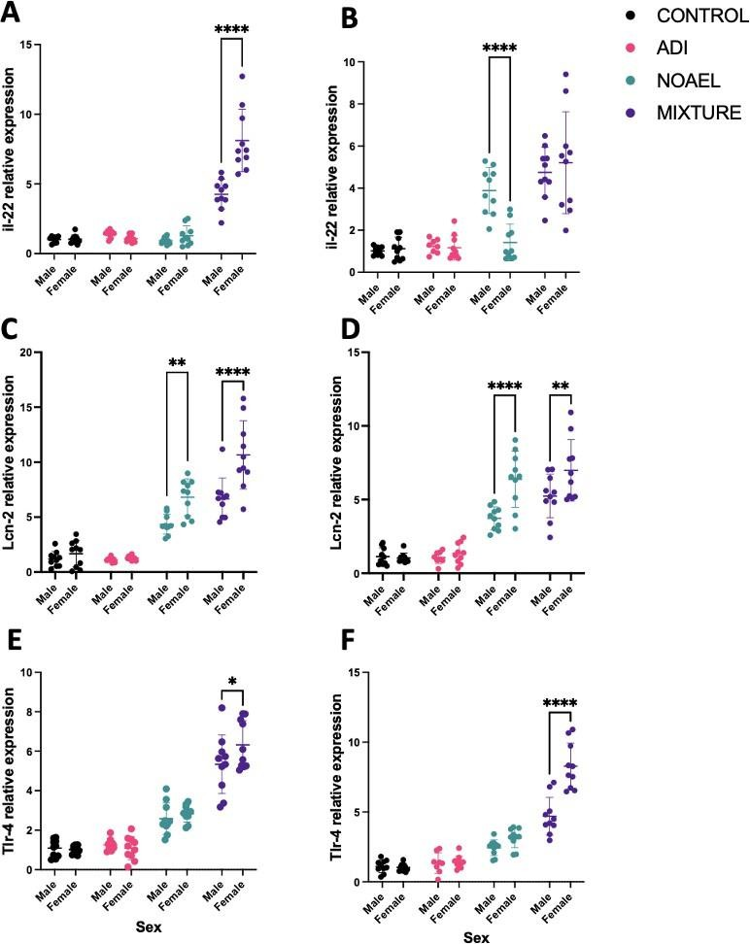

Supplementary Figure 2. Sex-specific effects of glyphosate or its mixture with dicamba and 2,4-D at regulatory permissible intake on genes associated with intestinal inflammation. A: Il22 large intestine, B: Il22 ileum, C: Lcn2 large intestine, D: Lcn2 ileum, E: Tlr4 large intestine F: Tlr4 ileum. Mixture groups of females had significantly increased expression compared to males of Il22 in the large intestine (A; purple), Lcn2 in both the large intestine and ileum (C, D; purple) and Tlr4 in both the large intestine and ileum (E, F; purple). Expression of Lcn2 in the large intestine and ileum was increased in females compared to males exposed to glyphosate at the highest dose (C, D; green). The assay was performed in duplicate, and averages of the duplicates were plotted for each individual. Each dot represents the result from a single animal. The longer horizontal line within each set of data points denotes the average value for the group. *p <0.05; **p <0.01; ****p<0.0001 in a Šídák multiple comparison test which followed a one-way ANOVA.
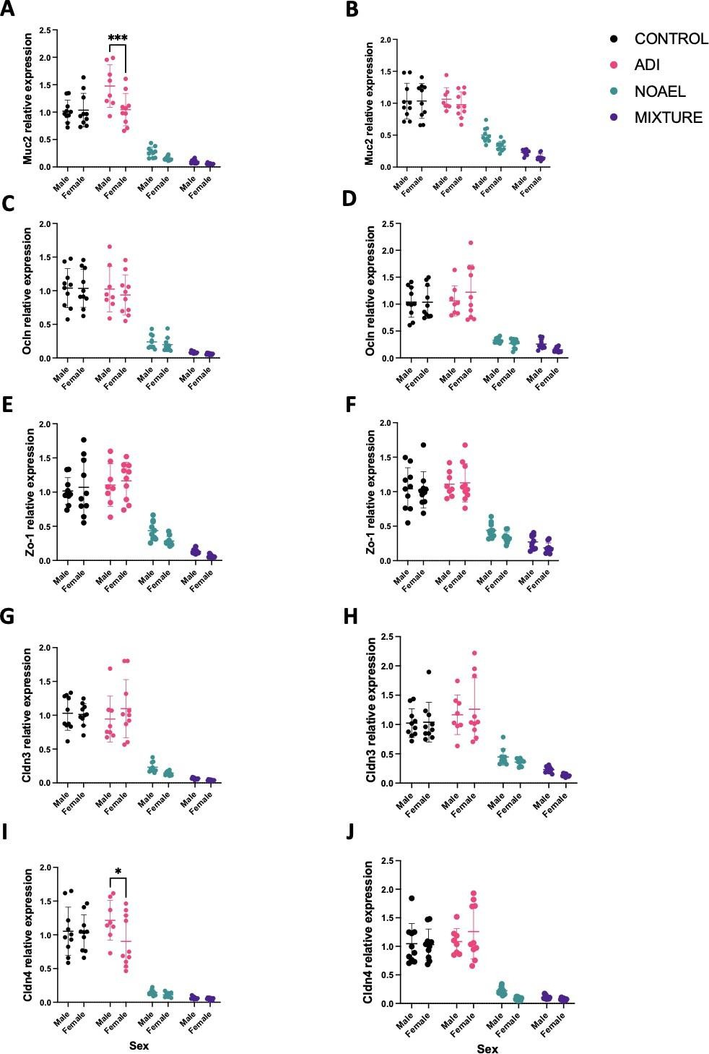

Supplementary Figure 3. Sex-specific effects of exposure to glyphosate at the EU ADI and NOAEL doses or its mixture with dicamba and 2,4-D (each at their EU ADI doses) on expression of genes associated with intestinal integrity. A: Muc2 large intestine, B: Muc2 ileum, C: Ocln large intestine, D: Ocln ileum, E: Zo-1 large intestine, F: Zo-1 ileum female, G: Cldn3 large intestine, H: Cldn3 ileum, I: Cldn4 large intestine, J: Cldn4 ileum. Between the ADI groups, large intestine expression of Muc2 (A; pink), and Cldn4 (I; pink) was significantly decreased in females compared to males. The assay was performed in duplicate, and averages of the duplicates were plotted for each rat. Each dot represents the result from a single animal. The longer horizontal line within each set of data points denotes the average value for the group. *p <0.05; **p <0.01; ***p <0.001; ****p<0.0001 in a Šídák multiple comparison test which followed a one-way ANOVA.

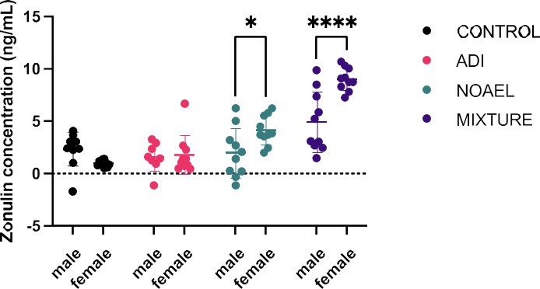

Supplementary Figure 4. Comparison of serum zonulin as an indicator of gut integrity status after exposure to glyphosate, 2,4-D and dicamba. Zonulin concentration was significantly increased in females exposed to glyphosate at its NOAEL dose (green) and females exposed to the mixture of glyphosate, dicamba and 2,4-D (purple) compared to males. The assay was performed in duplicate, and averages of the duplicates were plotted for each rat. The longer horizontal line within each set of data points denotes the average value for the group. *p <0.05; **p <0.01; ****p <0.0001 in a Šídák multiple comparison test which followed a one- way ANOVA.

Supplementary Figure 5. Variation in gut bacterial phylum abundance in response to exposure with glyphosate at the EU acceptable daily intake (ADI) and no-observed adverse effect level (NOAEL) doses, and a combination of glyphosate, 2,4-D and dicamba (Mixture) with each at the EU ADI. Microbiota composition was determined by ITS2 region sequencing for fungi. Data represents relative abundance of the different 16S amplicon sequence variants having their abundance agglomerated at the phylum level. (A) Firmicutes, (B) Desulfobacterota, (C) Bacteroidota, (D) Ascomycota, (E) Basidiomycota.

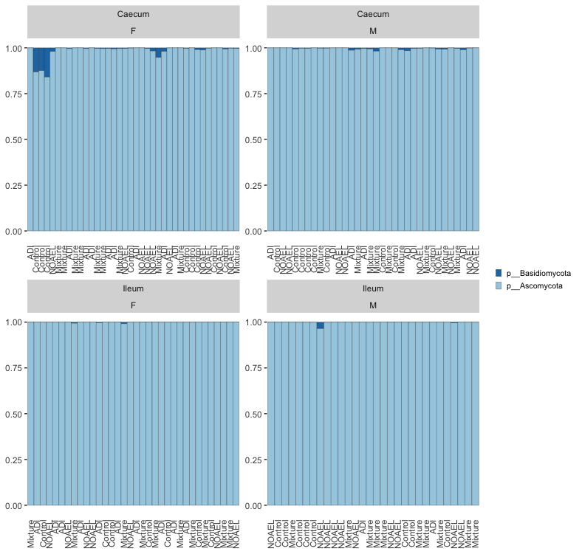

Supplementary Figure 6. Phylum abundance for the gut fungal analysis in response to treatment with glyphosate at the EU acceptable daily intake (ADI) and no-observed adverse effect level (NOAEL) doses, and a glyphosate, 2,4-D and dicamba mixture (each at the EU ADI). Microbiota composition was determined by ITS2 region sequencing for fungi. Data represents relative abundance of the different ITS2 amplicon sequence variants having their abundance agglomerated at the phylum level.

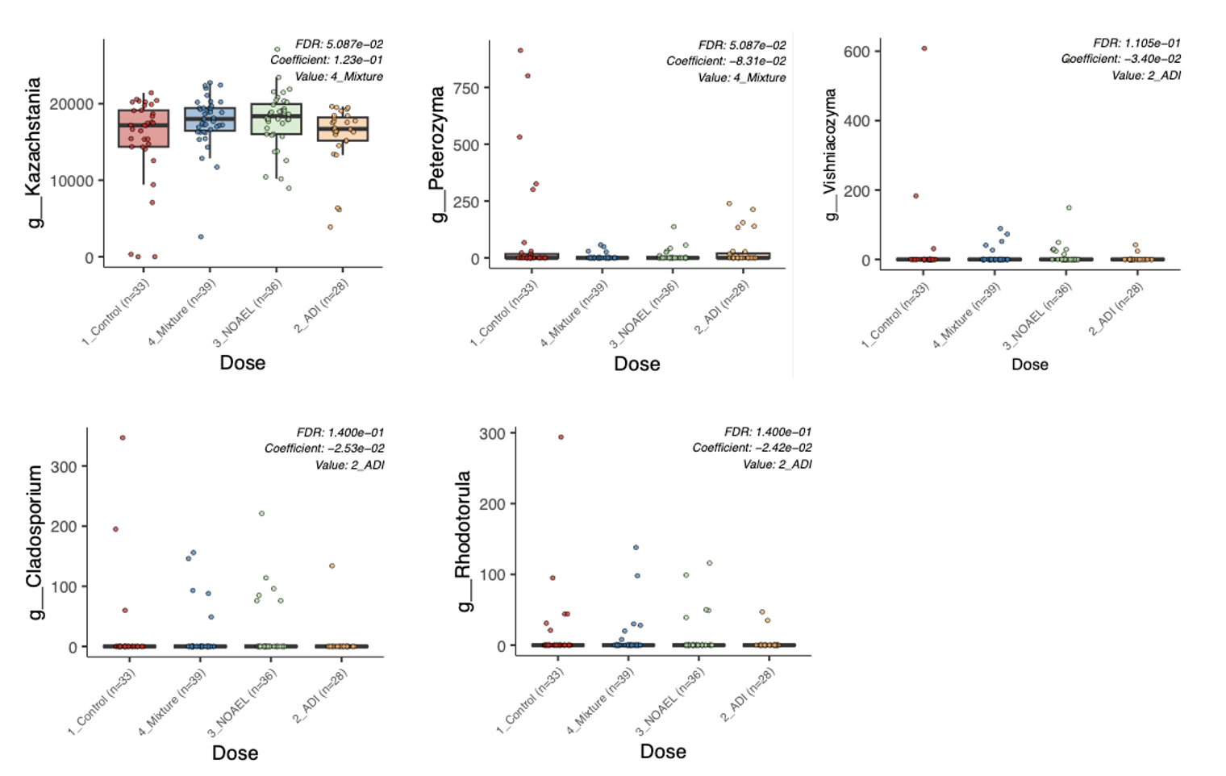

Supplementary Figure 7 Variation in gut fungal phylum abundance for the different treatment groups. Microbiota composition was determined by ITS2 region sequencing for fungi in the different animals exposed to glyphosate at the EU acceptable daily intake (ADI) and no-observed adverse effect level (NOAEL) doses, and a glyphosate, 2,4-D and dicamba mixture (each at the EU ADI). Statistical analysis was done using a linear-mixed model with the specialist gut microbiota analysis software Maaslin2. FDR, statistical significance corrected for multiple comparisons. Coefficient, beta value of the linear-mixed model showing changes in abundance in comparison to the control group; Value, group for which the statistical significance is displayed having the most significant variations compared to the control group.

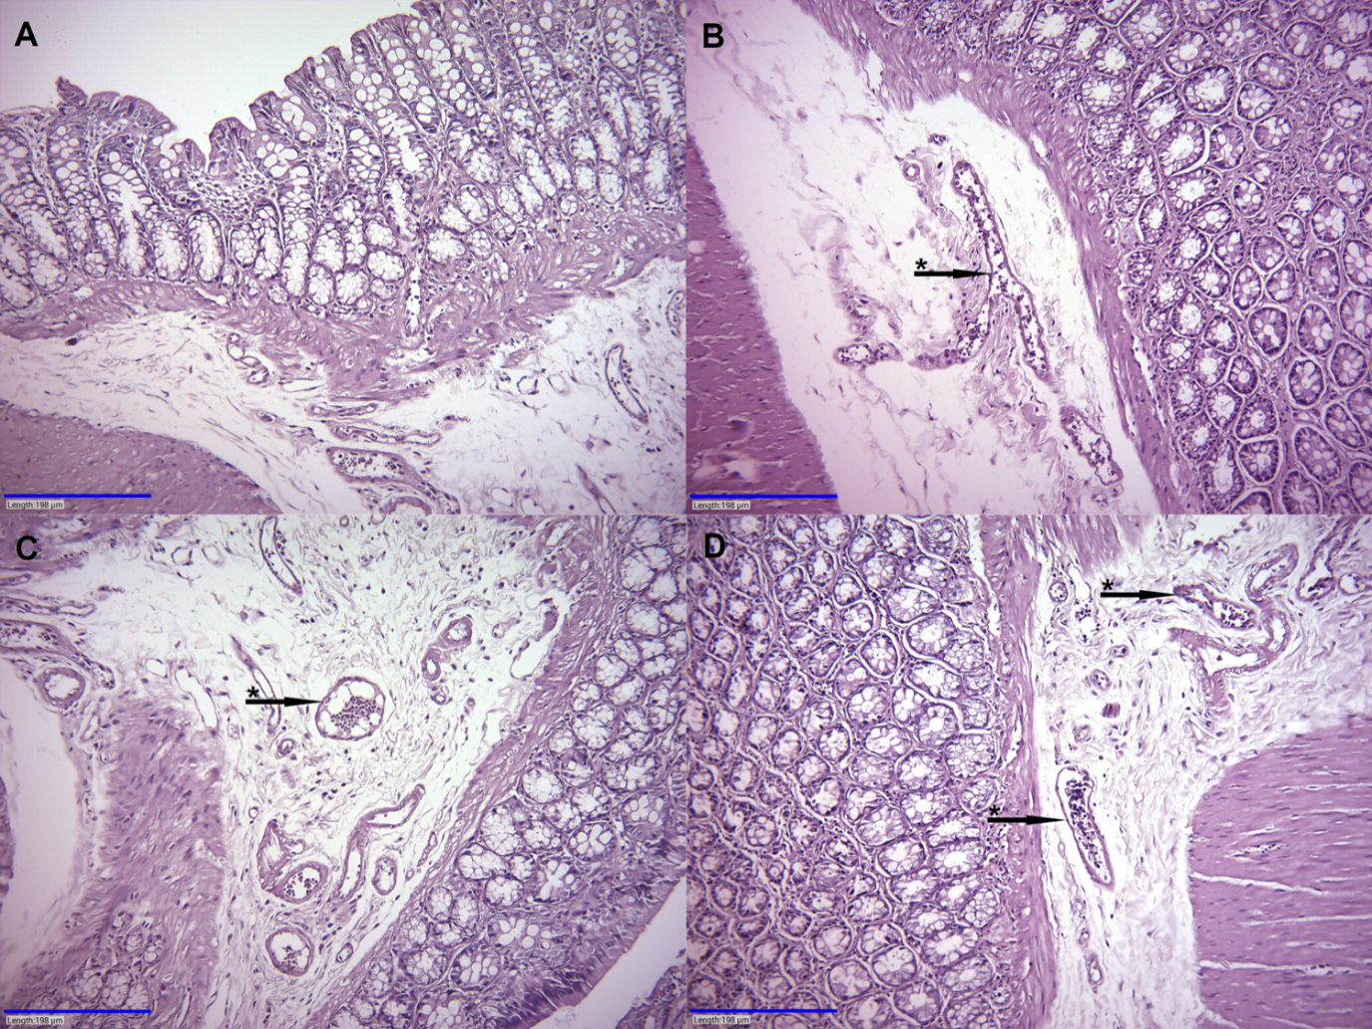

Supplementary Figure 8. Histological alteration in the large intestine of female rats exposed to glyphosate or its mixture with dicamba and 2,4-D. Hematoxylin-Eosin staining of large intestine sections from female rats. A: control group sample showing normal architecture. B: Glyphosate NOAEL dose group sample; dilatated vessels with congestion (black arrow with *). C: Glyphosate ADI dose group sample; dilated hyperemic vessel (black arrow with *). D: Herbicide mixture group sample; vessels dilatated with vascular congestion (black arrow with *). Magnification: x200.

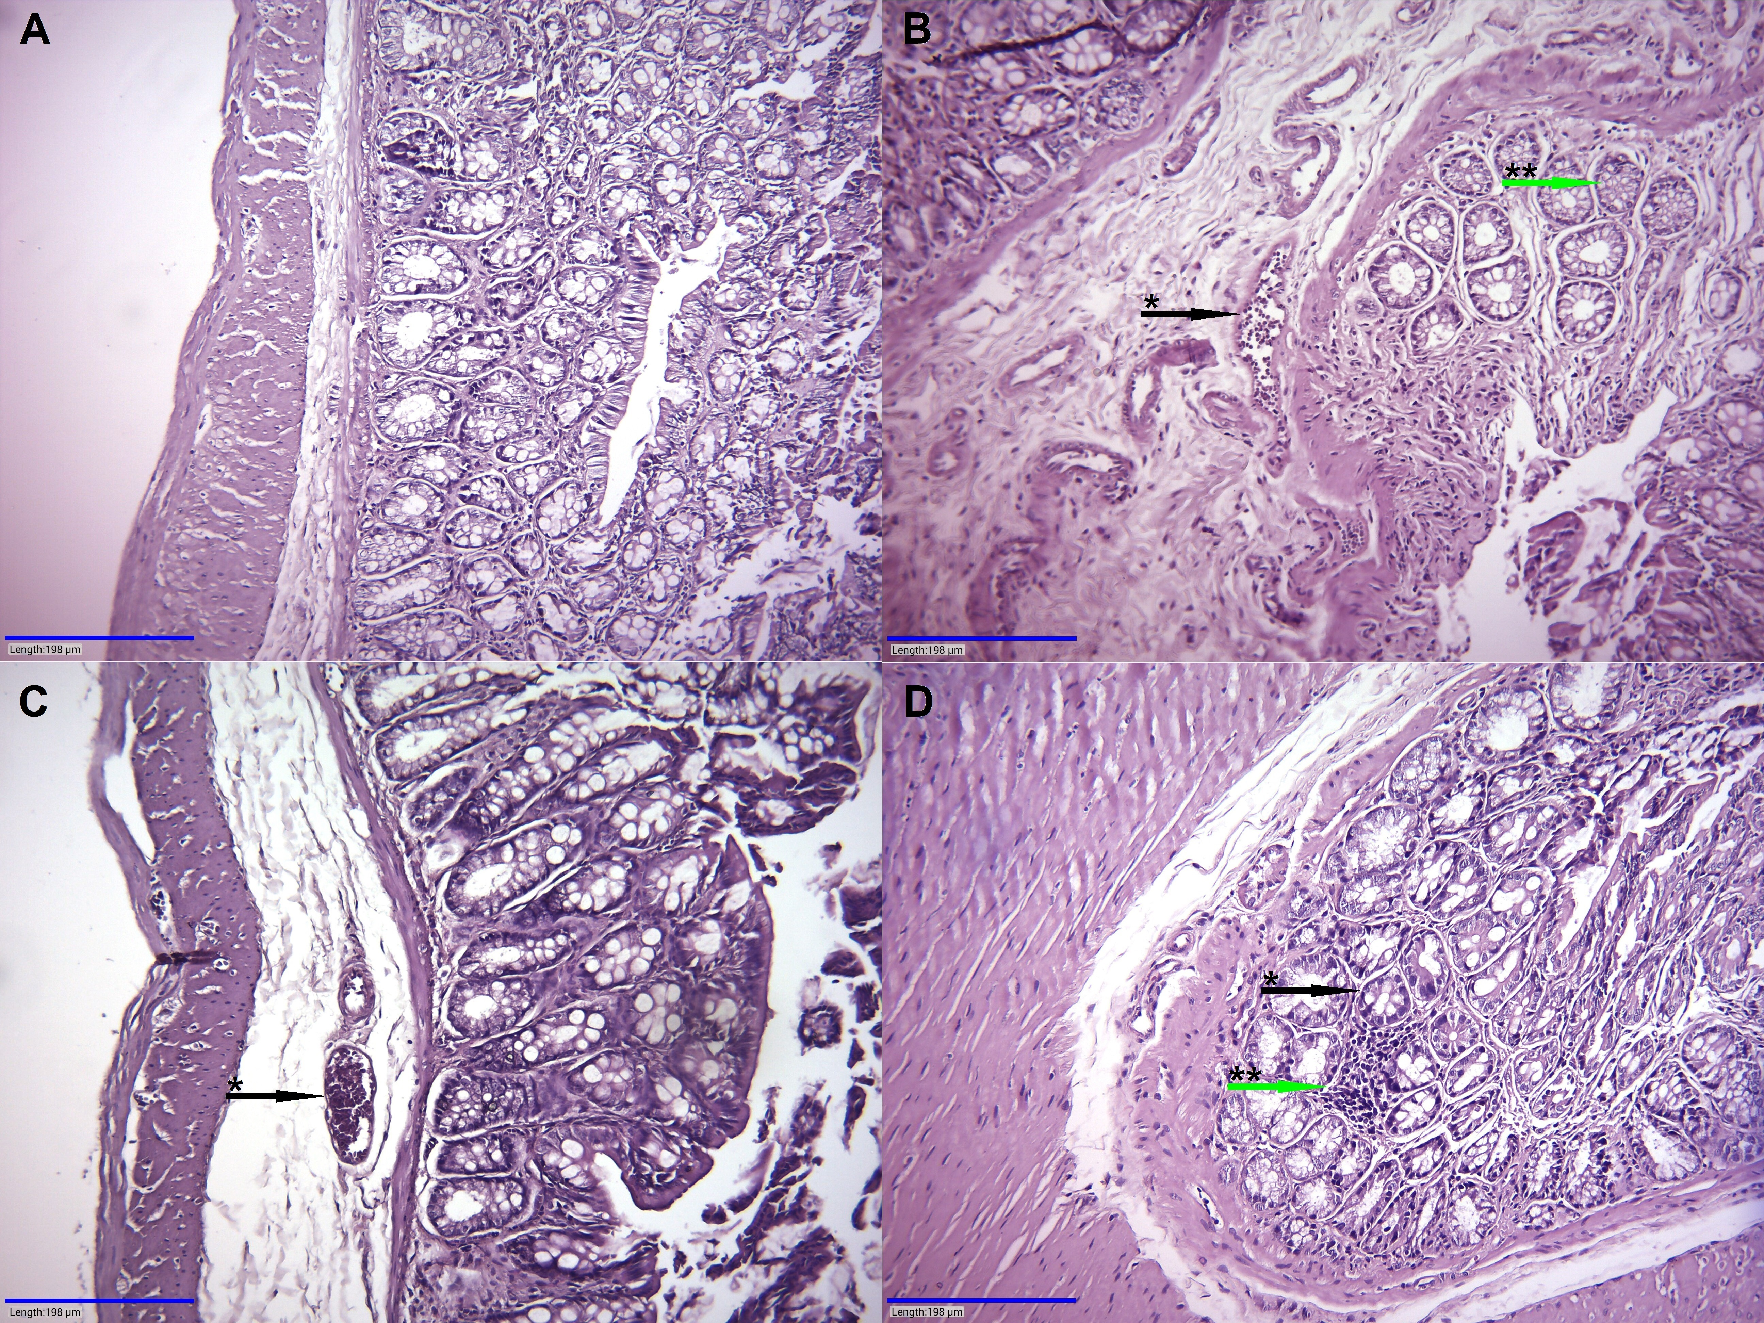

Supplementary Figure 9. Histological alteration in the large intestine of male rats exposed to glyphosate or its mixture with dicamba and 2,4-D. Hematoxylin-Eosin staining of large intestine sections from male rats. A: control group sample; normal architecture. B: glyphosate NOAEL group sample; hyperemic dilatated vessel (black arrow with *) and glands with microvacuolar cytoplasm (green arrow with **). C: glyphosate ADI group sample; dilatated vessel with congestion (black arrow with *). D: glyphosate, dicamba, 2,4-D mixture group sample; glands with hypertrophic and hyperchromatic nuclei (black arrow with *) and intramural chronic inflammation (green arrow with **). Magnification: x200.

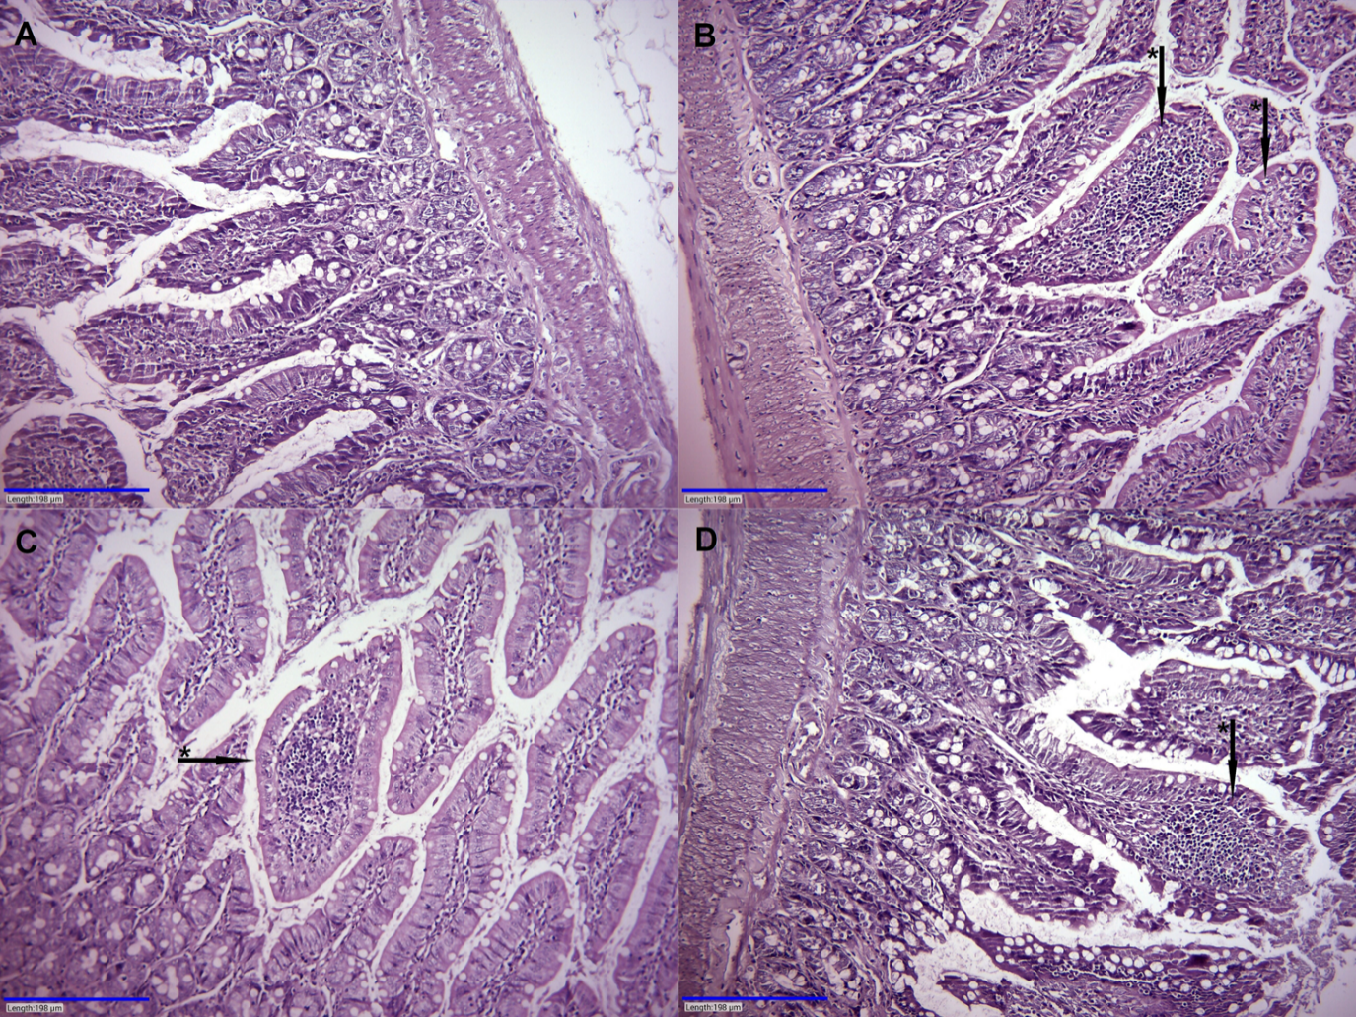

Supplementary Figure 10. Histological alteration in the ileum of female rats exposed to glyphosate or its mixture with dicamba and 2,4-D. Hematoxylin-Eosin staining of ileum sections from female rats. A: control group sample; normal architecture. B: glyphosate NOAEL group sample; chronic inflammation in the villous core (black arrow with *). C: glyphosate ADI group sample; villi with chronic inflammation (black arrow with *). D: glyphosate, 2,4-D, dicamba mixture group sample; mild chronic inflammation in the villi (black arrow with *). Magnification: x200.

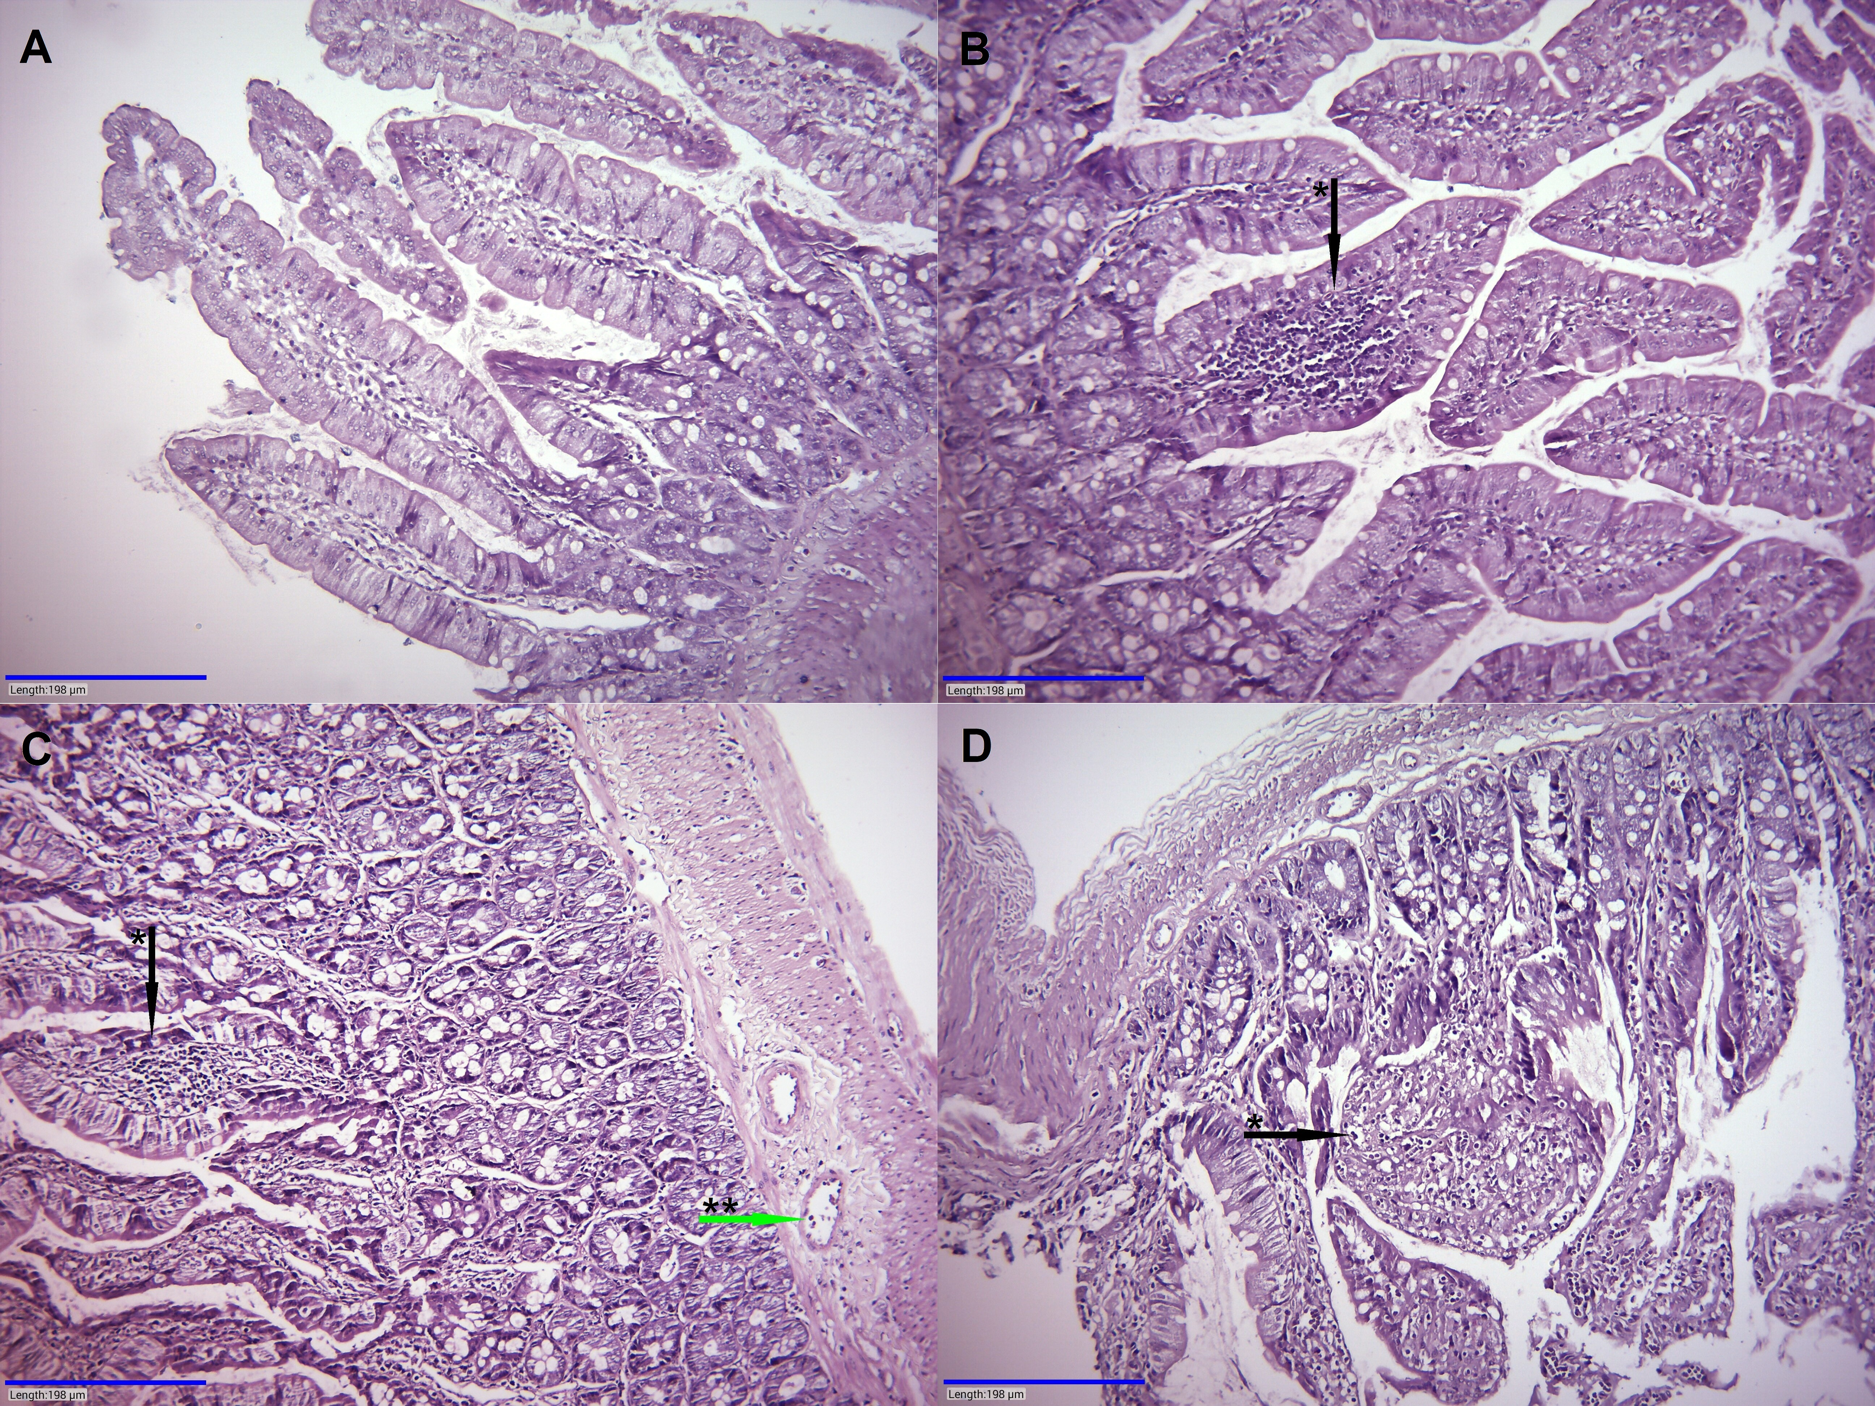

Supplementary Figure 11. Histological alteration in the ileum of male rats exposed to glyphosate or its mixture with dicamba and 2,4-D. Hematoxylin-Eosin staining of ileum sections from male rats. A: control group sample; normal architecture. B: glyphosate NOAEL group sample; chronic inflammation in the villous core (black arrow with *). C: glyphosate ADI group sample; villi with chronic inflammation (black arrow with *) and dilated slightly hyperemic vessel (green arrow with **). D: glyphosate, 2,4-D, dicamba mixture group sample; dilatated villi with frequent small vessels (black arrow with *). Magnification: x200.

