Supplementary Material

Isatin–Pyridine Oxime Hybrids as Potential Reactivators of A-242–Inhibited Acetylcholinesterase

Amanda M. V. Pinto^{1,2}, Dipanjan Bhattacharyya^{2,3,4}, Munique C. J. da Silva^{1,5}, Daniel A. S. Kitagawa⁶, Marcelo C. dos Santos¹, Samir F, de A, Cavalcante^{5,7,*}, Salim T. Islam,^{8,9} Steven R. LaPlante^{8,9}, Pat Forgione^{2,3,4}, Joyce S. F. Diz^{1,5}, Tanos C. C. França^{1,5,8,9,*}

¹Laboratory of Molecular Modeling Applied to Chemical and Biological Defense, Military Institute of Engineering; Rio de Janeiro, 22290-270, RJ, Brazil.

²Department of Chemistry and Biochemistry, Concordia University, Montreal, H4B 1R6, QC, Canada.

³School of Health, Concordia University, Montreal, H4B 1R6, QC, Canada.

⁴Centre for Nanoscience Research (CeNSR), Concordia University, Montreal, H4B 1R6, QC, Canada.

⁵Institute of Chemical, Biological, Radiological and Nuclear Defense (IDQBRN), Brazilian Army Technological Center (CTEx); Rio de Janeiro, 23020-470, RJ, Brazil.

⁶Agency for Technology Management and Innovation (AGITEC), Rio de Janeiro, 23020-470, RJ, Brazil.

⁷Center for Basic and Applied Research, Faculty of Informatics and Management, University of Hradec Kralove, 50003 Hradec Kralove, Czech Republic.

⁸Institut National de la Recherche Scientifique (INRS), Centre Armand-Frappier Santé Biotechnologie, Pasteur Network, Laval, QC H7V 1B7, Canada.

⁹PROTEO, the Quebec Network for Research on Protein Function, Engineering, and Applications, Universite Laval, Quebec, QC G1V 0A6, Canada.

Characterization data for compounds AM01-AM03.
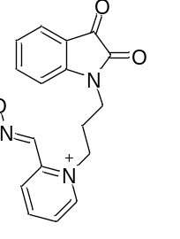
(E)-1-(3-(2,3-dioxoindolin-1-yl)propyl)-2-((hydroxyimino)methyl)pyridin-1-ium (AM01)
Yield: 68%; ¹³C NMR (126 MHz, CDCl₃): δ 183.33, 161.03, 158.25, 151.68, 150.71, 150.58, 149.38, 138.42, 136.87, 124.11, 123.84, 117.63, 110.02, 63.04,39.71, 25.96, 23.89. ¹H NMR (500 MHz, cdcl₃): δ 9.45 (s, 2H), 8.64 (d, J = 4.9 Hz, 2H), 8.31 (s, 1H), 8.07 (d, J = 12.8 Hz, 1H), 7.84 – 7.79 (m, 2H), 7.65 – 7.56 (m, 2H), 4.25 (dt, J = 20.7, 5.9 Hz, 3H), 3.86 (t, J = 7.1 Hz, 1H), 2.15 – 2.03 (m, 1H), 1.86 – 1.73 (m, 3H). HPLC-MS-ESI: 310.1 (M⁺).

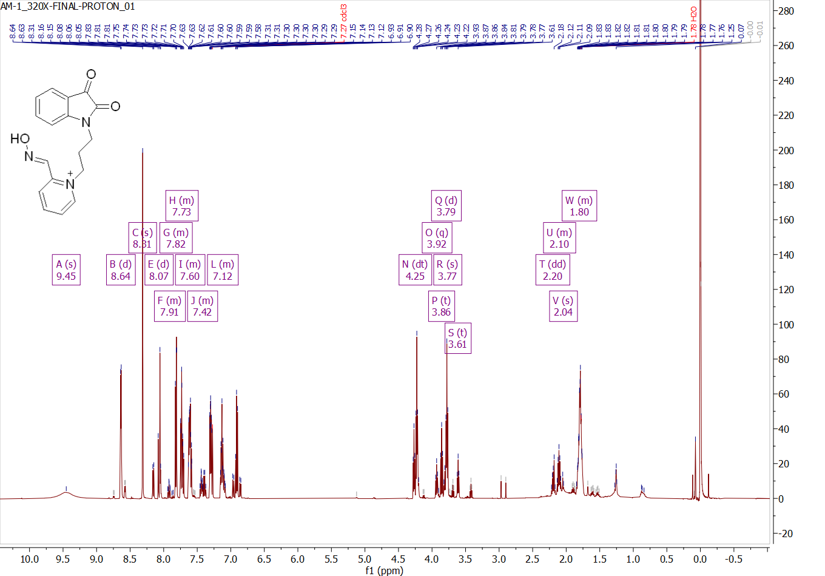
Figure S1. ¹H NMR spectra of AM01.

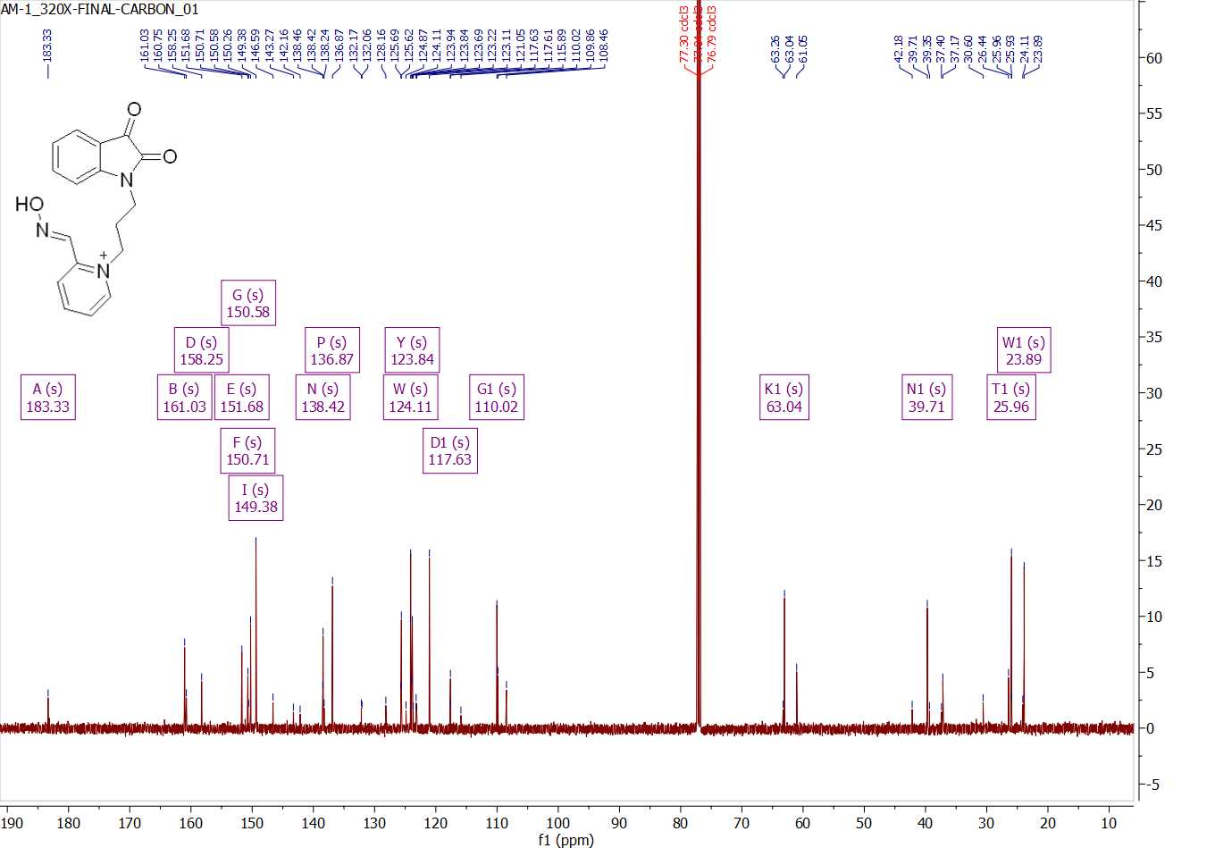
Figure S2. ¹³C NMR spectra of AM01.
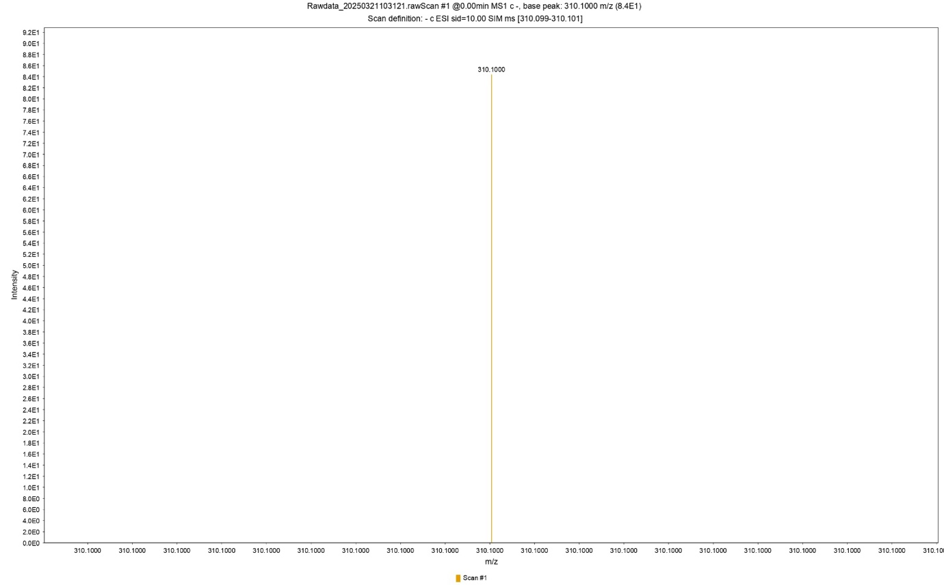
Figure S3. MS spectra of AM01.

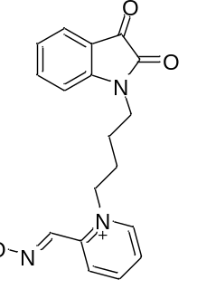
(E)-1-(4-(2,3-dioxoindolin-1-yl)butyl)-2-((hydroxyimino)methyl)pyridin-1-ium (AM02)
Yield: 68%; ¹³C NMR (126 MHz, CDCl₃) δ 183.33, 161.01, 158.24, 151.73, 150.71, 150.42, 149.43, 138.40, 136.78, 124.09, 123.83, 117.62, 110.01, 63.03, 39.71, 31.59, 29.05, 25.96. ¹H NMR (500 MHz, CDCl₃) δ 9.37 (s, 2H), 8.64 (ddd, J = 5.0, 1.8, 1.0 Hz, 2H), 8.32 (s, 2H), 8.06 (d, J = 0.9 Hz, 1H), 7.82 (dt, J = 8.0, 1.1 Hz, 2H), 7.73 (td, J = 7.7, 1.8 Hz, 2H), 7.65 – 7.55 (m, 2H), 7.30 (ddd, J = 7.5, 4.9, 1.2 Hz, 2H), 7.13 (td, J = 7.5, 0.8 Hz, 1H), 6.91 (dt, J = 7.8, 0.8 Hz, 1H), 4.23 (td, J = 6.1, 0.9 Hz, 2H), 3.84 – 3.71 (m, 2H). HPLC-MS-ESI: 368.4 (M⁺).
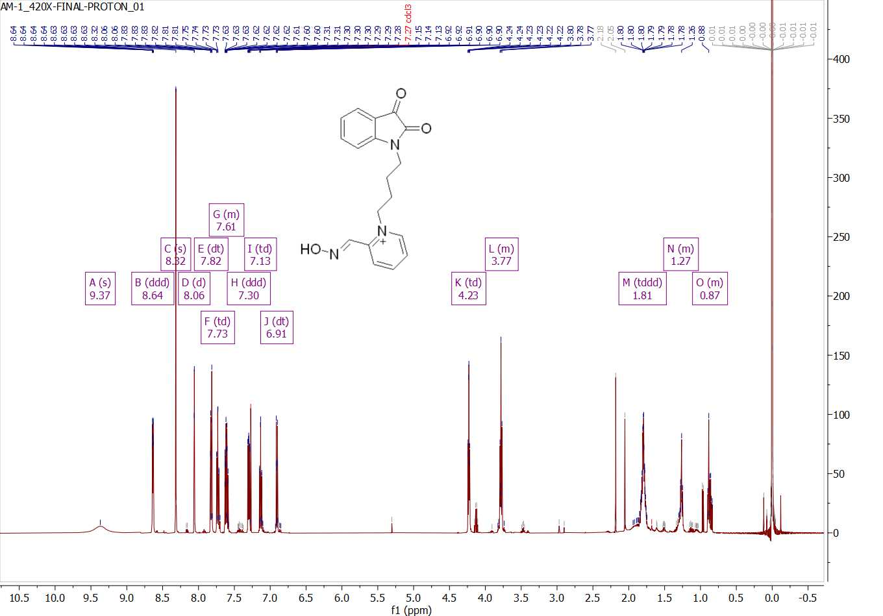
Figure S4. ¹H NMR spectra of AM02.

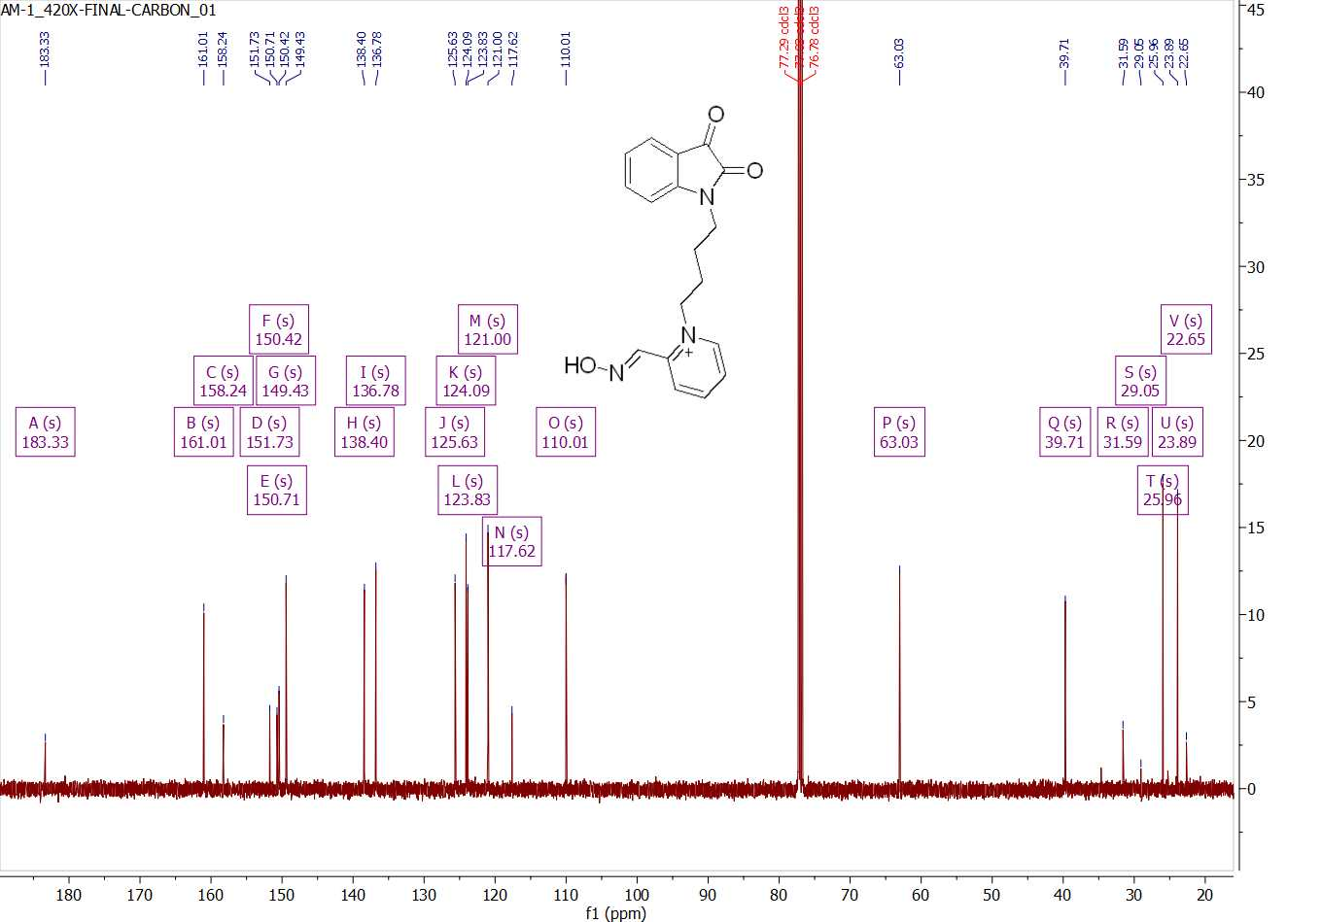
Figure S5. ¹³C NMR spectra of AM02.

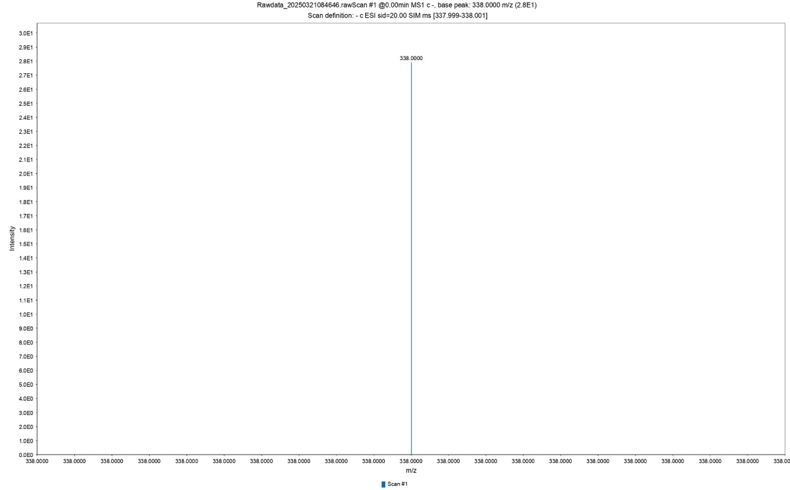
Figure S6. LC-MS spectra of AM02.

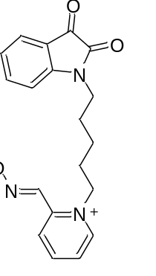
(E)-1-(5-(2,3-dioxoindolin-1-yl)pentyl)-2-((hydroxyimino)methyl)pyridin-1-ium (AM03)

Yield: 76%; ¹³C NMR (126 MHz, CDCl₃) δ 183.47, 161.12, 158.20, 151.70, 150.85, 150.53, 149.48, 138.36, 136.75, 125.58, 124.10, 123.75, 121.00, 117.61, 110.05, 63.49, 39.97, 28.06, 26.84. ¹H NMR (500 MHz, cdcl₃) δ 9.11 (s, 2H), 8.66 – 8.61 (m, 2H), 8.31 (s, 2H), 8.05 (s, 1H), 7.82 (d, J = 7.9 Hz, 2H), 7.73 (td, J = 7.7, 1.7 Hz, 2H), 7.65 – 7.56 (m, 2H), 7.33 – 7.26 (m, 2H), 7.13 (t, J = 7.5 Hz, 1H), 6.90 (d, J = 7.9 Hz, 1H), 4.18 (t, J = 6.5 Hz, 2H), 3.75 (t, J = 7.3 Hz, 2H), 1.75 – 1.61 (m, 1H). HPLC-MS-ESI: 338 (M⁺).
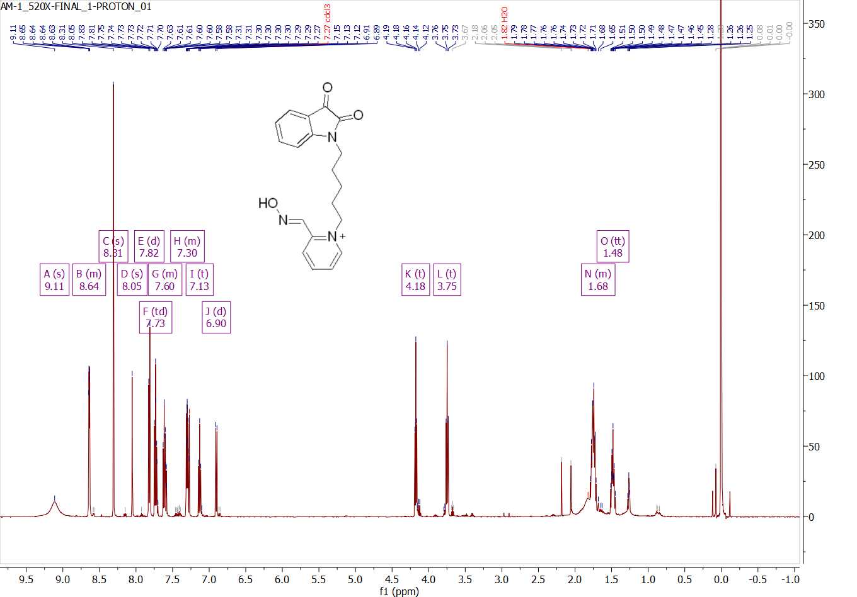
Figure S7. ¹H NMR spectra of AM03.
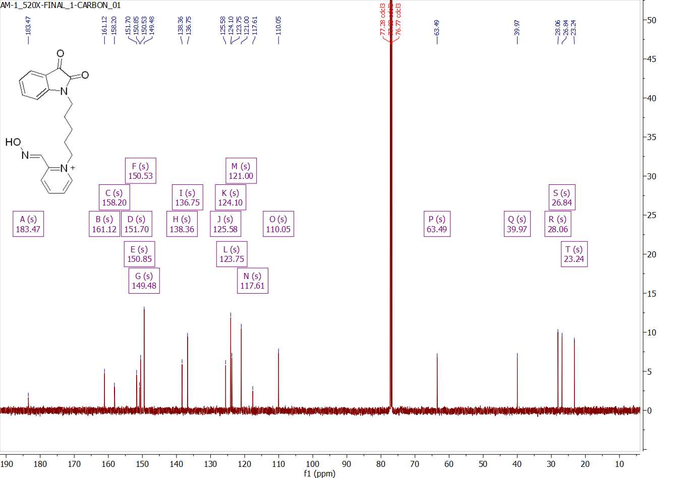
Figure S8. ¹³C NMR spectra of AM03.

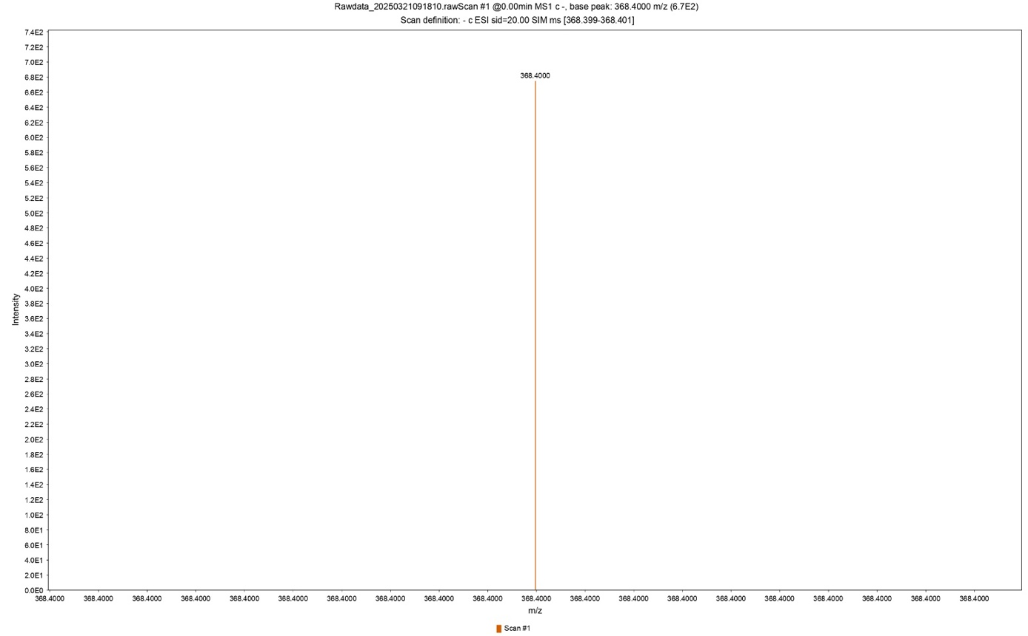
Figure S9. LC-MS spectra of AM03.

