Suppl. Fig. 1. A forest plot for the change in interleukin-6 (pg/mL).

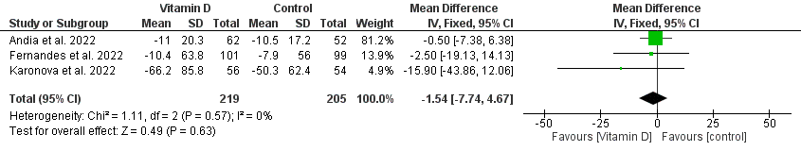

Suppl. Fig. 2. A forest plot for the change in C-reactive protein.

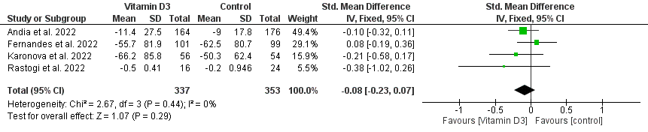

Suppl. Fig. 3. A forest plot for the change in vitamin D.
(A) Before sensitivity analysis
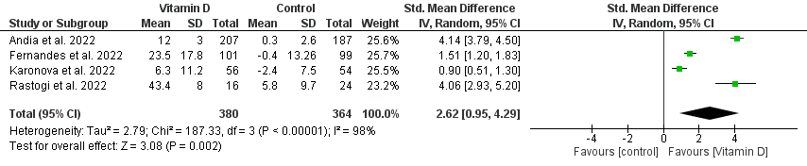
(B) After sensitivity analysis
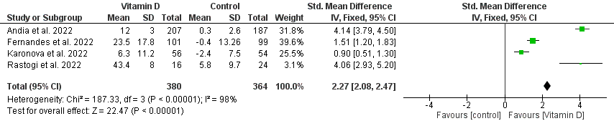

Suppl. Fig. 4. A forest plot for the change in LDH (U/L).

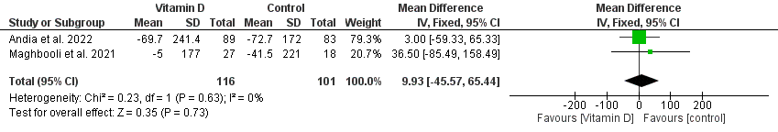

Suppl. Fig. 5. A forest plot for the change in serum calcium (mg/dL).

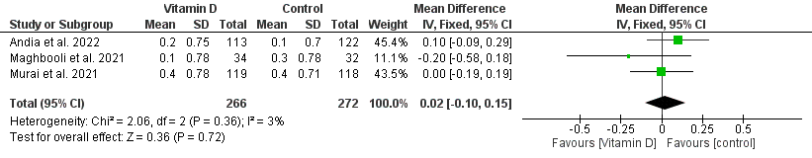
Suppl. Fig. 6. A forest plot for the change in serum creatinine level (mg/dl).
(A) Before sensitivity analysis
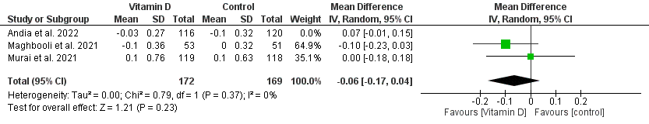
(B) After sensitivity analysis

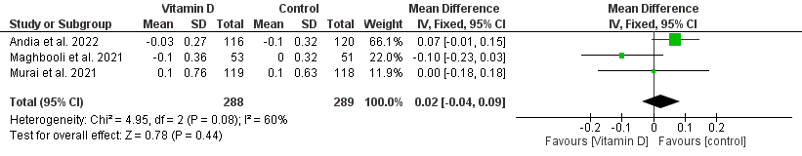

Suppl. Fig. 7. A forest plot for the change in d-dimer.
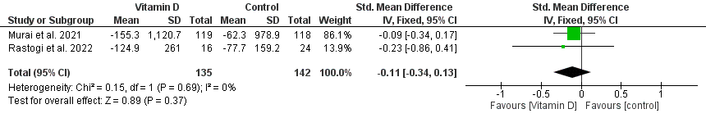

Suppl. Fig. 8. A forest plot for the change in neutrophils count (x10³/mm³).
(A) Before sensitivity analysis

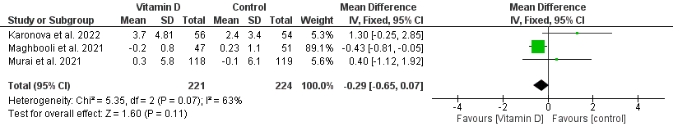

(B) After sensitivity analysis

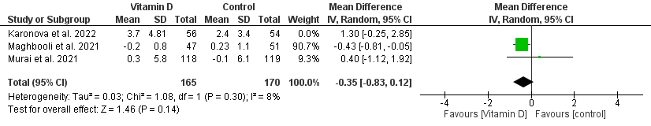

Suppl. Fig. 9. A forest plot for the change in lymphocyte count (x10³/mm³).
(A) Before sensitivity analysis
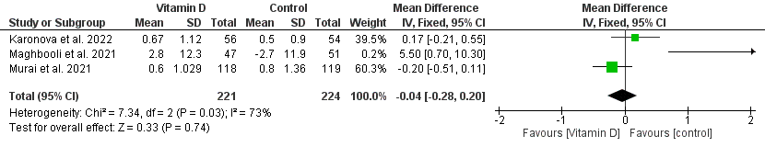

(B) After sensitivity analysis
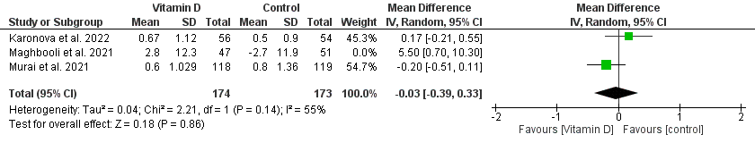
Suppl. Fig. 10. A forest plot for the change in platelet count (x10³/mm³).

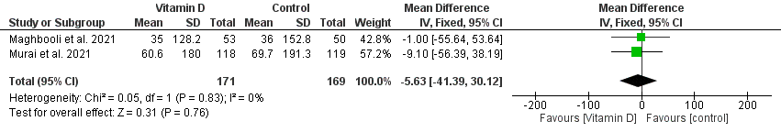
Suppl. Fig. 11. A forest plot for the change in leucocytes (No./μL).
(A) Before sensitivity analysis
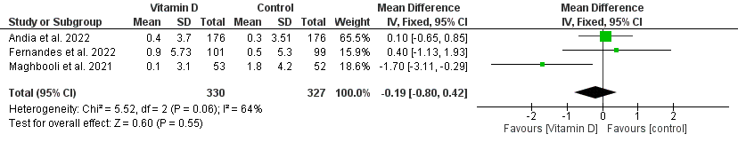

(B) After sensitivity analysis
