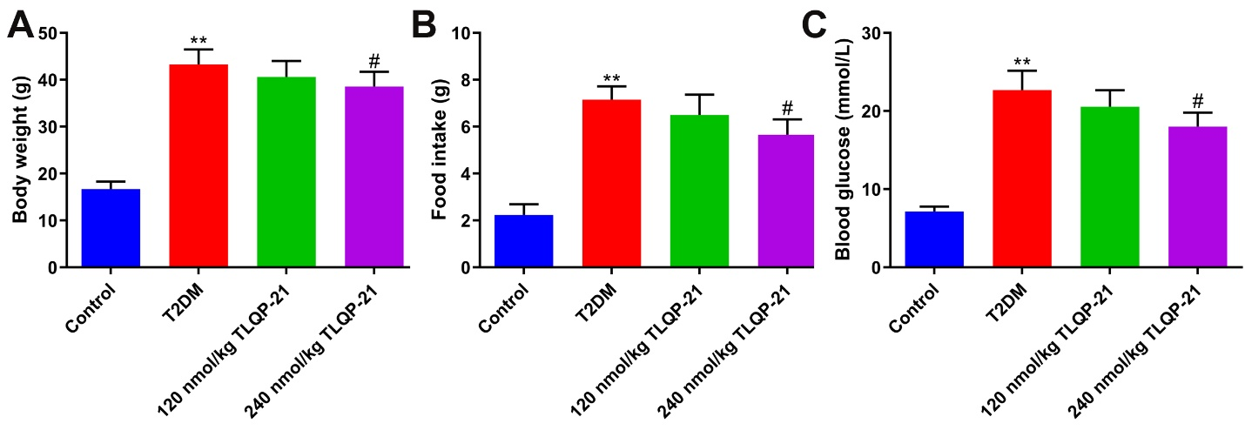
Fig S1. TLQP-21 slightly repressed the body weight (A), food intake (B), and fasting blood glucose levels (C) in T2DM mice (**p<0.01 vs. control, #p<0.05 vs. T2DM).
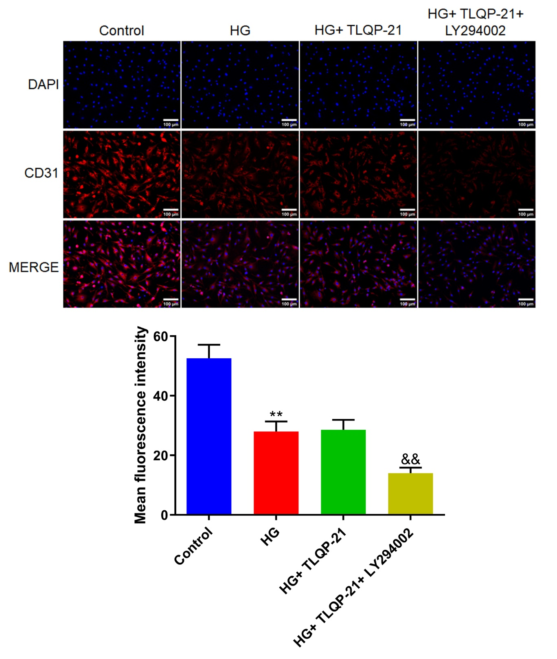
Fig S2. TLQP-21 did not show impacts on the differentiation of EPCs to ECs. The expression of CD31 in each group was detected using the immunofluorescence assay (**p<0.01 vs. control, &&p<0.01 vs. HG+ TLQP-21).

