Pyrazolyl amide-chalcones conjugates: Synthesis and antikinetoplastid activity
Devesh S Agarwalª, Richard M. Beteckª, Dorien Mabille^{b}, Guy Caljon^{b}, Lesetja J. Legoabeª*
ªCentre of Excellence for Pharmaceutical Sciences, North-West University, Potchefstroom 2520, South Africa
^{b}Laboratory of Microbiology, Parasitology and Hygiene, Infla-med Centre of Excellence, University of Antwerp, Antwerp, Belgium
*Corresponding Author: LJL- lesetja.legoabe@nwu.ac.za; Tel.: +27 18 299 2182.

Supporting information
S. No. |  | Page No.
1 | ¹H and ¹³C NMR of 4 | 2
2 | ¹H and ¹³C NMR of 5 | 3
3 | ¹H and ¹³C NMR of 7 | 4
4 | ¹H and ¹³C NMR of 9a-n | 5
5 | HRMS spectra of 4, 5, 7 and 9a-n | 19

¹H NMR of 4
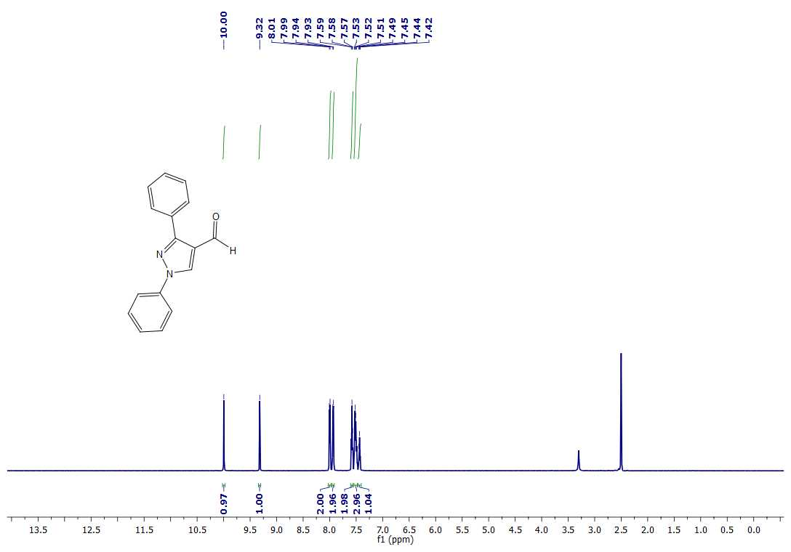
¹³C NMR of 4
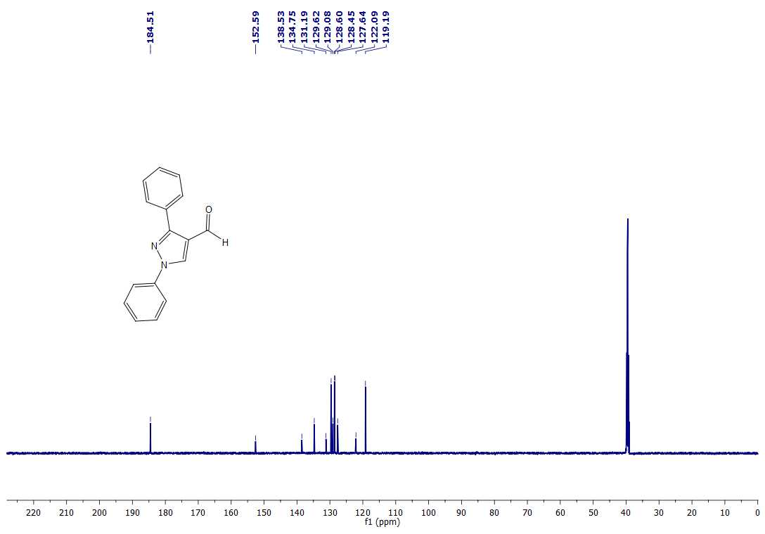
¹H NMR of 5
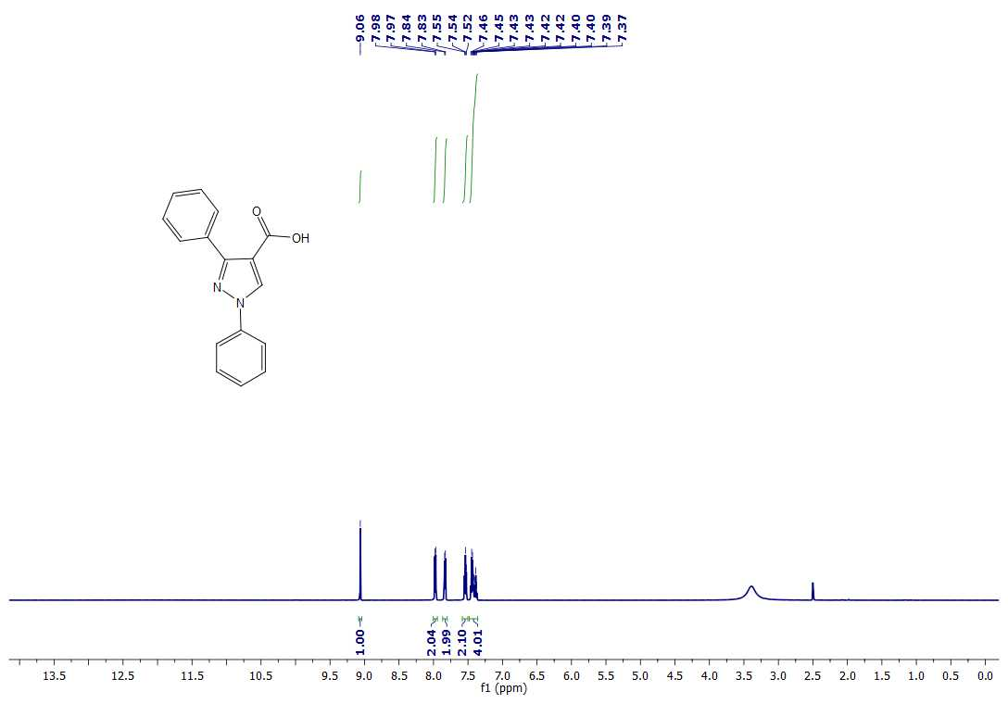
¹³C NMR of 5
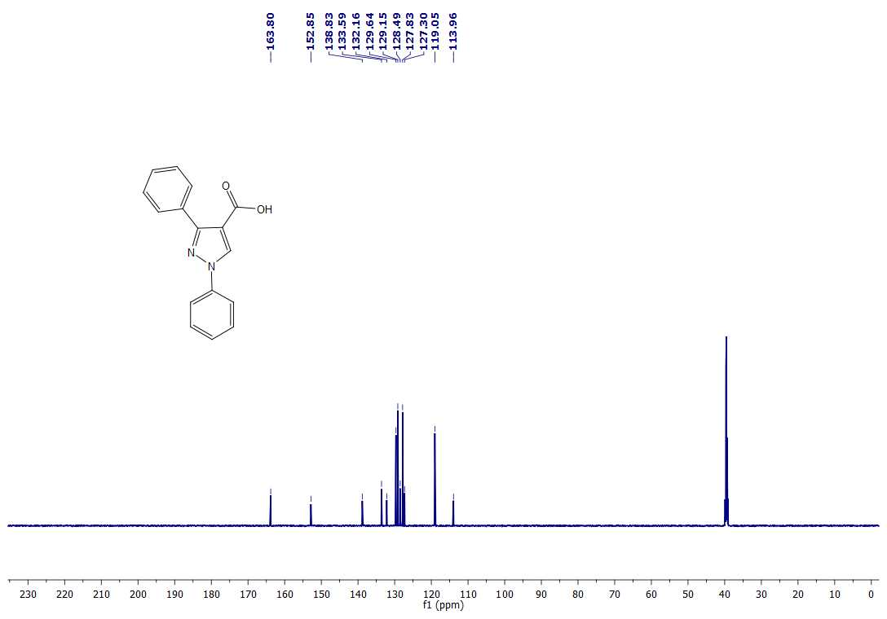
¹H NMR of 7
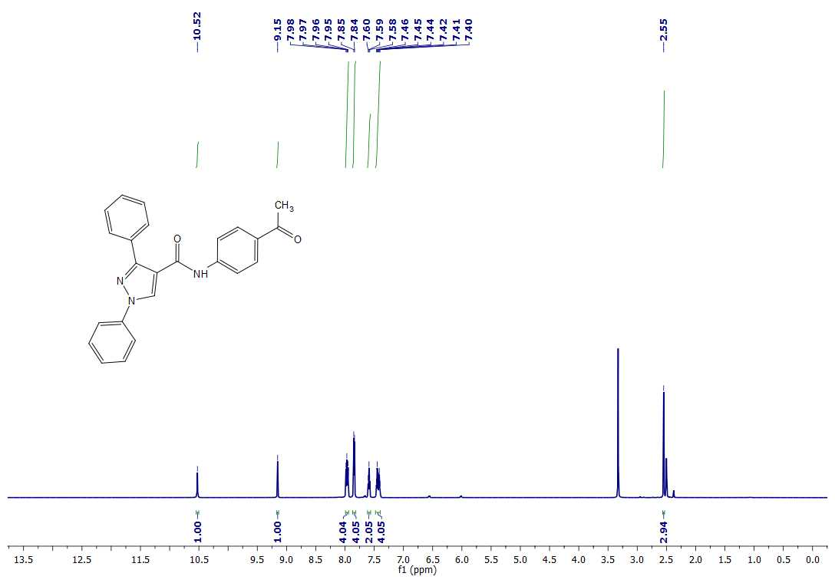
¹³C NMR of 7
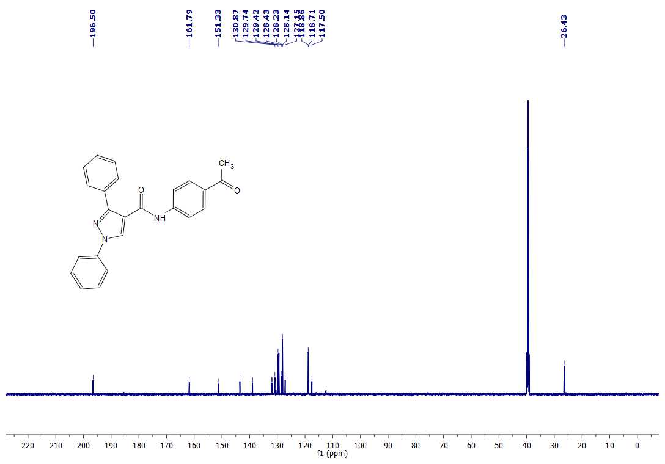
¹H NMR of 9a
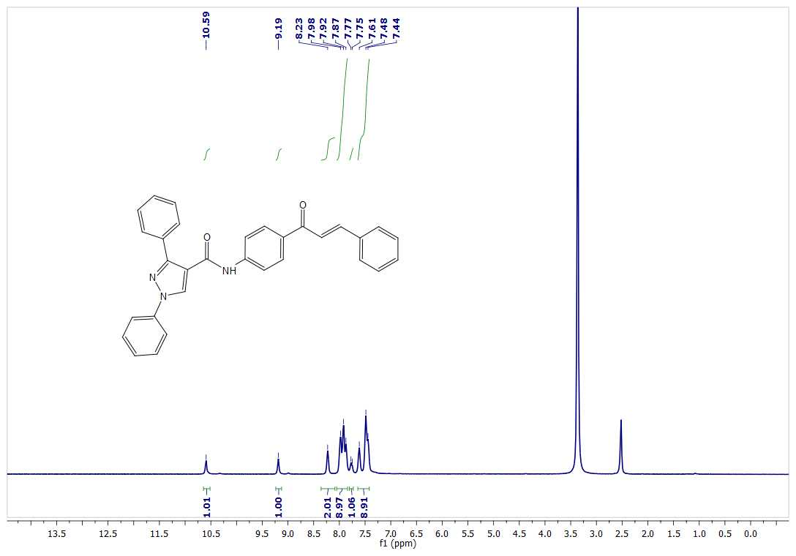
¹³C NMR of 9a
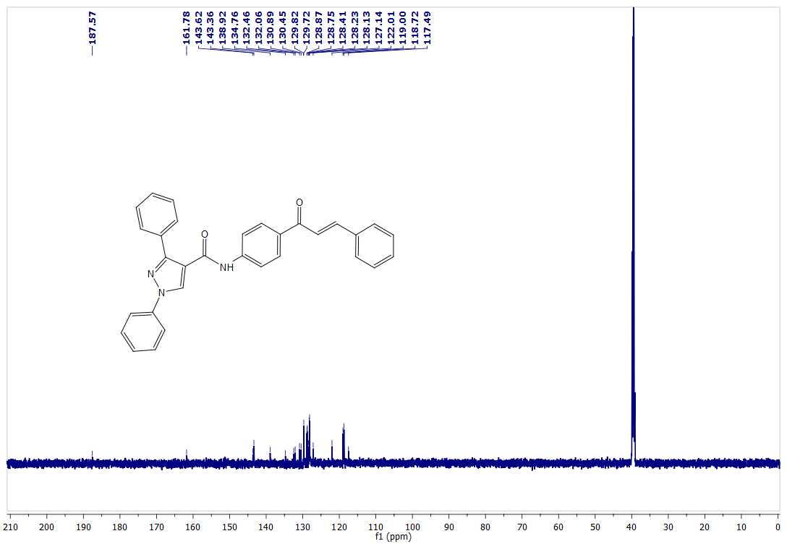
¹H NMR of 9b
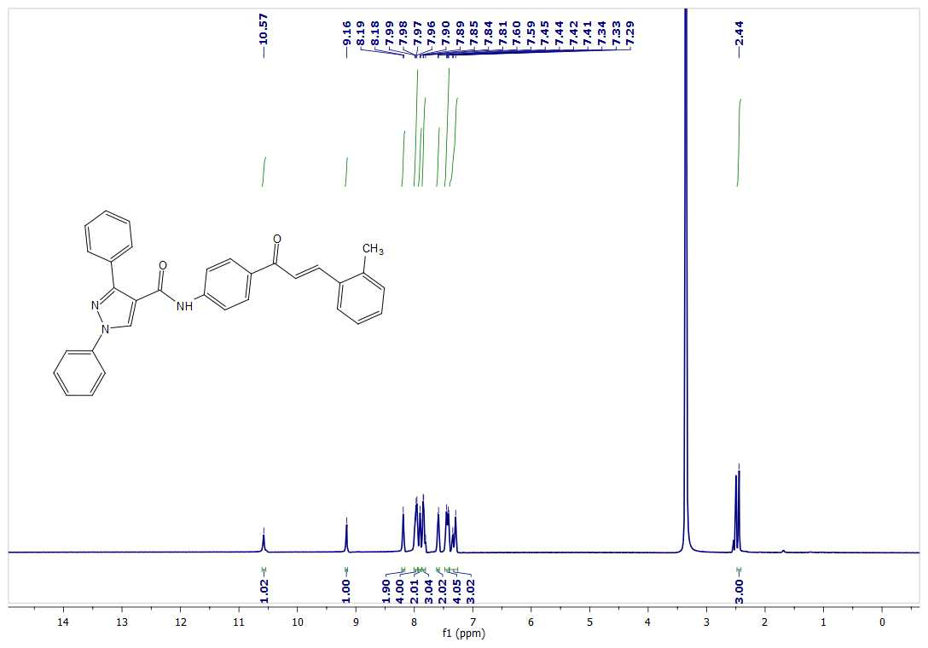
¹³C NMR of 9b
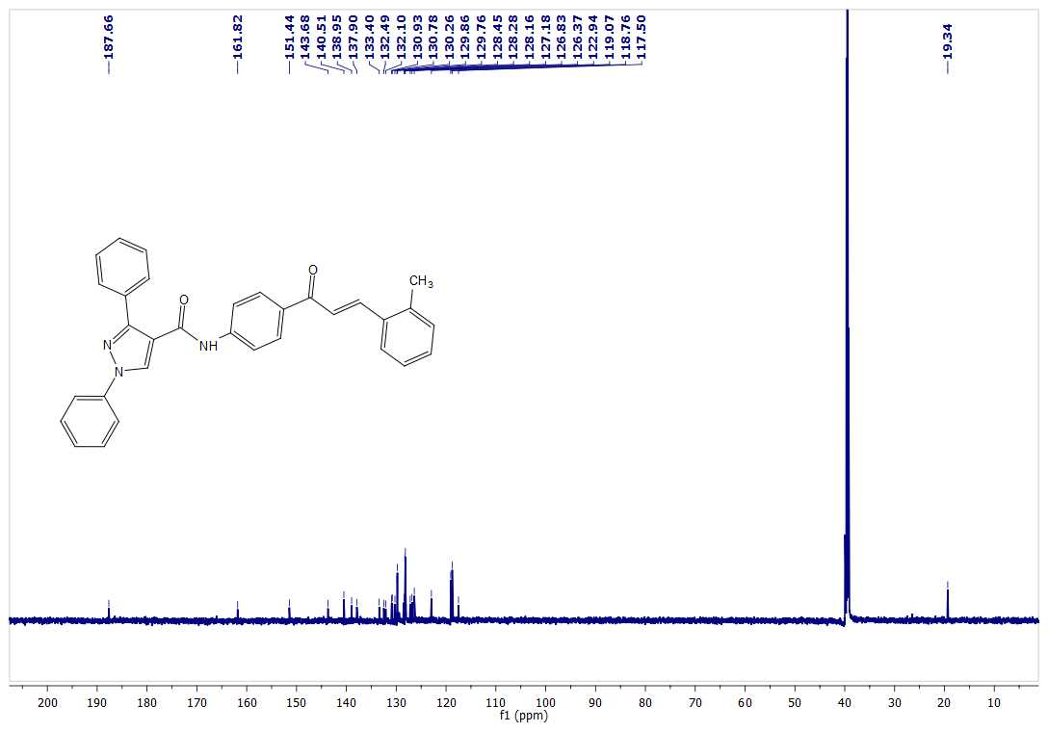
¹H NMR of 9c
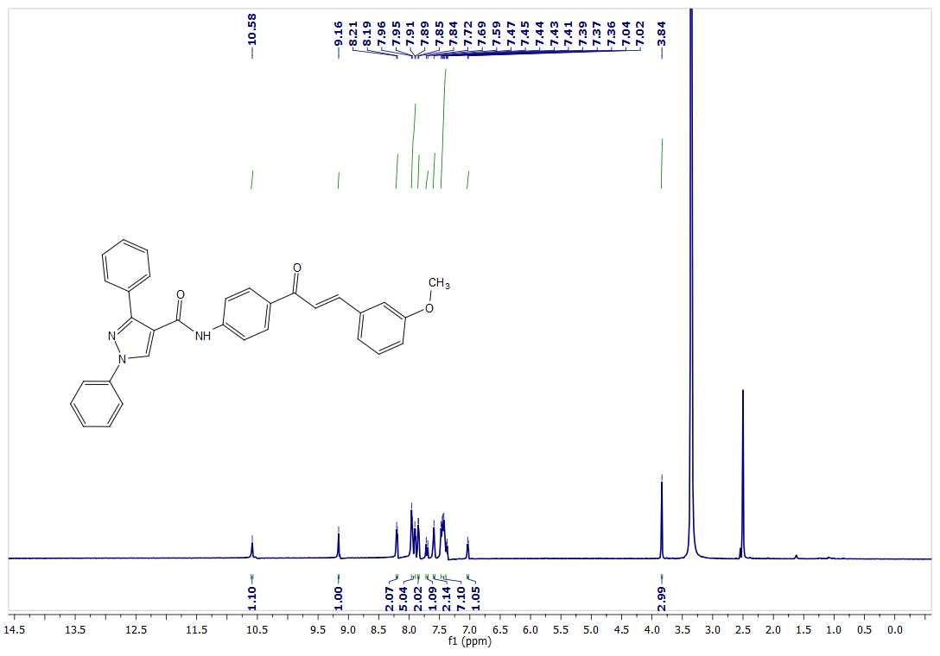
¹³C NMR of 9c
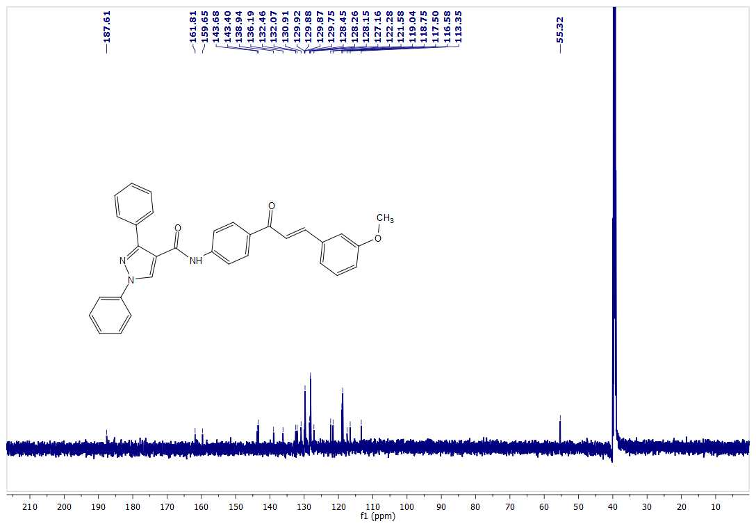
¹H NMR of 9d
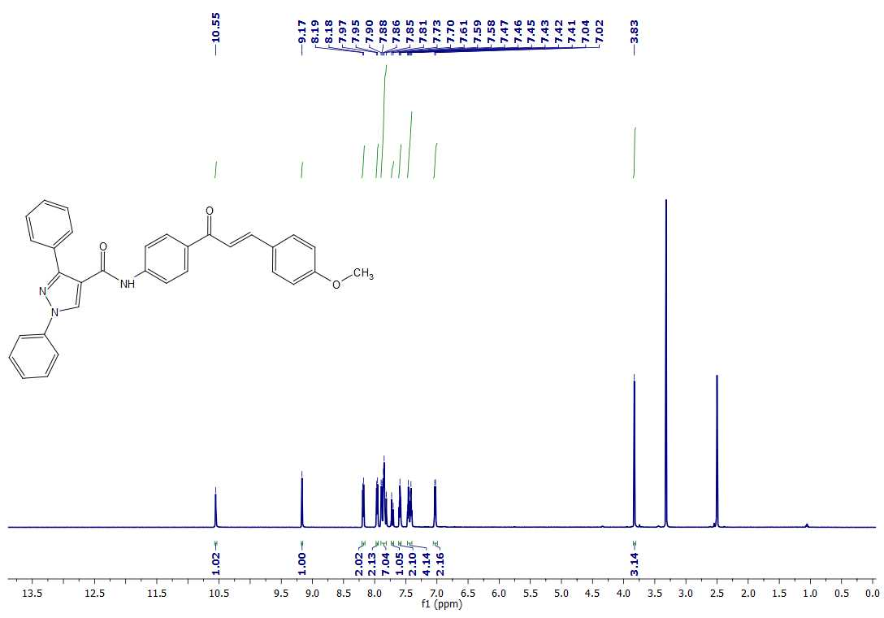
¹³C NMR of 9d
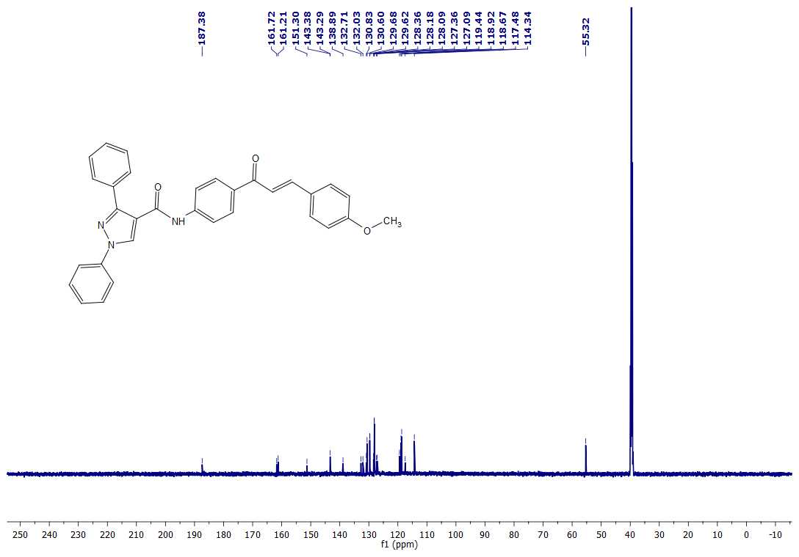
¹H NMR of 9e
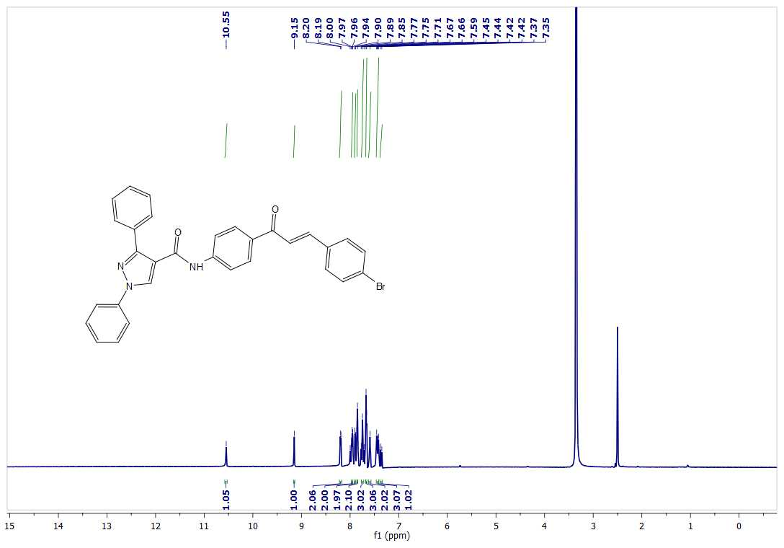
¹³C NMR of 9e
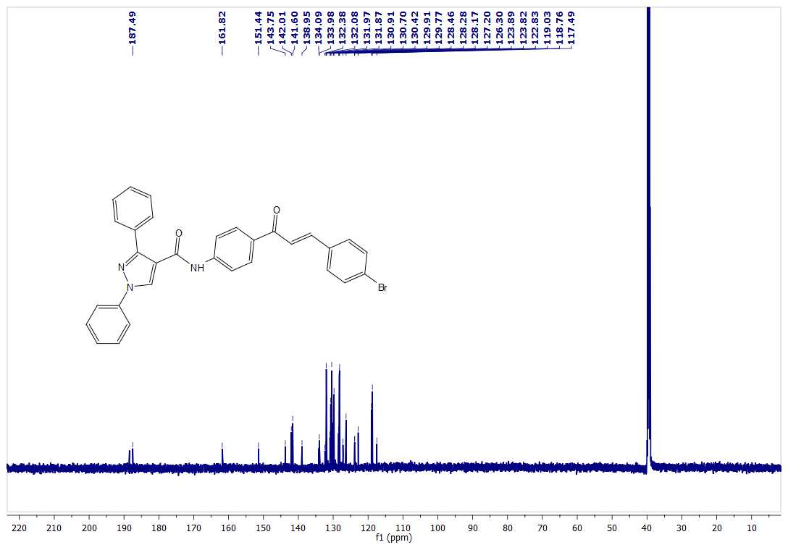
¹H NMR of 9f
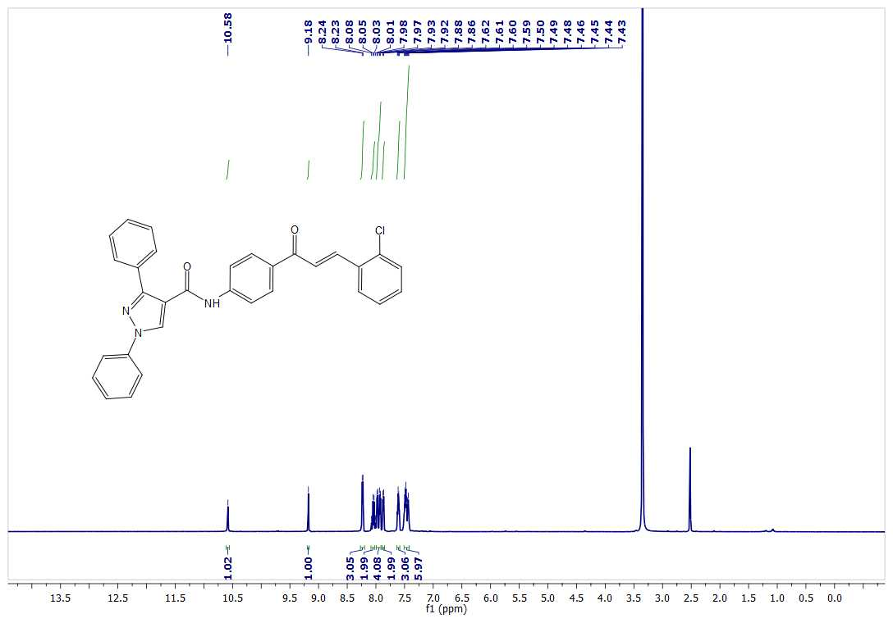
¹³C NMR of 9f
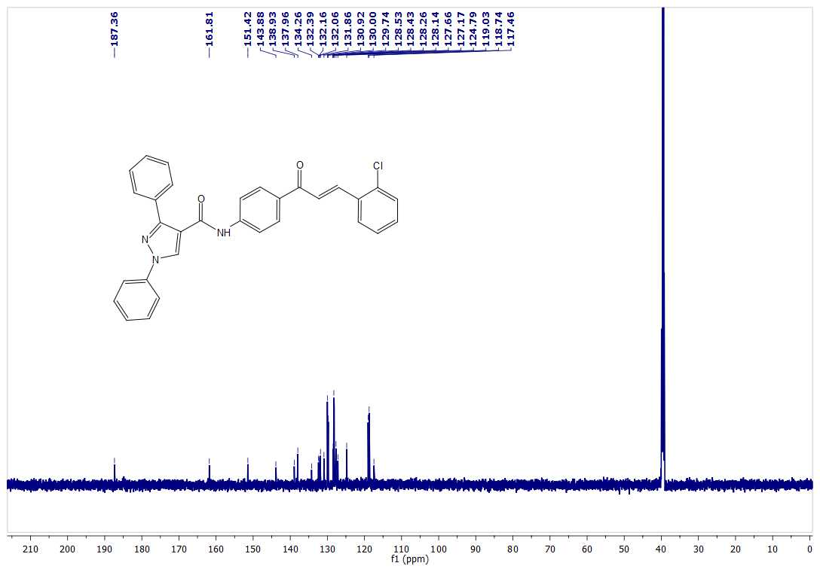
¹H NMR of 9g
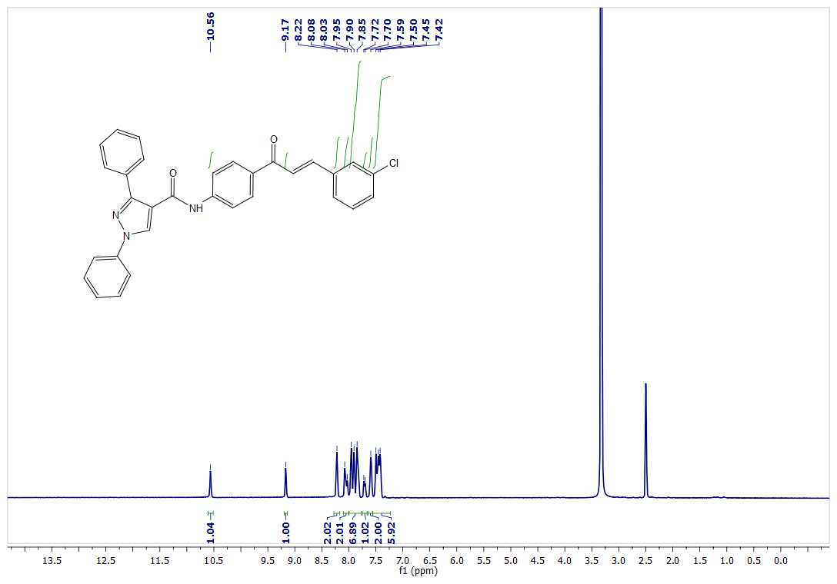
¹³C NMR of 9g
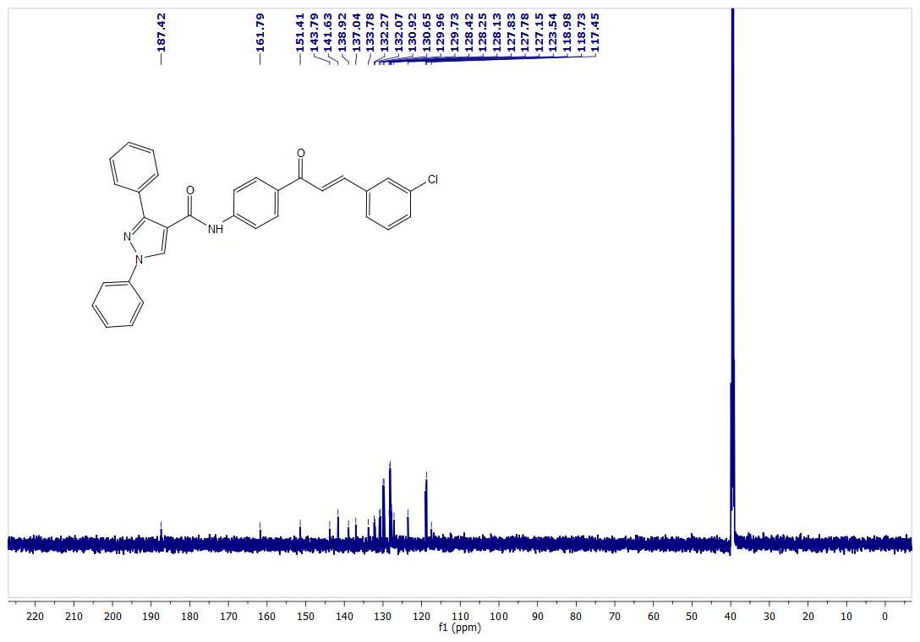
¹H NMR of 9h
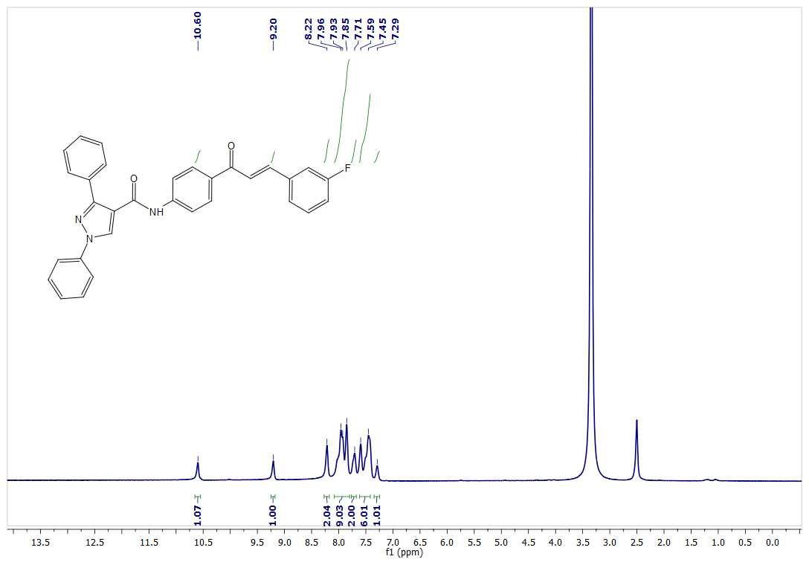
¹³C NMR of 9h
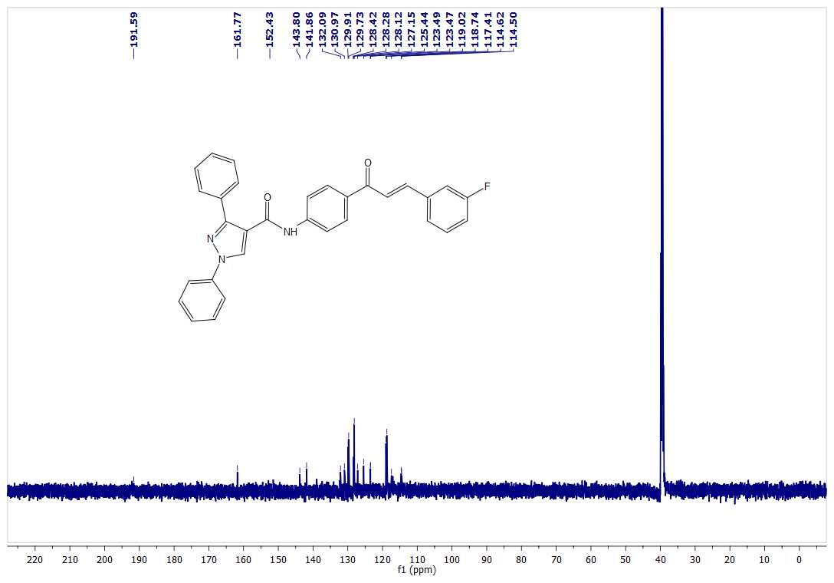
¹H NMR of 9i
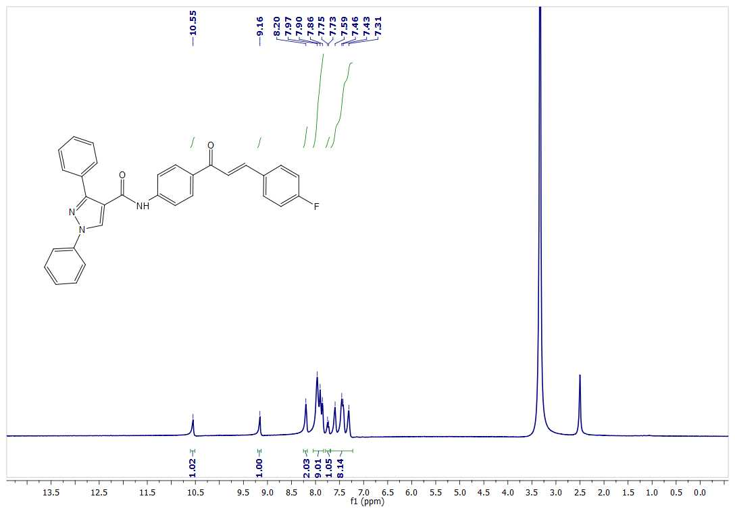
¹³C NMR of 9i
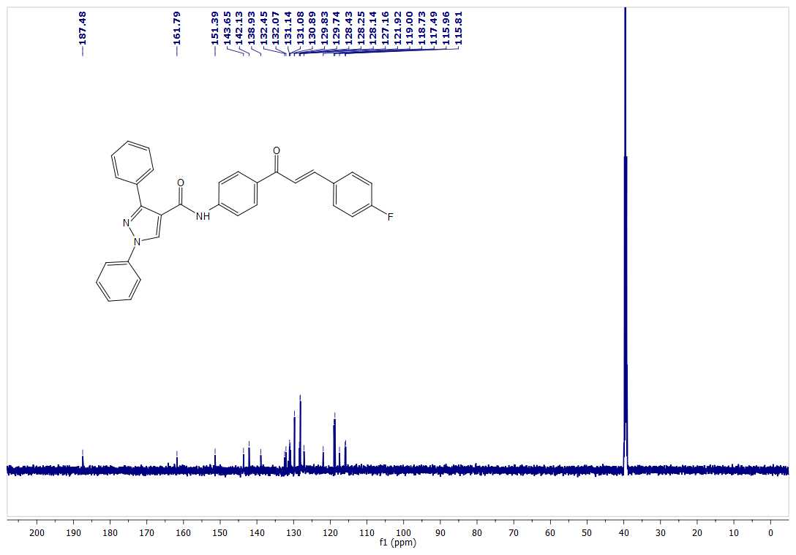
¹H NMR of 9j
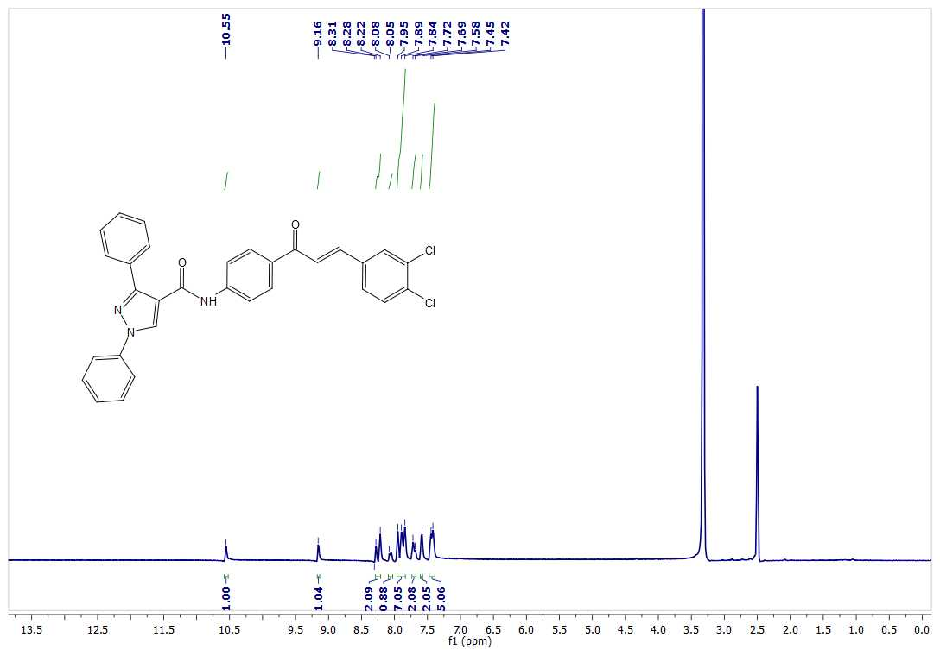
¹³C NMR of 9j
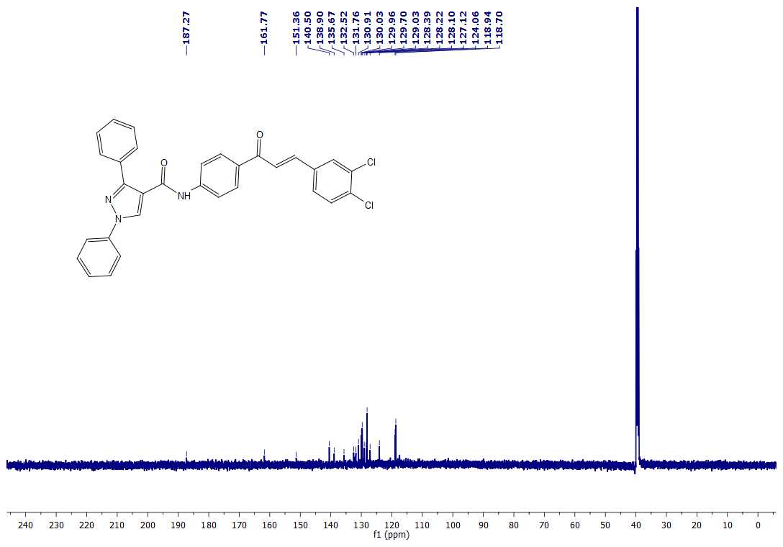
¹H NMR of 9k
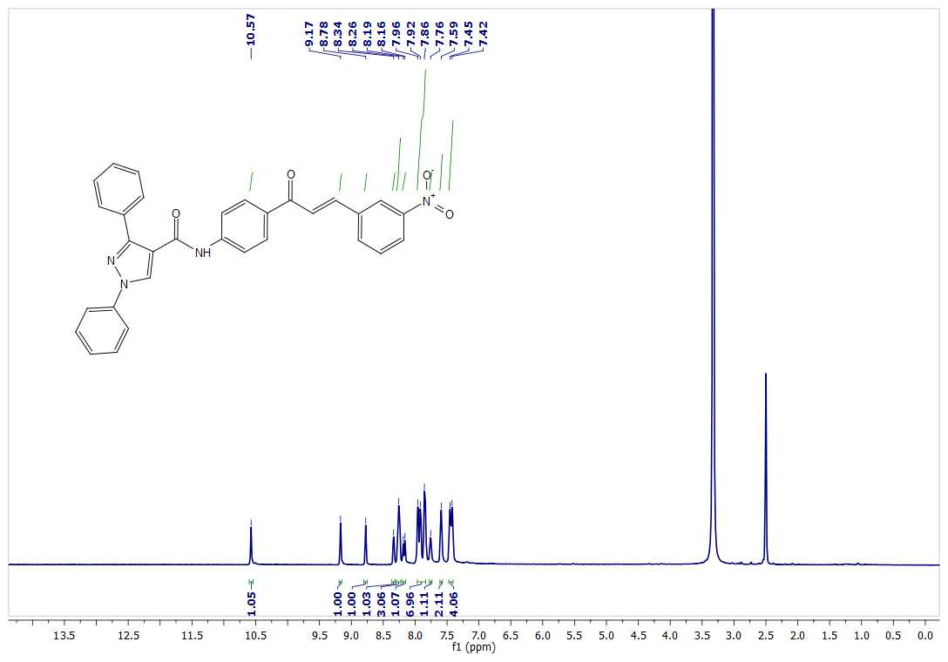
¹³C NMR of 9k
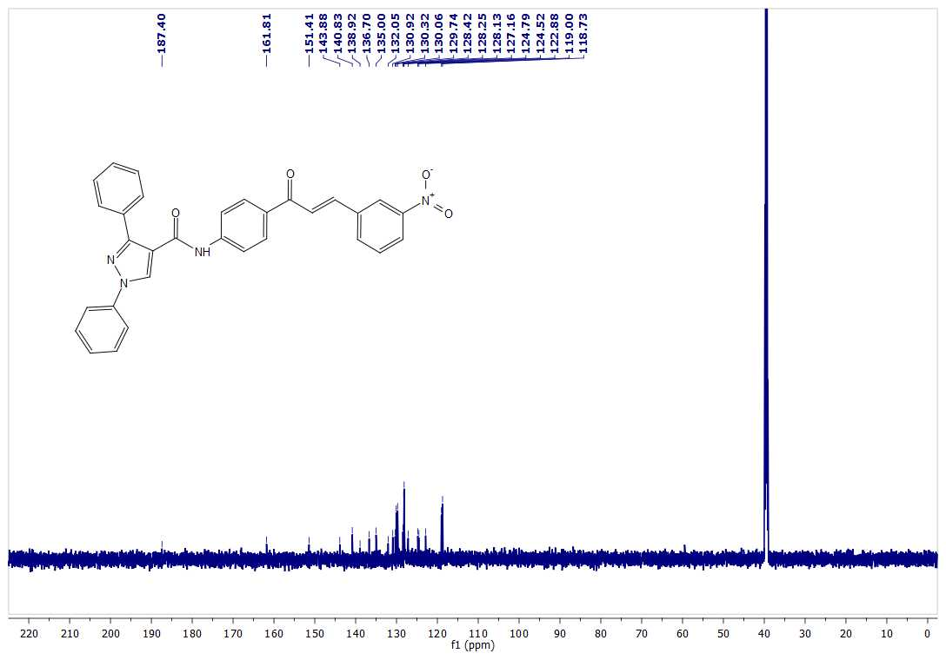
¹H NMR of 9l
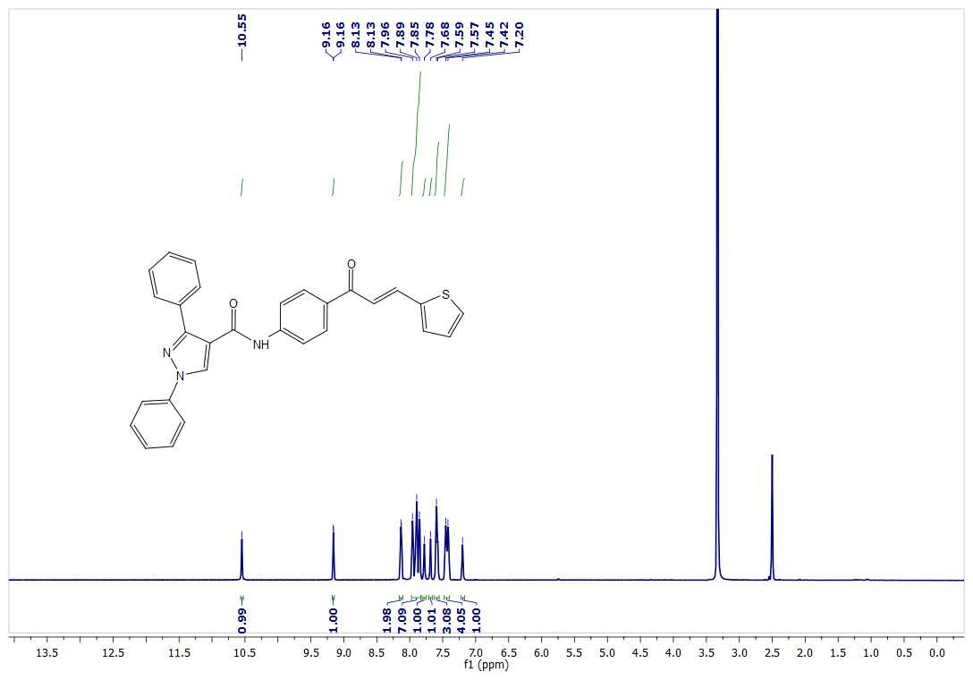
¹³C NMR of 9l
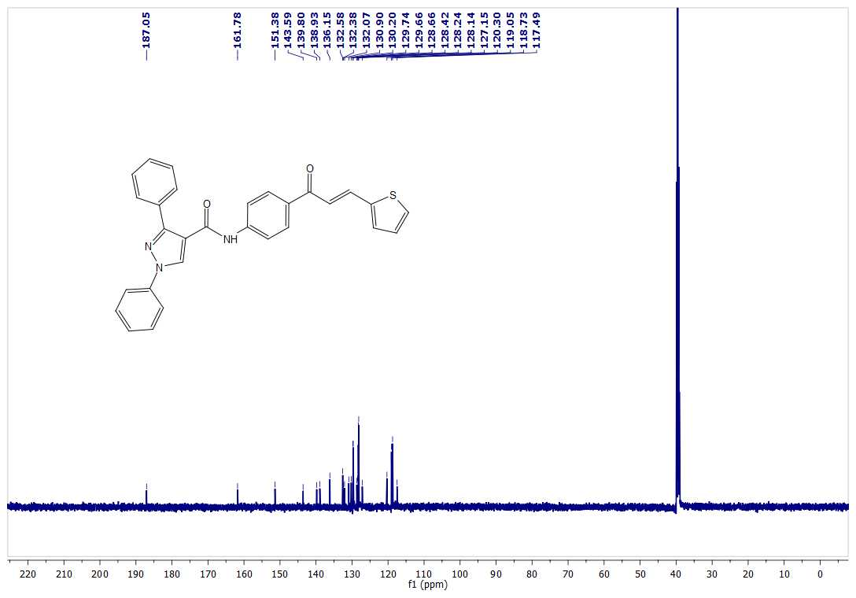
¹H NMR of 9m
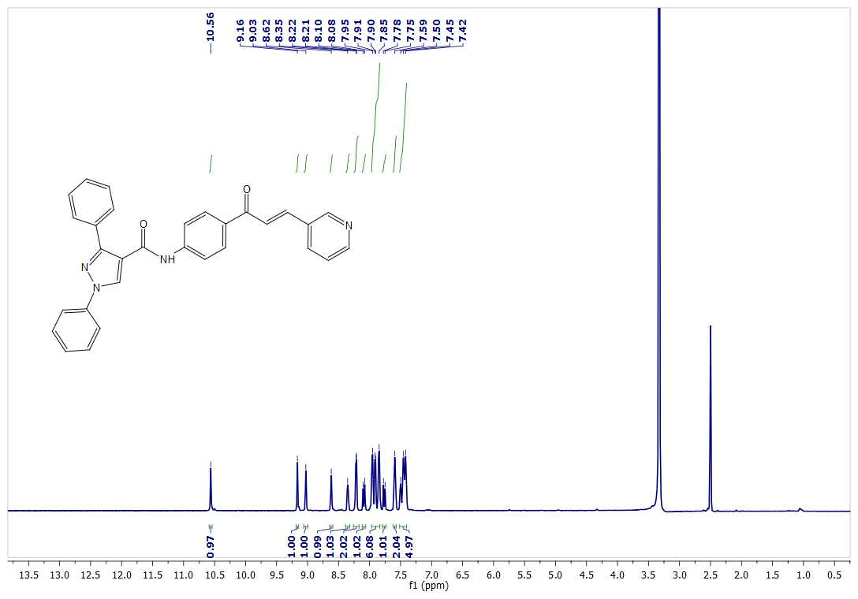
¹³C NMR of 9m
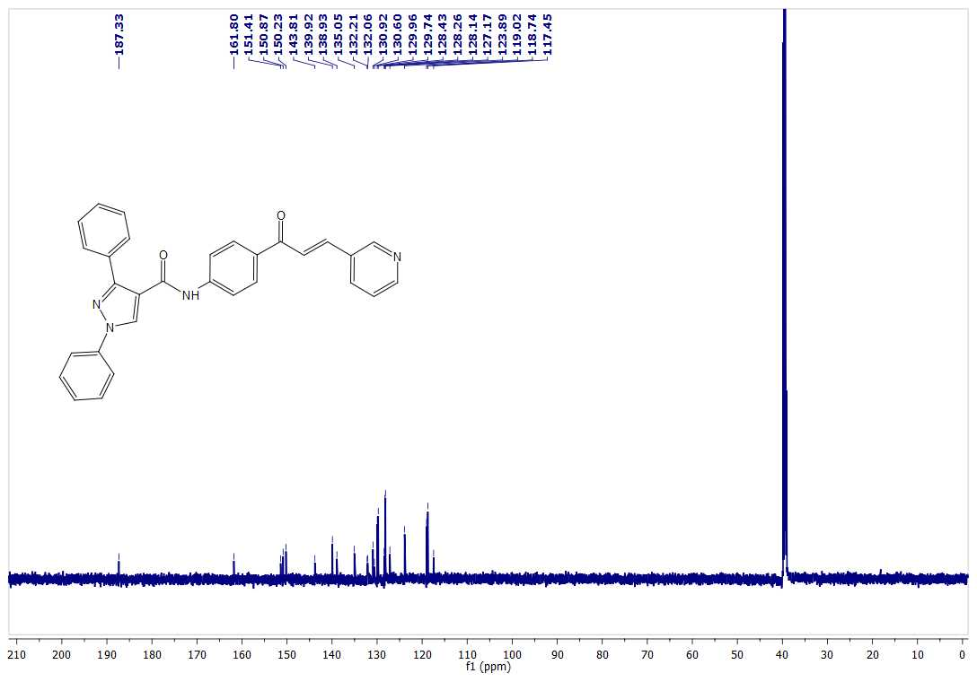
¹H NMR of 9n
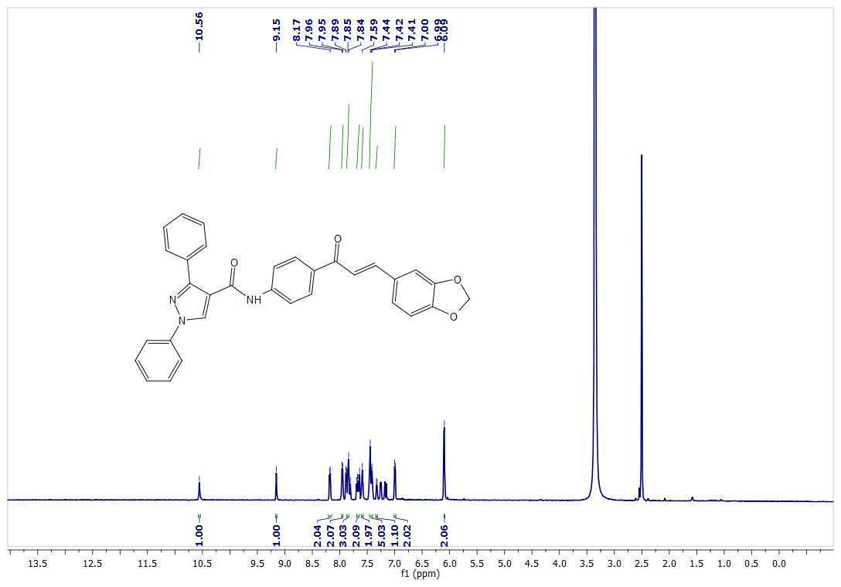
¹³C NMR of 9n
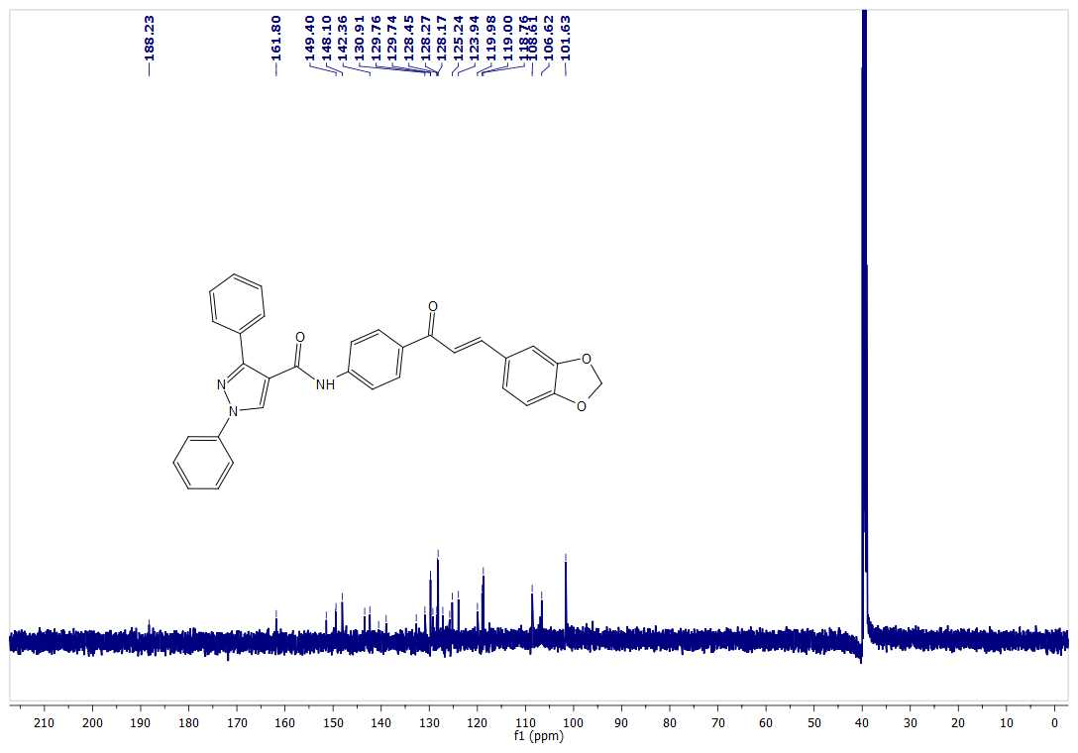
HRMS spectra of 4
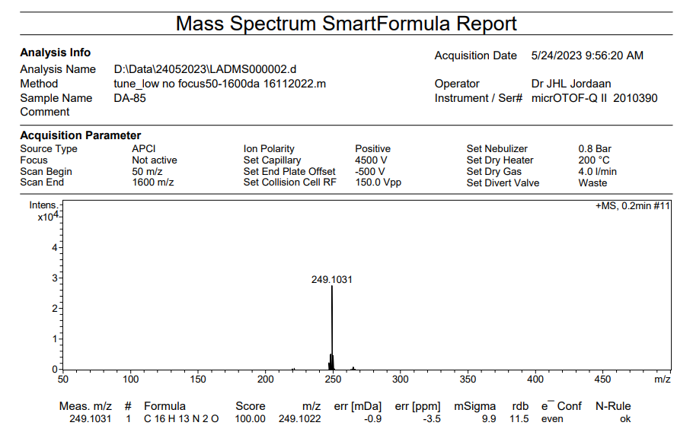
HRMS spectra of 5
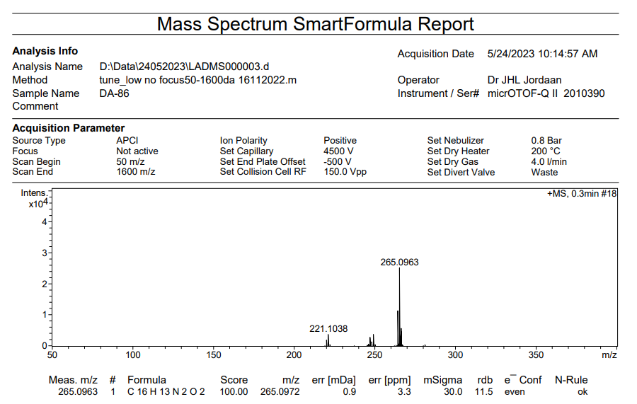

HRMS spectra of 7
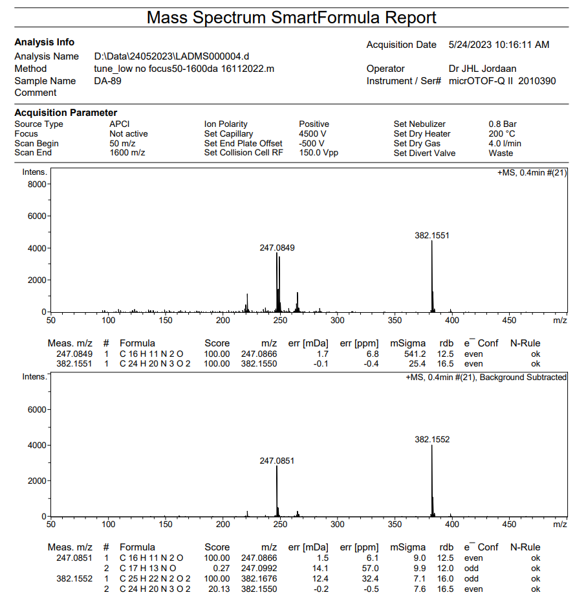

HRMS spectra of 9a
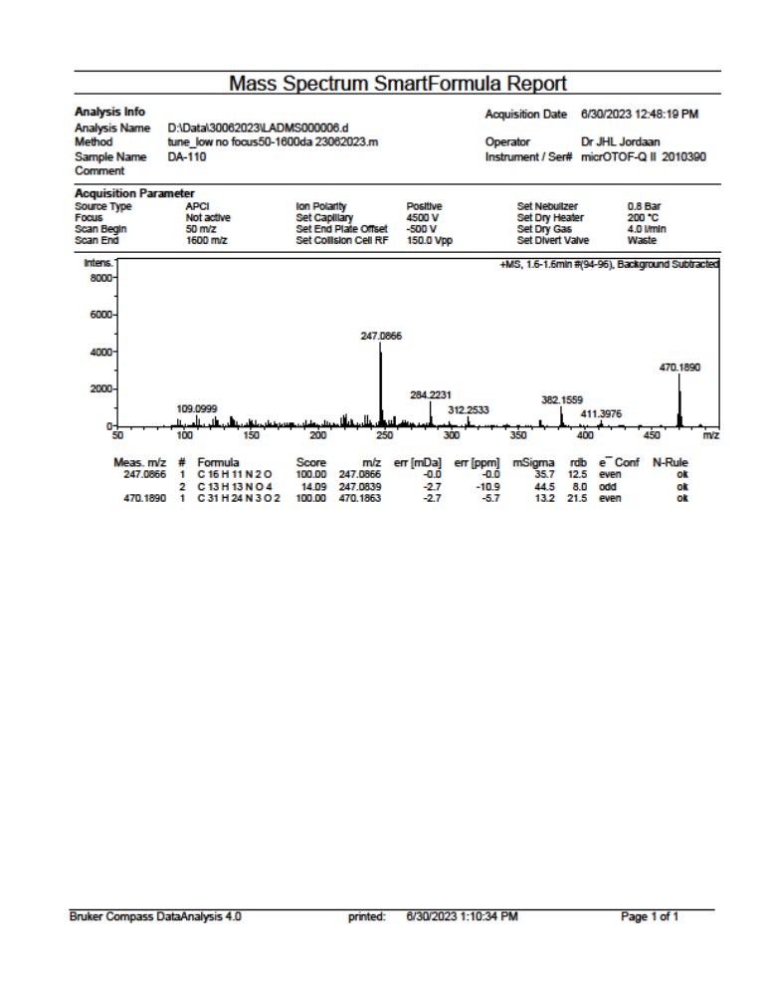

HRMS spectra of 9b
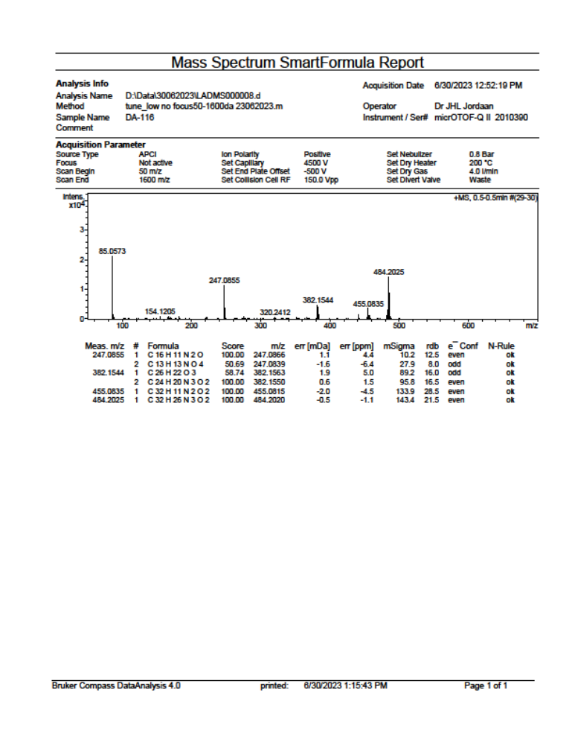

HRMS spectra of 9c
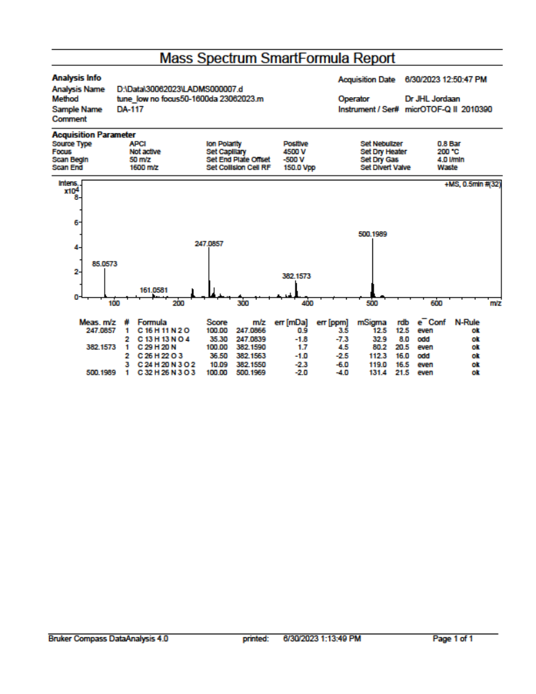

HRMS spectra of 9d
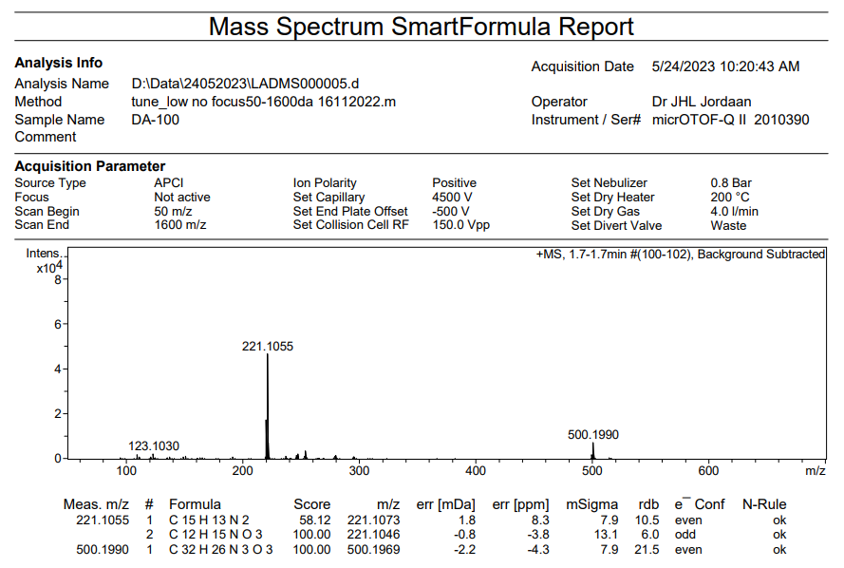
HRMS spectra of 9e
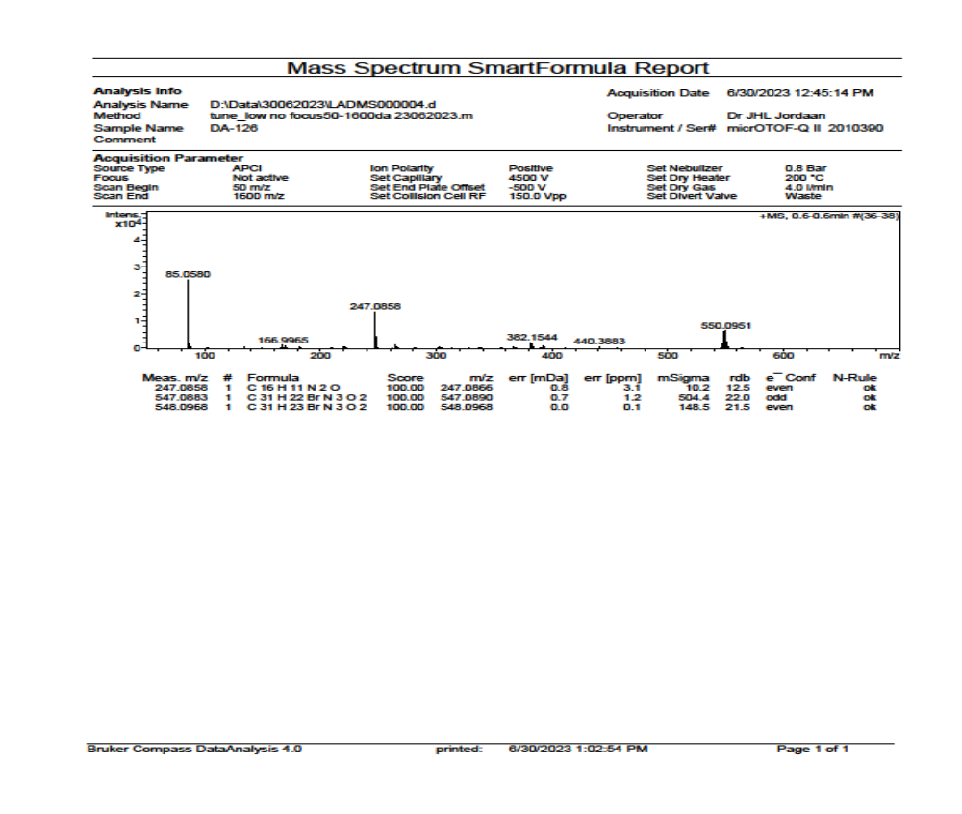
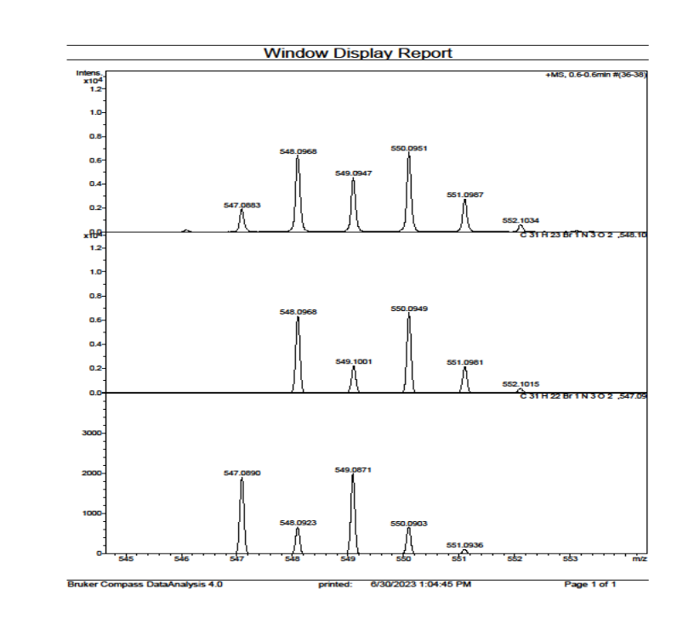
HRMS spectra of 9f
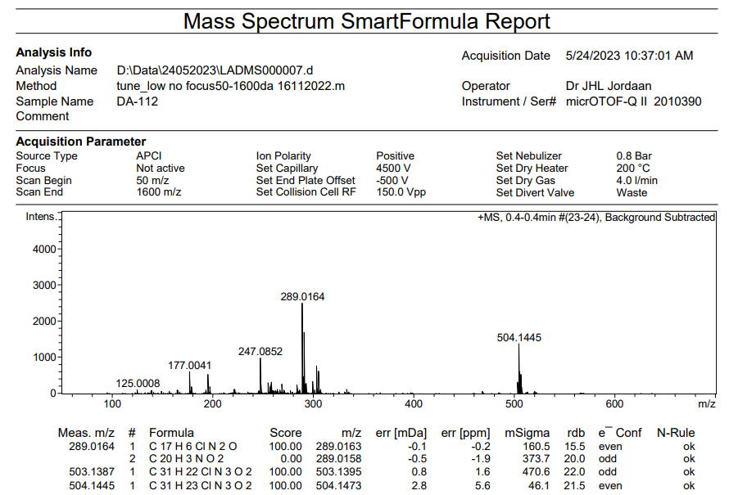

HRMS spectra of 9g
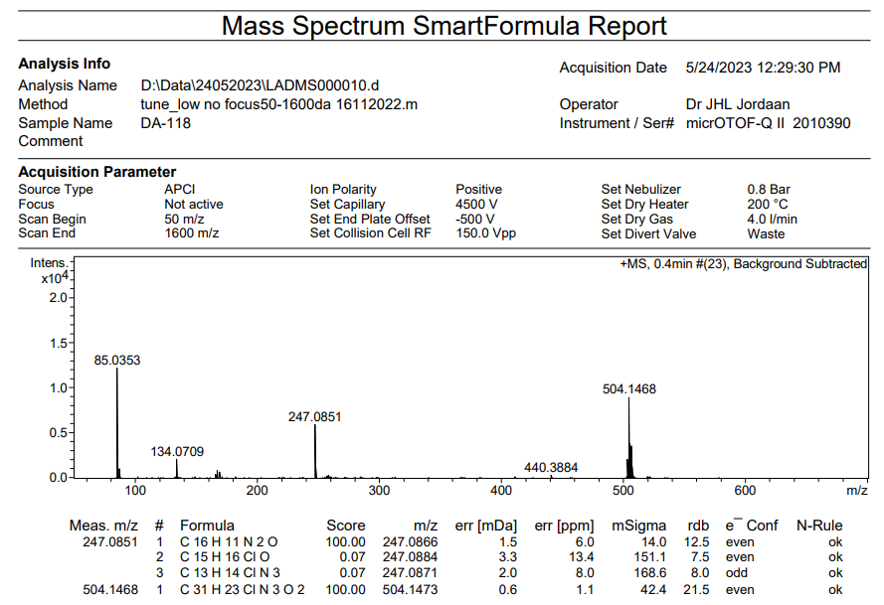
HRMS spectra of 9h
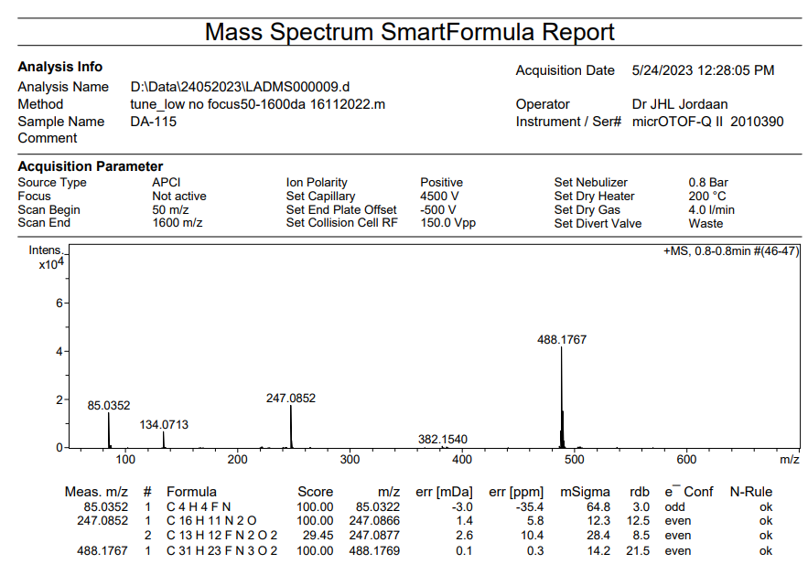
HRMS spectra of 9i
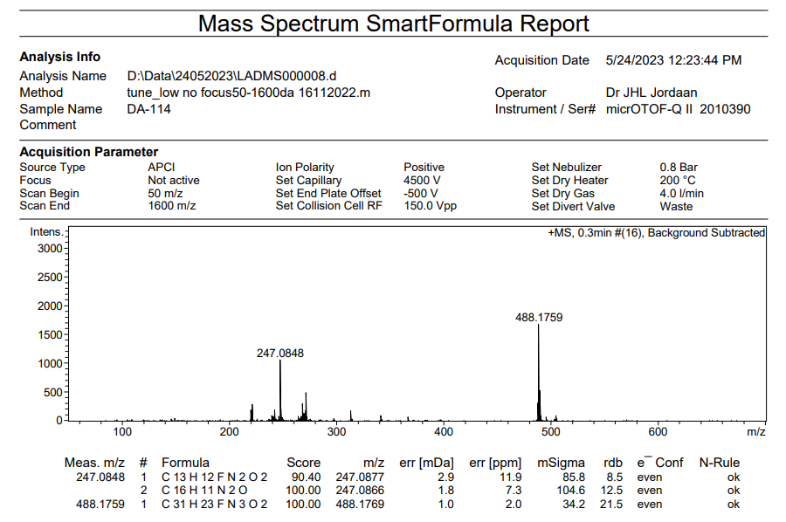
HRMS spectra of 9j
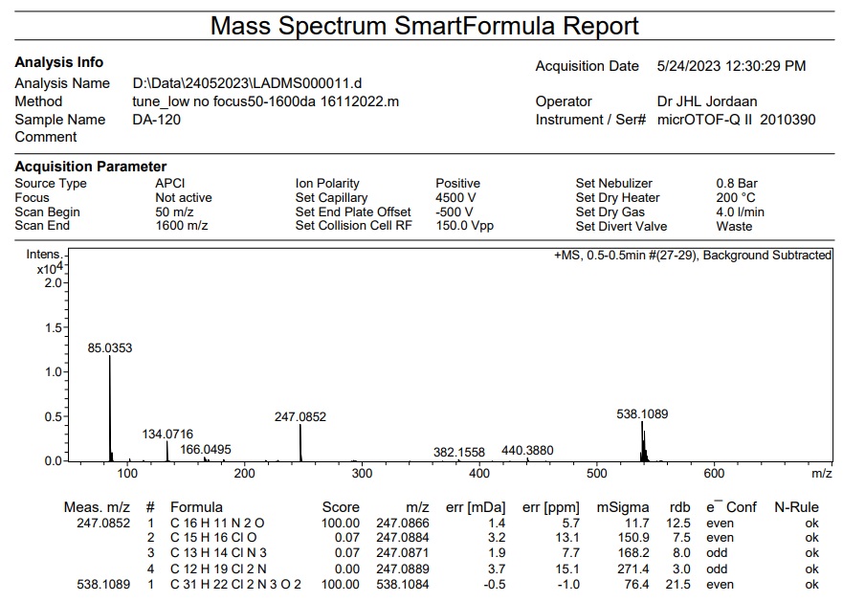

HRMS spectra of 9k
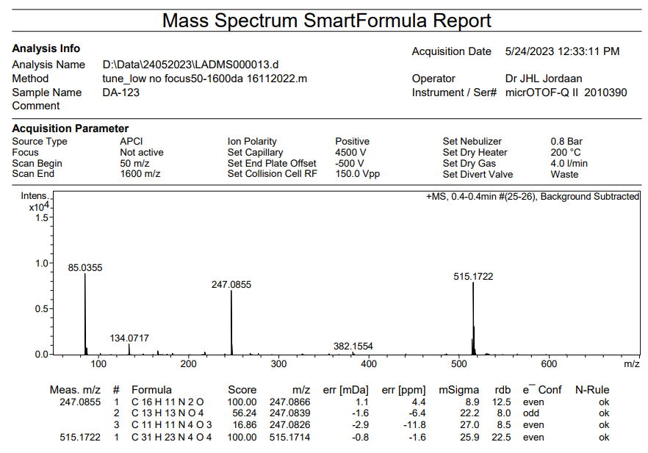
HRMS spectra of 9l
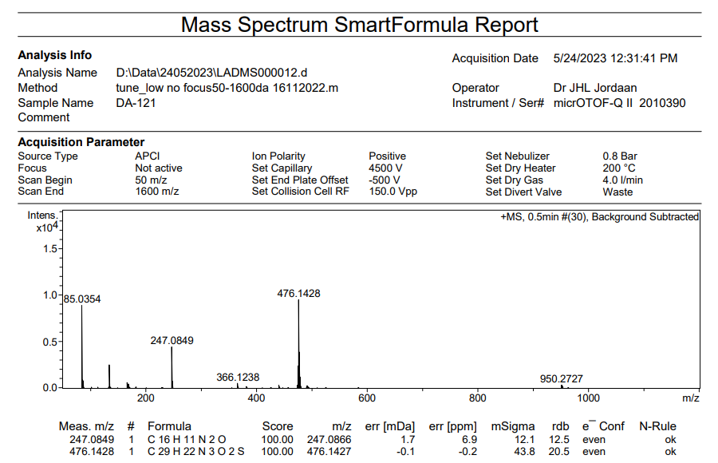

HRMS spectra of 9m
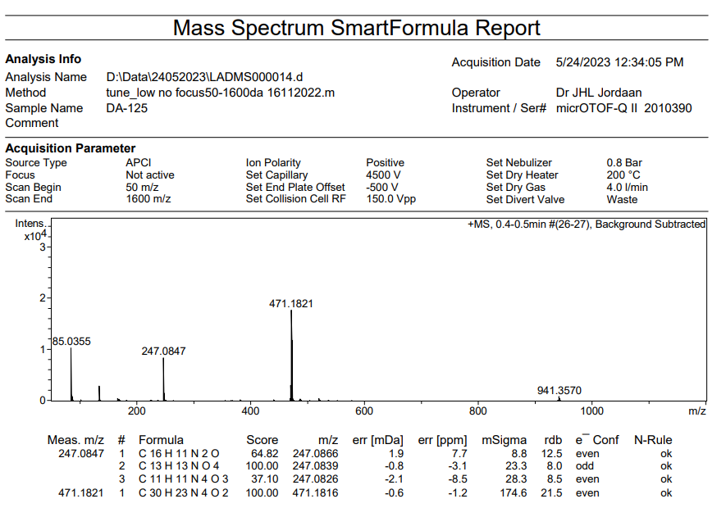
HRMS spectra of 9n
