Supplemental figures - Disinformation on dietary supplements by German influencers on Instagram

Jan-Niklas Ricke · Roland Seifert
Figure S1 Distribution of discount codes offered by influencers as a bar chart
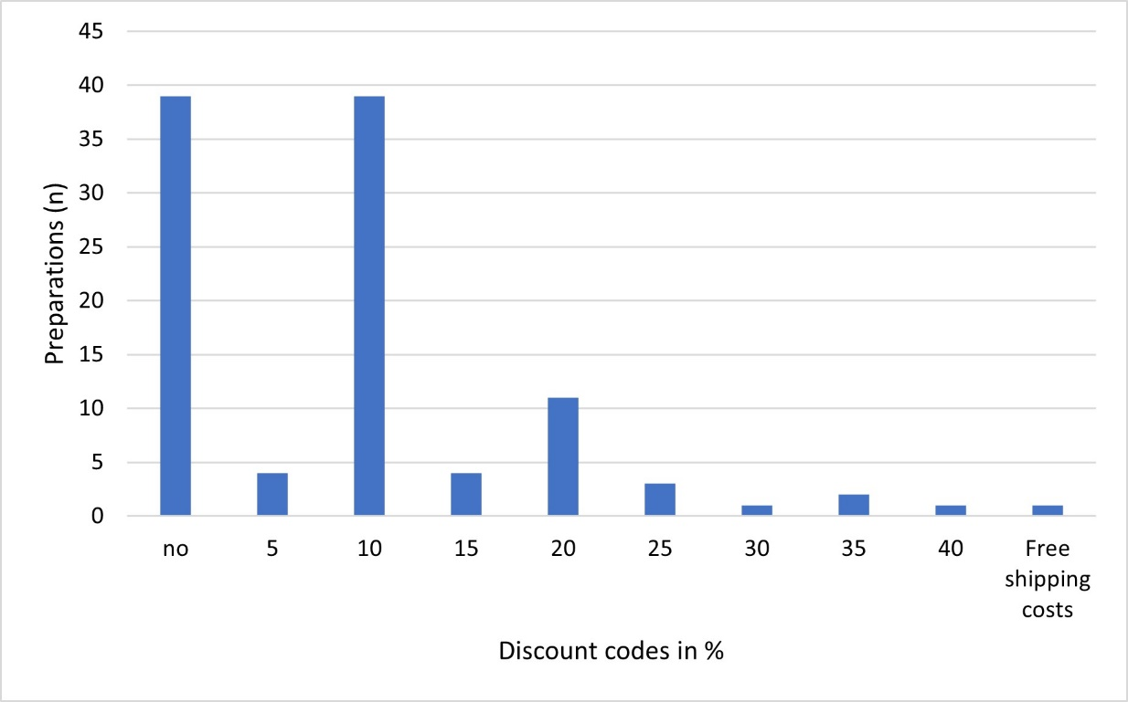

Figure S2 Representation of the frequency of suggestiveness of the preparations as a pie chart, whereby the proportion of preparations with suggestiveness is coloured blue and the proportion of preparations without suggestiveness is coloured orange
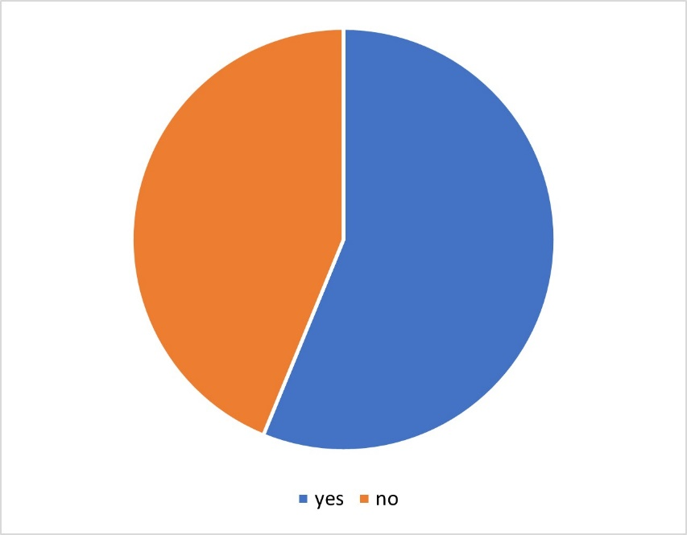

Figure S3 Presentation of the frequency of a promise of effectiveness in the posts as a pie chart, with the proportion of posts with a promise of effectiveness coloured blue and the proportion of posts without a promise of effectiveness coloured orange
