Supplementary Materials
Tables 3
Table 1 Search strategy 3
Table 2.1 Authors judgment with justifications of Athauda et al.; 2017 5
Table 2.2 Authors judgment with justifications of Aviles-Olmos et al.; 2013 6
Table 2.3 Authors judgment with justifications of McGarry et al.; 2024 7
Table 2.4 Authors judgment with justifications of Meissner et al.; 2024 8
Table 2.5 Authors judgment with justifications of Hogg et al.; preprinted 9
Sensitivity analysis forest plots 10
Figure 1 Sensitivity analysis of MDS-UPDRS I 10
Figure 2 Sensitivity analysis of MDS-UPDRS II 10
Figure 3 Sensitivity analysis of MDS-UPDRS III on-medication 10
Figure 4 Sensitivity analysis of LED 10
Figure 5 Sensitivity analysis of Nausea 11
Figure 6.1 Sensitivity analysis of weight loss (excluding Aviles-Olmos et al.; 2013) 11
Figure 5.2 Sensitivity analysis of weight loss (excluding Athauda et al.; 2017) 11
Figure 7.1 Sensitivity analysis of UTI (excluding McGarry et al.; 2024) 11
Figure 6.2 Sensitivity analysis of UTI (excluding Meissner et al.; 2024) 12
Meta-analysis including the pre-printed paper 13
Figure 8 Forest plot of MDS-UPDRS I including Hogg et al.; pre-printed 13
Figure 9 Forest plot of MDS-UPRDS II including Hogg et al.; pre-printed 13
Figure 10 Forest plot of MDS-UPDRS III On-medication including Hogg et al.; pre-printed 13
Figure 11 Forest plot of MDS-UPRDS III Off-medication including Hogg et al.; pre-printed 13
Figure 12 Forest plot of MDS-UPRDS IV including Hogg et al.; pre-printed 14
Figure 13 Forest plot of PDQ-39 including Hogg et al.; pre-printed 14
Figure 14 Forest plot of NMSS including Hogg et al.; pre-printed 14
Figure 15 Forest plot of Administration site disorder including Hogg et al.; pre-printed 14
Figure 16 Forest plot of Fatigue including Hogg et al.; pre-printed 15
Figure 17 Forest plot of UTI including Hogg et al.; pre-printed 15
Figure 18 Forest plot of Anxiety including Hogg et al.; pre-printed 15
Figure 19 Forest plot of Nausea including Hogg et al.; pre-printed 15
Figure 20 Forest plot of Constipation including Hogg et al.; pre-printed 16
Figure 21 Forest plot of Vomiting including Hogg et al.; pre-printed 16
Figure 22 Forest plot of Diarrhea including Hogg et al.; pre-printed 16
Figure 23 Forest plot of Headache including Hogg et al.; pre-printed 16

Tables

Table 1 Search strategy
Data Base | Search Strategy
PubMed | 1= ("Glucagon-Like Peptide-1 Receptor Agonists"[Mesh]) AND "Parkinson Disease"[Mesh])  2= ((Glucagon-like peptide-1) OR (GLP-1)) AND (parkinson's disease) AND ((Randomized Controlled Trial) OR (RCT))  3= 1 AND 2
Scopus | (parkinson*) AND ((GLP-1) OR (GLP-1 agonists) OR (Glucagon-Like Peptide-1 Receptor Agonists) OR (Lixisenatide) OR (Taspoglutide) OR (Liraglutide) OR (Dulaglutide) OR (Exenatide) OR (Semaglutide))
Web of Science | (TI=(“Glucagon-Like Peptide-1 Receptor Agonist” OR “Glucagon Like Peptide 1 Receptor Agonist” OR “GLP-1 Receptor Agonist” OR “GLP 1 Receptor Agonist” OR “Incretin Mimetic” OR “GLP-1 Analog” OR “GLP 1 Analog” OR “Exenatide” OR “Liraglutide” OR “Dulaglutide” OR “Semaglutide” OR “Lixisenatide” OR “Albiglutide” OR “Efpeglenatide” )) AND TI=(“Parkinson's Disease” OR “Parkinson Disease” OR “Parkinsonism” OR “Parkinsonian” OR “Paralysis Agitans”)
Clinical Trial.gov | ("GLP-1 Receptor Agonists" OR "Incretins" OR "liraglutide" OR "exenatide") AND ("Parkinson's Disease" OR "Parkinsonism" OR "Neurodegenerative Disorders")
MEDLINE  (OVID) | 1= ("Glucagon-Like Peptide-1 Receptor Agonist" or "Glucagon Like Peptide 1 Receptor Agonist" or "GLP-1 Receptor Agonist" or "GLP 1 Receptor Agonist" or "Incretin Mimetic" or "GLP-1 Analog" or "GLP 1 Analog" or "Exenatide" or "Liraglutide" or "Dulaglutide" or "Semaglutide" or "Lixisenatide" or "Albiglutide" or "Efpeglenatide").m_titl.  2= ("Parkinson's Disease" or "Parkinson Disease" or "Parkinsonism" or "Parkinsonian" or "Paralysis Agitans").m_titl.  3= 1 AND 2
Cochrane central | (Parkinson OR "Parkinson's") AND (GLP1 OR GLP OR "Glucagon Like Peptide 1 Receptor Agonists" OR "Glucagon Like Peptide 1" OR "Glucagon-Like Peptide-1 Receptor Agonists" OR "Glucagon-Like Peptide 1 Receptor Agonists" OR "Glucagon-Like Peptide1 Receptor Agonists" OR "Glucagon Like Peptide 1" OR "Glucagon Like Peptide1" OR "Glucagon-Like Peptide-1" OR "Glucagon Like Peptide-1" OR Exenatide OR Byetta OR Bydureon OR Liraglutide OR Victoza OR Saxenda OR Dulaglutide OR Trulicity OR Semaglutide OR Ozempic OR Rybelsus OR Wegovy OR Lixisenatide OR Lyxumia OR Tirzepatide OR Mounjaro OR Efpeglenatide OR Albiglutide OR Tanzeum OR Eperzan OR Cagrilintide OR AM833 OR IDegLira OR IGlarLixi OR Xultophy OR Soliqua)
Google scholar | Parkinson OR "Parkinson's" AND (GLP1 OR GLP OR "Glucagon Like Peptide 1" OR "Glucagon-Like Peptide-1" OR Exenatide OR Byetta OR Bydureon OR Liraglutide OR Victoza OR Saxenda OR Dulaglutide OR Trulicity OR Semaglutide OR Ozempic OR Rybelsus OR Wegovy OR Lixisenatide OR Lyxumia OR Tirzepatide OR Mounjaro OR Efpeglenatide OR Albiglutide OR Tanzeum OR Eperzan OR Cagrilintide OR AM833 OR IDegLira OR IGlarLixi OR Xultophy OR Soliqua)

Table 2.1 Authors judgment with justifications of Athauda et al.; 2017
Paper ID | Domain | Question | Author judgement | Support for judgment
Athauda et al.; 2017 | Risk of bias arising from the randomization process | Random Sequence Generation | YES | “We used SealedEnvelope, an independent, commerical, internetbased randomisation service that generated the online randomisation list on the basis of guidance from the trial IT manager (SH) and trial statistician (SSS)”
Athauda et al.; 2017 | Risk of bias arising from the randomization process | Allocation concealment | YES | “The trial statistician (SSS) generated and uploaded unique three-digit identifers for every active and placebo drug kit to the randomisation service to allow allocation of masked study drug kits (sufcient for 12 weeks) at randomisation and follow-up visits by assessing clinicians.”
Athauda et al.; 2017 | Risk of bias arising from the randomization process | Baseline balance differences | NO | No baseline differences
Athauda et al.; 2017 | Risk of bias due to deviations from the intended interventions | Participants awareness | NO | “Patients and investigators were masked to treatment allocation throughout the study.”
Athauda et al.; 2017 |  | Investigators awareness | NO | “Patients and investigators were masked to treatment allocation throughout the study.”
Athauda et al.; 2017 |  | Appropriate analysis | YES | “Individuals who withdrew before 12 weeks could not contribute data to the primary outcome, and so were replaced per protocol. All 60 patients who completed at least the initial 12-week follow-up were included in the primary analysis.”
Athauda et al.; 2017 |  | Potential impact of the failure to analyze participants | NO
Athauda et al.; 2017 | Risk of bias due to missing outcome data | Outcome data for all participants | YES | “All efficacy analyses were based on a modified intention-to-treat principle”
Athauda et al.; 2017 | Risk of bias in measurement of the outcome | Inappropriate outcome measurement method | NO | “The primary outcome was the adjusted difference in the Movement Disorders Society Unified Parkinson’s Disease Rating Scale (MDS-UPDRS) motor subscale (part 3) in the practically defined off-medication state at 60 weeks.”
Athauda et al.; 2017 | Risk of bias in measurement of the outcome | Differences between interventional groups | NO | The same outcomes measured in the two groups
Athauda et al.; 2017 | Risk of bias in measurement of the outcome | Outcome assessor awareness | NO | The trial statistician (SSS) generated and uploaded unique three-digit identifers for every active and placebo drug kit to the randomisation service to allow allocation of masked study drug kits (sufficient for 12 weeks) at randomisation and follow-up visits by assessing clinicians. Patients and investigators were masked to treatment allocation throughout the study.
Athauda et al.; 2017 | Risk of bias in measurement of the outcome | Assessment of the outcome could have been influenced by knowledge. | NO
Athauda et al.; 2017 | Risk of bias in measurement of the outcome | Assessment of the outcome have been likely influenced by knowledge. | NO
Athauda et al.; 2017 | Risk of bias in selection of the reported result | Results selected from multiple outcome measurements | NO | All the outcomes that could assess a PD patients are found in the paper.
Athauda et al.; 2017 | Risk of bias in selection of the reported result | Results selected from multiple analysis | Probably NO | “All study analyses were done according to a predefined statistical analysis plan.”
Athauda et al.; 2017 | Risk of bias in selection of the reported result | Trial analyzed in accordance | Probably YES | “All study analyses were done according to a predefined statistical analysis plan.”

Table 2.2 Authors judgment with justifications of Aviles-Olmos et al.; 2013
Paper ID | Domain | Question | Author judgement | Support for judgment
Aviles-Olmos et al.; 2013 | Risk of bias arising from the randomization process | Random Sequence Generation | YES | “Block randomisation will be used with random block sizes. Separate randomisation lists will be generated for patients of greater (Hoehn & Yahr stage 2.5) or lesser (Hoehn & Yahr stage 2.0) disease severity to balance this as a possible prognostic factor” (Found in the protocol section 8.3)
Aviles-Olmos et al.; 2013 | Risk of bias arising from the randomization process | Allocation concealment | YES | Randomisation lists will be created prior to trial commencement, and stored by the trial pharmacist. (See protocol Section 8.3)
Aviles-Olmos et al.; 2013 | Risk of bias arising from the randomization process | Baseline balance differences | NO | “Randomization was stratified by Hoehn and Yahr stage (2, low; 2.5, high) to help ensure similar baseline disability between the 2 groups.”
Aviles-Olmos et al.; 2013 | Risk of bias due to deviations from the intended interventions | Participants awareness | YES | In view of the prohibitive costs associated with manufacture of (QP released) placebo versions of the exenatide pens, these were not available for the purposes of this trial, which was necessarily configured to be open-label from the patient’s perspective.
Aviles-Olmos et al.; 2013 |  | Investigators awareness | YES | In view of the prohibitive costs associated with manufacture of (QP released) placebo versions of the exenatide pens, these were not available for the purposes of this trial, which was necessarily configured to be open-label from the patient’s perspective.
Aviles-Olmos et al.; 2013 |  | deviations arose due to experimental context | NO | Patients in both groups continued any licensed PD medication after enrollment and throughout the trial according to the judgement of their treating neurologists. No adjustment of PD medications was made at trial visits unless clinically urgent.
Aviles-Olmos et al.; 2013 |  | Appropriate analysis | NO | “‘per-protocol’ Patients with- drawing from the trial prior to the 3-month visit were replaced, and new recruits were randomly allocated to the 2 groups”
Aviles-Olmos et al.; 2013 |  | Potential impact of the failure to analyze participants | Probably NO | 1 drop out < 3 months due to L-dopa dose failures
Aviles-Olmos et al.; 2013 | Risk of bias due to missing outcome data | Outcome data for all participants | YES | “Last observation carried forward” was used for participants with missing data.”
Aviles-Olmos et al.; 2013 | Risk of bias in measurement of the outcome | Inappropriate outcome measurement method | NO | “Their PD was compared after overnight withdrawal of conventional PD medication using blinded video assessment of the Movement Disorders Society Unified Parkinson’s Disease Rating Scale (MDS-UPDRS)”
Aviles-Olmos et al.; 2013 | Risk of bias in measurement of the outcome | Differences between interventional groups | NO | The same outcomes measured in the two groups
Aviles-Olmos et al.; 2013 | Risk of bias in measurement of the outcome | Outcome assessor awareness | NO | “Assessments of PD severity using MDS-UPDRS part 3 were made “off-medication” after an overnight period and were video recorded to allow objective rating of PD disability by observers blinded to randomization outcomes. Each patient video was rated by the same blinded clinician at each time point.”
Aviles-Olmos et al.; 2013 | Risk of bias in measurement of the outcome | Assessment of the outcome could have been influenced by knowledge. | NO
Aviles-Olmos et al.; 2013 | Risk of bias in measurement of the outcome | Assessment of the outcome have been likely influenced by knowledge. | NO
Aviles-Olmos et al.; 2013 | Risk of bias in selection of the reported result | Results selected from multiple outcome measurements | Probably YES | “SCOPA Sleep, SCOPA AUT (they shoud be assessed but we can't find their measures)”
Aviles-Olmos et al.; 2013 | Risk of bias in selection of the reported result | Results selected from multiple analysis | NO | Measure the change values as mentioned in protocol
Aviles-Olmos et al.; 2013 | Risk of bias in selection of the reported result | Trial analyzed in accordance | YES | Section 13 in the protocol

Table 2.3 Authors judgment with justifications of McGarry et al.; 2024
Paper ID | Domain | Question | Author judgement | Support for judgment
McGarry et al.; 2024 | Risk of bias arising from the randomization process | Random Sequence Generation | YES | “Participants were randomly allocated (1:1:1) to one of two active treatment groups (2·5 mg or 5·0 mg NLY01) or placebo, using a central computergenerated randomisation scheme with permuted block randomisation and varying block sizes.”
McGarry et al.; 2024 | Risk of bias arising from the randomization process | Allocation concealment | YES | “The production randomisation schedule was generated by the Rho Unblinded Interactive Web Response System team and was uploaded into Medidata Randomization and Trial Supply Management. Site staﬀ used this software to randomly allocate participants and receive kit numbers to dispense to them.”
McGarry et al.; 2024 | Risk of bias arising from the randomization process | Baseline balance differences | NO | Baseline characteristics were similar across treatment groups (table 1).
McGarry et al.; 2024 | Risk of bias due to deviations from the intended interventions | Participants awareness | NO | “Placebo was matched to the study drug for physical characteristics and packaging. All participants, investigators, coordinators, study staﬀ, and sponsor personnel were masked to treatment assignments throughout the study.”
McGarry et al.; 2024 |  | Investigators awareness | NO | “Placebo was matched to the study drug for physical characteristics and packaging. All participants, investigators, coordinators, study staﬀ, and sponsor personnel were masked to treatment assignments throughout the study.”
McGarry et al.; 2024 |  | Appropriate analysis | YES | “The primary analysis of the primary endpoint (treatment difference of least squares mean change from baseline to week 36 in the sum of MDSUPDRS parts II and III for 2·5 and 5·0 mg NLY01 vs placebo) was conducted in a modified intentiontotreat (mITT) population using a mixed model for repeated measures.”
McGarry et al.; 2024 |  | Potential impact of the failure to analyze participants | NO
McGarry et al.; 2024 | Risk of bias due to missing outcome data | Outcome data for all participants | YES | intention-to-treat
McGarry et al.; 2024 | Risk of bias in measurement of the outcome | Inappropriate outcome measurement method | NO | “The primary efficacy endpoint was the change from baseline to week 36 in the sum of MDSUPDRS scores for parts II and III. The MDSUPDRS is a well established and widely used assessment to quantify the signs and symptoms of Parkinson’s disease. The MDSUPDRS has four parts: part I (nonmotor aspects of experiences of daily living), part II (motor aspects of experiences of daily living), part III (motor examination), and part IV (motor complications).”
McGarry et al.; 2024 | Risk of bias in measurement of the outcome | Differences between interventional groups | NO | The same outcomes measured in the two groups
McGarry et al.; 2024 | Risk of bias in measurement of the outcome | Outcome assessor awareness | NO | “All participants, investigators, coordinators, study staff, and sponsor personnel were masked to treatment assignments throughout the study.”
McGarry et al.; 2024 | Risk of bias in measurement of the outcome | Assessment of the outcome could have been influenced by knowledge. | NO
McGarry et al.; 2024 | Risk of bias in measurement of the outcome | Assessment of the outcome have been likely influenced by knowledge. | NO
McGarry et al.; 2024 | Risk of bias in selection of the reported result | Results selected from multiple outcome measurements | NO | The outcomes reported in protocol were reported in paper
McGarry et al.; 2024 | Risk of bias in selection of the reported result | Results selected from multiple analysis | NO | Change in Unified Parkinson's Disease Rating Scale in combined score of Parts II and III from baseline to 36 weeks (protocol)
McGarry et al.; 2024 | Risk of bias in selection of the reported result | Trial analyzed in accordance | YES | Section 12 in protocol

Table 2.4 Authors judgment with justifications of Meissner et al.; 2024
Paper ID | Domain | Question | Author judgement | Support for judgment
Meissner et al.; 2024 | Risk of bias arising from the randomization process | Random Sequence Generation | YES | “Randomization, performed with the use of a Webbased system, was in unstratified blocks of 4 and 6.”
Meissner et al.; 2024 | Risk of bias arising from the randomization process | Allocation concealment | YES | “According to their protocol, researchers stated that concealment was done by the EUCLID trial platform in co-opertation with Sanofi. This allowed the investigatior (which was responsible for the allocation) to get the number corresponding to the treatment to be adminstered to the patient without knowing the group that the patient was allocated to.” (See protocol section 6.3)
Meissner et al.; 2024 | Risk of bias arising from the randomization process | Baseline balance differences | NO | “The demographic and clinical characteristics of the participants at baseline were similar in the two groups and were typical of early disease.”
Meissner et al.; 2024 | Risk of bias due to deviations from the intended interventions | Participants awareness | NO | All the authors vouch for the completeness and accuracy of the data, the fidelity of the trial to the protocol. THE PROTOCOL: “The labels will not provide any information on the type of treatment. Only the treatment number will identify the treatment to be administered to a trial participant. The lixisenatide and placebo are blinded and indistinguishable. The injected volume is a fixed dose of 0.2 mL each. During the double blind treatment period, each treatment kit (and the corresponding pens) is labelled with a treatment number, which is displayed, during the randomization and dispensation process, by the validated web-based system (Ennov Clinical® software) used by the EUCLID clinical trial platform”
Meissner et al.; 2024 |  | Investigators awareness | NO | All the authors vouch for the completeness and accuracy of the data, the fidelity of the trial to the protocol. THE PROTOCOL: “The labels will not provide any information on the type of treatment. Only the treatment number will identify the treatment to be administered to a trial participant. The lixisenatide and placebo are blinded and indistinguishable. The injected volume is a fixed dose of 0.2 mL each. During the double blind treatment period, each treatment kit (and the corresponding pens) is labelled with a treatment number, which is displayed, during the randomization and dispensation process, by the validated web-based system (Ennov Clinical® software) used by the EUCLID clinical trial platform”
Meissner et al.; 2024 |  | Appropriate analysis | YES | “Efficacy and safety end points were assessed in the modified intention-to-treat population, excluding participants with missing data.”
Meissner et al.; 2024 |  | Potential impact of the failure to analyze participants | NO
Meissner et al.; 2024 | Risk of bias due to missing outcome data | Outcome data for all participants | YES | There are data for 149 participants from 156, the missed data isnt significance (4.5% from data was missed)
Meissner et al.; 2024 | Risk of bias in measurement of the outcome | Inappropriate outcome measurement method | NO | “The primary end point was the change from base- line in scores on the Movement Disorder Society–Unified Parkinson’s Disease Rating Scale (MDS-UPDRS) part III”
Meissner et al.; 2024 | Risk of bias in measurement of the outcome | Differences between interventional groups | NO | The same outcomes measured in the two groups
Meissner et al.; 2024 | Risk of bias in measurement of the outcome | Outcome assessor awareness | NO | Neither the manuscript nor the protocol stated that there were outcome assessors other than the investigators themselves. Thus, being blinded to allocation and patient groups, they were blinded as regarding outcome assessment.
Meissner et al.; 2024 | Risk of bias in measurement of the outcome | Assessment of the outcome could have been influenced by knowledge. | NO
Meissner et al.; 2024 | Risk of bias in measurement of the outcome | Assessment of the outcome have been likely influenced by knowledge. | NO
Meissner et al.; 2024 | Risk of bias in selection of the reported result | Results selected from multiple outcome measurements | NO | The outcomes reported in protocol were reported in paper
Meissner et al.; 2024 | Risk of bias in selection of the reported result | Results selected from multiple analysis | NO | “A statistical analysis plan (SAP) will be produced by the statistician before the database freeze”
Meissner et al.; 2024 | Risk of bias in selection of the reported result | Trial analyzed in accordance | YES | “A statistical analysis plan (SAP) will be produced by the statistician before the database freeze”

Table 2.5 Authors judgment with justifications of Hogg et al.; preprinted
Paper ID | Domain | Question | Author judgement | Support for judgment
Hogg et al.; pre-printed | Risk of bias arising from the randomization process | Random Sequence Generation | Probably YES | it is only stated in the study "Subjects were randomized by a pre-determined randomization list generated by the biostatistics team." Without showing the way the biostatiscs team made the randomization list; however, this paper is preprinted on Lancet.
Hogg et al.; pre-printed | Risk of bias arising from the randomization process | Allocation concealment | YES | “The randomization schedule was maintained by the investigational pharmacy, who were the only unblinded study”
Hogg et al.; pre-printed | Risk of bias arising from the randomization process | Baseline balance differences | Probably NO | “Both motor and cognitive disease severity scores were slightly higher at baseline for subjects randomized to placebo, while non-motor scores were slightly higher in the active treatment group. None of these differences reached statistical significance”
Hogg et al.; pre-printed | Risk of bias due to deviations from the intended interventions | Participants awareness | NO | The randomization schedule was maintained by the investigational pharmacy, who were the only unblinded study members during the treatment period.The liraglutide and matching placebo injection pens were designed to be identical and visually indistinguishable to the investigators, the subjects, or others assisting in treatment administration.
Hogg et al.; pre-printed |  | Investigators awareness | NO | All clinical assessments were only performed by investigators blinded to the treatment allocation of each patient.
Hogg et al.; pre-printed |  | Appropriate analysis | YES | Efficacy analyses were based on an intention-to-treat and per- protocol design for patients completing post-randomization follow-up assessments.
Hogg et al.; pre-printed |  | Potential impact of the failure to analyze participants | NO
Hogg et al.; pre-printed | Risk of bias due to missing outcome data | Outcome data for all participants | NO | There are data for 51 participants from 63, the missed data is significance (19% from data was missed)
Hogg et al.; pre-printed | Risk of bias due to missing outcome data | Resulted evidence are not biased | YES | Missing values were imputed using the last observation carried forward (LOCF) method, including clinical scores at discontinuation visit. Baseline values were not carried forward. Analyses of primary and secondary efficacy endpoints were conducted both on the ‘full analysis set’ (FAS) and ‘per protocol’ (PP) population.
Hogg et al.; pre-printed | Risk of bias in measurement of the outcome | Inappropriate outcome measurement method | NO | Primary outcomes included adjusted difference in the OFF-state Movement Disorders Society Unified PD Rating Scale (MDS-UPDRS) part III, non-motor symptom scale (NMSS) and Mattis Dementia Rating Scale (MDRS-2) at week 54.
Hogg et al.; pre-printed | Risk of bias in measurement of the outcome | Differences between interventional groups | NO | The same outcomes measured in the two groups
Hogg et al.; pre-printed | Risk of bias in measurement of the outcome | Outcome assessor awareness | NO | Blinded clinical assessments were performed by the study investigators at pre-determined intervals
Hogg et al.; pre-printed | Risk of bias in measurement of the outcome | Assessment of the outcome could have been influenced by knowledge. | NO
Hogg et al.; pre-printed | Risk of bias in measurement of the outcome | Assessment of the outcome have been likely influenced by knowledge. | NO
Hogg et al.; pre-printed | Risk of bias in selection of the reported result | Results selected from multiple outcome measurements | NO | I can't find its protocol; however, all the outcomes that could assess a PD patients are found in the paper
Hogg et al.; pre-printed | Risk of bias in selection of the reported result | Results selected from multiple analysis | Probably NO | All study analyses were performed according to a predefined statistical analysis protocol
Hogg et al.; pre-printed | Risk of bias in selection of the reported result | Trial analyzed in accordance | Probably YES | All study analyses were performed according to a predefined statistical analysis protocol

Sensitivity analysis forest plots
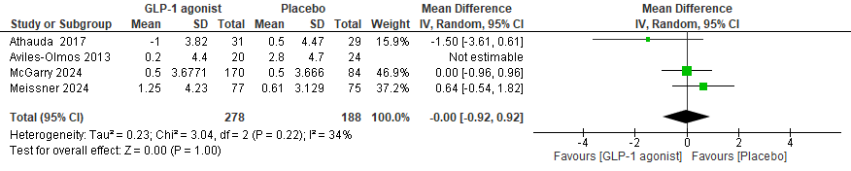

Figure 1 Sensitivity analysis of MDS-UPDRS I

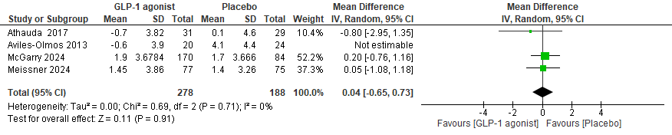

Figure 2 Sensitivity analysis of MDS-UPDRS II
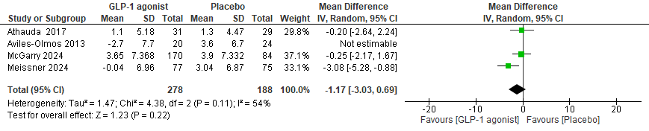

Figure 3 Sensitivity analysis of MDS-UPDRS III on-medication

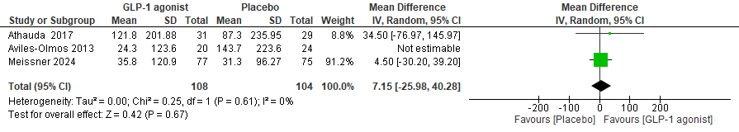

Figure 4 Sensitivity analysis of LED

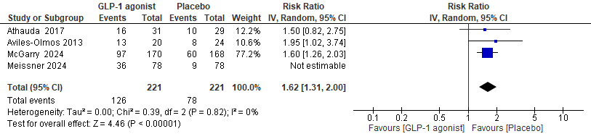

Figure 5 Sensitivity analysis of Nausea

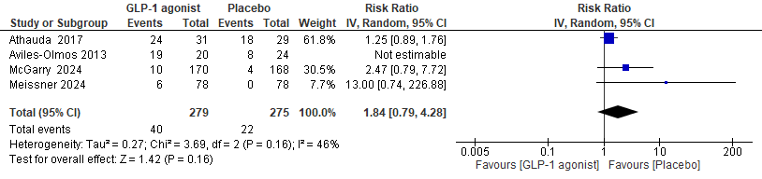

Figure 6.1 Sensitivity analysis of weight loss (excluding Aviles-Olmos et al.; 2013)

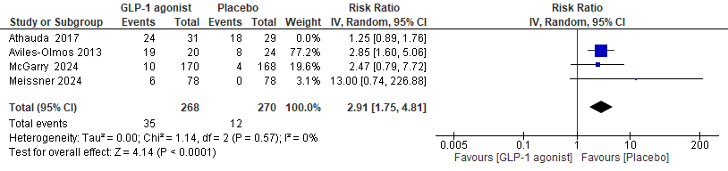

Figure 5.2 Sensitivity analysis of weight loss (excluding Athauda et al.; 2017)

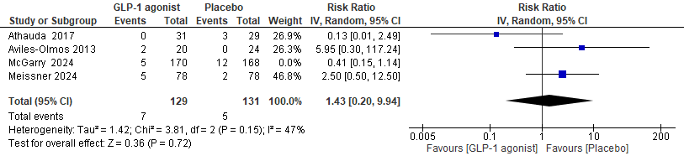

Figure 7.1 Sensitivity analysis of UTI (excluding McGarry et al.; 2024)

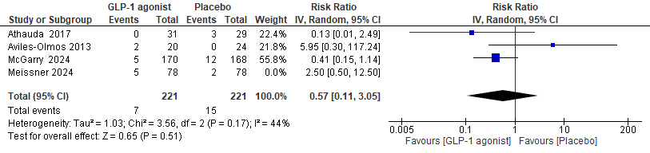

Figure 6.2 Sensitivity analysis of UTI (excluding Meissner et al.; 2024)

Meta-analysis including the pre-printed paper
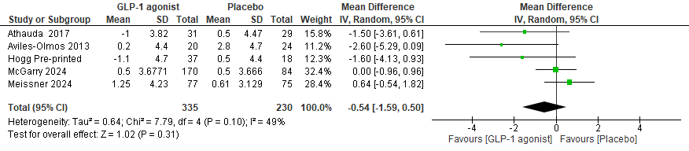

Figure 8 Forest plot of MDS-UPDRS I including Hogg et al.; pre-printed

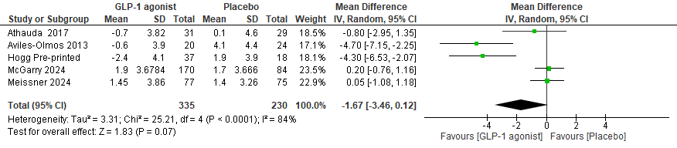

Figure 9 Forest plot of MDS-UPRDS II including Hogg et al.; pre-printed

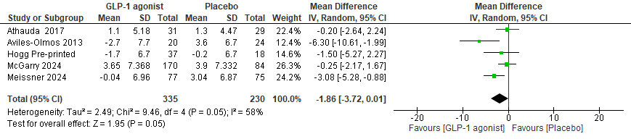

Figure 10 Forest plot of MDS-UPDRS III On-medication including Hogg et al.; pre-printed

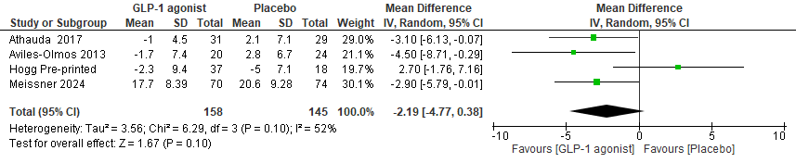

Figure 11 Forest plot of MDS-UPRDS III Off-medication including Hogg et al.; pre-printed

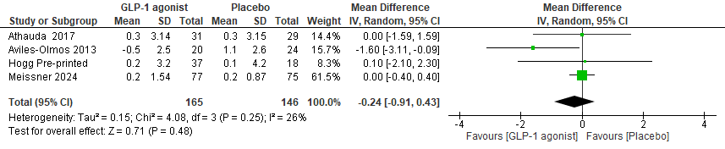

Figure 12 Forest plot of MDS-UPRDS IV including Hogg et al.; pre-printed

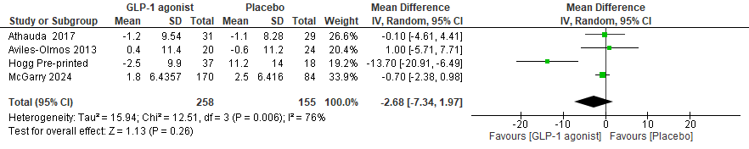

Figure 13 Forest plot of PDQ-39 including Hogg et al.; pre-printed

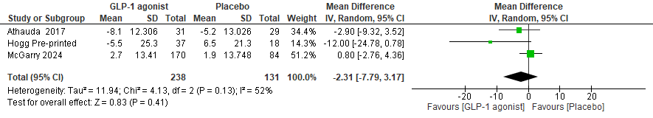

Figure 14 Forest plot of NMSS including Hogg et al.; pre-printed

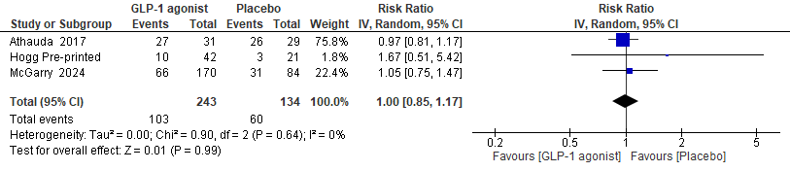

Figure 15 Forest plot of Administration site disorder including Hogg et al.; pre-printed

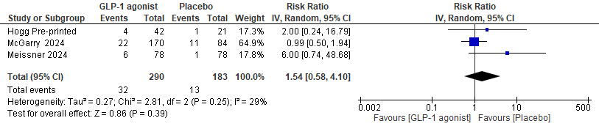

Figure 16 Forest plot of Fatigue including Hogg et al.; pre-printed

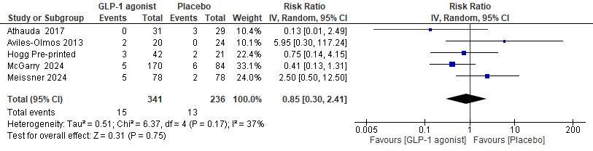

Figure 17 Forest plot of UTI including Hogg et al.; pre-printed

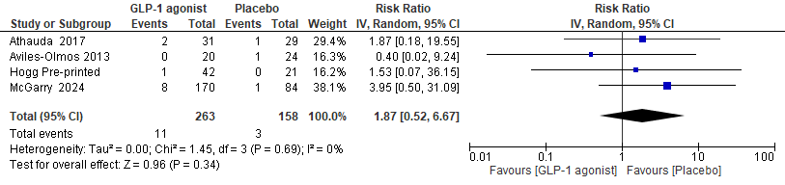

Figure 18 Forest plot of Anxiety including Hogg et al.; pre-printed

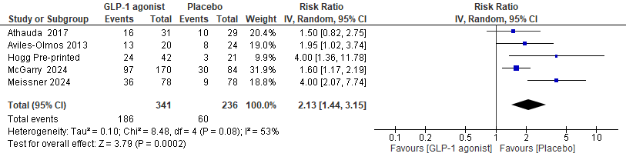

Figure 19 Forest plot of Nausea including Hogg et al.; pre-printed
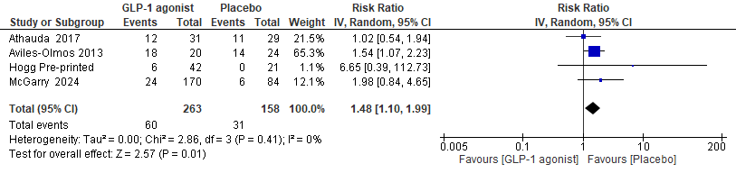

Figure 20 Forest plot of Constipation including Hogg et al.; pre-printed

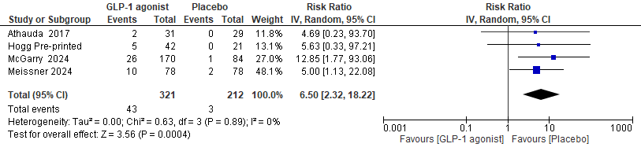

Figure 21 Forest plot of Vomiting including Hogg et al.; pre-printed

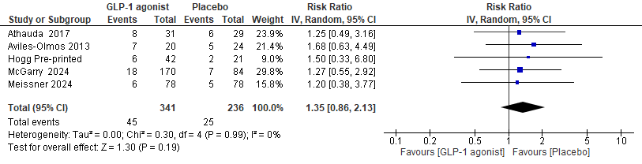

Figure 22 Forest plot of Diarrhea including Hogg et al.; pre-printed

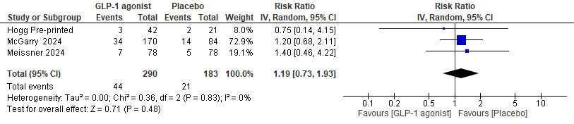

Figure 23 Forest plot of Headache including Hogg et al.; pre-printed

