BETA ACTIN

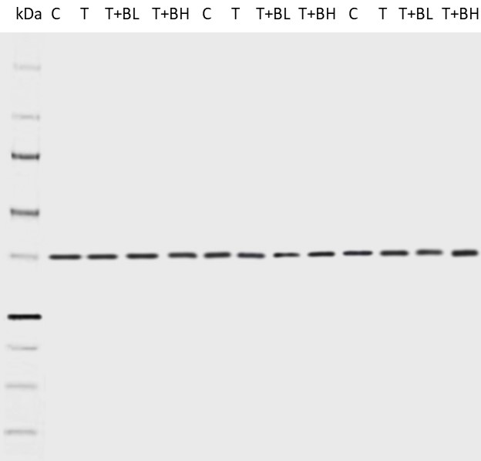
C: control
T: tamoxifen
BL: low dose of Bempedoic acid (15 mg⁄kg)
BH: high dose of Bempedoic acid (15 mg⁄kg)

ACC
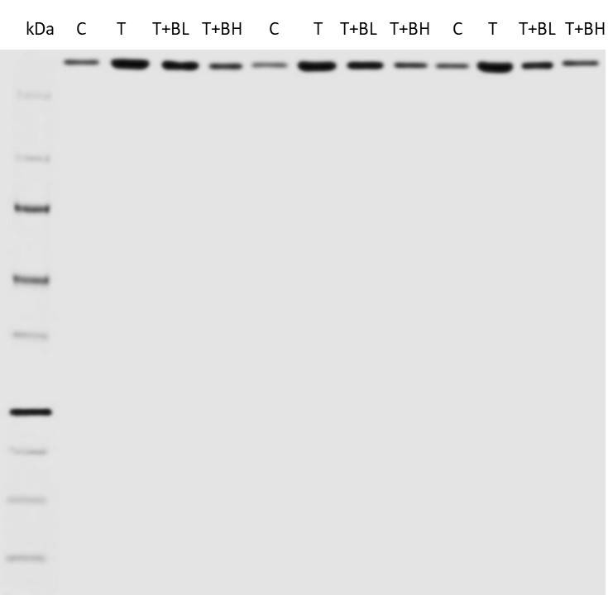

C: control
T: tamoxifen
BL: low dose of Bempedoic acid (15 mg⁄kg)
BH: high dose of Bempedoic acid (15 mg⁄kg)

CPT-1

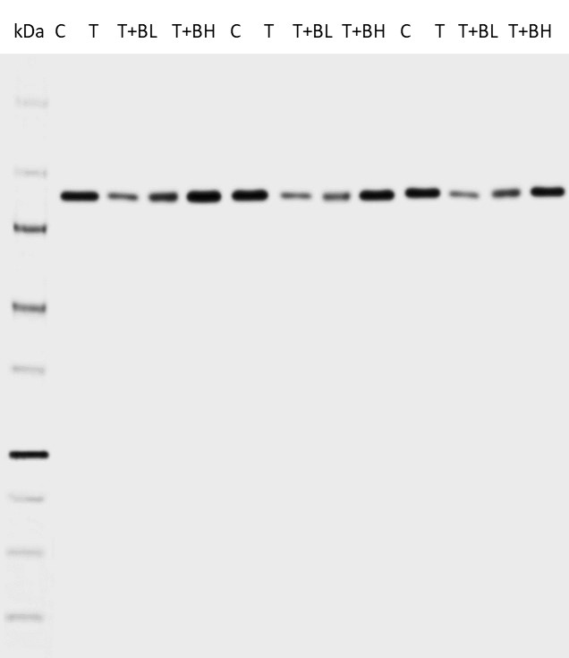

C: control
T: tamoxifen
BL: low dose of Bempedoic acid (15 mg⁄kg)
BH: high dose of Bempedoic acid (15 mg⁄kg)

