Efficacy and Safety of Lemborexant vs Placebo in treating Adults with Insomnia disorder: A Systematic Review and Meta-Analysis of 1,976 Patients

Figure S1. Analysis of TEAE risk ratio between Lemborexant and placebo.
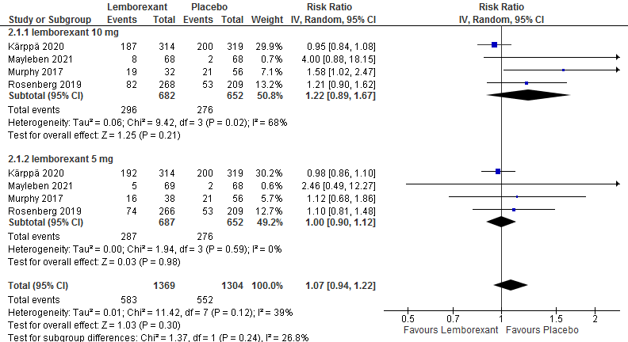

Figure S2. Analysis of treatment related AE risk ratio between Lemborexant and placebo.
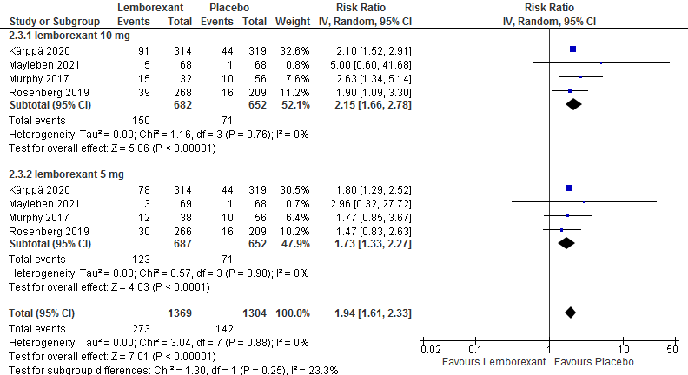

Figure S3. Analysis of TEAEs leading to discontinuation risk ratio between Lemborexant and placebo.
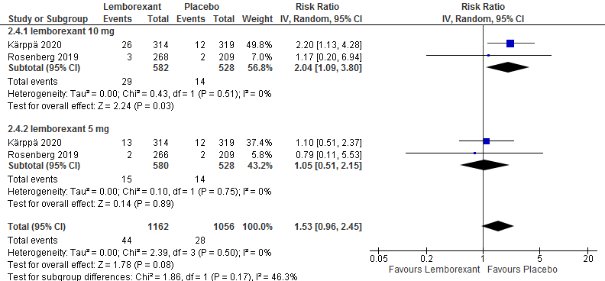

Figure S4. Analysis of Headche risk ratio between Lemborexant and placebo.
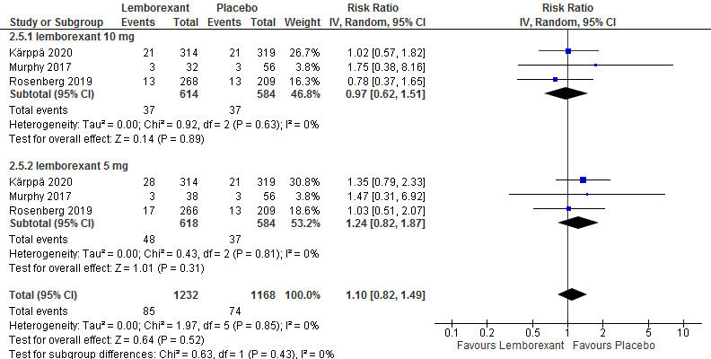

Figure S5. Analysis of Somnolence risk ratio between Lemborexant and placebo.
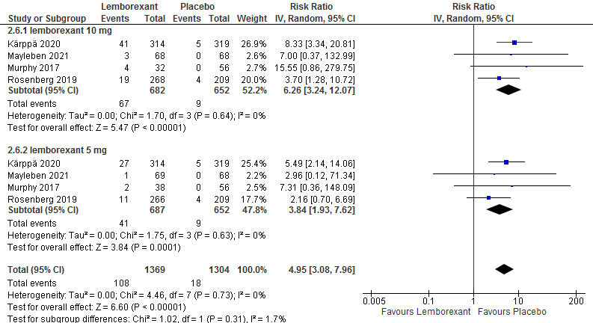

Figure S6. Analysis of serious AE risk ratio between Lemborexant and placebo.
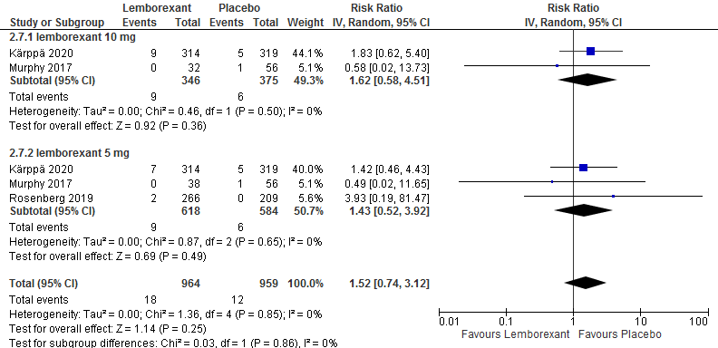

Table. S1: Leave one out analysis for the efficacy outcomes.
Study removed | No. of Participants | No. of trials | Quantitative data synthesis |  |  | Heterogeneity analysis
Study removed | No. of Participants | No. of trials | MD | 95% CI | P-value | P-value | I²(%)
Sleep onset latency (5 mg)
Kärppä 2020 | 705 | 2 | -8.80 [-18.47, 0.87] |  | P= 0.07 | P<0.001 | 92%
Murphy 2017 | 1105 | 2 | -7.50 [-15.53, 0.53] |  | P= 0.07 | P<0.001 | 93%
Rosenberg 2019 | 725 | 2 | -8.48 [-17.36, 0.39] |  | P= 0.06 | P<0.001 | 94%
Mayleben 2021 | 1062 | 2 | -11.77 [-14.97, -8.56] |  | P< 0.001 | P=0.61 | 0%
Sleep onset latency (10 mg)
Kärppä 2020 | 705 | 2 | -11.52 [-21.50, -1.53] |  | P= 0.02 | P<0.001 | 92%
Murphy 2017 | 1105 | 2 | -10.59 [-19.69, -1.49] |  | P= 0.02 | P<0.001 | 94%
Rosenberg 2019 | 725 | 2 | -12.31 [-23.14, -1.48] |  | P= 0.03 | P<0.001 | 94%
Mayleben 2021 | 1062 | 2 | -15.55 [-19.11, -11.98] |  | P< 0.001 | P=0.54 | 0%
Sleep efficiency (5 mg)
Kärppä 2020 | 568 | 2 | 7.20 [5.57, 8.83] |  | P< 0.001 | P=0.41 | 0%
Murphy 2017 | 968 | 2 | 6.13 [3.25, 9.01] |  | P< 0.001 | P=0.05 | 74%
Rosenberg 2019 | 588 | 2 | 4.82 [2.78, 6.86] |  | P< 0.001 | P=0.66 | 0%
Sleep efficiency (10 mg)
Kärppä 2020 | 568 | 2 | 8.84 [7.15, 10.54] |  | P< 0.001 | P=0.69 | 0%
Murphy 2017 | 968 | 2 | 6.76 [2.81, 10.70] |  | P< 0.001 | P=0.008 | 86%
Rosenberg 2019 | 588 | 2 | 6.81 [1.97, 11.65] |  | P= 0.006 | P=0.05 | 74%
Wake after sleep onset (5 mg)
Kärppä 2020 | 568 | 2 | -19.92 [-33.25, -6.59] |  | P= 0.003 | P=0.1 | 62%
Murphy 2017 | 968 | 2 | -22.16 [-29.68, -14.64] |  | P< 0.001 | P=0.22 | 34%
Rosenberg 2019 | 588 | 2 | -15.58 [-23.96, -7.19] |  | P< 0.001 | P=0.51 | 0%
Wake after sleep onset (10 mg)
Kärppä 2020 | 568 | 2 | -27.61 [-34.34, -20.89] |  | P< 0.001 | P=0.91 | 0%
Murphy 2017 | 968 | 2 | -20.64 [-35.45, -5.84] |  | P= 0.006 | P=0.02 | 82%
Rosenberg 2019 | 588 | 2 | -18.26 [-31.76, -4.77] |  | P= 0.008 | P=0.15 | 53%

Table. S2: Meta regression of sleep efficiency outcome on age and its value at baseline.
Model Coefficients - Sleep efficiency
Predictor |  | Estimate |  | SE |  | t |  | p
Intercept |  | 8.377 |  | 15.3066 |  | 0.547 |  | 0.622
Age |  | -0.297 |  | 0.0968 |  | -3.065 |  | 0.055
Sleep efficiency at baseline |  | 0.351 |  | 0.2589 |  | 1.357 |  | 0.268

Table. S3: Meta regression of sleep onset latency outcome on age and its value at baseline.
Model Coefficients – Sleep onset latency
Predictor |  | Estimate |  | SE |  | t |  | p
Intercept |  | -5.423 |  | 87.238 |  | -0.0622 |  | 0.953
Sleep onset latency Baseline |  | -0.130 |  | 0.916 |  | -0.1417 |  | 0.893
Age |  | -0.160 |  | 0.902 |  | -0.1776 |  | 0.866

Table. S4: Meta regression of WASO outcome on age and its value at baseline.

Model Coefficients – WASO
Predictor |  | Estimate |  | SE |  | t |  | P
Intercept |  | -84.825 |  | 32.558 |  | -2.605 |  | 0.080
Age |  | 0.429 |  | 0.419 |  | 1.023 |  | 0.381
WASO baseline |  | 0.119 |  | 0.211 |  | 0.564 |  | 0.612

