Ivermectin repurposing for COVID-19: Pharmacological and bibliometric analysis

Maresa Dulle and Roland Seifert

Supplemental Figures (Web of Science analysis)

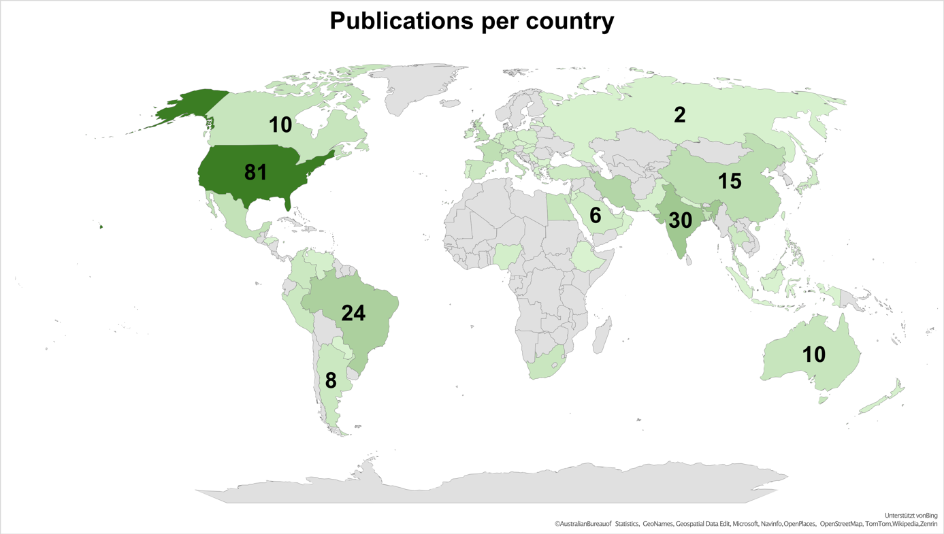
Supplemental Figure 1 The world map shows the number of publications per country in 2020, 2021 and 2022.

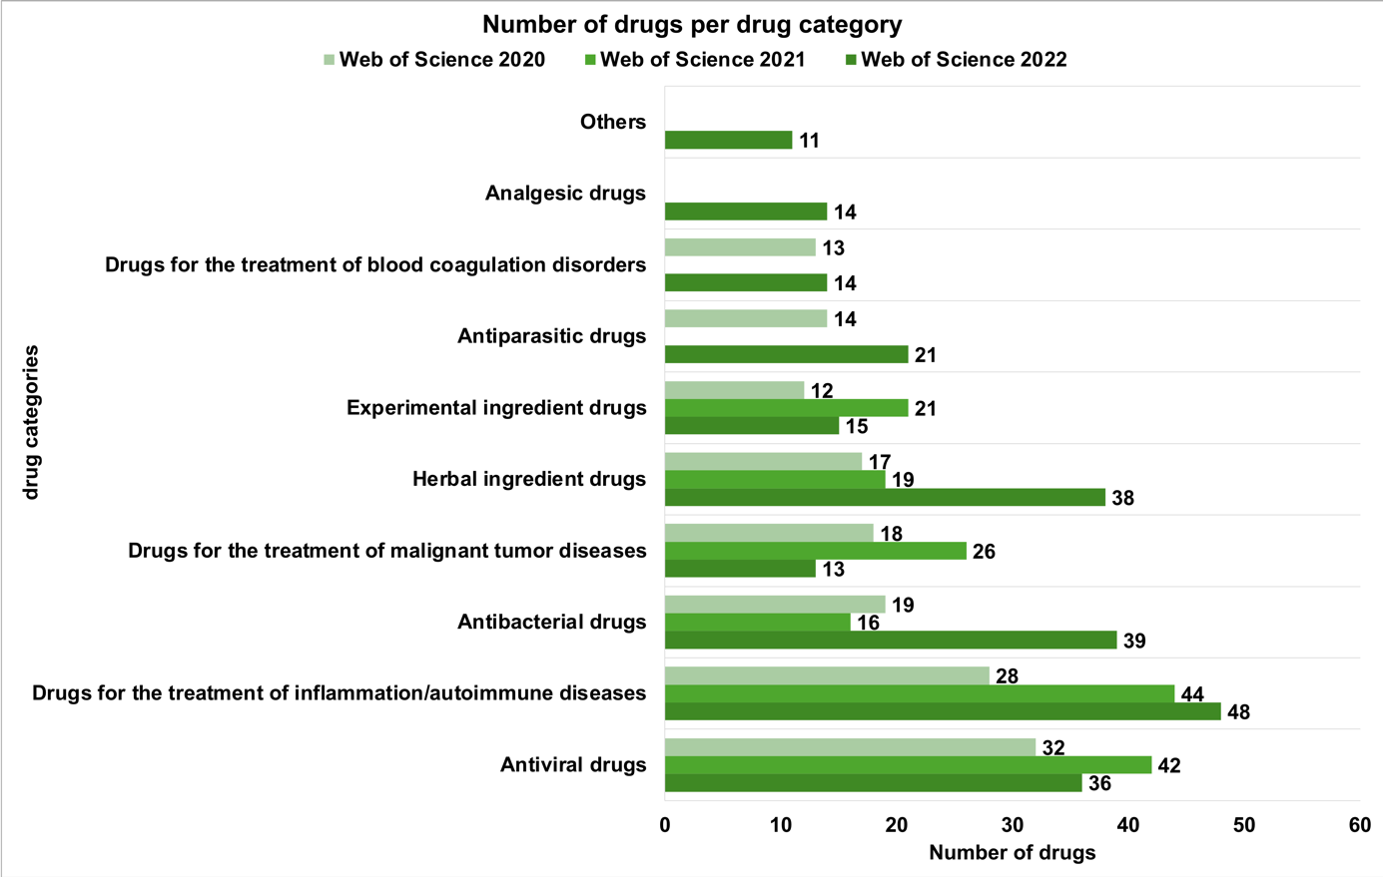
Supplemental Figure 2 The illustration shows the absolute number of drugs per drug category in the years 2020, 2021 and 2022 mentioned in all publications.

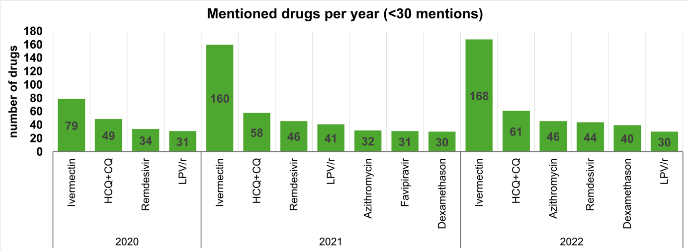
Supplemental Figure 3 Looking at each drug individually, this graph shows the total number of mentions of each drug in the years 2020, 2021 and 2022. Only drugs mentioned more than 30 times are included. The y-axis shows the absolute number of drugs.

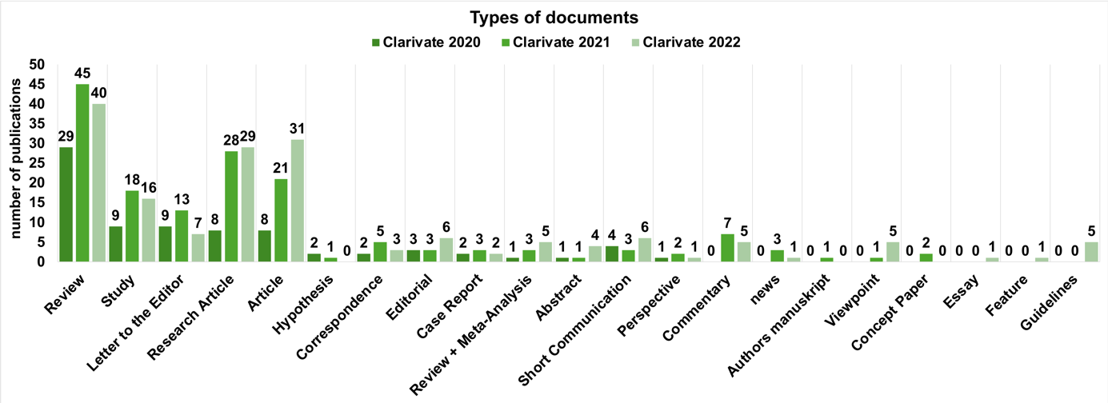
Supplemental Figure 4 Looking at each drug individually, this graph shows the total number of mentions of each drug in the years 2020, 2021 and 2022. Only drugs mentioned more than 30 times are included. The y-axis shows the absolute number of drugs.

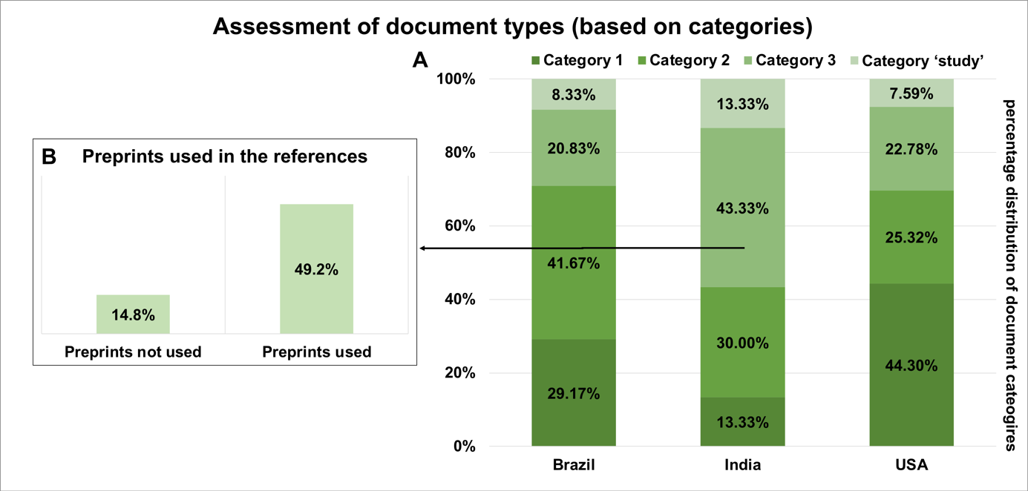
Supplemental Figure 5 This chart shows the distribution of the different document types in the document categories for quality assessment. A Percentage distribution of document types in the categories within the countries Brazil, India and the USA B Percentage distribution of the use of preprints in the references in category 3 in India

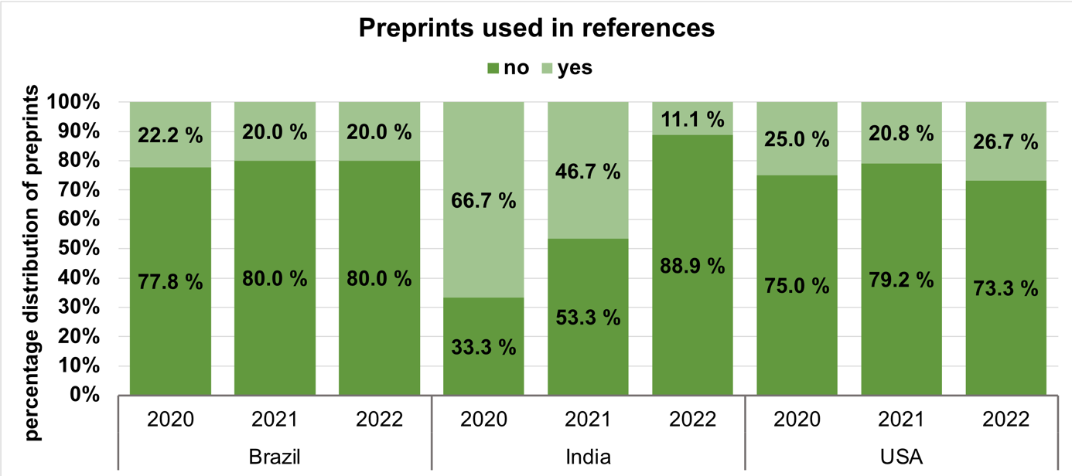
Supplemental Figure 6 This chart shows the percentage distribution of the usage of preprints in the references in Brazil, India and the USA in 2020, 2021 and 2022.

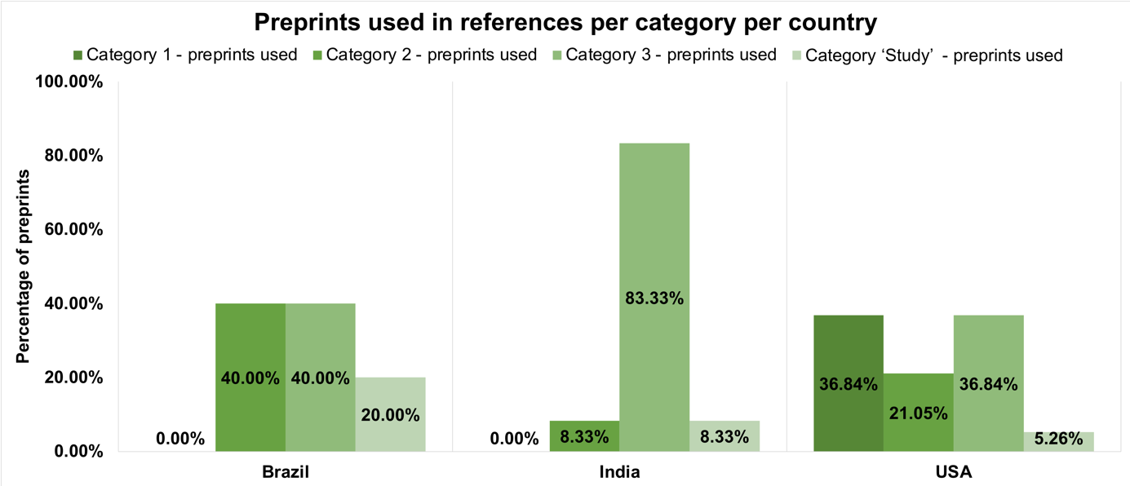
Supplemental Figure 7 This chart shows a breakdown of the percentage distribution of the usage of preprints in the references per document category in Brazil, India and the USA.

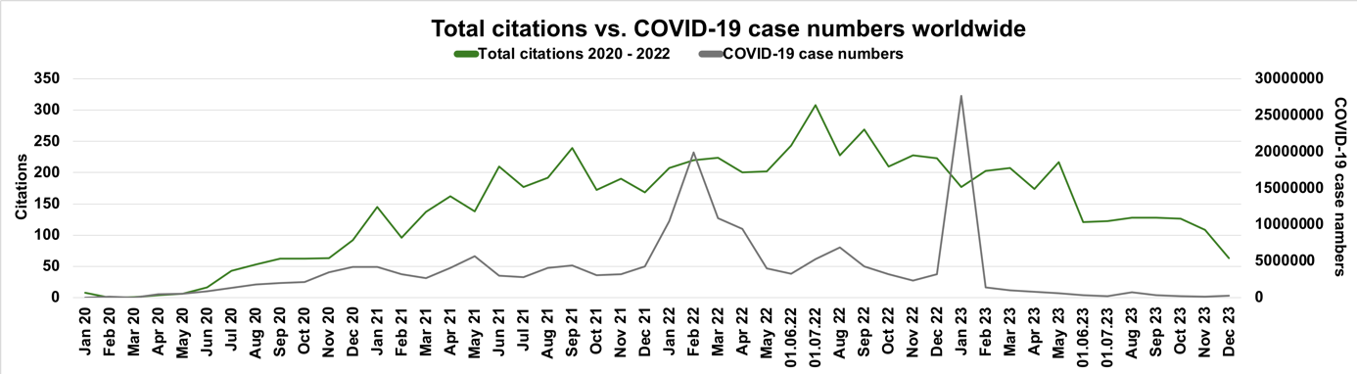
Supplemental Figure 8 This chart shows the total number of citations in a period from 2020 to 2023 of all included publications from 2020 to 2022 in comparison to the COVID-19 case numbers. The x-axis shows the months, the left y-axis shows the number of citations and the right y-axis shows the number of COVID-19 case numbers.

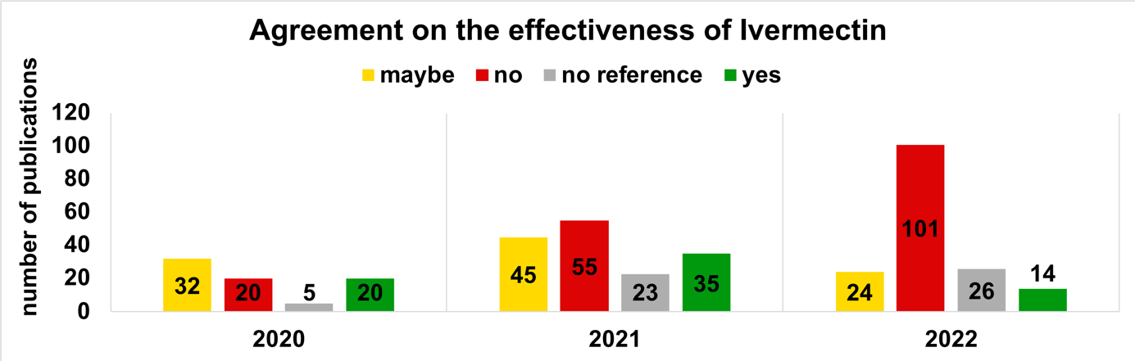
Supplemental Figure 9 This chart describes the opinion of the individual publications on the efficacy of ivermectin for COVID-19 between 2020 and 2022.

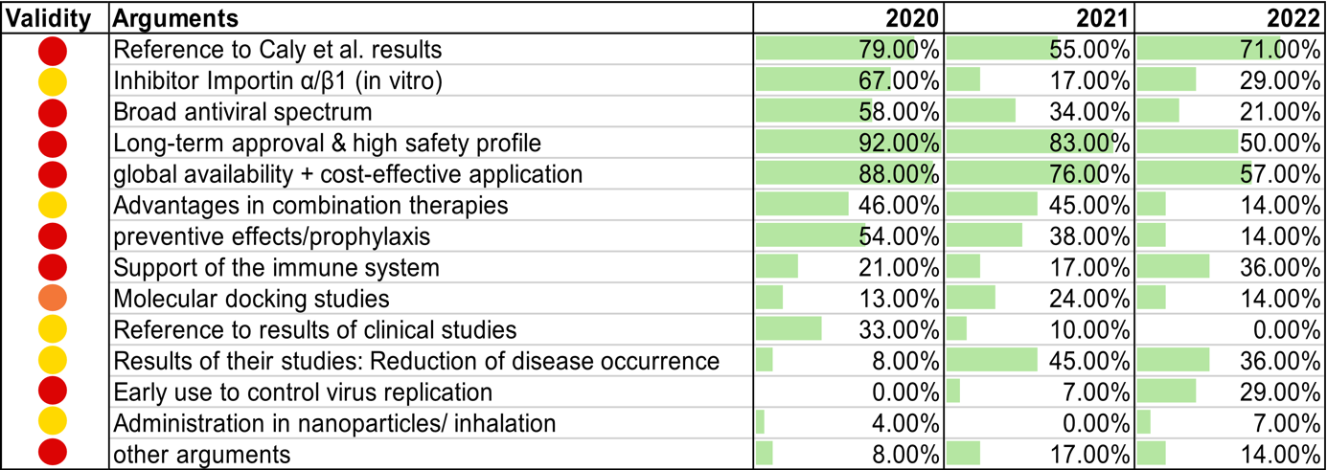
medium validity questionable validity low validity

Supplemental Figure 10 This table lists all the arguments that justify the prescription and use of ivermectin for COVID-19. The percentage use of these arguments in 2020, 2021 and 2022 is shown in the bar chart. The arguments are coded using a traffic light colour system according to their validity.

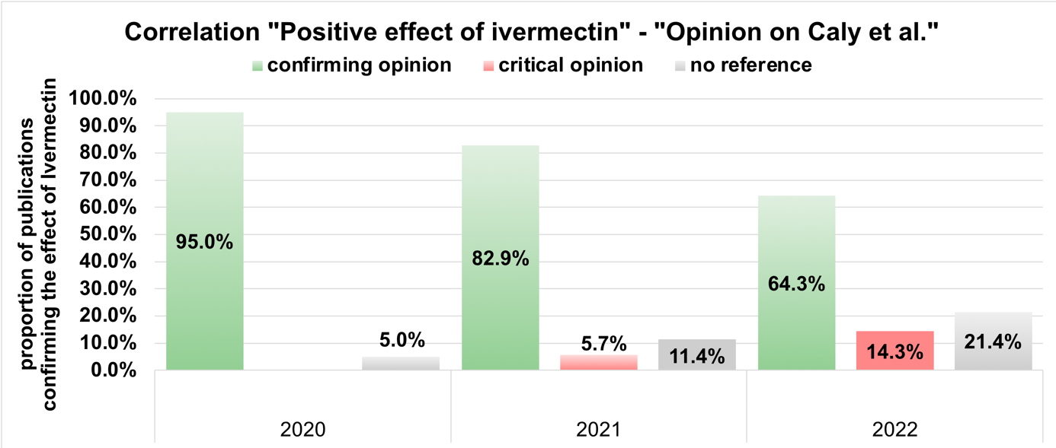
Supplemental Figure 11 This chart describes the correlation between the statement that ivermectin has a positive effect and the opinion of the individual publications on the study results of the in vitro study by Caly et al. The years 2020, 2021 and 2022 are shown. The proportion of publications confirming the effect of ivermectin is shown on the y-axis.

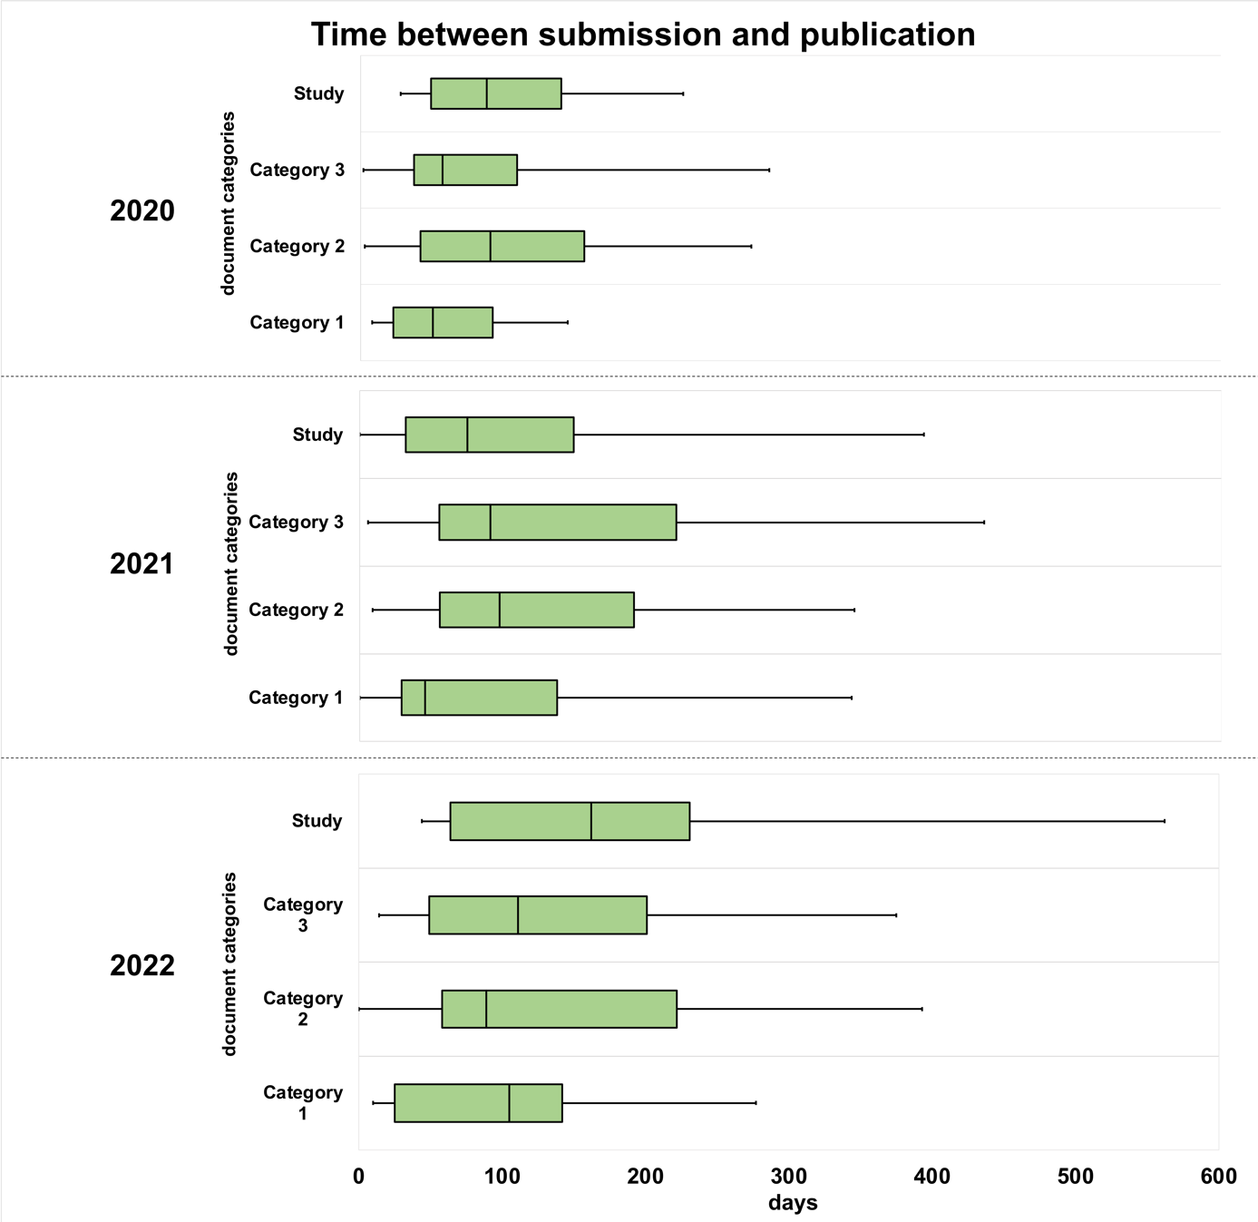
Supplemental Figure 12 This chart uses boxplots to show the time between submission and acceptance for publication, divided into the three categories according to document type (see Fig. 5) and studies. The x-axis describes the time in days. On the y-axis the categories are subordinated into the years 2020, 2021 and 2022.

The ANOVA analysis showed that the duration between submission and publication (measured in days) differs significantly between the years 2020 - 2022 for category 3: F (2, 110) = 5.207, p = < .007. There is no statistically significant difference between the publication time of the years 2020 - 2022 in the category 1, category 2 and category ‘Study’: in category 1: F (2, 56) = 2.241, p < 0.116; in category 2: F (2, 102) = 1.271, p < 0.285; in category ‘Study’: F (2, 39) = 1.679, p < 0.200. The Bonferroni-corrected post-hoc analysis revealed several significant differences (p < 0.05) in the number of days to publication; in category 3 between 2020 and 2021 (MDiff = 52.01, 95%-CI [9.93, 94.10] and between 2020 and 2022 (MDiff = 47.82, 95%-CI [6.28, 89.37] (Supplemental Tables 5-7)

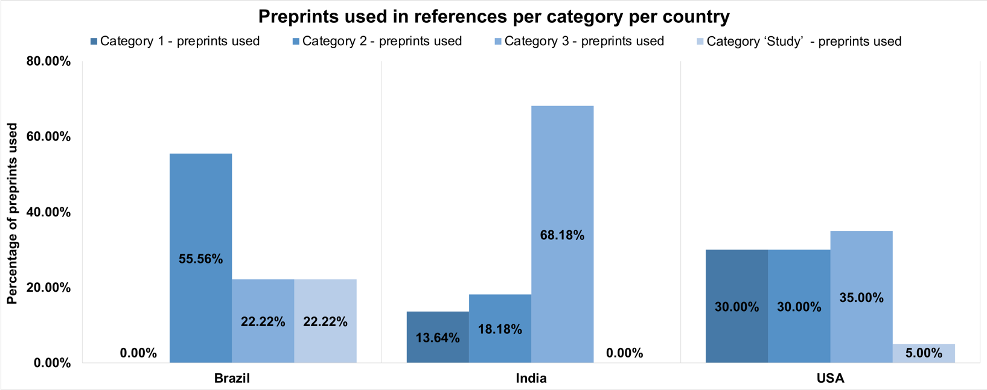
Supplemental Figures (Pubmed analysis)
Supplemental Figure 13 This chart shows a breakdown of the percentage distribution of the usage of preprints in the references per document category in Brazil, India and the USA.

Supplemental Tables

# | Amino acid residues Amino acid residues in the receptor binding site (RBS) of the spike protein | Affinity | Binding energy | Investigation methods
I | Leu492, Gln493, Gly496, Tyr505 | -9.0 kcal/mol | -30.60 kcal/mol | MD, MM-PBSA
J | Arg403, Ile418, Tyr489, Phe490 | -8.1 kcal/mol | / | MD, MM-PBSA
L | Tyr449, Tyr453, Leu455, Phe456, Ala475, Gly476, Phe486, Asn487, Tyr489, Gln493, Gly496, Gln498, Thr500, Asn501, Gly502, Tyr505 | -10.8697 kcal/mol | -89.360 kJ/mol | MM-PBSA
K | Leu492, Gln493, Gly496, Tyr505 | -9.0 kcal/mol | -22.4 kcal/mol (estimated using DFT) | MD, DFT
H | Tyr51, Ala54, Lys60, Pro66, Glu88, Arg90, Ser55, Asp87, Thr97, Thr182, Glu239, Lys245, Asp500, Thr183 | -372.99 kcal/mol | / | MD
G | Tyr453, Gln493, Asn501, Gly496 | -8.78 kcal/mol | / | Ensemble Docking, Reverse Docking
Supplemental Table 1 The table shows all the molecular docking studies investigating the receptor binding site of the spike protein

Descriptives
 |  | N | Mean | Std. Deviation | Std. Error | 95% Confidence Interval for Mean |  | Minimum | Maximum
 |  |  |  |  |  | Lower Bound | Upper Bound | Minimum
Category 1 | 01/01/2020 | 37 | 54,16 | 41,309 | 6,791 | 40,39 | 67,94 | 8 | 153
Category 1 | 01/01/2021 | 23 | 74,87 | 66,610 | 13,889 | 46,07 | 103,67 | 0 | 233
Category 1 | 01/01/2022 | 27 | 108,37 | 74,505 | 14,339 | 78,90 | 137,84 | 10 | 308
Category 1 | Total | 87 | 76,46 | 63,733 | 6,833 | 62,88 | 90,04 | 0 | 308
Category 2 | 01/01/2020 | 18 | 83,28 | 52,530 | 12,381 | 57,16 | 109,40 | 3 | 182
Category 2 | 01/01/2021 | 58 | 104,59 | 62,774 | 8,243 | 88,08 | 121,09 | 9 | 300
Category 2 | 01/01/2022 | 62 | 141,65 | 84,346 | 10,712 | 120,23 | 163,07 | 9 | 346
Category 2 | Total | 138 | 118,46 | 75,080 | 6,391 | 105,82 | 131,09 | 3 | 346
Category 3 | 01/01/2020 | 16 | 48,56 | 28,383 | 7,096 | 33,44 | 63,69 | 2 | 90
Category 3 | 01/01/2021 | 48 | 125,94 | 89,797 | 12,961 | 99,86 | 152,01 | 14 | 354
Category 3 | 01/01/2022 | 41 | 112,12 | 67,269 | 10,506 | 90,89 | 133,35 | 14 | 287
Category 3 | Total | 105 | 108,75 | 78,732 | 7,684 | 93,52 | 123,99 | 2 | 354
Study | 01/01/2020 | 9 | 73,22 | 36,650 | 12,217 | 45,05 | 101,39 | 28 | 137
Study | 01/01/2021 | 18 | 107,11 | 104,898 | 24,725 | 54,95 | 159,28 | 2 | 404
Study | 01/01/2022 | 23 | 139,78 | 96,731 | 20,170 | 97,95 | 181,61 | 37 | 400
Study | Total | 50 | 116,04 | 94,173 | 13,318 | 89,28 | 142,80 | 2 | 404
Supplemental Table 2 The table shows the descriptive analysis of the Pubmed data of the publication time for categories 1 to 3 and years, 2020 – 2022, carried out with SPSS.

ANOVA
 |  | Sum of Squares | df | Mean Square | F | Sig.
Category 1 | Between Groups | 45947,677 | 2 | 22973,839 | 6,361 | ,003
Category 1 | Within Groups | 303371,932 | 84 | 3611,571
Category 1 | Total | 349319,609 | 86
Category 2 | Between Groups | 66772,366 | 2 | 33386,183 | 6,389 | ,002
Category 2 | Within Groups | 705493,874 | 135 | 5225,881
Category 2 | Total | 772266,239 | 137
Category 3 | Between Groups | 72606,422 | 2 | 36303,211 | 6,473 | ,002
Category 3 | Within Groups | 572069,140 | 102 | 5608,521
Category 3 | Total | 644675,562 | 104
Study | Between Groups | 30900,674 | 2 | 15450,337 | 1,799 | ,177
Study | Within Groups | 403655,246 | 47 | 8588,409
Study | Total | 434555,920 | 49
Supplemental Table 3 The table shows the results of the Pubmed data of the ANOVA analysis for category 1 to 3, carried out with SPSS.

Multiple Comparisons
Bonferroni
Dependent Variable | (I) Year | (J) Year | Mean Difference (I-J) | Std. Error | Sig. | 95% Confidence Interval
 |  |  |  |  |  | Lower Bound | Upper Bound
Category 1 | 01/01/2020 | 01/01/2021 | -20,707 | 15,957 | ,594 | -59,69 | 18,27
Category 1 | 01/01/2020 | 01/01/2022 | -54,208* | 15,211 | ,002 | -91,37 | -17,05
Category 1 | 01/01/2021 | 01/01/2020 | 20,707 | 15,957 | ,594 | -18,27 | 59,69
Category 1 | 01/01/2021 | 01/01/2022 | -33,501 | 17,052 | ,158 | -75,16 | 8,16
Category 1 | 01/01/2022 | 01/01/2020 | 54,208* | 15,211 | ,002 | 17,05 | 91,37
Category 1 | 01/01/2022 | 01/01/2021 | 33,501 | 17,052 | ,158 | -8,16 | 75,16
Category 2 | 01/01/2020 | 01/01/2021 | -21,308 | 19,505 | ,830 | -68,59 | 25,97
Category 2 | 01/01/2020 | 01/01/2022 | -58,367* | 19,355 | ,009 | -105,29 | -11,45
Category 2 | 01/01/2021 | 01/01/2020 | 21,308 | 19,505 | ,830 | -25,97 | 68,59
Category 2 | 01/01/2021 | 01/01/2022 | -37,059* | 13,206 | ,017 | -69,07 | -5,05
Category 2 | 01/01/2022 | 01/01/2020 | 58,367* | 19,355 | ,009 | 11,45 | 105,29
Category 2 | 01/01/2022 | 01/01/2021 | 37,059* | 13,206 | ,017 | 5,05 | 69,07
Category 3 | 01/01/2020 | 01/01/2021 | -77,375* | 21,619 | ,002 | -130,00 | -24,75
Category 3 | 01/01/2020 | 01/01/2022 | -63,559* | 22,075 | ,015 | -117,29 | -9,83
Category 3 | 01/01/2021 | 01/01/2020 | 77,375* | 21,619 | ,002 | 24,75 | 130,00
Category 3 | 01/01/2021 | 01/01/2022 | 13,816 | 15,926 | 1,000 | -24,95 | 52,58
Category 3 | 01/01/2022 | 01/01/2020 | 63,559* | 22,075 | ,015 | 9,83 | 117,29
Category 3 | 01/01/2022 | 01/01/2021 | -13,816 | 15,926 | 1,000 | -52,58 | 24,95
Study | 01/01/2020 | 01/01/2021 | -33,889 | 37,834 | 1,000 | -127,82 | 60,04
Study | 01/01/2020 | 01/01/2022 | -66,560 | 36,437 | ,222 | -157,02 | 23,90
Study | 01/01/2021 | 01/01/2020 | 33,889 | 37,834 | 1,000 | -60,04 | 127,82
Study | 01/01/2021 | 01/01/2022 | -32,671 | 29,164 | ,805 | -105,08 | 39,73
Study | 01/01/2022 | 01/01/2020 | 66,560 | 36,437 | ,222 | -23,90 | 157,02
Study | 01/01/2022 | 01/01/2021 | 32,671 | 29,164 | ,805 | -39,73 | 105,08
*. The mean difference is significant at the 0.05 level.
Supplemental Table 4 The table shows the results of the Pubmed data of the post hoc analysis for category 1 to 3, carried out with SPSS.

Descriptives
 |  | N | Mean | Std. Deviation | Std. Error | 95% Confidence Interval for Mean |  | Minimum | Maximum
 |  |  |  |  |  | Lower Bound | Upper Bound | Minimum | Maximum
Category 1 | 2020 | 16 | 46,94 | 28,515 | 7,129 | 31,74 | 62,13 | 8 | 94
Category 1 | 2021 | 26 | 80,58 | 75,383 | 14,784 | 50,13 | 111,02 | 0 | 297
Category 1 | 2022 | 17 | 87,53 | 52,942 | 12,840 | 60,31 | 114,75 | 10 | 172
Category 1 | Total | 59 | 73,46 | 60,891 | 7,927 | 57,59 | 89,33 | 0 | 297
Category 2 | 2020 | 16 | 84,31 | 51,887 | 12,972 | 56,66 | 111,96 | 3 | 182
Category 2 | 2021 | 40 | 96,30 | 52,210 | 8,255 | 79,60 | 113,00 | 9 | 247
Category 2 | 2022 | 49 | 110,63 | 72,138 | 10,305 | 89,91 | 131,35 | 0 | 304
Category 2 | Total | 105 | 101,16 | 62,509 | 6,100 | 89,06 | 113,26 | 0 | 304
Category 3 | 2020 | 26 | 63,15 | 47,017 | 9,221 | 44,16 | 82,14 | 2 | 228
Category 3 | 2021 | 42 | 115,17 | 79,702 | 12,298 | 90,33 | 140,00 | 6 | 344
Category 3 | 2022 | 45 | 110,98 | 69,679 | 10,387 | 90,04 | 131,91 | 14 | 264
Category 3 | Total | 113 | 101,53 | 71,929 | 6,767 | 88,12 | 114,94 | 2 | 344
Study | 2020 | 9 | 73,11 | 36,498 | 12,166 | 45,06 | 101,17 | 28 | 137
Study | 2021 | 16 | 99,44 | 93,193 | 23,298 | 49,78 | 149,10 | 0 | 318
Study | 2022 | 17 | 136,65 | 100,493 | 24,373 | 84,98 | 188,32 | 44 | 400
Study | Total | 42 | 108,86 | 89,519 | 13,813 | 80,96 | 136,75 | 0 | 400
Supplemental Table 5 The table shows the descriptive analysis of the Clarivate data of the publication time for categories 1 to 3 and years, 2020 – 2022, carried out with SPSS.

ANOVA
 |  | Sum of Squares | df | Mean Square | F | Sig.
Category 1 | Between Groups | 15937,125 | 2 | 7968,563 | 2,241 | ,116
Category 1 | Within Groups | 199109,519 | 56 | 3555,527
Category 1 | Total | 215046,644 | 58
Category 2 | Between Groups | 9883,022 | 2 | 4941,511 | 1,271 | ,285
Category 2 | Within Groups | 396481,225 | 102 | 3887,071
Category 2 | Total | 406364,248 | 104
Category 3 | Between Groups | 50117,946 | 2 | 25058,973 | 5,207 | ,007
Category 3 | Within Groups | 529344,196 | 110 | 4812,220
Category 3 | Total | 579462,142 | 112
Study | Between Groups | 26048,434 | 2 | 13024,217 | 1,679 | ,200
Study | Within Groups | 302510,709 | 39 | 7756,685
Study | Total | 328559,143 | 41
Supplemental Table 6 The table shows the results of the Clarivate data of the ANOVA analysis for category 1 to 3, carried out with SPSS.

Multiple Comparisons
Bonferroni
Dependent Variable | (I) Year | (J) Year | Mean Difference (I-J) | Std. Error | Sig. | 95% Confidence Interval
 |  |  |  |  |  | Lower Bound | Upper Bound
Category 1 | 2020 | 2021 | -33,639 | 18,947 | ,244 | -80,40 | 13,12
Category 1 | 2020 | 2022 | -40,592 | 20,769 | ,167 | -91,85 | 10,67
Category 1 | 2021 | 2020 | 33,639 | 18,947 | ,244 | -13,12 | 80,40
Category 1 | 2021 | 2022 | -6,952 | 18,598 | 1,000 | -52,85 | 38,95
Category 1 | 2022 | 2020 | 40,592 | 20,769 | ,167 | -10,67 | 91,85
Category 1 | 2022 | 2021 | 6,952 | 18,598 | 1,000 | -38,95 | 52,85
Category 2 | 2020 | 2021 | -11,987 | 18,442 | 1,000 | -56,88 | 32,90
Category 2 | 2020 | 2022 | -26,320 | 17,952 | ,437 | -70,02 | 17,38
Category 2 | 2021 | 2020 | 11,987 | 18,442 | 1,000 | -32,90 | 56,88
Category 2 | 2021 | 2022 | -14,333 | 13,286 | ,850 | -46,67 | 18,01
Category 2 | 2022 | 2020 | 26,320 | 17,952 | ,437 | -17,38 | 70,02
Category 2 | 2022 | 2021 | 14,333 | 13,286 | ,850 | -18,01 | 46,67
Category 3 | 2020 | 2021 | -52,013* | 17,311 | ,010 | -94,10 | -9,93
Category 3 | 2020 | 2022 | -47,824* | 17,089 | ,018 | -89,37 | -6,28
Category 3 | 2021 | 2020 | 52,013* | 17,311 | ,010 | 9,93 | 94,10
Category 3 | 2021 | 2022 | 4,189 | 14,883 | 1,000 | -31,99 | 40,37
Category 3 | 2022 | 2020 | 47,824* | 17,089 | ,018 | 6,28 | 89,37
Category 3 | 2022 | 2021 | -4,189 | 14,883 | 1,000 | -40,37 | 31,99
Study | 2020 | 2021 | -26,326 | 36,697 | 1,000 | -118,13 | 65,48
Study | 2020 | 2022 | -63,536 | 36,306 | ,264 | -154,36 | 27,29
Study | 2021 | 2020 | 26,326 | 36,697 | 1,000 | -65,48 | 118,13
Study | 2021 | 2022 | -37,210 | 30,677 | ,697 | -113,95 | 39,53
Study | 2022 | 2020 | 63,536 | 36,306 | ,264 | -27,29 | 154,36
Study | 2022 | 2021 | 37,210 | 30,677 | ,697 | -39,53 | 113,95
*. The mean difference is significant at the 0.05 level.

Supplemental Table 7 The table shows the results of the Clarivate data of the post hoc analysis for category 1 to 3, carried out with SPSS.

# | Author (year) | Title | Opinion on Caly et al
1 | Samaddar et al. (2020) | Pathophysiology and Potential Therapeutic Candidates for COVID-19: A Poorly Understood Arena | Results adopted
2 | Rocha Formiga et al. (2020) | Ivermectin: an award-winning drug with expected antiviral activity against COVID-19 | Results criticized
3 | Martin et al. (2020) | Ivermectin: An Anthelmintic, an Insecticide, and Much More | Results criticized
4 | Bray et al. (2020) | Ivermectin and COVID-19: A report in Antiviral Research, widespread interest, an FDA warning, two letters to the editor and the authors' responses | Results criticized
5 | Gouvea Dos Santos (2020) | Natural history of COVID-19 and current knowledge on treatment therapeutic options | Results criticized
6 | Chan et al. (2020) | Pandemic COVID-19: Current status and challenges of antiviral therapies | Results criticized
7 | Schmith et al. (2020) | The Approved Dose of Ivermectin Alone is not the Ideal Dose for the Treatment of COVID-19 | Results criticized
8 | Khana et al. (2020) | Reply to “Ivermectin Treatment May Improve the Prognosis of Patients With COVID-19” | Results criticized
9 | Wang, Yang (2020) | Turning the Tide: Natural Products and Natural-Product-Inspired Chemicals as Potential Counters to SARS-CoV-2 Infection | Results criticized
10 | Marcolino, Pimentel, Barão (2020) | What to expect from different drugs used in the treatment of COVID-19: A study on applications and in vivo and in vitro results | Results criticized
11 | Chaccour et al. (2020) | Nebulized ivermectin for COVID‐19 and other respiratory diseases, a proof of concept, dose‐ranging study in rats | Results criticized
12 | Peña-Silva et al. (2020) | Pharmacokinetic considerations on the repurposing of ivermectin for treatment of COVID-19 | Results criticized
13 | Gupta (2020) | Progress in Studies on Structural and Remedial Aspects of Newly Born Coronavirus, SARS-CoV-2 | Results criticized
14 | Segura-Aguilar, Tizabi (2020) | Ivermectin as a potential therapeutic in COVID-19 | Results criticized
15 | López Reboiro et al. (2020) | Ivermectin in COVID-19. Argumentun ad ignorantiam? | Results criticized
16 | Hossen et al. (2020) | A Review on Current Repurposing Drugs for the Treatment of COVID-19: Reality and Challenges | Results criticized
17 | Lehrer, Rheinstein et al. (2020) | Ivermectin Docks to the SARS-CoV-2 Spike Receptor-binding Domain Attached to ACE2 | Results criticized
18 | Elkholy et al. (2020) | Ivermectin: A Closer Look at a Potential Remedy | Results criticized
19 | Heidary, Gharebaghi (2020) | Ivermectin: a systematic review from antiviral effects to COVID-19 complementary regimen | Results criticized
20 | Drożdża et al. (2020) | FDA approved drugs with pharmacotherapeutic potential for SARS-CoV-2 (COVID-19) therapy | Results adopted
21 | Patrì et al. (2020) | Hydroxychloroquine and Ivermectin: A synergistic combination for COVID-19 chemoprophylaxis and treatment? | Results adopted
22 | Hellwig et al. (2020) | A COVID-19 prophylaxis? Lower incidence associated with prophylactic administration of ivermectin | Results adopted
23 | Perez-Garcia et al. (2020) | Ivermectin: repurposing a multipurpose drug for Venezuela's humanitarian crisis | Results adopted
24 | Alonso et al. (2020) | Repurposing of host-based therapeutic agents for the treatment of coronavirus disease 2019 (COVID-19): a link between antiviral and anticancer mechanisms? | Results adopted
25  Supplemental Table 8 The table shows a list of all publications 2020 – 2022 and their opinion on the publication of Caly et al. | Kumar et al. (2020) | A chronicle of SARS-CoV-2: Part-I - Epidemiology, diagnosis, prognosis, transmission and treatment | Results adopted
26 | Ahmed et al. (2020) | A five-day course of ivermectin for the treatment of COVID-19 may reduce the duration of illness | Results adopted
27 | Rajter et al. (2020) | Use of Ivermectin Is Associated With Lower Mortality in Hospitalized Patients With Coronavirus Disease 2019: The Ivermectin in COVID Nineteen Study | Results adopted
28 | Taguchi, Turki (2020) | A new advanced in silico drug discovery method for novel coronavirus (SARS-CoV-2) with tensor decomposition-based unsupervised feature extraction | Results adopted
29 | Kelleni (2020) | Nitazoxanide/azithromycin combination for COVID-19: A suggested new protocol for early management | Results adopted
30 | Yuan et al. (2020) | Discovery of the FDA-approved drugs bexarotene, cetilistat, diiodohydroxyquinoline, and abiraterone as potential COVID-19 treatments with a robust two-tier screening system | Results adopted
31 | Beltrão Molento (2020) | COVID-19 and the rush for self-medication and self-dosing with ivermectin: A word of caution | Results adopted
32 | Pandey et al. (2020) | Ivermectin in COVID-19: What do we know? | Results adopted
33 | Parvez et al. (2020) | Prediction of potential inhibitors for RNA-dependent RNA polymerase of SARS-CoV-2 using comprehensive drug repurposing and molecular docking approach | Results adopted
34 | Jans, Wagstaff (2020) | Ivermectin as a Broad-Spectrum Host-Directed Antiviral: The Real Deal? | Results adopted
35 | Panoutsopoulos (2020) | Known drugs and small molecules in the battle for COVID-19 treatment | Results adopted
36 | Sharun et al. (2020) | Ivermectin, a new candidate therapeutic against SARS-CoV-2/COVID-19 | Results adopted
37 | Li, Zhao, Zhan (2020) | Quantitative proteomics reveals a broad‐spectrum antiviral property of ivermectin, benefiting for COVID‐19 treatment | Results adopted
38 | Khan et al. (2020) | Ivermectin Treatment May Improve the Prognosis of Patients With COVID-19 | Results adopted
39 | Perišić (2020) | Recognition of Potential COVID-19 Drug Treatments through the Study of Existing Protein-Drug and Protein-Protein Structures: An Analysis of Kinetically Active Residues | Results adopted
40 | Hussman (2020) | Cellular and Molecular Pathways of COVID-19 and Potential Points of Therapeutic Intervention | Results adopted
41 | Gupta, Rana (2020) | Ivermectin, Famotidine, and Doxycycline: A Suggested Combinatorial Therapeutic for the Treatment of COVID-19 | Results adopted
42 | Surnar et al. (2020) | Clinically Approved Antiviral Drug in an Orally Administrable Nanoparticle for COVID-19 | Results adopted
43 | Vanachayangkul et al. (2020) | Safety, Pharmacokinetics, and Activity of High-Dose Ivermectin and Chloroquine against the Liver Stage of Plasmodium cynomolgi Infection in Rhesus Macaques | Results adopted
44 | Jean, Hsueh (2020) | Old and re-purposed drugs for the treatment of COVID-19 | Results adopted
45 | Low, Farouk, Lal (2020) | Drug Repositioning: New Approaches and Future Prospects for Life-Debilitating Diseases and the COVID-19 Pandemic Outbreak | Results adopted
46 | Hanafy, Abd-Elsalam (2020) | Challenges in COVID-19 drug treatment in patients with advanced liver diseases: A hepatology perspective | Results adopted
47 | Vital de Oliveiraa et al. (2020) | Repurposing approved drugs as inhibitors of SARS-CoV-2 S-protein from molecular modeling and virtual screening | Results adopted
48 | Siddiquia et al. (2020) | Current status and strategic possibilities on potential use of combinational drug therapy against COVID-19 caused by SARS-CoV-2 | Results adopted
49 | Kalhor et al. (2020) | Repurposing of the approved small molecule drugs in order to inhibit SARS-CoV-2 S protein and human ACE2 interaction through virtual screening approaches | Results adopted
50 | Gupta et al. (2020) | Binding mechanism and structural insights into the identified protein target of COVID-19 and importin-a with in-vitro effective drug ivermectin | Results adopted
51 | Azama et al. (2020) | An in-silico analysis of ivermectin interaction with potential SARS-CoV-2 targets and host nuclear importin alpha | Results adopted
52 | Ali et al. (2020) | Treatment Options for COVID-19: A Review | Results adopted
53 | Anastasiou et al. (2020) | In Vitro Data of Current Therapies for SARS-CoV-2 | Results adopted
54 | Mittal (2020) | Inhaled route and anti-inflammatory action of ivermectin: Do they hold promise in fighting against COVID-19? | Results adopted
55 | Horowitz, Freeman (2020) | Three novel prevention, diagnostic, and treatment options for COVID-19 urgently necessitating controlled randomized trials | Results adopted
56 | Heimfarth et al. (2020) | IVERMECTIN: PANACEA OR TRUE PROMISE FOR COVID-19? | Results adopted
57 | Camprubí et al. (2020) | Lack of efficacy of standard doses of ivermectin in severe COVID-19 patients | Results adopted
58 | Jerman et al. (2020) | Development of a Minimal Physiologically-Based Pharmacokinetic Model to Simulate Lung Exposure in Humans Following Oral Administration of Ivermectin for COVID-19 Drug Repurposing | Results adopted
59 | Merone, Finlay (2020) | Pandemic and promise: progress towards finding an effective treatment for Novel Coronavirus 19 | Results adopted
60 | Trivedi, Verma, Kumar (2020) | Possible treatment and strategies for COVID-19: review and assessment | Results adopted
61 | Chaccour et al. (2020) | Ivermectin and COVID-19: Keeping Rigor in Times of Urgency | Results adopted
62 | Tapia (2020) | COVID-19 and Fake News in the Dominican Republic | Results adopted
63 | Jans, Wagstaff (2020) | The broad spectrum host-directed agent ivermectin as an antiviral for SARS-CoV-2 ? | Results adopted
64 | Gupta, Sahoo, Singh (2020) | Ivermectin: potential candidate for the treatment of Covid 19 | Results adopted
65 | Padhy et al. (2020) | Therapeutic potential of ivermectin as add-on treatment in COVID 19: A systematic review and meta-analysis | Results adopted
66 | Mishra, Tripathi (2020) | One year update on the COVID-19 pandemic: Where are we now? | Results adopted
67 | Rizzo (2020) | Ivermectin, antiviral properties and COVID-19: a possible new mechanism of action | Results adopted
68 | Khan et al. (2020) | Toward Preparing a Knowledge Base to Explore Potential Drugs and Biomedical Entities Related to COVID-19: Automated Computational Approach | Results adopted
69 | Hamed (2020) | An overview on COVID-19: reality and expectation | Results adopted
70 | Galvao de Castro, Gregianin, Burger (2020) | Continuous high-dose ivermectin appears to be safe in patients with acute myelogenous leukemia and could inform clinical repurposing for COVID-19 infection | Results adopted
71 | Yavuz, Ünal (2020) | Antiviral treatment of COVID-19 | Results adopted
72 | Vallejos et al. (2020) | Ivermectin to prevent hospitalizations in patients with COVID-19 (IVERCOR-COVID19): a structured summary of a study protocol for a randomized controlled trial | Results adopted
73 | Banerjee et al. (2020) | The Battle against COVID 19 Pandemic: What we Need to Know Before we "Test Fire" Ivermectin | Results adopted
74 | Paumgartten, de Oliveira (2020) | Off label, compassionate and irrational use of medicines in Covid-19 pandemic, health consequences and ethical issues | Results adopted
75 | Akshayaa et al. (2020) | Data on known anti-virals in combating Covid-19 | Results adopted
76 | Khadka et al. (2020) | Repurposing Drugs for COVID-19: An Approach for Treatment in the Pandemic | Results adopted
77 | Guerrero et al. (2020) | COVID-19: The Ivermectin African Enigma | Results adopted
78 | Peron et al. (2020) | COVID-19 Pandemic and Dysbiosis: Can the Ivermectin Hysteria Lead to an Increase of Autoimmune Neuroinflammatory Diseases? | Results adopted
79 | Vora et al. (2020) | White paper on Ivermectin as a potential therapy for COVID-19 | Results adopted
80 | Daghir Janabi (2020) | Effective Anti-SARS-CoV-2 RNA Dependent RNA Polymerase Drugs Based on Docking Methods: The Case of Milbemycin, Ivermectin, and Baloxavir Marboxil | Results adopted
81 | Dixit et al. (2020) | Ivermectin: Potential Role as Repurposed Drug for COVID-19 | Results adopted
82 | Choudhary, Sharma (2020) | Potential use of hydroxychloroquine, ivermectin and azithromycin drugs in fighting COVID-19: trends, scope and relevance | Results adopted
83 | Khan et al. (2020) | Diagnostic approaches and potential therapeutic options for coronavirus disease 2019 | Results adopted
84 | García-Álvarez, García-Vigil (2020) | Guidelines for clinical management of SARS-CoV-2 infection | Results adopted
85 | Cedillo-Alvarez et al. (2020) | COVID-19: a basic approach to understanding potential treatments | Results adopted
86 | Agarwal et al. (2020) | A living WHO guideline on drugs for covid-19 | no reference
87 | Torres-Atencio et al. (2020) | COVID-19: Panama stockpiles unproven drugs | no reference
88 | Nunes Szente Fonseca et al. (2020) | Risk of hospitalization for Covid-19 outpatients treated with various drug regimens in Brazil: Comparative analysis | no reference
89 | Kim et al (2020) | Comparative efficacy and safety of pharmacological interventions for the treatment of COVID-19: A systematic review and network meta-analysis | no reference
90 | Chuang et al. (2020) | Successful treatment of tocilizumab and ivermectin for a patient with ARDS due to COVID-19 | no reference
91 | Marchese et al. (2020) | Strongyloides infection manifested during immunosuppressive therapy for SARS-CoV-2 pneumonia | no reference
92 | Idda, Soru, Floris (2020) | Overview of the First 6 Months of Clinical Trials for COVID-19 Pharmacotherapy: The Most Studied Drugs | no reference
93 | Procterr et al. (2020) | Clinical outcomes after early ambulatory multidrug therapy for high-risk SARS-CoV-2 (COVID-19) infection | no reference
94 | Montoya et al. (2020) | COVID-19 in pediatric cancer patients in a resource-limited setting: National data from Peru | no reference
95 | Mohapatra et al. (2020) | Computational investigations of three main drugs and their comparison with synthesized compounds as potent inhibitors of SARS-CoV-2 main protease (Mpro): DFT, QSAR, molecular docking, and in silico toxicity analysis | no reference
96 | de Carvalho (2020) | COVID-19 in Still’s disease | no reference
97 | Wamae (2020) | Mass Drug Administration and Worms Experience in Africa: Envisage Repurposing Ivermectin for SARS-COV-2 | no reference
98 | López Reboiro et al. (2020) | Reply to- Ivermectin in COVID-19. Argumentum ad ignorantiam? | no reference
99 | Chaccour et al. (2020) | The SARS-CoV-2 Ivermectin Navarra-ISGlobal Trial (SAINT) to Evaluate the Potential of Ivermectin to Reduce COVID-19 Transmission in low risk, non-severe COVID-19 patients in the first 48 hours after symptoms onset: A structured summary of a study protocol for a randomized control pilot trial | no reference
100 | Suzuki et al. (2020) | Severe Coronavirus Disease 2019 That Recovered from Respiratory Failure by Treatment That Included High-dose Intravenous Immunoglobulin | no reference
101 | Turkia (2020) | The History of Methylprednisolone, Ascorbic Acid, Thiamine, and Heparin Protocol and I- MASK+ Ivermectin Protocol for COVID-19 | no reference
102 | Malik et al. (2020) | Clinical Presentation, Management and In-Hospital Outcome of Healthcare Personnel With COVID-19 Disease | no reference
103 | Wadvalla (2021) | Covid-19: Ivermectin’s politicisation is a warning sign for doctors | Results criticized
104 | Vallejos et al. (2021) | Ivermectin to prevent hospitalizations in patients with COVID-19 (IVERCOR-COVID19) a randomized, double-blind, placebo- controlled trial | Results criticized
105 | Temple, Hoang, Hendrickson (2021) | Toxic Effects from Ivermectin Use Associated with Prevention and Treatment of Covid-19 | Results criticized
106 | Tawfeek et al. (2021) | Protective effect of vitamin C against ivermectin induced nephrotoxicity in different age groups of male wistar rats: bio-histopathological study | Results criticized
107 | Siedner (2021) | Ivermectin for the Treatment of COVID-19 Disease: Too Good to Pass Up or Too Good to Be True? | Results criticized
108 | Shukla, Misra (2021) | > | Results criticized
109 | Rothrock et al. (2021) | Meta-Analyses Do Not Establish Improved Mortality With Ivermectin Use in COVID-19 | Results criticized
110 | Reardon (2021) | Flawed ivermectin preprint highlights challenges of COVID drug studies | Results criticized
111 | Popp et al. (2021) | Ivermectin for preventing and treating COVID-19 (Review) | Results criticized
112 | Popp et al. (2021) | Evidence on the efficacy of ivermectin for COVID-19: another story of apples and oranges | Results criticized
113 | Pecho-Silva et al. (2021) | Non-recommended medical interventions and their possible harm in patients with COVID-19 | Results criticized
114 | Payne et al. (2021) | Evidence-based approach to early outpatient treatment of SARS-CoV-2 (COVID-19) infection | Results criticized
115 | Patil, Verma, Masand (2021) | Prospective mode of action of Ivermectin: SARS-CoV-2. | Results criticized
116 | Parrish et al. (2021) | Meta-analytic magic, ivermectin, and socially responsible reporting | Results criticized
117 | Mouffaka et al. (2021) | Recent advances in management of COVID-19: A review | Results criticized
118 | Mohan et al (2021) | Single-dose oral ivermectin in mild and moderate COVID-19 (RIVET-COV): A single-centre randomized, placebo-controlled trial | Results criticized
119 | Mody et al (2021) | Identification of 3-chymotrypsin like protease (3CLPro) inhibitors as potential anti-SARS-CoV-2 agents | Results criticized
120 | Mahmud et al. (2021) | Ivermectin in combination with doxycycline for treating COVID-19 symptoms: a randomized trial | Results criticized
121 | Low, Yip, Lal (2021) | Repositioning Ivermectin for Covid-19 treatment: Molecular mechanisms of action against SARS-CoV-2 replication | Results criticized
122 | Lawrence et al. (2021) | The lesson of ivermectin: meta-analyses based on summary data alone are inherently unreliable | Results criticized
123 | Lasco, Yu (2021) | Pharmaceutical messianism and the COVID-19 pandemic | Results criticized
124 | Khandelwal, Singh, Jamil (2021) | Ivermectin as a multifaceted drug in COVID-19: Current insights | Results criticized
125 | Izcovich et al. (2021) | Bias as a source of inconsistency in ivermectin trials for COVID-19: A systematic review. Ivermectin’s suggested benefits are mainly based on potentially biased results | Results criticized
126 | Iwanaga et al. (2021) | A fatal case of COVID-19-associated invasive pulmonary aspergillosis | Results criticized
127 | Gurung et al. (2021) | Molecular modelling studies unveil potential binding sites on human serum albumin for selected experimental and in silico COVID-19 drug candidate molecules | Results criticized
128 | García-Lledó et al. (2021) | Pharmacological treatment of COVID-19: an opinion paper | Results criticized
129 | Fittler et al. (2021) | Effect of Infodemic Regarding the Illegal Sale of Medications on the Internet: Evaluation of Demand and Online Availability of Ivermectin during the COVID-19 Pandemic | Results criticized
130 | Elalfy et al. (2021) | Effect of a combination of nitazoxanide, ribavirin, and ivermectin plus zinc supplement (MANS.NRIZ study) on the clearance of mild COVID‐19 | Results criticized
131 | Echeverría-Esnal, Grau (2021) | Ivermectin: a pathway out of the pandemic or another dead end? | Results criticized
132 | Dyer (2021) | Covid-19: Hospital may cease giving patient ivermectin, US court rules, as prescriptions soar | Results criticized
133 | Drozdzal et al. (2021) | An update on drugs with therapeutic potential for SARS-CoV-2 (COVID-19) treatment | Results criticized
134 | Dietl, Frick (2021) | Channels and Transporters of the Pulmonary Lamellar Body in Health and Disease | Results criticized
135 | Deng et al. (2021) | Efficacy and safety of ivermectin for the treatment of COVID-19: a systematic review and meta-analysis | Results criticized
136 | Deng et al. (2021) | Caution should be exercised when assessing ivermectin for the treatment of COVID‐19 in systematic reviews | Results criticized
137 | Chaccour et al. (2021) | The effect of early treatment with ivermectin on viral load, symptoms and humoral response in patients with non-severe COVID-19: A pilot, double-blind, placebo-controlled, randomized clinical trial | Results criticized
138 | Buonfrate, Bisoffi, (2021) | Standard Dose Ivermectin for COVID-19 | Results criticized
139 | Bryant et al. (2021) | Ivermectin for Prevention and Treatment of COVID-19 Infection: A Systematic Review, Meta-analysis, and Trial Sequential Analysis to Inform Clinical Guidelines | Results criticized
140 | Borges dos Santos (2021) | Regional drug information center disseminates educational materials related to the COVID-19 pandemic | Results criticized
141 | Beltrã̃o Molento (2021) | Ivermectin against COVID-19: The unprecedented consequences in Latin America | Results criticized
142 | Bartoleetti et al. (2021) | ESCMID COVID-19 living guidelines: drug treatment and clinical management | Results criticized
143 | Alvarez-Moreno et al. (2021) | Long-term consequences of the misuse of ivermectin data | Results criticized
144 | Abd‐Elsalam et al. (2021) | Clinical study evaluating the efficacy of ivermectin in COVID‐19 treatment: A randomized controlled study | Results criticized
145 | Rensburg et al. (2021) | Ivermectin for COVID-19: Promising but not yet conclusive | Results criticized
146 | Zein et al. (2021) | Ivermectin and mortality in patients with COVID-19: A systematic review, meta-analysis, and meta-regression of randomized controlled trials | Results adopted
147 | Zaidi, Dehgani-Mobaraki (2021) | The mechanisms of action of ivermectin against SARS-CoV-2—an extensive review | Results adopted
148 | Yuce et al. (2021) | Repurposing of FDA-approved drugs against active site and potential allosteric drug-binding sites of COVID-19 main protease | Results adopted
149 | Younis et al. (2021) | COVID‐19: potential therapeutics for pediatric patients | Results adopted
150 | Yadav et al. (2021) | Antiviral treatment in COVID-19: which is the most promising? - a narrative review | Results adopted
151 | WiWanitkit (2021) | Ivermectin and COVID-19 | Results adopted
152 | Wietzikoski Lovato et al. (2021) | Repurposing Drugs for the Management of Patients with Confirmed Coronavirus Disease 2019 (COVID-19) | Results adopted
153 | Wehbe et al. (2021) | Repurposing Ivermectin for COVID-19: Molecular Aspects and Therapeutic Possibilities | Results adopted
154 | Udofia et al. (2021) | In silico studies of selected multi-drug targeting against 3CLpro and nsp12 RNA-dependent RNA-polymerase proteins of SARS-CoV-2 and SARS-CoV | Results adopted
155 | Uddin et al. (2021) | Potential Drugs for the Treatment of COVID-19: Synthesis, Brief History and Application | Results adopted
156 | Toro et al. (2021) | Effect of Ivermectin and Atorvastatin on Nuclear Localization of Importin Alpha and Drug Target Expression Profiling in Host Cells from Nasopharyngeal Swabs of SARS-CoV-2- Positive Patients | Results adopted
157 | Telbisz et al. (2021) | Interactions of Potential Anti-COVID-19 Compounds with Multispecific ABC and OATP Drug Transporters | Results adopted
158 | Tan et al. (2021) | Combination Treatment With Remdesivir and Ivermectin Exerts Highly Synergistic and Potent Antiviral Activity Against Murine Coronavirus Infection | Results adopted
159 | Taher, Tik Susanti (2021) | Drugs intervention study in COVID-19 management | Results adopted
160 | Shimizu et al. (2021) | Ivermectin administration is associated with lower gastrointestinal complications and greater ventilator-free days in ventilated patients with COVID-19: A propensity score analysis | Results adopted
161 | Shahbaznejad et al. (2021) | Effects of Ivermectin in Patients With COVID-19: A Multicenter, Double-blind, Randomized, Controlled Clinical Trial | Results adopted
162 | Shahbaznejad et al. (2021) | Response to Letter Regarding Article, “Effects of Ivermectin in Patients With COVID-19: A Multicenter, Double-Blind, Randomized, Controlled Clinical Trial” | Results adopted
163 | Semiz (2021) | SIT1 transporter as a potential novel target in treatment of COVID-19 | Results adopted
164 | Seeta et al. (2021) | Positive impact of oral hydroxychloroquine and povidone-iodine throat spray for COVID-19 prophylaxis: An open-label randomized trial | Results adopted
165 | Sardana, Mathachan (2021) | Is there any prophylactic role for ivermectin in COVID-19—A literature summary | Results adopted
166 | Saha, Raihan (2021) | The binding mechanism of ivermectin and levosalbutamol with spike protein of SARS-CoV-2 | Results adopted
167 | Roche, O’Connor, Murphy (2021) | Ivermectin in dermatology: why it ‘mite’ be useless against COVID-19 | Results adopted
168 | Ravikirti et al. (2021) | Evaluation of Ivermectin as a Potential Treatment for Mild to Moderate COVID-19: A Double-Blind Randomized Placebo Controlled Trial in Eastern India | Results adopted
169 | Ramíreza et al. (2021) | Is ivermectin ready to be part of a public health policy for COVID-19 prophylaxis? | Results adopted
170 | Rakedzon et al. (2021) | From hydroxychloroquine to ivermectin: what are the anti-viral properties of anti-parasitic drugs to combat SARS-CoV-2? | Results adopted
171 | Rajter et al. (2021) | Response: Standard Dose Ivermectin for COVID-19 | Results adopted
172 | Qureshi et al. (2021) | Mechanistic insights into the inhibitory activity of FDA approved ivermectin against SARS-CoV-2: old drug with new implications | Results adopted
173 | Quek et al. (2021) | Treatment of COVID-19: a review of current and prospective pharmacotherapies | Results adopted
174 | Pedroso et al. (2021) | Self-prescribed Ivermectin use is associated with a lower rate of seroconversion in health care workers diagnosed with COVID, in a dose-dependent response | Results adopted
175 | Ozer et al. (2021) | Effectiveness and safety of Ivermectin in COVID‐19 patients: A prospective study at a safety‐net hospital | Results adopted
176 | Ohe, Furuya, Goudarz (2021) | Multidrug treatment for COVID-19 | Results adopted
177 | Naik, Shakya (2021) | Therapeutic Strategies in the Management of COVID-19 | Results adopted
178 | Morgenstern et al. (2021) | Ivermectin as a SARS-CoV-2 Pre-Exposure Prophylaxis Method in Healthcare Workers: A Propensity Score-Matched Retrospective Cohort Study | Results adopted
179 | Mathachan, Sardana, Khurana (2021) | Current Use of Ivermectin in Dermatology, Tropical Medicine, and COVID-19: An Update on Pharmacology, Uses, Proven and Varied Proposed Mechanistic Action | Results adopted
180 | Martínez (2021) | Electron Donor–Acceptor Capacity of Selected Pharmaceuticals against COVID-19 | Results adopted
181 | Martin, Jans (2021) | Antivirals that target the host IMPα/β1-virus interface | Results adopted
182 | Marik, Kory (2021) | Ivermectin, A Reanalysis of the Data | Results adopted
183 | López-Medina et al. (2021) | Effect of Ivermectin on Time to Resolution of Symptoms Among Adults With Mild COVID-19 | Results adopted
184 | Little; Cosetti (2021) | A Narrative Review of Pharmacologic Treatments for COVID-19: Safety Considerations and Ototoxicity | Results adopted
185 | Lima-Morales et al. (2021) | Effectiveness of a multidrug therapy consisting of Ivermectin, Azithromycin, Montelukast, and Acetylsalicylic acid to prevent hospitalization and death among ambulatory COVID-19 cases in Tlaxcala, Mexico | Results adopted
186 | Leung et al. (2021) | Ivermectin treatment for Strongyloides infection in patients with COVID-19 | Results adopted
187 | Law et al. (2021) | Gastrointestinal and hepatic side effects of potential treatment for COVID-19 and vaccination in patients with chronic liver diseases | Results adopted
188 | Kumar et al. (2021) | Moxidectin and Ivermectin Inhibit SARS-CoV-2 Replication in Vero E6 Cells but Not in Human Primary Bronchial Epithelial Cells | Results adopted
189 | Kow, Hasan (2021) | Pitfalls in Reporting Sample Size Calculation Across Randomized Controlled Trials Involving Ivermectin for the treatment of COVID-19 | Results adopted
190 | Kern et al. (2021) | Modeling of SARS-CoV-2 Treatment Effects for Informed Drug Repurposing | Results adopted
191 | Kaur et al. (2021) | Ivermectin as a potential drug for treatment of COVID‐19: an in‐sync review with clinical and computational attributes | Results adopted
192 | Jamir et al. (2021) | Determinants of Outcome Among Critically Ill Police Personnel With COVID-19: A Retrospective Observational Study From Andhra Pradesh, India | Results adopted
193 | Jain et al. (2021) | Management of COVID-19 in patients with seizures: Mechanisms of action of potential COVID-19 drug treatments and consideration for potential drug-drug interactions with anti-seizure medications | Results adopted
194 | Ismaila et al. (2021) | Therapeutic options for COVID-19: a quick review | Results adopted
195 | Hagiya, Otsuka (2021) | Ivermectin for Coronavirus Disease 2019: Yet to Be Well Evaluated Before Clinical Use | Results adopted
196 | H. Holzgreve (2021) | Ivermectin gegen Hakenwurm – und Coronavirus? | Results adopted
197 | González-Paz et al. (2021) | Structural deformability induced in proteins of potential interest associated with COVID-19 by binding of homologues present in ivermectin: Comparative study based in elastic networks models | Results adopted
198 | González-Paz et al. (2021) | Comparative study of the interaction of ivermectin with proteins of interest associated with SARS-CoV-2: A computational and biophysical approach | Results adopted
199 | Francés-Monerris et al. (2021) | Microscopic interactions between ivermectin and key human and viral proteins involved in SARS-CoV-2 infection | Results adopted
200 | Eweas, Alhossary, Abdel-Moneim (2021) | Molecular Docking Reveals Ivermectin and Remdesivir as Potential Repurposed Drugs Against SARS-CoV-2 | Results adopted
201 | Errecalde et al. (2021) | Safety and Pharmacokinetic Assessments of a Novel Ivermectin Nasal Spray Formulation in a Pig Model | Results adopted
202 | Duru et al. (2021) | Blocking the interactions between human ACE2 and coronavirus spike glycoprotein by selected drugs: a computational perspective | Results adopted
203 | DiNicolantonio, Barroso-Aranda, McCarty (2021) | Anti-inflammatory activity of ivermectin in late-stage COVID-19 may reflect activation of systemic glycine receptors | Results adopted
204 | de Oliveiraa et al. (2021) | Repurposing approved drugs as inhibitors of SARS-CoV-2 S-protein from molecular modeling and virtual screening | Results adopted
205 | de Melo et al. (2021) | Attenuation of clinical and immunological outcomes during SARS-CoV-2 infection by ivermectin Infection” | Results adopted
206 | de Lima Machado et al. (2021) | Effectiveness and safety of ivermectin in the treatment of COVID-19: protocol for a systematic review and meta-analysis | Results adopted
207 | Daoud et al. (2021) | Immunosuppression in kidney transplant recipients with COVID-19 infection – where do we stand and where are we heading? | Results adopted
208 | Cobos-Camposa et al. (2021) | Potential use of ivermectin for the treatment and prophylaxis of SARS-CoV-2 infection | Results adopted
209 | Chowdhury et al. (2021) | A secondary approach with conventional medicines and supplements to recuperate current COVID-19 status | Results adopted
210 | Chosidow et al.. (2021) | Ivermectin as a potential treatment for COVID-19? | Results adopted
211 | Chaudhry et al. (2021) | Role of ivermectin in patients hospitalized with COVID-19: a systematic review of literature | Results adopted
212 | Chakraborty et al. (2021) | The Drug Repurposing for COVID-19 Clinical Trials Provide Very Effective Therapeutic Combinations: Lessons Learned From Major Clinical Studies | Results adopted
213 | Chahla et al. (2021) | Intensive Treatment With Ivermectin and Iota-Carrageenan as Pre-exposure Prophylaxis for COVID-19 in Health Care Workers From Tucuman, Argentina | Results adopted
214 | Cardwell et al. (2021) | Pharmacological interventions to prevent Covid‐19 disease: A rapid review | Results adopted
215 | Cadegiani et al. (2021) | Early COVID-19 therapy with azithromycin plus nitazoxanide, ivermectin or hydroxychloroquine in outpatient settings significantly improved COVID-19 outcomes compared to known outcomes in untreated patients | Results adopted
216 | Budnitz et al. (2021) | Increase in Outpatient Ivermectin Dispensing in the US During the COVID-19 Pandemic: A Cross-Sectional Analysis | Results adopted
217 | Bryant, Lawrie, Fordham (2021) | Ivermectin for Prevention and Treatment of COVID-19 Infection: A Systematic Review, Meta-analysis, and Trial Sequential Analysis to Inform Clinical Guidelines. | Results adopted
218 | Bousquet-Mélou et al. (2021) | A Large Impact of Obesity on the Disposition of Ivermectin, Moxidectin and Eprinomectin in a Canine Model: Relevance for COVID-19 Patients | Results adopted
219 | Bhowmick et al. (2021) | Safety and Efficacy of Ivermectin and Doxycycline Monotherapy and in Combination in the Treatment of COVID‐19: A Scoping Review | Results adopted
220 | Bhattacharyy et al. (2021) | COVID-19: morphology and mechanism of the SARS-CoV-2, global outbreak, medication, vaccines and future of the virus | Results adopted
221 | Bestetti et al. (2021) | Pharmacological Treatment of Patients with Mild to Moderate COVID-19: A Comprehensive Review | Results adopted
222 | Bernigaud et al. (2021) | Oral ivermectin for a scabies outbreak in a long-term care facility: potential value in preventing COVID-19 and associated mortality | Results adopted
223 | Bermejo Galan et al. (2021) | Phase 2 randomized study on chloroquine, hydroxychloroquine or ivermectin in hospitalized patients with severe manifestations of SARS-CoV-2 infection | Results adopted
224 | Bello (2021) | Elucidation of the inhibitory activity of ivermectin with host nuclear importin a and several SARS-CoV-2 targets | Results adopted
225 | Behl et al. (2021) | CD147-spike protein interaction in COVID-19: Get the ball rolling with a novel receptor and therapeutic target | Results adopted
226 | Behera et al. (2021) | Role of ivermectin in the prevention of SARS-CoV-2 infection among healthcare workers in India: A matched case-control study | Results adopted
227 | Behera et al. (2021) | Prophylactic Role of Ivermectin in Severe Acute Respiratory Syndrome Coronavirus 2 Infection Among Healthcare Workers | Results adopted
228 | Azeez et al. (2021) | Chemoprophylaxis against COVID-19 among health-care workers using Ivermectin in low- and middle-income countries: A systematic review and meta-analysis | Results adopted
229 | Ayipo et al. (2021) | Pathomechanisms, therapeutic targets and potent inhibitors of some beta-coronaviruses from bench-to-bedside | Results adopted
230 | Aslan, Akova (2021) | Current status of therapeutic alternatives for COVID-19: A narrative review | Results adopted
231 | Aref et al. (2021) | Clinical, Biochemical and Molecular Evaluations of Ivermectin Mucoadhesive Nanosuspension Nasal Spray in Reducing Upper Respiratory Symptoms of Mild COVID-19 | Results adopted
232 | Apaydın et al. (2021) | Small-molecule Antiviral Agents in Ongoing Clinical Trials for COVID-19 | Results adopted
233 | Ambrus et al. (2021) | Interactions of anti‐COVID‐19 drug candidates with hepatic transporters may cause liver toxicity and affect pharmacokinetics | Results adopted
234 | Alam et al. (2021) | Therapeutic Effectiveness and Safety of Repurposing Drugs for the Treatment of COVID-19: Position Standing in 2021 | Results adopted
235 | Ahmed, Khan (2021) | A five-day course of ivermectin may reduce the duration of COVID-19 illness | Results adopted
236 | Aherfi et al. (2021) | Drug repurposing against SARS-CoV-1, SARS-CoV-2 and MERS-CoV | Results adopted
237 | Santin et al. (2021) | Ivermectin: a multifaceted drug of Nobel prize-honoured distinction with indicated efficacy against a new global scourge, COVID-19 | Results adopted
238 | Chen et al. (2021) | Efficacy and safety of current medications for treating severe and non-severe COVID-19 patients: an updated network meta-analysis of randomized placebo-controlled trials | Results adopted
239 | Zhang et al. (2021) | Efficacy of COVID-19 Treatments: A Bayesian Network Meta-Analysis of Randomized Controlled Trials | no reference
240 | Yesilbag, Toker, Ates (2021) | Ivermectin also inhibits the replication of bovine respiratory viruses (BRSV, BPIV-3, BoHV-1, BCoV and BVDV) in vitro | no reference
241 | Yanagida et al. (2021) | Comprehensive Cardiotoxicity Assessment of COVID-19 Treatments Using Human-Induced Pluripotent Stem Cell-Derived Cardiomyocytes | no reference
242 | Wise, Scialli (2021) | Ivermectin for COVID-19: Concerns during pregnancy | no reference
243 | Wang et al. (2021) | In vitro assays on the susceptibility of four species of nematophagous fungi to anthelmintics and chemical fungicides/antifungal drug | no reference
244 | Thigpen (2021) | SARS CoV-2 (COVID-19) Current Pharmacotherapy for Mother and Infant | no reference
245 | Suravajhala et al. (2021) | Molecular docking and dynamics studies of curcumin with COVID‐19 proteins | no reference
246 | Subbarao (2021) | Cancer vs. SARS‐CoV‐2 induced inflammation, overlapping functions, and pharmacological targeting | no reference
247 | Stylemans et al. (2021) | COVID-19–Associated Eosinopenia in a Patient With Chronic Eosinophilia Due to Chronic Strongyloidiasis | no reference
248 | Stokel-Walker (2021) | Ivermectin buyers clubs | no reference
249 | Simsek et al. (2021) | An update of anti-viral treatment of COVID-19 | no reference
250 | Shah, Hariharan, Chawla (2021) | Common anti‐COVID‐19 drugs and their anticipated interaction with anesthetic agents | no reference
251 | Samajdar et al. (2021) | Ivermectin and Hydroxychloroquine for Chemo-Prophylaxis of COVID-19: A Questionnaire Survey of Perception and Prescribing Practice of Physicians vis-a-vis Outcomes | no reference
252 | Romanowski et al. (2021) | The in vitro Evaluation of the Activity of COVID-19 Antiviral Drugs Against Adenovirus | no reference
253 | Rein (2021) | Harnessing autophagy to fight SARS-CoV-2: An update in view of recent drug development efforts | no reference
254 | Quincho-Lopez et al. (2021) | Self-medication practices to prevent or manage COVID-19: A systematic review | no reference
255 | Ortega-Guillén, Meneses, Coila (2021) | Remarks About Retrospective Analysis of Ivermectin Effectiveness on Coronavirus Disease 2019 (ICON Study) | no reference
256 | Olivera (2021) | Dexamethasone and COVID-19: Strategies in Low- and Middle-Income Countries to Tackle Steroid-Related Strongyloides Hyperinfection | no reference
257 | Okumus et al. (2021) | Evaluation of the effectiveness and safety of adding ivermectin to treatment in severe COVID-19 patients | no reference
258 | Okogbenin et al. (2021) | Clinical Characteristics, Treatment Modalities and Outcome of Coronavirus Disease 2019 Patients Treated at ThisDay Dome Isolation and Treatment Centre, Federal Capital Territory Abuja, Nigeria | no reference
259 | O’Higgins et al. (2021) | Off‐label use of ivermectin for COVID‐19: Are there any neuropsychiatric effects to be aware of? | no reference
260 | Nunes et al. (2021) | Antivirals virtual screening to SARS-CoV-2 non-structural proteins | no reference
261 | Nogrady (2021) | I hope you die': how the COVID pandemic unleashed attacks on scientists | no reference
262 | Ngoa et al. (2021) | The time to offer treatments for COVID-19 | no reference
263 | Murchu et al. (2021) | Interventions in an Ambulatory Setting to Prevent Progression to Severe Disease in Patients With COVID-19: A Systematic Review | no reference
264 | Misra et al (2021) | Formulating Hypotheses for Different Study Designs | no reference
265 | Mansour et al (2021) | Safety of inhaled ivermectin as a repurposed direct drug for treatment of COVID-19: A preclinical tolerance study | no reference
266 | Kow et al. (2021) | The association between the use of ivermectin and mortality in patients with COVID‐19: a meta‐analysis | no reference
267 | Kifle, Ayele, Enyew (2021) | Drug Repurposing Approach, Potential Drugs, and Novel Drug Targets for COVID-19 Treatment | no reference
268 | Khodavirdipour et al. (2021) | Potential of CRISPR/Cas13 System in Treatment and Diagnosis of COVID-19 | no reference
269 | Kamran et al. (2021) | SARS-CoV-2 infection pattern, transmission and treatment: Multi-center study in low to middle-income districts hospitals in Punjab, Pakistan | no reference
270 | Jasuja et al. (2021) | COVID-19 Infection Clinical Profile, Management, Outcome, and Antibody Response in Kidney Transplant Recipients: A Single Centre Experience | no reference
271 | Jagiasi et al. (2021) | Variation in therapeutic strategies for the management of severe COVID-19 in India: A nationwide cross-sectional survey | no reference
272 | Hossein et al. (2021) | The efficacy and safety of Ivermectin in patients with mild and moderate COVID-19: A structured summary of a study protocol for a randomized controlled trial | no reference
273 | Hamley et al. (2021) | What does the COVID-19 pandemic mean for the next decade of onchocerciasis control and elimination? | no reference
274 | Giannattasio et al (2021) | Concomitant SARS-CoV-2 infection and crusted scabies in a 4-month infant | no reference
275 | Garcia et al. (2021) | Randomized clinical trial to compare the efficacy of ivermectin versus placebo to negativize nasopharyngeal PCR in patients with early COVID-19 in Peru (SAINT-Peru): a structured summary of a study protocol for randomized controlled trial | no reference
276 | Fricke-Galindo, Falfán-Valencia (2021) | Pharmacogenetics Approach for the Improvement of COVID-19 Treatment | no reference
277 | Ferreira et al. (2021) | Outcomes associated with Hydroxychloroquine and Ivermectin in hospitalized patients with COVID-19: a single-center experience | no reference
278 | Elekofehinti et al. (2021) | Identification of Main Protease of Coronavirus SARS-CoV-2 (M pro) Inhibitors from Melissa officinalis | no reference
279 | Devi et al. (2021) | Deep vein thrombosis with pulmonary thromboembolism in a case of severe COVID-19 pneumonia | no reference
280 | Bukanova et al. (2021) | Antiviral Drug Ivermectin at Nanomolar Concentrations Inhibits Glycine-Induced Chloride Current in Rat Hippocampal Neurons | no reference
281 | Bryant et al. (2021) | Re: commentary by Rothrock et al. "Meta-analysis did not establish improved mortality with ivermectin use in COVID-19" | no reference
282 | Bhorat, Bhorat (2021) | A qualitative analysis of seven ivermectin formulations in South Africa | no reference
283 | Bhaskar (2021) | A Global Early Empirical Therapy Randomized Study Design for Ivermectin in SARS-CoV-2 Infection | no reference
284 | Bartoszko et al. (2021) | Prophylaxis against covid-19: living systematic review and network meta-analysis | no reference
285 | Badary (2021) | Pharmacogenomics and COVID-19: clinical implications of human genome interactions with repurposed drugs | no reference
286 | Ashraf et al. (2021) | Anti-COVID property of subcutaneous ivermectin in synergy with zinc among midlife moderately symptomatic patients: a structured summary of a study protocol for a randomised controlled trial | no reference
287 | Arouche et al. (2021) | Molecular Docking of Azithromycin, Ritonavir, Lopinavir, Oseltamivir, Ivermectin and Heparin Interacting with Coronavirus Disease 2019 Main and Severe Acute Respiratory Syndrome Coronavirus-2 3C-Like Proteases | no reference
288 | Arévalo et al. (2021) | Ivermectin reduces in vivo coronavirus infection in a mouse experimental model | no reference
289 | Anyaypoma-Ocón et al. (2021) | Factors associated with COVID-19 lethality in a hospital in the Cajamarca region in Peru | no reference
290 | Amazigo et al. (2021) | Community-directed distributors-The "foot soldiers" in the fight to control and eliminate neglected tropical diseases | no reference
291 | Ahsan et al. (2021) | Clinical Variants, Characteristics, and Outcomes Among COVID-19 Patients: A Case Series Analysis at a Tertiary Care Hospital in Karachi, Pakistan | no reference
292 | Agarwal et al. (2021) | Update to living WHO guideline on drugs for covid-19 | no reference
293 | Shukla, Misra (2022) | Antimicrobials in COVID-19: strategies for treating a COVID-19 pandemic | Results criticized
294 | Van Scoy et al. (2022) | A mixed methods study exploring requests for unproven COVID therapies such as ivermectin and healthcare distrust in the rural South | Results criticized
295 | Diaz et al. (2022) | The Politicization of Ivermectin Tweets During the COVID-19 Pandemic | Results criticized
296 | Onyeaka et al. (2022) | The use of Ivermectin for the treatment of COVID-19: Panacea or enigma? | Results criticized
297 | Barac et al. (2022) | Inappropriate use of ivermectin during the COVID-19 pandemic: primum non nocere! | Results criticized
298 | Alibudbud (2022) | A Case of Pharmaceutical Messianism Amidst the COVID-19 Pandemic: An Infodemiological Study of Ivermectin in the Philippines | Results criticized
299 | Rezai et al. (2022) | Non-effectiveness of Ivermectin on Inpatients and Outpatients With COVID-19; Results of Two Randomized, Double-Blinded, Placebo-Controlled Clinical Trials | Results criticized
300 | Shafiee et al. (2022) | Ivermectin under scrutiny: a systematic review and meta-analysis of efficacy and possible sources of controversies in COVID-19 patients | Results criticized
301 | Bazil et al. (2022) | COVID-19 update: NIH recommends against ivermectin | Results criticized
302 | Angkasekwinai et al.(2022) | Safety and Efficacy of Ivermectin for the Prevention and Treatment of COVID-19: A Double-Blinded Randomized Placebo-Controlled Study | Results criticized
303 | Long et al.(2022) | Clinical update on COVID-19 for the emergency and critical care clinician: Medical management | Results criticized
304 | Nino-Orrego et al.(2022) | Prescription for COVID-19 by non-medical professionals during the pandemic in Colombia: a cross-sectional study | Results criticized
305 | Kaduszkiewicz et al.(2022) | Recommendations for the Outpatient Drug Treatment of Patients With COVID-19 | Results criticized
306 | Zhenga et al.(2022) | Red blood cell-hitchhiking mediated pulmonary delivery of ivermectin: Effects of nanoparticle properties | Results criticized
307 | Reis et al. (2022) | Effect of Early Treatment with Ivermectin among Patients with Covid-19 | Results criticized
308 | Tedeschi, Ventura (2022) | Viral Load Reduction and High-Dose Ivermectin in Early Treatment: A Reappraisal | Results criticized
309 | Johnson-Arbor (2022) | Ivermectin: a mini-review | Results criticized
310 | Chary et al. (2022) | COVID-19 Therapeutics: Use, Mechanism of Action, and Toxicity (Xenobiotics) | Results criticized
311 | Chiu et al. (2022) | Safety profile of COVID-19 drugs in a real clinical setting | Results criticized
312 | Cardwell et al. (2022) | Pharmacological interventions to prevent Covid-19 disease: A rapid review | Results criticized
313 | Skarzynska et al. (2022) | Adverse Audio-Vestibular Effects of Drugs and Vaccines Used in the Treatment and Prevention of COVID-19: A Review | Results criticized
314 | Heilmann et al. (2022) | A VSV-based assay quantifies coronavirus Mpro/3CLpro/Nsp5 main protease activity and chemical inhibition | Results criticized
315 | Hill et al.(2022) | Ivermectin for the prevention of COVID-19: addressing potential bias and medical fraud | Results criticized
316 | Baracaldo-Santamaría et al. (2022) | Drug safety of frequently used drugs and substances for self-medication in COVID-19 | Results criticized
317 | Nadeem et al.(2022) | Development of Evidence-Based COVID-19 Management Guidelines for Local Context: The Methodological Challenges | Results criticized
318 | Meyerowitz-Katz et al.(2022) | Unethical studies of ivermectin for covid-19 | Results criticized
319 | Delandre et al.(2022) | Antiviral Activity of Repurposing Ivermectin against a Panel of 30 Clinical SARS-CoV-2 Strains Belonging to 14 Variants | Results criticized
320 | Taccone, Hites, Dauby (2022) | From hydroxychloroquine to ivermectin: how unproven "cures" can go viral | Results criticized
321 | Deng et al.(2022) | Safety cannot justify the use of ivermectin for the management of COVID-19 | Results criticized
322 | O’Mathúna (2022) | Ivermectin and the Integrity of Healthcare Evidence During COVID-19 | Results criticized
323 | Galkina et al.(2022) | Ivermectin Affects Neutrophil-Induced Inflammation through Inhibition of Hydroxylysine but Stimulation of Cathepsin G and Phenylalanine Secretion | Results criticized
324 | Duverger, Herlem, Picaud (2022) | Nanovectorization of Ivermectin to avoid overdose of drugs | Results criticized
325 | Madhavi et al.(2022) | Ivermectin in COVID-19 Management: What is the Current Evidence? | Results criticized
326 | O'Malley (2022) | Ivermectin: 21st Century "Snake Oil" or Safe & Effective for COVID-19? | Results criticized
327 | Šín, Kubiska (2022) | Death from COVID-19 of a 57-year-old man refusing medical care and self-medicating with ivermectin | Results criticized
328 | De Forni et al. (2022) | Synergistic drug combinations designed to fully suppress SARS-CoV-2 in the lung of COVID-19 patients | Results criticized
329 | Elshafie et al. (2022) | Ivermectin role in COVID-19 treatment (IRICT): single-center, adaptive, randomized, double-blind, placebo-controlled, clinical trial | Results criticized
330 | Castillejos-López et al. (2022) | Ivermectin: A Controversial Focal Point during the COVID-19 Pandemic | Results criticized
331 | Deng et al. (2022) | Caution should be exercised when assessing ivermectin for the treatment of COVID-19 in systematic reviews | Results criticized
332 | Na-Bangchang et al. (2022) | Perspective: repurposed drugs for COVID-19 | Results criticized
333 | Awad et al.(2022) | Repurposing Potential of the Antiparasitic Agent Ivermectin for the Treatment and/or Prophylaxis of COVID-19 | Results criticized
334 | Barati et al. (2022) | Potential therapeutic effects of Ivermectin in COVID-19 | Results criticized
335 | Farah et al. (2022) | Ivermectin associated adverse events in the treatment and prevention of COVID-19 reported to the FACT pharmacovigilance project | Results criticized
336 | Marcolino et al. (2022) | Systematic review and meta-analysis of ivermectin for treatment of COVID-19: evidence beyond the hype | Results criticized
337 | Maheshwari, Roy (2022) | In search for a panacea for coronavirus disease-19: Analysis of ongoing clinical trials for the management of coronavirus disease-19 pandemic in India | Results criticized
338 | Bryant et al.(2022) | Re: Expression of Concern for Bryant A, Lawrie TA, Dowswell T, Fordham EJ, Mitchell S, Hill SR, Tham TC. Ivermectin for Prevention and Treatment of COVID-19 Infection. Am J Ther. 2022;29:e232 | Results adopted
339 | Yang, Shen, Hou (2022) | Is Ivermectin Effective in Treating COVID-19? | Results adopted
340 | Goyal et al. (2022) | Ivermectin-Induced Acute Psychosis in Patients Infected With COVID-19 Pneumonia | Results adopted
341 | Popp et al. (2022) | Ivermectin for preventing and treating COVID‐19 | Results adopted
342 | Jitobaom et al. (2022) | Synergistic anti-SARS-CoV-2 activity of repurposed anti-parasitic drug combinations | Results adopted
343 | Schaffer et al.(2022) | Changes in dispensing of medicines proposed for re-purposing in the first year of the COVID-19 pandemic in Australia | Results adopted
344 | Prathapan (2022) | A determination of pan-pathogen antimicrobials? | Results adopted
345 | Fuentes-Gonzalez et al.(2022) | Outpatient prescription patterns of COVID-19 drugs in the metropolitan area of Mexico City | Results adopted
346 | Sezer et al.(2022) | A review on drug repurposing in COVID-19: from antiviral drugs to herbal alternatives | Results adopted
347 | Marquesa et al.(2022) | Ivermectin as a possible treatment for COVID-19: a review of the 2022 protocols | Results adopted
348 | Albariqia et al.(2022) | Pharmacokinetics and safety of inhaled ivermectin in mice as a potential COVID-19 treatment | Results adopted
349 | Sharmaa et al.(2022) | Combined therapy with ivermectin and doxycycline can effectively alleviate the cytokine storm of COVID-19 infection amid vaccination drive: A narrative review | Results adopted
350 | Ho et al. (2022) | COVID-19 and the promise of small molecule therapeutics: Are there lessons to be learnt? | Results adopted
351 | Molnar et al. (2022) | Ivermectin in COVID-19: The Case for a Moratorium on Prescriptions | Results adopted
352 | Mir et al.(2022) | Immune-related therapeutics: an update on antiviral drugs and vaccines to tackle the COVID-19 pandemic | Results adopted
353 | McCarthy (2022) | Current and emerging immunomodulators for treatment of SARS-CoV2 infection (COVID-19) | Results adopted
354 | Schellack et al.(2022) | Social Media and COVID-19—Perceptions and Public Deceptions of Ivermectin, Colchicine and Hydroxychloroquine: Lessons for Future Pandemics | Results adopted
355 | Foo et al.(2022) | Ivermectin Does Not Protect against SARS-CoV-2 Infection in the Syrian Hamster Model | Results adopted
356 | Liu et al.(2022) | Genome-wide analyses reveal the detrimental impacts of SARS-CoV-2 viral gene Orf9c on human pluripotent stem cell-derived cardiomyocytes | Results adopted
357 | Gonzalez et al. (2022) | Efficacy and Safety of Ivermectin and Hydroxychloroquine in Patients with Severe COVID-19: A Randomized Controlled Trial | Results adopted
358 | Schwart (2022) | Does ivermectin have a place in the treatment of mild Covid-19? | Results adopted
359 | Jeffreys et al.(2022) | Remdesivir-ivermectin combination displays synergistic interaction with improved in vitro activity against SARS-CoV-2 | Results adopted
360 | Oyefabi et al. (2022) | Comparison of the Ivermectin and Lopinavir/Ritonavir Treatment Outcomes among COVID-19 Mild to Moderate Cases in Kaduna State | Results adopted
361 | Ohe (2022) | Multi-drug Treatment for COVID-19-induced Acute Respiratory Distress Syndrome | Results adopted
362 | Alejandro Mayer et al.(2022) | Safety and Efficacy of a MEURI Program for the Use of High Dose Ivermectin in COVID-19 Patients | Results adopted
363 | Boretti (2022) | Zinc augments the antiviral potential of HCQ/CQ and ivermectin to reduce the risks of more serious outcomes from COVID-19 infection | Results adopted
364 | Shirazi et al. (2022) | Repurposing the drug, ivermectin, in COVID-19: toxicological points of view | Results adopted
365 | Hill et al. (2022) | Ivermectin for COVID-19: Addressing Potential Bias and Medical Fraud | Results adopted
366 | Buonfrate et al. (2022) | High-dose ivermectin for early treatment of COVID-19 (COVER study): a randomised, double-blind, multicentre, phase II, dose-finding, proof-of-concept clinical trial | Results adopted
367 | Zubair et al. (2022) | The effect of ivermectin on non-severe and severe COVID-19 disease and gender-based difference of its effectiveness | Results adopted
368 | Kumar et al. (2022) | Moxidectin and Ivermectin Inhibit SARS-CoV-2 Replication in Vero E6 Cells but Not in Human Primary Bronchial Epithelial Cells | Results adopted
369 | Babalola et al. (2022) | Ivermectin shows clinical benefits in mild to moderate COVID19: A randomised controlled double-blind, dose-response study in Lagos. | Results adopted
370 | Oscanoa et al. (2022) | Hepatic disorders associated with the use of Ivermectin for SARS- CoV-2 infection in adults: a pharmacovigilance study in VigiBase | Results adopted
371 | Porubcin et al. (2022) | Intravenous veterinary ivermectin in a COVID-19 patient causing neurotoxicity | Results adopted
372 | de la Rocha et al. (2022) | Dynamics and binding affinity of nucleoside and non-nucleoside inhibitors with RdRp of SARS-CoV-2: a molecular screening, docking, and molecular dynamics simulation study | Results adopted
373 | Samdani et al. (2022) | Targeting SARS-CoV-2 non-structural protein 13 via helicase-inhibitor-repurposing and non-structural protein 16 through pharmacophore-based screening | Results adopted
374 | Farfán-Castillo et al. (2022) | Use of Ivermectin and Chlorine Dioxide for for  COVID-19 Treatment and Prophylaxis in Peru: A Narrative Review | Results adopted
375 | Kujur et al. (2022) | Effect of Ivermectin prophylaxis in prevention of COVID 19: Meta-analysis and systematic review | Results adopted
376 | Hazan et al. (2022) | Letter in reply: more power to ivermectin multidrug therapy | Results adopted
377 | Harza-Santiago et al. (2022) | Comment on: 'Effectiveness of ivermectin-based multidrug therapy in severely hypoxic, ambulatory COVID-19 patients' | Results adopted
378 | Annie et al.(2022) | The Effect of Ivermectin on Cases of COVID-19 | Results adopted
379 | Bello (2022) | Elucidation of the inhibitory activity of ivermectin with host nuclear importin a and several SARS-CoV-2 targets | Results adopted
380 | Cheng et al.(2022) | Comparative efficacy and safety of pharmacological interventions for severe COVID-19 patients: An updated network meta-analysis of 48 randomized controlled trials | Results adopted
381 | George et al. (2022) | Single Dose of Ivermectin is not Useful in Patients with Hematological Disorders and COVID-19 Illness: A Phase II B Open Labelled Randomized Controlled Trial | Results adopted
382 | Albariqi et al. (2022) | Preparation and Characterization of Inhalable Ivermectin Powders as a Potential COVID-19 Therapy | Results adopted
383 | Sarojvisut et al. (2022) | An Open Label Randomized Controlled Trial of Ivermectin Plus Favipiravir-Based Standard of Care versus Favipiravir-Based Standard of Care for Treatment of Moderate COVID-19 in Thailand | Results adopted
384 | Qureshi et al. (2022) | Mechanistic insights into the inhibitory activity of FDA approved ivermectin against SARS-CoV-2: old drug with new implications | Results adopted
385 | Zhanga et al. (2022) | In vitro evaluation of the impact of Covid-19 therapeutic agents on the hydrolysis of the antiviral prodrug remdesivir | Results adopted
386 | Aref et al. (2022) | Possible Role of Ivermectin Mucoadhesive Nanosuspension Nasal Spray in Recovery of Post-COVID-19 Anosmia | Results adopted
387 | Michel et al. (2022) | Understanding the widespread use of veterinary ivermectin for Chagas disease, underlying factors and implications for the COVID-19 pandemic: a convergent mixed-methods study | Results adopted
388 | Mohseni et al (2022) | Potential limitations in systematic review studies assessing the effect of the main intervention for treatment/therapy of COVID-19 patients: An overview | Results adopted
389 | Hu et al. (2022) | Ivermectin's Role in the Prevention of COVID-19: A Systematic Review and Meta-Analysis | Results adopted
390 | Said et al. (2022) | Synthesis and greener pastures biological study of bis-thiadiazoles as potential Covid-19 drug candidates | Results adopted
391 | Biber et al. (2022) | The effect of ivermectin on the viral load and culture viability in early treatment of nonhospitalized patients with mild COVID-19 - a double-blind, randomized placebo-controlled trial | Results adopted
392 | Mirahmadizadeh et al. (2022) | Efficacy of single-dose and double-dose ivermectin early treatment in preventing progression to hospitalization in mild COVID-19: A multi-arm, parallel-group randomized, double-blind, placebo-controlled trial | Results adopted
393 | Alsmadi (2022) | The investigation of the complex population-drug-drug interaction between ritonavir-boosted lopinavir and chloroquine or ivermectin using physiologically-based pharmacokinetic modeling | Results adopted
394 | Barbash et al. (2022) | Adoption and Deadoption of Medications to Treat Hospitalized Patients With COVID-19 | no reference
395 | Franczyk et al. (2022) | Will the Use of Pharmacogenetics Improve Treatment Efficiency in COVID-19? | no reference
396 | Ogunyemi et al.(2022) | An internet-based cross-sectional study on infection control practices and drug use for COVID-19 prevention in Nigerian adults | no reference
397 | Alian et al.(2022) | Mucormycosis, one month after recovery from COVID-19: A case report | no reference
398 | Griffin et al.(2022) | Unexpected consequences of SARS-CoV-2 pandemic: scabies infestation | no reference
399 | Kieliszek (2022) | Selenium in the Prevention of SARS‐CoV‐2 and Other Viruses | no reference
400 | Parise et al.(2022) | Impact of COVID-19 therapy on hyperglycemia | no reference
401 | Buonfrate, Rulli, Bisoffi (2022) | Reply to: Viral load reduction and high-dose ivermectin in early treatment: a reappraisal | no reference
402 | Imran et al. (2022) | The Therapeutic and Prophylactic Potential of Quercetin against COVID-19: An Outlook on the Clinical Studies, Inventive Compositions, and Patent Literature | no reference
403 | Ahmed et al.(2022) | Identification of host transcriptome-guided repurposable drugs for SARS-CoV-1 infections and their validation with SARS-CoV-2 infections by using the integrated bioinformatics approaches | no reference
404 | Giannos et al.(2022) | Persistent Hiccups as an Atypical Presentation of SARS-CoV-2 Infection: A Systematic Review of Case Reports | no reference
405 | Czeresnia, Weiss (2022) | Strongyloides stercoralis | no reference
406 | Dicks, Deane,Grobbelaar (2022) | Could the COVID-19-Driven Increased Use of Ivermectin Lead to Incidents of Imbalanced Gut Microbiota and Dysbiosis? | no reference
407 | Lim et al. (2022) | Efficacy of Ivermectin Treatment on Disease Progression Among Adults With Mild to Moderate COVID-19 and Comorbidities: The I-TECH Randomized Clinical Trial | no reference
408 | Ocanha-Xavier, Xavier-Junior (2022) | Despite the use of ivermectin during the COVID pandemic, scabies keeps playing tricks with us | no reference
409 | Ascencio-Montiel et al. (2022) | A Multimodal Strategy to Reduce the Risk of Hospitalization/death in Ambulatory Patients with COVID-19 | no reference
410 | Okoye et al.(2022) | Self medication practices and its determinants in health care professionals during the coronavirus disease-2019 pandemic: cross-sectional study | no reference
411 | Vasquez-Elera et al.(2022) | Self-medication in hospitalized patients with COVID-19: A cross-sectional study in northern Peru | no reference
412 | Hernandez et al.(2022) | Reply to Banno et al and Padhi et al | no reference
413 | Imran et al.(2022) | Development of Therapeutic and Prophylactic Zinc Compositions for Use against COVID-19: A Glimpse of the Trends, Inventions, and Patents | no reference
414 | Ho et al.(2022) | Outpatient purchasing patterns of hydroxychloroquine and ivermectin in the USA and Canada during the COVID-19 pandemic: an interrupted time series analysis from 2016 to 2021 | no reference
415 | Mosharaf et al.(2022) | Computational identification of host genomic biomarkers highlighting their functions, pathways and regulators that influence SARS-CoV-2 infections and drug repurposing | no reference
416 | Valladales-Restrepo et al.(2022) | Prescription Patterns of Drugs Given to Hospitalized COVID-19 Patients: A Cross-Sectional Study in Colombia | no reference
417 | Quiñones-LaverianoI et al. (2022) | Mortality and associated risk factors in patients hospitalized due to COVID-19 in a Peruvian reference hospital | no reference
418 | Falavigna et al.(2022) | Brazilian guidelines for the treatment of outpatients with suspected or confirmed COVID-19. A joint guideline of the Brazilian Association of Emergency Medicine (ABRAMEDE), Brazilian Medical Association (AMB), Brazilian Society of Angiology and Vascular Surgery (SBACV), Brazilian Society of Geriatrics and Gerontology (SBGG), Brazilian Society of Infectious Diseases (SBI), Brazilian Society of Family and Community Medicine (SBFMC), and Brazilian Thoracic Society (SBPT) | no reference
419 | Bitterman et al.(2022) | Comparison of Trials Using Ivermectin for COVID-19 Between Regions With High and Low Prevalence of Strongyloidiasis | no reference
420 | Kalsar et al.(2022) | Coronavirus disease 2019 on routine testing in eclampsia: a case report | no reference
421 | Hazan et al.(2022) | Effectiveness of ivermectin-based multidrug therapy in severely hypoxic, ambulatory COVID-19 patients | no reference
422 | Giannattasio et al. (2022) | Concomitant SARS-CoV-2 infection and crusted scabies in a 4-month infant | no reference
423 | Murchu et al.(2022) | Interventions in an Ambulatory Setting to Prevent Progression to Severe Disease in Patients With COVID-19: A Systematic Review | no reference
424 | Dyer (2022) | Covid-19: Mexico City gave ivermectin kits to people with covid in “unethical” experiment | no reference
425 | Behl et al. (2022) | CD147-spike protein interaction in COVID-19/ Get the ball rolling with a novel receptor and therapeutic target | no reference
426 | Biswas et al. (2022) | Pharmacogenetics and Precision Medicine Approaches for the Improvement of COVID-19 Therapies | no reference
427 | Manu (2022) | Expression of Concern for Bryant a, Lawrie TA, Dowswell T, Fordham EJ, Mitchell S, Hill SR, Tham TC. Ivermectin for Prevention and Treatment of COVID-19 Infection: A Systematic Review, Meta-Analysis, and Trial Sequential Analysis to Inform Clinical Guidelines. Am J Ther. 2021;28(4): e434-e460 | no reference
428 | Paichitrojjana (2022) | Demodicosis Associated with Wearing a Face Mask: A Case Report | no reference
429 | Manu (2022) | Expression of Concern for Kory P, Meduri GU, Varon J, Iglesias J, Marik PE. Review of the Emerging Evidence Demonstrating the Efficacy of Ivermectin in the Prophylaxis and Treatment of COVID-19. Am J Ther. 2021;28(3): e299-e318 | no reference
430 | Rothrock et al. (2022) | Meta-Analyses Do Not Establish Improved Mortality With Ivermectin Use in COVID-19 | no reference
431 | Bhinder et al. (2022) | Chronic Kidney Disease and COVID-19: Outcomes of hospitalised adults from a tertiary care centre in North India | no reference
432 | Chua et al.(2022) | US Insurer Spending on Ivermectin Prescriptions for COVID-19 | no reference
433 | Nahalka (2022) | Transcription of the Envelope Protein by 1-L Protein–RNA Recognition Code Leads to Genes/Proteins That Are Relevant to the SARS-CoV-2 Life Cycle and Pathogenesis | no reference
434 | Reis, Mills (2022) | Ivermectin Treatment for Covid-19. Reply | no reference
435 | Dutta et al. (2022) | Demand of COVID-19 medicines without prescription among community pharmacies in Jodhpur, India: Findings and implications | no reference
436 | Rein (2022) | Harnessing autophagy to fight SARS‐CoV‐2: An update in view of recent drug development efforts | no reference
437 | Furlan (2022) | Ivermectin Treatment for Covid-19 | no reference
438 | Barkati, Greenaway, Libman (2022) | Strongyloidiasis in immunocompromised migrants to non-endemic countries in the era of COVID-19: What is the role for presumptive ivermectin? | no reference
439 | Niaee et al. (2022) | Ivermectin-Induced Clinical Improvement and Alleviation of Significant Symptoms of COVID-19 Outpatients: A Cross-Sectional Study | no reference
440 | Al-kuraishy et al. (2022) | Central Effects of Ivermectin in Alleviation of Covid-19-induced Dysauto- nomia | no reference
441 | Falavigna et al. (2022) | Brazilian Guidelines for the pharmacological treatment of patients hospitalized with COVID-19: Joint guideline of Associação Brasileira de Medicina de Emergência, Associação de Medicina Intensiva Brasileira, Associação Médica Brasileira, Sociedade Brasileira de Angiologia e Cirurgia Vascular, Sociedade Brasileira de Infectologia, Sociedade Brasileira de Pneumologia e Tisiologia, Sociedade Brasileira de Reumatologia | no reference
442 | Mejía, Jimenez (2022) | Ivermectin Treatment for Covid-19 | no reference
443 | Akaslan, Mert, Kücük (2022) | Scabies increase during the COVID-19 pandemic: should we change our treatment strategy during the pandemic? | no reference
444 | Calello, Kazzi, Stolbach (2022) | American College of Medical Toxicology (ACMT) Cautions Against Off-Label Prescribing of Ivermectin for the Prevention or Treatment of COVID-19 | no reference
445 | Koçak, İpek (2022) | Electrochemical Detection of Ivermectin Used for the Treatment of COVID‐19 with Glutardialdehyde‐Modified Glassy Carbon Electrode | no reference
446 | Barus, Gautier, Wabont (2022) | Ivermectin Treatment for Covid-19 | no reference
447 | Bramante, Buse, Boulware (2022) | Trial of Metformin, Ivermectin, and Fluvoxamine for Covid-19. Reply | no reference
448 | Shukla, Misra (2022) | Trial of Metformin, Ivermectin, and Fluvoxamine for Covid-19 | no reference
449 | de la Rocha et al (2022) | Ivermectin compared with placebo in the clinical course in Mexican patients with asymptomatic and mild COVID-19: a randomized clinical trial | no reference
450 | Boschi et al. (2022) | SARS-CoV-2 Spike Protein Induces Hemagglutination: Implications for COVID-19 Morbidities and Therapeutics and for Vaccine Adverse Effects | no reference
451 | Ilangovan et al. (2022) | Current status of usage of ivermectin in the management of COVID | no reference
452 | Hoang et al. (2022) | Characteristics of ivermectin toxicity in patients taking veterinary and human formulations for the prevention and treatment of COVID-19 | no reference
453 | Soriano-Moreno et al. (2022) | Factors Associated With Drug Consumption Without Scientific Evidence in Patients With Mild COVID-19 in Peru | no reference
454 | Polkinghorne, Branley (2022) | Medications for early treatment of COVID‐19 in Australia | no reference
455 | Homer et al. (2022) | The National COVID‐19 Clinical Evidence Taskforce: pregnancy and perinatal guidelines | no reference
456 | Manu (2022) | Ivermectin for COVID-19: The 2022 Update | no reference
457 | Caira-Chuquineyraa et al. (2022) | Association between prehospital medication and fatal outcomes in a cohort of hospitalized patients due to coronavirus disease-2019 in a referral hospital in Peru | no reference
458 | Campillo, Faillie (2022) | Adverse drug reactions associated with ivermectin use for COVID-19 reported in the WHO´s pharmacovigilance database | no reference
459 | Montastruc (2022) | Adverse drug reactions and ivermectin in COVID-19 | no reference
460 | Brady et al.(2022) | A guide to COVID-19 antiviral therapeutics: a summary and perspective of the antiviral weapons against SARS-CoV-2 infection | no reference
461 | Luvira et al. (2022) | Strongyloides stercoralis: A Neglected but Fatal Parasite | no reference
462 | Moraes et al. (2022) | COVID-19 incidence, severity, medication use, and vaccination among dentists: survey during the second wave in Brazil* | no reference
463 | Chellasamy, Watson (2022) | Docking and molecular dynamics studies of human ezrin protein with a modelled SARS-CoV-2 endodomain and their interaction with potential invasion inhibitors | no reference
464 | Stanford et al. (2022) | Evidence in decision-making in the context of COVID-19 in Latin America | no reference
465 | Hua et al (2022) | Using Twitter data to understand public perceptions of approved versus off-label use for COVID-19-related medications | no reference
466 | Schmidt et al. (2022) | The prevalence of onchocerciasis in Africa and Yemen, 2000-2018: a geospatial analysis | no reference
467 | Chakravarty et al. (2022) | COVID-19-associated Mucormycosis: A clinico-epidemiological study | no reference
468 | Choudhary et al. (2022) | Factors Associated With Severe Illness in Patients Aged <21 Years Hospitalized for COVID-19 | no reference
469 | Schwalb et al. (2022) | COVID-19 in Latin America and the Caribbean: Two years of the pandemic | no reference
470 | Kerr et al. (2022) | Regular Use of Ivermectin as Prophylaxis for COVID-19 Led Up to a 92% Reduction in COVID-19 Mortality Rate in a Dose-Response Manner: Results of a Prospective Observational Study of a Strictly Controlled Population of 88,012 Subjects | no reference
471 | Watari et al. (2022) | Incidence of and Ivermectin Prescription Trends for COVID-19 in Japan | no reference
472 | Manomaipiboon et al. (2022) | Efficacy and safety of ivermectin in the treatment of mild to moderate COVID-19 infection: a randomized, double-blind, placebo-controlled trial | no reference
473 | Coffin et al.(2022) | Putative COVID-19 therapies imatinib, lopinavir, ritonavir, and ivermectin cause hair cell damage: A targeted screen in the zebrafish lateral line | no reference
474 | Amaeze et al. (2022) | Community Pharmacists' Services during the COVID-19 Pandemic: A Case Study of Lagos State, Nigeria | no reference
475 | Bramante et al. (2022) | Randomized Trial of Metformin, Ivermectin, and Fluvoxamine for Covid-19 | no reference
476 | Fazio et al.(2022) | The Problem of Home Therapy during COVID-19 Pandemic in Italy: Government Guidelines versus Freedom of Cure? | no reference
477 | Lorente et al.(2022) | Ivermectin exposures reported to the Poisons Information Helpline in South Africa during the COVID-19 pandemic | no reference
478 | Romaní et al.(2022) | Association between the Use of Antibiotics and the Development of Acute Renal Injury in Patients Hospitalized for COVID-19 in a Hospital in the Peruvian Amazon | no reference
479 | Alvarado et al. (2022) | Interaction of the new inhibitor paxlovid (PF-07321332) and ivermectin with the monomer of the main protease SARS-CoV-2/ A volumetric study based on molecular dynamics, elastic networks, classical thermodynamics and SPT | no reference
480 | Bomze et al.(2022) | Severe cutaneous adverse reactions associated with systemic ivermectin: A pharmacovigilance analysis | no reference
481 | Shaw et al. (2022) | COVID-19 Misinformation and Social Network Crowdfunding: Cross-sectional Study of Alternative Treatments and Antivaccine Mandates | no reference
482 | Hentschke-Lopes et al. (2022) | Sales of "COVID kit" drugs and adverse drug reactions reported by the Brazilian Health Regulatory Agency | no reference
483 | Saha et al. (2022) | Manipulation of Spray-Drying Conditions to Develop an Inhalable Ivermectin Dry Powder | no reference
484 | Cosentino et al. (2022) | Early Outpatient Treatment of COVID-19: A Retrospective Analysis of 392 Cases in Italy | no reference
Supplemental Table 8 The table shows a list of all publications 2020 – 2022 and their opinion on the publication of Caly et al.

