Comparison of drug approvals in Europe and the USA: What are the differences between the FDA and the EMA?

Franziska Lau and Roland Seifert

Supplementary information
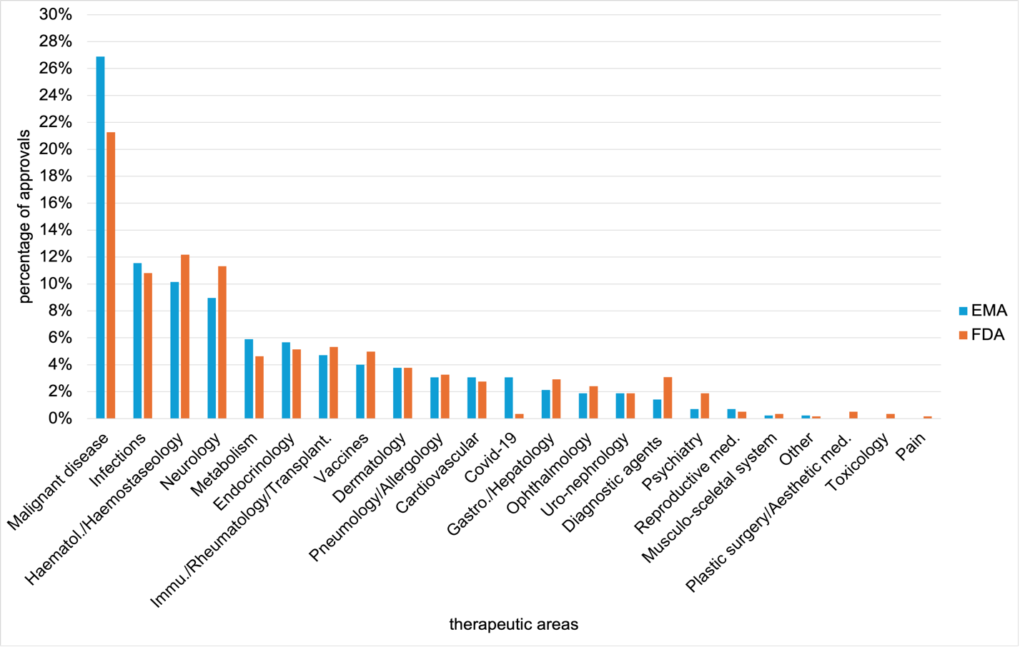
Fig. S1 Percentage distribution of EMA and FDA novel drug approvals across therapeutic areas from 2013-2023, shown in a bar chart
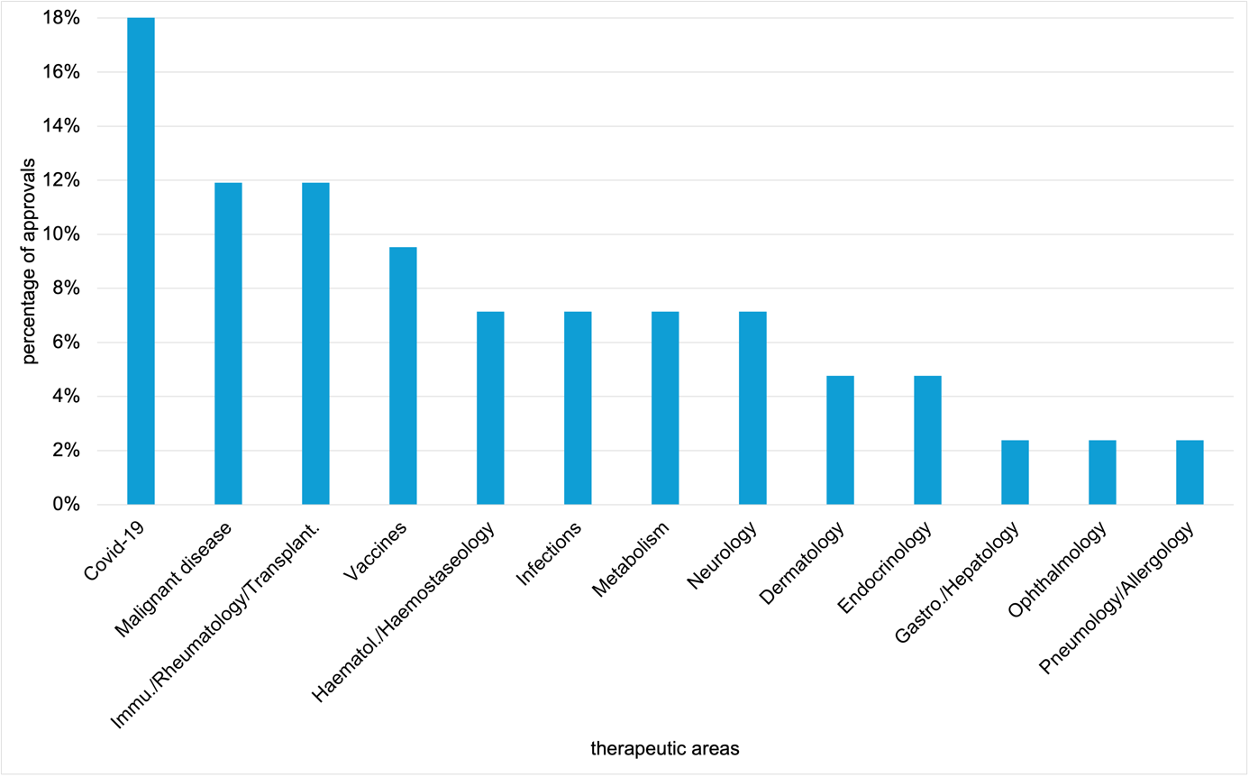Fig. S2 Percentage distribution of EMA novel drug approvals by therapeutic areas from 2013 to 2023, shown in a bar chart

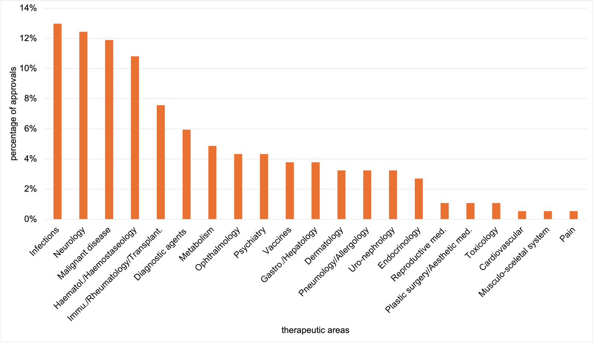Fig. S3 Percentage distribution of FDA novel drug approvals by therapeutic areas from 2013 to 2023, shown in a bar chart
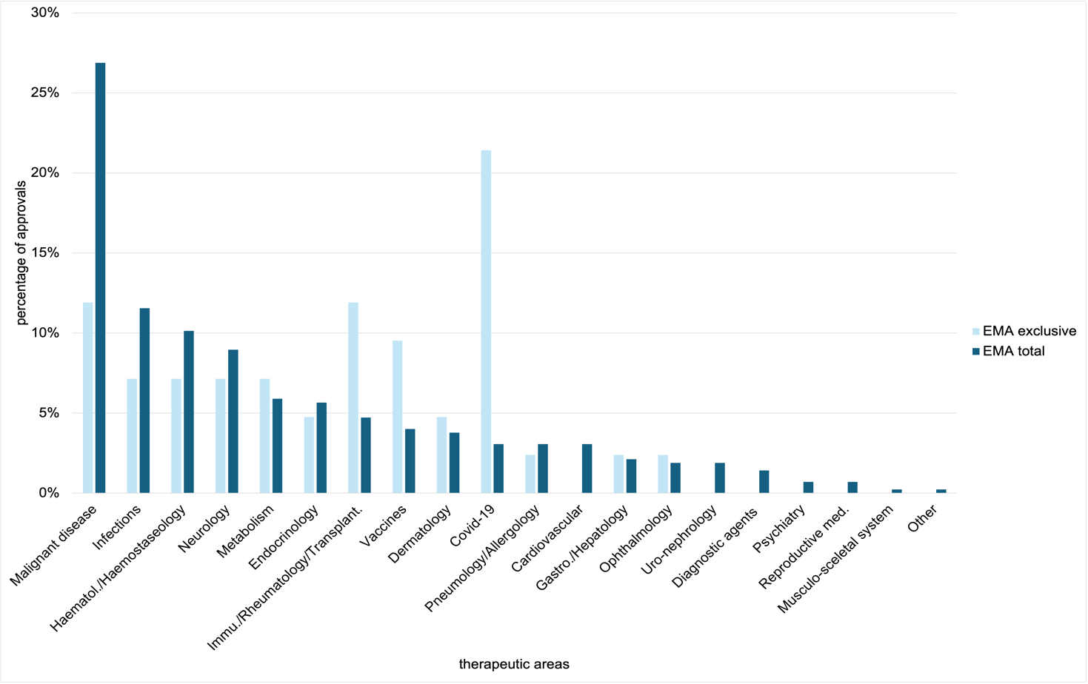Fig. S4 Percentage distribution of total and exclusive EMA approvals by therapeutic area from 2013 to 2023, shown in a bar chart

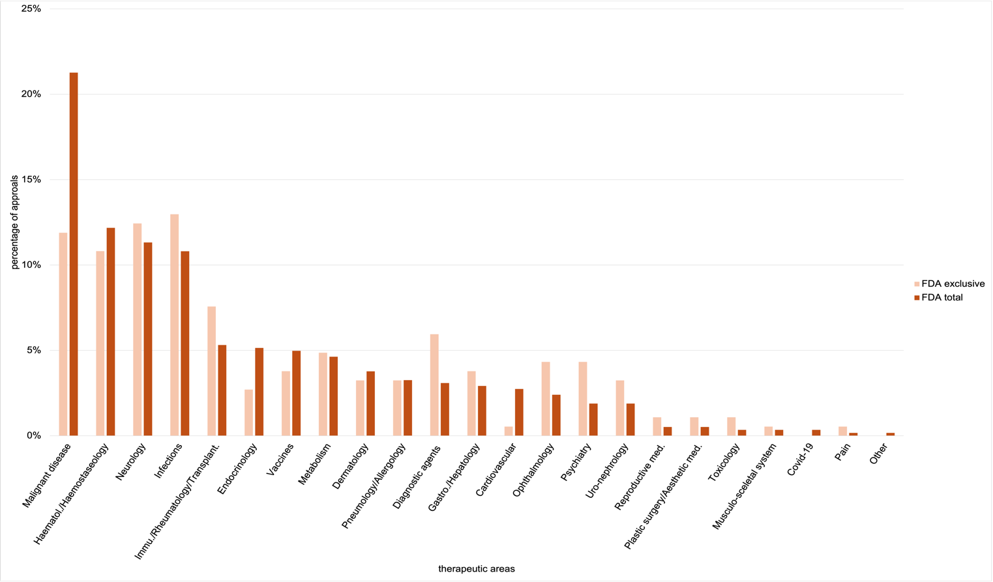
Fig S5 Percentage distribution of total and exclusive FDA approvals by therapeutic area from 2013 to 2023, shown in a bar chart

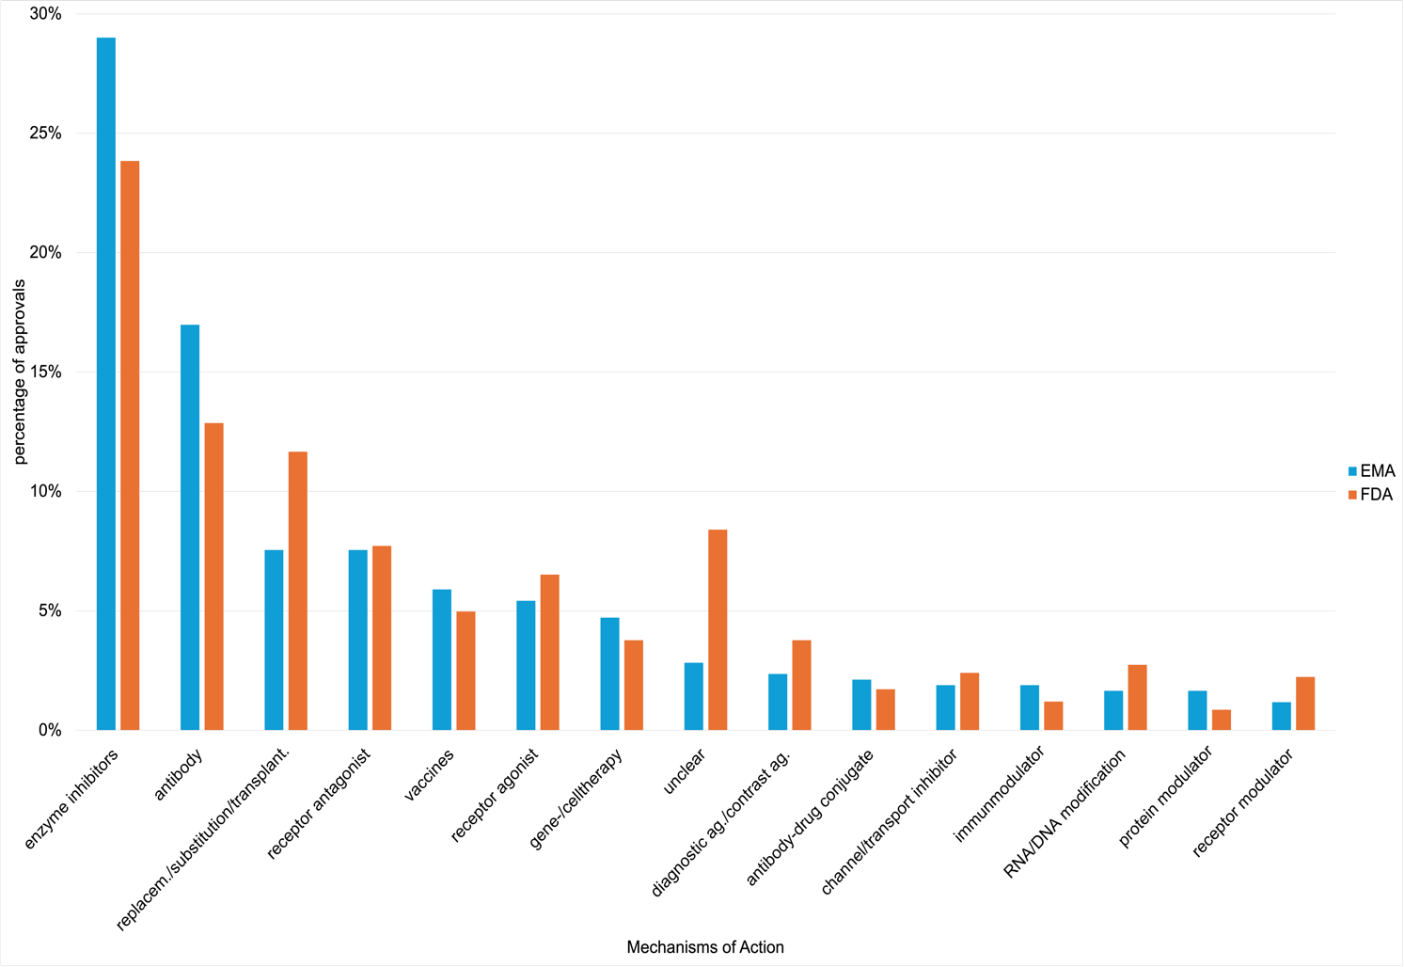Fig. S6 Percentage distribution of EMA and FDA novel drug approvals by the top 15 mechanisms of action from 2013 to 2023, shown in a bar chart

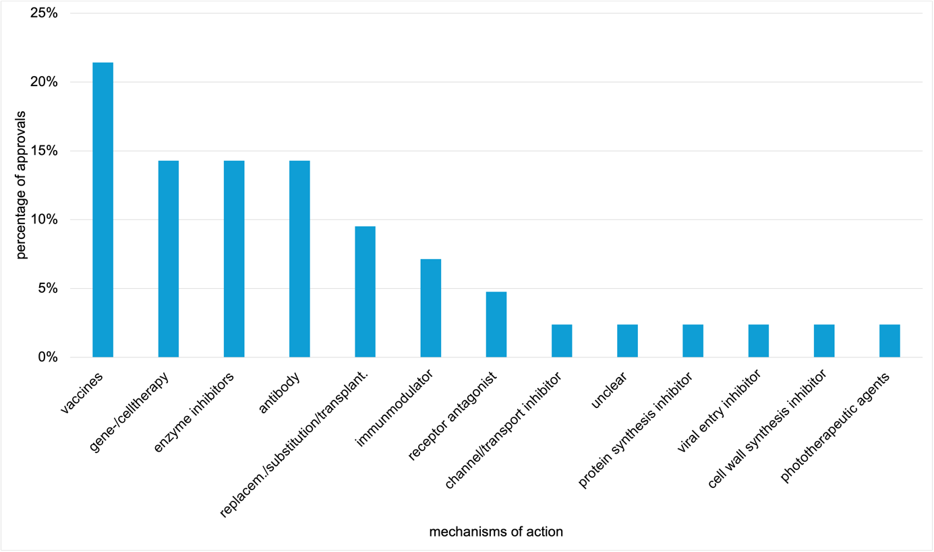Fig. S7 Percentage distribution of EMA novel drug approvals by mechanisms of action from 2013 to 2023, shown in a bar chart
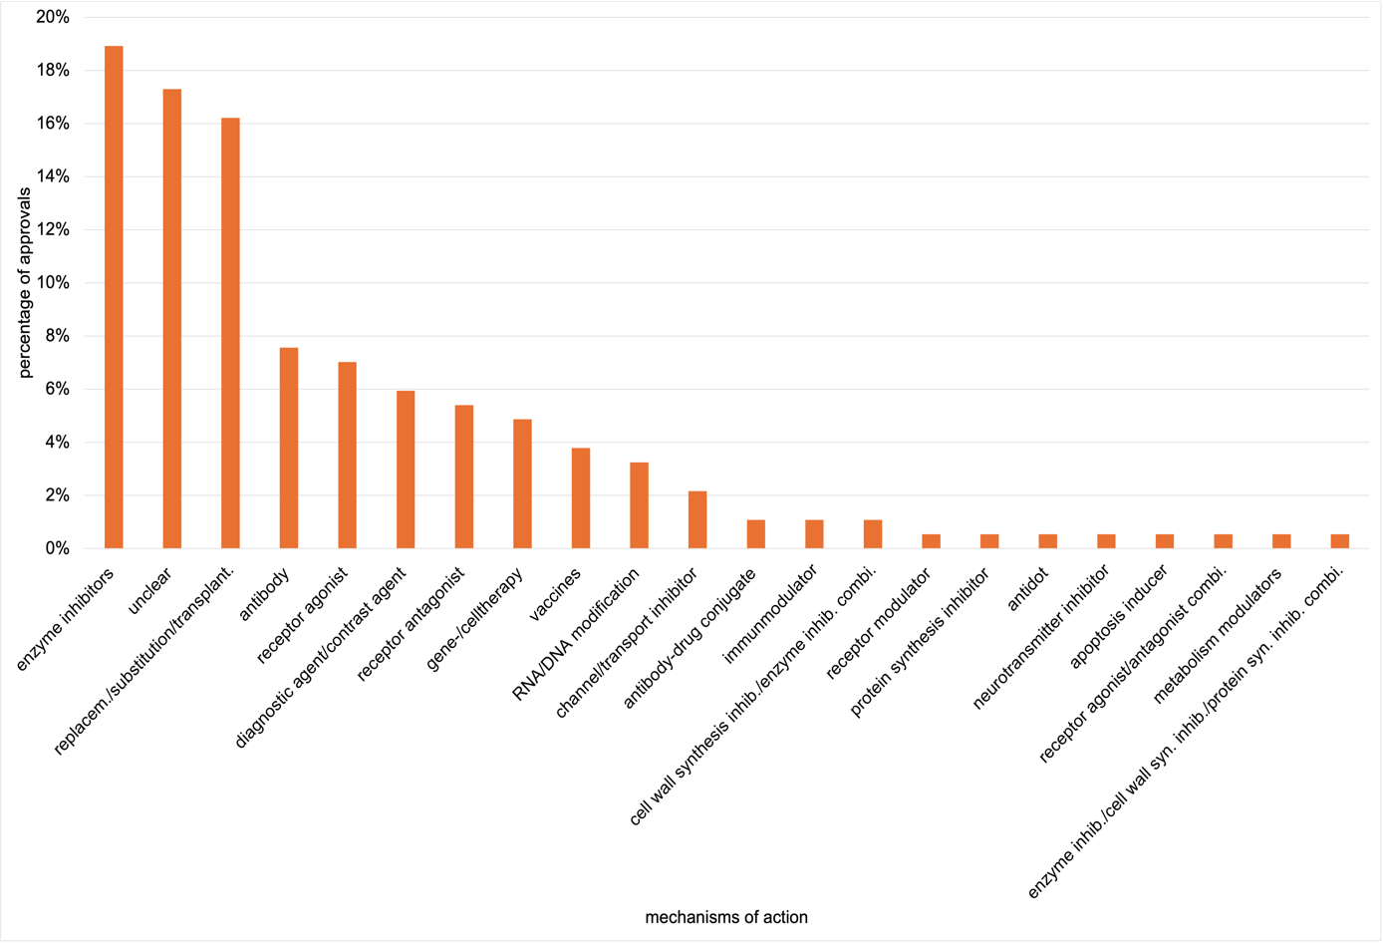Fig. S8 Percentage distribution of FDA novel drug approvals by mechanisms of action from 2013 to 2023, shown in a bar chart

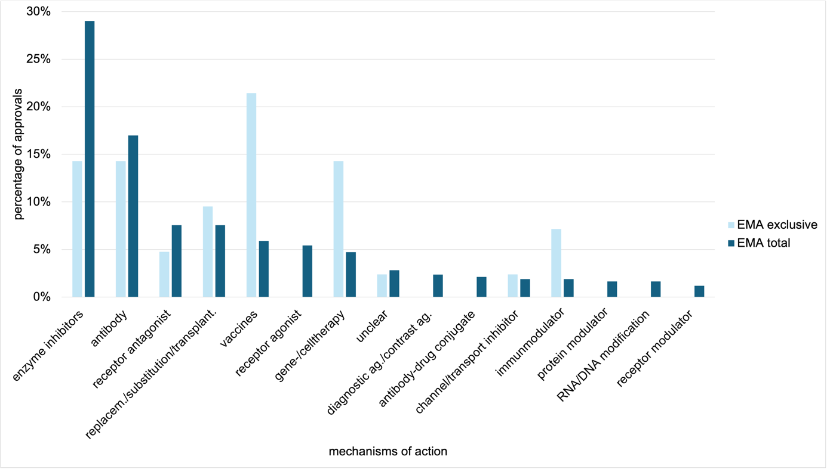Fig. S9 Percentage distribution of total and exclusive EMA approvals by top 15 mechanisms of action from 2013 to 2023, shown in a bar chart

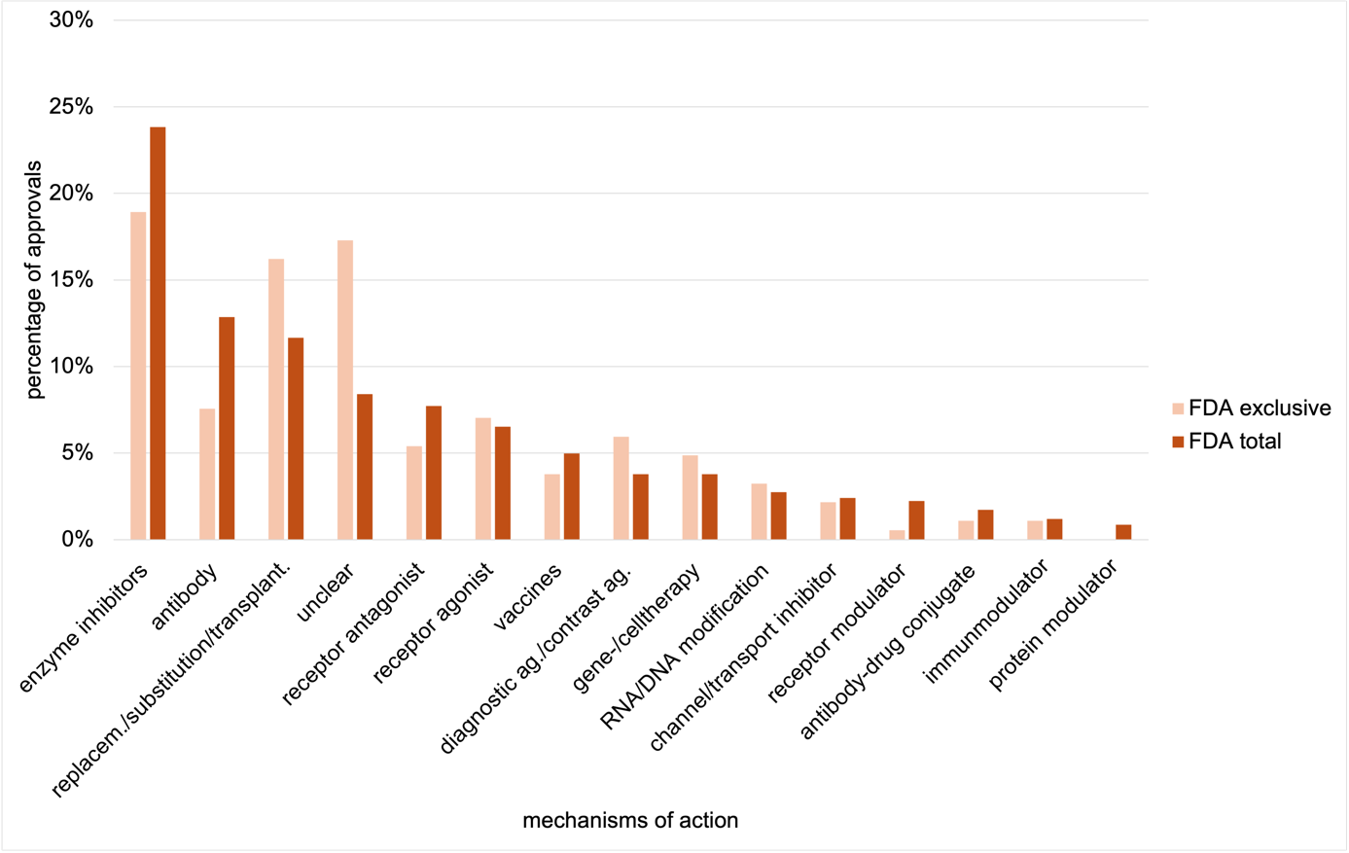Fig. S10 Percentage distribution of total and exclusive FDA approvals by top 15 mechanisms of action from 2013 to 2023, shown in a bar chart

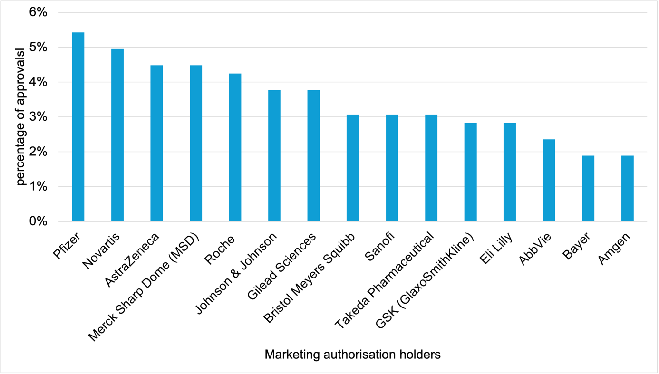
Fig. S11 Percentage distribution of EMA novel drug approvals by the top 15 marketing authorisation holders from 2013 to 2023, shown in a bar chart

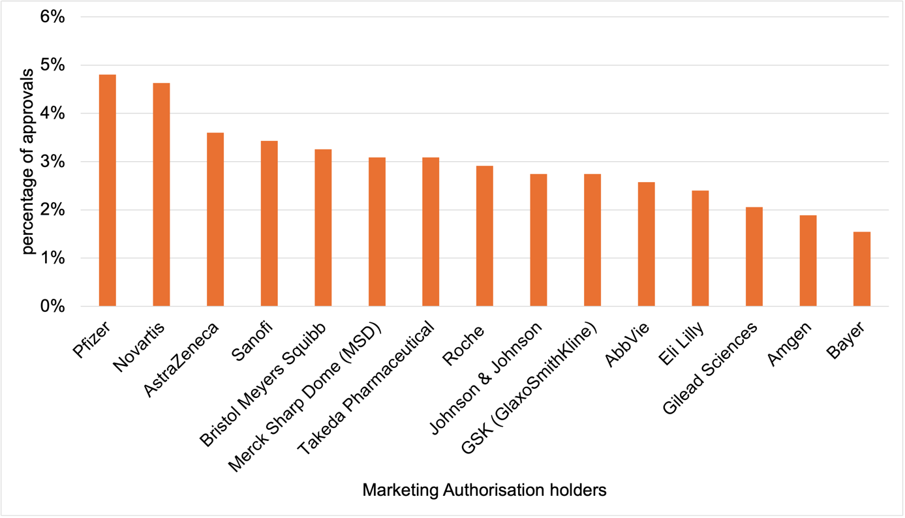
Fig. S12 Percentage distribution of FDA novel drug approvals by the top 15 marketing authorisation holders from 2013 to 2023, shown in a bar chart

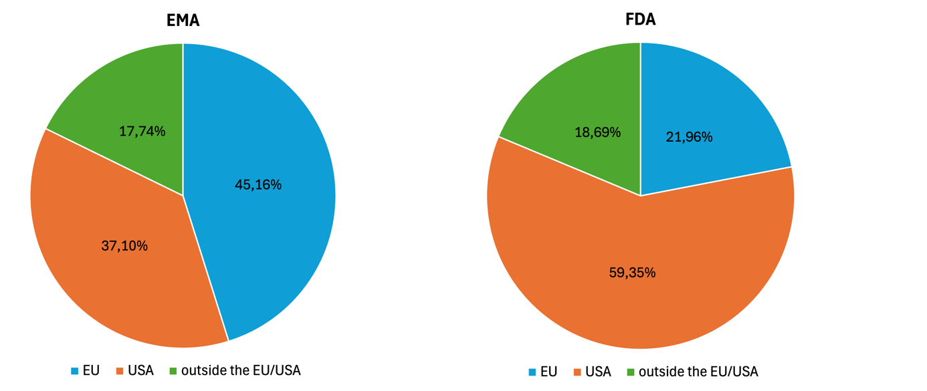
Fig. S13 Percentage distribution of company headquarters of marketing authorization holders from 2013 to 2023, based on the total number of authorization holders, shown in two pie charts

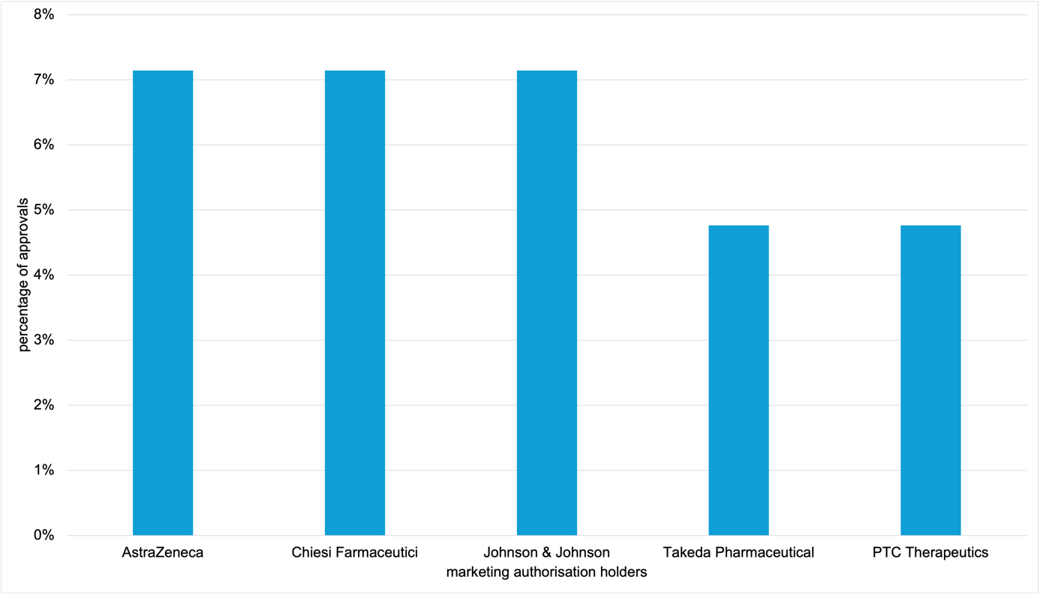Fig. S14 Percentage distribution of EMA novel drug approvals by the top 5 marketing authorisation holders from 2013 to 2023, shown in a bar chart
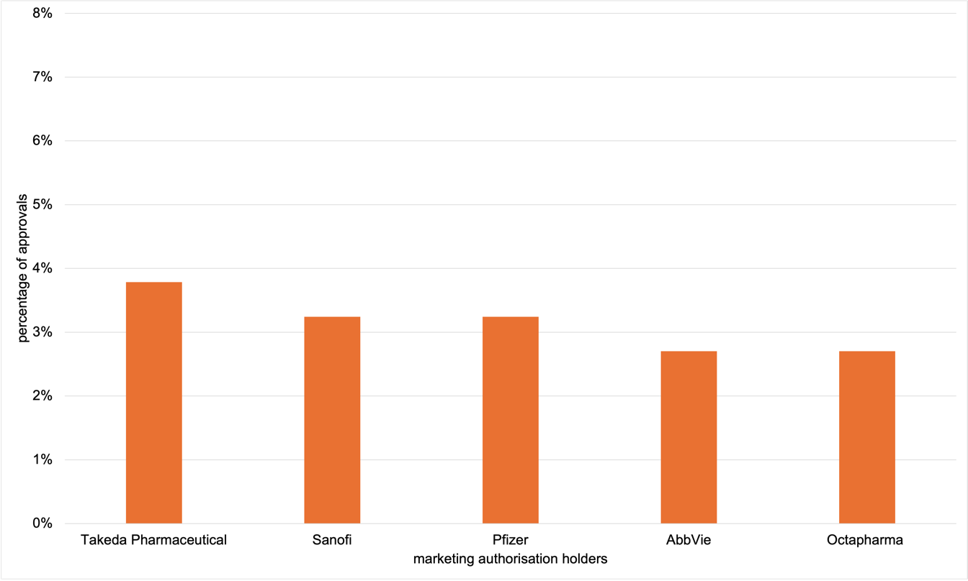Fig. S15 Percentage distribution of FDA novel drug approvals by the top 5 marketing authorisation holders from 2013 to 2023, shown in a bar chart

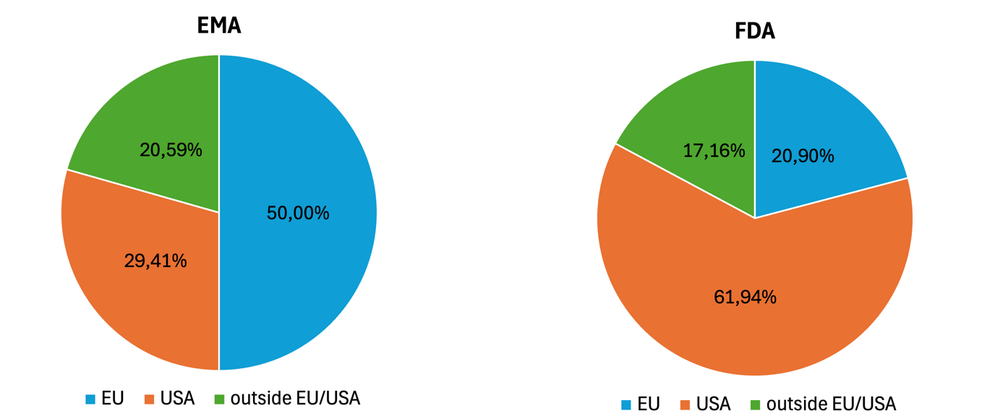
Fig. S16 Percentage distribution of company headquarters of marketing authorization holders for exclusive drug approvals from 2013 to 2023, based on the number of authorization holders, shown in two pie charts

