Legends

Supplementary Figure 1: The Top Ten Authors' Dynamics. Publication trends of the ten most prolific authors in Naunyn-Schmiedeberg’s Archives of Pharmacology (1969–2024), showing variations in research output over time. The data is for all research articles.

Supplementary Figure 2: The Top Universities' Dynamics. Publication trends of the most productive universities in Naunyn-Schmiedeberg’s Archives of Pharmacology (1969–2024), highlighting institutional contributions over the years. The data is for all research articles.

Supplementary Figure 3: The Top Ten Authors' Dynamics. Publication trends of the ten most prolific authors in Naunyn-Schmiedeberg’s Archives of Pharmacology (1969–2024), showing variations in research output over time. The data is for all reviews.

Supplementary Figure 4: The Top Universities' Dynamics. Publication trends of the most productive universities in Naunyn-Schmiedeberg’s Archives of Pharmacology (1969–2024), highlighting institutional contributions over the years. The data is for all reviews.

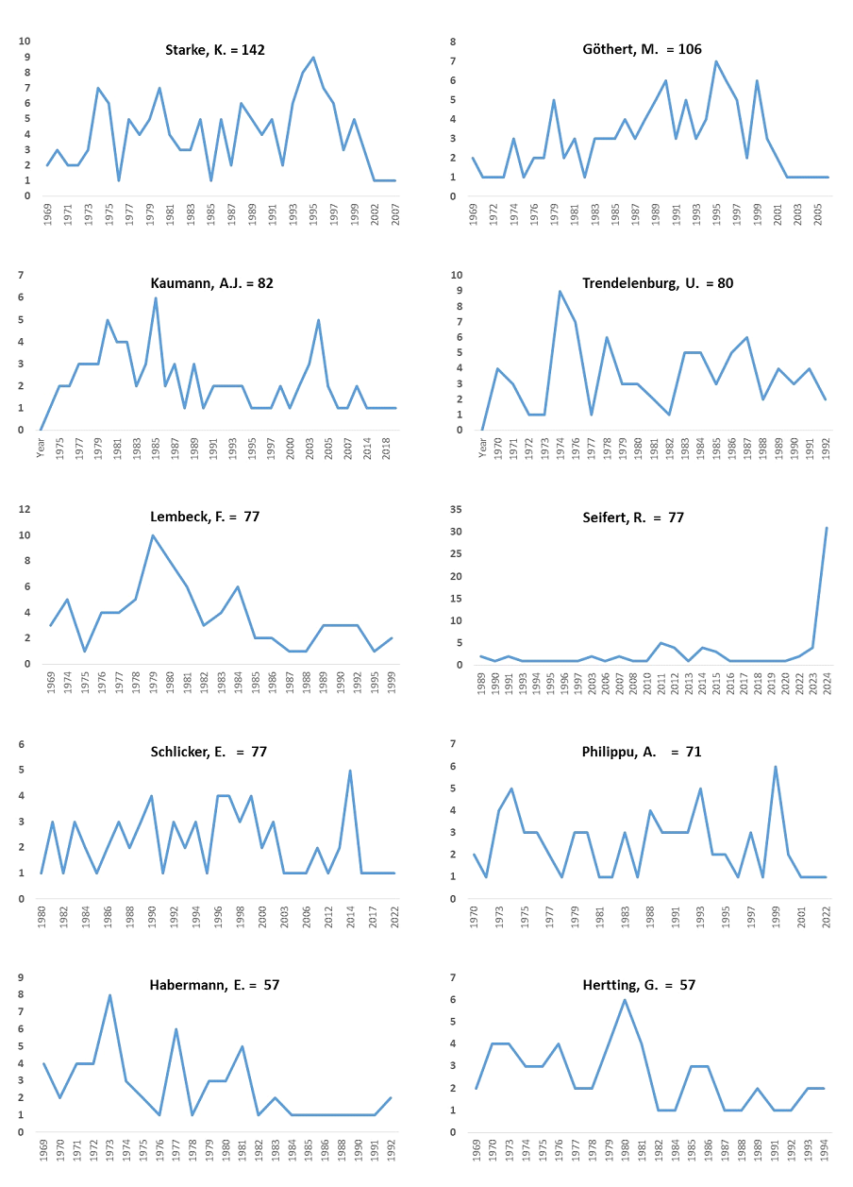
Figure 1: The Top Ten Authors' Dynamics. Publication trends of the ten most prolific authors in Naunyn-Schmiedeberg’s Archives of Pharmacology (1969–2024), showing variations in research output over time. The data is for all research articles.
Ranking # | Name of University
 | 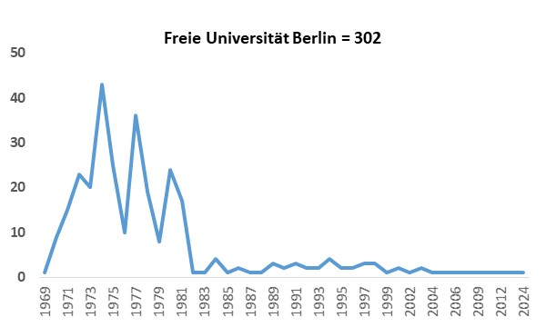
 | 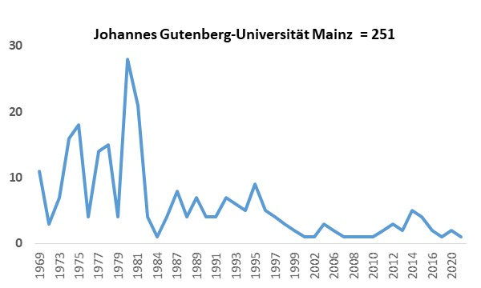
 | 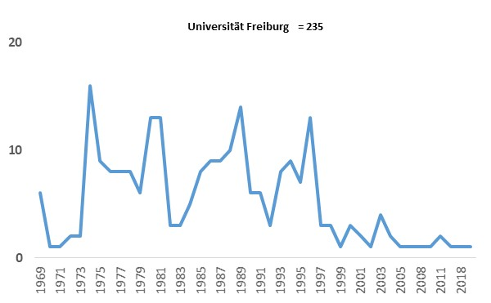
 | 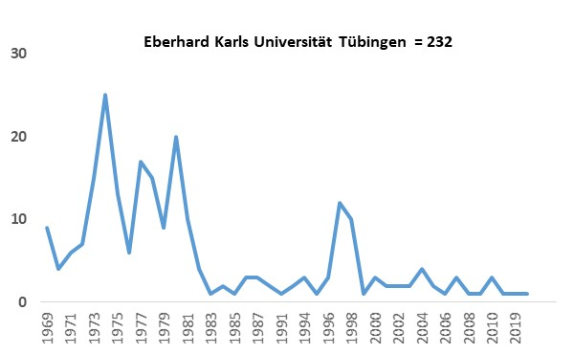
 | 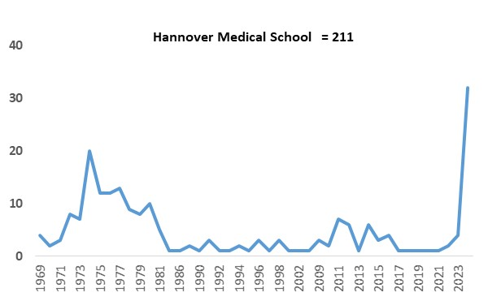
 | 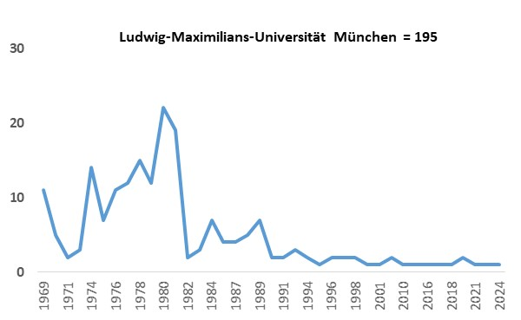
 | 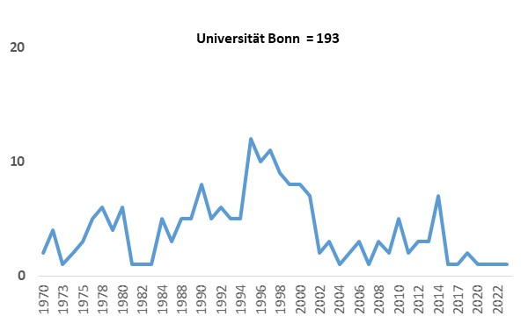
 | 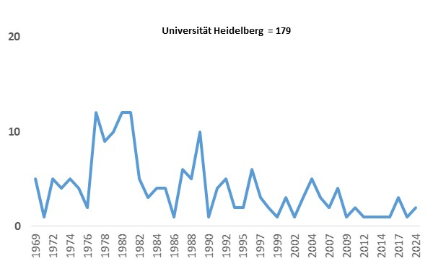
 | 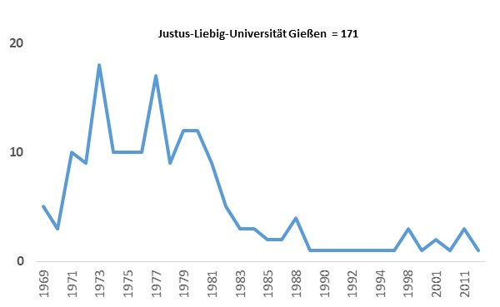
 | 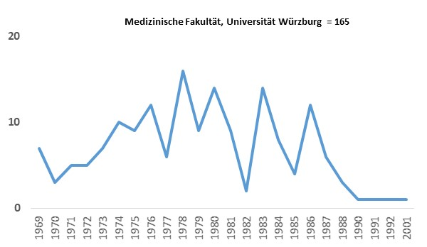

Figure 2: The Top Universities' Dynamics. Publication trends of the most productive universities in Naunyn-Schmiedeberg’s Archives of Pharmacology (1969–2024), highlighting institutional contributions over the years. The data is for all research articles.

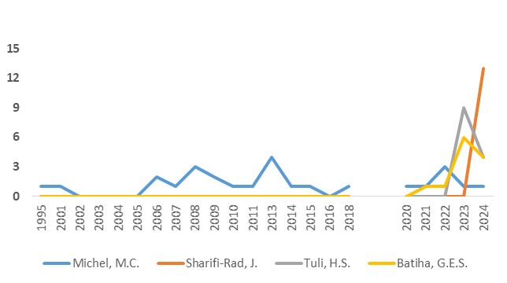
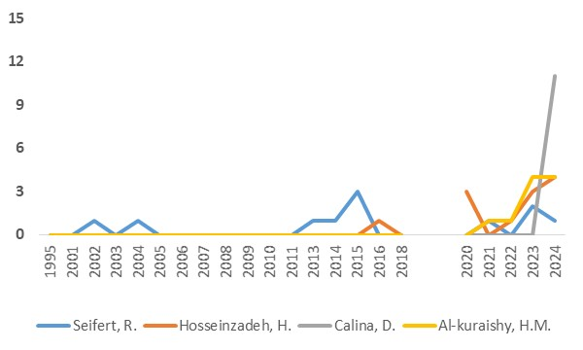

Figure 3: The Top Ten Authors' Dynamics. Publication trends of the ten most prolific authors in Naunyn-Schmiedeberg’s Archives of Pharmacology (1969–2024), showing variations in research output over time. The data is for all reviews.

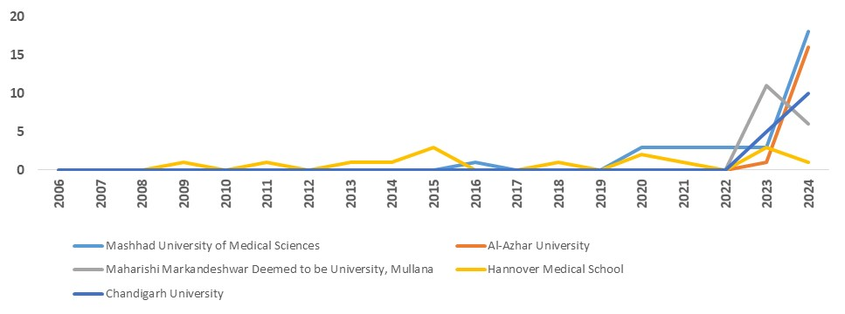
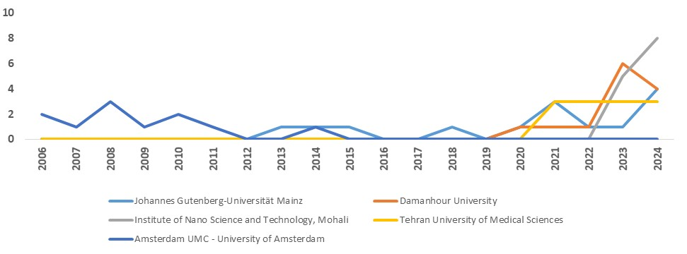

Figure 4: The Top Universities' Dynamics. Publication trends of the most productive universities in Naunyn-Schmiedeberg’s Archives of Pharmacology (1969–2024), highlighting institutional contributions over the years. The data is for all reviews.

