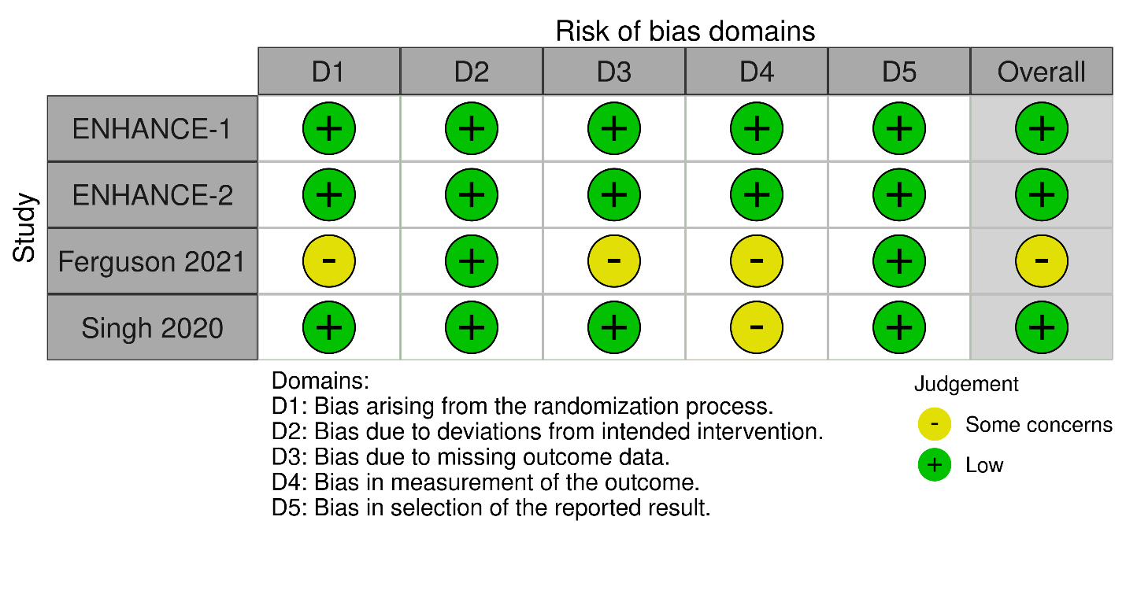
(Supplementary figure. 1) The bias-risk assessment diagram of the included articles
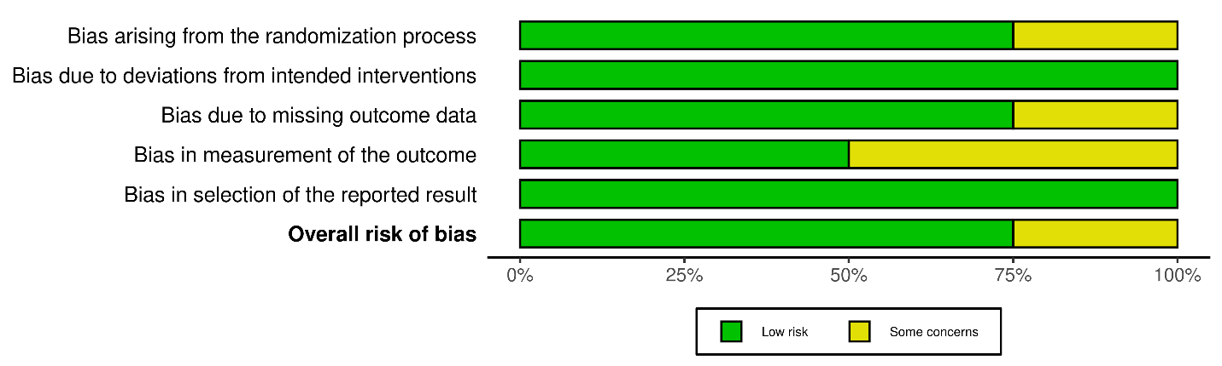
(Supplementary figure. 2) The bias evaluation bar graph of the included articles.

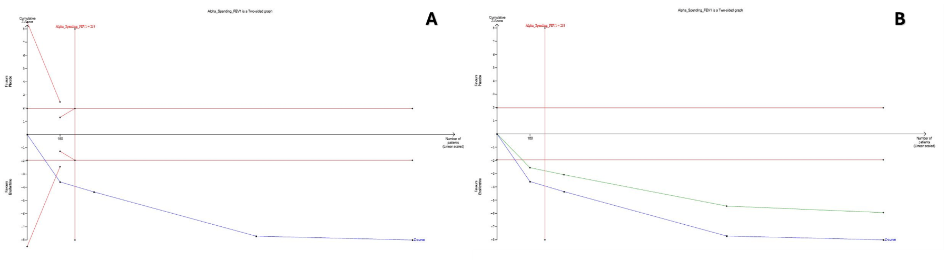

(Supplementary figure. 3) TSA on Mean Differences (MD) of change from baseline in average FEV1 (0–12h) between Ensifentrine 3 mg and placebo.
A) Average FEV1 cumulative z-curve passing the superiority boundary (True positive)
B) Average FEV1 penalized Z-curve passing the conventional boundary
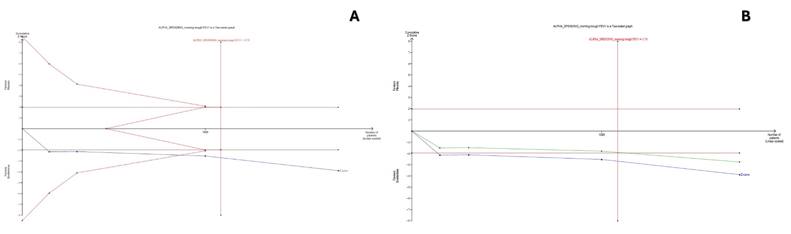

(Supplementary figure. 4) TSA on Mean Differences (MD) of Change from baseline in morning trough FEV1 between Ensifentrine 3 mg and placebo.
A) Morning trough FEV1 cumulative z-curve passing the superiority boundary (True positive)
B) Morning trough FEV1 penalized Z-curve passing the conventional boundary

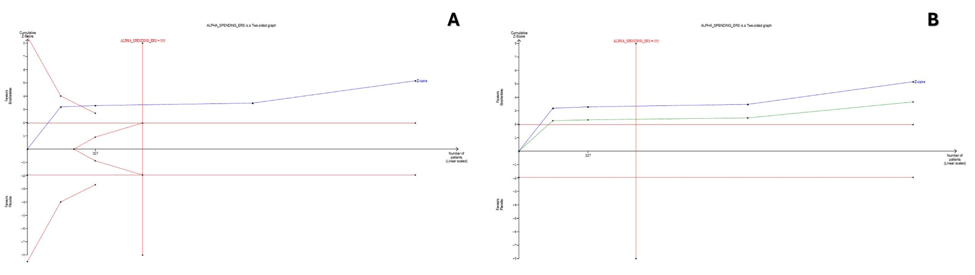

(Supplementary figure. 5) TSA on Mean Differences (MD) of Change from baseline in ERS between Ensifentrine 3 mg and placebo.
A) ERS cumulative z-curve passing the superiority boundary (True positive)
B) ERS penalized Z-curve passing the conventional boundary
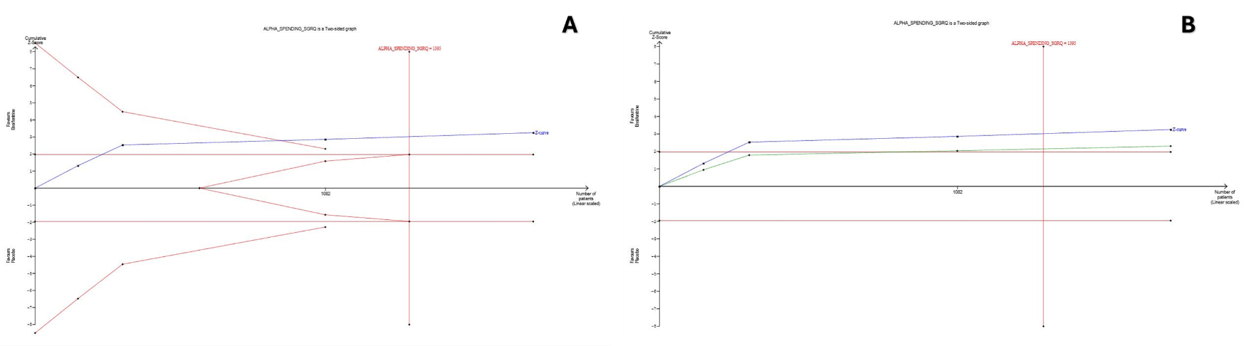

(Supplementary figure. 6) TSA on Mean Differences (MD) of Change from baseline in SGRQ between Ensifentrine 3 mg and placebo.
A) SGRQ cumulative z-curve passing the superiority boundary (True positive)
B) SGRQ penalized Z-curve passing the conventional boundary

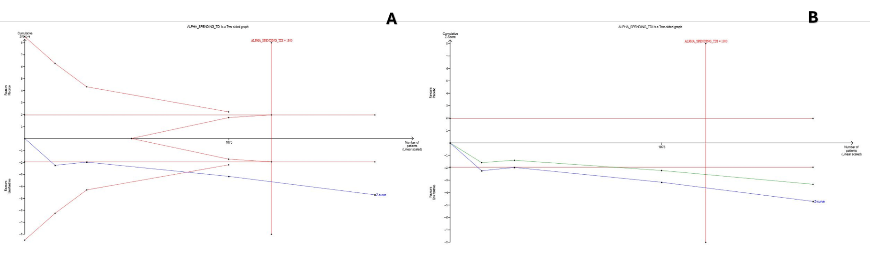

(Supplementary figure. 7) TSA on Mean Differences (MD) of Change from baseline in TDI between Ensifentrine 3 mg and placebo.
A) TDI cumulative z-curve passing the superiority boundary (True positive)
B) TDI penalized Z-curve passing the conventional boundary

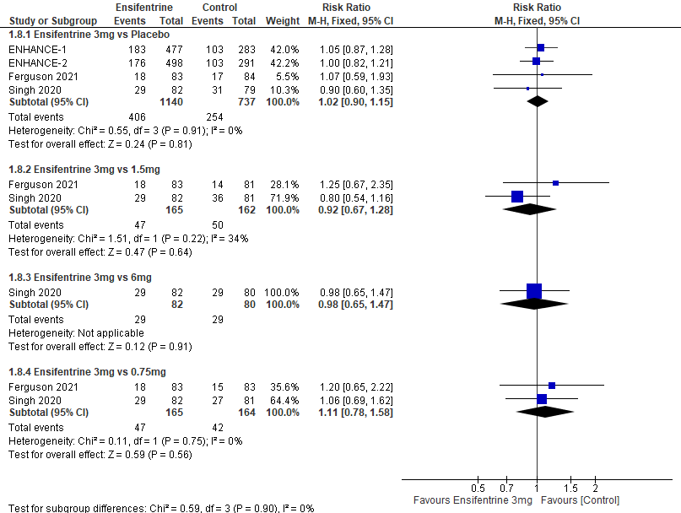 (Supplementary figure. 8) Forest plot comparing (RR) for TEAEs between Ensifentrine 3 mg and 0.75, 1.5 and 6 mg.
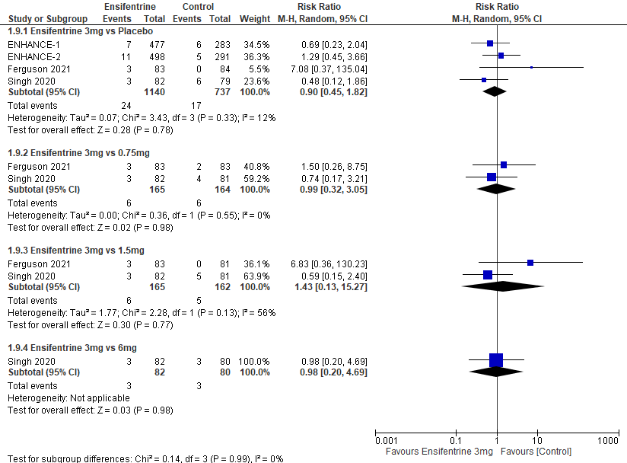 (Supplementary figure. 9) Forest plot comparing (RR) for COPD attacks between Ensifentrine 3 mg and 0.75, 1.5 and 6 mg.
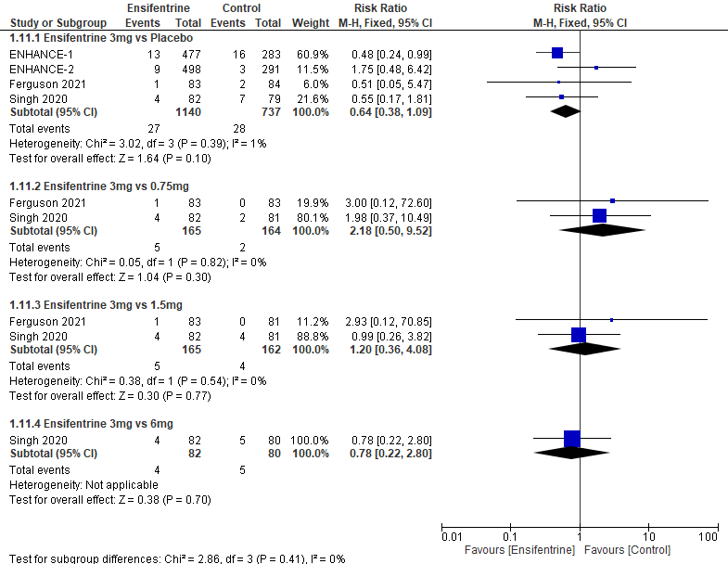 (Supplementary figure. 10) Forest plot comparing (RR) for Nasopharyngitis between Ensifentrine 3 mg and 0.75, 1.5 and 6 mg.

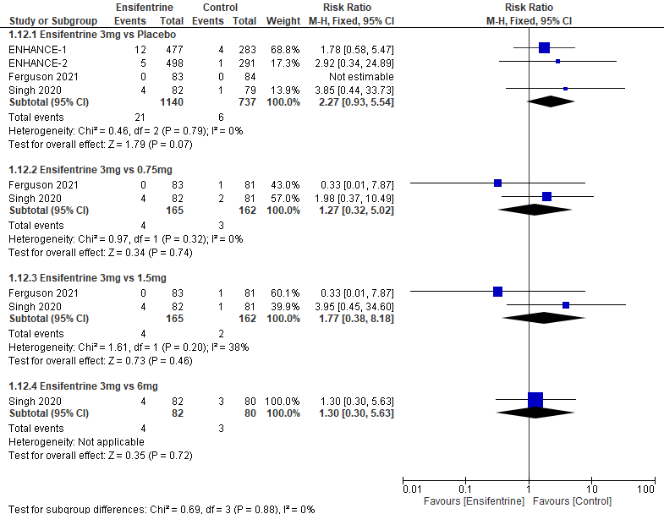
(Supplementary figure. 11) Forest plot comparing (RR) for Hypertension between Ensifentrine 3 mg and 0.75, 1.5 and 6 mg.

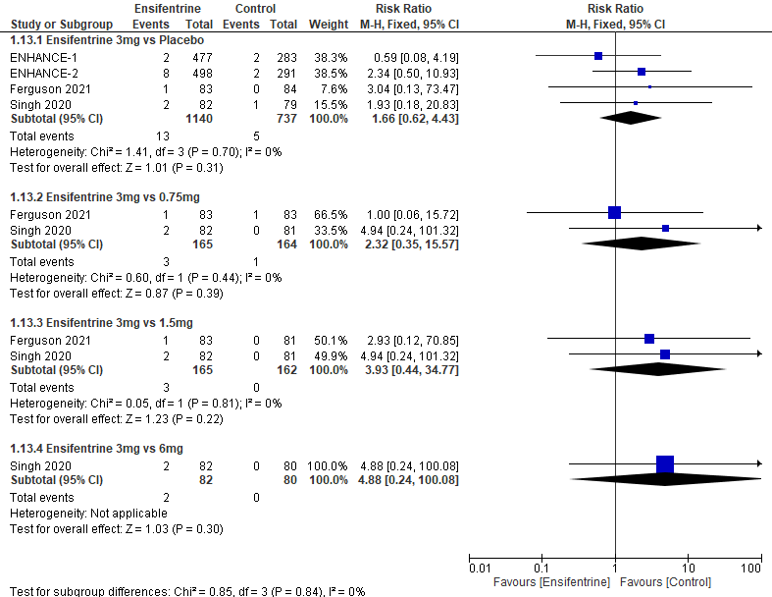
(Supplementary figure. 12) Forest plot comparing (RR) for Diarrhea between Ensifentrine 3 mg and 0.75, 1.5 and 6 mg.

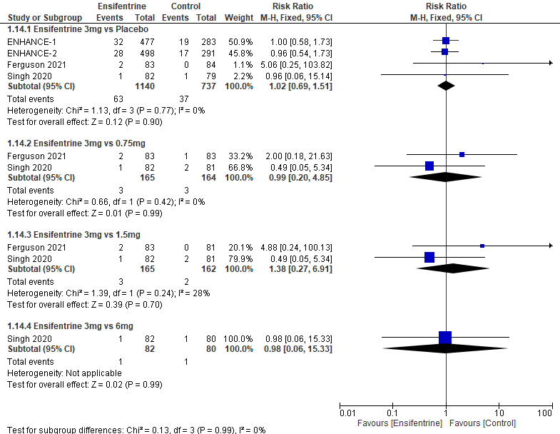
(Supplementary figure. 13) Forest plot comparing (RR) for Serious TEAEs between Ensifentrine 3 mg and 0.75, 1.5 and 6 mg.

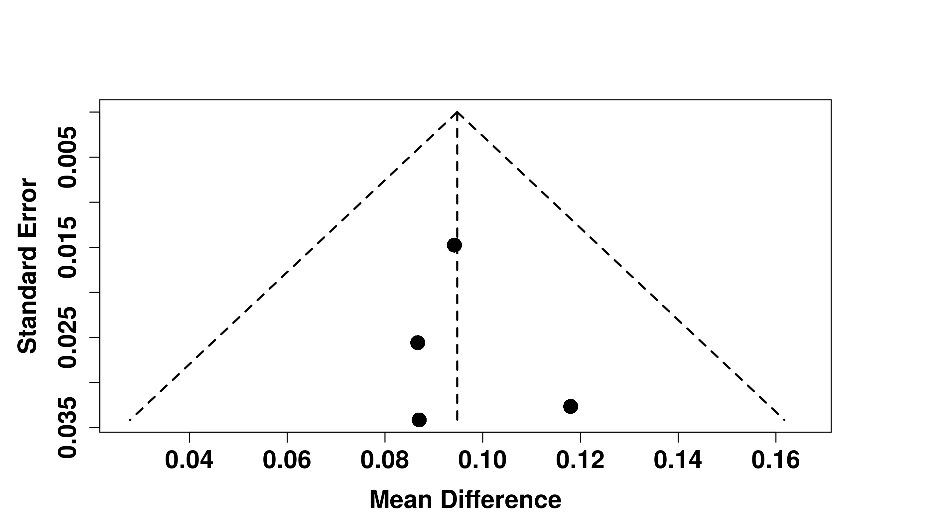
(Supplementary figure. 14) Funnel Plot for change from baseline in average FEV1 (0–12h) between Ensifentrine 3 mg and placebo.

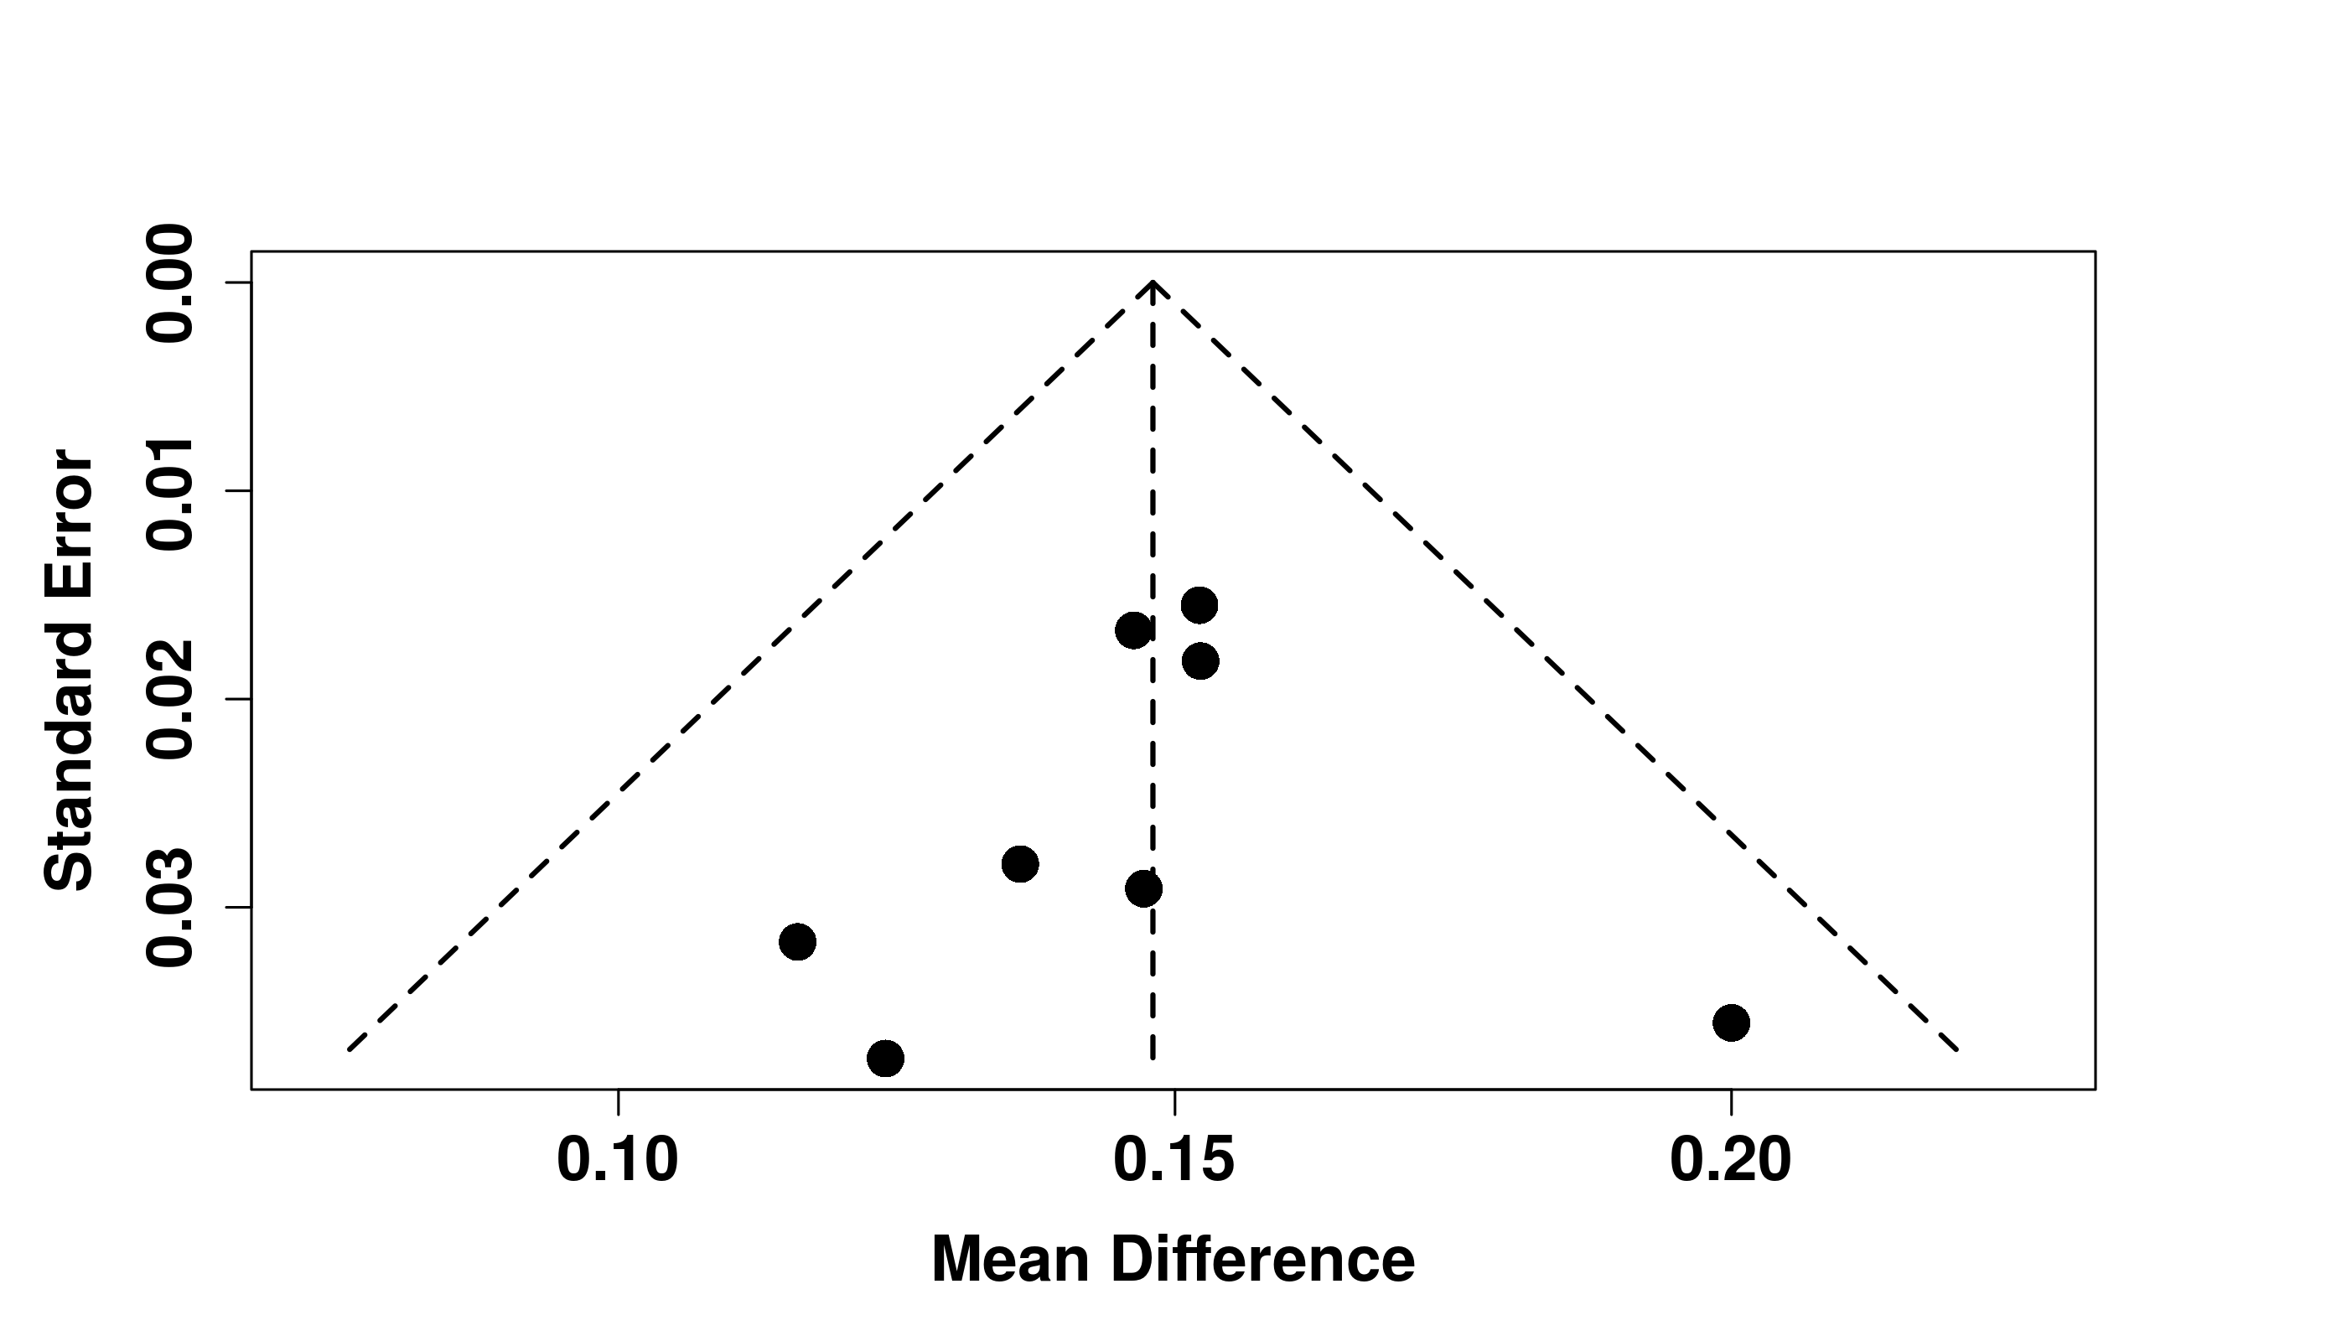
(Supplementary figure. 15) Funnel plot comparing (MD) for change from baseline in peak FEV1 (0–3h) Ensifentrine 3 mg and placebo.

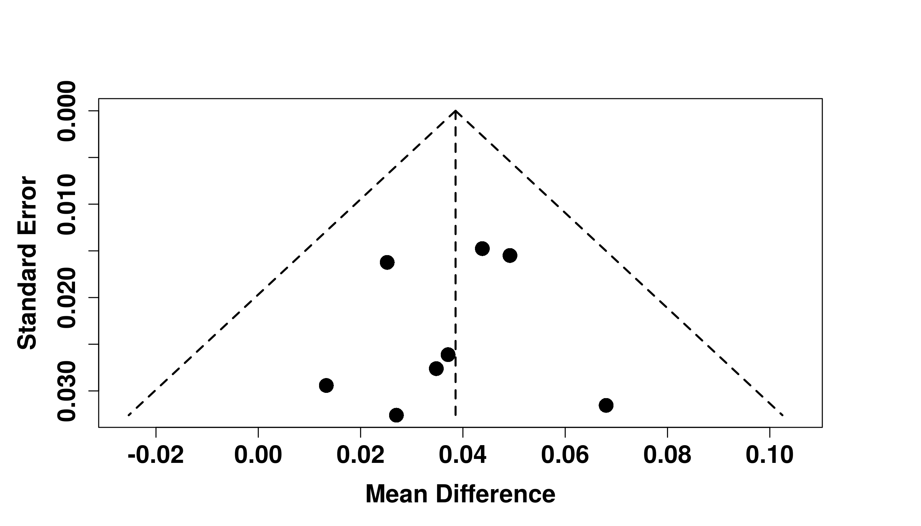
(Supplementary figure. 16) Funnel plot comparing (MD) for change from baseline in morning trough FEV1 Ensifentrine 3 mg and placebo.

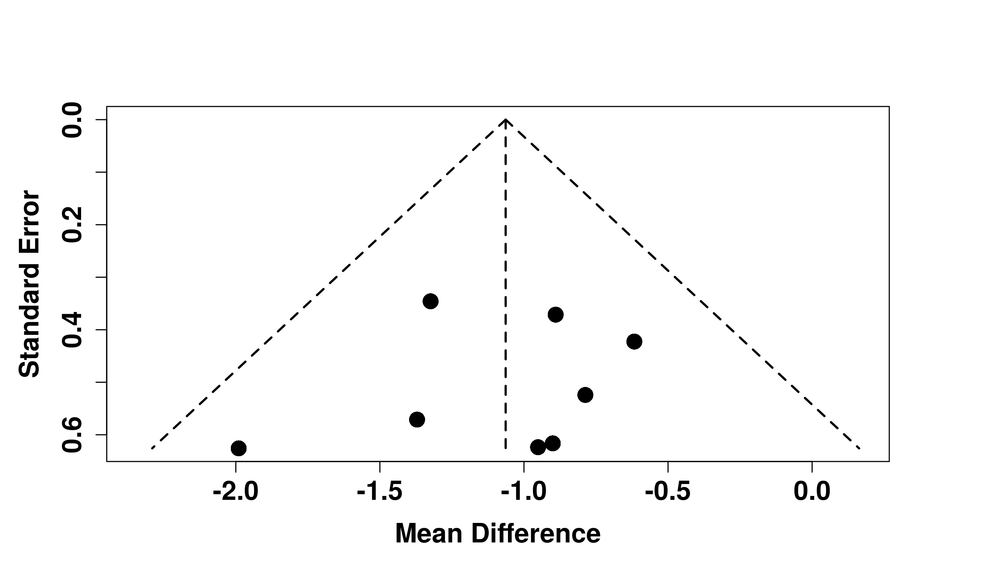
(Supplementary figure. 17) Funnel plot for change from baseline in ERS between Ensifentrine 3 mg and placebo.
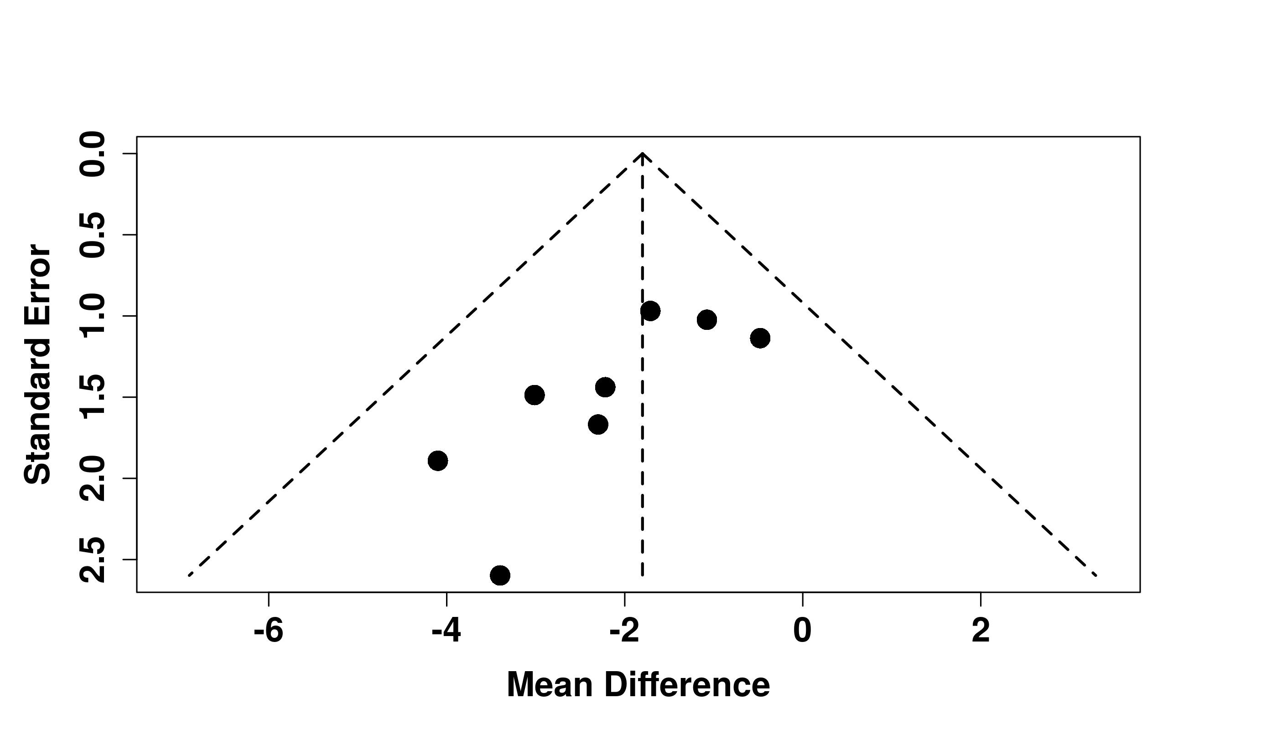
(Supplementary figure. 18) Funnel plot for Change from baseline in SGRQ between Ensifentrine 3 mg and placebo.
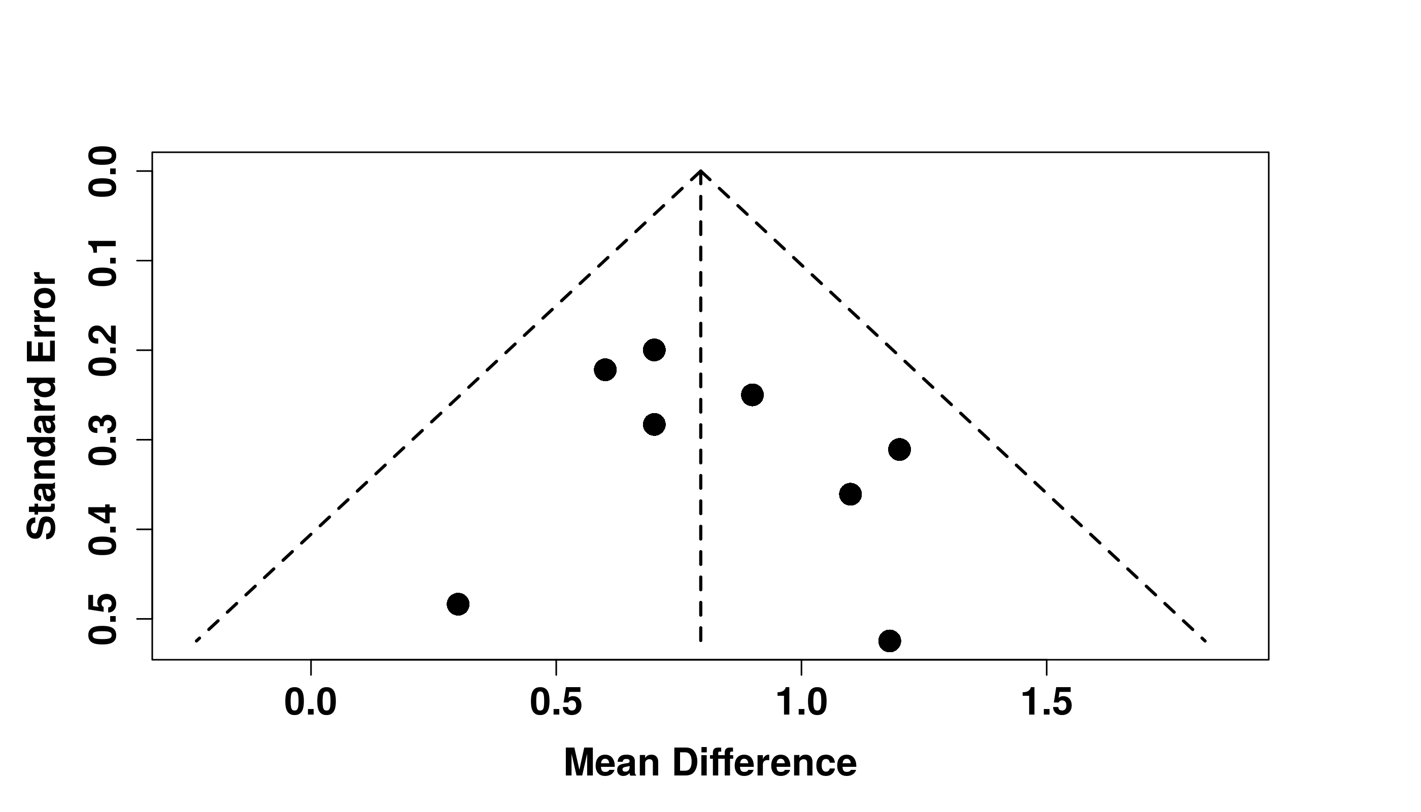
(Supplementary figure. 19) Funnel plot for Change from baseline in TDI between Ensifentrine 3 mg and placebo

Supplementary Table S1. Comprehensive Search Strategy Used Across Databases
Databases Searched | Search Strategy (Keywords and Boolean Operators)
PubMed, Web of Science, Scopus | ("ensifentrine" OR "RPL-554" OR "Phosphodiesterase 3 and 4 Inhibitor" OR "Ohtuvayre") AND ("Chronic Obstructive Pulmonary Disease" OR "COPD"); Search included MeSH terms (where applicable), title/abstract/keyword fields. No language or date restrictions were applied during the initial search.

