Investigating the impact of ramelteon on all-cause mortality in ischemic stroke ICU patients: a retrospective propensity-matched study from the MIMIC-IV Database

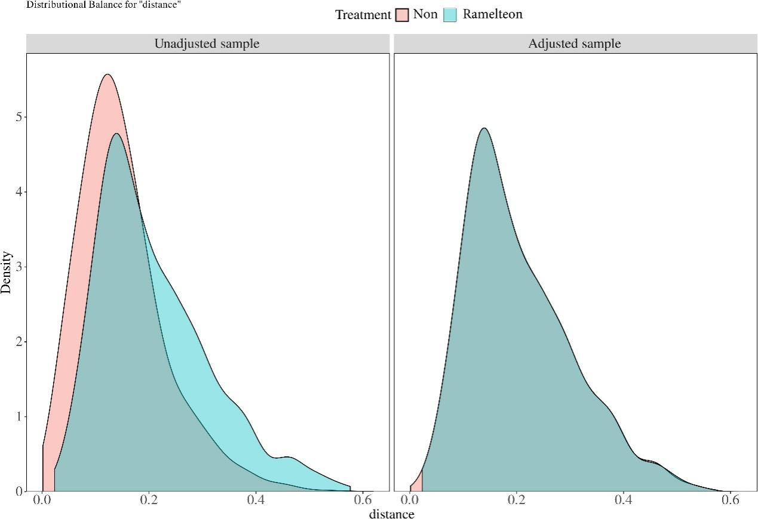
Supplementary Figure 1 Distributional balance before and after PSM
Note: Kernel density plots of the propensity score distance for the ramelteon and non-ramelteon groups before (left) and after (right) PSM. Improved overlap in the adjusted sample indicates successful balancing of the groups via PSM.
Abbreviation: PSM, propensity score matching

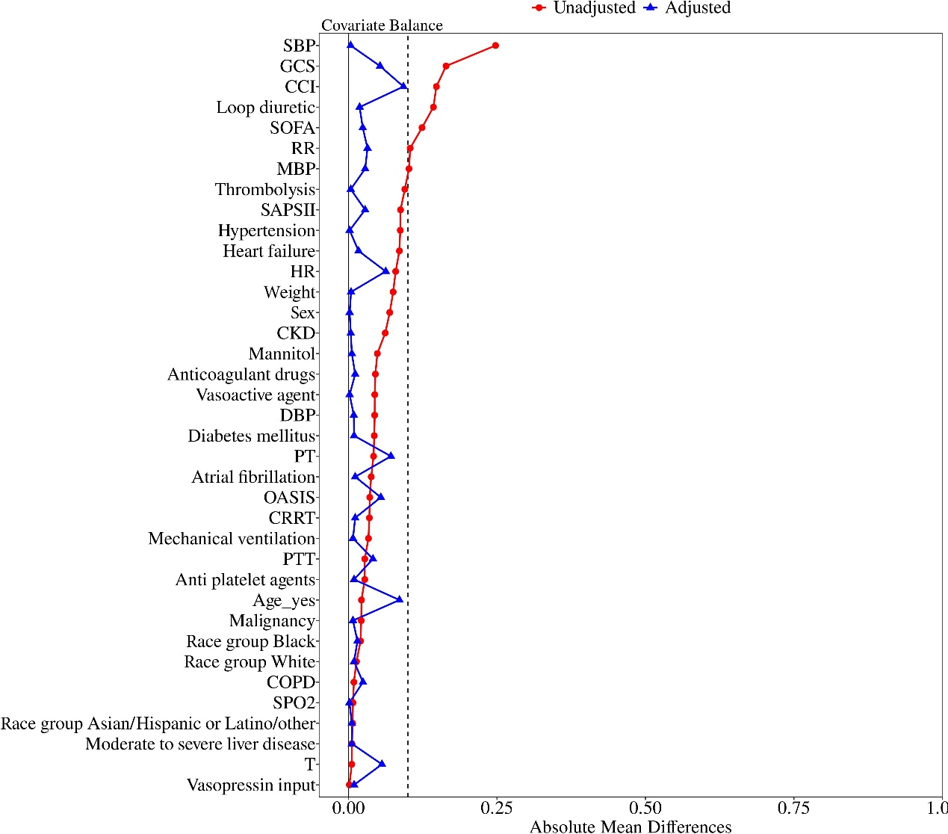
Supplementary Figure 2 SMD of covariates before and after PSM
Note: Each point denotes the SMD of a baseline covariate between the ramelteon and non- ramelteon groups, before and after PSM. Following matching, the majority of covariates exhibited absolute SMDs below 0.1, indicating satisfactory covariate balance.
Abbreviation: SMD, standardized mean difference; PSM, propensity score matching; SOFA, sequential organ failure assessment; GCS, glasgow coma scale; CCI, charlson comorbidity index; SAPSII, simplified acute physiology score II; OASIS, oxford acute severity of illness score; PT, prothrombin time; PTT, partial thromboplastin time; CKD, chronic kidney disease; HR, heart rate; SBP, systolic blood pressure; DBP, diastolic blood pressure; MBP, mean blood pressure; RR, respiratory rate; T, temperature; SPO2, oxygen saturation; CRRT, continuous renal replacement therapy; COPD, chronic obstructive pulmonary disease; PSM, propensity score matching

