Supplemental data
Pseudoephedrine poisoning reported to German poison centers: Analysis of Documented Patient Cases and the Particular Vulnerability of Infants and Toddlers

Funda Gezgin, Florian Eyer, Gabriel Zorn, Andreas Schaper, Rafael Wagner and Roland Seifert

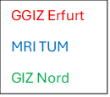
Fig. S1: Federal states in Germany covered by the participating Poison Centers (PC). Colors show the covered regions by the PCs. Grey areas show federal states without available data, because the responsible PCs did not participate in the study.

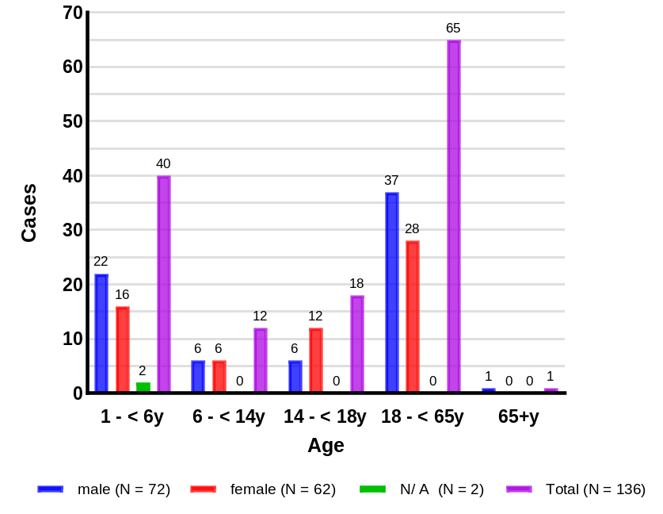
Fig. S2: Number of cases by age group for male, female, N/ A (unknown age and/ or sex) and total cases (PC Erfurt).

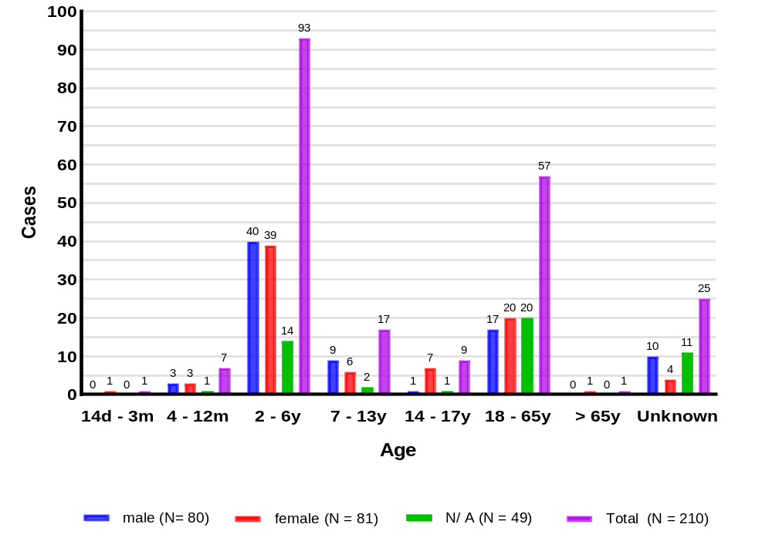
Fig. S3: Number of cases by age group for male, female, N/ A (unknown age and/ or sex) and total cases (MRI TUM).

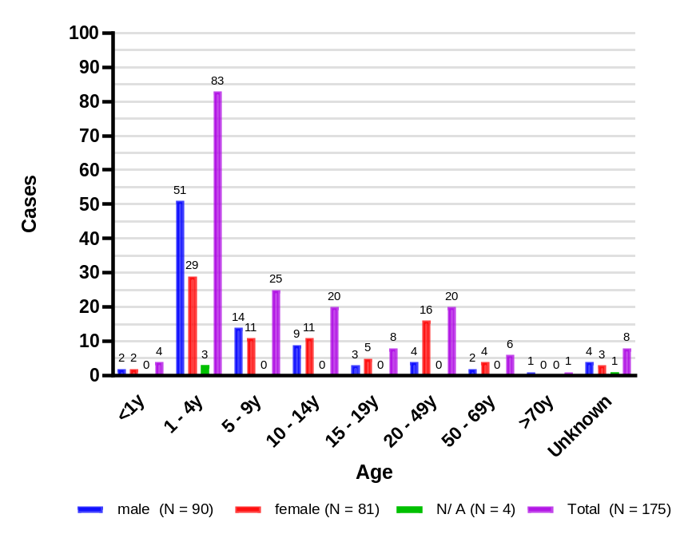
Fig. S4: Number of cases by age group for male, female, N/ A (unknown age and/ or sex) and total cases (PC Nord Göttingen).

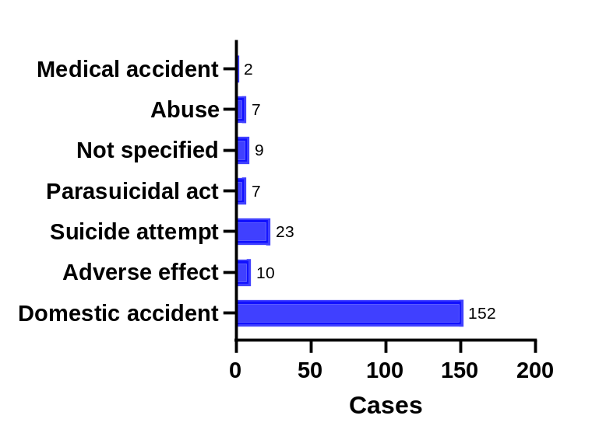
Fig. S5: Etiology of pseudoephedrine intoxication-related calls reported to the Munich Poison center (MRI TUM) shown as absolute case numbers.

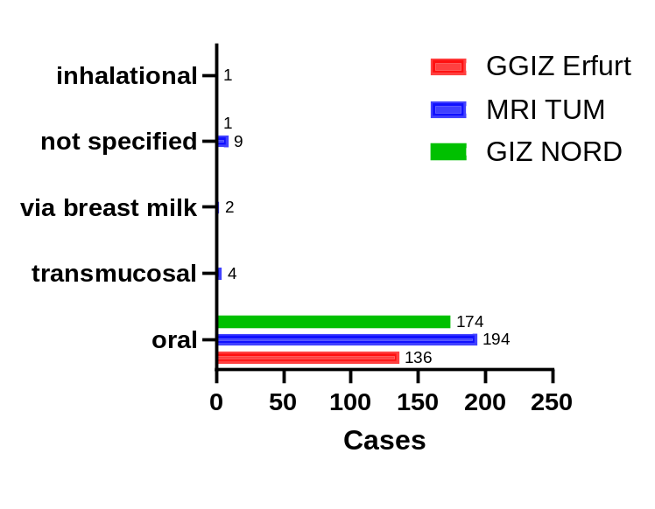
Fig. S6: Application form for pseudoephedrine intoxication cases reported by the three participating poison centers shown as absolute numbers.

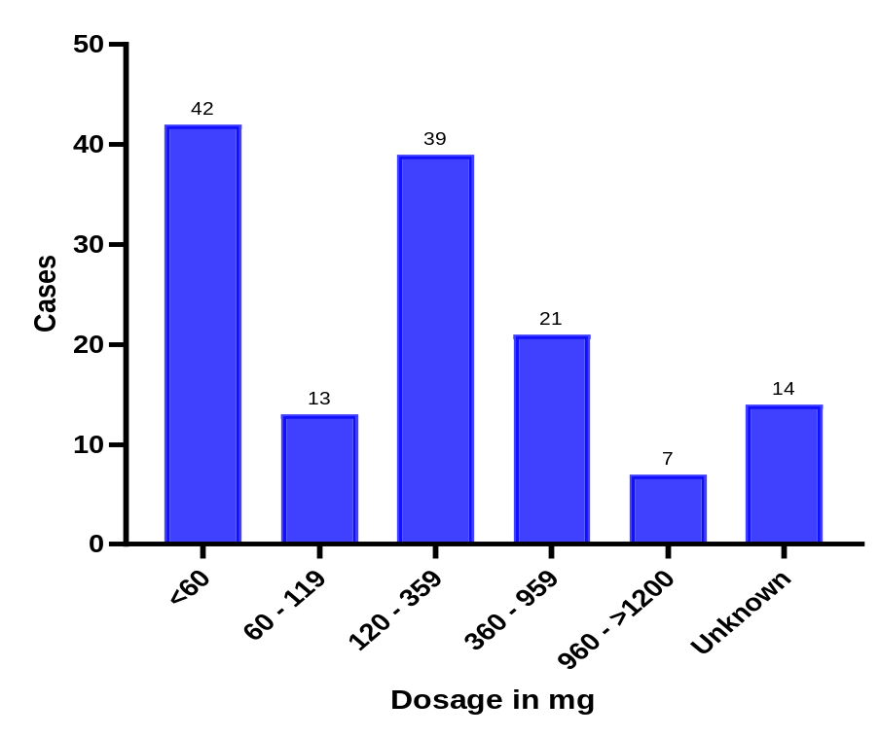
Fig. S7: Number of reported pseudoephedrine intoxication cases by dosage range in mg (absolute number) reported to PC GGIZ Erfurt.

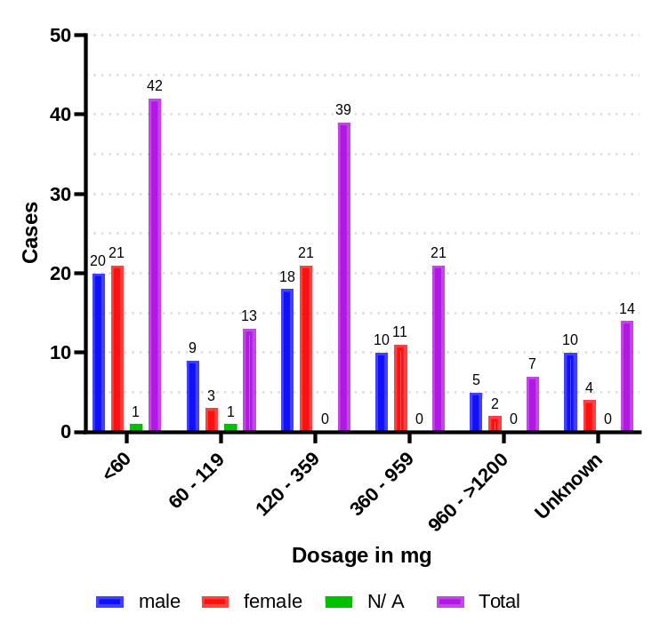
Fig. S8: Number of reported pseudoephedrine intoxication cases by dosage range in mg for male, female, N/ A (unknown age and/or sex) and total cases (absolute number) reported to PC GGIZ Erfurt.
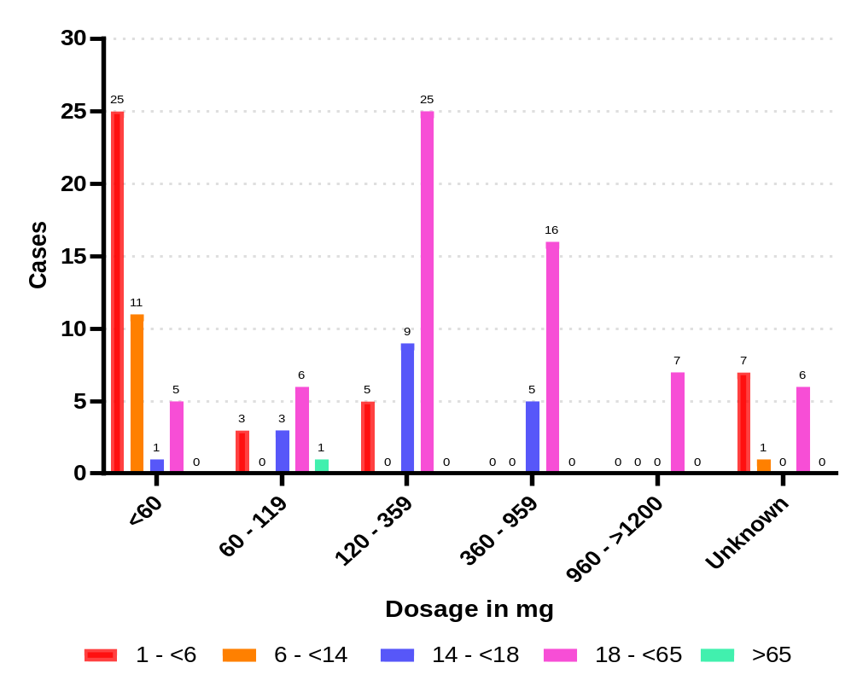
Fig. S9: Number of reported pseudoephedrine intoxication cases by dosage range in mg for age groups (absolute number) reported to PC GGIZ Erfurt.

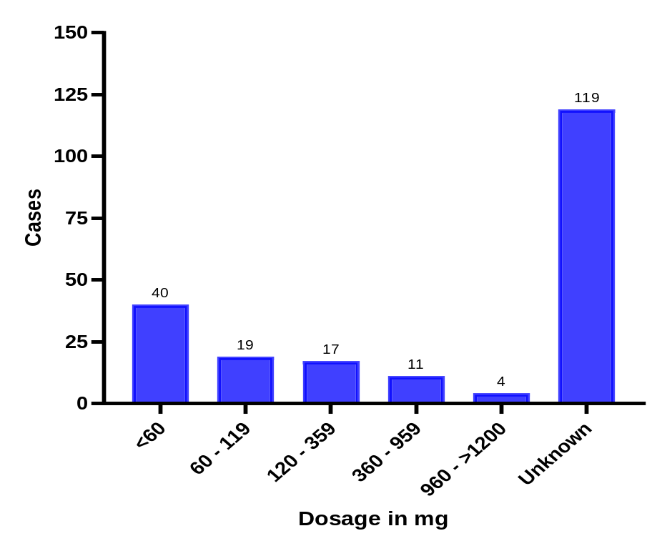
Fig. S10: Number of reported pseudoephedrine intoxication cases by dosage range in mg (absolute number) reported to PC MRI TUM.

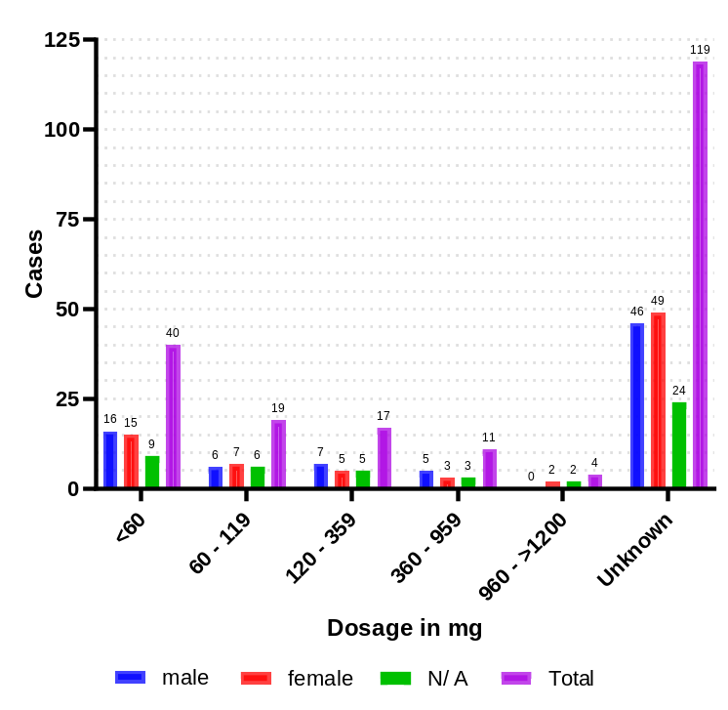
Fig. S11: Number of reported pseudoephedrine intoxication cases by dosage range in mg for male, female, N/ A (unknown age and/or sex) and total cases (absolute number) reported to PC MRI TUM.
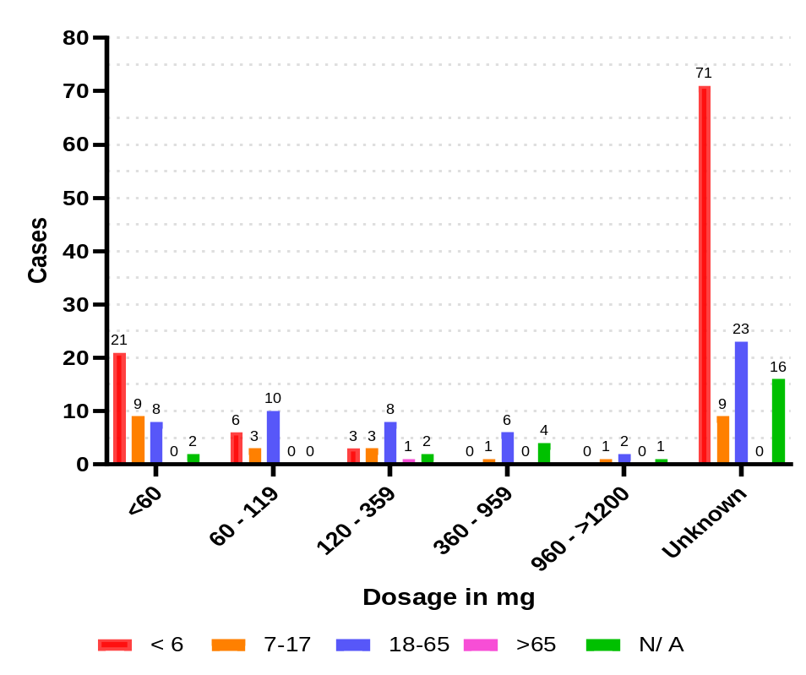
Fig. S12: Number of reported pseudoephedrine intoxication cases by dosage range in mg for age groups (absolute number) reported to PC MRI TUM.

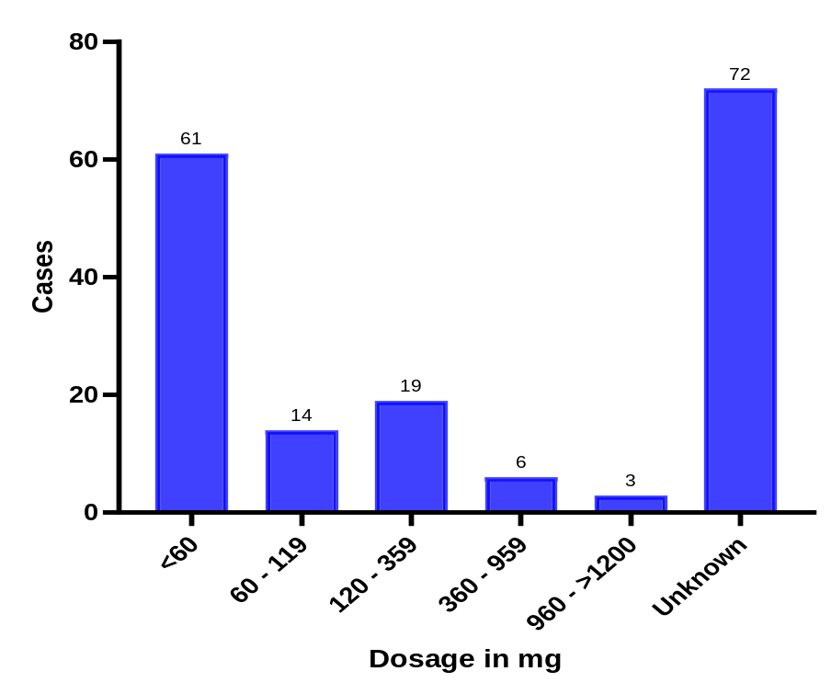
Fig. S13: Number of reported pseudoephedrine intoxication cases by dosage range in mg (absolute number) reported to PC Nord Göttingen.
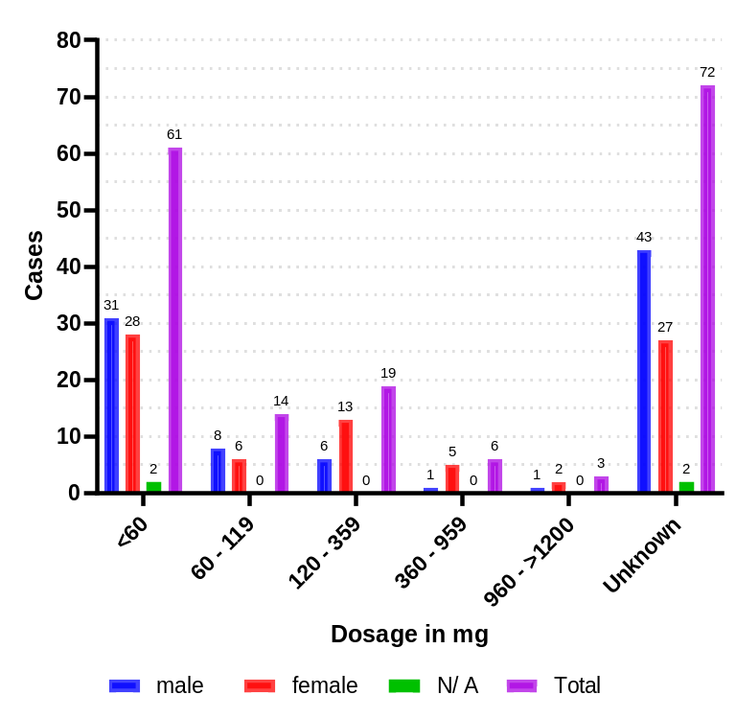
Fig. S14: Number of reported pseudoephedrine intoxication cases by dosage range in mg for male, female, N/ A (unknown age and/or sex) and total cases (absolute number) reported to PC Nord Göttingen.

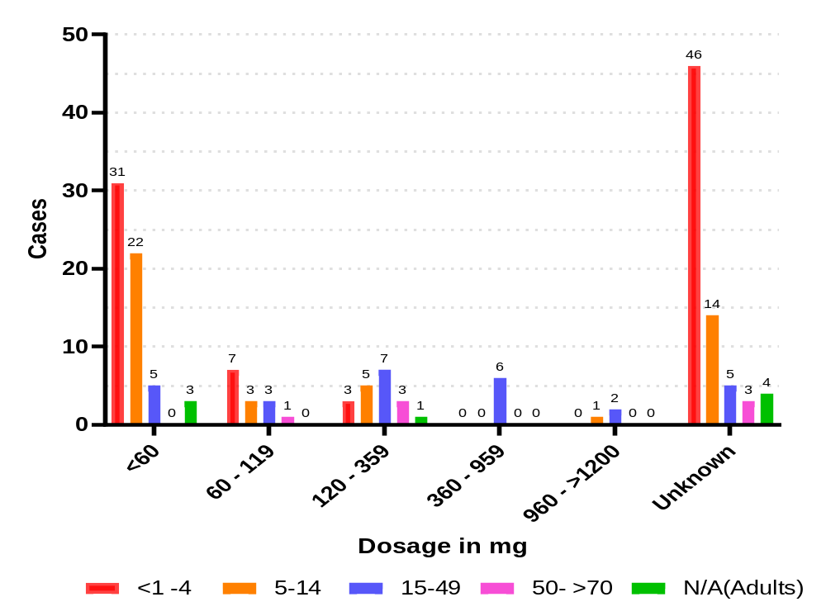
Fig. S15: Number of reported pseudoephedrine intoxication cases by dosage range in mg for age groups (absolute number) reported to PC Nord Göttingen.

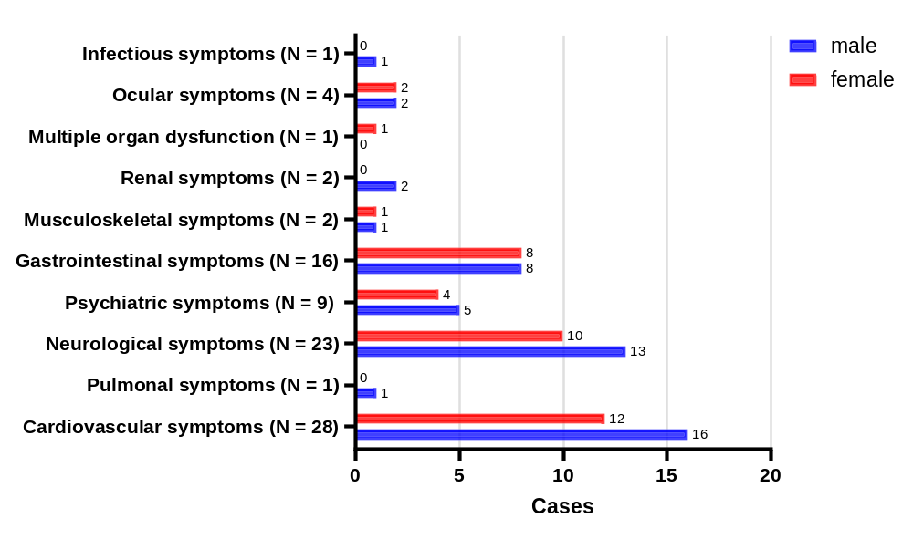
Figure S16: Absolute number of cases with specific symptoms by sex (PC Erfurt).

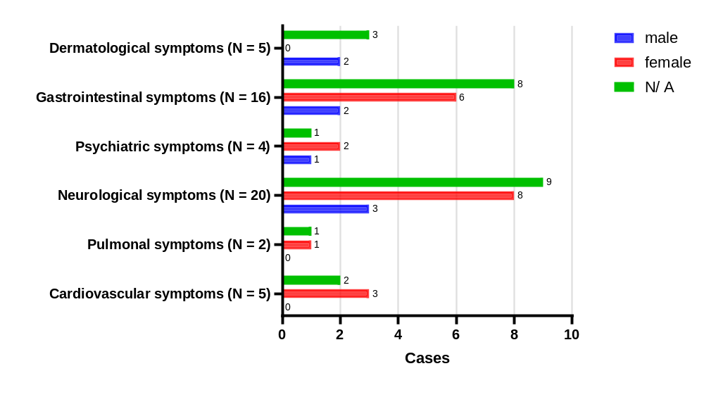
Figure S17: Absolute number of cases with specific symptoms by sex (MRI TUM).

Case Number | Sex | Age | Age Group | Call Year | Intake form | PSE dose (mg) | Co-Medic. | Clin. symptoms
1. | 1 | 4 | 0 | 2004 | oral | 30 | 4 | 6
2. | 1 | 39 | 3 | 2004 | oral |  | 1
3. | 1 | 2 | 0 | 2004 | oral |  | 4
4. | 0 | 3 | 0 | 2005 | oral | 60 | 1 | 5
5. | 2 | 24 | 3 | 2007 | oral | 180 | 1 | 1 (x2)
6. | 2 | 17 | 2 | 2008 | oral | 786 | 4
7. | 0 | 4 | 0 | 2008 | oral | <30 | 1
8. | 1 | 0 | 3 | 2008 | oral | 300 | 4 | 1, 5
9. | 1 | 20 | 3 | 2008 | oral | 600 | 4 | 1, 4
10. | 1 | 24 | 3 | 2009 | oral | 1080 | 4 | 6, 8
11. | 2 | 0 | 3 | 2009 | oral | 120 | 1
12. | 2 | 3 | 0 | 2009 | oral | 30 | 1 | 3
13. | 1 | 18 | 3 | 2009 | oral | 60 | 1
14. | 2 | 1,5 | 0 | 2009 | oral | <30 | 1
15. | 2 | 0 | 3 | 2009 | oral | 30 | 1 | 1
16. | 2 | 0 | 3 | 2010 | oral | 660 | 4
17. | 1 | 0 | 3 | 2010 | oral | 270 | 1 | 9
18. | 1 | 0 | 0 | 2010 | oral | 225 | 2, 5 | 3
19. | 1 | 3 | 0 | 2011 | oral | 300 | 4
20. | 2 | 0 | 3 | 2011 | oral | 30 | 1
21. | 2 | 16 | 2 | 2011 | oral | 240 | 2
22. | 1 | 3 | 0 | 2011 | oral |  | 2, 5 | 3, 4
23. | 2 | 25 | 3 | 2011 | oral | 120 | 1 | 3
24. | 1 | 0 | 3 | 2011 | oral | 30 | 1
25. | 1 | 29 | 3 | 2012 | oral | 300 | 1
26. | 2 | 2,5 | 0 | 2012 | oral | 3 | 1
27. | 2 | 1 | 0 | 2012 | oral | 6 | 1 | 4
28. | 1 | 2 | 0 | 2012 | oral |  | 1 | 5
29. | 2 | 18 | 3 | 2012 | oral |  | 1 | 3
30. | 2 | 40 | 3 | 2012 | oral | 1440 | 4
31. | 2 | 37 | 3 | 2012 | oral | 300 | 2, 4, 5
32. | 1 | 0 | 3 | 2013 | oral | 300 | 1
33. | 2 | 10 | 1 | 2013 | oral | 30 | 1
34. | 1 | 11 | 1 | 2013 | oral | 30 | 1
35. | 1 | 25 | 3 | 2013 | oral | 1440 | 4 | 1, 3
36. | 2 | 0 | 3 | 2013 | oral | 360 | 4
37. | 1 | 5 | 0 | 2013 | oral | 30 | 1
38. | 2 | 3,5 | 0 | 2014 | oral | 15 | 1
39. | 1 | 4 | 0 | 2014 | oral | 22,5 | 1 | 1
40. | 1 | 35 | 3 | 2014 | oral | 2400 | 4
41. | 1 | 10 | 1 | 2014 | oral | 30 | 1
42. | 1 | 0 | 3 | 2014 | oral | 720 | 4 | 1
43. | 1 | 36 | 3 | 2014 | oral | 180 | 3
44. | 2 | 41 | 3 | 2015 | oral | 180 | 3
45. | 1 | 0 | 4 | 2015 | oral | 60 | 1
46. | 2 | 26 | 3 | 2015 | oral | 600 | 2, 4, 5 | 5
47. | 1 | 19 | 3 | 2015 | oral | 30 | 1
48. | 2 | 15 | 2 | 2015 | oral | 60 | 3
49. | 2 | 16 | 2 | 2015 | oral | 360 | 2, 5
50. | 2 | 22 | 3 | 2015 | oral | 720 | 4 | 1 (x2), 3
51. | 1 | 24 | 3 | 2015 | oral | 1440 | 4 | 1
52. | 2 | 35 | 3 | 2016 | oral |  | 3 | 1, 4
53. | 2 | 28 | 3 | 2016 | oral | 300 | 3
54. | 2 | 14 | 2 | 2016 | oral | 60 | 1
55. | 1 | 0 | 3 | 2016 | oral | 120 | 4 | 1
56. | 1 | 19 | 3 | 2016 | oral | 300 | 3
57. | 2 | 18 | 3 | 2016 | oral | 240 | 3
58. | 2 | 19 | 3 | 2016 | oral | 600 | 3
59. | 1 | 33 | 3 | 2017 | oral |  | 2 | 5
60. | 1 | 3 | 0 | 2017 | oral | 30 | 3
61. | 1 | 29 | 3 | 2017 | oral | 60 | 1 | 3
62. | 2 | 36 | 3 | 2017 | oral | 300 | 3
63. | 2 | 15 | 2 | 2017 | oral | 180 | 4
64. | 2 | 11 | 1 | 2017 | oral | 30 | 1 | 3
65. | 2 | 41 | 3 | 2017 | oral | 450 | 1 | 3, 5
66. | 1 | 17 | 2 | 2017 | oral | 300 | 1
67. | 1 | 18 | 3 | 2017 | oral |  | 1
68. | 1 | 3 | 0 | 2017 | oral | 30 | 1
69. | 2 | 4 | 0 | 2017 | oral | 30 | 3 | 3, 5
70. | 1 | 62 | 3 | 2017 | oral | 240 | 1
71. | 1 | 5 | 0 | 2017 | oral | 30 | 1
72. | 1 | 9 | 1 | 2018 | oral | 30 | 3
73. | 2 | 2 | 0 | 2018 | oral | 30 | 1 | 1 (x2), 3, 4, 10
74. | 1 | 37 | 3 | 2018 | oral | 600 | 3 | 1, 5
75. | 2 | 52 | 3 | 2018 | oral | 420 | 3
76. | 1 | 15,5 | 2 | 2018 | oral | 30 | 1 | 1
77. | 2 | 30 | 3 | 2018 | oral | 1200 | 3
78. | 2 | 0 | 3 | 2018 | oral | 120 | 4 | 1, 2, 3
79. | 1 | 43 | 3 | 2018 | oral | 1200 | 4 | 7
80. | 1 | 40 | 3 | 2018 | oral | 600 | 1
81. | 2 | 1,08 | 0 | 2018 | oral | 30 | 1
82. | 1 | 34 | 3 | 2018 | oral | 180 | 2, 4
83. | 1 | 14 | 2 | 2018 | oral | 720 | 4 | 4
84. | 1 | 0 | 3 | 2019 | oral | 60 | 3
85. | 2 | 1,58 | 0 | 2019 | oral |  | 1
86. | 2 | 3 | 0 | 2019 | oral | 30 | 1
87. | 2 | 1,9 | 0 | 2019 | oral | 120 | 2, 5 | 1 (x2)
88. | 2 | 17 | 2 | 2019 | oral | 300 | 3
89. | 2 | 3 | 0 | 2019 | oral | 15 | 1 | 1 (x2), 3, 9
90. | 1 | 37 | 3 | 2019 | oral | 210 | 2, 5
91. | 1 | 0 | 3 | 2019 | oral |  | 4 | 3
92. | 2 | 32 | 3 | 2019 | oral | 180 | 1 | 1 (x2)
93. | 1 | 31 | 3 | 2019 | oral | 120 | 1 | 3,4
94. | 2 | 17 | 2 | 2020 | oral | 90 | 2 | 1 (x2), 3, 5, 9
95. | 2 | 18 | 3 | 2020 | oral | 420 | 3
96. | 1 | 2 | 0 | 2020 | oral | 240 | 4
97. | 1 | 2 | 0 | 2020 | oral | 7,5 | 1 | 3, 5
98. | 1 | 0 | 3 | 2021 | oral | 90 | 1 | 1, 3, 5
99. | 1 | 21 | 3 | 2021 | oral | 90 | 3
100. | 1 | 2,25 | 0 | 2021 | oral | 30 | 1 | 7
101. | 1 | 20 | 3 | 2021 | oral | 900 | 2, 4, 5 | 5
102. | 1 | 0 | 3 | 2022 | oral | 240 | 3
103. | 2 | 0 | 3 | 2022 | oral | 30 | 1
104. | 2 | 1 | 0 | 2022 | oral | 270 | 4
105. | 1 | 17 | 2 | 2022 | oral | 600 | 1
106. | 1 | 2 | 0 | 2022 | oral | 101,25 | 2, 6 | 3, 4
107. | 2 | 14 | 2 | 2022 | oral | 120 | 2 | 3, 4
108. | 1 | 15 | 2 | 2022 | oral | 120 | 2
109. | 1 | 38 | 3 | 2022 | oral | 720 | 2 | 5
110. | 2 | 8 | 1 | 2022 | oral | 30 | 1 | 3
111. | 2 | 44 | 3 | 2022 | oral | 750 | 0
112. | 2 | 5 | 0 | 2022 | oral | 15 | 1 | 1, 3
113. | 1 | 22 | 3 | 2022 | oral | 300 | 1
114. | 2 | 2,8 | 0 | 2023 | oral | 15 | 2
115. | 1 | 11,5 | 1 | 2023 | oral | 30 | 1
116. | 1 | 10 | 1 | 2023 | oral | 30 | 1
117. | 1 | 2 | 0 | 2023 | oral | 7,5 | 1
118. | 2 | 8 | 1 | 2023 | oral | 30 | 3
119. | 2 | 14 | 2 | 2023 | oral | 270 | 2
120. | 1 | 1,5 | 0 | 2023 | oral |  | 1
121. | 2 | 6 | 1 | 2023 | oral |  | 1
122. | 1 | 4 | 0 | 2023 | oral |  | 1
123. | 1 | 53 | 3 | 2023 | oral | 540 | 3
124. | 1 | 2 | 0 | 2023 | oral | 15 | 1
125. | 2 | 2 | 0 | 2024 | oral | 30 | 1
126. | 1 | 31 | 3 | 2024 | oral | 60 | 1 | 5, 9
127. | 2 | 14 | 2 | 2024 | oral | 300 | 3
128. | 2 | 32 | 3 | 2024 | oral | 210 | 2, 5
129. | 1 | 2 | 0 | 2024 | oral | 60 | 2, 4, 5
130. | 2 | 12 | 1 | 2024 | oral | 30 | 1 | 5
131. | 2 | 17 | 2 | 2024 | oral | 210 | 3
132. | 1 | 1,9 | 0 | 2024 | oral | 15 | 1 | 5
133. | 2 | 0 | 3 | 2024 | oral | 720 | 2
134. | 1 | 7,5 | 1 | 2024 | oral | 30 | 1
135. | 1 | 3 | 0 | 2024 | oral |  | 1
136. | 1 | 15 | 2 | 2024 | oral | 600 | 2

Tab. S1A Simplified overview of PSE-intoxications in PC GGIZ Erfurt

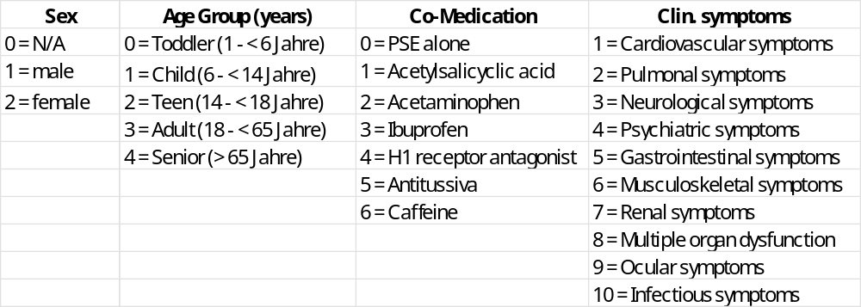
Tab S1B: Number code for categories used in Tab. 1A: Sex, Age, Age Group, Call Year, Intake form, PSE dose (mg), Co-Medication, Clinical symptoms

Case Number | Sex | Age group | Call Year | Intake form | Etiology | PSE dose (mg) | Co-Medic. | Clin. symptoms
1. | 0 | 2 | 2004 | 0 | 0 | 30 | 2
2. | 0 | 5 | 2006 | 0 | 1 | 30 | 1 | 5, 6
3. | 0 | 2 | 2007 | 0 | 0 |  | 1
4. | 0 | 5 | 2007 | 0 | 0 |  | 1 | 2
5. | 1 | 3 | 2008 | 0 | 0 | 30 | 1
6. | 1 | 5 | 2009 | 0 | 1 |  | 1 | 5
7. | 1 | 3 | 2010 | 0 | 0 | 30 | 1
8. | 2 | 2 | 2010 | 0 | 0 |  | 1
9. | 2 | 2 | 2010 | 1 | 0 |  | 1
10. | 2 | 5 | 2011 | 0 | 2 |  | 1 | 5
11. | 2 | 2 | 2011 | 0 | 0 |  | 1
12. | 0 | 2 | 2011 | 0 | 0 | 180 - 210 | 1
13. | 2 | 2 | 2012 | 0 | 0 |  | 1
14. | 1 | 2 | 2012 | 0 | 0 |  | 1
15. | 2 | 2 | 2012 | 0 | 0 | 15 | 1
16. | 2 | 0 | 2012 | 0 | 0 | 60 | 1
17. | 0 | 5 | 2012 | 0 | 3 | 90 | 1 | 3
18. | 1 | 5 | 2012 | 0 | 1 |  | 1
19. | 1 | 2 | 2013 | 0 | 0 | 15 | 1
20. | 2 | 3 | 2013 | 0 | 1 | 30 | 1
21. | 2 | 6 | 2014 | 0 | 3 | 270 | 2
22. | 1 | 5 | 2014 | 0 | 1 |  | 1 | 6
23. | 1 | 2 | 2014 | 0 | 0 | 30 | 1
24. | 0 | 7 | 2014 | 3 | 4 |  | 1
25. | 1 | 2 | 2014 | 0 | 0 |  | 1
26. | 1 | 2 | 2014 | 0 | 0 | 30 | 2
27. | 2 | 1 | 2014 | 0 | 0 |  | 1
28. | 1 | 5 | 2014 | 0 | 5 | 167 | 1
29. | 2 | 4 | 2014 | 0 | 6 | 20 | 1 | 3
30. | 1 | 5 | 2014 | 0 | 0 | 60 | 2
31. | 0 | 5 | 2015 | 0 | 2 | 60 | 1 | 5
32. | 2 | 2 | 2015 | 0 | 0 |  | 1 | 5
33. | 2 | 4 | 2015 | 0 | 1 | 90 | 1 | 3, 4
34. | 1 | 2 | 2015 | 0 | 0 | 30 | 1
35. | 2 | 5 | 2015 | 0 | 0 | 120 | 1 | 3, 5
36. | 1 | 3 | 2015 | 0 | 0 |  | 1
37. | 2 | 2 | 2015 | 0 | 0 |  | 1
38. | 1 | 2 | 2015 | 0 | 0 |  | 1
39. | 1 | 2 | 2015 | 0 | 0 |  | 1
40. | 1 | 2 | 2015 | 0 | 0 |  | 2
41. | 2 | 2 | 2015 | 0 | 0 | 8,35 | 1
42. | 0 | 2 | 2016 | 0 | 0 |  | 1
43. | 2 | 2 | 2016 | 0 | 0 |  | 1
44. | 1 | 2 | 2016 | 0 | 0 | 15 | 2
45. | 0 | 2 | 2016 | 0 | 0 |  | 2
46. | 1 | 2 | 2016 | 0 | 0 |  | 1
47. | 0 | 1 | 2016 | 0 | 0 |  | 1 | 4, 6
48. | 1 | 3 | 2016 | 0 | 0 | 30 | 1
49. | 2 | 2 | 2016 | 0 | 0 |  | 2
50. | 2 | 5 | 2016 | 0 | 2 | 300 | 2
51. | 1 | 3 | 2016 | 0 | 0 |  | 1
52. | 1 | 2 | 2016 | 0 | 0 | 30 | 1
53. | 1 | 2 | 2016 | 0 | 0 |  | 1
54. | 1 | 1 | 2016 | 0 | 0 | 90 | 1
55. | 2 | 2 | 2016 | 0 | 0 | 8,35 | 1
56. | 1 | 2 | 2016 | 0 | 0 | 30 | 1
57. | 1 | 3 | 2017 | 0 | 0 |  | 1
58. | 2 | 5 | 2017 | 0 | 3 | 720 | 2
59. | 0 | 2 | 2017 | 0 | 0 | 60 | 2
60. | 1 | 5 | 2017 | 0 | 0 | 60 | 1
61. | 2 | 2 | 2017 | 0 | 0 |  | 1
62. | 1 | 1 | 2017 | 2 | 0 |  | 1
63. | 2 | 2 | 2017 | 0 | 0 | 8,35 | 1
64. | 2 | 5 | 2017 | 0 | 1 | 90 | 1 | 3
65. | 1 | 5 | 2017 | 0 | 0 |  | 2 | 3
66. | 1 | 1 | 2017 | 2 | 0 | 90 | 1
67. | 1 | 2 | 2017 | 0 | 0 |  | 1
68. | 2 | 2 | 2017 | 0 | 0 |  | 1
69. | 2 | 2 | 2017 | 0 | 0 |  | 1
70. | 2 | 1 | 2017 | 0 | 0 |  | 1
71. | 2 | 5 | 2017 | 0 | 2 |  | 2
72. | 2 | 2 | 2017 | 0 | 0 |  | 1
73. | 0 | 5 | 2017 | 0 | 2 | 300 | 2
74. | 1 | 2 | 2017 | 0 | 0 | 30 | 2
75. | 2 | 2 | 2018 | 0 | 0 |  | 1
76. | 2 | 2 | 2018 | 0 | 0 |  | 1
77. | 2 | 2 | 2018 | 0 | 0 |  | 1
78. | 1 | 5 | 2018 | 0 | 0 | 30 | 1
79. | 1 | 5 | 2018 | 0 | 0 |  | 1
80. | 0 | 5 | 2018 | 0 | 2 | 24 | 2 | 5, 6
81. | 0 | 2 | 2018 | 0 | 0 | 30 | 2
82. | 0 | 2 | 2018 | 0 | 0 | 30 | 2
83. | 1 | 3 | 2018 | 0 | 0 |  | 1
84. | 1 | 2 | 2018 | 0 | 0 |  | 1
85. | 0 | 5 | 2018 | 0 | 3 | 660 | 1 | 3
86. | 2 | 2 | 2018 | 0 | 0 | 30 | 2
87. | 0 | 3 | 2018 | 0 | 0 | 30 | 1
88. | 1 | 4 | 2018 | 0 | 2 | 300 | 2
89. | 1 | 2 | 2018 | 0 | 0 | 30 | 1
90. | 0 | 7 | 2018 | 0 | 0 | 8,35 | 1
91. | 0 | 2 | 2018 | 0 | 0 |  | 2
92. | 1 | 5 | 2018 | 0 | 0 |  | 2
93. | 2 | 5 | 2018 | 0 | 1 | 4,8 | 2 | 3, 5
94. | 2 | 5 | 2018 | 0 | 0 | 30 | 2
95. | 1 | 2 | 2019 | 0 | 0 |  | 1
96. | 0 | 7 | 2019 | 3 | 4 |  | 1
97. | 2 | 5 | 2019 | 0 | 2 |  | 1 | 1, 3
98. | 0 | 5 | 2019 | 0 | 2 | 24 | 2 | 3
99. | 1 | 2 | 2019 | 0 | 0 | 0,67 | 1
100. | 2 | 4 | 2019 | 0 | 2 | 480 | 2
101. | 2 | 5 | 2019 | 0 | 0 |  | 2 | 3
102. | 2 | 4 | 2019 | 0 | 2 | 240 | 2 | 1
103. | 2 | 5 | 2019 | 4 | 0 |  | 1 | 2
104. | 0 | 2 | 2019 | 0 | 0 | 30 | 2
105. | 2 | 4 | 2019 | 0 | 0 | 300 | 2 | 5
106. | 0 | 5 | 2019 | 0 | 2 | 450 | 2
107. | 2 | 5 | 2019 | 0 | 2 | 450 | 2 | 1, 4
108. | 1 | 5 | 2019 | 0 | 0 | 180 | 1
109. | 2 | 5 | 2019 | 0 | 2 |  | 2 | 3, 5
110. | 2 | 5 | 2019 | 0 | 0 | 60 | 1
111. | 2 | 2 | 2019 | 0 | 0 |  | 1
112. | 1 | 2 | 2019 | 0 | 0 | 30 | 1
113. | 2 | 5 | 2019 | 0 | 2 | 90 | 1
114. | 2 | 5 | 2019 | 0 | 0 | 90 | 2
115. | 1 | 5 | 2020 | 0 | 0 | 60-90 | 2
116. | 0 | 2 | 2020 | 0 | 0 | 120 | 2
117. | 1 | 2 | 2020 | 0 | 0 |  | 1
118. | 2 | 5 | 2020 | 0 | 0 |  | 1
119. | 2 | 3 | 2020 | 0 | 0 |  | 1
120. | 2 | 3 | 2020 | 0 | 0 |  | 1
121. | 1 | 5 | 2020 | 0 | 3 | 120 | 3 | 6
122. | 0 | 5 | 2020 | 0 | 2 |  | 2 | 3
123. | 1 | 2 | 2020 | 0 | 0 |  | 1
124. | 2 | 5 | 2020 | 0 | 2 |  | 2
125. | 1 | 2 | 2020 | 0 | 0 |  | 1
126. | 1 | 3 | 2020 | 0 | 0 |  | 1
127. | 2 | 1 | 2020 | 0 | 0 |  | 1
128. | 2 | 2 | 2020 | 0 | 0 |  | 1
129. | 0 | 5 | 2020 | 0 | 2 | 510 | 1 | 3
130. | 2 | 3 | 2020 | 0 | 0 |  | 1
131. | 1 | 2 | 2020 | 0 | 0 |  | 1
132. | 1 | 2 | 2020 | 1 | 0 |  | 1
133. | 1 | 2 | 2021 | 1 | 0 | 60 | 3
134. | 0 | 5 | 2021 | 0 | 1 |  | 2 | 3
135. | 2 | 2 | 2021 | 0 | 0 |  | 1
136. | 0 | 5 | 2021 | 0 | 1 |  | 1 | 5
137. | 0 | 3 | 2021 | 0 | 0 | 60 | 1 | 5
138. | 2 | 2 | 2021 | 0 | 0 |  | 1
139. | 0 | 7 | 2021 | 3 | 4 |  | 1
140. | 0 | 4 | 2021 | 0 | 3 | 90 | 2 | 5
141. | 0 | 2 | 2021 | 0 | 0 |  | 1 | 5
142. | 1 | 2 | 2022 | 0 | 0 |  | 1
143. | 0 | 7 | 2022 | 3 | 4 |  | 1
144. | 1 | 2 | 2022 | 0 | 0 |  | 1
145. | 1 | 3 | 2022 | 0 | 0 |  | 1
146. | 2 | 2 | 2022 | 0 | 0 |  | 1
147. | 1 | 2 | 2022 | 0 | 0 |  | 3
148. | 0 | 5 | 2022 | 0 | 5 |  | 1 | 3
149. | 2 | 2 | 2022 | 0 | 0 |  | 1
150. | 1 | 2 | 2022 | 0 | 0 |  | 3
151. | 1 | 5 | 2023 | 0 | 5 | 480 | 3 | 3
152. | 1 | 5 | 2023 | 0 | 5 |  | 1 | 4
153. | 2 | 2 | 2023 | 0 | 0 |  | 3
154. | 1 | 2 | 2023 | 0 | 0 | 120 | 2
155. | 2 | 2 | 2023 | 0 | 0 |  | 3
156. | 2 | 4 | 2023 | 0 | 3 | 960 | 3
157. | 0 | 5 | 2023 | 0 | 0 |  | 2 | 1, 3, 5
158. | 0 | 5 | 2023 | 0 | 2 |  | 1
159. | 2 | 2 | 2023 | 0 | 0 |  | 1
160. | 0 | 7 | 2023 | 3 | 4 |  | 1
161. | 1 | 5 | 2023 | 0 | 0 |  | 3
162. | 1 | 2 | 2023 | 0 | 0 |  | 1
163. | 1 | 7 | 2023 | 0 | 0 |  | 2
164. | 1 | 5 | 2023 | 0 | 5 | 30 | 1 | 3, 5
165. | 0 | 2 | 2023 | 0 | 0 | 90 | 2
166. | 0 | 7 | 2023 | 3 | 4 |  | 1
167. | 2 | 2 | 2023 | 0 | 0 |  | 1
168. | 1 | 2 | 2024 | 0 | 0 |  | 1
169. | 1 | 2 | 2024 | 0 | 0 |  | 1
170. | 0 | 5 | 2024 | 0 | 0 | 120 | 1 | 1
171. | 1 | 2 | 2024 | 0 | 0 |  | 1
172. | 2 | 3 | 2024 | 0 | 0 | 30 | 1
173. | 2 | 2 | 2024 | 0 | 0 |  | 2
174. | 0 | 7 | 2024 | 3 | 4 |  | 1
175. | 2 | 2 | 2024 | 0 | 0 | 30 | 2
176. | 0 | 5 | 2024 | 1 | 2 | 300 | 1 | 3
177. | 2 | 2 | 2024 | 0 | 0 |  | 1
178. | 2 | 5 | 2024 | 0 | 0 | 60 | 1
179. | 2 | 2 | 2024 | 0 | 0 |  | 1
180. | 2 | 2 | 2024 | 0 | 0 |  | 1
181. | 1 | 2 | 2024 | 0 | 0 |  | 1
182. | 1 | 2 | 2024 | 0 | 0 |  | 3
183. | 1 | 2 | 2024 | 0 | 0 |  | 1
184. | 0 | 5 | 2024 | 0 | 2 | 1860 | 3
185. | 0 | 5 | 2024 | 0 | 2 | 1860 | 3
186. | 2 | 3 | 2024 | 0 | 0 | 30 | 1
187. | 2 | 4 | 2024 | 0 | 0 | 30 | 1
188. | 2 | 2 | 2024 | 0 | 0 |  | 3
189. | 0 | 2 | 2024 | 0 | 0 |  | 1
190. | 2 | 2 | 2024 | 0 | 0 |  | 1
191. | 1 | 2 | 2024 | 0 | 0 |  | 3
192. | 2 | 2 | 2024 | 0 | 0 |  | 1
193. | 0 | 7 | 2024 | 3 | 4 |  | 1
194. | 2 | 2 | 2024 | 0 | 0 |  | 1
195. | 2 | 5 | 2024 | 0 | 0 | 30 | 1
196. | 1 | 7 | 2008 | 0 | 0 |  | 4
197. | 1 | 7 | 2008 | 0 | 0 | 240 - 360 | 4
198. | 2 | 7 | 2008 | 0 | 2 | 1680 | 4
199. | 1 | 7 | 2009 | 0 | 0 | 240 - 600 | 4
200. | 2 | 7 | 2009 | 0 | 0 | 20 | 4
201. | 1 | 7 | 2010 | 0 | 0 |  | 4
202. | 2 | 7 | 2010 | 0 | 0 |  | 4
203. | 2 | 7 | 2011 | 0 | 0 |  | 4
204. | 1 | 7 | 2013 | 0 | 6 | 600 | 4
205. | 1 | 7 | 2015 | 0 | 5 | 360 | 4
206. | 1 | 7 | 2015 | 0 | 5 | 720 | 4
207. | 1 | 7 | 2017 | 0 | 0 |  | 4
208. | 1 | 7 | 2018 | 0 | 0 | 120 | 4
209. | 0 | 7 | 2019 | 3 | 4 |  | 4
210. | 0 | 7 | 2020 | 0 | 0 |  | 4
Tab. S2A Simplified overview of PSE-intoxications in PC MRI-TUM

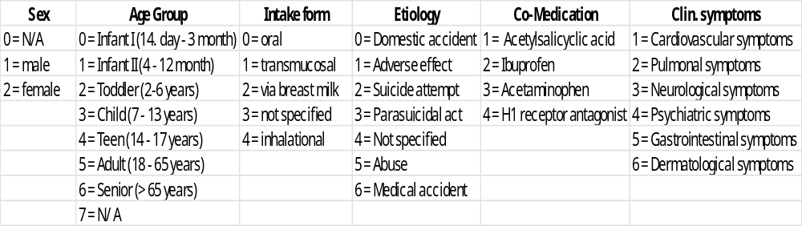
Tab S2B: Number code for categories used in Tab. 1A: Sex, Age Group, Call Year, Intake form, Etiology, PSE dose (mg), Co-Medication, Clinical symptoms

Case Number | Sex | Age group | Call Year | Intake form | PSE dose (mg) | Co-Medic.
1. | 1 | 3 | 2023 | 0 |  | 1
2. | 1 | 3 | 2023 | 0 |  | 1
3. | 2 | 2 | 2023 | 0 |  | 1
4. | 2 | 5 | 2023 | 0 |  | 1
5. | 2 | 0 | 2023 | 0 | 30 | 1
6. | 2 | 5 | 2023 | 0 |  | 1
7. | 1 | 1 | 2023 | 0 |  | 1
8. | 2 | 1 | 2023 | 0 | 15 | 1
9. | 1 | 2 | 2023 | 0 |  | 1
10. | 1 | 5 | 2023 | 0 | 30 | 1
11. | 2 | 2 | 2023 | 0 | 30 | 1
12. | 2 | 5 | 2023 | 0 |  | 1
13. | 2 | 1 | 2022 | 0 | 15 | 1
14. | 2 | 8 | 2022 | 0 |  | 1
15. | 1 | 2 | 2022 | 0 | 15 | 1
16. | 1 | 1 | 2022 | 0 |  | 1
17. | 1 | 1 | 2022 | 0 |  | 1
18. | 1 | 2 | 2022 | 0 | 30 | 1
19. | 2 | 8 | 2022 | 0 |  | 1
20. | 1 | 3 | 2022 | 0 | 30 | 1
21. | 1 | 2 | 2022 | 0 |  | 1
22. | 1 | 1 | 2022 | 0 |  | 1
23. | 0 | 8 | 2021 | 0 |  | 1
24. | 1 | 1 | 2021 | 0 |  | 1
25. | 0 | 1 | 2021 | 0 | 30 | 1
26. | 1 | 1 | 2021 | 0 | 30 | 1
27. | 2 | 5 | 2021 | 0 |  | 1
28. | 2 | 2 | 2021 | 0 | 30 | 1
29. | 2 | 0 | 2021 | 0 | 60 | 1
30. | 2 | 1 | 2021 | 0 | 30 | 1
31. | 1 | 1 | 2021 | 0 |  | 1
32. | 1 | 1 | 2021 | 0 |  | 1
33. | 2 | 3 | 2021 | 0 | 15 | 1
34. | 1 | 1 | 2021 | 0 |  | 1
35. | 1 | 1 | 2021 | 0 |  | 1
36. | 1 | 1 | 2021 | 0 | 15 | 1
37. | 1 | 1 | 2020 | 0 | 60 | 1
38. | 2 | 2 | 2020 | 0 |  | 1
39. | 1 | 3 | 2020 | 0 | 30 | 1
40. | 2 | 3 | 2020 | 0 | 60 | 1
41. | 2 | 3 | 2020 | 0 | 60 | 1
42. | 1 | 3 | 2020 | 0 | 15 | 1
43. | 2 | 1 | 2020 | 0 |  | 1
44. | 1 | 1 | 2020 | 0 |  | 1
45. | 1 | 1 | 2020 | 0 | 30 | 1
46. | 1 | 4 | 2020 | 0 | 18 | 1
47. | 2 | 1 | 2019 | 0 |  | 1
48. | 2 | 1 | 2019 | 0 |  | 1
49. | 1 | 1 | 2019 | 0 |  | 1
50. | 2 | 1 | 2019 | 0 |  | 1
51. | 2 | 1 | 2019 | 0 |  | 1
52. | 1 | 1 | 2019 | 0 | 60 | 1
53. | 1 | 1 | 2019 | 0 |  | 1
54. | 1 | 1 | 2019 | 0 | 30 | 1
55. | 1 | 1 | 2019 | 0 |  | 1
56. | 1 | 1 | 2019 | 0 | 30 | 1
57. | 1 | 5 | 2019 | 0 | 540 | 1
58. | 2 | 3 | 2019 | 0 | 30 | 1
59. | 1 | 3 | 2019 | 0 | 30 | 1
60. | 2 | 3 | 2019 | 0 | 180 | 1
61. | 2 | 1 | 2019 | 0 | 30 | 1
62. | 1 | 8 | 2019 | 0 | 30 | 1
63. | 1 | 1 | 2018 | 0 | 15 | 1
64. | 1 | 1 | 2018 | 0 | 30 | 1
65. | 1 | 1 | 2018 | 0 |  | 1
66. | 1 | 0 | 2018 | 0 |  | 1
67. | 2 | 1 | 2018 | 0 | 7,5 | 1
68. | 2 | 1 | 2018 | 0 | 210 | 1
69. | 2 | 1 | 2018 | 0 | 7,5 | 1
70. | 1 | 1 | 2018 | 0 |  | 1
71. | 1 | 1 | 2018 | 0 |  | 1
72. | 2 | 3 | 2018 | 0 | 30 | 1
73. | 1 | 2 | 2017 | 0 |  | 1
74. | 1 | 1 | 2017 | 0 |  | 1
75. | 1 | 1 | 2017 | 0 | 15 | 1
76. | 2 | 1 | 2017 | 0 |  | 1
77. | 2 | 1 | 2017 | 0 |  | 1
78. | 2 | 1 | 2017 | 0 | 15 | 1
79. | 1 | 1 | 2017 | 0 |  | 1
80. | 2 | 1 | 2017 | 0 | 30 | 1
81. | 2 | 1 | 2017 | 0 |  | 1
82. | 2 | 5 | 2017 | 0 | 30 | 1
83. | 1 | 3 | 2017 | 0 | 30 | 1
84. | 1 | 1 | 2017 | 0 |  | 1
85. | 1 | 1 | 2017 | 0 | 30 | 1
86. | 1 | 2 | 2016 | 0 | 15 | 1
87. | 2 | 1 | 2016 | 0 | 15 | 1
88. | 1 | 1 | 2016 | 0 |  | 1
89. | 1 | 4 | 2016 | 0 | 60 | 1
90. | 1 | 2 | 2016 | 0 |  | 1
91. | 1 | 1 | 2016 | 0 |  | 1
92. | 2 | 4 | 2016 | 0 | 30 | 1
93. | 1 | 2 | 2016 | 0 |  | 1
94. | 2 | 3 | 2016 | 0 | 30 | 1
95. | 1 | 1 | 2016 | 0 |  | 1
96. | 2 | 2 | 2016 | 0 | 30 | 1
97. | 2 | 1 | 2015 | 1 |  | 1
98. | 2 | 1 | 2015 | 0 | 30 | 1
99. | 1 | 1 | 2015 | 0 |  | 1
100. | 1 | 5 | 2015 | 0 | 30 | 1
101. | 2 | 1 | 2015 | 0 |  | 1
102. | 1 | 1 | 2015 | 0 |  | 1
103. | 1 | 2 | 2015 | 0 |  | 1
104. | 1 | 1 | 2015 | 0 |  | 1
105. | 1 | 6 | 2015 | 0 | 60 | 1
106. | 1 | 2 | 2015 | 0 | 30 | 1
107. | 1 | 1 | 2014 | 0 | 30 | 1
108. | 1 | 1 | 2014 | 0 | 15 | 1
109. | 2 | 5 | 2014 | 0 | 420 | 1
110. | 1 | 2 | 2014 | 0 | 30 | 1
111. | 1 | 3 | 2014 | 0 | 120 | 1
112. | 1 | 0 | 2013 | 0 | 90 | 1
113. | 0 | 1 | 2013 | 0 | 30 | 1
114. | 1 | 8 | 2013 | 0 | 24 | 1
115. | 1 | 1 | 2013 | 0 |  | 1
116. | 2 | 5 | 2006 | 0 |  | 1
117. | 2 | 1 | 2013 | 0 | 15 | 1
118. | 1 | 1 | 2012 | 0 |  | 1
119. | 2 | 5 | 2012 | 0 | 240 | 1
120. | 2 | 2 | 2012 | 0 | 30 | 1
121. | 1 | 1 | 2012 | 0 |  | 1
122. | 2 | 1 | 2011 | 0 | 15 | 1
123. | 2 | 2 | 2011 | 0 | 30 | 1
124. | 1 | 2 | 2011 | 0 | 30 | 1
125. | 1 | 3 | 2011 | 0 |  | 1
126. | 2 | 2 | 2011 | 0 |  | 1
127. | 1 | 1 | 2010 | 0 |  | 1
128. | 2 | 6 | 2010 | 0 | 120 | 1
129. | 2 | 2 | 2010 | 0 |  | 1
130. | 1 | 8 | 2010 | 0 | 300 | 1
131. | 2 | 4 | 2009 | 0 | 240 | 1
132. | 0 | 1 | 2008 | 0 |  | 1
133. | 2 | 1 | 2008 | 0 |  | 1
134. | 2 | 3 | 2007 | 0 | 30 | 1
135. | 1 | 7 | 2022 | 0 |  | 4
136. | 2 | 1 | 2023 | 0 | 15 | 2
137. | 2 | 5 | 2023 | 0 | 90 | 2
138. | 2 | 5 | 2022 | 0 | 390 | 2
139. | 2 | 2 | 2022 | 0 |  | 2
140. | 1 | 1 | 2020 | 0 |  | 2
141. | 2 | 5 | 2019 | 0 | 240 | 2
142. | 1 | 2 | 2019 | 0 | 300 | 2
143. | 1 | 1 | 2019 | 0 | 30 | 2
144. | 2 | 4 | 2018 | 0 | 480 | 2
145. | 2 | 2 | 2018 | 0 | 180 | 2
146. | 2 | 5 | 2018 | 0 | 240 | 2
147. | 2 | 3 | 2018 | 0 | 1800 | 2
148. | 1 | 1 | 2018 | 0 | 30 | 2
149. | 2 | 1 | 2018 | 0 | 30 | 2
150. | 2 | 3 | 2016 | 0 | 30 | 2
151. | 1 | 8 | 2016 | 0 | 30 | 2
152. | 2 | 4 | 2015 | 0 | 90 | 2
153. | 1 | 1 | 2015 | 0 | 7,5 | 2
154. | 2 | 5 | 2015 | 0 | 600 | 2
155. | 1 | 4 | 2014 | 0 | 150 | 2
156. | 2 | 5 | 2013 | 0 | 900 | 2
157. | 2 | 8 | 2023 | 0 |  | 3
158. | 1 | 5 | 2023 | 0 | 1200 | 3
159. | 2 | 1 | 2023 | 0 |  | 3
160. | 2 | 1 | 2023 | 0 | 60 | 3
161. | 2 | 1 | 2023 | 0 |  | 3
162. | 1 | 1 | 2022 | 0 | 180-240 | 3
163. | 2 | 5 | 2022 | 0 | 1200 | 3
164. | 1 | 1 | 2022 | 0 | 60 | 3
165. | 2 | 6 | 2022 | 0 |  | 3
166. | 1 | 2 | 2022 | 0 | 60 | 3
167. | 1 | 1 | 2021 | 0 |  | 3
168. | 2 | 5 | 2021 | 0 | 300-360 | 3
169. | 2 | 6 | 2021 | 0 | 240 | 3
170. | 1 | 1 | 2004 | 0 | 300 | 3
171. | 2 | 3 | 2020 | 0 | 300 | 3
172. | 2 | 4 | 2019 | 0 | 300 | 3
173. | 1 | 6 | 2014 | 0 |  | 3
174. | 1 | 1 | 2011 | 0 | 60 | 3
175. | 2 | 6 | 2011 | oral | 150-300 | 3

Tab. S3A Simplified overview of PSE-intoxications in PC Nord Göttingen

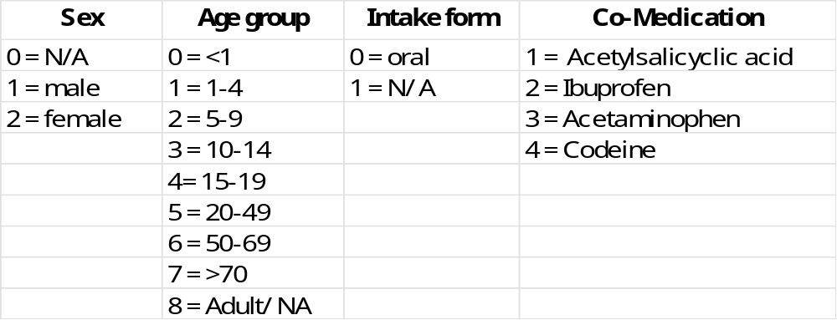

Tab. S3B: Number code for categories used in Tab. 1A: Sex, Age Group, Call Year, Intake form, PSE dose (mg), Co-Medication

