Supplementary Materials
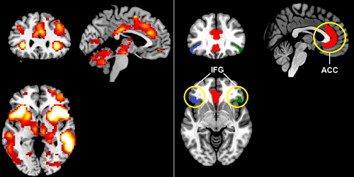
a
b
Supplementary Figure 1: a) Significant pattern of task-induced activation for successful inhibitions (p<0.05, Family-wise error) b) Region of interest masks, defined by Neuromorphometrics, Inc. (www.neuromorphometrics.com), under academic subscription, including the anterior cingulate cortex (ACC), rightand left inferior frontal gyri (IFG).

