Supplementary Results

Body weight significantly differed between men and women (F(1,72) = 30.8, p < 0.001), so this was included as a co-variate in the following analyses, though it did not significantly influence any behavioral or subjective outcome measure. As we used a standard dose (20mg), on average, men received a dose of 0.88 mg/kg and women received a dose of 0.90 mg/kg.

MID task results (RM-ANOVA)
To analyze behavioral data in the MID task, we used a 5 (trial type; high gain, low gain, no incentive, low loss, high loss) x 2 (drug; MA, PBO) RM-ANOVA. It revealed main effects of trial type (F(4,284) = 30.3, p < 0.001), drug (F(1,71) = 12.1, p = 0.001), and gender (F(1,71) = 6.53, p = 0.013), and a drug*gender interaction (F(1,71) = 7.11, p = 0.009). Overall, women had longer reaction times than men at the PBO session (effect of gender: p = 0.002) but there was no difference in reaction times on MA (effect of gender: p = 0.13). In women, MA reduced reaction times to high gain (p = 0.016), low gain (p = 0.001), low loss (p = 0.001), and high loss (p = 0.021) cues, but not no incentive cues (p = 0.060). MA did not influence responses to any cues for men (high gain, p = 0.086; low gain, p = 0.17; no incentive, p = 0.96; low loss, p = 0.96; high loss, p = 0.44). Body weight (p = 0.30) and BMI (p = 0.51) were not a significant co-variates.

Subjective and Cardiovascular Measures (N = 73)
POMS: MA produced the expected stimulant-like effects on the Profile of Mood States (POMS). We found the expected main effects of drug (F(1,71) = 57.6 p < 0.001) and scale (F(7,504) = 2.49, p = 0.016), as well as drug*scale (F(7,497 = 28.8, p < 0.001) and drug*scale*gender (F(7,497) = 4.09, p < 0.001) interactions. MA increased ratings of Friendliness (p < 0.001), Elation (p < 0.001), and Vigor (p < 0.001), and reduced Fatigue (p < 0.001). There was a significant drug*gender interaction for the POMS Vigor scale (p = 0.009) such that women reported a greater increase in vigor than men. We also found and a marginal drug*gender interaction effect on Friendliness such that women reported a greater MA-induced increase in Friendliness than men (p = 0.041), but this did not remain significant after correcting for multiple comparisons.
ARCI: There was a main effect of drug (F(1,71) = 116, p < 0.001), scale (F(5,355) = 22.8, p < 0.001), as well as drug*scale (F(5,355) = 60.6, p < 0.001) and drug*scale*gender (F(5,355) = 3.14, p = 0.009) interaction. In particular, MA increase the ARCI A (Amphetamine/stimulant-effects; p < 0.001), MBG (Morphine-Benzedrine Group; euphoric effects; p < 0.001), LSD (Lysergic Acid diethylamide; p = 0.014), BG (Benzedrine Group; p < 0.001) and M (Marijuana; p < 0.001) scales and reduced ratings on the PCAG (Pentobarbital, Chlorpromazine, and Alcohol Group; sedative effects; p < 0.001) scale. There was a significant drug*gender interaction (p = 0.011) such that females reported a greater reduction in sedative-like effects than men.
DEQ: There was a main effect of drug (F(1,71) = 197, p < 0.001), scale (F(4,284) = 24.8, p < 0.001) and a scale*drug interaction (F(4,284) = 41.4, p < 0.001). MA increased DEQ ratings of “Feel Drug” (p < 0.001), “Like Effects” (p < 0.001), “Feel High” (p < 0.001), and “Want More” (p < 0.001). There was no interaction with gender for any factor (drug*gender, p = 0.073; scale*gender, p = 0.48; scale*drug*gender, p = 0.98).
Cardiovascular effects: MA increased heart rate (F(1,72) = 56.4, p < 0.001), but there was no effect of gender (p = 0.33) or gender*drug interaction (p = 0.73). MA also increased blood pressure (calculated as mean arterial pressure; F(1,71) = 140, p < 0.001). There was no drug*gender interaction (p = 0.82), but there was an effect of gender (F(1,71) = 5.01, p = 0.028) such that men had lower mean arterial pressure across both sessions.

Subjective Effects (N = 90)
We verified that these effects remained when including the full study sample (n = 90), to ensure that the gender differences were not a consequence of removing subjects without complete behavioral data.
POMS: We found main effects of drug (F(1,88) = 84.6, p < 0.001) and scale (F(7, 616) = 2.48, p = 0.016), as well as significant interactions: drug*gender (F(1,88) = 4.30, p = 0.041; drug*scale (F(7,616) = 43.6, p < 0.001); drug*scale*gender (F(7,616) = 7.95, p < 0.001). As before, MA increased Friendliness (p < 0.001), Elation (p < 0.001), and Vigor (p < 0.001) and reduced Confusion (p < 0.01) and Fatigue (p < 0.001). With this larger sample size, we also detected significant gender*drug interactions such that women reported more Vigor (p = 0.001), Friendliness (p = 0.010), and Elation (p = 0.013), and less Fatigue (p = 0.030), Confusion (p = 0.030), and Depression (p = 0.032) as compared to men.
ARCI: We found main effects of drug (F(1, 88) = 130, p < 0.001) and scale (F(5,440) = 24.7), p < 0.001) and interactions between drug*scale (F(5,440) = 74.4, p < 0.001) and drug*scale*gender (F(5,440) = 5.71, p < 0.001), but not drug*gender (p = 0.62) or scale*gender (p = 0.78). MA influenced ratings on the A (p < 0.001), MBG (p < 0.001), LSD (p = 0.029), BG (p < 0.001), PCAG (p < 0.001), and M (p < 0.001) scales. There was a drug*gender interaction for PCAG (p = 0.001), ARCI-A (p = 0.041), and BG (p = 0.048) scales, such that women reported greater ratings on the A and BG scales, and less on the PCAG (sedative-like) scale.
DEQ: There were main effects of drug (F(1,88) = 215, p < 0.001) and scale (F(4,352) = 33.8, p < 0.001) and a drug*scale interaction (F(4,352) = 50.8, p < 0.001). MA increased ratings of “Feel Drug” (p < 0.001), “Like Effects” (p < 0.001), “Feel High” (p < 0.001), and “Want More” (p < 0.001). There were no other interaction effects (drug*gender, p = 0.13; scale*gender, p = 0.21; drug*scale*gender, p = 0.92).
Cardiovascular effects. MA significantly increased heart rate (F(1,88) = 71.5, p < 0.001) but there was no effect of gender (p = 0.11) or gender*drug interaction (p = 0.73). MA also increased mean arterial blood pressure (F(1,89) = 58.0, p < 0.001). There was a main effect of gender (p = 0.011) such that men had lower MAP overall, but this was not affected by drug (drug*gender interaction: p = 0.29).

 | Overall (N = 90) |  |  | Males (N = 50) |  |  | Females (N = 40)
 | PBO | MA |  | PBO | MA |  | PBO | MA
POMS
Friendly | -1.88 (3.57) | 1.65 (4.71)*# |  | -1.29 (2.89) | 0.93 (4.42) |  | -2.61 (4.20) | 2.55 (4.95)
Anxious | -0.16 (1.69) | 0.53 (2.81) |  | -0.05 (1.82) | 0.88 (2.65) |  | -0.30 (1.52) | 0.10 (2.96)
Elation | -1.23 (2.68) | 2.64 (3.50)*# |  | -0.81 (2.48) | 2.09 (3.28) |  | -1.76 (2.86) | 3.34 (3.67)
Anger | -0.22 (1.77) | -0.32 (1.37) |  | -0.01 (1.92) | -0.12 (1.34) |  | -0.48 (1.55) | -0.56 (1.38)
Fatigue | 1.16 (2.90) | -1.01 (2.83)*# |  | 0.54 (2.68) | -0.67 (2.58) |  | 1.94 (3.00) | -1.43 (3.09)
Depression | -0.28 (1.82) | -0.52 (2.07)# |  | -0.38 (2.08) | -0.15 (1.86) |  | -0.15 (1.44) | -0.99 (2.24)
Confusion | 0.54 (2.09) | -0.21 (1.84)*# |  | 0.16 (1.97) | -0.06 (1.73) |  | 1.01 (2.17) | -0.41 (1.99)
Vigor | -2.25 (3.42) | 2.81 (5.34)*# |  | -1.52 (3.34) | 1.60 (4.479 |  | -3.16 (3.34) | 4.33 (5.98)
ARCI
A | -0.08 (1.35) | 3.34 (2.81)*# |  | 0.06 (1.45) | 2.95 (3.03) |  | -0.27 (1.21) | 3.85 (2.45)
MBG | -0.20 (1.89) | 5.24 (4.45)* |  | -0.11 (2.06) | 4.78 (4.69) |  | -0.31 (1.68) | 5.82 (4.10)
LSD | 0.33 (1.37) | 0.93 (1.95) |  | 0.39 (1.47) | 1.10 (2.00) |  | 0.26 (1.23) | 0.73 (1.89)
BG | -1.47 (1.75) | 2.13 (2.95)*# |  | -1.10 (1.71) | 1.81 (3.03) |  | -1.95 (1.72) | 2.53 (2.84)
PCAG | 2.57 (3.00) | -0.15 (3.18)*# |  | 1.83 (2.90) | 0.35 (3.32) |  | 3.51 (2.90) | -0.78 (2.92)
M | 0.98 (1.17) | 3.58 (2.12) * |  | 2.95 (3.03) | 3.51 (2.36) |  | 1.00 (1.12) | 3.66 (1.80)
DEQ
Feel Drug | 17.7 (16.5) | 46.1 (23.4)* |  | 18.4 (16.4) | 45.3 (25.39 |  | 16.8 (16.8) | 47.2 (20.9)
Like Effects | 20.5 (20.9) | 61.6 (29.3)* |  | 24.0 (22.8) | 61.7 (29.6) |  | 16.0 (17.5) | 61.6 (29.2)
Dislike Effects | 23.2 (24.4) | 24.8 (21.2) |  | 22.9 (24.1) | 23.0 (21.8) |  | 23.6 (25.1) | 27.1 (20.5)
Feel High | 10.9 (14.7) | 33.7 (24.3)* |  | 11.2 (15.1) | 31.4 (25.4) |  | 10.5 (14.3) | 36.6 (22.9)
Want More | 17.0 (20.7) | 58.4 (30.6)* |  | 20.9 (23.4) | 58.7 (32.2) |  | 12.2 (15.9) | 58.0 (30.6)
Cardiovascular Effects
Heart Rate | -7.36 ( 9.68) | 4.6 (12.2)* |  | -8.48 (7.58) | 3.12 (11.7) |  | -5.96 (11.7) | 6.61 (12.6)
Blood Pressure | -4.09 (6.69) | 13.4 (21.1)* |  | -5.74 (5.29) | 9.50 (11.0) |  | -2.15 (7.66) | 18.1 (28.2)
Supplemental Table 2: Values represent peak change scores at each session ± SD. *significant effect of drug; #significant gender*drug interaction. Blood pressure was calculated as mean arterial pressure: MAP = (systolic BP + 2 x diastolic BP)/3

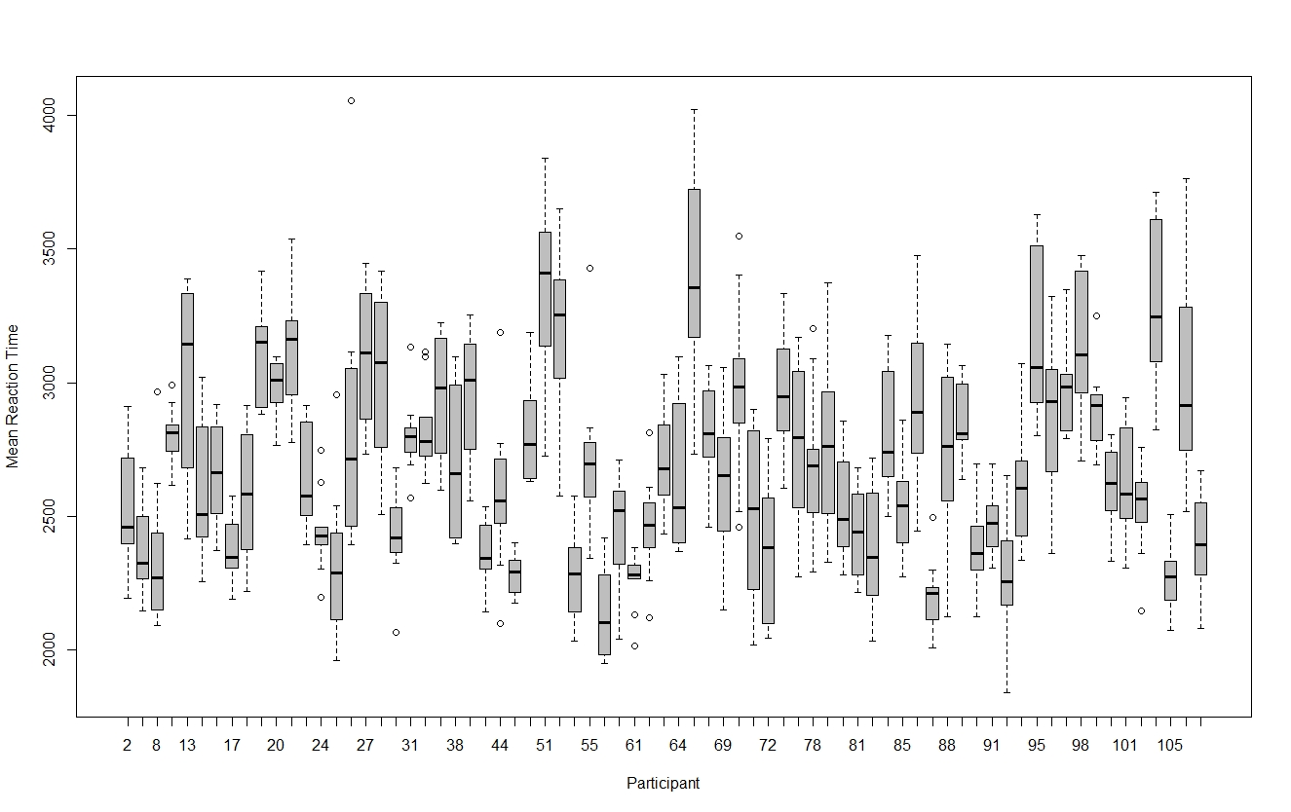
Supplementary Figure 1. Variation between participants in mean reaction time across drug and trial type.

