Supplementary Online Material
Analysis of Recreational Psychedelic Substance Use Experiences Classified by Substance
For Publication in Psychopharmacology
Adrian Hase¹
Max Erdmann²
Verena Limbach³
Gregor Hasler¹
¹ Department of Medicine, Faculty of Science and Medicine, University of Fribourg, Fribourg, Switzerland
² Faculty of Medicine, University of Rostock, Rostock, Germany
³ Department of Psychology, Faculty of Humanities, University of Basel, Basel, Switzerland
Corresponding author: Adrian Hase, e-mail: adrian.hase@unifr.ch

Table S1
Paired T-Tests Comparing Shortened and Full Reports on LIWC Outcome Variables
 | Complete Reports |  | Shortened Reports |  |  |  |  | 95% CI
Outcome | M | SD | M | SD | t | p | d | LB | UB
Affective Processes | 4.34 | 1.52 | 4.34 | 1.55 | -0.80 | .42 | -0.03 | -0.10 | 0.04
Positive Emotion | 2.59 | 1.09 | 2.58 | 1.12 | 1.00 | .32 | 0.03 | -0.03 | 0.10
Negative Emotion | 1.67 | 0.99 | 1.68 | 1.01 | -1.82 | .07 | -0.06 | -0.13 | 0.00
Sadness | 0.33 | 0.32 | 0.34 | 0.33 | -0.80 | .43 | -0.03 | -0.10 | 0.04
Anxiety | 0.45 | 0.40 | 0.45 | 0.42 | -1.79 | .07 | -0.06 | -0.13 | 0.01
Cognitive Processes | 12.25 | 2.55 | 12.26 | 2.60 | -0.78 | .44 | -0.03 | -0.09 | 0.04
Analytical Thinking | 57.88 | 17.66 | 57.83 | 17.82 | 0.34 | .73 | 0.01 | -0.06 | 0.08
Note. N = 835.

Table S2
One-Way Between-Group Comparisons of All LIWC Outcomes
 | Test Statistic |  |  |  | Effect Size
 | Type | Value | p | p_{adj} | Type |  | Value |  | Interpretation
WC | χ² | 406.927 | < .001 | < .001 | ε²_{ordinal} | .138 |  | Medium
Analytic | F | 18.442 | < .001 | < .001 | ε²_{ordinal} | .098 |  | Medium
Clout | χ² | 374.209 | < .001 | < .001 | ε²_{ordinal} | .127 |  | Medium
Authentic | χ² | 27.488 | < .001 | .004 | ε²_{ordinal} | .009 |  | Very small
Tone | χ² | 396.946 | < .001 | < .001 | ε²_{ordinal} | .135 |  | Medium
WPS | χ² | 13.107 | .022 | > .999 | ε²_{ordinal} | .004 |  | Very small
Sixltr | F _{(trimmed-means)} | 28.394 | < .001 | < .001 | ξ | .260 |  | Small
Dic | F _{(trimmed-means)} | 55.231 | < .001 | < .001 | ξ | .360 |  | Medium
function | F _{(trimmed-means)} | 9.462 | < .001 | < .001 | ξ | .243 |  | Small
pronoun | F _{(trimmed-means)} | 8.256 | < .001 | < .001 | ξ | .182 |  | Small
ppron | F | 13.170 | < .001 | < .001 | η² | .073 |  | Medium
i | F _{(trimmed-means)} | 14.083 | < .001 | < .001 | ξ | .236 |  | Small
we | χ² | 483.126 | < .001 | < .001 | ε²_{ordinal} | .164 |  | Large
you | χ² | 72.899 | < .001 | < .001 | ε²_{ordinal} | .025 |  | Small
shehe | χ² | 177.589 | < .001 | < .001 | ε²_{ordinal} | .060 |  | Medium
they | χ² | 200.856 | < .001 | < .001 | ε²_{ordinal} | .068 |  | Medium
ipron | F _{(trimmed-means)} | 13.969 | < .001 | < .001 | ξ | .182 |  | Small
article | F | 29.808 | < .001 | < .001 | η² | .151 |  | Large
prep | F _{(trimmed-means)} | 14.164 | < .001 | < .001 | ξ | .204 |  | Small
auxverb | F _{(trimmed-means)} | 8.477 | < .001 | < .001 | ξ | .155 |  | Small
adverb | F _{(trimmed-means)} | 20.469 | < .001 | < .001 | ξ | .214 |  | Small
conj | F _{(trimmed-means)} | 7.502 | < .001 | < .001 | ξ | .167 |  | Small
negate | F _{(trimmed-means)} | 25.302 | < .001 | < .001 | ξ | .333 |  | Small
verb | F | 14.601 | < .001 | < .001 | η² | .079 |  | Medium
adj | F _{(trimmed-means)} | 17.000 | < .001 | < .001 | ξ | .209 |  | Small
compare | F _{(trimmed-means)} | 19.244 | < .001 | < .001 | ξ | .239 |  | Small
interrog | F _{(trimmed-means)} | 12.182 | < .001 | < .001 | ξ | .244 |  | Small
number | χ² | 159.372 | < .001 | < .001 | ε²_{ordinal} | .054 |  | Small
quant | F _{(trimmed-means)} | 6.228 | < .001 | .001 | ξ | .148 |  | Very small
affect | F _{(trimmed-means)} | 75.664 | < .001 | < .001 | ξ | .449 |  | Medium
posemo | F _{(trimmed-means)} | 88.756 | < .001 | < .001 | ξ | .496 |  | Medium
negemo | χ² | 284.916 | < .001 | < .001 | ε²_{ordinal} | .097 |  | Medium
anx | χ² | 21.701 | < .001 | .057 | ε²_{ordinal} | .007 |  | Very small
anger | χ² | 75.073 | < .001 | < .001 | ε²_{ordinal} | .025 |  | Small
sad | χ² | 79.441 | < .001 | < .001 | ε²_{ordinal} | .027 |  | Small
social | F _{(trimmed-means)} | 119.964 | < .001 | < .001 | ξ | .537 |  | Large
family | χ² | 77.720 | < .001 | < .001 | ε²_{ordinal} | .026 |  | Small
friend | χ² | 347.487 | < .001 | < .001 | ε²_{ordinal} | .118 |  | Medium
female | χ² | 77.026 | < .001 | < .001 | ε²_{ordinal} | .026 |  | Small
male | χ² | 185.045 | < .001 | < .001 | ε²_{ordinal} | .063 |  | Medium
cogproc | F | 13.321 | < .001 | < .001 | η² | .073 |  | Medium
insight | F _{(trimmed-means)} | 5.866 | < .001 | .003 | ξ | .164 |  | Small
cause | F _{(trimmed-means)} | 9.889 | < .001 | < .001 | ξ | .294 |  | Small
discrep | F _{(trimmed-means)} | 3.293 | .006 | .587 | ξ | .141 |  | Very small
tentat | F _{(trimmed-means)} | 9.676 | < .001 | < .001 | ξ | .235 |  | Small
certain | χ² | 86.750 | < .001 | < .001 | ε²_{ordinal} | .029 |  | Small
differ | F _{(trimmed-means)} | 12.510 | < .001 | < .001 | ξ | .238 |  | Small
percept | F _{(trimmed-means)} | 34.996 | < .001 | < .001 | ξ | .427 |  | Medium
see | χ² | 534.272 | < .001 | < .001 | ε²_{ordinal} | .181 |  | Large
hear | χ² | 152.659 | < .001 | < .001 | ε²_{ordinal} | .052 |  | Small
feel | χ² | 248.524 | < .001 | < .001 | ε²_{ordinal} | .084 |  | Medium
bio | χ² | 577.560 | < .001 | < .001 | ε²_{ordinal} | .196 |  | Large
body | χ² | 144.243 | < .001 | < .001 | ε²_{ordinal} | .049 |  | Small
health | χ² | 716.275 | < .001 | < .001 | ε²_{ordinal} | .243 |  | Large
sexual | χ² | 32.601 | < .001 | < .001 | ε²_{ordinal} | .011 |  | Small
ingest | χ² | 295.953 | < .001 | < .001 | ε²_{ordinal} | .100 |  | Medium
drives | F _{(trimmed-means)} | 131.973 | < .001 | < .001 | ξ | .531 |  | Large
affiliation | χ² | 618.027 | < .001 | < .001 | ε²_{ordinal} | .210 |  | Large
achieve | χ² | 48.033 | < .001 | < .001 | ε²_{ordinal} | .016 |  | Small
power | F _{(trimmed-means)} | 1.538 | .176 | > .999 | ξ | .110 |  | Very small
reward | χ² | 511.146 | < .001 | < .001 | ε²_{ordinal} | .174 |  | Large
risk | χ² | 79.305 | < .001 | < .001 | ε²_{ordinal} | .027 |  | Small
focuspast | F _{(trimmed-means)} | 19.588 | < .001 | < .001 | ξ | .265 |  | Small
focuspresent | F _{(trimmed-means)} | 13.001 | < .001 | < .001 | ξ | .257 |  | Small
focusfuture | χ² | 8.159 | .148 | > .999 | ε²_{ordinal} | .003 |  | Very small
relativ | F _{(trimmed-means)} | 16.125 | < .001 | < .001 | ξ | .226 |  | Small
motion | F _{(trimmed-means)} | 52.228 | < .001 | < .001 | ξ | .412 |  | Medium
space | F | 87.590 | < .001 | < .001 | η² | .341 |  | Large
time | F _{(trimmed-means)} | 34.969 | < .001 | < .001 | ξ | .414 |  | Medium
work | χ² | 109.664 | < .001 | < .001 | ε²_{ordinal} | .037 |  | Small
leisure | χ² | 293.419 | < .001 | < .001 | ε²_{ordinal} | .100 |  | Medium
home | χ² | 151.847 | < .001 | < .001 | ε²_{ordinal} | .052 |  | Small
money | χ² | 63.708 | < .001 | < .001 | ε²_{ordinal} | .022 |  | Small
relig | χ² | 207.303 | < .001 | < .001 | ε²_{ordinal} | .070 |  | Medium
death | χ² | 72.680 | < .001 | < .001 | ε²_{ordinal} | .025 |  | Small
informal | χ² | 115.040 | < .001 | < .001 | ε²_{ordinal} | .039 |  | Small
swear | χ² | 97.443 | < .001 | < .001 | ε²_{ordinal} | .033 |  | Small
netspeak | χ² | 189.191 | < .001 | < .001 | ε²_{ordinal} | .064 |  | Medium
assent | χ² | 164.938 | < .001 | < .001 | ε²_{ordinal} | .056 |  | Small
nonflu | χ² | 26.293 | < .001 | .007 | ε²_{ordinal} | .009 |  | Very small
filler | χ² | 43.734 | < .001 | < .001 | ε²_{ordinal} | .015 |  | Small
AllPunc | F _{(trimmed-means)} | 2.308 | .043 | > .999 | ξ | .119 |  | Very small
Period | F _{(trimmed-means)} | 2.153 | .058 | > .999 | ξ | .114 |  | Very small
Comma | F | 1.045 | .390 | > .999 | η² | .006 |  | Very small
Colon | χ² | 28.315 | < .001 | .003 | ε²_{ordinal} | .010 |  | Very small
SemiC | χ² | 35.765 | < .001 | < .001 | ε²_{ordinal} | .012 |  | Small
QMark | χ² | 109.854 | < .001 | < .001 | ε²_{ordinal} | .037 |  | Small
Exclam | χ² | 51.270 | < .001 | < .001 | ε²_{ordinal} | .017 |  | Small
Dash | χ² | 26.941 | < .001 | .006 | ε²_{ordinal} | .009 |  | Very small
Quote | χ² | 87.304 | < .001 | < .001 | ε²_{ordinal} | .030 |  | Small
Apostro | χ² | 15.918 | .007 | .673 | ε²_{ordinal} | .005 |  | Very small
Parenth | χ² | 26.968 | < .001 | .005 | ε²_{ordinal} | .009 |  | Very small
OtherP | χ² | 15.943 | .007 | .666 | ε²_{ordinal} | .005 |  | Very small

Figure S1
Significant Differences Between Report Groups on Age
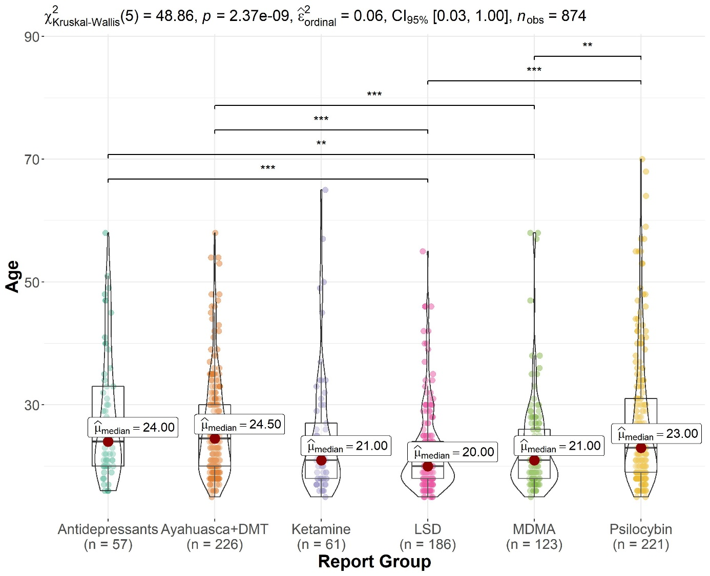
Note. ** p < .01, *** p < .001.
Figure S2
Significant Differences Between Report Groups on Body Weight
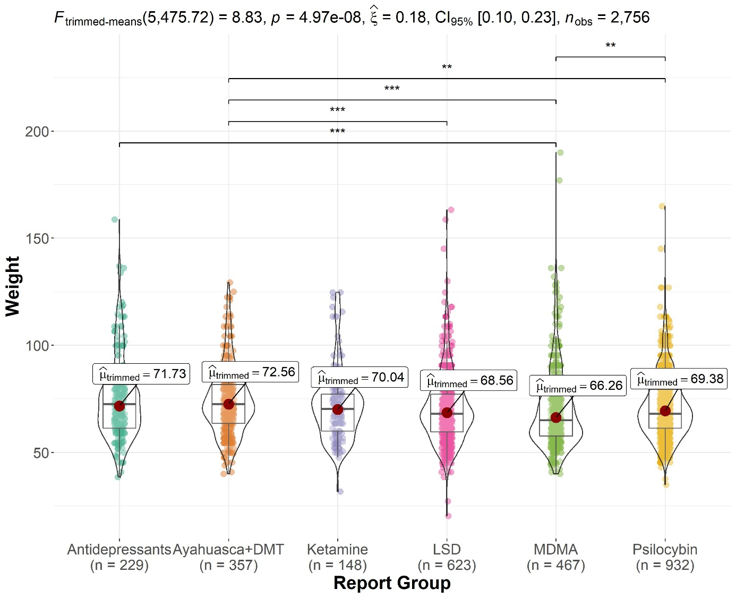
Note. ** p < .01, *** p < .001.

Figure S3
Significant Differences Between Report Groups on Proportion of Affective Process Words
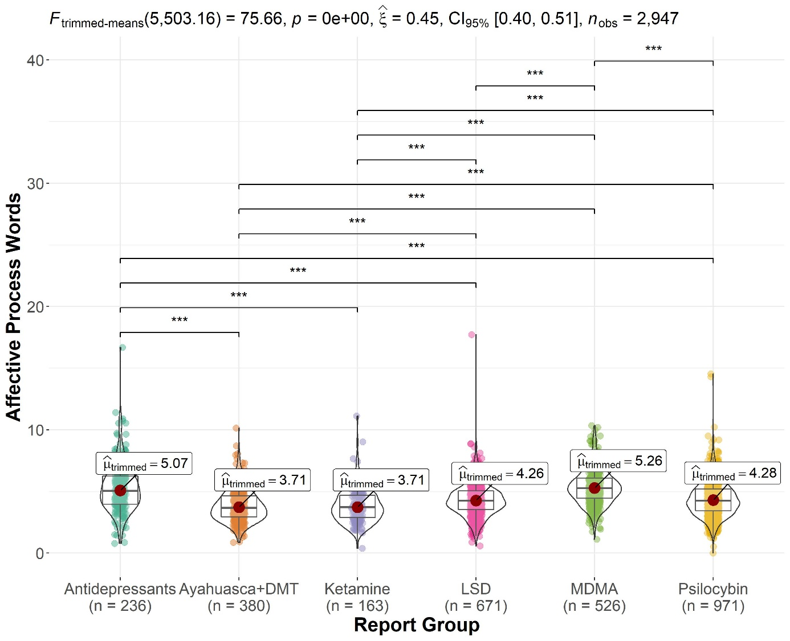
Note. *** p < .001.

Figure S4
Significant Differences Between Report Groups on Proportion of Sadness Words
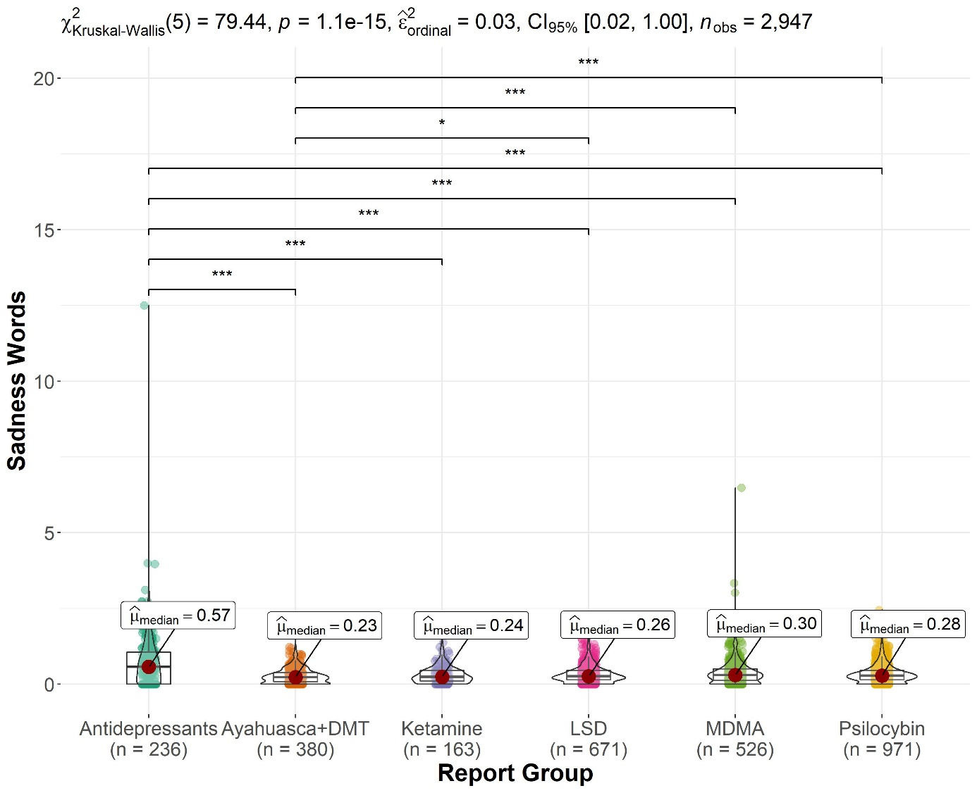
Note. * p < .05, *** p < .001.

Figure S5
Significant Differences Between Report Groups on Proportion of Anxiety Words
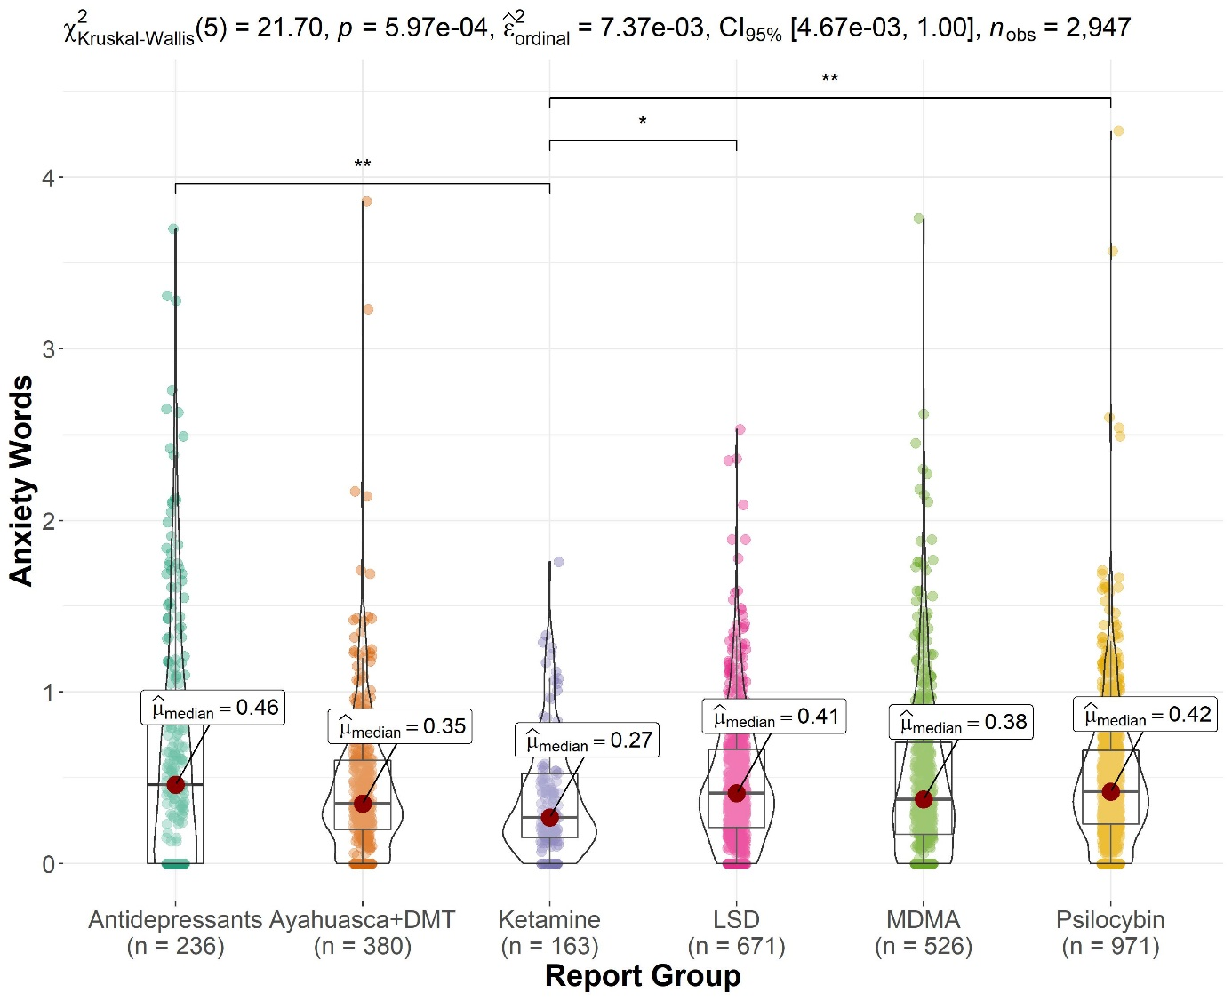
Note. * p < .05, ** p < .01.

Figure S6
Significant Differences Between Report Groups on Proportion of Negative Emotion Words
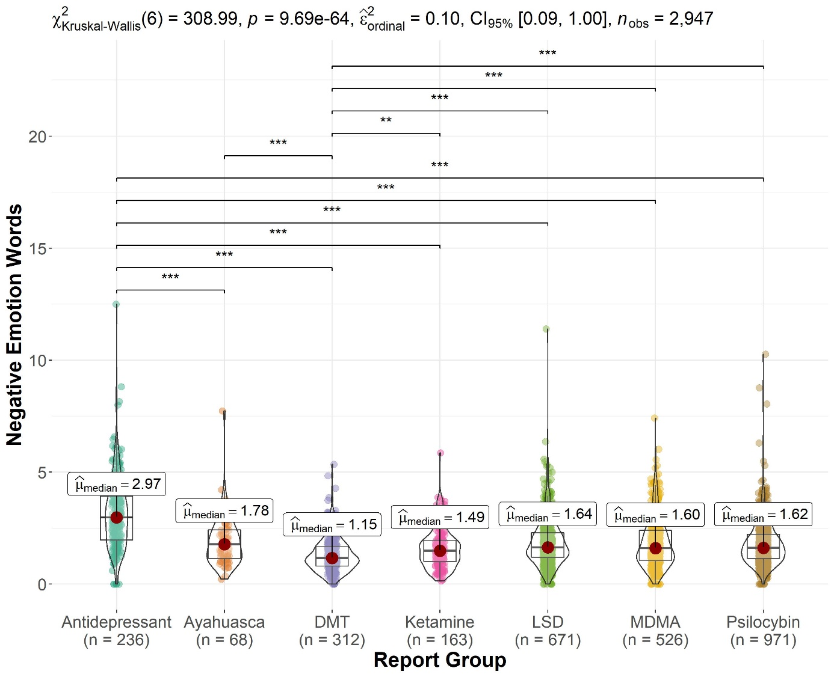
Note. ** p < .01, *** p < .001.

Figure S7
Significant Differences Between Report Groups on Hood’s M Scale Semantic Similarity Index
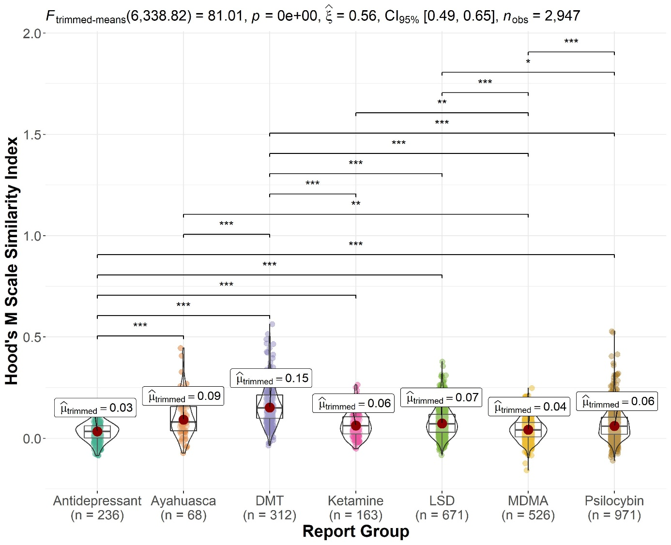
Note. * p < .05, ** p < .01, *** p < .001.

Figure S8
Significant Differences Between Report Groups on Proportion of First-Person Plural Words
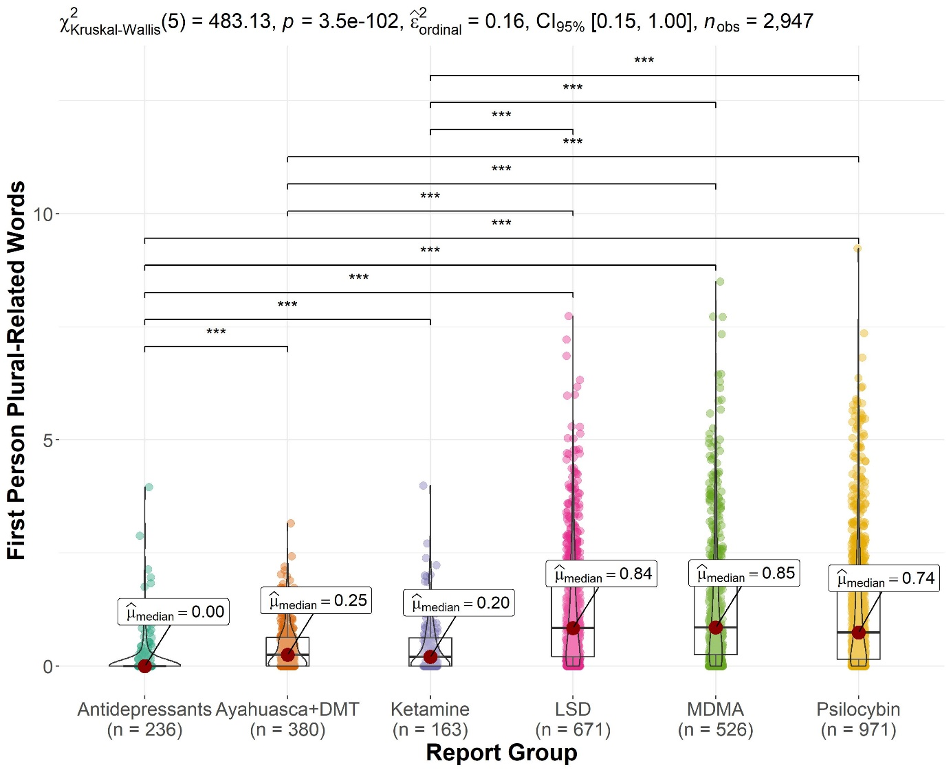
Note. *** p < .001.

Figure S9
Significant Differences Between Report Groups on Proportion of Articles
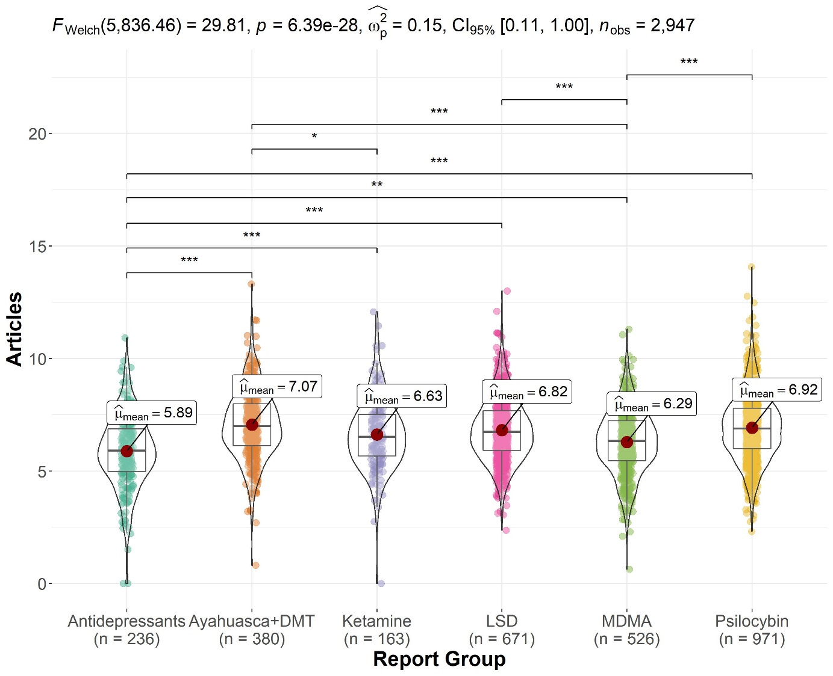
Note. * p < .05, ** p < .01, *** p < .001.

Figure S10
Significant Differences Between Report Groups on Social Process Word Proportions
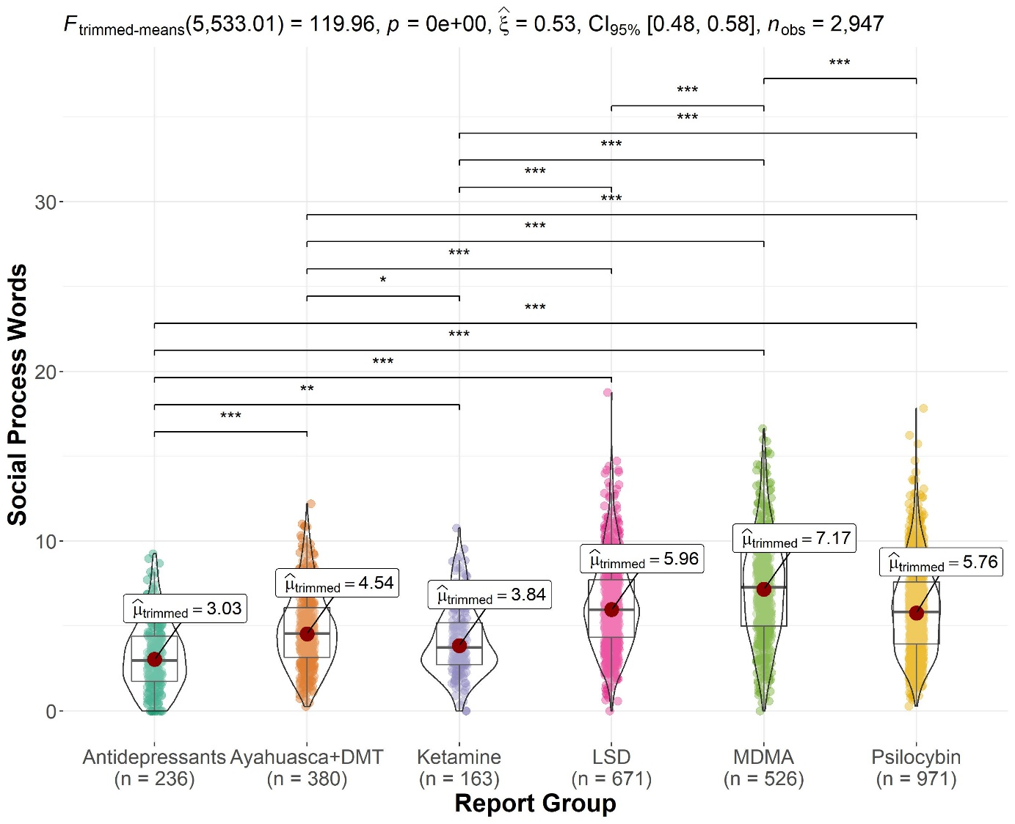
Note. * p < .05, ** p < .01, *** p < .001.

Figure S11
Significant Differences Between Report Groups on Vision-Related Word Proportions
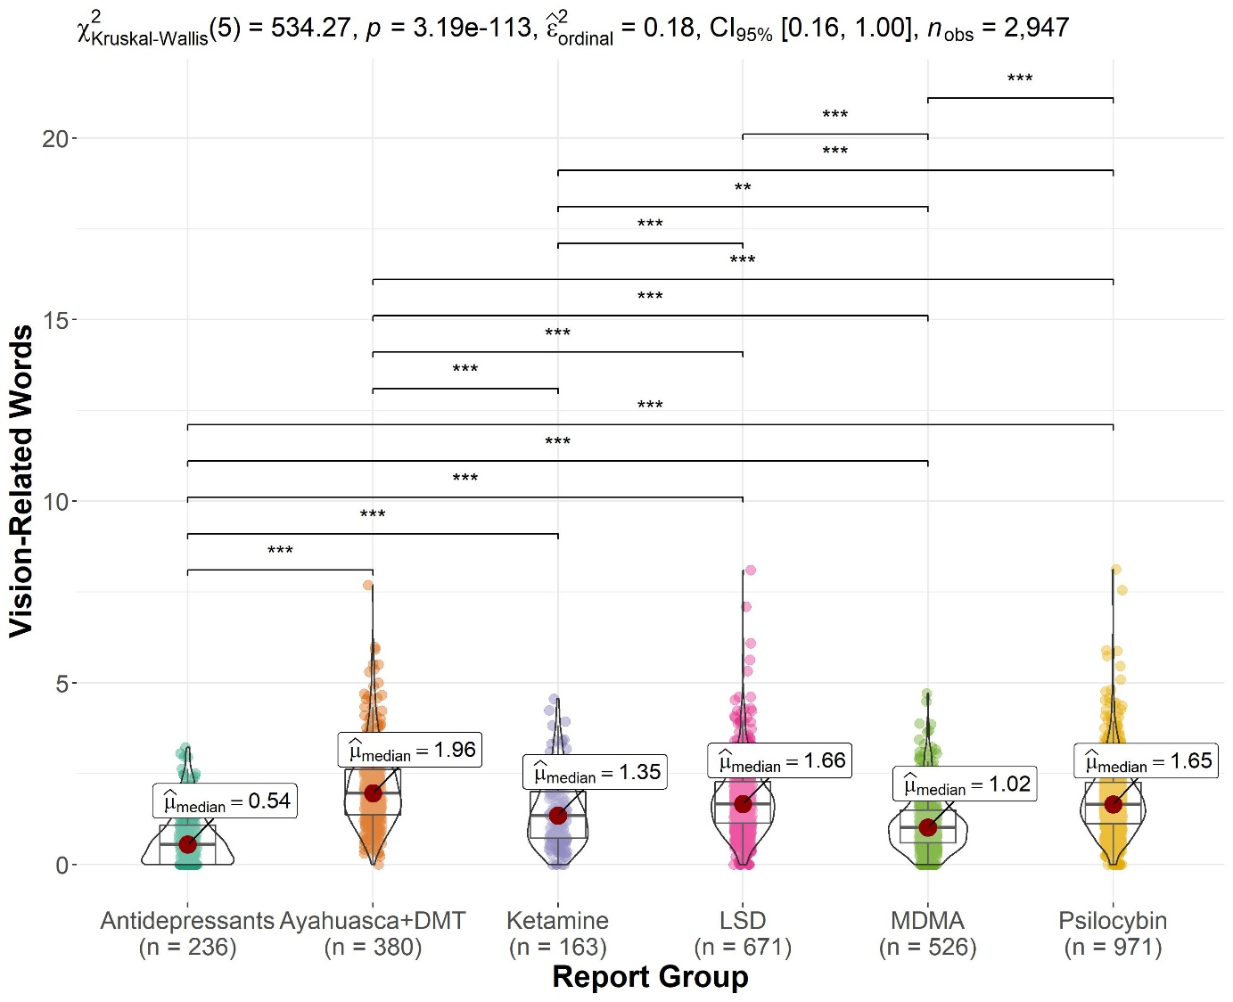
Note. ** p < .01, *** p < .001.

Figure S12
Significant Differences Between Report Groups on Biological Process Word Proportions
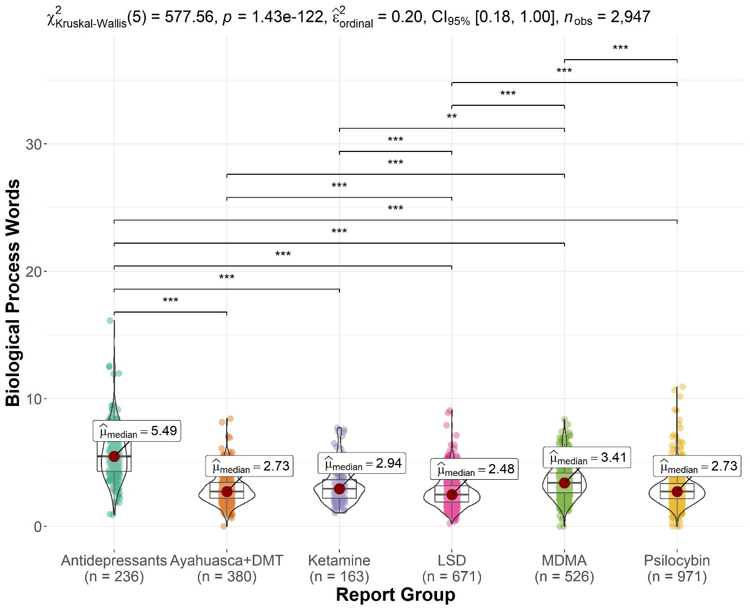
Note. ** p < .01, *** p < .001.

Figure S13
Significant Differences Between Report Groups on Health-Related Word Proportions
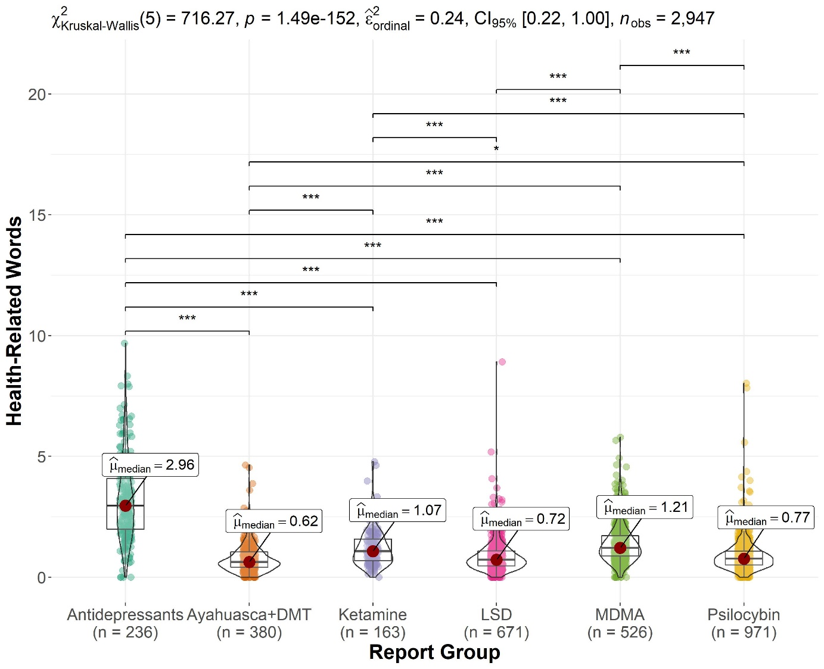
Note. * p < .05, *** p < .001.

Figure S14
Significant Differences Between Report Groups on Drive-Related Word Proportions
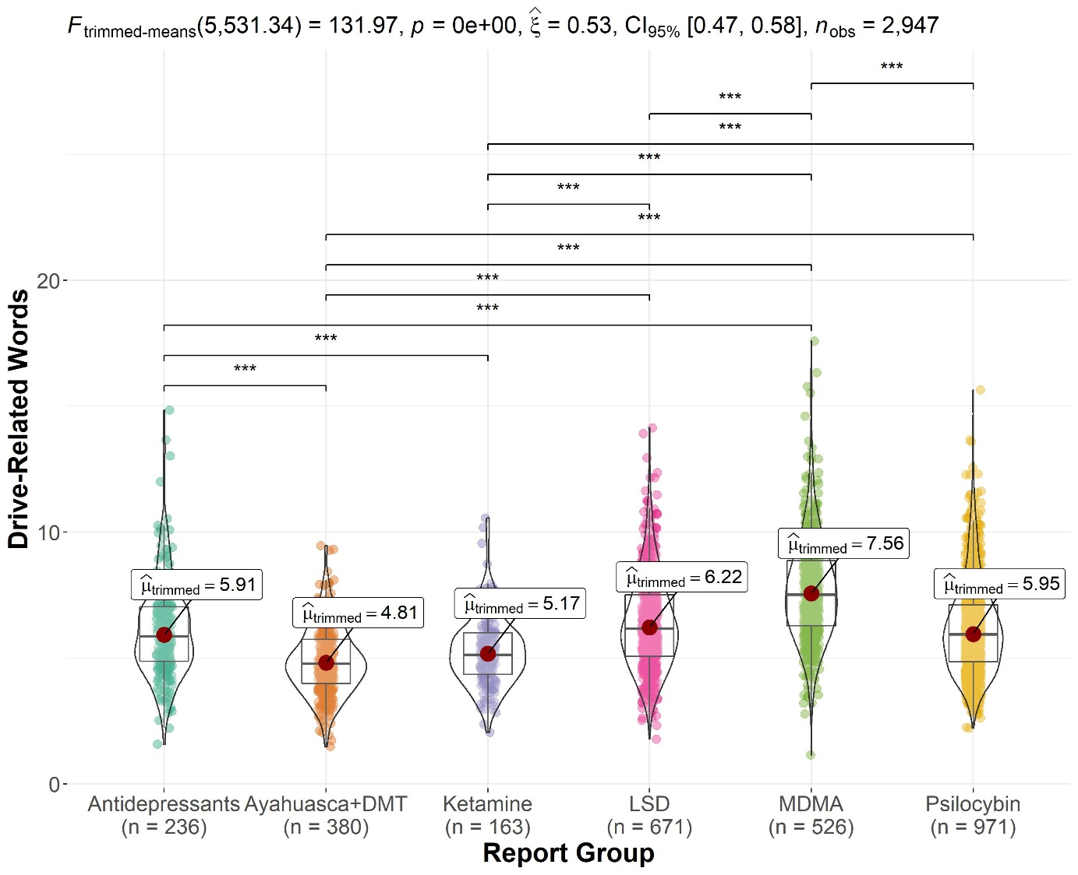
Note. *** p < .001.

Figure S15
Significant Differences Between Report Groups on Affiliation-Related Word Proportions
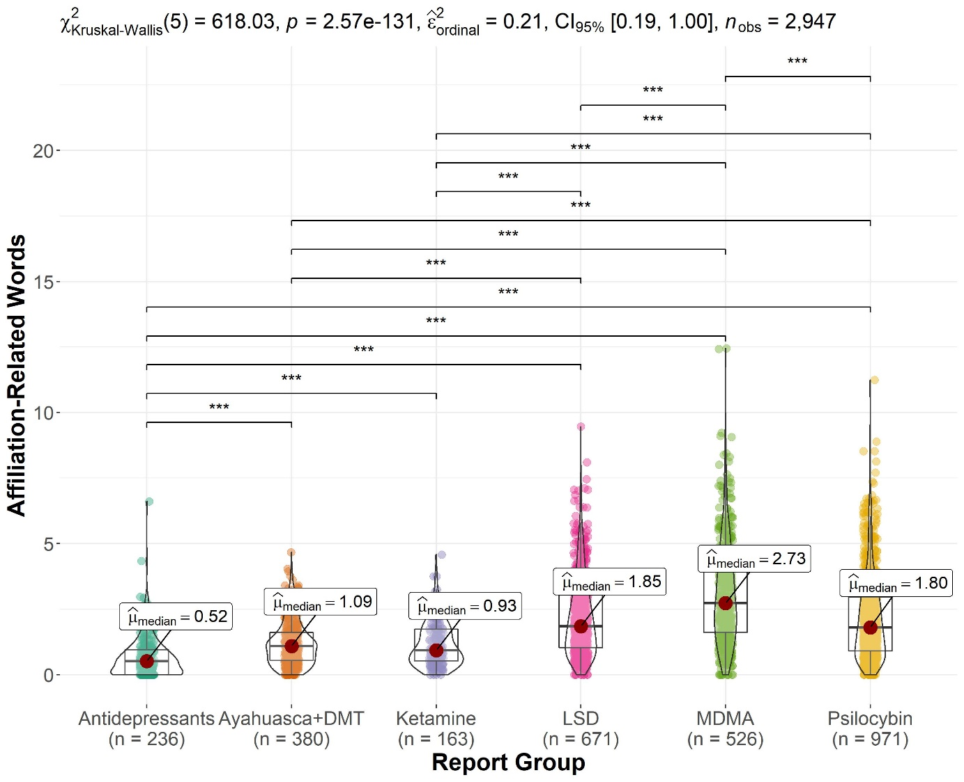
Note. *** p < .001.

Figure S16
Significant Differences Between Report Groups on Reward-Related Word Proportions
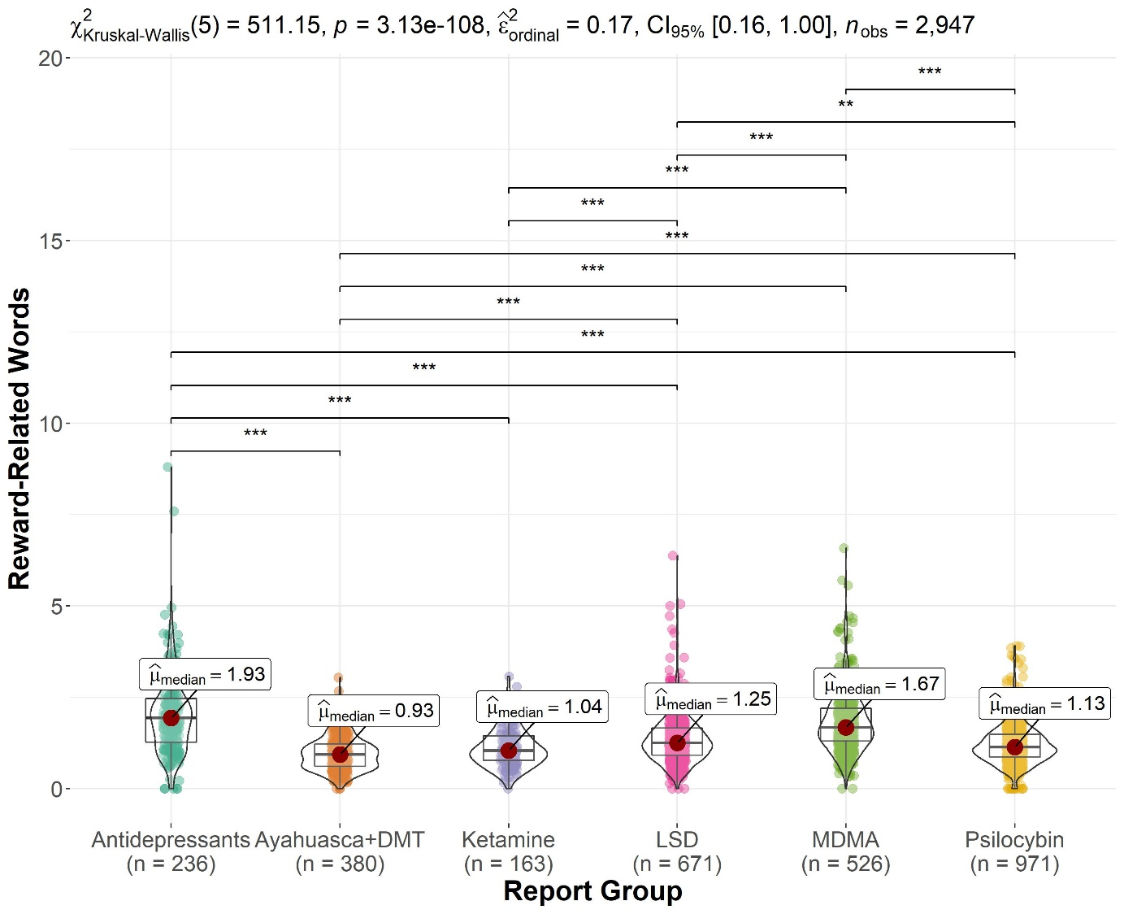
Note. ** p < .01, *** p < .001.

Figure S17
Significant Differences Between Report Groups on Space-Related Word Proportions
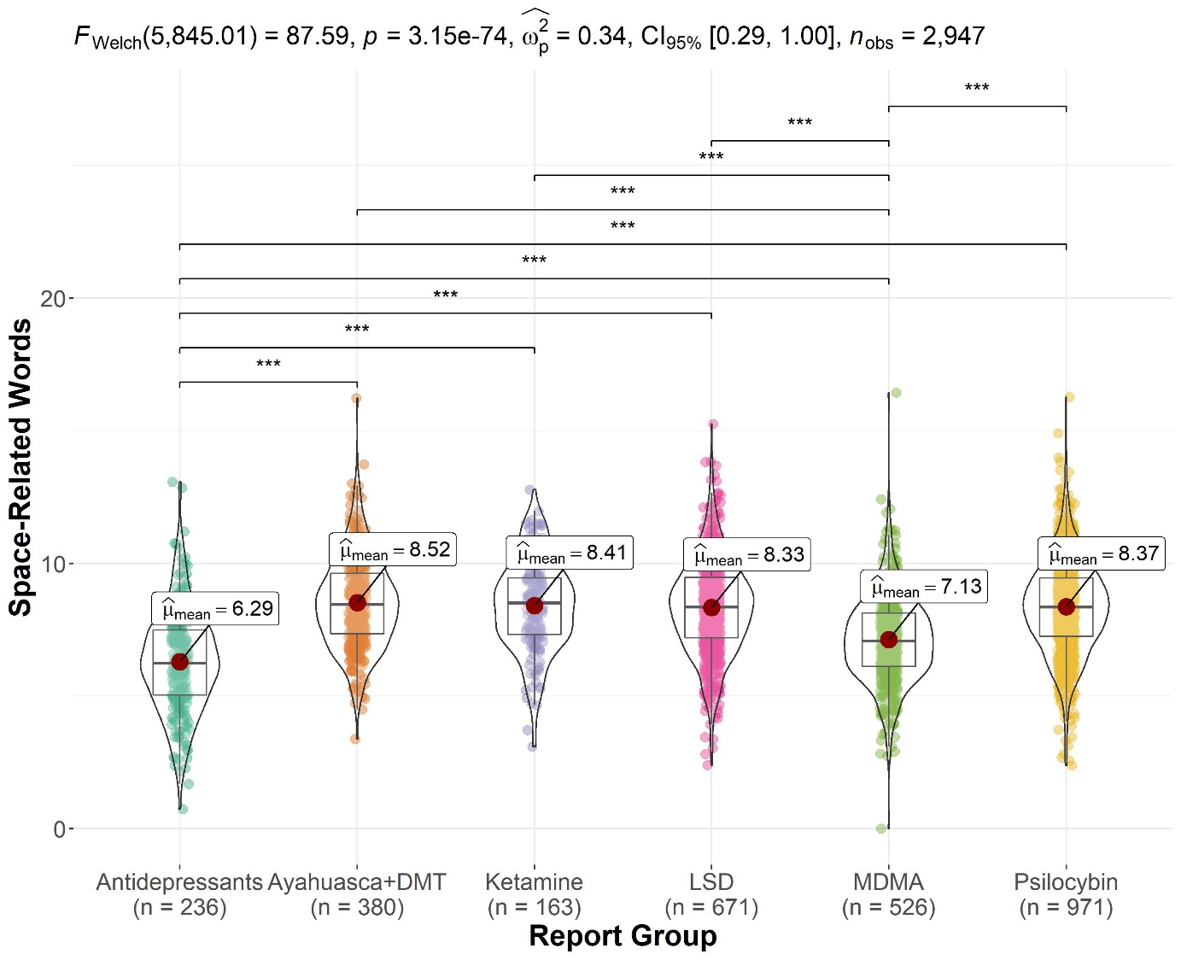
Note. *** p < .001.

