Differential Contributions of Serotoninergic and Dopaminergic Functional Connectivity to the Phenomenology of LSD
Timothy Lawn (timothy.lawn@kcl.ac.uk) MSc¹, Ottavia Dipasquale PhD¹, Alexandros Vamvakas MSc^{1,2}, Ioannis Tsougos PhD^{1,2}, Mitul A. Mehta PhD¹, Matthew A. Howard PhD¹

¹ Department of Neuroimaging, Institute of Psychiatry, Psychology and Neuroscience, King’s college London, London, UK
² School of Medicine, University of Thessaly, Volos, Greece

Supplementary Information

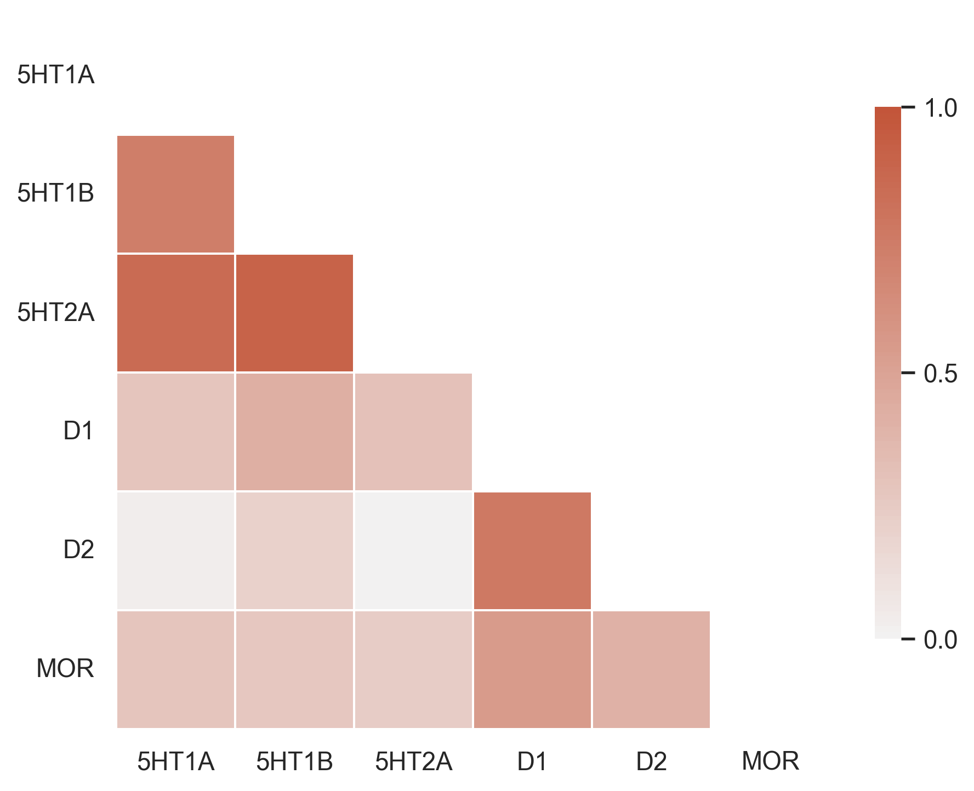
SI fig.1 Bivariate spatial correlation coefficients between each of the PET receptor systems

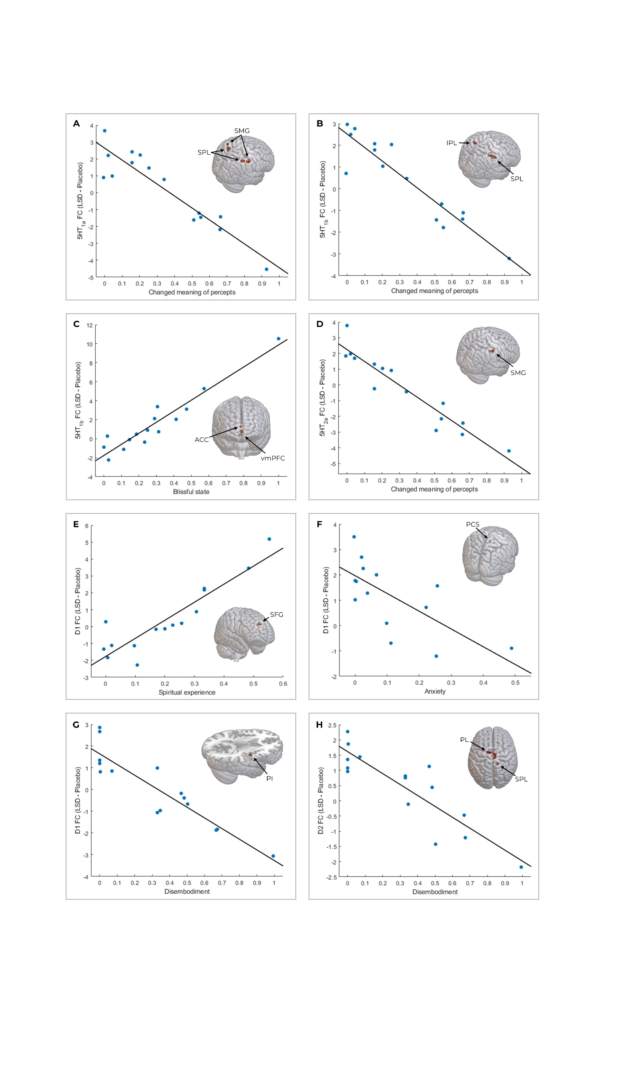
SI fig.2 correlations between receptor enriched FC the subjective effects of LSD as measured by the individual ASC sub-scores. Several correlations were found to be significant following correction for multiple comparisons across voxels using TFCE. Serotonergic FC showed relationships with altered meaning of percepts (A/B/D) and blissful state (C). Dopaminergic FC showed relationships with spiritual experience and anxiety (E/F), and with disembodiment (G/H). SPL; Superior parietal lobule. SMG; Supramarginal gyrus. IPL; Inferior parietal lobule. ACC; Anterior cingulate cortex. vmPFC; Ventromedial prefrontal cortex. SFG; Superior frontal gyrus. PCS; Posterior cingulate sulcus. PI; Posterior Insula. PL; Paracentral lobule.

Supplementary table 1: correlations between receptor enriched FC and principal components as well as VAS scores. Results are shown TFCE corrected at p_{FWE} < 0.1 to additionally show clusters nearing significance. Significant clusters are emboldened.
 |  |  | MNI co-ordinates
 | Voxels | p value | MAX X | MAX Y | MAX Z
D1 enriched FC - Principal component 2 - Negative correlation | 247 | 0.045 | -6 | -14 | 68
 | 191 | 0.026 | 48 | -8 | 10
 | 44 | 0.049 | -40 | -38 | 18
 | 5 | 0.098 | 10 | -14 | 50
D2 enriched FC - Principal component 2 - Negative correlation | 1998 | 0.011 | 8 | -24 | 58
 | 458 | 0.042 | 38 | -18 | 56
 | 72 | 0.007 | -40 | -38 | 18
 | 68 | 0.048 | 34 | -8 | 0
 | 17 | 0.094 | 64 | 6 | 14
 | 13 | 0.09 | 66 | -4 | 2
 | 10 | 0.086 | 50 | -6 | 10
D1 enriched FC - Principal component 1 - Positive correlation | 17 | 0.081 | 36 | 88 | 52
5HT1a enriched FC - Principal component 3 - Negative correlation | 12 | 0.072 | 71 | 54 | 31
5HT1a enriched FC - Complex Imagery - Negative correlation | 251 | 0.005 | 6 | -62 | 52
 | 190 | 0.038 | -10 | -64 | 60
 | 168 | 0.065 | -28 | -52 | 38
 | 40 | 0.05 | -24 | 2 | 58
 | 17 | 0.073 | 38 | -36 | 38
5HT1a enriched FC - Simple Hallucination - Negative correlation | 120 | 0.051 | -18 | -56 | 50
 | 119 | 0.055 | -34 | -44 | 42
 | 15 | 0.089 | 8 | -56 | 54
5HT1a enriched FC - Ego dissolution - Negative correlation | 15 | 0.081 | 64 | -32 | 46
 | 4 | 0.094 | 54 | -34 | 46
 | 1 | 0.099 | -64 | -16 | 22
5HT1b enriched FC - Complex Imagery - Negative correlation | 84 | 0.051 | -30 | -52 | 40
 | 25 | 0.073 | 40 | -48 | 42
 | 8 | 0.09 | 38 | -36 | 36
5HT1b enriched FC - Simple Hallucination - Negative correlation | 126 | 0.024 | -28 | -52 | 42

