Identification of studies via other methods
Identification of studies via databases and registers

Identification
Records identified from:

- Citation searching (n = 2)

Records removed before screening:

- Duplicate records removed (n = 146)

Records identified from:

- Databases (n = 700)

Records excluded
(n = 543)

- Ketamine only intervention
- Addiction present
- Narrative Review

Records screened
(n = 554)

Screening

Reports assessed for eligibility
(n = 2)

Reports assessed for eligibility
(n = 11)

Reports excluded:

- Intervention not in line with definition of KAP (n = 2)

Studies included in review
(n = 11)

Included

Figure S1: PRISMA flow chart showing results from first OVID search, performed October 2023 (Stern et al., 2019)


CONSORT 2010 checklist– study no. 1

Section/Topic | Item No | Checklist item | Reported on page No
Title and abstract
 | 1a | Identification as a randomised trial in the title | N/A
 | 1b | Structured summary of trial design, methods, results, and conclusions (for specific guidance see CONSORT for abstracts) | Abstract
Introduction
Background and objectives | 2a | Scientific background and explanation of rationale | Abstract, pg 2,3
Background and objectives | 2b | Specific objectives or hypotheses
Methods
Trial design | 3a | Description of trial design (such as parallel, factorial) including allocation ratio | Pg 3, 4
Trial design | 3b | Important changes to methods after trial commencement (such as eligibility criteria), with reasons
Participants | 4a | Eligibility criteria for participants | Pg 3
Participants | 4b | Settings and locations where the data were collected
Interventions | 5 | The interventions for each group with sufficient details to allow replication, including how and when they were actually administered | Pg 3, 4, 5
Outcomes | 6a | Completely defined pre-specified primary and secondary outcome measures, including how and when they were assessed | Abstract
Outcomes | 6b | Any changes to trial outcomes after the trial commenced, with reasons
Sample size | 7a | How sample size was determined
Sample size | 7b | When applicable, explanation of any interim analyses and stopping guidelines | N/A
Randomisation:
Sequence generation | 8a | Method used to generate the random allocation sequence | N/A
Sequence generation | 8b | Type of randomisation; details of any restriction (such as blocking and block size) | N/A
Allocation concealment mechanism | 9 | Mechanism used to implement the random allocation sequence (such as sequentially numbered containers), describing any steps taken to conceal the sequence until interventions were assigned | N/A
Implementation | 10 | Who generated the random allocation sequence, who enrolled participants, and who assigned participants to interventions | N/A
Blinding | 11a | If done, who was blinded after assignment to interventions (for example, participants, care providers, those assessing outcomes) and how | N/A
Blinding | 11b | If relevant, description of the similarity of interventions | N/A
Statistical methods | 12a | Statistical methods used to compare groups for primary and secondary outcomes
Statistical methods | 12b | Methods for additional analyses, such as subgroup analyses and adjusted analyses | N/A
Results
Participant flow (a diagram is strongly recommended) | 13a | For each group, the numbers of participants who were randomly assigned, received intended treatment, and were analysed for the primary outcome | N/A
Participant flow (a diagram is strongly recommended) | 13b | For each group, losses and exclusions after randomisation, together with reasons | N/A
Recruitment | 14a | Dates defining the periods of recruitment and follow-up
Recruitment | 14b | Why the trial ended or was stopped | N/A
Baseline data | 15 | A table showing baseline demographic and clinical characteristics for each group
Numbers analysed | 16 | For each group, number of participants (denominator) included in each analysis and whether the analysis was by original assigned groups | Pg 5
Outcomes and estimation | 17a | For each primary and secondary outcome, results for each group, and the estimated effect size and its precision (such as 95% confidence interval)
Outcomes and estimation | 17b | For binary outcomes, presentation of both absolute and relative effect sizes is recommended | N/A
Ancillary analyses | 18 | Results of any other analyses performed, including subgroup analyses and adjusted analyses, distinguishing pre-specified from exploratory | N/A
Harms | 19 | All important harms or unintended effects in each group (for specific guidance see CONSORT for harms)
Discussion
Limitations | 20 | Trial limitations, addressing sources of potential bias, imprecision, and, if relevant, multiplicity of analyses | Pg 6 (brief)
Generalisability | 21 | Generalisability (external validity, applicability) of the trial findings
Interpretation | 22 | Interpretation consistent with results, balancing benefits and harms, and considering other relevant evidence
Other information
Registration | 23 | Registration number and name of trial registry | Pg
Protocol | 24 | Where the full trial protocol can be accessed, if available | Pg 6
Funding | 25 | Sources of funding and other support (such as supply of drugs), role of funders | Pg 7

CONSORT 2010 checklist– study no. 5

Section/Topic | Item No | Checklist item | Reported on page No
Title and abstract
 | 1a | Identification as a randomised trial in the title | N/A
 | 1b | Structured summary of trial design, methods, results, and conclusions (for specific guidance see CONSORT for abstracts) | Abstract
Introduction
Background and objectives | 2a | Scientific background and explanation of rationale | Pg 1,2
Background and objectives | 2b | Specific objectives or hypotheses | Pg 2
Methods
Trial design | 3a | Description of trial design (such as parallel, factorial) including allocation ratio | Pg 2
Trial design | 3b | Important changes to methods after trial commencement (such as eligibility criteria), with reasons
Participants | 4a | Eligibility criteria for participants | Pg 2 (brief)
Participants | 4b | Settings and locations where the data were collected
Interventions | 5 | The interventions for each group with sufficient details to allow replication, including how and when they were actually administered | Pg 2 (brief)
Outcomes | 6a | Completely defined pre-specified primary and secondary outcome measures, including how and when they were assessed | Pg 2 (brief)
Outcomes | 6b | Any changes to trial outcomes after the trial commenced, with reasons
Sample size | 7a | How sample size was determined
Sample size | 7b | When applicable, explanation of any interim analyses and stopping guidelines | N/A
Randomisation:
Sequence generation | 8a | Method used to generate the random allocation sequence | N/A
Sequence generation | 8b | Type of randomisation; details of any restriction (such as blocking and block size) | N/A
Allocation concealment mechanism | 9 | Mechanism used to implement the random allocation sequence (such as sequentially numbered containers), describing any steps taken to conceal the sequence until interventions were assigned | N/A
Implementation | 10 | Who generated the random allocation sequence, who enrolled participants, and who assigned participants to interventions | N/A
Blinding | 11a | If done, who was blinded after assignment to interventions (for example, participants, care providers, those assessing outcomes) and how | N/A
Blinding | 11b | If relevant, description of the similarity of interventions | N/A
Statistical methods | 12a | Statistical methods used to compare groups for primary and secondary outcomes | Pg 2
Statistical methods | 12b | Methods for additional analyses, such as subgroup analyses and adjusted analyses | N/A
Results
Participant flow (a diagram is strongly recommended) | 13a | For each group, the numbers of participants who were randomly assigned, received intended treatment, and were analysed for the primary outcome | N/A
Participant flow (a diagram is strongly recommended) | 13b | For each group, losses and exclusions after randomisation, together with reasons | N/A
Recruitment | 14a | Dates defining the periods of recruitment and follow-up
Recruitment | 14b | Why the trial ended or was stopped | N/A
Baseline data | 15 | A table showing baseline demographic and clinical characteristics for each group | Pg 3
Numbers analysed | 16 | For each group, number of participants (denominator) included in each analysis and whether the analysis was by original assigned groups
Outcomes and estimation | 17a | For each primary and secondary outcome, results for each group, and the estimated effect size and its precision (such as 95% confidence interval) | Pg 3 (not specified 95% CI)
Outcomes and estimation | 17b | For binary outcomes, presentation of both absolute and relative effect sizes is recommended | N/A
Ancillary analyses | 18 | Results of any other analyses performed, including subgroup analyses and adjusted analyses, distinguishing pre-specified from exploratory | N/A
Harms | 19 | All important harms or unintended effects in each group (for specific guidance see CONSORT for harms)
Discussion
Limitations | 20 | Trial limitations, addressing sources of potential bias, imprecision, and, if relevant, multiplicity of analyses | Pg 3
Generalisability | 21 | Generalisability (external validity, applicability) of the trial findings | Pg 3
Interpretation | 22 | Interpretation consistent with results, balancing benefits and harms, and considering other relevant evidence
Other information
Registration | 23 | Registration number and name of trial registry | -
Protocol | 24 | Where the full trial protocol can be accessed, if available
Funding | 25 | Sources of funding and other support (such as supply of drugs), role of funders | Pg 3

CONSORT 2010 checklist– study no. 6

Section/Topic | Item No | Checklist item | Reported on page No
Title and abstract
 | 1a | Identification as a randomised trial in the title | N/A
 | 1b | Structured summary of trial design, methods, results, and conclusions (for specific guidance see CONSORT for abstracts) | Abstract
Introduction
Background and objectives | 2a | Scientific background and explanation of rationale | Abstract, pg 1,2
Background and objectives | 2b | Specific objectives or hypotheses | Pg 2
Methods
Trial design | 3a | Description of trial design (such as parallel, factorial) including allocation ratio | Pg 2, 3, 4
Trial design | 3b | Important changes to methods after trial commencement (such as eligibility criteria), with reasons
Participants | 4a | Eligibility criteria for participants
Participants | 4b | Settings and locations where the data were collected | Pg 3
Interventions | 5 | The interventions for each group with sufficient details to allow replication, including how and when they were actually administered | Pg 4
Outcomes | 6a | Completely defined pre-specified primary and secondary outcome measures, including how and when they were assessed | Abstract, pg 4
Outcomes | 6b | Any changes to trial outcomes after the trial commenced, with reasons
Sample size | 7a | How sample size was determined
Sample size | 7b | When applicable, explanation of any interim analyses and stopping guidelines | N/A
Randomisation:
Sequence generation | 8a | Method used to generate the random allocation sequence | N/A
Sequence generation | 8b | Type of randomisation; details of any restriction (such as blocking and block size) | N/A
Allocation concealment mechanism | 9 | Mechanism used to implement the random allocation sequence (such as sequentially numbered containers), describing any steps taken to conceal the sequence until interventions were assigned | N/A
Implementation | 10 | Who generated the random allocation sequence, who enrolled participants, and who assigned participants to interventions | N/A
Blinding | 11a | If done, who was blinded after assignment to interventions (for example, participants, care providers, those assessing outcomes) and how | N/A
Blinding | 11b | If relevant, description of the similarity of interventions | N/A
Statistical methods | 12a | Statistical methods used to compare groups for primary and secondary outcomes | N/A
Statistical methods | 12b | Methods for additional analyses, such as subgroup analyses and adjusted analyses | N/A
Results
Participant flow (a diagram is strongly recommended) | 13a | For each group, the numbers of participants who were randomly assigned, received intended treatment, and were analysed for the primary outcome | N/A
Participant flow (a diagram is strongly recommended) | 13b | For each group, losses and exclusions after randomisation, together with reasons | N/A
Recruitment | 14a | Dates defining the periods of recruitment and follow-up
Recruitment | 14b | Why the trial ended or was stopped | N/A
Baseline data | 15 | A table showing baseline demographic and clinical characteristics for each group | Pg 3
Numbers analysed | 16 | For each group, number of participants (denominator) included in each analysis and whether the analysis was by original assigned groups | N/A
Outcomes and estimation | 17a | For each primary and secondary outcome, results for each group, and the estimated effect size and its precision (such as 95% confidence interval) | N/A
Outcomes and estimation | 17b | For binary outcomes, presentation of both absolute and relative effect sizes is recommended | N/A
Ancillary analyses | 18 | Results of any other analyses performed, including subgroup analyses and adjusted analyses, distinguishing pre-specified from exploratory | N/A
Harms | 19 | All important harms or unintended effects in each group (for specific guidance see CONSORT for harms) | Pg 5, 6, 7
Discussion
Limitations | 20 | Trial limitations, addressing sources of potential bias, imprecision, and, if relevant, multiplicity of analyses | Pg 7
Generalisability | 21 | Generalisability (external validity, applicability) of the trial findings | Pg 7
Interpretation | 22 | Interpretation consistent with results, balancing benefits and harms, and considering other relevant evidence | Pg 7
Other information
Registration | 23 | Registration number and name of trial registry
Protocol | 24 | Where the full trial protocol can be accessed, if available | Pg 8
Funding | 25 | Sources of funding and other support (such as supply of drugs), role of funders | N/A

CONSORT 2010 checklist– study no. 8

Section/Topic | Item No | Checklist item | Reported on page No
Title and abstract
 | 1a | Identification as a randomised trial in the title | N/A
 | 1b | Structured summary of trial design, methods, results, and conclusions (for specific guidance see CONSORT for abstracts) | Pg 1
Introduction
Background and objectives | 2a | Scientific background and explanation of rationale | Pg 1
Background and objectives | 2b | Specific objectives or hypotheses | Pg 1, 2
Methods
Trial design | 3a | Description of trial design (such as parallel, factorial) including allocation ratio | Pg 1, 2
Trial design | 3b | Important changes to methods after trial commencement (such as eligibility criteria), with reasons
Participants | 4a | Eligibility criteria for participants | Pg 2
Participants | 4b | Settings and locations where the data were collected | Pg 2
Interventions | 5 | The interventions for each group with sufficient details to allow replication, including how and when they were actually administered | Pg 2
Outcomes | 6a | Completely defined pre-specified primary and secondary outcome measures, including how and when they were assessed | Pg 2
Outcomes | 6b | Any changes to trial outcomes after the trial commenced, with reasons
Sample size | 7a | How sample size was determined
Sample size | 7b | When applicable, explanation of any interim analyses and stopping guidelines | N/A
Randomisation:
Sequence generation | 8a | Method used to generate the random allocation sequence | N/A
Sequence generation | 8b | Type of randomisation; details of any restriction (such as blocking and block size) | N/A
Allocation concealment mechanism | 9 | Mechanism used to implement the random allocation sequence (such as sequentially numbered containers), describing any steps taken to conceal the sequence until interventions were assigned | N/A
Implementation | 10 | Who generated the random allocation sequence, who enrolled participants, and who assigned participants to interventions | N/A
Blinding | 11a | If done, who was blinded after assignment to interventions (for example, participants, care providers, those assessing outcomes) and how | N/A
Blinding | 11b | If relevant, description of the similarity of interventions | N/A
Statistical methods | 12a | Statistical methods used to compare groups for primary and secondary outcomes | Pg 3
Statistical methods | 12b | Methods for additional analyses, such as subgroup analyses and adjusted analyses
Results
Participant flow (a diagram is strongly recommended) | 13a | For each group, the numbers of participants who were randomly assigned, received intended treatment, and were analysed for the primary outcome | N/A
Participant flow (a diagram is strongly recommended) | 13b | For each group, losses and exclusions after randomisation, together with reasons | N/A
Recruitment | 14a | Dates defining the periods of recruitment and follow-up
Recruitment | 14b | Why the trial ended or was stopped | N/A
Baseline data | 15 | A table showing baseline demographic and clinical characteristics for each group | Pg 3
Numbers analysed | 16 | For each group, number of participants (denominator) included in each analysis and whether the analysis was by original assigned groups
Outcomes and estimation | 17a | For each primary and secondary outcome, results for each group, and the estimated effect size and its precision (such as 95% confidence interval) | Pg 3, 4 (not specified 95% CI)
Outcomes and estimation | 17b | For binary outcomes, presentation of both absolute and relative effect sizes is recommended | N/A
Ancillary analyses | 18 | Results of any other analyses performed, including subgroup analyses and adjusted analyses, distinguishing pre-specified from exploratory | N/A
Harms | 19 | All important harms or unintended effects in each group (for specific guidance see CONSORT for harms)
Discussion
Limitations | 20 | Trial limitations, addressing sources of potential bias, imprecision, and, if relevant, multiplicity of analyses | Pg 5
Generalisability | 21 | Generalisability (external validity, applicability) of the trial findings | Pg 4, 5
Interpretation | 22 | Interpretation consistent with results, balancing benefits and harms, and considering other relevant evidence | Pg 4, 5
Other information
Registration | 23 | Registration number and name of trial registry | Pg 2
Protocol | 24 | Where the full trial protocol can be accessed, if available | Pg 2
Funding | 25 | Sources of funding and other support (such as supply of drugs), role of funders | Pg 5

CONSORT 2010 checklist– study no. 9

Section/Topic | Item No | Checklist item | Reported on page No
Title and abstract
 | 1a | Identification as a randomised trial in the title | Pg 1
 | 1b | Structured summary of trial design, methods, results, and conclusions (for specific guidance see CONSORT for abstracts) | Pg 1
Introduction
Background and objectives | 2a | Scientific background and explanation of rationale | Pg 2
Background and objectives | 2b | Specific objectives or hypotheses | Pg 1, 2
Methods
Trial design | 3a | Description of trial design (such as parallel, factorial) including allocation ratio | Pg 1, 2
Trial design | 3b | Important changes to methods after trial commencement (such as eligibility criteria), with reasons
Participants | 4a | Eligibility criteria for participants | Pg 2
Participants | 4b | Settings and locations where the data were collected | Pg 2
Interventions | 5 | The interventions for each group with sufficient details to allow replication, including how and when they were actually administered | Pg 2, 3
Outcomes | 6a | Completely defined pre-specified primary and secondary outcome measures, including how and when they were assessed | Pg 2, 3
Outcomes | 6b | Any changes to trial outcomes after the trial commenced, with reasons | Pg 3
Sample size | 7a | How sample size was determined
Sample size | 7b | When applicable, explanation of any interim analyses and stopping guidelines
Randomisation:
Sequence generation | 8a | Method used to generate the random allocation sequence | Pg 2
Sequence generation | 8b | Type of randomisation; details of any restriction (such as blocking and block size) | Pg 2
Allocation concealment mechanism | 9 | Mechanism used to implement the random allocation sequence (such as sequentially numbered containers), describing any steps taken to conceal the sequence until interventions were assigned | Pg 2
Implementation | 10 | Who generated the random allocation sequence, who enrolled participants, and who assigned participants to interventions | Pg 2
Blinding | 11a | If done, who was blinded after assignment to interventions (for example, participants, care providers, those assessing outcomes) and how | Pg 2
Blinding | 11b | If relevant, description of the similarity of interventions | Pg 2, 3
Statistical methods | 12a | Statistical methods used to compare groups for primary and secondary outcomes | Pg 3, 4
Statistical methods | 12b | Methods for additional analyses, such as subgroup analyses and adjusted analyses
Results
Participant flow (a diagram is strongly recommended) | 13a | For each group, the numbers of participants who were randomly assigned, received intended treatment, and were analysed for the primary outcome | Pg 3, 4
Participant flow (a diagram is strongly recommended) | 13b | For each group, losses and exclusions after randomisation, together with reasons | Pg 4
Recruitment | 14a | Dates defining the periods of recruitment and follow-up | Pg 2
Recruitment | 14b | Why the trial ended or was stopped | N/A
Baseline data | 15 | A table showing baseline demographic and clinical characteristics for each group | Pg 4
Numbers analysed | 16 | For each group, number of participants (denominator) included in each analysis and whether the analysis was by original assigned groups | Pg 3, 4, 5
Outcomes and estimation | 17a | For each primary and secondary outcome, results for each group, and the estimated effect size and its precision (such as 95% confidence interval) | Pg 3, 5
Outcomes and estimation | 17b | For binary outcomes, presentation of both absolute and relative effect sizes is recommended | N/A
Ancillary analyses | 18 | Results of any other analyses performed, including subgroup analyses and adjusted analyses, distinguishing pre-specified from exploratory | N/A
Harms | 19 | All important harms or unintended effects in each group (for specific guidance see CONSORT for harms) | Pg 5
Discussion
Limitations | 20 | Trial limitations, addressing sources of potential bias, imprecision, and, if relevant, multiplicity of analyses | Pg 8
Generalisability | 21 | Generalisability (external validity, applicability) of the trial findings
Interpretation | 22 | Interpretation consistent with results, balancing benefits and harms, and considering other relevant evidence | Pg 6, 7, 8
Other information
Registration | 23 | Registration number and name of trial registry | Pg 3
Protocol | 24 | Where the full trial protocol can be accessed, if available | Pg 4
Funding | 25 | Sources of funding and other support (such as supply of drugs), role of funders | Pg 8

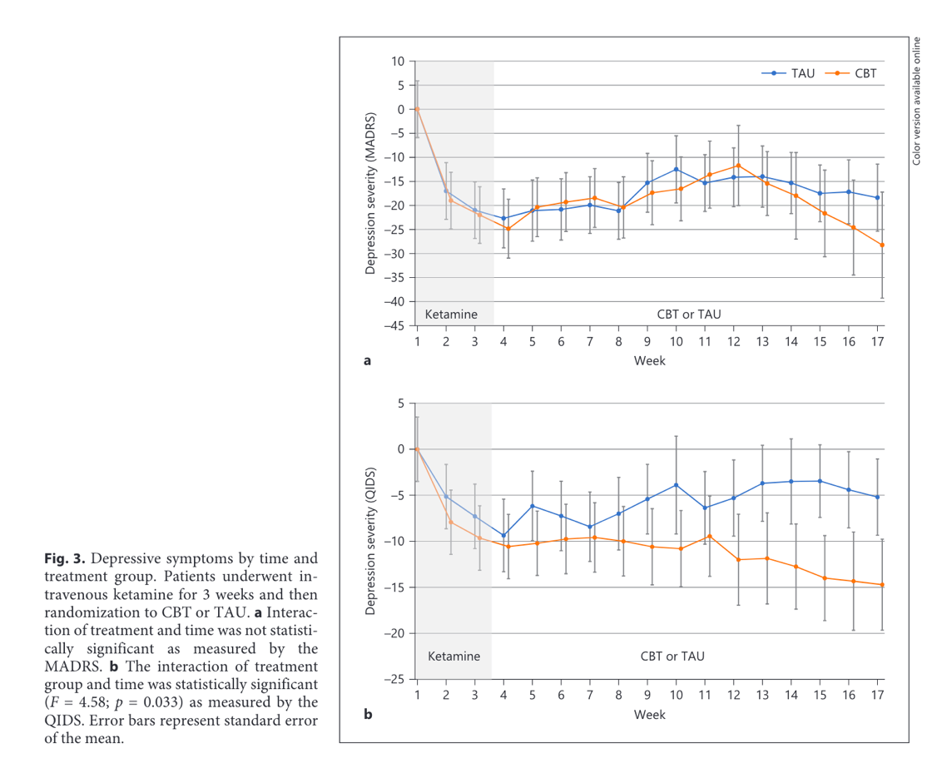

Figure S2: Graphs from Wilkinson et al., 2021 (study no.9) used to calculate the average change in depression scores.

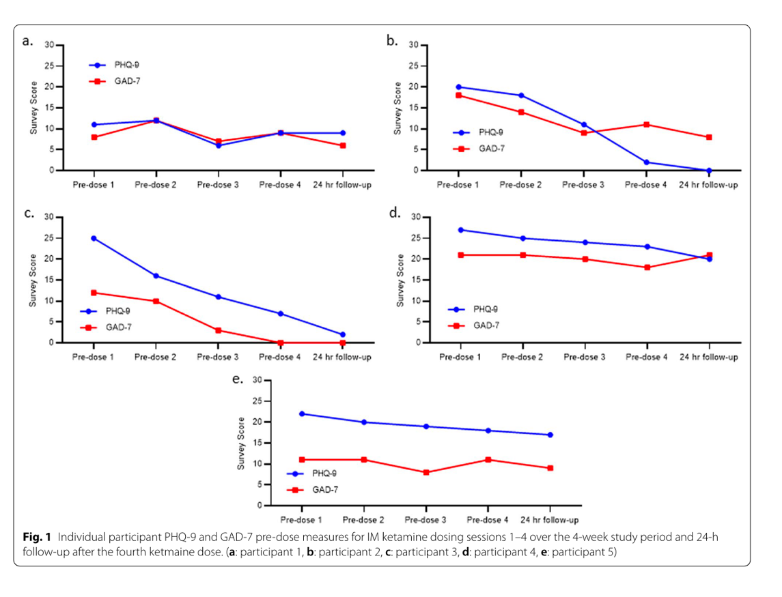
Figure S3: Line graphs from Robinson et al., 2022 (study no.6) used to calculate the mean change in PHQ-9 scores.

