SUPPLEMENTARY MATERIALS
Figure S1. Testing under conditions of equal fixed ratio requirements for both cocaine and sucrose
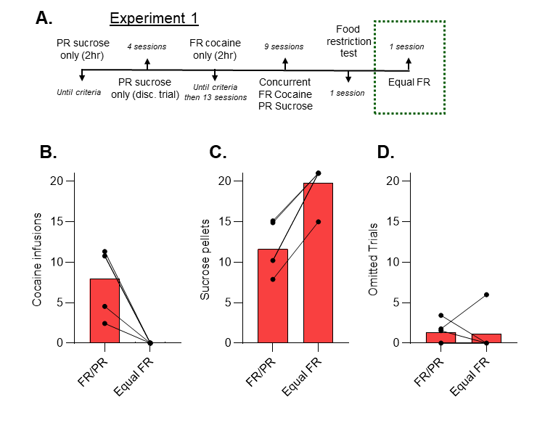
A subset of animals from Experiment 1 (n = 5, males) did not proceed to cocaine non-reward training, but instead were tested under conditions of equal ratio requirements for both sucrose and cocaine (FR3/FR3). All of the rats reduced their cocaine responding to 0 (B), while increasing their sucrose choice (C) without an impact on the number of trials omitted (D). These data, although limited, suggest that offering sucrose on a progressive ratio is a key factor for eliciting mixed choice in this choice model, since rats will readily reallocate to sucrose when prices are equivalent.
Figure S2. Sucrose-only progressive ratio training
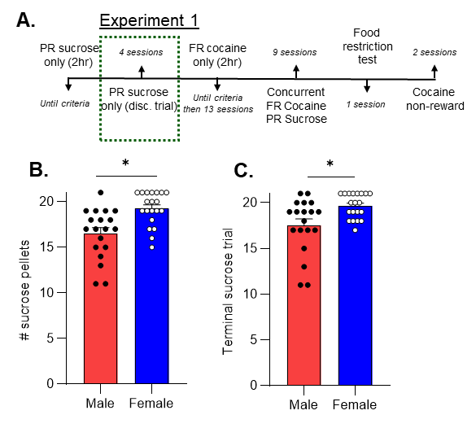
In Experiment 1, rats were first trained to respond under a progressive ratio schedule of sucrose pellet reinforcement with no time restriction for each ratio requirement (2-hour limit for each session). After responding was acquired, rats completed 4 discrete trial sucrose-only training sessions that were structured identically to the dual-reinforcer choice sessions, except that only the sucrose lever was inserted (Fig. S2A). Data from the last discrete trial session are shown with bars indicating the mean plus standard error and each symbol represents one animal (Fig. S2B, C). We observed that female rats achieved more sucrose pellets than males (Fig. S2B, Mann-Whitney test, *p < 0.05). Additionally, female rats are willing to exert more effort for their last sucrose pellet (terminal sucrose trial) than male rats (Fig. S2C, Mann-Whitney test, *p < 0.05).

Figure S3. Effects of acute sucrose satiety on choice behavior
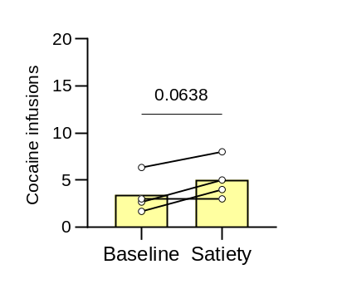
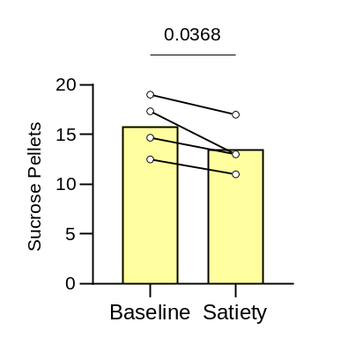
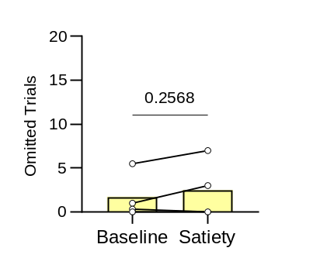
A.
B.
C.

In a small cohort of female Long-Evans rats (n=4), we examined the effect of acute sucrose satiety on choice between sucrose and cocaine (0.5 mg/kg/inf). Data shown is the mean baseline (avg. last 3 choice sessions) versus single satiety session data. Each pair of symbols and connecting line represents 1 animal. We found a trend towards increased cocaine choice (Fig. S3A, paired t-test, p = 0.064), a significant decrease in sucrose choice (Fig. S3B, paired t-test, p = 0.037), and no change in omitted trials (Fig. S3C, paired t-test, p = 0.257).

Table S1. Summary of reported statistics
Experiment / Condition | Dependent Variable / Metric | Comparison / Group | Statistical Test | Result / p-value
Exp 1: Dose Effects | # Cocaine Infusions | 0.2 vs. 0.5 mg/kg (Dose) | Dunn’s multiple comparisons | p = 0.006
Exp 1: Dose Effects | # Sucrose Pellets | 0.2 vs. 0.5 mg/kg (Dose) | Dunn’s multiple comparisons | p = 0.003
Exp 1: Dose Effects | # Omitted Trials | Among dose groups | Kruskal-Wallis | p > 0.05
Exp 1: Dose Effects | First Cocaine Choice (Trial #) | 0.2 vs. 0.5 mg/kg (Dose) | Dunn’s multiple comparisons | p = 0.037
Exp 1: Dose Effects | Last Sucrose Choice (Trial #) | 0.2 vs. 0.5 mg/kg (Dose) | Dunn’s multiple comparisons | p = 0.024
Exp 1: Dose Effects | Cocaine, Sucrose, Omissions, etc. | Male vs. Female | Mann-Whitney | p > 0.05
Exp 1: Food Restriction | Cocaine Infusions | Baseline vs. Restricted (Overall) | Wilcoxon signed-rank | p = 0.056
Exp 1: Food Restriction | Δ Cocaine Infusions | Difference Score (Overall) | One-sample t-test | p = 0.037
Exp 1: Food Restriction | Δ Cocaine Infusions | Difference Score (Males) | One-sample t-test | p = 0.038
Exp 1: Food Restriction | Δ Cocaine Infusions | Difference Score (Females) | One-sample t-test | p = 0.477
Exp 1: Food Restriction | Δ Cocaine Infusions | Male vs. Female | Unpaired t-test | p > 0.05
Exp 1: Food Restriction | Sucrose Pellets | Baseline vs. Restricted (Overall) | Wilcoxon signed-rank | p = 0.010
Exp 1: Food Restriction | Δ Sucrose Pellets | Difference Score (Overall) | One-sample t-test | p = 0.010
Exp 1: Food Restriction | Δ Sucrose Pellets | Difference Score (Males) | One-sample t-test | p = 0.006
Exp 1: Food Restriction | Δ Sucrose Pellets | Male vs. Female | Unpaired t-test | p > 0.05
Exp 1: Food Restriction | # Omitted Trials | Baseline vs. Restricted (Overall) | Wilcoxon signed-rank | p = 0.510
Exp 1: Food Restriction | # Omitted Trials | Male vs. Female | Unpaired t-test | p > 0.05
Exp 1: Food Restriction | Last Sucrose Choice (Trial #) | Baseline vs. Restricted (Overall) | Wilcoxon signed-rank | p = 0.031
Exp 1: Food Restriction | Δ Last Sucrose Choice | Difference Score (Overall) | One-sample t-test | p = 0.026
Exp 1: Food Restriction | Δ Last Sucrose Choice | Difference Score (Males) | One-sample t-test | p = 0.013
Exp 1: Food Restriction | Δ Last Sucrose Choice | Difference Score (Females) | One-sample t-test | p = 0.382
Exp 1: Food Restriction | Δ Last Sucrose Choice | Male vs. Female | Unpaired t-test | p > 0.05
Exp 1: Food Restriction | First Cocaine Choice (Trial #) | Baseline vs. Restricted (Overall) | Wilcoxon signed-rank | p = 0.465
Exp 1: Satiety (Long Evans) | Cocaine Choice | Baseline vs. Satiety | Paired t-test | p = 0.064
Exp 1: Satiety (Long Evans) | Sucrose Choice | Baseline vs. Satiety | Paired t-test | p = 0.037
Exp 1: Satiety (Long Evans) | Omitted Trials | Baseline vs. Satiety | Paired t-test | p = 0.257
Exp 1: Cocaine Non-Reward | Cocaine Infusions | Baseline vs. Non-Reward (Overall) | Wilcoxon signed-rank | p < 0.001
Exp 1: Cocaine Non-Reward | Δ Cocaine Infusions | Difference Score (Overall) | One-sample t-test | p < 0.001
Exp 1: Cocaine Non-Reward | Δ Cocaine Infusions | Difference Score (Males) | One-sample t-test | p = 0.001
Exp 1: Cocaine Non-Reward | Δ Cocaine Infusions | Difference Score (Females) | One-sample t-test | p = 0.021
Exp 1: Cocaine Non-Reward | Δ Cocaine Infusions | Male vs. Female | Unpaired t-test | p = 0.043
Exp 1: Cocaine Non-Reward | Sucrose Pellets | Baseline vs. Non-Reward (Overall) | Wilcoxon signed-rank | p = 0.016
Exp 1: Cocaine Non-Reward | Δ Sucrose Pellets | Difference Score (Males) | One-sample t-test | p = 0.034
Exp 1: Cocaine Non-Reward | Δ Sucrose Pellets | Difference Score (Females) | One-sample t-test | p = 0.256
Exp 1: Cocaine Non-Reward | # Omitted Trials | Baseline vs. Non-Reward (Overall) | Wilcoxon signed-rank | p = 0.008
Exp 1: Cocaine Non-Reward | Δ Omitted Trials | Difference Score (Males & Females) | One-sample t-test | p > 0.05
Exp 1: Cocaine Non-Reward | Last Sucrose Choice (Trial #) | Baseline vs. Non-Reward (Overall) | Wilcoxon signed-rank | p = 0.014
Exp 1: Cocaine Non-Reward | Δ Last Sucrose Choice | Difference Score (Males) | One-sample t-test | p = 0.042
Exp 1: Cocaine Non-Reward | Δ Last Sucrose Choice | Difference Score (Females) | One-sample t-test | p = 0.129
Exp 1: Cocaine Non-Reward | First Cocaine Choice (Trial #) | Baseline vs. Non-Reward (Overall) | Wilcoxon signed-rank | p > 0.05
Exp 2: Punished (AWN) Choice | Cocaine Infusions | Baseline vs. AWN (Overall) | Wilcoxon signed-rank | p = 0.002
Exp 2: Punished (AWN) Choice | Δ Cocaine Infusions | Difference Score (Overall) | One-sample t-test | p = 0.003
Exp 2: Punished (AWN) Choice | Δ Cocaine Infusions | Difference Score (Males) | One-sample t-test | p = 0.026
Exp 2: Punished (AWN) Choice | Δ Cocaine Infusions | Difference Score (Females) | One-sample t-test | p = 0.062
Exp 2: Punished (AWN) Choice | Sucrose Pellets | Baseline vs. AWN (Overall) | Wilcoxon signed-rank | p = 0.031
Exp 2: Punished (AWN) Choice | Δ Sucrose Pellets | Male vs. Female | Unpaired t-test | p = 0.041
Exp 2: Punished (AWN) Choice | Δ Sucrose Pellets | Difference Score (Males) | One-sample t-test | p = 0.041
Exp 2: Punished (AWN) Choice | Δ Sucrose Pellets | Difference Score (Females) | One-sample t-test | p = 0.588
Exp 2: Punished (AWN) Choice | # Omitted Trials | Baseline vs. AWN (Overall) | Wilcoxon signed-rank | p = 0.004
Exp 2: Punished (AWN) Choice | Δ Omitted Trials | Difference Score (Males & Females) | One-sample t-test | p > 0.05
Exp 2: Punished (AWN) Choice | Last Sucrose Choice (Trial #) | Baseline vs. AWN (Overall) | Wilcoxon signed-rank | p = 0.023
Exp 2: Punished (AWN) Choice | Δ Last Sucrose Choice | Male vs. Female | Unpaired t-test | p = 0.012
Exp 2: Punished (AWN) Choice | Δ Last Sucrose Choice | Difference Score (Males) | One-sample t-test | p = 0.016
Exp 2: Punished (AWN) Choice | Δ Last Sucrose Choice | Difference Score (Females) | One-sample t-test | p = 0.618
Exp 2: Punished (AWN) Choice | First Cocaine Choice (Trial #) | Baseline vs. AWN (Overall) | Wilcoxon signed-rank | p = 0.048
Exp 2: Punished (AWN) Choice | Δ First Cocaine Choice | Within & Between Groups | One-sample & Unpaired t-test | p > 0.05
Supplementary Data | Sucrose Only Pellets | Male vs. Female (Sucrose Only) | Mann-Whitney | p < 0.05
Supplementary Data | Terminal Sucrose Trial | Male vs. Female (Sucrose Only) | Mann-Whitney | p < 0.05

