Online Resource 2
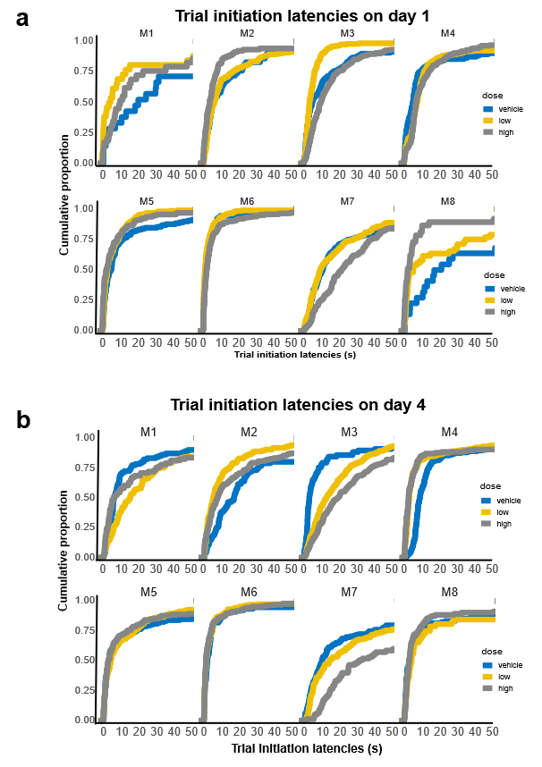
The graphs on the left show empirical cumulative distributions of trial initiation times for vehicle, high and low doses of scopolamine, on day 1 (a) and day 4 (b) stratified by subject for the chronic drug condition. (Day 5 lacked one subject so was not included).
Subjects M3 and M7 were slower to initiate their trials on high dose of scopolamine, while subject M8 became faster. Marmosets M4-M6 initiated the majority of their trials with short latencies and in their case, the scopolamine dose had little impact on the latency.

