Supplementary methods
Dexamethasone administration and blood sample collection
Male C57BL/6J mice (9 weeks old; Japan SLC, Shizuoka, Japan) received intraperitoneal injections of dexamethasone (Dex; FUJIFILM Wako Pure Chemical Corporation, Osaka, Japan) at doses of 10, 30, 50, and 100 mg/kg or vehicle, administered at Zeitgeber time 12 (ZT12). They were housed under controlled environmental conditions with a 12:12-h light/dark cycle (lights on at 8:00 a.m.), constant temperature (24 ± 1 ℃), and free access to food and water. Four mice were housed per cage, and food intake was measured for each cage to calculate the average intake per mouse. Body weight and food intake were monitored daily throughout the treatment period, and the animals were observed for signs of abnormal behavior. Peripheral blood was collected one day before the first injection and again on the day after the final injection. Hematological parameters were determined using a Celltac α MEK-6450 hematology analyzer (Nihon Kohden, Tokyo, Japan).

Plasma allopregnanolone measurement
Mice were deeply anesthetized with a mixture consisting of 0.75 mg/kg medetomidine (Domitor® Nippon Zenyaku Kogyo Co., Ltd., Tokyo, Japan), 4.0 mg/kg midazolam (Dormicum®, Astellas Pharma Inc., Tokyo, Japan), and 5.0 mg/kg butorphanol (Vetorphale®, Meiji Seika Kaisha, Ltd., Tokyo, Japan). Whole blood was collected through a cardiac puncture into a tube (Becton, Dickinson and Company, Franklin Lakes, NJ, USA) containing EDTA, and then centrifuged at 1000 × g for 10 minutes at room temperature to obtain plasma. Plasma allopregnanolone levels were determined using an Allopregnanolone ELISA Kit (Abcam, Cambridge, UK) according to the manufacturer’s instructions. The correlation between plasma allopregnanolone levels and electroencephalographic (EEG) parameters was also examined.

Hypothalamic tissue collection and corticotropin-releasing hormone​ quantification
Mice were sacrificed by cervical dislocation. The brains were quickly removed on ice and immediately frozen in liquid nitrogen. ​A coronal brain section spanning Bregma −0.5 mm to −2.5 mm was prepared using a Brain Blocker (Muromachi Kikai Co., Ltd., Tokyo, Japan), and the hypothalamic region was isolated from this section for subsequent analysis. Hypothalamic tissues were homogenized in 30 volumes of PBS containing 0.2% Nonidet P-40 (Nacalai Tesque, Kyoto, Japan), followed by centrifugation at 18,360 × g for 20 min at 4 °C. The resulting supernatant was collected and used as the brain extract to quantify corticotropin-releasing hormone​ (CRH). The obtained extract was analyzed for CRH levels using a Mouse/Rat CRF-HS ELISA Kit (Yanaihara Institute Inc., Shizuoka, Japan) according to the manufacturer’s instructions.

Supplementary figures
Fig. S1 Physiological and hematological assessment of chronic Dex treatment.
(a, b) General physiological monitoring. Time course of (a) body weight and (b) daily food intake during the 5-day treatment period (Baseline to Day 5). Mice were treated with vehicle or varying doses of Dex (10, 30, 50, and 100 mg/kg, i.p.). (c–j) Hematological analysis performed after the 5-day treatment. (c) White blood cell (WBC) counts. (d–j) Erythropoietic and platelet parameters: (d) red blood cell (RBC) count, (e) platelet (PLT) count, (f) hemoglobin (HGB), (g) hematocrit (HCT), (h) mean corpuscular volume (MCV), (i) mean corpuscular hemoglobin (MCH), and (j) mean corpuscular hemoglobin concentration (MCHC). Data are presented as mean with SD. (n = 4); *p < 0.05 vs. Vehicle group (two-way ANOVA followed by Tukey's post hoc test or paired t test)

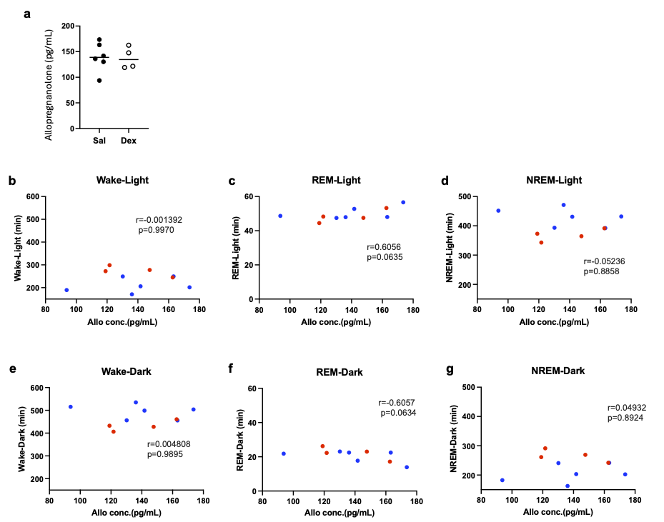
Fig. S2 Relationship between plasma allopregnanolone levels and sleep–wake patterns.
(a) Plasma concentrations of allopregnanolone measured after the 5-day treatment with Sal or Dex. (b–g) Correlation analysis between plasma allopregnanolone concentrations (Allo conc.) and the total duration of each sleep–wake stage. Scatter plots show the relationships with (b) wakefulness, (c) REM sleep, and (d) NREM sleep during the light phase, and with (e) wakefulness, (f) REM sleep, and (g) NREM sleep during the dark phase. Blue circles: Sal-treated mice; Red circles: Dex-treated mice. Pearson’s correlation coefficient (r) and p-value are indicated in each panel. Data in (a) are presented as individual data points with the median indicated (two-tailed unpaired Student’s t-test)

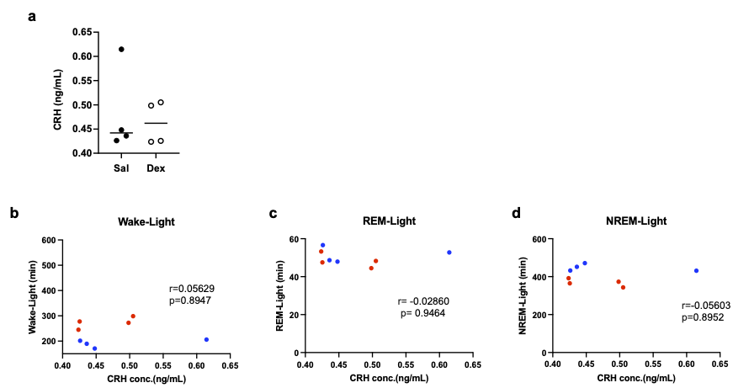

Fig. S3 Relationship between hypothalamic CRH levels and sleep–wake patterns.
(a) Hypothalamic CRH concentrations measured after 5-day treatment with Sal or Dex. (b–d) Correlation analysis between hypothalamic CRH levels and sleep duration during the light phase. Scatter plots showing the relationships between CRH concentration and (b) wakefulness, (c) REM sleep, and (d) NREM sleep. Blue circles: Sal group; Red circles: Dex group. Pearson’s correlation coefficient (r) and p-value are indicated in each panel. Data in (a) are presented as individual data points with the median indicated (two-tailed unpaired Student’s t-test)

