Supplementary Materials

Acute and delayed effects of THC on memories of stress in healthy adults
Psychopharmacology

Hanna Molla¹*, Evan Hahn¹, Christian Ramos¹, Harriet de Wit¹

¹Department of Psychiatry and Behavioral Neuroscience
University of Chicago
5841 S Maryland Ave MC3077
Chicago IL, 60637, USA

*Corresponding author
Email: hmolla@uchicago.edu

Fig. S1
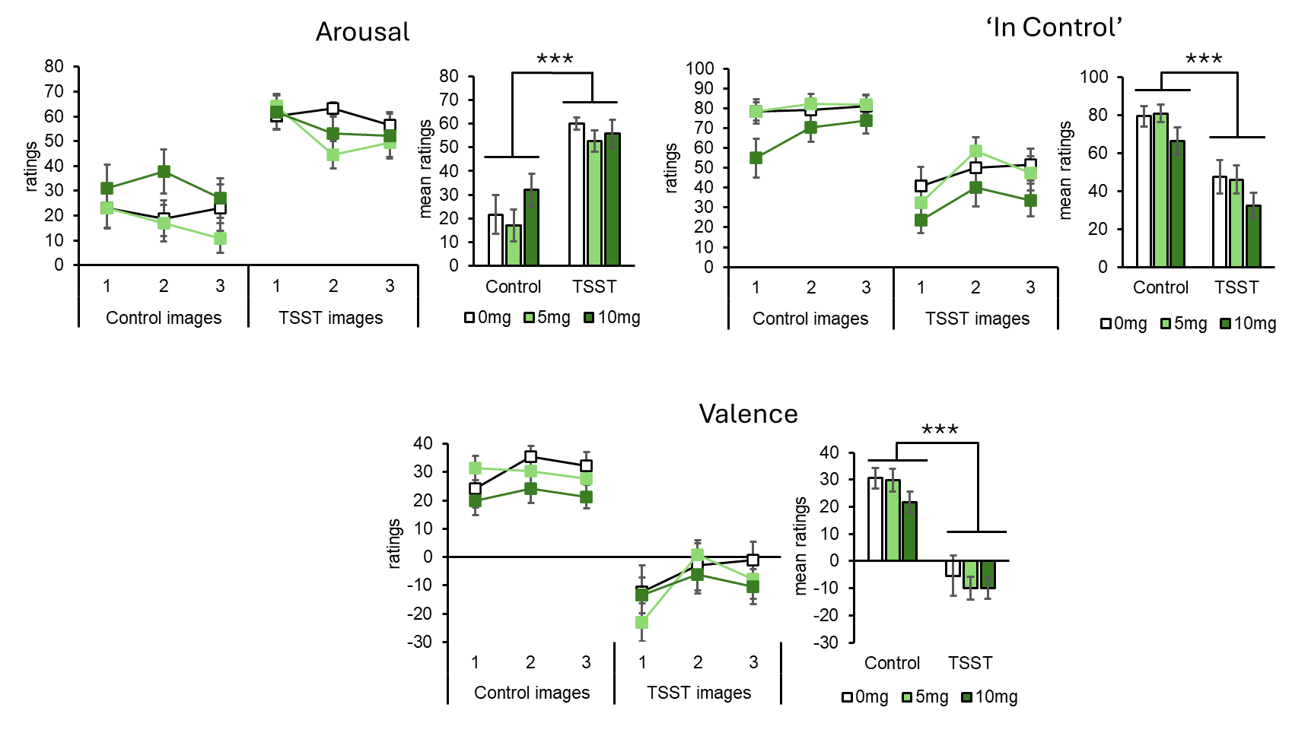

Fig. S1. Mean (±SEM) ratings of Arousal, In Control, and Valence after Control- and TSST-images across three presentations, 2 hours post-administration of placebo (0 mg), THC 5 mg, or THC 10 mg. Bar graphs show mean (±SEM) ratings for control and TSST cues across drug condition; *** p < 0.001.

Fig. S2
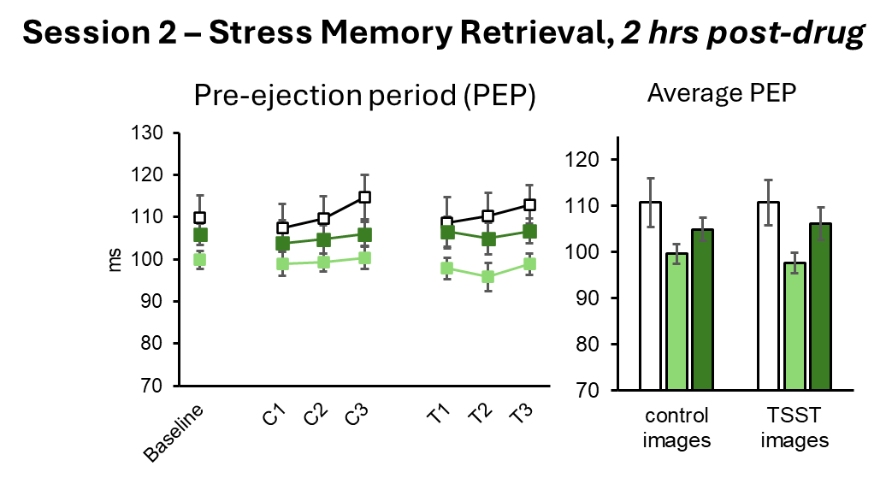
Fig. S2. Mean (±SEM) pre-ejection period values in ms during baseline, and across three presentations of Control- and TSST-images in placebo (0 mg), THC 5 mg, or THC 10 mg groups 2-hrs post-drug. Bar graphs show mean (±SEM) values for control and TSST images across drug condition; *** p < 0.001.

Fig. S3
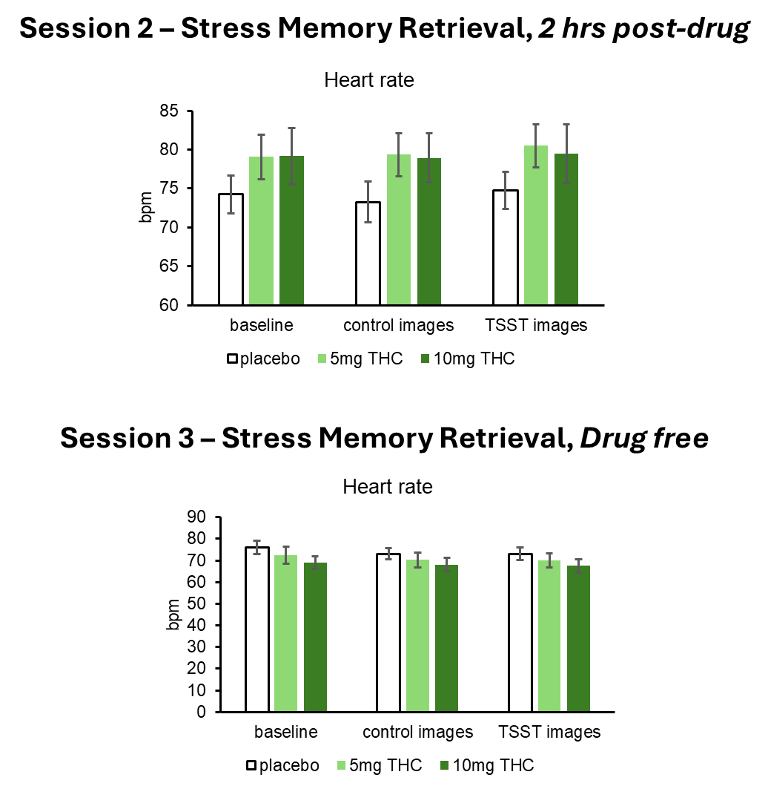

Fig. S3. Mean (±SEM) heart rate (bpm) for baseline, control and TSST images across drug condition during same time intervals when PEP was collected.

Fig. S4
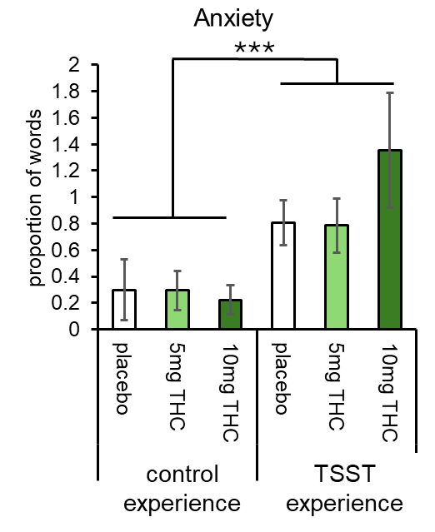

Fig. S3. Bar graphs reflect mean (±SEM) proportion of anxiety words used while recalling the Control and TSST experience, in placebo (0 mg), THC 5 mg, and THC 10 mg groups, 2.5-hrs post-drug; *** p < 0.001.

