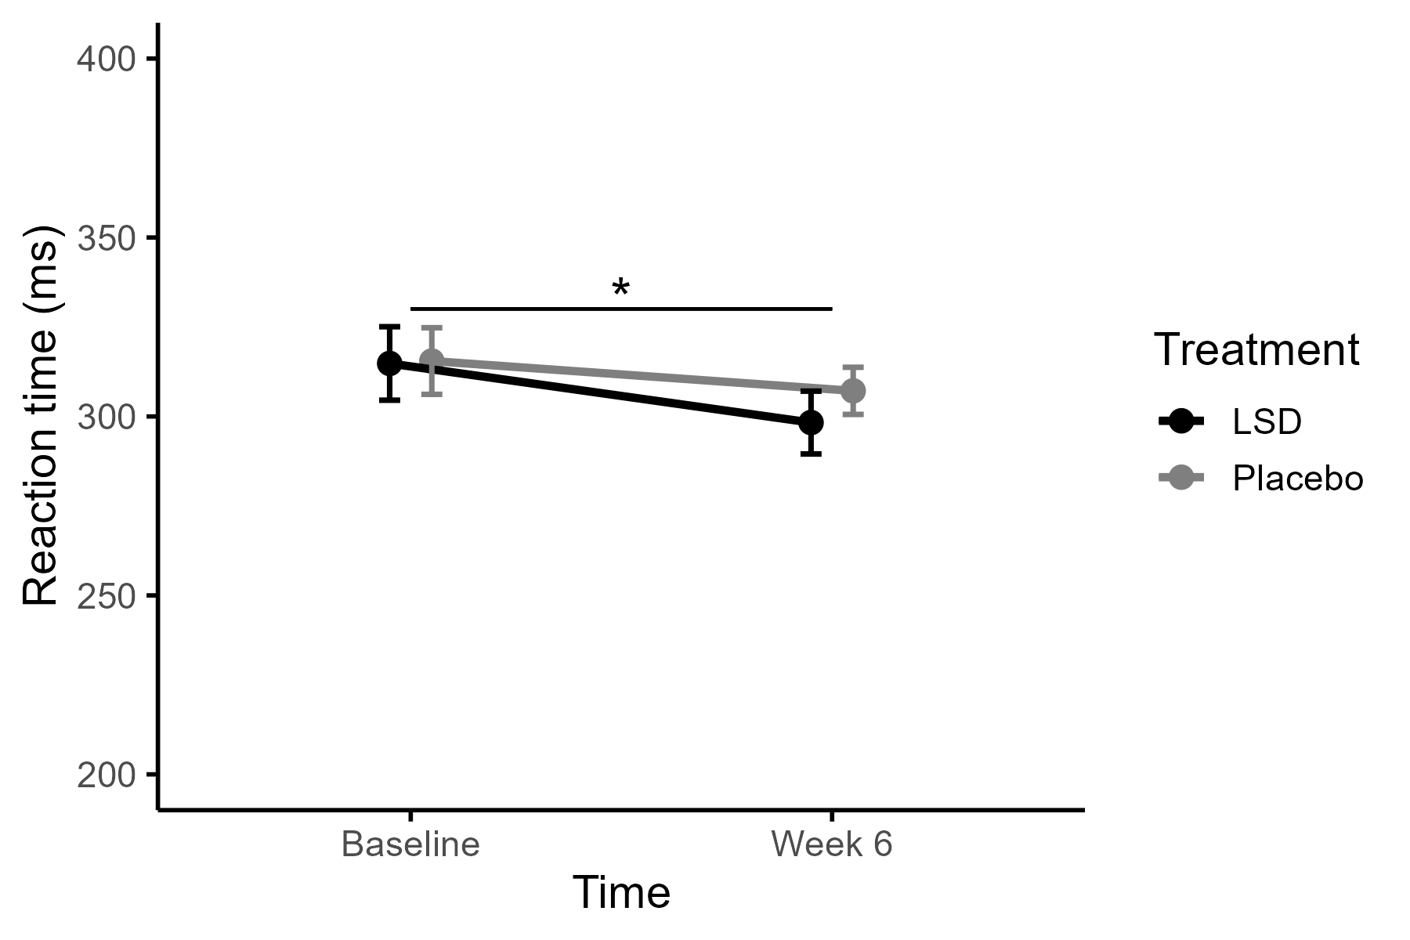
Fig. S1 Raw mean reaction time of the Psychomotor Vigilance Task per Treatment (Placebo vs. LSD) and Time (Baseline and Week 6). Error bars represent standard errors of the mean. At baseline, 25 (LSD) and 25 (placebo) participants were included, and at week 6, 23 (LSD) and 23 (placebo) participants were included. No significant Time x Treatment interaction effect or main effect of Treatment was found, but a main effect of Time (p= .025)

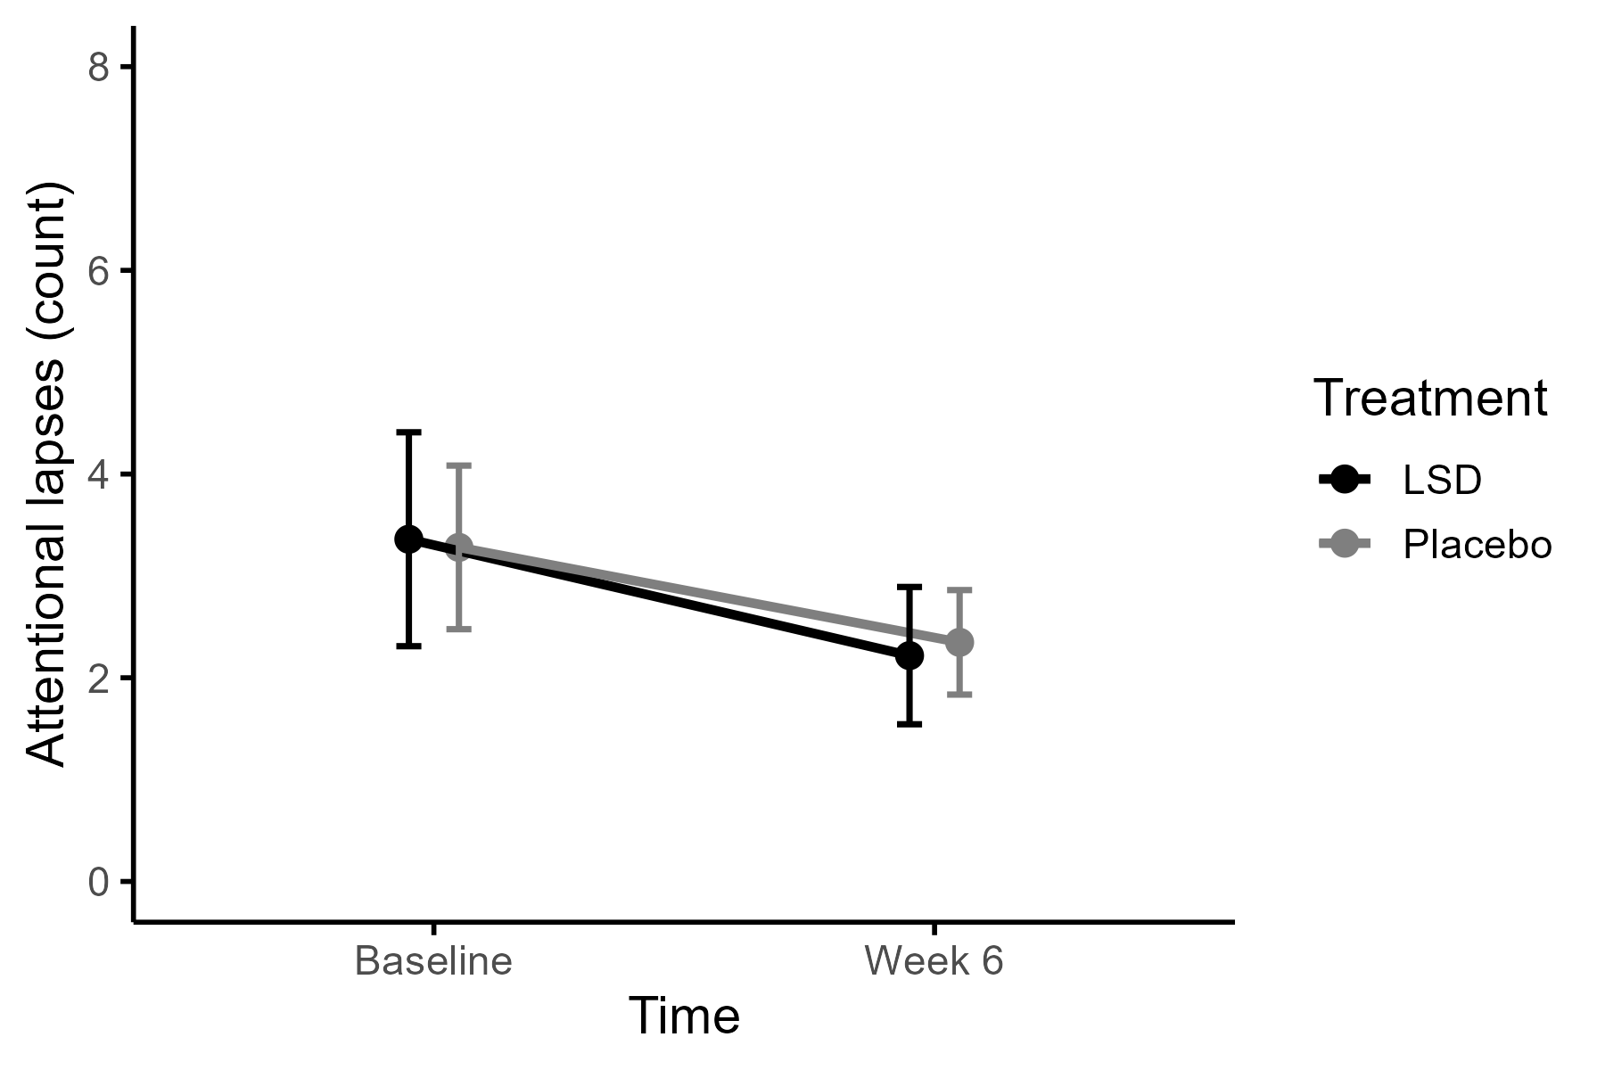
Fig. S2 Raw mean attentional lapses of the Psychomotor Vigilance Task per Treatment (Placebo vs. LSD) and Time (Baseline and Week 6). Error bars represent standard errors of the mean. At baseline, 25 (LSD) and 25 (placebo) participants were included, and at week 6, 23 (LSD) and 23 (placebo) participants were included. No significant Time x Treatment interaction, and main effects of Time or Treatment were found

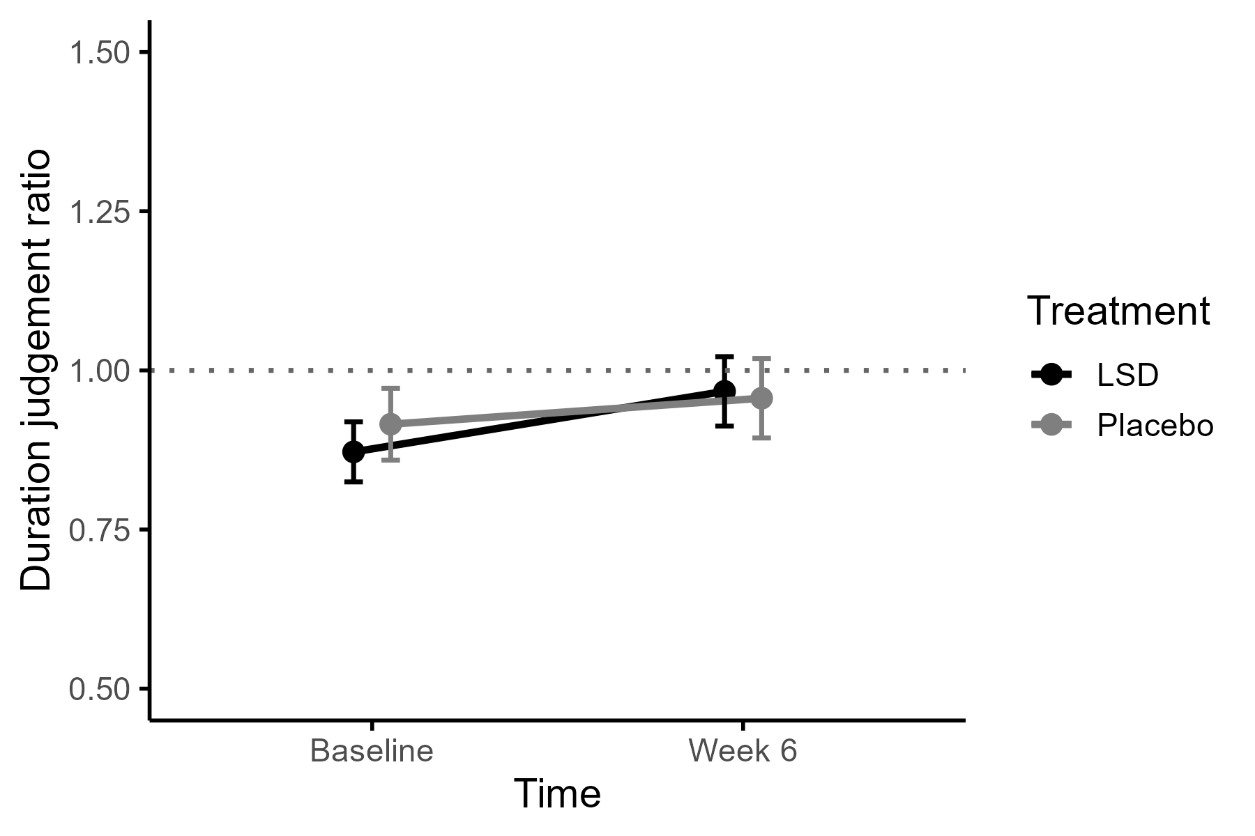
Fig. S3 Raw mean duration judgment ratio averaged over all six time intervals of the Time Production Task per Treatment (Placebo vs. LSD) and Time (Baseline and Week 6). The duration judgment ratio was calculated as subjective duration divided by objective interval duration. The horizontal dotted line at y = 1 indicates perfect temporal production. At baseline, 27 (LSD) and 25 (placebo) participants were included, and at week 6, 23 (LSD) and 22 (placebo) participants were included. Error bars represent standard errors of the mean. No significant Time x Treatment interaction, and main effects of Time or Treatment were found

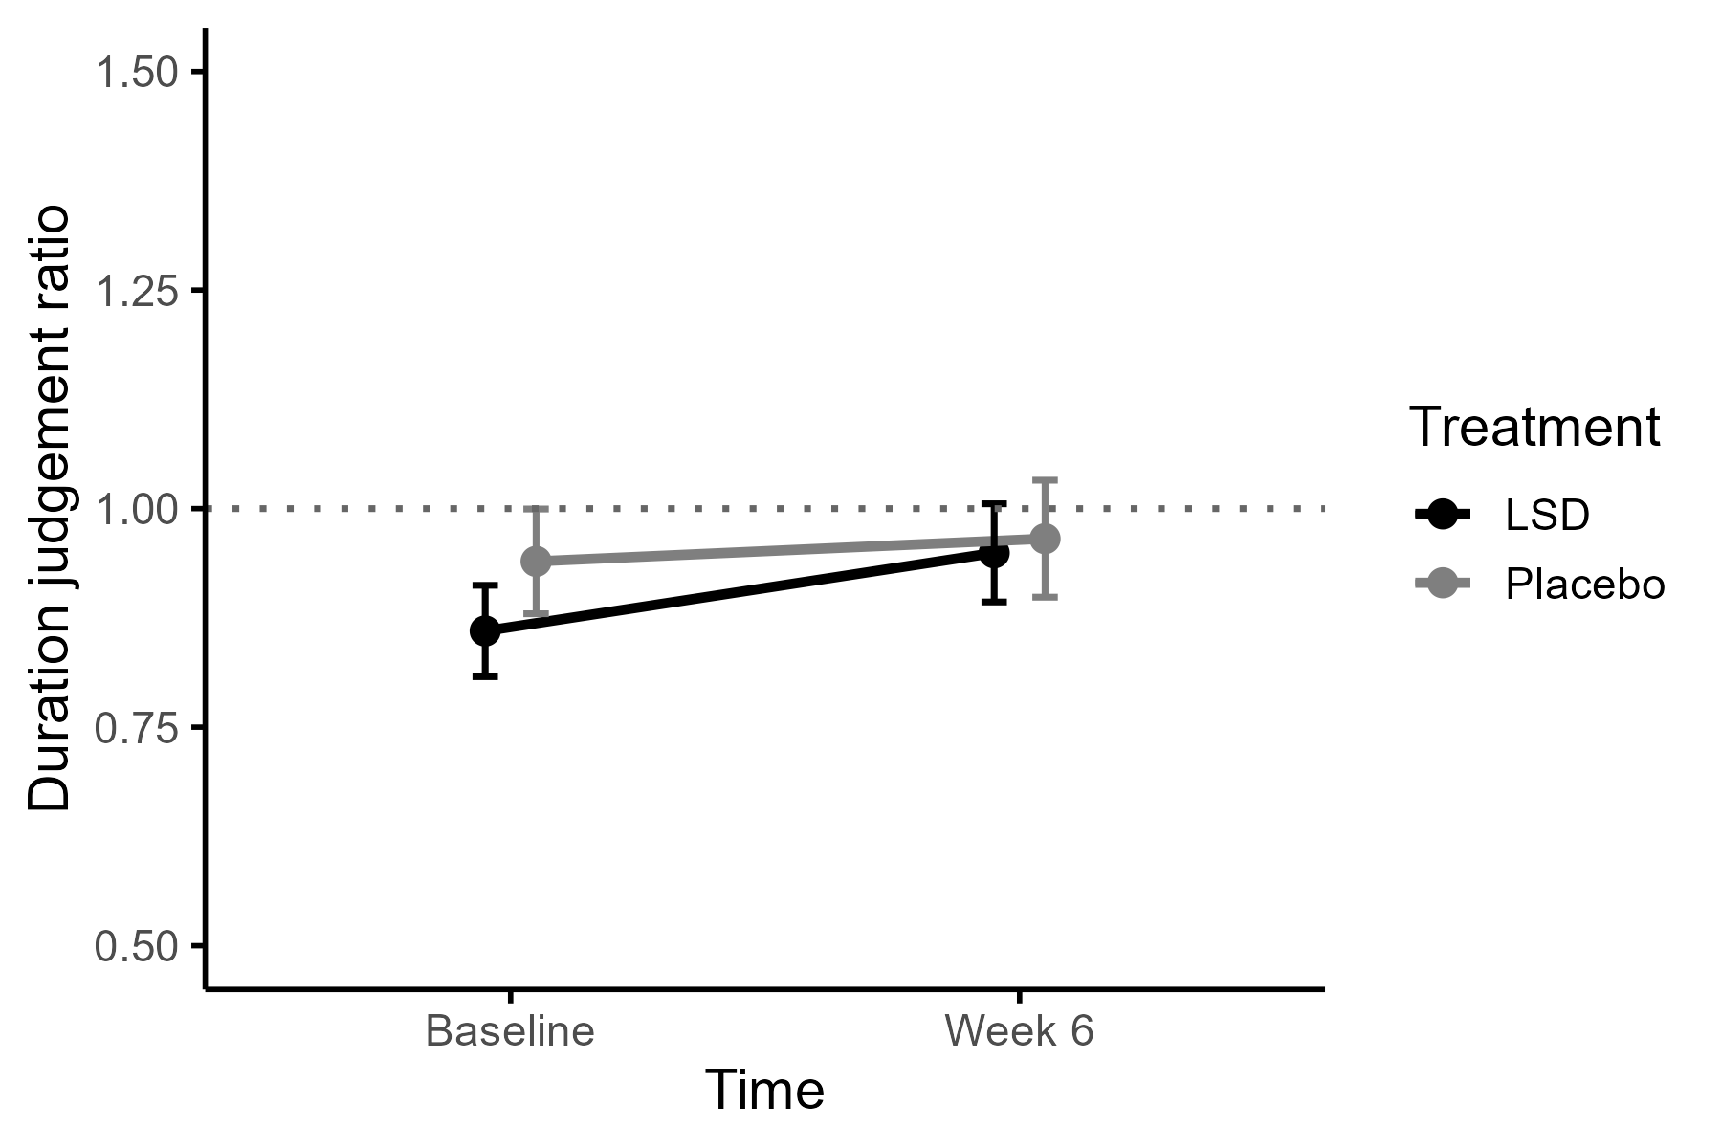
Fig. S4 Raw mean duration judgment ratio of the short time intervals (3 and 6 seconds) of the Time Production Task per Treatment (Placebo vs. LSD) and Time (Baseline and Week 6). The duration judgment ratio was calculated as subjective duration divided by objective interval duration. The horizontal dotted line at y = 1 indicates perfect temporal production. At baseline, 27 (LSD) and 25 (placebo) participants were included, and at week 6, 23 (LSD) and 22 (placebo) participants were included. Error bars represent standard errors of the mean. No significant Time x Treatment interaction, or main effects of Time and Treatment were found

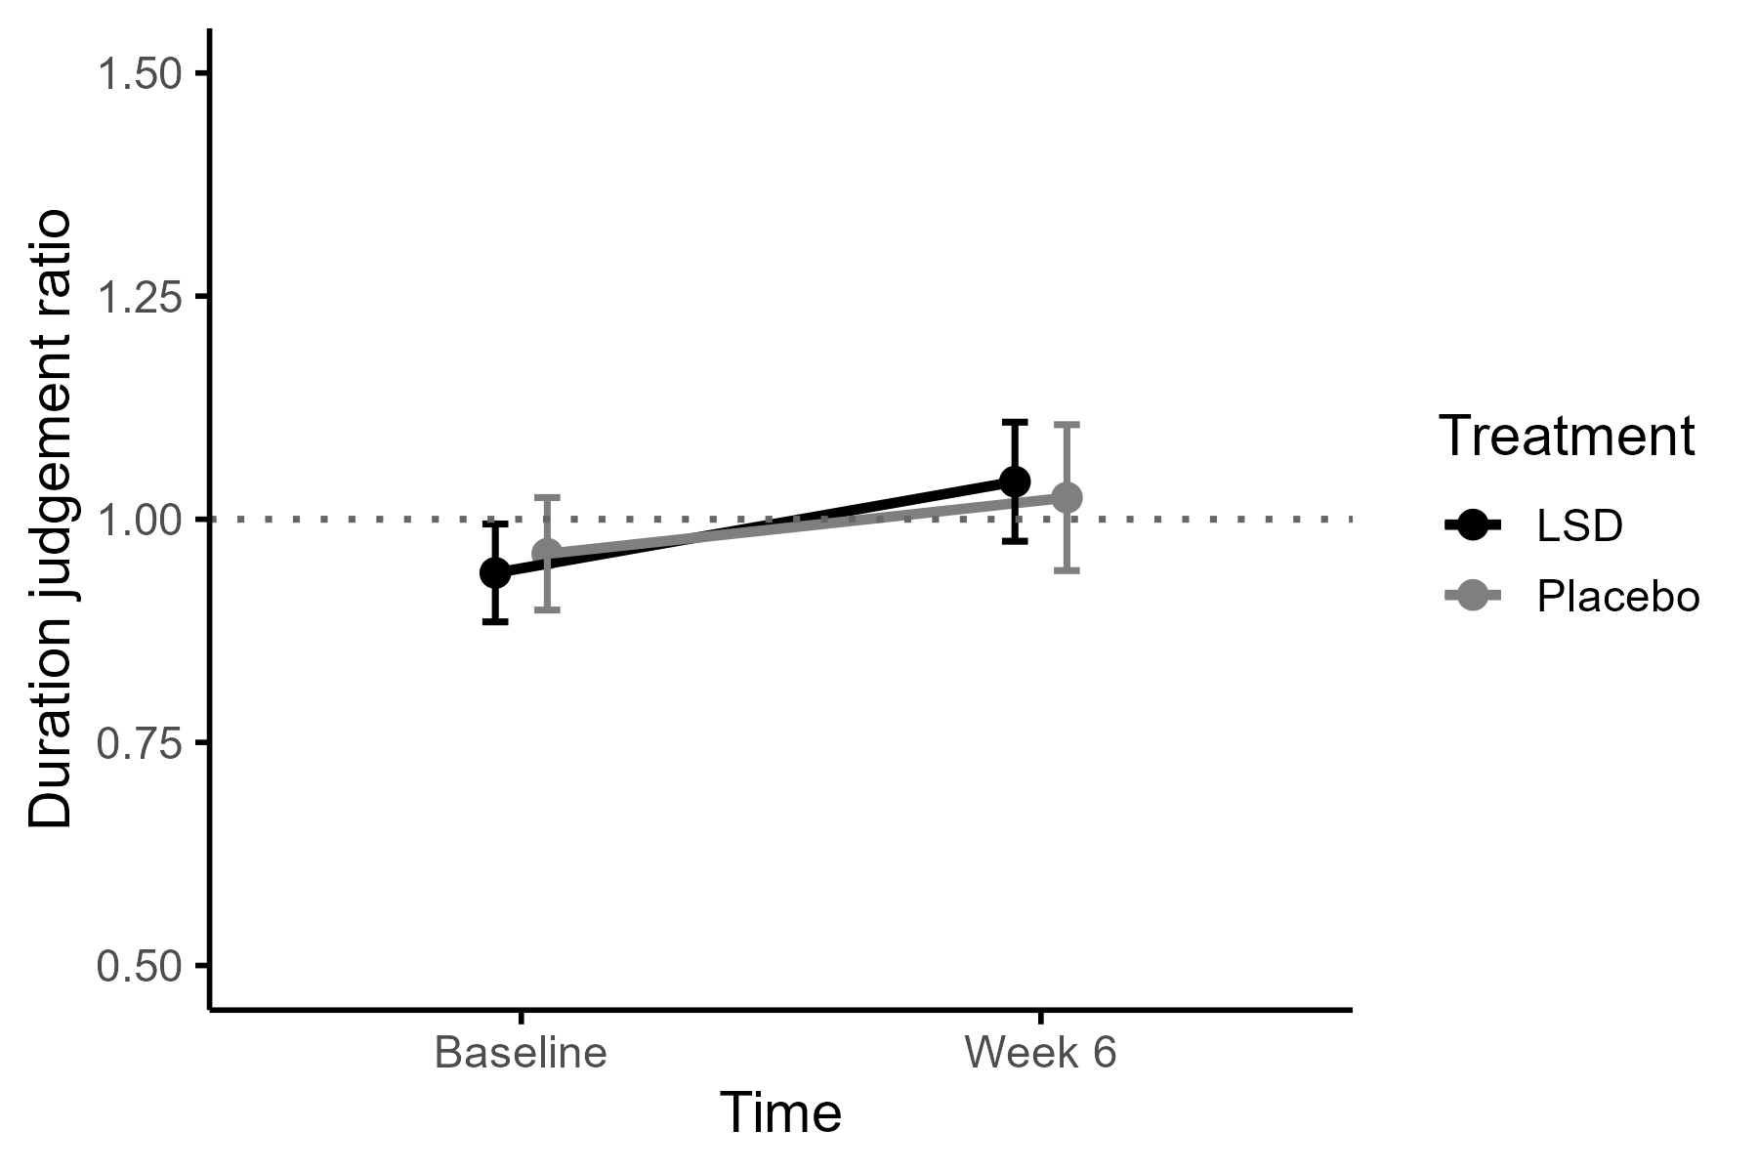
Fig. S5 Raw mean duration judgment ratio of the medium time intervals (12 and 15 seconds) of the Time Production Task per Treatment (Placebo vs. LSD) and Time (Baseline and Week 6). The duration judgment ratio was calculated as subjective duration divided by objective interval duration. The horizontal dotted line at y = 1 indicates perfect temporal production. At baseline, 27 (LSD) and 25 (placebo) participants were included, and at week 6, 23 (LSD) and 22 (placebo) participants were included. Error bars represent standard errors of the mean. No significant Time x Treatment interaction, or main effects of Time and Treatment were found

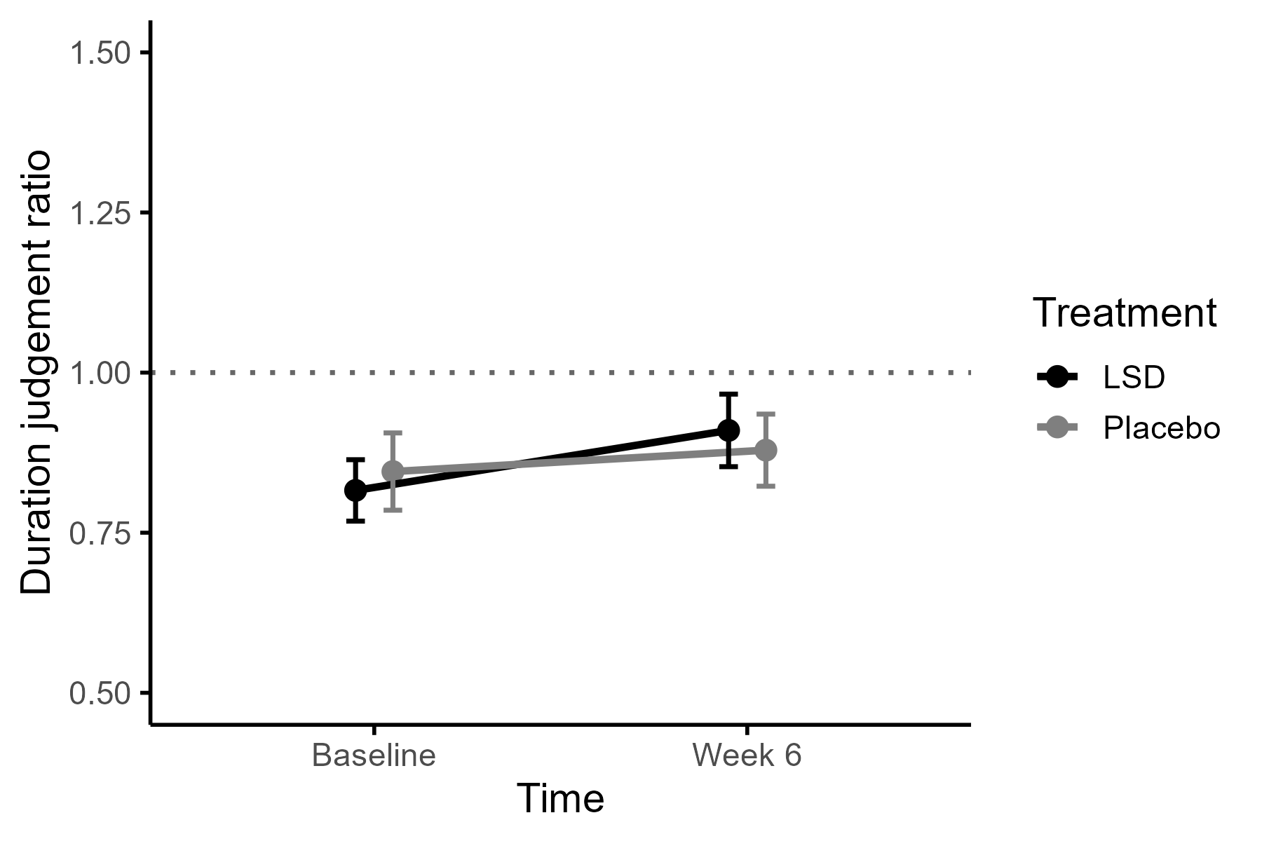
Fig. S6 Raw mean duration judgment ratio of the long time intervals (30 and 45 seconds) of the Time Production Task per Treatment (Placebo vs. LSD) and Time (Baseline and Week 6). The duration judgment ratio was calculated as subjective duration divided by objective interval duration. The horizontal dotted line at y = 1 indicates perfect temporal production. At baseline, 27 (LSD) and 25 (placebo) participants were included, and at week 6, 23 (LSD) and 22 (placebo) participants were included. Error bars represent standard errors of the mean. No significant Time x Treatment interaction, or main effects of Time and Treatment were found

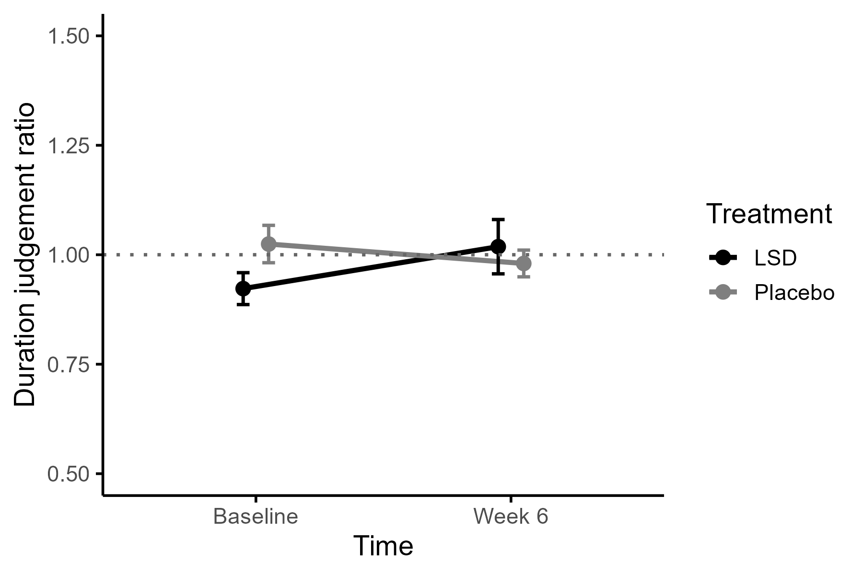
Fig. S7 Raw mean duration judgment ratio averaged over all six time intervals of the Time Reproduction Task per Treatment (Placebo vs. LSD) and Time (Baseline and Week 6). The duration judgment ratio was calculated as subjective duration divided by objective interval duration. The horizontal dotted line at y = 1 indicates perfect temporal production. At baseline, 26 (LSD) and 26 (placebo) participants were included, and at week 6, 19 (LSD) and 23 (placebo) participants were included. Error bars represent standard errors of the mean. No significant Time x Treatment interaction, or main effects of Time and Treatment were found

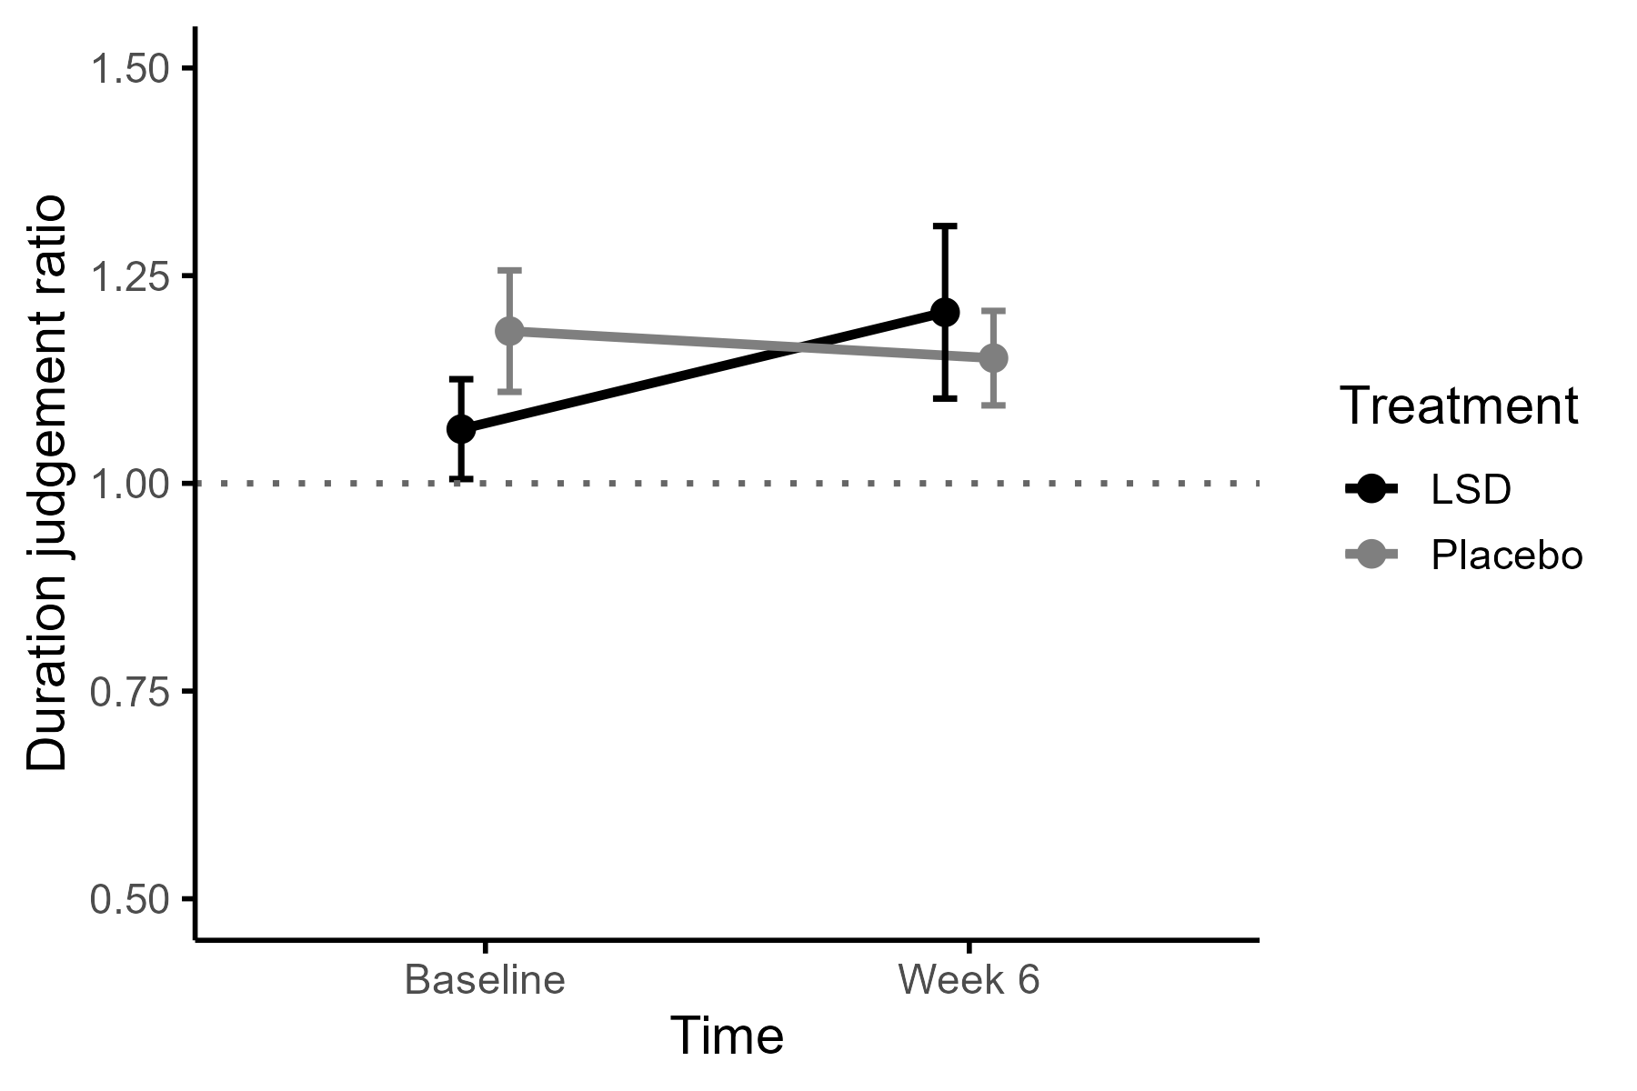
Fig. S8 Raw mean duration judgment ratio of the short time intervals (i.e., 3 and 6 seconds) of the Time Reproduction Task per Treatment (Placebo vs. LSD) and Time (Baseline and Week 6). The duration judgment ratio was calculated as subjective duration divided by objective interval duration. The horizontal dotted line at y = 1 indicates perfect temporal production. At baseline, 26 (LSD) and 26 (placebo) participants were included, and at week 6, 19 (LSD) and 23 (placebo) participants were included. Error bars represent standard errors of the mean. No significant Time x Treatment interaction, or main effects of Time and Treatment were found

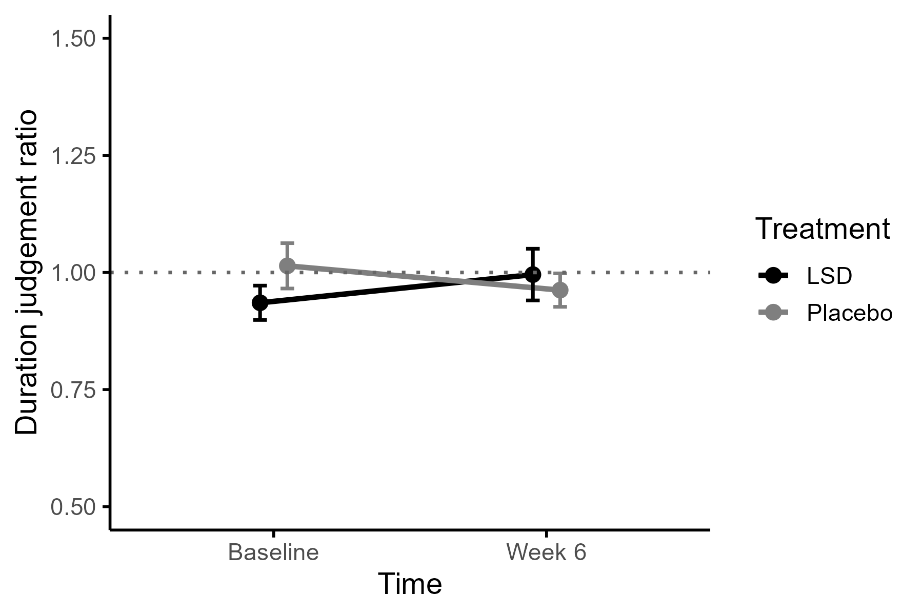
Fig. S9 Raw mean duration judgment ratio of the medium time intervals (i.e., 12 and 15 seconds) of the Time Reproduction Task per Treatment (Placebo vs. LSD) and Time (Baseline and Week 6). The duration judgment ratio was calculated as subjective duration divided by objective interval duration. The horizontal dotted line at y = 1 indicates perfect temporal production. At baseline, 26 (LSD) and 26 (placebo) participants were included, and at week 6, 19 (LSD) and 23 (placebo) participants were included. Error bars represent standard errors of the mean. No significant Time x Treatment interaction, or main effects of Time and Treatment were found

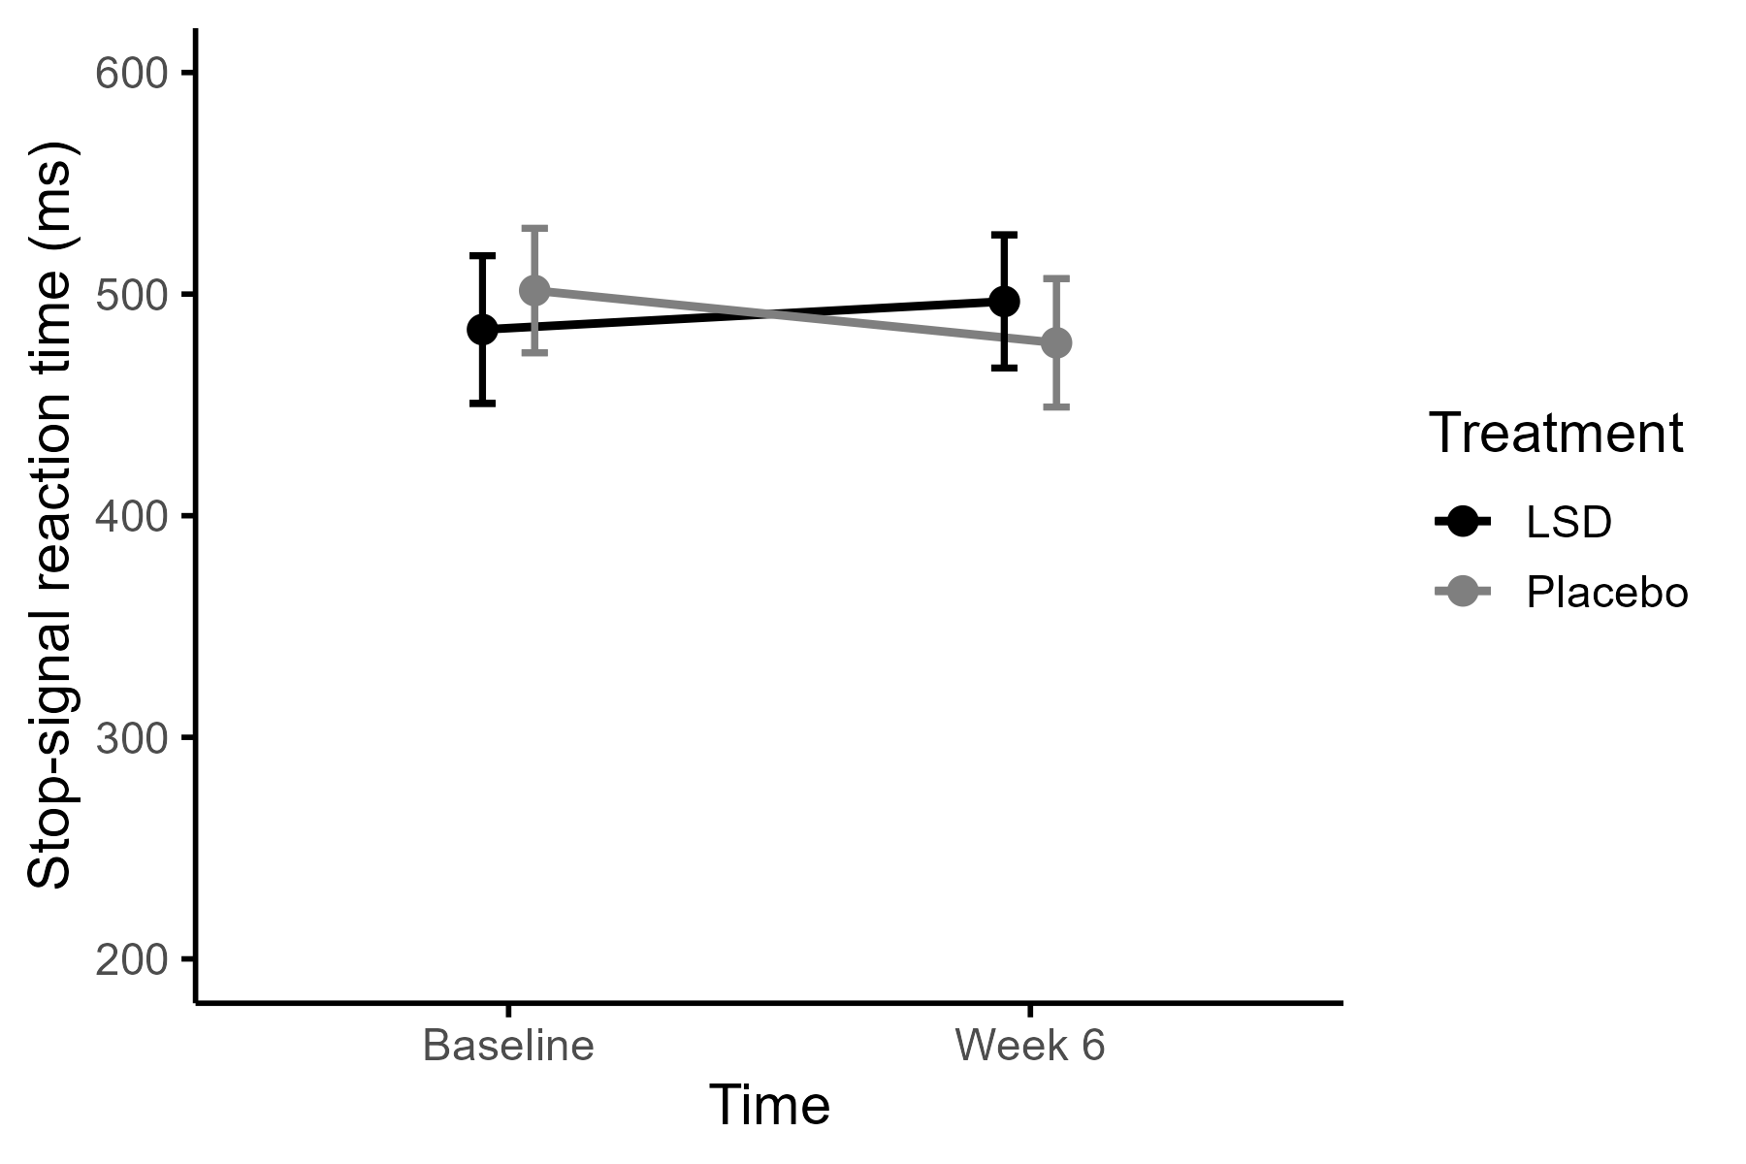
Fig. S10 Mean stop-signal reaction time (SSRT) in the Stop-Signal Task, by Treatment (placebo vs. LSD) and Time (baseline and Week 6). SSRT was estimated using the integration method based on the go reaction time distribution, the overall proportion of responses on stop trials, and the mean stop-signal delay. A higher SSRT indicates more difficulty inhibiting responses. At baseline, 24 (LSD) and 26 (placebo) participants were included, and at week 6, 23 (LSD) and 23 (placebo) participants were included. Error bars represent standard errors of the mean. No significant Time x Treatment interaction, or main effects of Time and Treatment were found

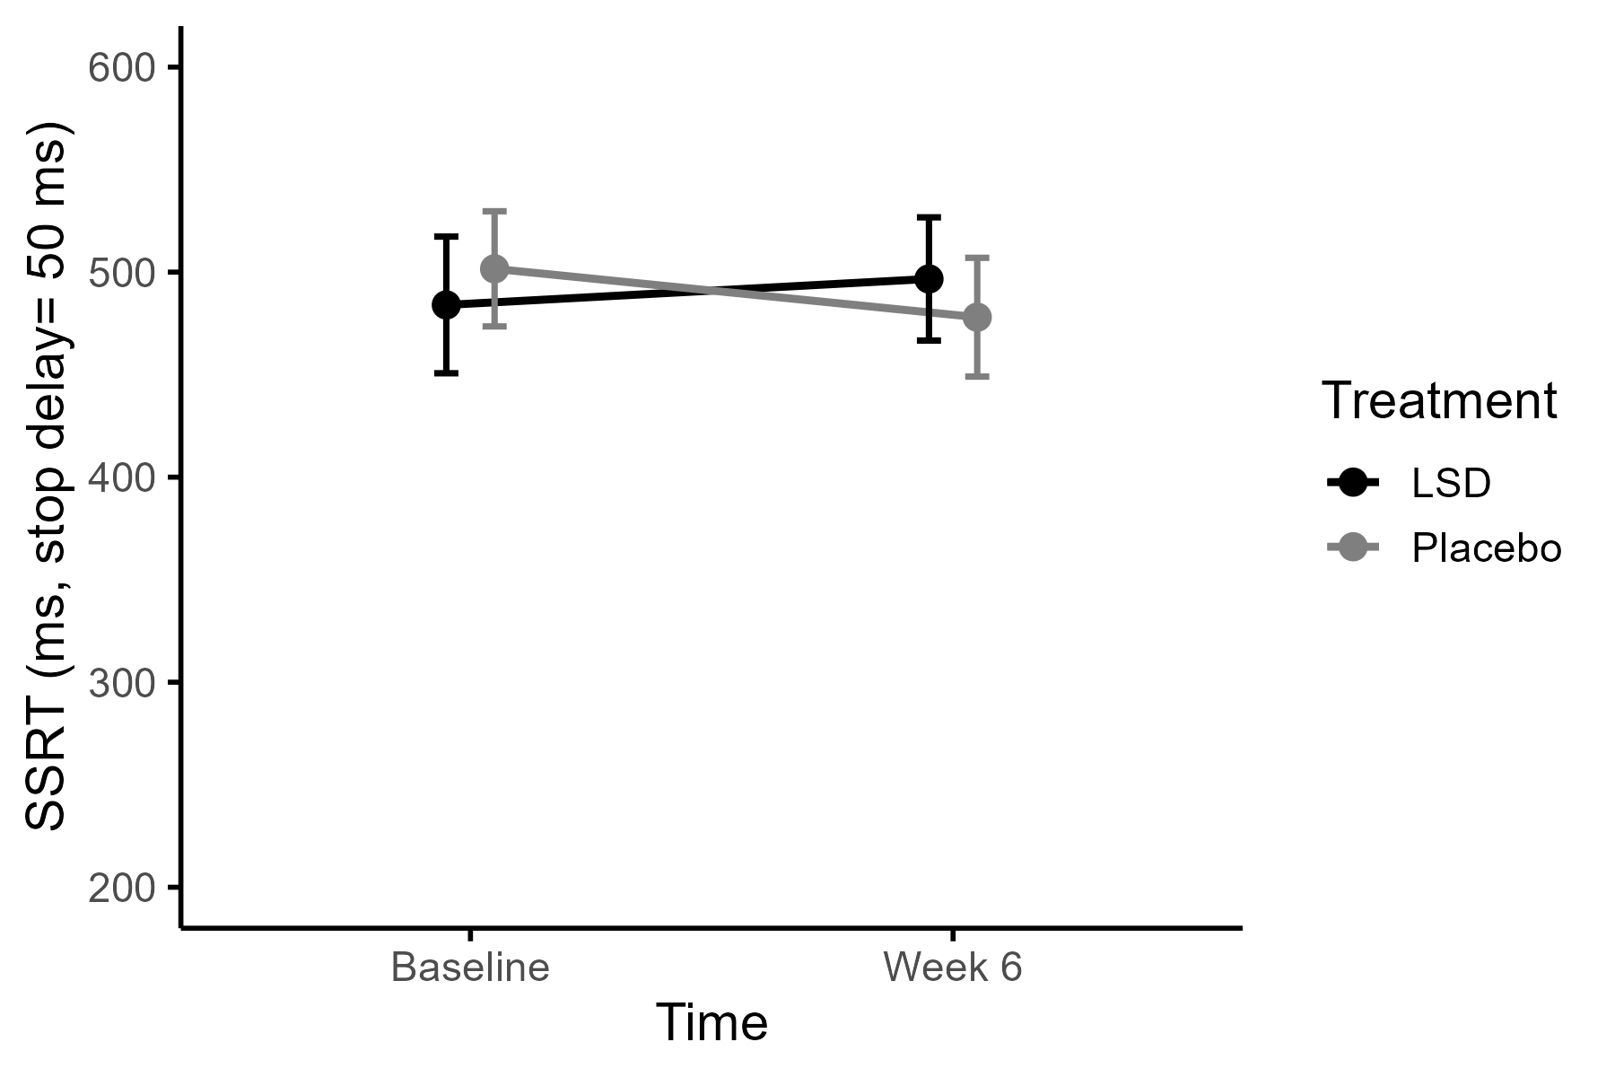
Fig. S11 Mean stop-signal reaction time (SSRT) estimated at a stop-signal delay of 50 ms in the Stop-Signal Task, by Treatment (placebo vs. LSD) and Time (baseline and Week 6). SSRT was calculated using the integration method based on the go reaction time distribution and the proportion of responses on stop trials at this delay. A higher SSRT indicates more difficulty inhibiting responses. At baseline, 24 (LSD) and 26 (placebo) participants were included, and at week 6, 23 (LSD) and 23 (placebo) participants were included. Error bars represent standard errors of the mean. No significant Time x Treatment interaction, or main effects of Time and Treatment were found

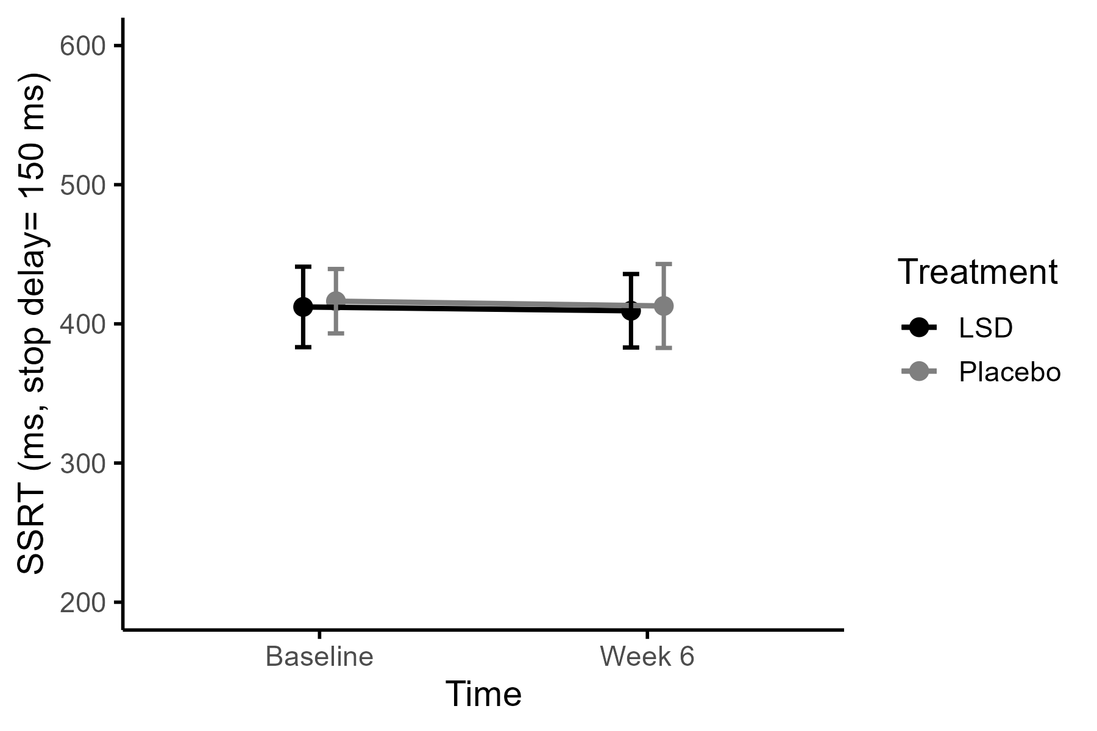
Fig. S12 Mean stop-signal reaction time (SSRT) estimated at a stop-signal delay of 150 ms in the Stop-Signal Task, by Treatment (placebo vs. LSD) and Time (baseline and Week 6). SSRT was calculated using the integration method based on the go reaction time distribution and the proportion of responses on stop trials at this delay. A higher SSRT indicates more difficulty inhibiting responses. At baseline, 24 (LSD) and 26 (placebo) participants were included, and at week 6, 23 (LSD) and 23 (placebo) participants were included. Error bars represent standard errors of the mean. No significant Time x Treatment interaction, or main effects of Time and Treatment were found

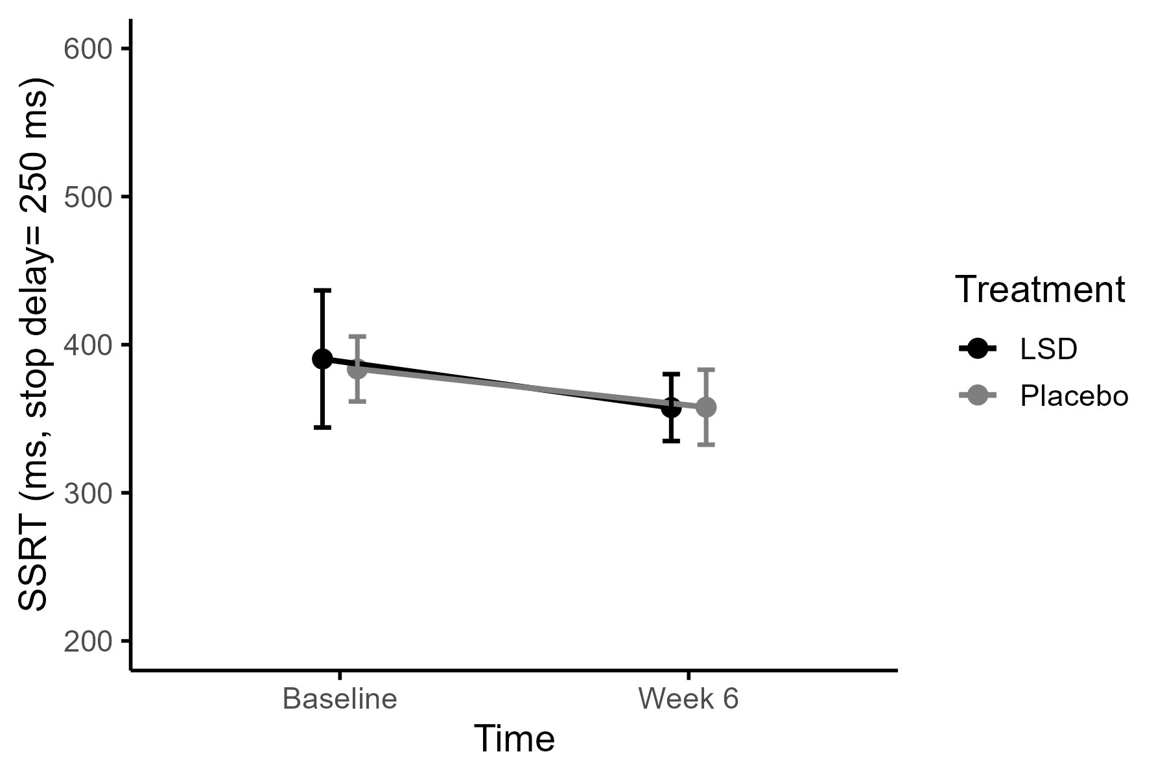
Fig. S13 Mean stop-signal reaction time (SSRT) estimated at a stop-signal delay of 250 ms in the Stop-Signal Task, by Treatment (placebo vs. LSD) and Time (baseline and Week 6). SSRT was calculated using the integration method based on the go reaction time distribution and the proportion of responses on stop trials at this delay. A higher SSRT indicates more difficulty inhibiting responses. At baseline, 24 (LSD) and 26 (placebo) participants were included, and at week 6, 23 (LSD) and 23 (placebo) participants were included. Error bars represent standard errors of the mean. No significant Time x Treatment interaction, or main effects of Time and Treatment were found

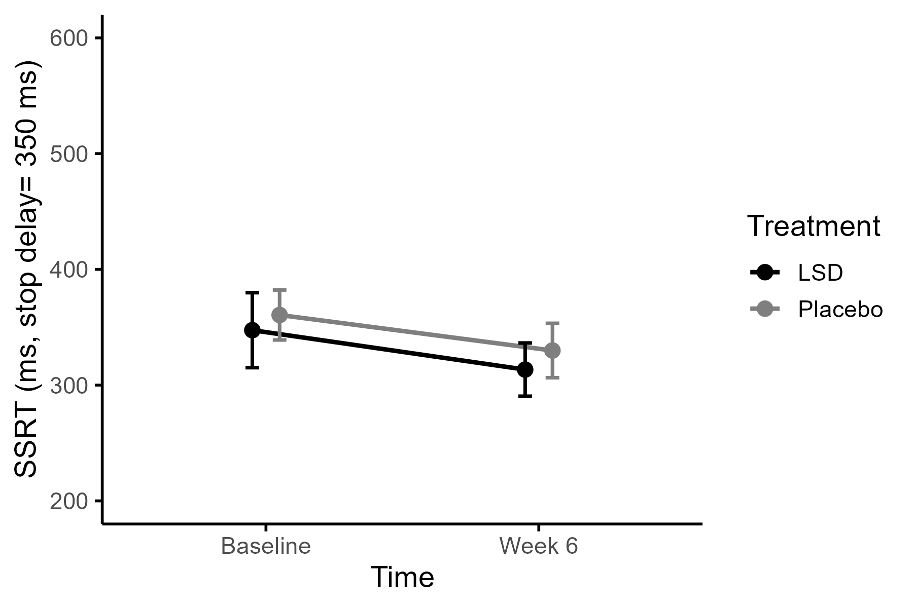
Fig. S14 Mean stop-signal reaction time (SSRT) estimated at a stop-signal delay of 350 ms in the Stop-Signal Task, by Treatment (placebo vs. LSD) and Time (baseline and Week 6). SSRT was calculated using the integration method based on the go reaction time distribution and the proportion of responses on stop trials at this delay. A higher SSRT indicates more difficulty inhibiting responses. At baseline, 24 (LSD) and 26 (placebo) participants were included, and at week 6, 23 (LSD) and 23 (placebo) participants were included. Error bars represent standard errors of the mean. No significant Time x Treatment interaction, or main effects of Time and Treatment were found

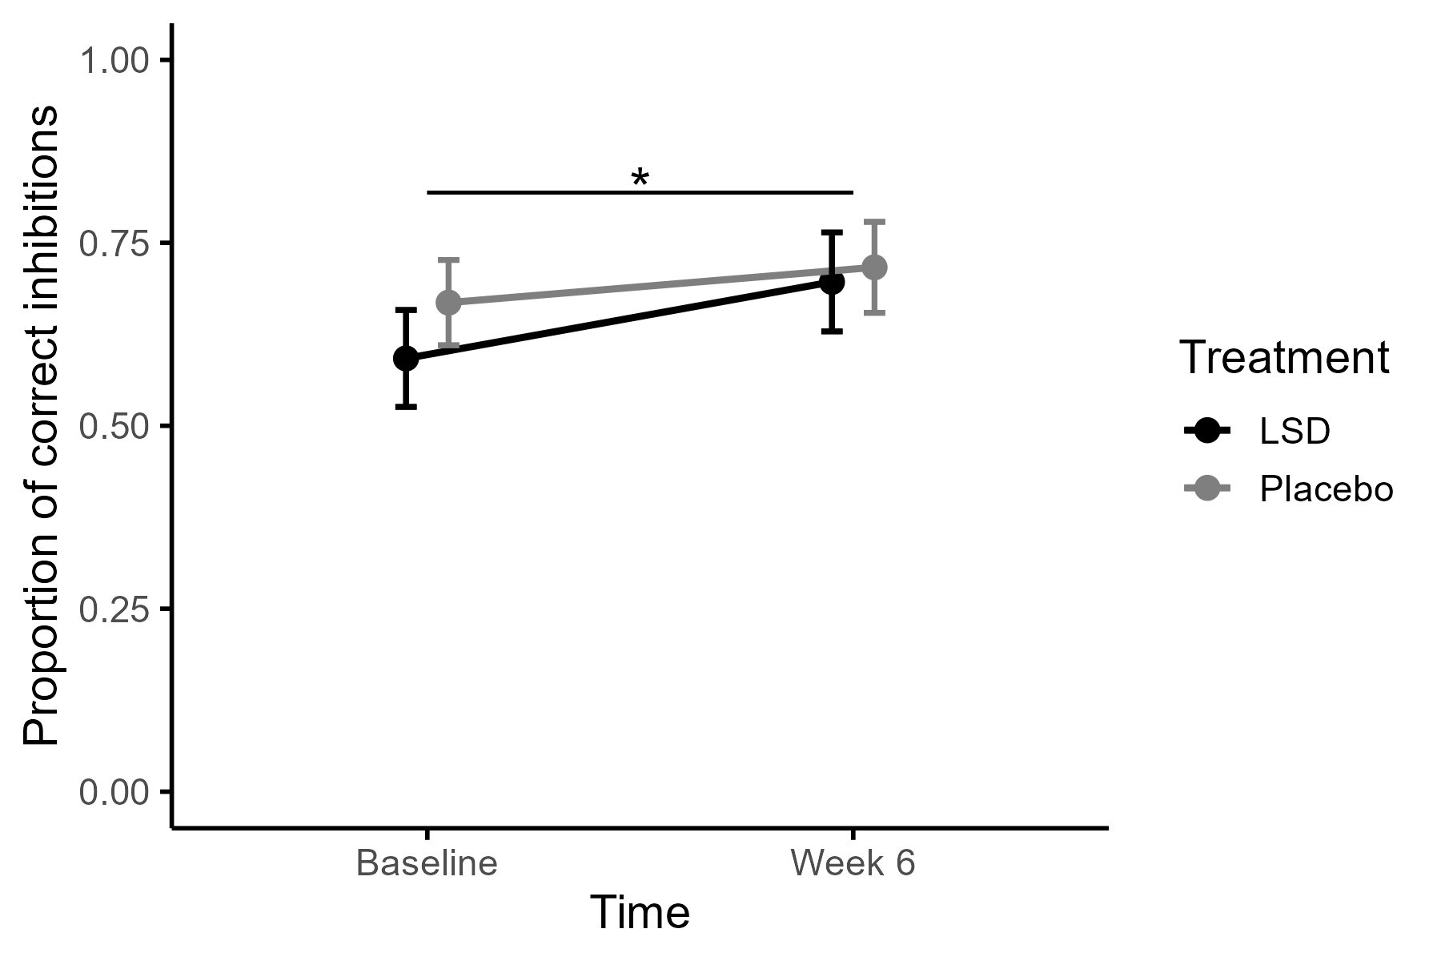
Fig. S15 Mean proportion of correctly inhibited stop trials of the Stop-Signal Task per Treatment (Placebo vs. LSD) and Time (Baseline and Week 6). At baseline, 24 (LSD) and 26 (placebo) participants were included, and at week 6, 23 (LSD) and 23 (placebo) participants were included. Error bars represent standard errors of the mean. No significant Time x Treatment interaction or main effect of Treatment was found, but a main effect of Time (p=.024)

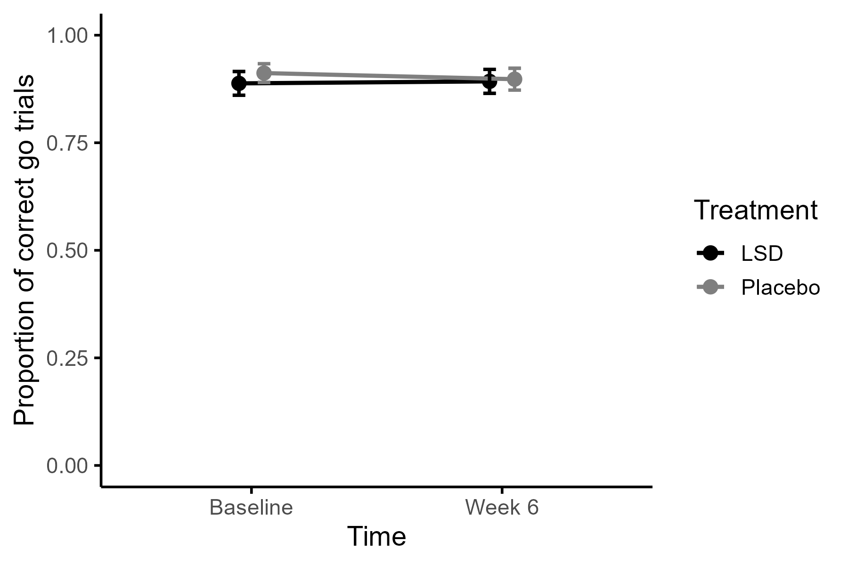
Fig. S16 Mean proportion of correct go trials of the Stop-Signal Task per Treatment (Placebo vs. LSD) and Time (Baseline and Week 6). At baseline, 24 (LSD) and 26 (placebo) participants were included, and at week 6, 23 (LSD) and 23 (placebo) participants were included. Error bars represent standard errors of the mean. No significant Time x Treatment interaction or main effects of Time or Treatment were found

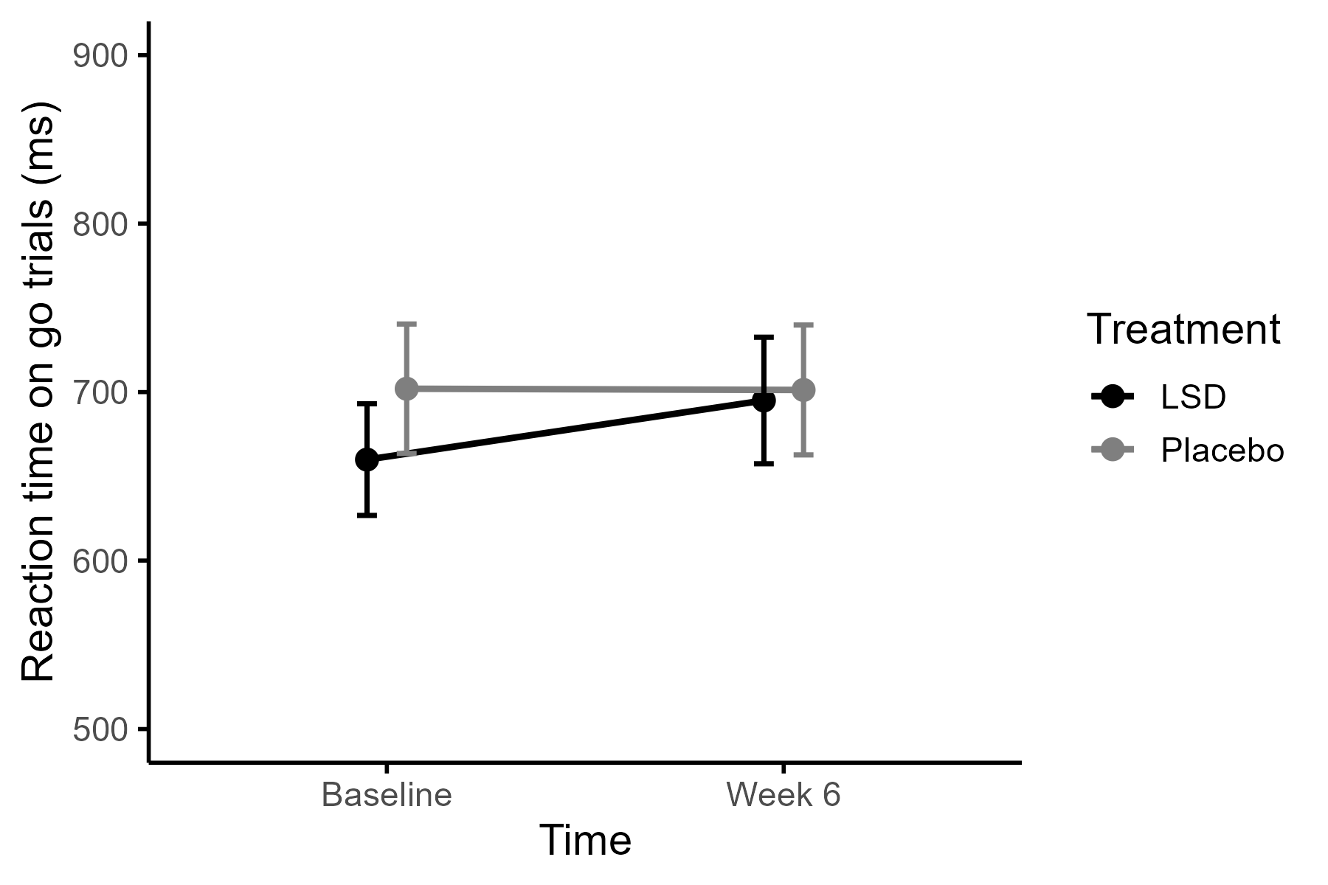
Fig. S17 Raw mean reaction time on go trials of the Stop-Signal Task per Treatment (Placebo vs. LSD) and Time (Baseline and Week 6). At baseline, 24 (LSD) and 26 (placebo) participants were included, and at week 6, 23 (LSD) and 23 (placebo) participants were included. Error bars represent standard errors of the mean. No significant Time x Treatment interaction, or main effects of Time and Treatment were found

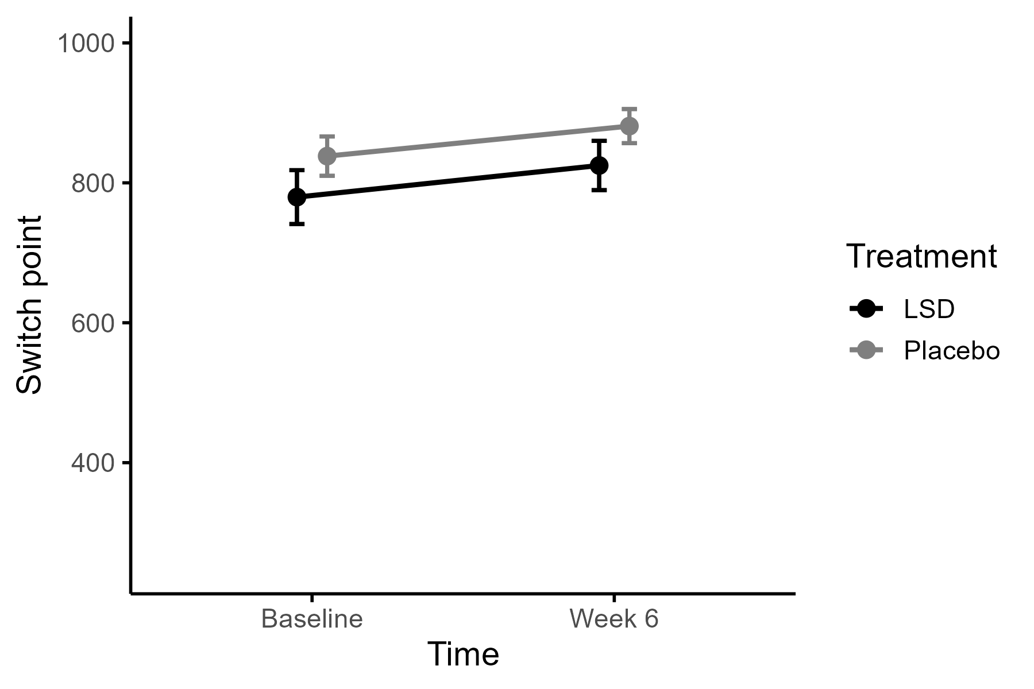
Fig. S18 Mean switch point in the Delay Discounting Task, by Treatment (placebo vs. LSD) and Time (baseline and Week 6). Lower switch points indicate a stronger preference for the immediate reward. At baseline, 27 (LSD) and 26 (placebo) participants were included, and at week 6, 23 (LSD) and 23 (placebo) participants were included. Error bars represent standard errors of the mean. No significant Time x Treatment interaction, or main effects of Time and Treatment were found

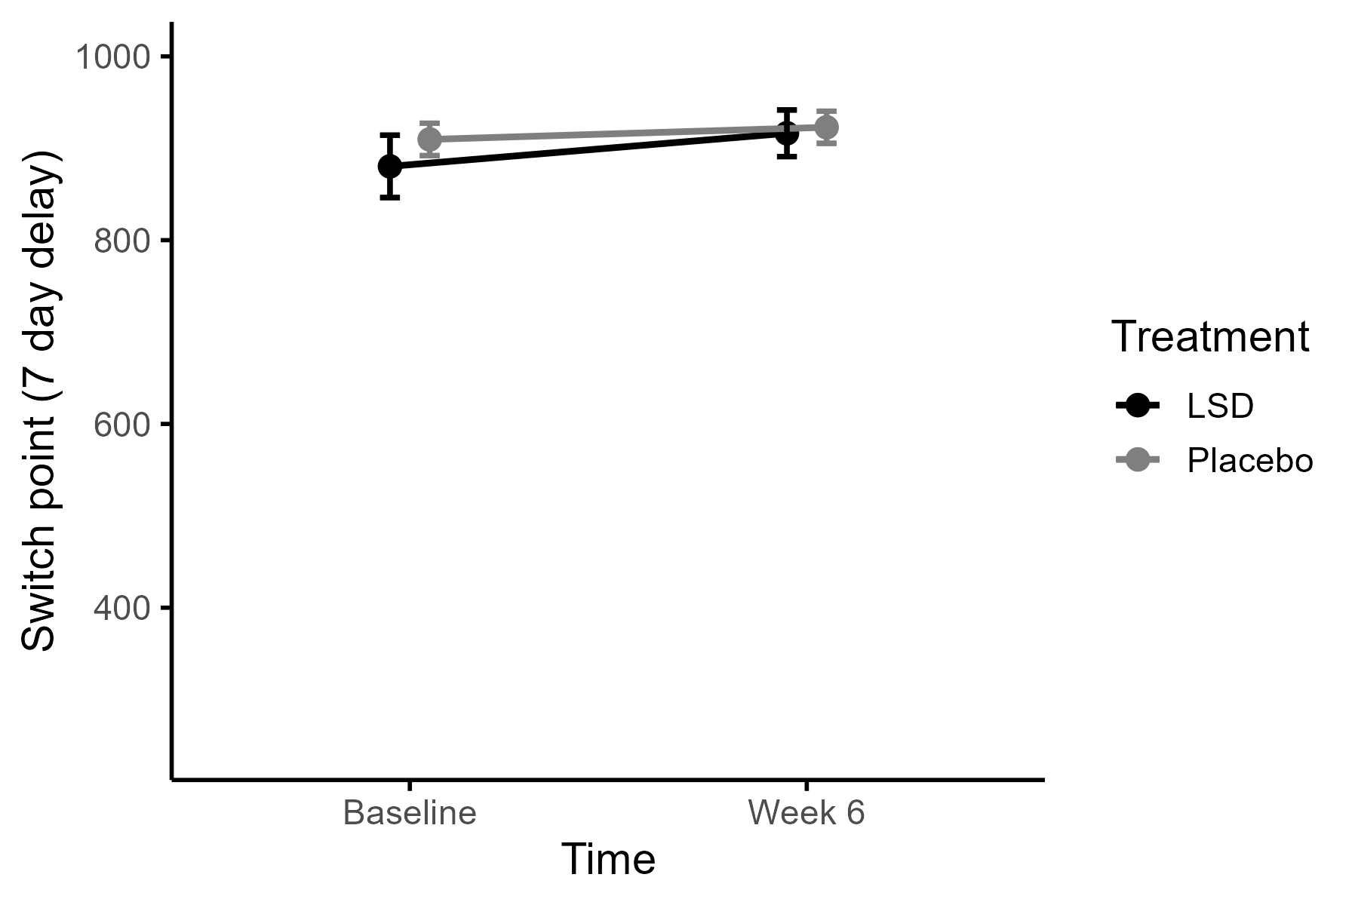
Fig. S19 Mean switch point estimated at a delay of 7 days in the Delay Discounting Task, by Treatment (placebo vs. LSD) and Time (baseline and Week 6). Lower switch points indicate a stronger preference for the immediate reward. At baseline, 27 (LSD) and 26 (placebo) participants were included, and at week 6, 23 (LSD) and 23 (placebo) participants were included. Error bars represent standard errors of the mean. No significant Time x Treatment interaction, or main effects of Time and Treatment were found

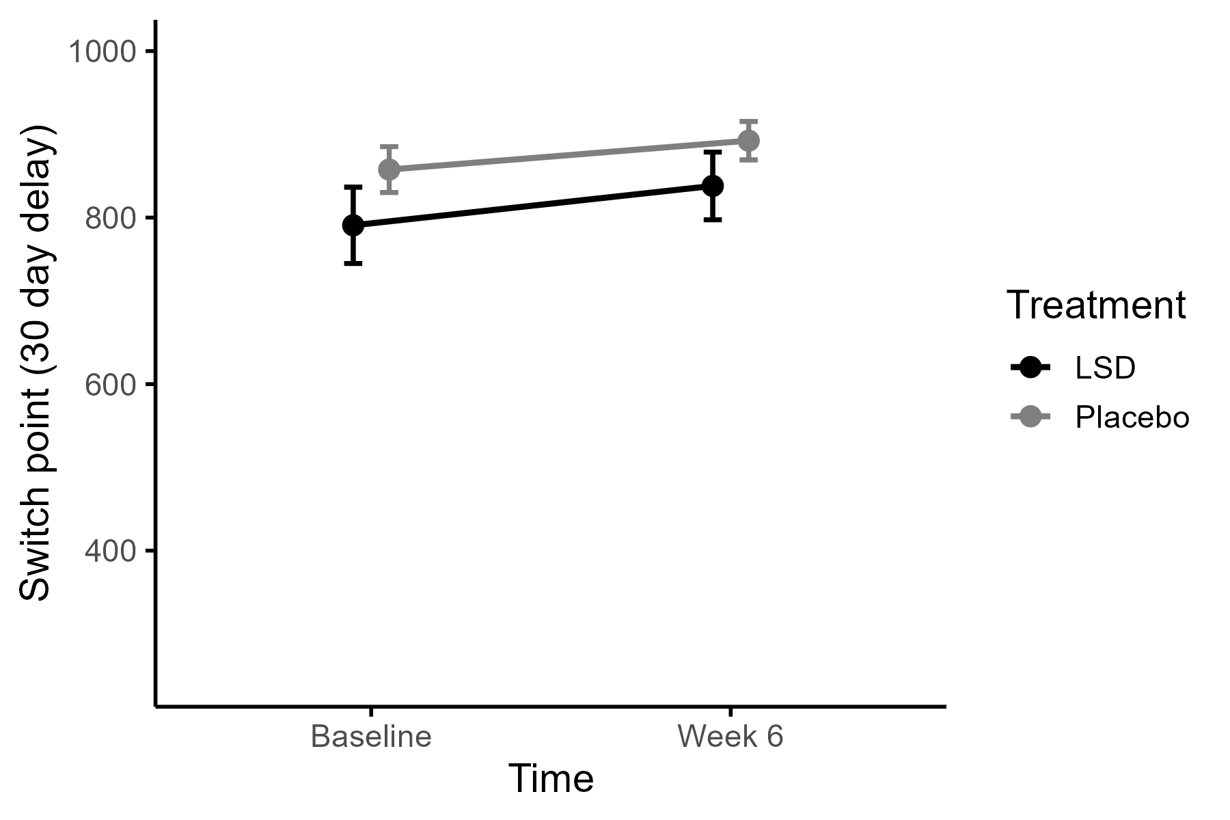
Fig. S20 Mean switch point estimated at a delay of 30 days in the Delay Discounting Task, by Treatment (placebo vs. LSD) and Time (baseline and Week 6). Lower switch points indicate a stronger preference for the immediate reward. At baseline, 27 (LSD) and 26 (placebo) participants were included, and at week 6, 23 (LSD) and 23 (placebo) participants were included. Error bars represent standard errors of the mean. No significant Treatment × Time interaction was found, but a main effect of time (p= .003)

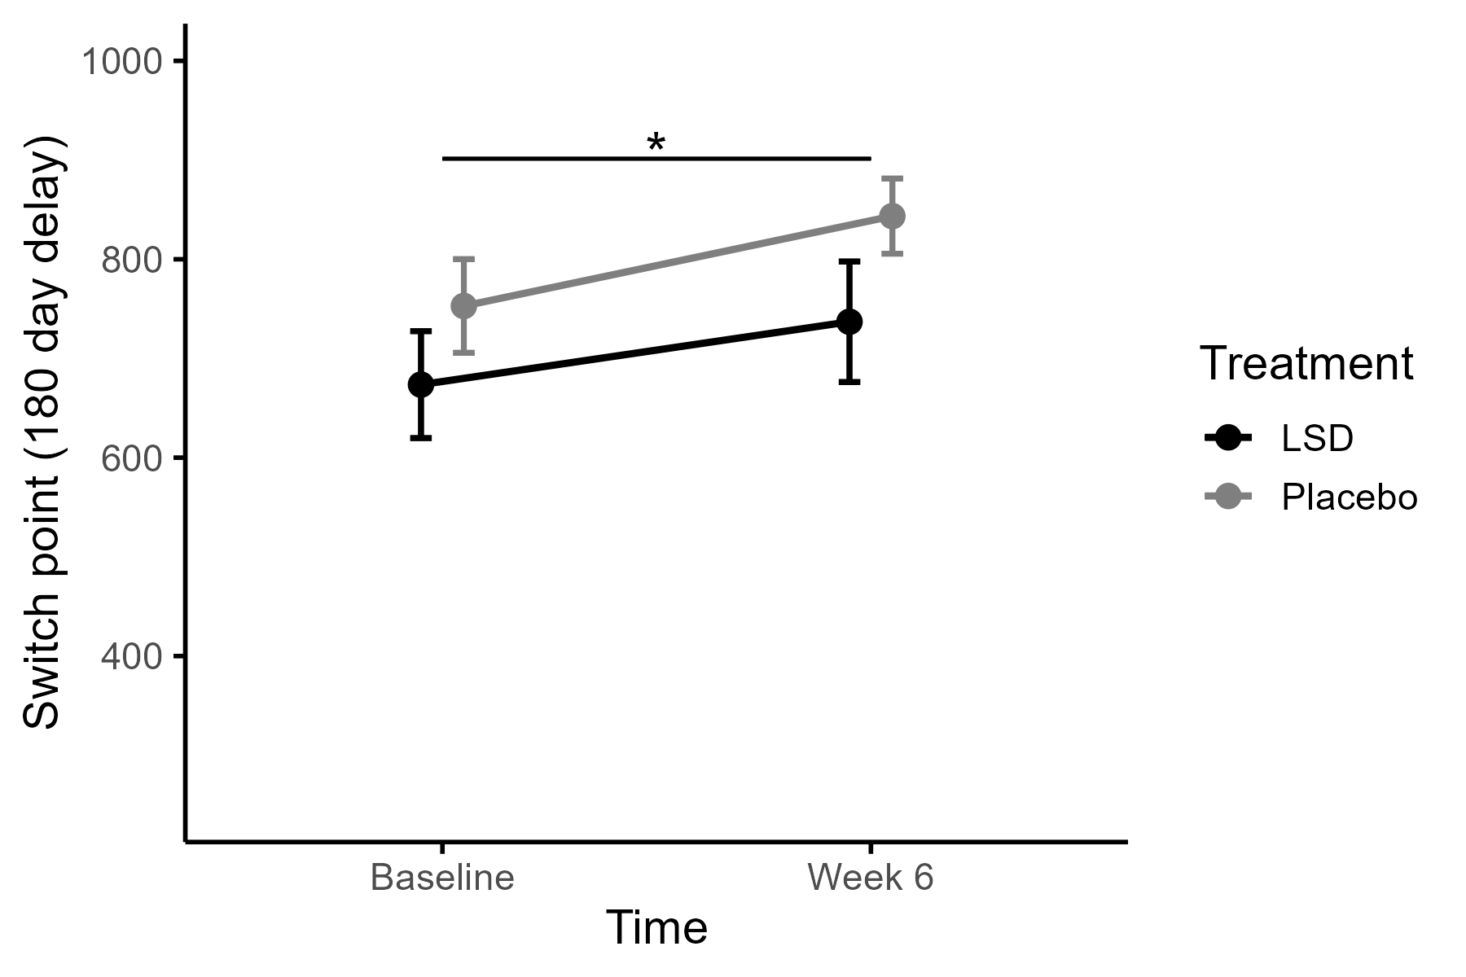
Fig. S21 Mean switch point estimated at a delay of 180 days in the Delay Discounting Task, by Treatment (placebo vs. LSD) and Time (baseline and Week 6). Lower switch points indicate a stronger preference for the immediate reward. At baseline, 27 (LSD) and 26 (placebo) participants were included, and at week 6, 23 (LSD) and 23 (placebo) participants were included. Error bars represent standard errors of the mean. No significant Treatment × Time interaction or main effect of Treatment was found, but a main effect of Time (p= .003)

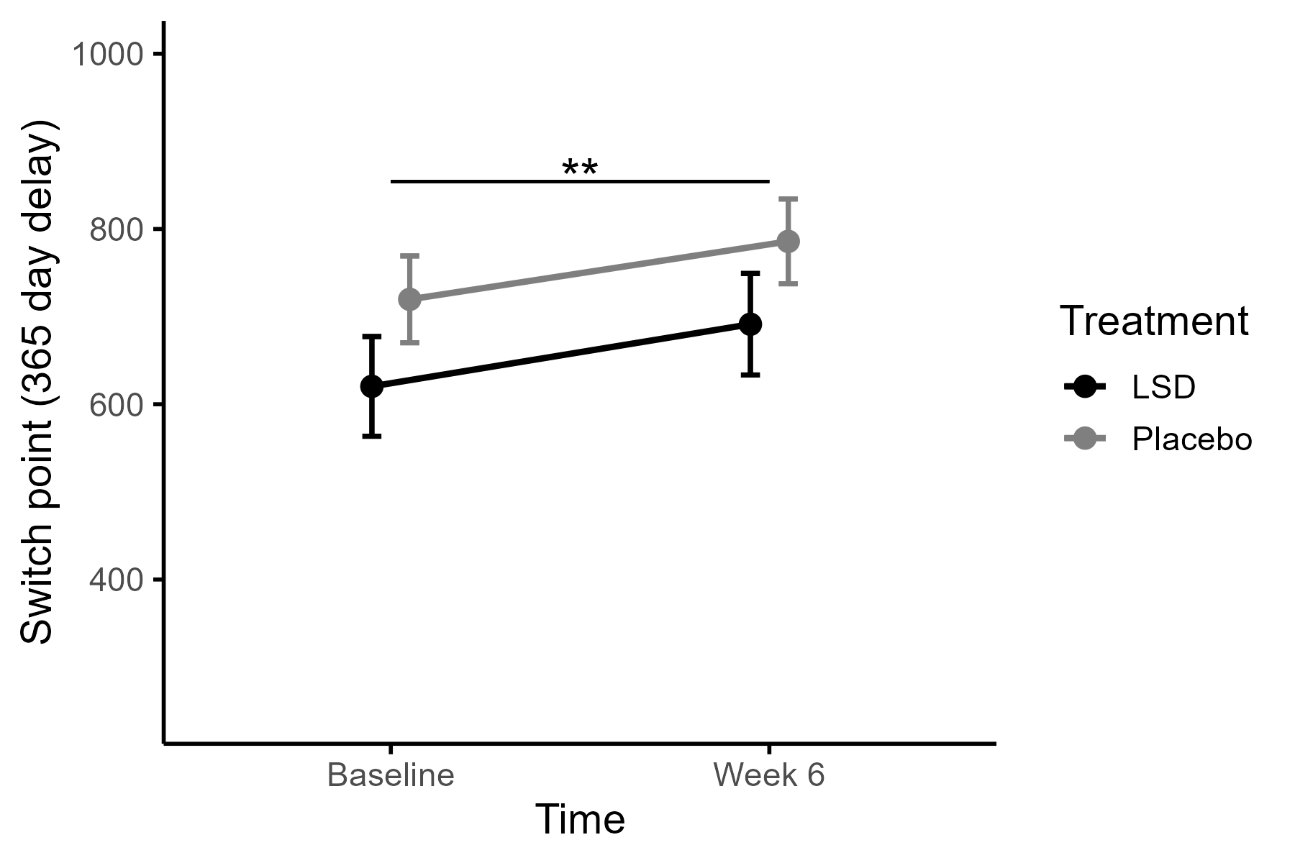
Fig. S22 Mean switch point estimated at a delay of 365 days in the Delay Discounting Task, by Treatment (placebo vs. LSD) and Time (baseline and Week 6). Lower switch points indicate a stronger preference for the immediate reward. Error bars represent standard errors of the mean. No significant Treatment × Time interaction or main effect of Treatment was found, but a main effect of Time (p< .001)

