Table S1: Abbreviatios used in paper with the corresponding allen brain atlas areas making up the area
in paper abbreviations | Allen Brain atlas area abbreviations
ACg (anterior cingulate cortrex) | ACAd + ACAv
AUD (auditory areas) | AUDd + AUDp + AUDpo + AUDv
Amyg (amygdala) | PA + LA + BLAa + BLAp + BLAv + BMAa + BMAp + MEA + IA + AAA + CEAc + CEAl + CEAm
BLA (basolateral amygdala) | BLAa + BLAp + BLAv
CAd (dorsal hippocampus) | CA1d + CA2d + CA3d + DGd
CAv (ventral hippocampus) | CA1v + CA2v + CA3v + DGv
CAmyg (central amygdala) | CEAc + CEAl + CEAm
CLA (claustrum) | CLA
CPu (caudate putamen) | CPadl + CPadm + CPaml + CPamm + cpavl + CPavm + CPcdl + CPcdm + CPcml + CPcmm + CPcv + CPmdc + CPmdl + CPmdm + CPmmc + CPmml + CPmmm + CPmvc + CPmvl + CPmvm
Ent (entorhinal cortex) | ENTl + ENTm
Hypo (hypothalamus) | LHA + ZI + PST + PSTN + STN + TU + PeF + RCH + LPO + ME + AHN + LM + Mmm + Mmd + Mml + Mmme + Mmp + SUM + TMd + TMv + PMd + PH + PMv + VMH + PVHd + MPN + ADP + AVPV + AVP + DMH + MPO + MEPO + PS + PVp + PVpo + PVa + PVi + SFO + PD + SBPV + SCH + OV + VLPO + VMPO + ASO + ARH + PVH + PVa + PVi + SO
IC (inferior colliculis) | ICc + ICd + ICe
InfL (infralimbic cortex) | ILA
Ins (insular cortex) | ALp + Alv + Ald
M1 (primary motor area) | MOp
M2 (secondary motor area) | MOs
MD (mediodorsal nucleus of the thalamus) | MD
NAc (nucleus accumbens) | ACB
OLF (olfactory cortex) | OLF
Orb (orbitofrontal cortex) | ORB + ORBm6B
Pag (periaqueductal gray) | PAGa + PAGmd + PAGml + PAGmv + PAGpd + PAGpl + PAGpv + PRC + ND + INC + Su3
Pir (piriform cortex) | PIR + EPd + EPv
Pal (globus pallidus) | GPe + GPi
PreL (prelimbic cortex) | PL
PVT (paraventricular thalamic nucleus) | PVT
RSP (retrosplenial cortex) | RSPagl + RSPd + RSPv
SC (scaphoid nucleus) | SCd(p) + SCi(al) + SCi(am) + SCi(pl) + SCs(al) + SCs(am) + SCs(pl) + SCs(pm)
SN (substantia nigra) | SNc + SNr
SS (somatosensory areas) | SSp-bf + SSp-ll + SSp-n + SSp-tr + SSp-ul + SSp-un + SSs
SUB (subiculum) | SUB + PRE + ProS
Sep (septum) | LSv + LSc + LSr + TRS + MS
Th (thalamus) | AD + AMd + AMv + AV + IAD + IAM + LD + LH + MH + IGL + LGv + IntG + SubG + CL + CM + PCN + PF + PIL + RH + Eth + PO + LP + SGN + POL + IMD + MD + PR + SMT + RE + PT + PVT + Xi + RT + LGd-co + LGd-ip + LGd-sh + MGm + MGv + PP + SPA + SPFm + SPFp + PoT + VAL + VM + VPL + VPLpc + VPM + VPMpc
VIS (visual cortex) | VISli + VISa + VISal + VISam + VISl + VISp(pl) + VISp(al) + VISp(am) + VISp(pm) + VISpm + VISrl + VISpl + VISpor
VTA (ventral tegmental area) | VTA

Fig S1: Comparison performance of surgerized and non-surgerized animals in a 2s-delay paradigm. Working memory performance was not different between the two groups of mice when assessing vehicle data at a 2s delay. (unpaired T-test).
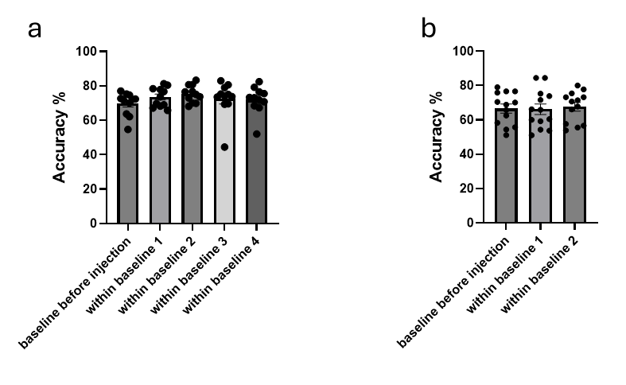
Fig S2: Comparison of performance of non-surgerized animals (cohort 1) before and during the baseline re-training sessions of the experiment. Working memory performance was not different between the baseline before the first experiment day and the retraining days during the experiment. (one-way ANOVA for non-surgerized animals p=0.1761, one-way ANOVA for surgerized animals p=0.9667)
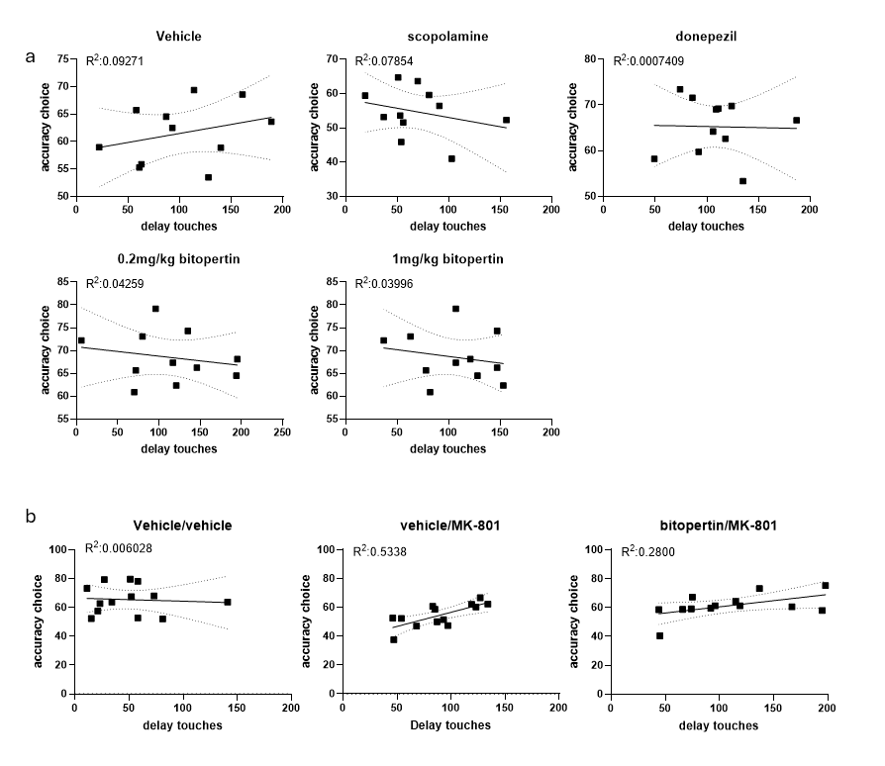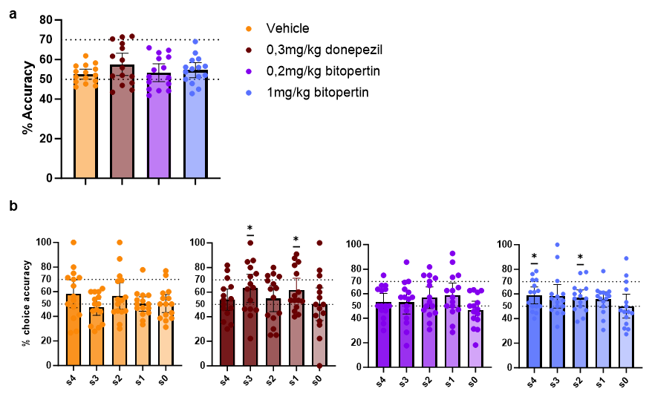
Figure S3: Correlation of delay touches and accuracy in the choice phase for cohort 1 (a) and cohort 2 (b). (a) No correlations were found between delay touches and accuracy in cohort 1 (Pearson’s correlation). (b) For the vehicle/MK-801 condition, mice performed better with increasing delay touches (Pearson’s correlation r: 0.7306, P = 0.0046), but no significant correlations were found for the vehicle/vehicle or bitopertin/MK-801 conditions (Pearson’s correlation: r: -0.07764, P = 0.8010; r: 0.5292, P = 0.0629).
Fig S4: Effect of pro-cognitive drugs in a 4s-delay paradigm. (a) Working memory performance was measured using the accuracy on the choice phase, no changes in working memory was found. Mice performed no different from chance level with 0.2mg/kg bitopertin, while in the other conditions the mice performed slightly above chance. (b) For vehicle and 0.2mg/kg bitopertin, mice perform at chance level for each separation level. Data presented as individual data points, means ± SEM (RM ANOVA against vehicle (a); one sample t-test against 50 (b)) * p < 0.05
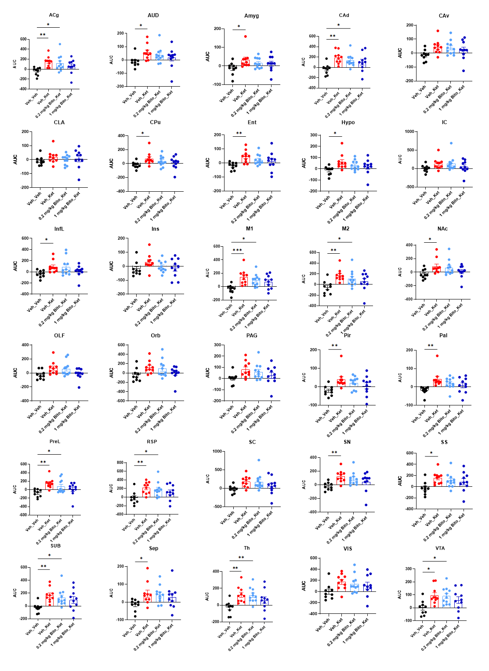
Fig S5: CBV area under the curve plots for the measured brain areas. Data presented as individual data points, means ± SEM (ANCOVA against vehicle * = p < 0.05; ** = p < 0.01; *** = p < 0.001
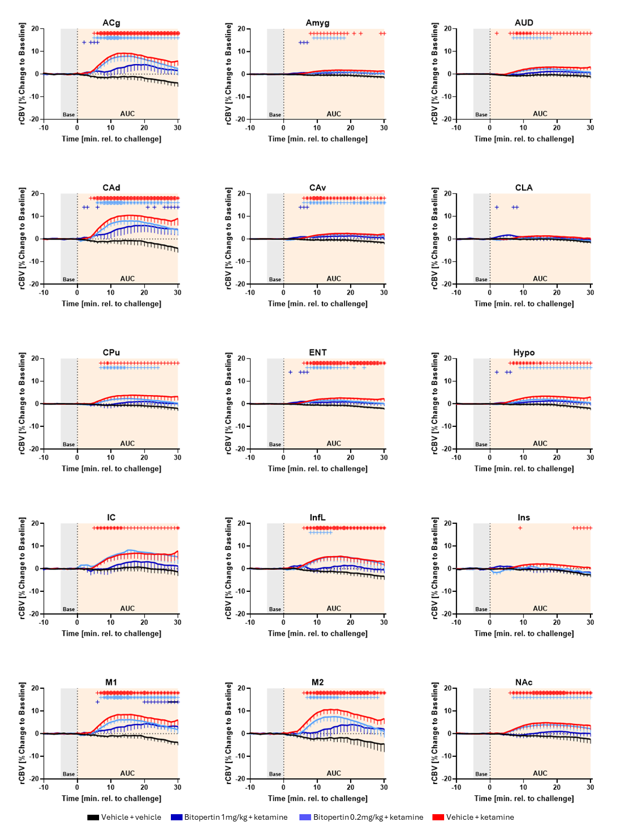
Fig S6: regional cerebral blood volume over time for regions from A to N. + p=0.05, * p=0.01

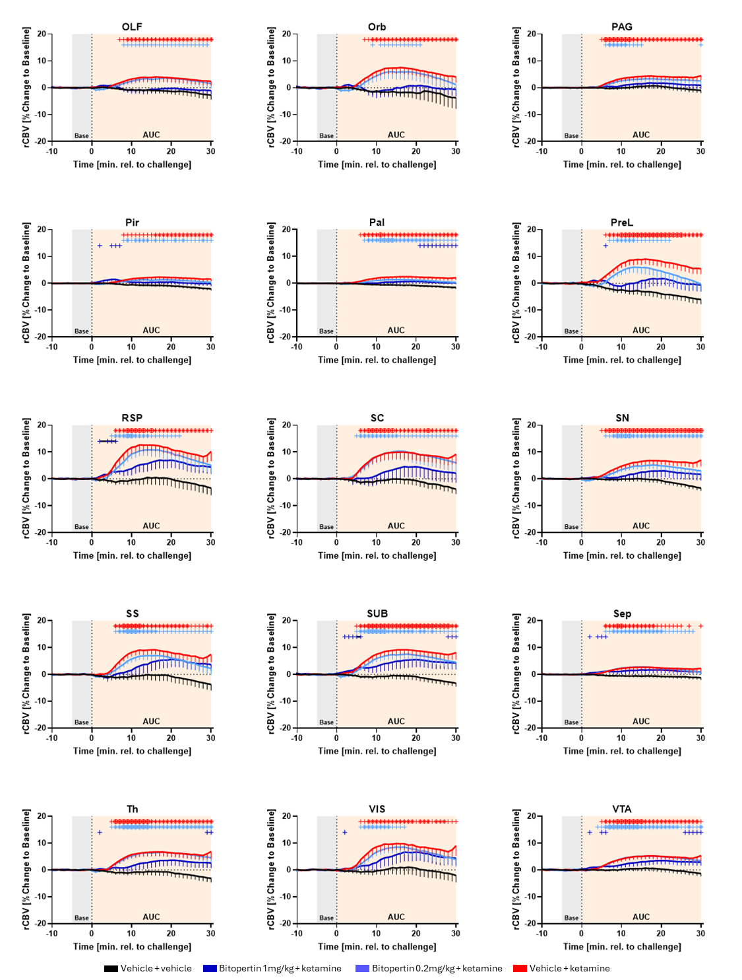
Fig S7: regional cerebral blood volume over time for regions from O to V. + p=0.05, * p=0.01

