Khodavirdilou, Lida^{1,2}; Zuarth Gonzalez, Julio D¹; Mukhopadhyay, Sushobhan³; Guadagnoli, Nicholas³; Obeng, Samuel¹; McCurdy, Christopher R³; McMahon, Lance R¹; and Wilkerson, Jenny L^{1,2*}
¹ Department of Pharmaceutical Sciences, Texas Tech University Health Sciences Center, Amarillo, TX, USA
² Department of Anesthesiology and Perioperative Medicine, Rutgers Biomedical and Health Sciences, Rutgers, The State University of New Jersey, Newark, NJ, USA
³ Department of Medicinal Chemistry, College of Pharmacy, University of Florida, Gainesville, FL, USA
Supplemental Results
Experiment 1: Effects of MG on Responding for Methamphetamine Under a Fixed Ratio Schedule
Active vs. Inactive Lever Presses
Under vehicle pretreatment, there were more active (252.5 presses) than inactive lever responses (59.82 presses; p = 0.0046). Mixed-effects analysis revealed significant main effects of lever type (F(1.965, 23.59) = 22.38, p < 0.0001) and MG dose (F(1, 14) = 22.11, p = 0.0003), as well as a significant lever × dose interaction (F(4, 48) = 9.675, p < 0.0001). Active lever pressing was significantly greater than inactive pressing at vehicle, 10, 17.8, and 32 mg/kg, but not at 56 mg/kg, where responding was markedly reduced. Inactive lever responding remained low and unchanged across doses (Supplemental Figure 1A).
Sex Differences in Active Lever Presses
Under vehicle pretreatment conditions, females and males exhibited mean active lever press counts of 245.8 and 259.3, respectively, with no significant difference between sexes (p = 0.4664). Mixed-effects analysis revealed a significant main effect of dose, F(2.632, 13.16) = 31.59, p < 0.0001, but no main effect of sex, F(1, 6) = 0.6046, p = 0.4664, and no dose × sex interaction, F(4, 20) = 0.7065, p = 0.5969. These results indicate that MG’s effects on methamphetamine self-administration lever presses were consistent across sexes (Supplemental Figure 2A).
Sex Differences in Response Rate
Under vehicle pretreatment conditions, females and males responded at a mean rate of 0.0408 and 0.0448 responses/sec, respectively, with no significant difference between sexes (p = 0.4415). Mixed-effects analysis of response rate indicated a significant main effect of dose, F(2.400, 12.00) = 26.02, p < 0.0001, but no main effect of sex, F(1, 6) = 0.6787, p = 0.4415, and no dose × sex interaction, F(4, 20) = 0.5515, p = 0.7001. These results indicate that MG’s effects on methamphetamine self-administration response rates were consistent across sexes (Supplemental Figure 2B).

Experiment 2: Effects of MG on Responding for Food
Active vs. Inactive Lever Presses
Under vehicle pretreatment, there were more active than inactive lever presses (500.0 vs. 0.625, p < 0.0001). Analysis revealed a significant main effect of lever type (F(1, 14) = 150132, p < 0.0001), but no main effect of MG dose (F(4, 56) = 2.286, p = 0.0714) and no lever × dose interaction (F(4, 56) = 2.286, p = 0.0714). Active lever pressing was significantly greater than inactive pressing at all doses tested, and inactive lever responding remained low and unchanged across doses (Supplemental Figure 1B).
Sex Differences in Active Lever Presses
Under vehicle pretreatment conditions, both females and males exhibited a mean of 500 active lever presses per session. Active lever responding remained identical across all MG doses (10, 17.8, 32, and 56 mg/kg; 500 ± 0 for each), and statistical analysis could not be performed due to the absence of within-group variability. These results indicate that MG pretreatment did not alter food-maintained responding in either sex (Supplemental Figure 3A).
Sex Differences in Response Rate
Under vehicle pretreatment conditions, females and males had mean response rates of 2.198 and 1.378 responses/sec, respectively, with no significant difference between sexes (p = 0.9625). No significant main effect of dose, F(2.496, 14.98) = 0.5124, p = 0.6481, no main effect of sex, F(1, 6) = 0.0024, p = 0.9625, and no dose × sex interaction, F(4, 24) = 0.9927, p = 0.4305 were observed. These results indicate that MG’s effects on food-maintained response rates were consistent across sexes (Supplemental Figure 3B).
Experiment 3: Effects of MG on Methamphetamine Self-Administration Under a Progressive Ratio Schedule
Sex Differences in Active Lever Presses
Under vehicle conditions, females and males made an average of 1014 and 1580 active lever presses, respectively, with no significant difference between sexes (p = 0.2903). Two-way ANOVA revealed a significant main effect of dose, F(1.665, 14.99) = 14.45, p = 0.0005, no main effect of sex, F(1, 9) = 1.262, p = 0.2903, and no dose × sex interaction, F(4, 36) = 1.988, p = 0.1172. These results indicate that MG’s effects on methamphetamine-maintained active lever responding were dose-dependent and consistent across sexes (Supplemental Figure 4A).
Sex Differences in Breakpoints
Under vehicle pretreatment conditions, females responded at a breakpoint of 176.7 and males at 236.0, with no significant difference between sexes (p = 0.4786). Analysis of breakpoint revealed a significant main effect of dose, F(1.651, 14.86) = 8.775, p = 0.0043, no main effect of sex, F(1, 9) = 0.5464, p = 0.4786, and no dose × sex interaction, F(4, 36) = 0.2872, p = 0.8844. These results indicate that MG’s effects on methamphetamine-maintained breakpoints were consistent across sexes (Supplemental Figure 4B).

Supplemental Figures
Fig S1.
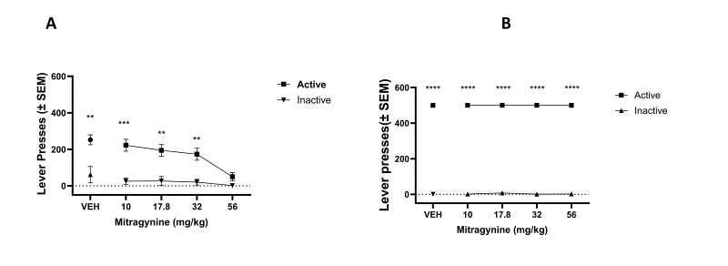
Supplemental Fig S1. Active and inactive lever responding during methamphetamine and food self-administration after MG pretreatment.
(A) Active lever presses were significantly higher than inactive lever presses across all doses. MG (10–56 mg/kg, i.p.) reduced active lever presses in a dose-dependent manner, with no significant changes in inactive lever responding. (B) Active lever presses remained significantly higher than inactive lever presses across all doses during food-maintained sessions, indicating that MG did not alter non–drug-related operant behavior.
Data are expressed as mean ± SEM. *p < .05, **p < .01, ***p < .001, ****p < .0001 vs. vehicle. (n = 4/sex)

Fig S2.
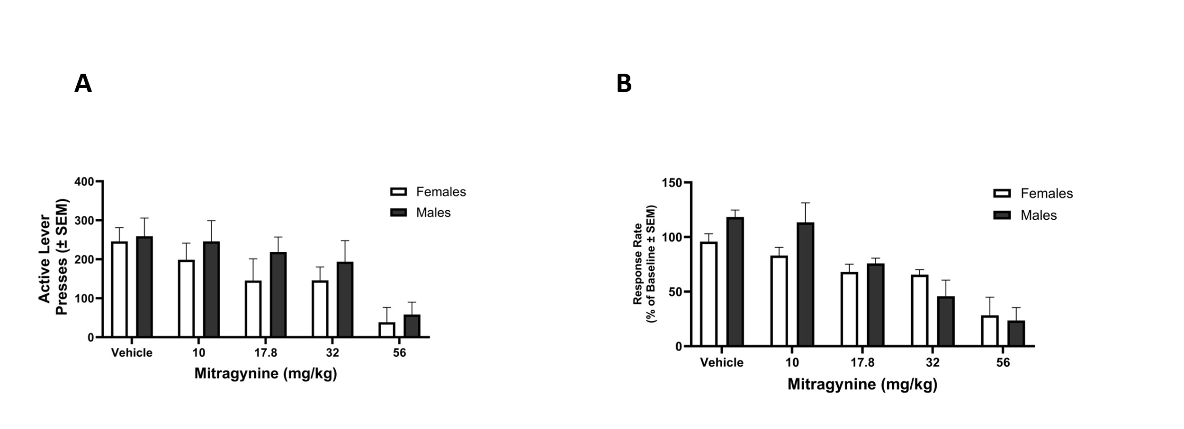Supplemental Figure S2. Effects of MG on methamphetamine self-administration Under a Fixed Ratio Schedule by sex.
(A) Active lever presses did not differ between males and females across MG doses (10–56 mg/kg, i.p.).
(D) Normalized response rate (% of baseline) was not significantly different between sexes, with no main effect of sex or dose × sex interaction detected.
Data are expressed as mean ± SEM. Analyses were not powered to detect sex differences.
Fig S3.
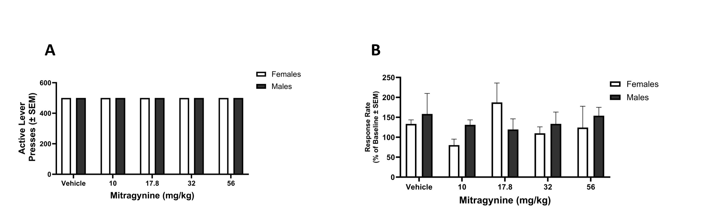
Supplemental Figure S3. Effects of MG on food-maintained responding by sex.
(A) Active lever presses for food reward appeared similar between males and females across MG doses (10–56 mg/kg, i.p.). (B) Normalized response rate (% of baseline) showed no apparent differences between sexes, with no main effect of sex or dose × sex interaction detected.
Data are expressed as mean ± SEM. Analyses were not powered to detect sex differences, and responding was constrained by a ceiling effect.

Fig S4.
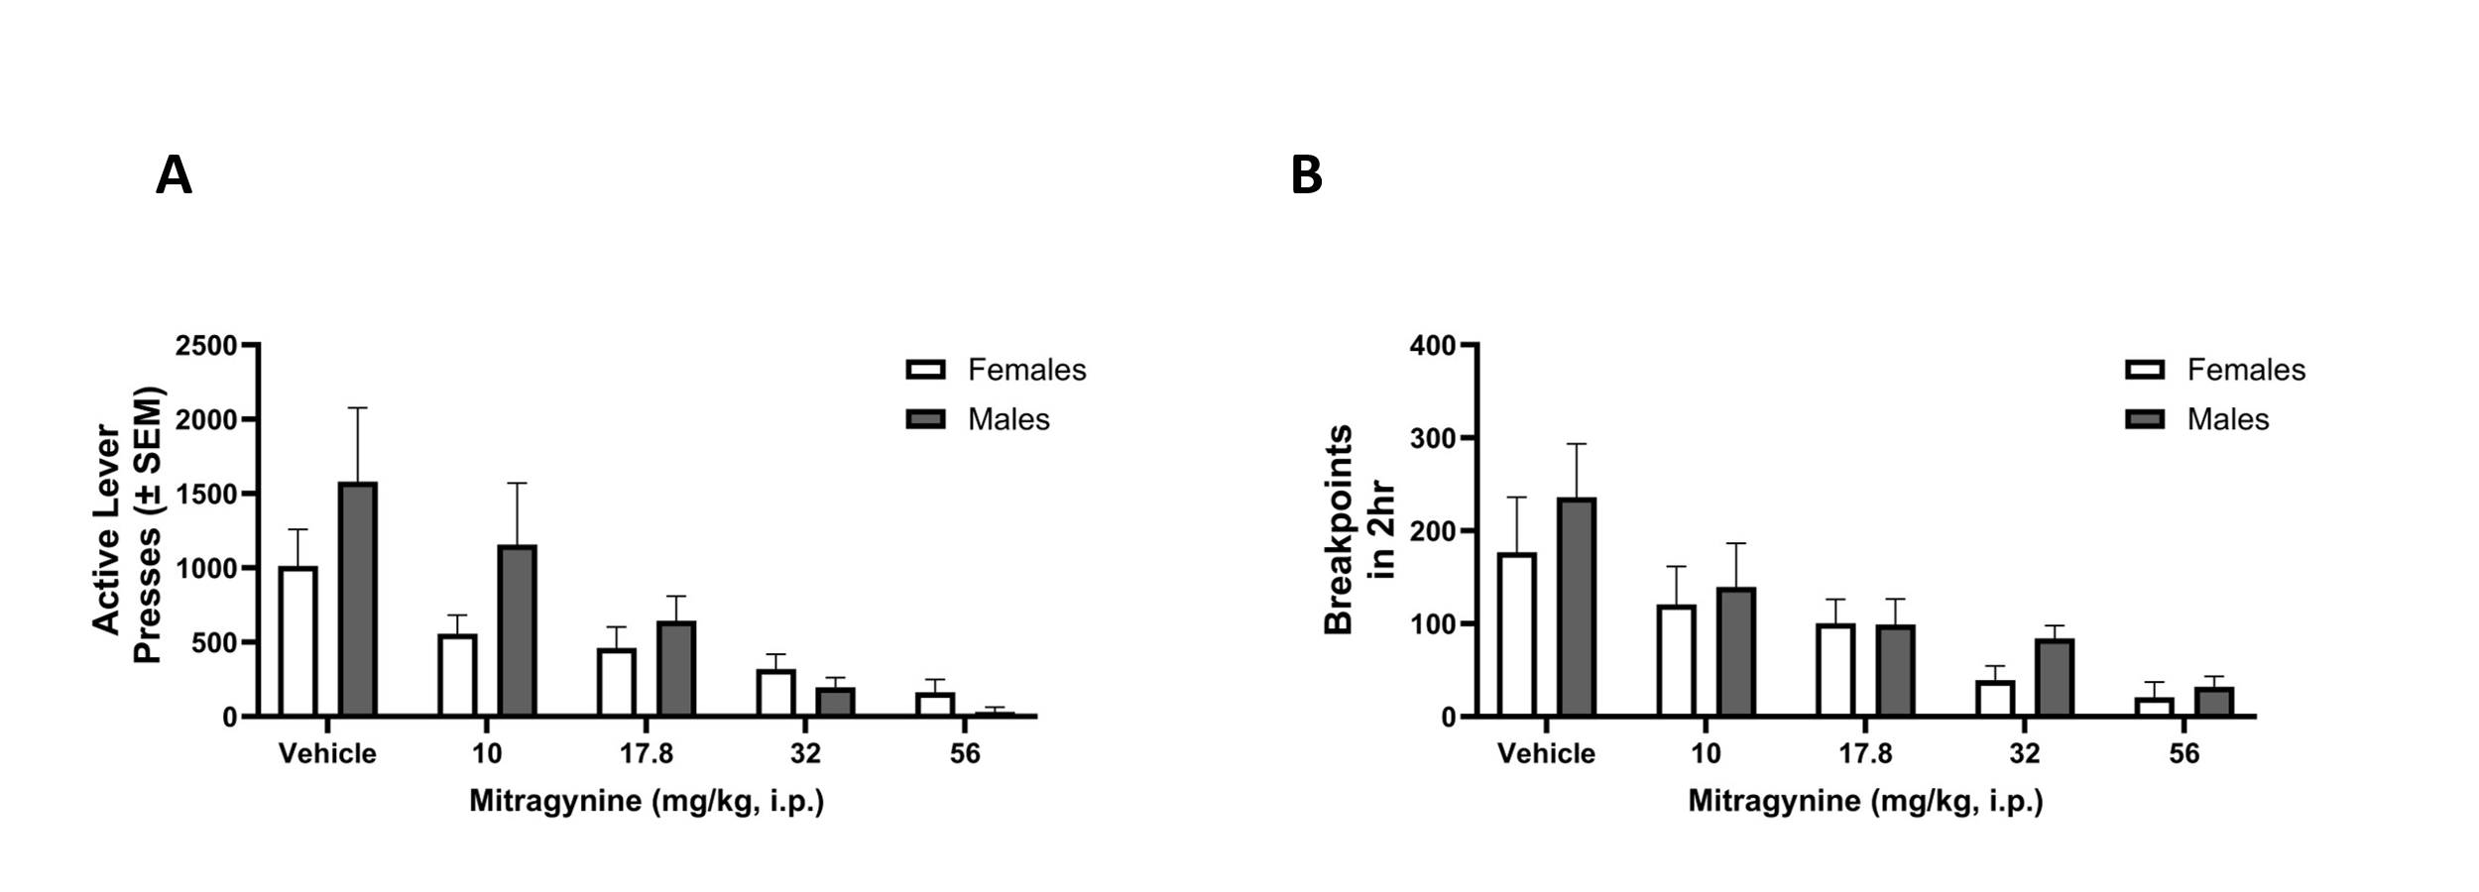
Supplemental Figure S4. Effects of MG on progressive-ratio performance by sex.
(A) Active lever presses appeared similar between males and females across MG doses (10–56 mg/kg, i.p.). (B) Breakpoints showed no apparent differences between sexes, with no main effect of sex or dose × sex interaction detected.
Data are expressed as mean ± SEM. Analyses were not powered to detect sex differences.

Fig S5.
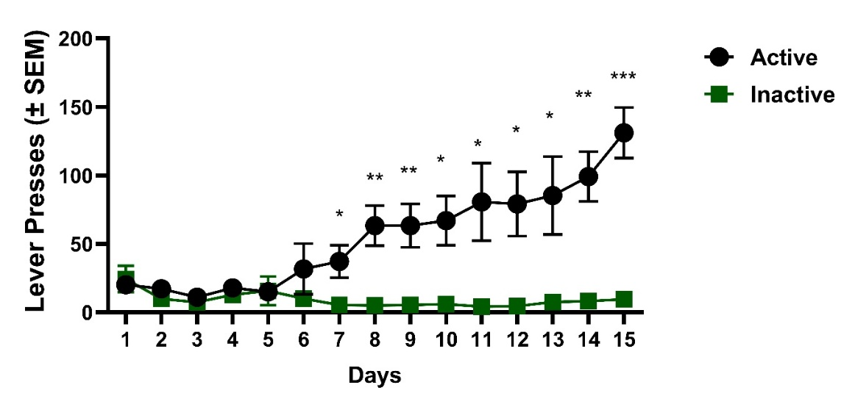
Supplemental Fig S5. Fixed Ratio (FR), Acquisition of methamphetamine self-administration.
Mean (± SEM) active and inactive lever presses during daily 2-h acquisition sessions under an FR1→FR3→FR5 schedule (0.032 mg/kg/infusion; n = 8). Two-way repeated-measures ANOVA revealed significant main effects of Lever [F(1, 14) = 12.75, p = 0.0031] and Session [F(2.506, 35.08) = 7.84, p = 0.0007], as well as a significant Lever × Session interaction [F(14, 196) = 10.19, p < 0.0001]. Post-hoc comparisons indicated that active-lever responding became significantly greater than inactive-lever responding beginning on Day 7 (p = 0.03) and remained elevated through Day 15 (p = 0.0003). These findings confirm successful acquisition of methamphetamine-maintained behavior prior to MG testing.
Fig S6.
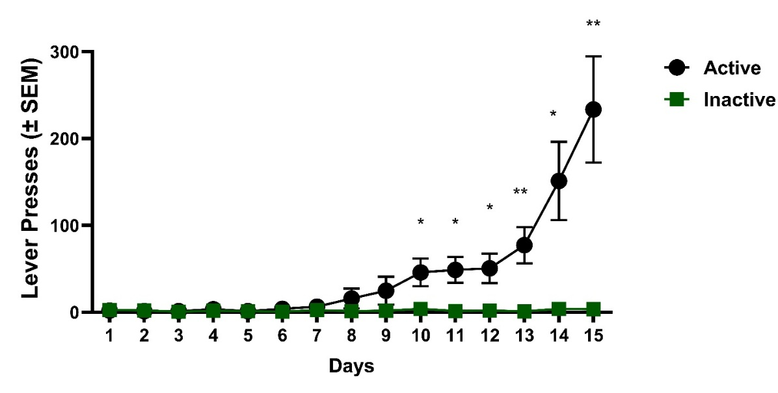
Supplemental Fig S6. Progressive ratio (PR) responding for methamphetamine.
Mean (± SEM) active and inactive lever presses across PR sessions (0.032 mg/kg/infusion; n = 8). Two-way repeated-measures ANOVA revealed significant main effects of Lever [F(1, 14) = 14.97, p = 0.0017] and Session [F(1.695, 23.73) = 11.23, p = 0.0006], as well as a significant Lever × Session interaction [F(14, 196) = 10.79, p < 0.0001]. Post-hoc comparisons indicated that active-lever responding became significantly greater than inactive-lever responding beginning on Day 10 (p = 0.035) and remained elevated through Day 15 (p = 0.007). These results confirm stable motivation to obtain methamphetamine under the progressive-ratio schedule prior to MG testing.
Fig S7.

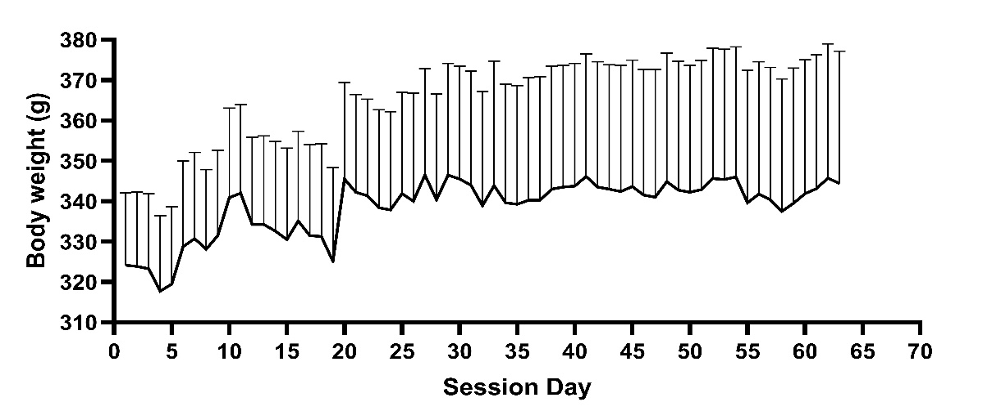
Supplemental Fig S7. Body weight during food-maintained responding experiment.
Body weights (mean ± SEM) were recorded daily throughout the food self-administration experiment under food-restricted conditions (~85% free-feeding weight). Body weight remained stable across the duration of the study. (n = 8)

