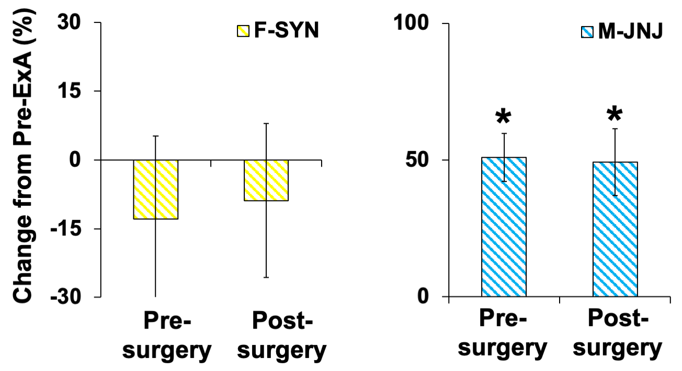
Supplemental Figure 1. No change in motivation for cocaine after cannula surgery. Percent change (± SEM), relative to baseline motivation established before extended-access (ExA) cocaine self-administration (Pre-ExA PR), in the number of cocaine infusions obtained under a progressive-ratio (PR) schedule, averaged across three PR testing days, measured at two timepoints: after the 7-day withdrawal period (i.e., prior to cannula implantation; pre-surgery) and prior to naspm treatment (i.e., following cannula implantation and on average 33 days after the final JNJ or SYN treatment; post-surgery) in SYN-treated females (n = 4) and JNJ-treated males (n = 5). * Significant difference from baseline (or zero).

